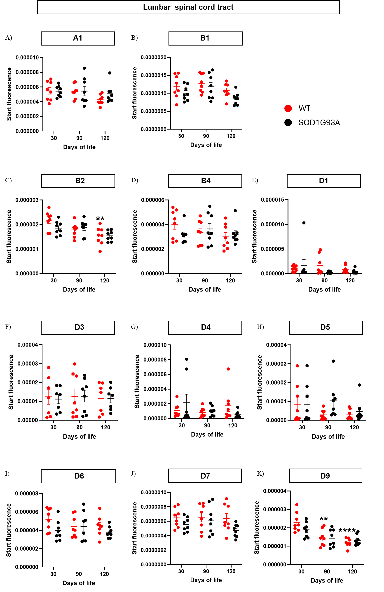

Supplementary Figure 1. mRNA expression of PDE4 isoforms in lumbar spinal cord of SOD1^{G93A} and WT mice. mRNA expression of A1 (A), B1 (B), B2 (C), B4 (D), D1 (E), D3 (F), D4 (G), D5 (H), D6 (I), D7 (J), and D9 (K) isoforms of PDE4 is reported as mean ± SEM of at least 7 independent experiments. Two-way ANOVA, followed by Tukey post-hoc test. **p<0.01, and ***p<0.001 vs the 30-day-old condition (within the genotype).
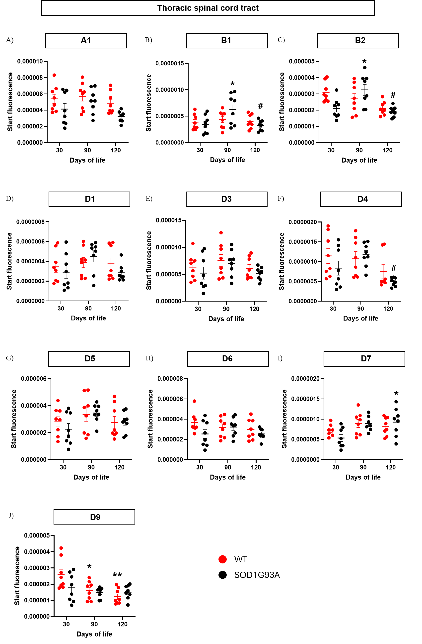

Supplementary Figure 2. mRNA expression of PDE4 isoforms in thoracic spinal cord of SOD1^{G93A} and WT mice. mRNA expression of A1 (A), B1 (B), B2 (C), D1 (D), D3 (E), D4 (F), D5 (G), D6 (H), D7 (I), and D9 (J) isoforms of PDE4 is reported as mean ± SEM of at least 7 independent experiments. Two-way ANOVA, followed by Tukey post-hoc test. *p<0.05 and **p<0.01 vs the 30-day-old condition (within the genotype); #p<0.05 vs the 90-day-old condition (within the genotype).
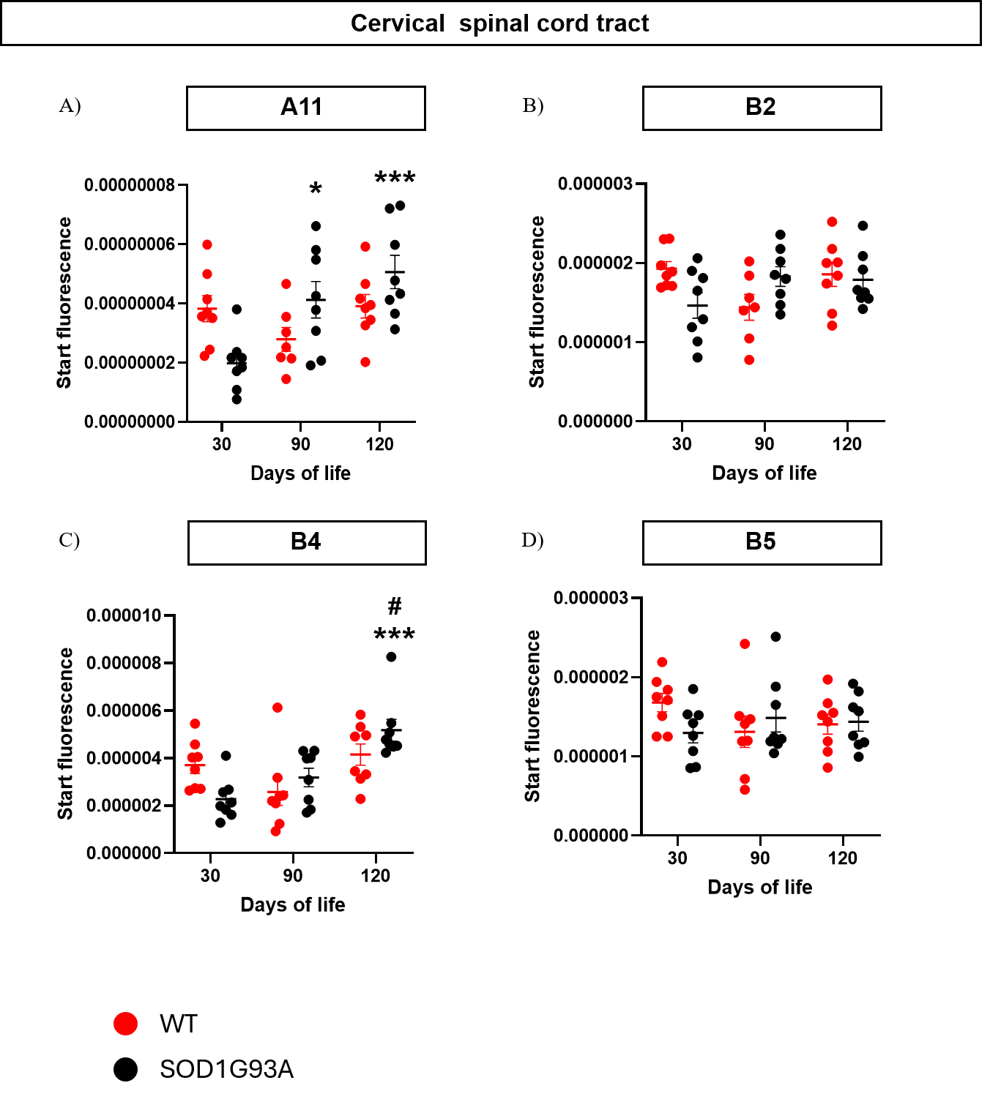

Supplementary Figure 3. mRNA expression of PDE4 isoforms in cervical spinal cord of SOD1^{G93A} and WT mice. mRNA expression of A11 (A), B2 (B), B4 (C), and B5 (D) isoforms of PDE4 is reported as mean ± SEM of at least 7 independent experiments. Two-way ANOVA, followed by Tukey post-hoc test. *p<0.05 and ***p<0.001 vs the 30-day-old condition (within the genotype); #p<0.05 vs the 90-day-old condition (within the genotype).
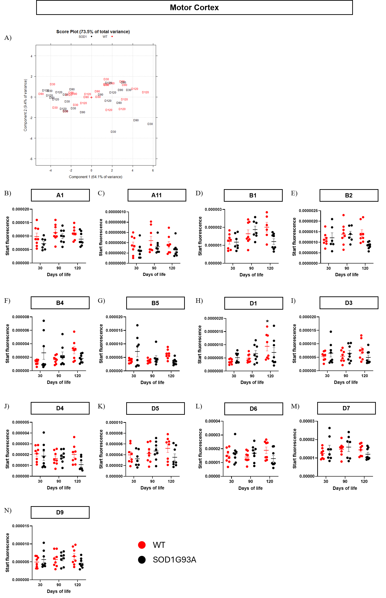
Supplementary Figure 4. mRNA expression of PDE4 isoforms in motor cortex of SOD1^{G93A} and WT mice. PCA loading plot of mRNA expression data is reported (A). mRNA expression of A1 (B), A11 (C), B1 (D), B2 (E), B4 (F), B5 (G), D1 (H), D3 (I), D4 (J), D5 (K), D6 (L), D7 (M), and D9 (M) isoforms of PDE4 is reported as mean ± SEM of at least 6 independent experiments. Two-way ANOVA, followed by Tukey post-hoc test.
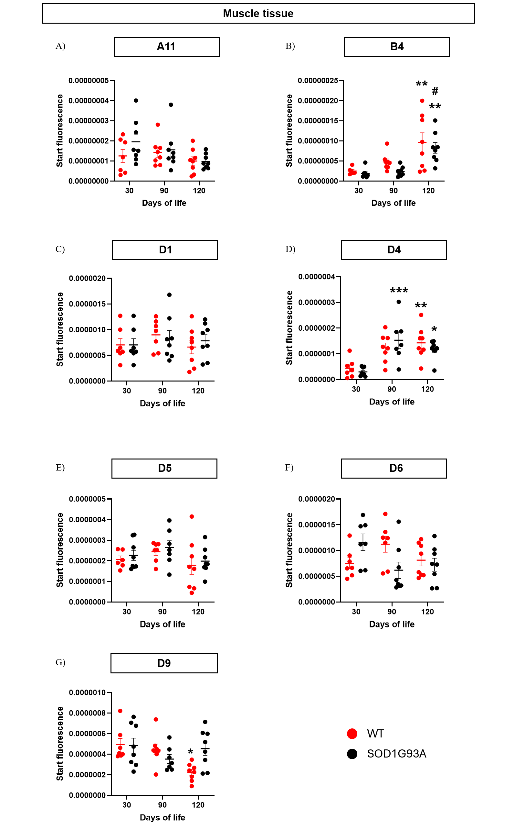

Supplementary Figure 5. mRNA expression distribution of PDE4 isoforms in hind limb muscles of SOD1^{G93A} and WT mice. mRNA expression of A11 (A), B4 (B), D1 (C), D4 (D), D5 (E), D6 (F), and D9 (G) isoforms of PDE4 is reported as mean ± SEM of at least 6 independent experiments. Two-way ANOVA, followed by Tukey post-hoc test. *p<0.05, **p<0.01, and ***p<0.001 vs the 30-day-old condition (within the genotype); #p<0.05 vs the 90-day-old condition (within the genotype).

