Supplementary data

Accelerated biological aging in people with Down syndrome with full and segmental trisomy 21 begins in childhood as revealed by immunoglobulin G glycosylation

Supplementary Figure 1. Relative abundances of directly measured IgG glycan traits (GP1-GP24) in persons with Down syndrome (DS) and in healthy controls shown separately for three cohorts of adults with DS from France (FRA), Italy (ITA) and the UK. Data are shown as box plots. Each box represents the 25th to 75th percentiles (IQR). Lines inside the boxes represent the median. Lines outside the boxes indicate data within 1.5 x IQR from the 25th and 75th percentiles. Black dots indicate outliers. Glycan structures corresponding to individual glycan peaks (GP1-24) are provided in Figure 1. Asterisk * sign next to the glycan trait name indicates statistically significant differences (p <0.05, meta-analysis) between DS individuals and healthy controls (additional information is available in Supplementary Table 1).

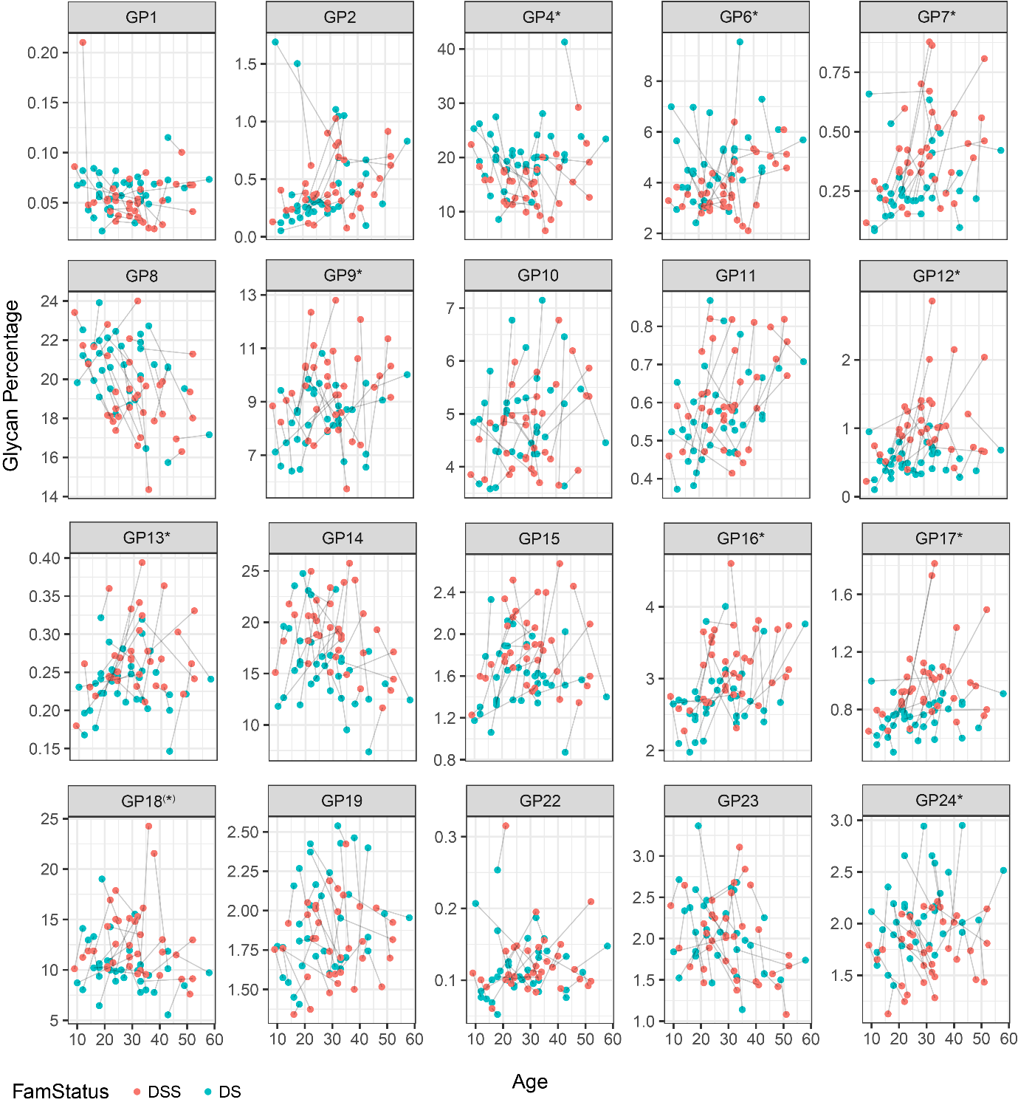
Supplementary Figure 2. Relative abundances of directly measured IgG glycan traits (GP1-GP24) in persons with Down syndrome (DS) and in their healthy siblings (DSS) from the Italian cohort of DS. Each dot represents a single individual. Lines connect the dots of each sibling pair. The age of each individual in years is shown on the x-axis. Asterisk * sign next to the glycan trait name indicates statistically significant differences (p <0.05, meta-analysis) between DS individuals and their healthy siblings and asterisk in brackets (*) next to the glycan trait name indicates nominal significance (p value slightly above 0.05) (additional information is available in Supplementary Table 2).

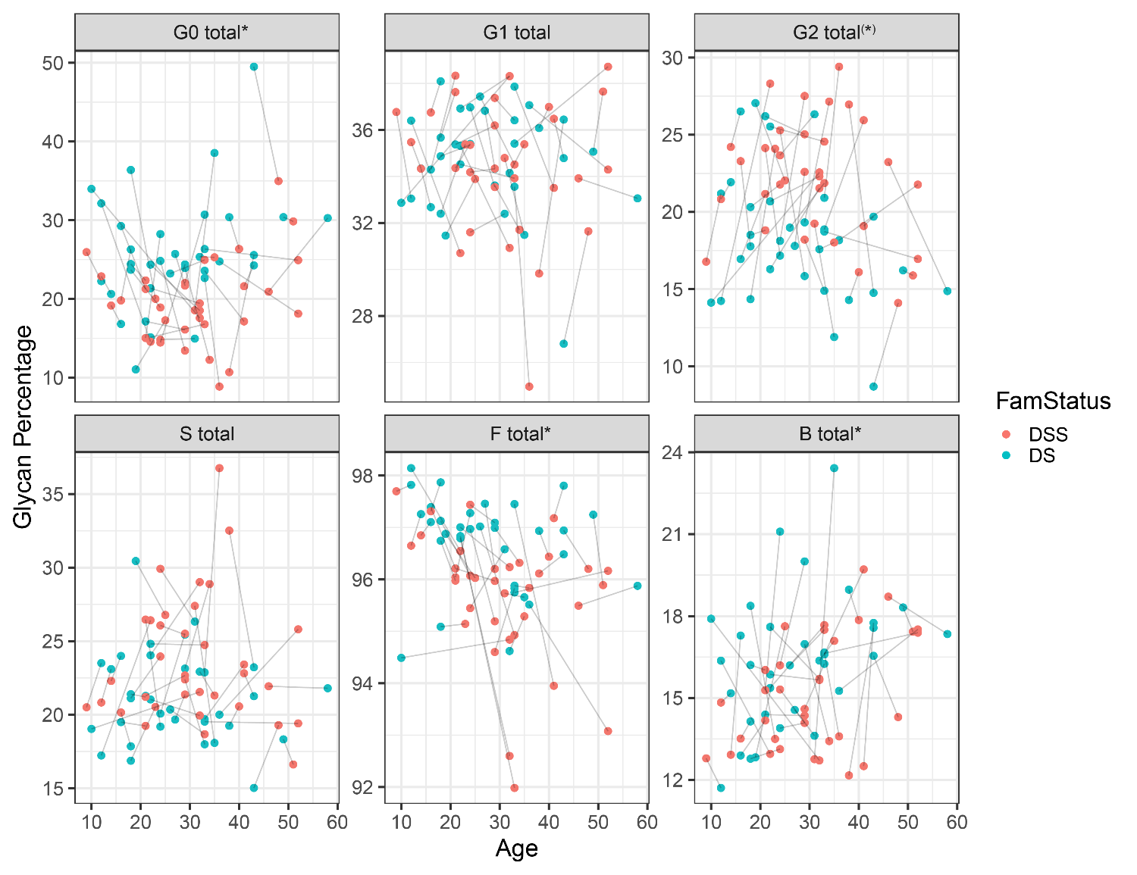
Supplementary Figure 3. Levels of derived IgG glycan traits in persons with Down syndrome (DS) and in their healthy siblings (DSS) from the Italian cohort of DS. Each dot represents a single individual. Lines connect the dots of each sibling pair. The age of each individual in years is shown on the x-axis. G0 total – sum of IgG glycans without galactose, G1 total – sum of IgG glycans with one galactose, G2 total – sum of IgG glycans with two galactoses, S total – sum of IgG glycans with sialic acid(s), F total – sum of IgG glycans with core fucose, B total – sum of IgG glycans with bisecting GlcNAc. Asterisk * sign next to the derived trait name indicates statistically significant differences (p <0.05, meta-analysis) between DS individuals and their healthy siblings and asterisk in brackets (*) next to the derived trait name indicates nominal significance (p value slightly above 0.05) (additional information is available in Supplementary Table 2).

Supplementary Figure 4. Relationship between IgG glycosylation and dementia within the French and UK cohorts of Down syndrome. a, Comparison of levels of derived IgG glycan traits between healthy control individuals, persons with Down syndrome (DS) without dementia and persons with DS with dementia. FRA – DS cohort from France, UK – DS cohort from the UK. G0 total – sum of IgG glycans without galactose, G1 total – sum of IgG glycans with one galactose, G2 total – sum of IgG glycans with two galactoses, S total – sum of IgG glycans with sialic acid(s), F total – sum of IgG glycans with core fucose, B total – sum of IgG glycans with bisecting GlcNAc. Data are shown as box plots. Each box represents the 25th to 75th percentiles (the interquartile range (IQR)). Lines inside the boxes represent the median. Lines outside the boxes indicate data within 1.5 x IQR from the 25th and 75th percentiles. Black dots indicate outliers. No significant difference was observed between persons with DS with or without dementia (additional information is available in Supplementary Tables 3 and 4). b, Age distribution of DS individuals with and without dementia within the French and UK cohorts of Down syndrome.

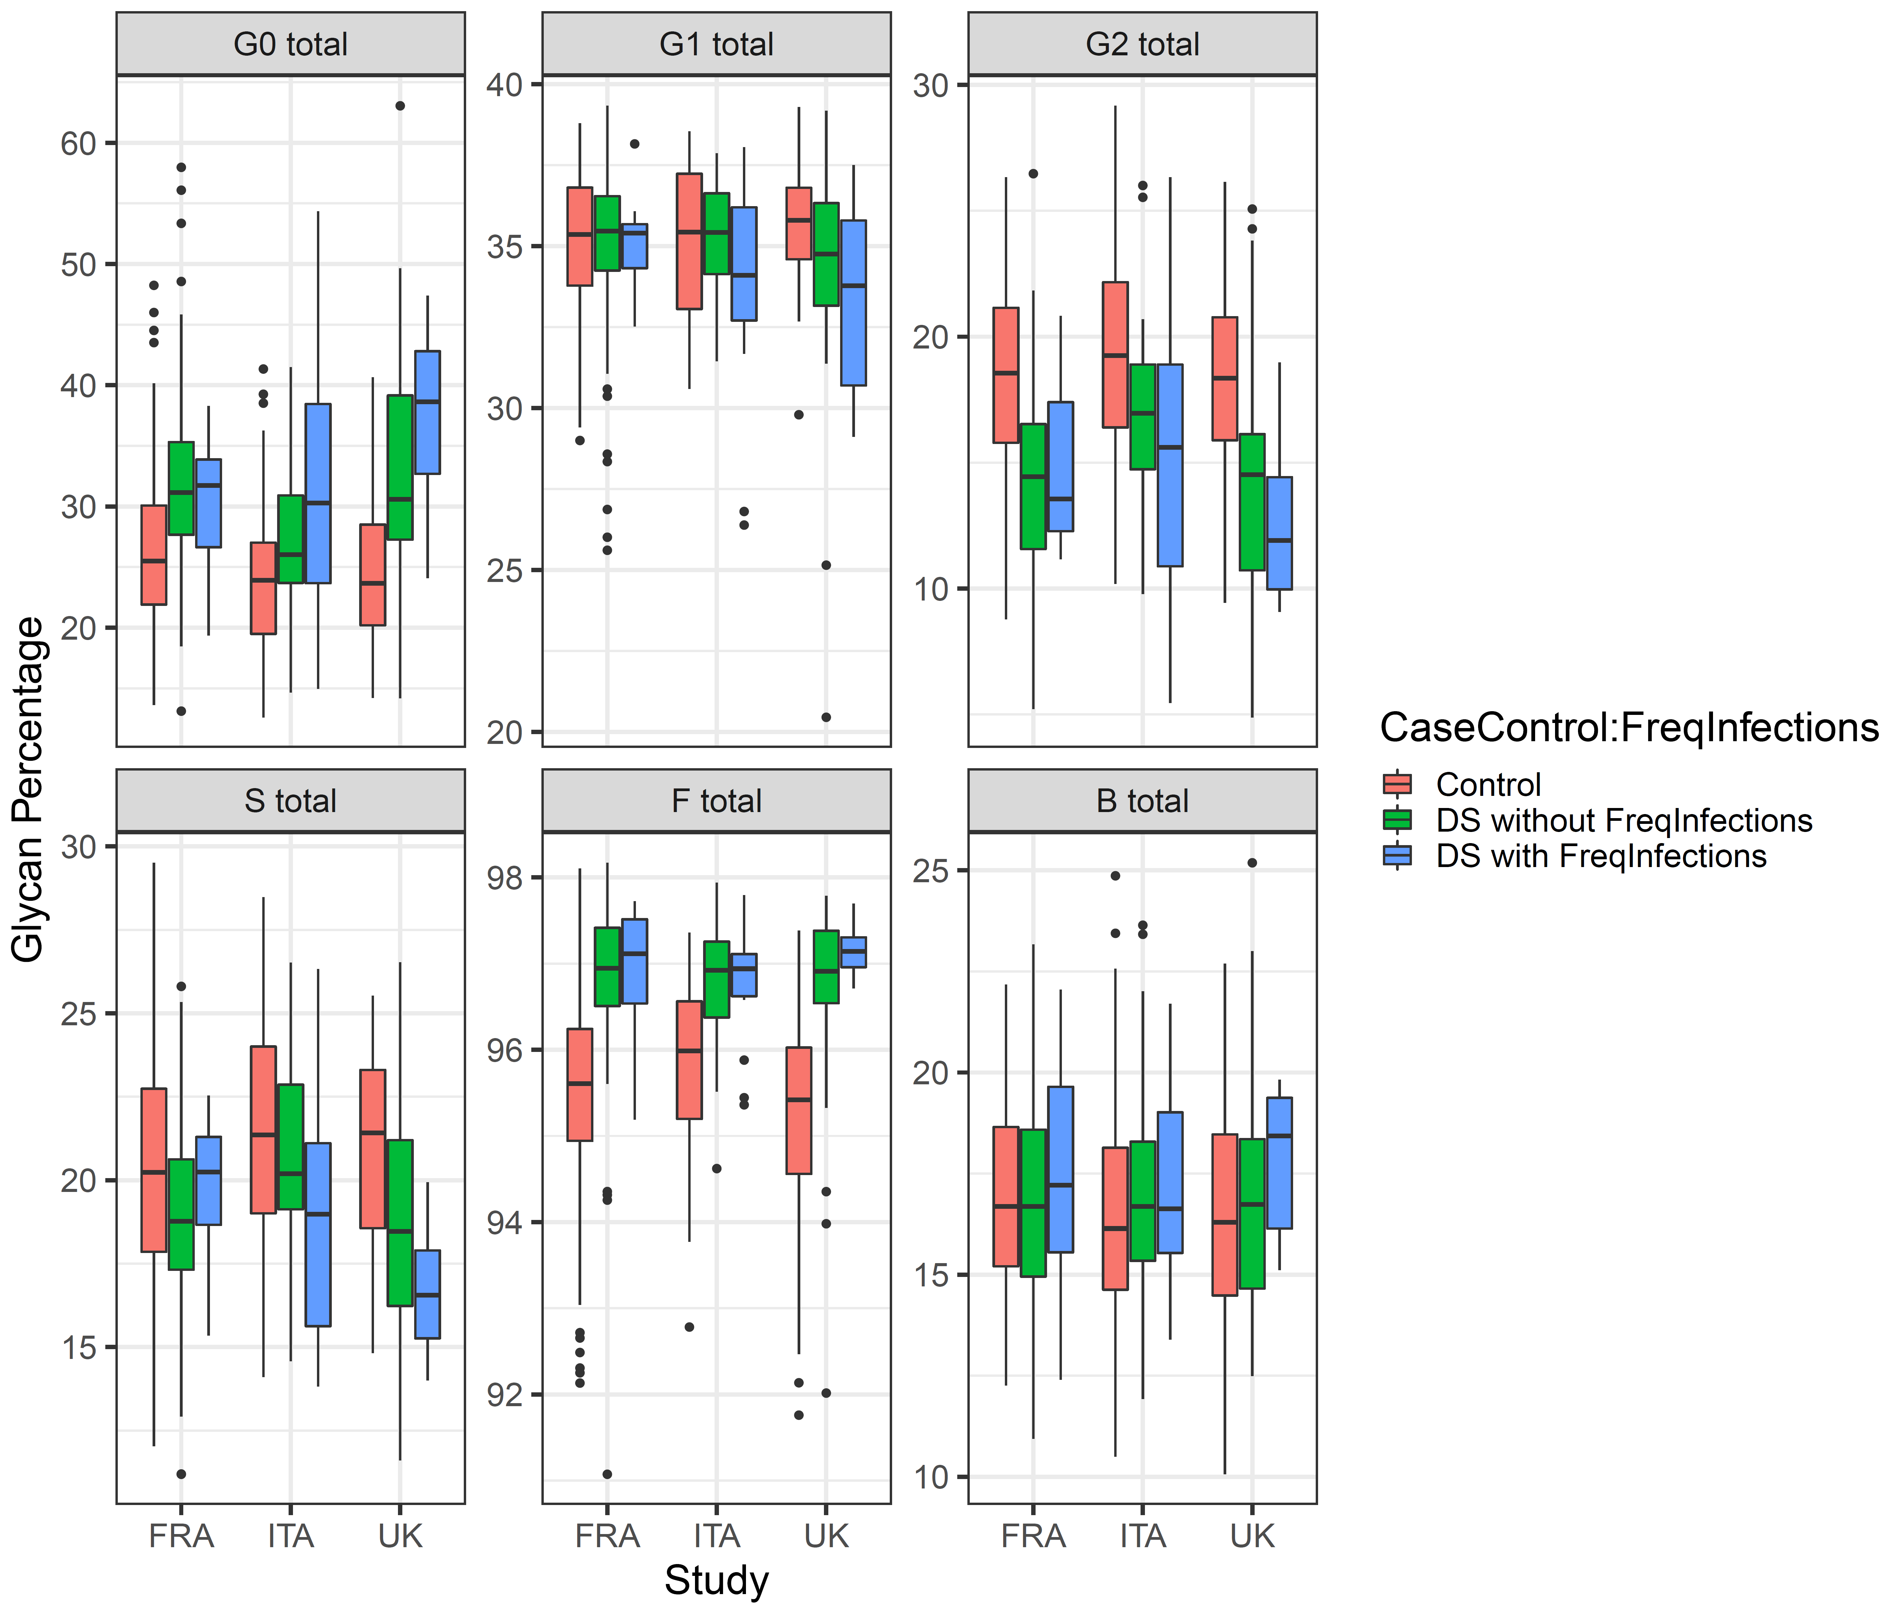
Supplementary Figure 5. Comparison of levels of derived IgG glycan traits between healthy control individuals, persons with Down syndrome (DS) without frequent infections and persons with DS with frequent infections. FRA – DS cohort from France, ITA – DS cohort from Italy, UK – DS cohort from the UK. G0 total – sum of IgG glycans without galactose, G1 total – sum of IgG glycans with one galactose, G2 total – sum of IgG glycans with two galactoses, S total – sum of IgG glycans with sialic acid(s), F total – sum of IgG glycans with core fucose, B total – sum of IgG glycans with bisecting GlcNAc. Data are shown as box plots. Each box represents the 25th to 75th percentiles (the interquartile range (IQR)). Lines inside the boxes represent the median. Lines outside the boxes indicate data within 1.5 x IQR from the 25th and 75th percentiles. Black dots indicate outliers. No significant difference was observed between persons with DS with or without frequent infections (additional information is available in Supplementary Tables 3 and 4).
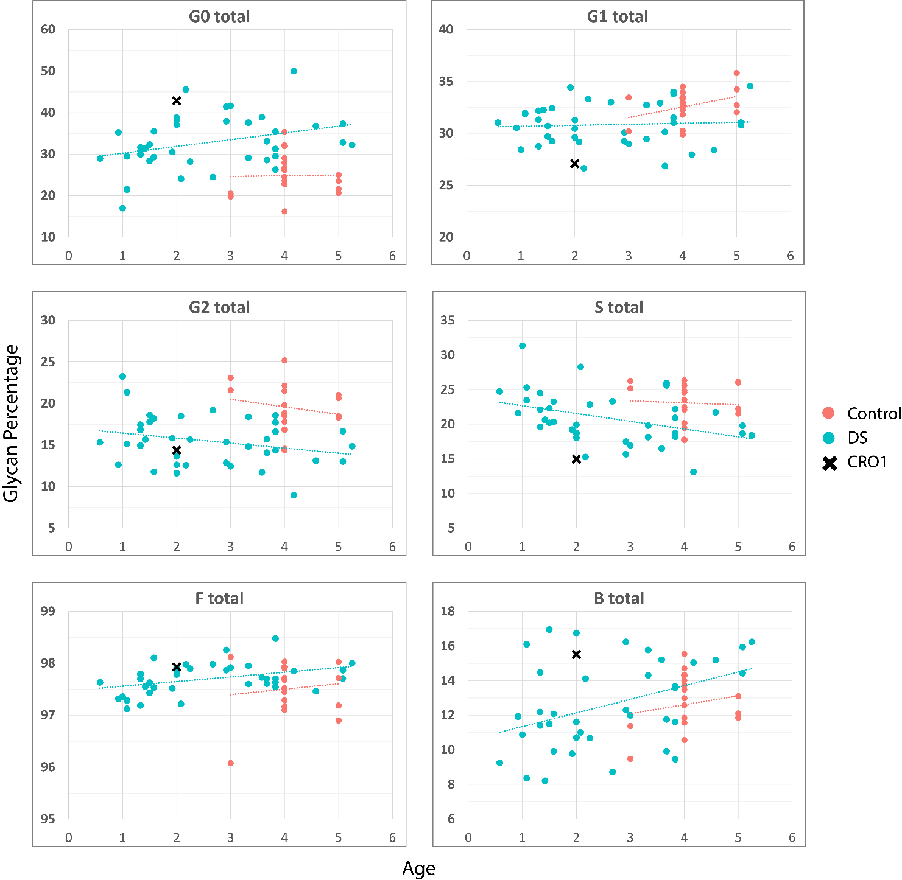
Supplementary Figure 6. Scatter plot of the levels of derived IgG glycan traits in 1 to 5-year-old children with Down syndrome (DS) from the UK cohort of DS, in CRO1 child with segmental trisomy 21 and in 3 to 5-year-old healthy children. n (children with DS) = 38, n (healthy children) = 17. G0 total – sum of IgG glycans without galactose, G1 total – sum of IgG glycans with one galactose, G2 total – sum of IgG glycans with two galactoses, S total – sum of IgG glycans with sialic acid(s), F total – sum of IgG glycans with core fucose, B total – sum of IgG glycans with bisecting GlcNAc. Each dot represents one child. CRO1 child is marked as single black cross. The age of each child in years is shown on the x-axis.

Supplementary Table 1. Comparison of directly measured IgG glycan traits and derived IgG glycan traits between persons with Down syndrome (DS) and healthy controls from the general population. FRA – DS cohort from France, ITA – DS cohort from Italy, UK – DS cohort from the UK, meta – meta-analysis. G0 total – sum of IgG glycans without galactose, G1 total – sum of IgG glycans with one galactose, G2 total – sum of IgG glycans with two galactoses, S total – sum of IgG glycans with sialic acid(s), F total – sum of IgG glycans with core fucose, B total – sum of IgG glycans with bisecting GlcNAc. The significance of the differences between the DS group and the control group was assessed using a general linear model. Glycan data were adjusted for age and sex. False discovery rate was controlled using the Benjamini–Hochberg method. Effect sizes are expressed in standard deviation units. Statistically significant findings (p <0.05) are shown in bold. The rows shaded gray indicate glycans that differed significantly between persons with DS and controls in all three examined cohorts.
Directly measured IgG glycan traits
 | FRA |  |  |  |  | ITA |  |  |  |  | UK |  |  |  |  | meta
Glycan | effect | DF | SE | p.val | p.adj | effect | DF | SE | p.val | p.adj | effect | DF | SE | p.val | p.adj | effect | SE | p.val | p.adj
GP1 | 0.345 | 198 | 0.120 | 3.747E-03 | 4.371E-03 | 0.171 | 101 | 0.158 | 2.616E-01 | 2.930E-01 | 0.576 | 86 | 0.175 | 8.050E-04 | 1.252E-03 | 0.349 | 0.084 | 3.360E-05 | 4.091E-05
GP2 | -0.867 | 198 | 0.118 | 1.938E-12 | 4.933E-12 | -0.372 | 101 | 0.172 | 2.548E-02 | 3.397E-02 | -0.507 | 86 | 0.190 | 5.948E-03 | 7.570E-03 | -0.665 | 0.087 | 1.703E-14 | 2.980E-14
GP3 | 0.650 | 198 | 0.111 | 8.559E-09 | 1.410E-08 | 0.579 | 101 | 0.161 | 2.759E-04 | 5.518E-04 | 0.818 | 86 | 0.167 | 1.315E-06 | 2.629E-06 | 0.671 | 0.080 | 5.452E-17 | 1.018E-16
GP4 | 0.873 | 198 | 0.104 | 2.050E-15 | 9.568E-15 | 0.645 | 101 | 0.156 | 3.208E-05 | 1.210E-04 | 0.973 | 86 | 0.156 | 2.602E-09 | 1.575E-08 | 0.843 | 0.076 | 7.750E-29 | 3.617E-28
GP5 | -0.016 | 198 | 0.118 | 8.915E-01 | 8.915E-01 | -0.383 | 101 | 0.161 | 1.419E-02 | 2.208E-02 | -0.737 | 86 | 0.175 | 2.392E-05 | 4.185E-05 | -0.281 | 0.084 | 7.965E-04 | 9.293E-04
GP6 | 0.044 | 198 | 0.115 | 6.950E-01 | 7.484E-01 | 0.368 | 101 | 0.164 | 2.054E-02 | 2.875E-02 | 0.512 | 86 | 0.162 | 1.279E-03 | 1.790E-03 | 0.243 | 0.082 | 2.947E-03 | 3.300E-03
GP7 | -1.322 | 198 | 0.106 | 4.801E-28 | 6.722E-27 | -0.891 | 101 | 0.166 | 1.429E-07 | 8.001E-07 | -1.053 | 86 | 0.178 | 1.218E-08 | 5.504E-08 | -1.168 | 0.080 | 1.080E-48 | 1.513E-47
GP8 | 0.770 | 198 | 0.122 | 7.336E-10 | 1.369E-09 | 0.669 | 101 | 0.167 | 5.725E-05 | 1.603E-04 | 0.158 | 86 | 0.190 | 3.818E-01 | 3.818E-01 | 0.613 | 0.087 | 2.499E-12 | 4.116E-12
GP9 | -0.665 | 198 | 0.127 | 2.033E-07 | 2.995E-07 | -1.031 | 101 | 0.168 | 3.383E-09 | 4.737E-08 | -0.916 | 86 | 0.186 | 1.145E-06 | 2.466E-06 | -0.825 | 0.089 | 1.500E-20 | 3.001E-20
GP10 | -0.424 | 198 | 0.137 | 1.752E-03 | 2.133E-03 | 0.076 | 101 | 0.184 | 6.678E-01 | 6.678E-01 | -0.295 | 86 | 0.202 | 1.259E-01 | 1.305E-01 | -0.257 | 0.096 | 7.680E-03 | 8.271E-03
GP11 | -0.593 | 198 | 0.127 | 3.040E-06 | 4.054E-06 | -0.623 | 101 | 0.164 | 1.230E-04 | 2.870E-04 | -0.444 | 86 | 0.176 | 9.281E-03 | 1.130E-02 | -0.565 | 0.087 | 8.342E-11 | 1.298E-10
GP12 | -1.393 | 198 | 0.099 | 7.437E-33 | 2.082E-31 | -1.032 | 101 | 0.152 | 1.231E-10 | 3.446E-09 | -1.228 | 86 | 0.166 | 8.773E-12 | 2.456E-10 | -1.273 | 0.074 | 1.260E-65 | 3.528E-64
GP13 | -1.023 | 198 | 0.116 | 1.525E-16 | 8.540E-16 | -0.524 | 101 | 0.177 | 2.522E-03 | 4.154E-03 | -0.975 | 86 | 0.187 | 3.250E-07 | 7.584E-07 | -0.894 | 0.086 | 3.806E-25 | 1.522E-24
GP14 | -0.766 | 198 | 0.098 | 1.042E-13 | 4.166E-13 | -0.523 | 101 | 0.147 | 3.228E-04 | 6.026E-04 | -0.810 | 86 | 0.146 | 7.059E-08 | 2.196E-07 | -0.719 | 0.071 | 6.806E-24 | 2.382E-23
GP15 | -0.878 | 198 | 0.113 | 1.267E-13 | 4.436E-13 | -0.632 | 101 | 0.167 | 1.371E-04 | 2.953E-04 | -0.892 | 86 | 0.167 | 1.807E-07 | 5.058E-07 | -0.823 | 0.082 | 8.085E-24 | 2.515E-23
GP16 | -0.866 | 198 | 0.125 | 2.099E-11 | 4.521E-11 | -0.714 | 101 | 0.183 | 8.368E-05 | 2.130E-04 | -1.049 | 86 | 0.178 | 1.376E-08 | 5.504E-08 | -0.876 | 0.089 | 1.049E-22 | 2.938E-22
GP17 | -0.918 | 198 | 0.125 | 1.547E-12 | 4.332E-12 | -0.903 | 101 | 0.154 | 1.460E-08 | 1.022E-07 | -1.105 | 86 | 0.178 | 2.812E-09 | 1.575E-08 | -0.956 | 0.085 | 2.908E-29 | 1.628E-28
GP18 | -0.752 | 198 | 0.104 | 2.731E-12 | 6.372E-12 | -0.472 | 101 | 0.156 | 1.944E-03 | 3.401E-03 | -0.823 | 86 | 0.155 | 2.218E-07 | 5.645E-07 | -0.703 | 0.075 | 1.091E-20 | 2.350E-20
GP19 | 0.785 | 198 | 0.128 | 1.942E-09 | 3.399E-09 | 0.174 | 101 | 0.193 | 3.474E-01 | 3.602E-01 | 0.464 | 86 | 0.205 | 1.908E-02 | 2.226E-02 | 0.570 | 0.095 | 1.708E-09 | 2.392E-09
GP22 | -0.733 | 198 | 0.129 | 2.470E-08 | 3.843E-08 | -0.175 | 101 | 0.189 | 3.333E-01 | 3.589E-01 | -0.720 | 86 | 0.198 | 2.283E-04 | 3.761E-04 | -0.592 | 0.094 | 3.005E-10 | 4.428E-10
GP23 | 0.612 | 198 | 0.130 | 2.643E-06 | 3.701E-06 | 0.263 | 101 | 0.177 | 1.226E-01 | 1.430E-01 | 0.374 | 86 | 0.177 | 2.845E-02 | 3.187E-02 | 0.460 | 0.090 | 3.247E-07 | 4.133E-07
GP24 | 0.919 | 198 | 0.122 | 5.999E-13 | 1.866E-12 | 0.895 | 101 | 0.175 | 5.001E-07 | 2.334E-06 | 0.639 | 86 | 0.207 | 1.539E-03 | 2.052E-03 | 0.859 | 0.090 | 1.762E-21 | 4.110E-21
Derived IgG glycan traits
 | FRA |  |  |  |  | ITA |  |  |  |  | UK |  |  |  |  | meta
Glycan | effect | DF | SE | p.val | p.adj | effect | DF | SE | p.val | p.adj | effect | DF | SE | p.val | p.adj | effect | SE | p.val | p.adj
G0 total | 0.708 | 198 | 0.103 | 2.900E-11 | 5.800E-11 | 0.616 | 101 | 0.150 | 3.892E-05 | 1.211E-04 | 0.876 | 86 | 0.155 | 4.255E-08 | 1.489E-07 | 0.724 | 0.074 | 2.517E-22 | 6.406E-22
G1 total | -0.034 | 198 | 0.133 | 7.911E-01 | 8.204E-01 | -0.288 | 101 | 0.184 | 1.044E-01 | 1.271E-01 | -0.625 | 86 | 0.194 | 1.012E-03 | 1.491E-03 | -0.240 | 0.094 | 1.093E-02 | 1.134E-02
G2 total | -0.897 | 198 | 0.097 | 8.792E-18 | 6.154E-17 | -0.607 | 101 | 0.147 | 3.457E-05 | 1.210E-04 | -0.919 | 86 | 0.147 | 2.222E-09 | 1.575E-08 | -0.834 | 0.071 | 7.375E-32 | 5.163E-31
S total | -0.424 | 198 | 0.119 | 3.506E-04 | 4.462E-04 | -0.383 | 101 | 0.169 | 1.955E-02 | 2.875E-02 | -0.726 | 86 | 0.170 | 1.905E-05 | 3.557E-05 | -0.488 | 0.085 | 7.698E-09 | 1.026E-08
F total | 1.126 | 198 | 0.117 | 5.820E-19 | 5.432E-18 | 0.960 | 101 | 0.160 | 7.031E-09 | 6.562E-08 | 1.136 | 86 | 0.177 | 9.812E-10 | 1.374E-08 | 1.083 | 0.083 | 1.357E-38 | 1.266E-37
B total | -0.065 | 198 | 0.131 | 6.127E-01 | 6.862E-01 | 0.300 | 101 | 0.173 | 7.122E-02 | 9.065E-02 | 0.278 | 86 | 0.186 | 1.189E-01 | 1.280E-01 | 0.119 | 0.091 | 1.909E-01 | 1.909E-01

Supplementary Table 2. Comparison of directly measured IgG glycan traits and derived IgG glycan traits between persons with Down syndrome and their healthy siblings from Italian Down syndrome cohort. G0 total – sum of IgG glycans without galactose, G1 total – sum of IgG glycans with one galactose, G2 total – sum of IgG glycans with two galactoses, S total – sum of IgG glycans with sialic acid(s), F total – sum of IgG glycans with core fucose, B total – sum of IgG glycans with bisecting GlcNAc. The significance of the differences between the affected and unaffected siblings was assessed using a general linear model. Glycan data were adjusted for age and sex. False discovery rate was controlled using the Benjamini–Hochberg method. Effect sizes are expressed in standard deviation units. Statistically significant findings (p <0.05) are shown in bold.
Directly measured IgG glycan traits
Glycan | effect | SE | p.val | p.adj
GP1 | 0.003 | 0.200 | 2.376E-01 | 3.024E-01
GP2 | -0.234 | 0.206 | 8.646E-01 | 8.646E-01
GP3 | 0.322 | 0.203 | 2.886E-01 | 3.367E-01
GP4 | 0.643 | 0.170 | 1.252E-03 | 5.010E-03
GP5 | -0.321 | 0.221 | 3.424E-01 | 3.763E-01
GP6 | 0.602 | 0.234 | 2.088E-02 | 4.872E-02
GP7 | -0.603 | 0.158 | 9.655E-04 | 4.506E-03
GP8 | 0.106 | 0.182 | 2.673E-01 | 3.254E-01
GP9 | -1.052 | 0.225 | 4.748E-05 | 4.431E-04
GP10 | 0.466 | 0.247 | 1.143E-01 | 1.684E-01
GP11 | -0.373 | 0.203 | 1.720E-01 | 2.409E-01
GP12 | -0.853 | 0.139 | 5.165E-07 | 1.446E-05
GP13 | -0.677 | 0.200 | 2.829E-03 | 8.801E-03
GP14 | -0.417 | 0.192 | 7.988E-02 | 1.378E-01
GP15 | -0.292 | 0.149 | 1.845E-01 | 2.459E-01
GP16 | -0.897 | 0.196 | 1.941E-04 | 1.087E-03
GP17 | -0.774 | 0.173 | 9.815E-05 | 6.870E-04
GP18 | -0.502 | 0.188 | 2.432E-02 | 5.237E-02
GP19 | 0.433 | 0.220 | 1.068E-01 | 1.661E-01
GP22 | -0.192 | 0.228 | 5.182E-01 | 5.374E-01
GP23 | 0.121 | 0.224 | 3.495E-01 | 3.763E-01
GP24 | 0.984 | 0.196 | 3.156E-05 | 4.418E-04
Derived IgG glycan traits
Glycan | effect | SE | pval | p.adj
G0 total | 0.614 | 0.186 | 4.664E-03 | 1.306E-02
G1 total | -0.479 | 0.222 | 6.922E-02 | 1.292E-01
G2 total | -0.486 | 0.185 | 2.661E-02 | 5.323E-02
S total | -0.433 | 0.203 | 8.365E-02 | 1.378E-01
F total | 0.611 | 0.176 | 2.447E-03 | 8.564E-03
B total | 0.702 | 0.247 | 9.500E-03 | 2.418E-02

Supplementary Table 3. Comparison of derived IgG glycan traits between persons with Down syndrome (DS) without certain comorbidity and healthy controls from the general population. FRA – DS cohort from France, ITA – DS cohort from Italy, UK – DS cohort from the UK, meta – meta-analysis. G0 total – sum of IgG glycans without galactose, G1 total – sum of IgG glycans with one galactose, G2 total – sum of IgG glycans with two galactoses, S total – sum of IgG glycans with sialic acid(s), F total – sum of IgG glycans with core fucose, B total – sum of IgG glycans with bisecting GlcNAc. The significance of the differences between the DS group and the control group was assessed using general linear model. Glycan data were adjusted for age and sex. False discovery rate was controlled using the Benjamini–Hochberg method. Effect sizes are expressed in standard deviation units. Statistically significant findings (p <0.05) are shown in bold.

Supplementary Table 4. Comparison of derived IgG glycan traits between persons with Down syndrome (DS) with and without a certain comorbidity. FRA – DS cohort from France, ITA – DS cohort from Italy, UK – DS cohort from the UK, meta – meta-analysis. G0 total – sum of IgG glycans without galactose, G1 total – sum of IgG glycans with one galactose, G2 total – sum of IgG glycans with two galactoses, S total – sum of IgG glycans with sialic acid(s), F total – sum of IgG glycans with core fucose, B total – sum of IgG glycans with bisecting GlcNAc. The significance of the differences between the two DS groups (with and without certain comorbidity) was assessed using general linear model. Glycan data were adjusted for age and sex. False discovery rate was controlled using the Benjamini–Hochberg method. Effect sizes are expressed in standard deviation units. Statistically significant findings (p <0.05) are shown in bold. NA = data not available
Supplementary Table 5. Association of derived IgG glycan traits with age in controls and in persons with Down syndrome (DS). FRA – DS cohort from France, ITA – DS cohort from Italy, UK – DS cohort from the UK, meta – meta-analysis. G0 total – sum of IgG glycans without galactose, G1 total – sum of IgG glycans with one galactose, G2 total – sum of IgG glycans with two galactoses, S total – sum of IgG glycans with sialic acid(s), F total – sum of IgG glycans with core fucose, B total – sum of IgG glycans with bisecting GlcNAc. Statistically significant associations (p <0.05) are shown in bold. Cor = correlation coefficient.
Controls
 | FRA |  | ITA |  | UK |  | meta
Glycan | Cor | p.val | Cor | p.val | Cor | p.val | effect | p.val | p.adj
G0 total | 0.551 | 5.360E-10 | 0.441 | 9.414E-04 | 0.636 | 5.899E-06 | 0.554 | 9.545E-30 | 5.727E-29
G1 total | -0.189 | 4.875E-02 | 0.124 | 3.771E-01 | -0.007 | 9.660E-01 | -0.074 | 2.820E-01 | 2.820E-01
G2 total | -0.496 | 4.204E-08 | -0.445 | 8.322E-04 | -0.662 | 1.785E-06 | -0.540 | 3.305E-27 | 9.914E-27
S total | -0.438 | 1.952E-06 | -0.373 | 5.931E-03 | -0.525 | 3.608E-04 | -0.445 | 3.375E-15 | 6.749E-15
F total | -0.096 | 3.203E-01 | -0.148 | 2.918E-01 | -0.160 | 3.103E-01 | -0.123 | 7.654E-02 | 9.185E-02
B total | 0.350 | 1.884E-04 | 0.377 | 5.444E-03 | 0.408 | 7.239E-03 | 0.370 | 1.215E-09 | 1.823E-09
Persons with Down syndrome
 | FRA |  | ITA |  | UK |  | meta
Glycan | Cor | p.val | Cor | p.val | Cor | p.val | effect | p.val | p.adj
G0 total | 0.464 | 1.471E-06 | 0.518 | 3.715E-05 | 0.532 | 4.148E-05 | 0.498 | 2.073E-21 | 6.220E-21
G1 total | -0.224 | 2.684E-02 | -0.191 | 1.544E-01 | -0.241 | 8.236E-02 | -0.219 | 9.607E-04 | 1.153E-03
G2 total | -0.555 | 3.012E-09 | -0.526 | 2.675E-05 | -0.575 | 6.709E-06 | -0.553 | 3.711E-30 | 2.227E-29
S total | -0.356 | 3.162E-04 | -0.438 | 6.490E-04 | -0.543 | 2.702E-05 | -0.440 | 4.632E-15 | 9.264E-15
F total | -0.059 | 5.611E-01 | -0.216 | 1.072E-01 | -0.039 | 7.789E-01 | -0.100 | 1.459E-01 | 1.459E-01
B total | 0.327 | 1.009E-03 | 0.440 | 6.110E-04 | 0.524 | 5.684E-05 | 0.422 | 1.424E-13 | 2.136E-13

Supplementary Table 6. Comparison of the rate of change in the IgG glycan levels with age between persons with Down syndrome (DS) and healthy controls. FRA – DS cohort from France, ITA – DS cohort from Italy, UK – DS cohort from the UK, meta – meta-analysis. G0 total – sum of IgG glycans without galactose, G1 total – sum of IgG glycans with one galactose, G2 total – sum of IgG glycans with two galactoses, S total – sum of IgG glycans with sialic acid(s), F total – sum of IgG glycans with core fucose, B total – sum of IgG glycans with bisecting GlcNAc. False discovery rate was controlled using the Benjamini–Hochberg method. Data yielding a p-value of less than 0.05 was considered statistically significant. Effect sizes are expressed in standard deviation units. No significant difference was observed in the rate of change in IgG glycan levels with age between controls and persons with DS.
 | FRA |  |  |  |  | ITA |  |  |  |  | UK |  |  |  |  | meta
Glycan | effect | DF | SE | p.val | p.adj | effect | DF | SE | p.val | p.adj | effect | DF | SE | p.val | p.adj | effect | SE | p.val | p.adj
G0 total | -0.002 | 202 | 0.013 | 0.870 | 0.870 | 0.008 | 105 | 0.013 | 0.546 | 0.931 | 0.010 | 90 | 0.011 | 0.378 | 0.454 | 0.006 | 0.007 | 0.438 | 0.526
G1 total | -0.009 | 202 | 0.016 | 0.570 | 0.851 | -0.016 | 105 | 0.016 | 0.314 | 0.931 | -0.018 | 90 | 0.014 | 0.199 | 0.454 | -0.015 | 0.009 | 0.102 | 0.526
G2 total | -0.007 | 202 | 0.012 | 0.544 | 0.851 | -0.006 | 105 | 0.013 | 0.647 | 0.931 | -0.004 | 90 | 0.011 | 0.709 | 0.709 | -0.006 | 0.007 | 0.421 | 0.526
S total | 0.016 | 202 | 0.014 | 0.267 | 0.851 | -0.008 | 105 | 0.014 | 0.586 | 0.931 | -0.012 | 90 | 0.012 | 0.308 | 0.454 | -0.003 | 0.008 | 0.743 | 0.743
F total | 0.005 | 202 | 0.014 | 0.709 | 0.851 | 0.001 | 105 | 0.014 | 0.931 | 0.931 | 0.013 | 90 | 0.013 | 0.282 | 0.454 | 0.007 | 0.008 | 0.370 | 0.526
B total | 0.006 | 202 | 0.015 | 0.705 | 0.851 | -0.003 | 105 | 0.015 | 0.853 | 0.931 | 0.017 | 90 | 0.013 | 0.198 | 0.454 | 0.007 | 0.008 | 0.374 | 0.526

Supplementary Table 7. Comparison of derived IgG glycan traits between around 4-year-old children with Down syndrome (DS) from the UK DS cohort and 4-year-old healthy children. G0 total – sum of IgG glycans without galactose, G1 total – sum of IgG glycans with one galactose, G2 total – sum of IgG glycans with two galactoses, S total – sum of IgG glycans with sialic acid(s), F total – sum of IgG glycans with core fucose, B total – sum of IgG glycans with bisecting GlcNAc. The significance of the differences between children with DS and healthy children was assessed using general linear model. Glycan data were adjusted for age and sex. False discovery rate was controlled using the Benjamini–Hochberg method. Effect sizes are expressed in standard deviation units. Statistically significant findings (p <0.05) are shown in bold.

Glycan | Cohort | Disease | effect | DF | SE | p.val | p.adj
G0 total | UK | Down | 1.446 | 15 | 0.551 | 0.007 | 0.044
G1 total | UK | Down | -0.520 | 15 | 0.651 | 0.374 | 0.463
G2 total | UK | Down | -1.241 | 15 | 0.543 | 0.017 | 0.052
S total | UK | Down | -1.195 | 15 | 0.631 | 0.043 | 0.087
F total | UK | Down | 0.537 | 15 | 0.690 | 0.386 | 0.463
B total | UK | Down | 0.279 | 15 | 0.584 | 0.592 | 0.592

Supplementary Table 8. Clinical observations for the child (code-named as CRO1) with partial trisomy 21 caused by the segmental duplication in 21q22. Clinical features were examined following the list published for other partial trisomy 21 cases (Lyle et al. 2009, ref 66 in the main text)

+ feature present; - feature absent; ? feature unknown
 | Case
Clinical features | CRO1
Short stature | -
Microcephaly | -
Brachycephaly | -
Flat facies | +
Upslanting palpebral fissures | -
Epicanthic folds | +
Brushfield spots | -
Flat nasal bridge | -
High arched palate | +
Furrowed tongue | -
Open mouth | -
Malpositioned ears | +
Small dysmorphic ears | +
Cardiac anomaly | -
Duodenal stenosis | -
Broad short hands | -
Clinodactyly of fifth finger | +
Wide-gap toes 1 and 2 | +
Abnormal dermatoglyphics | -
Palmar crease | -
Hypotonia | +
Hyperlax. ligaments | +
Delayed Intellectual development | +
Short neck | -
Delayed language and speech development | +
Autism spectrum disorders | -
Behavioral and emotional problems (ADHD, anxiety, impulsive behavior, aggression, psychosis, depression…) | ADHD
DM type 1 | -
Thyroid gland dysfunction (hypothyroidism or Hashimoto) | -
Celiac disease | -
Hearing loss | -
Vision problems | +
Frequent/recurrent infections | +
Immunodeficiency | ?
Leukemia | -
Sideropenic anemia | -
Polycythemia | -
Atlantoaxial instability | -
Sleep disorder | -
Gum disease and dental problems | -
Seizures/epilepsy | -
Digestive problems | -

Supplementary Discussion

Whole plasma proteome glycosylation in DS
An earlier study of the whole blood plasma protein glycosylation found differences in 76 individuals with DS from a single population compared to euploid controls (Borelli et al. 2015, ref 59 in the main text), indicating that glycosylation changes associated with ageing of uncharacterised plasma proteins appeared earlier in DS, but were only partially overlapping with ageing markers of euploid persons, revealing a DS-specific ageing phenotype (Borelli et al. 2015, ref 59 in the main text). However, this study investigated changes in glycans that originate from total plasma proteins, and not from one specific protein such as IgG, thus, in addition to changes in glycosylation, the observed differences also probably reflected changes in the levels of individual plasma proteins. Our data allow us to calculate a chronological age estimate, which based on DS values for G2 and G0 corresponded on average to 19 years older euploid individuals (range 11.7-31.1 years).

Additional discussion on glycans with core fucose in DS
Our study also reveals the increase in fucosylated (F) structures of IgG, which appears to be a DS-specific trait. Increase in IgG glycans with core fucose has rarely been reported in other diseases, and these reports include rheumatoid arthritis, ANCA-associated vasculitis, Chron’s disease, visceral leishmaniasis, HIV infection, hepatocellular carcinoma, galactosaemia and hypertension (Gudelj, Lauc, and Pezer 2018, ref 27 in the main text). The presence of core fucose is known to decrease the binding of IgG to activating FcγRIIIA and FcγRIIIB receptors up to 100-fold, dampening the downstream antibody-dependent cellular cytotoxicity (ADCC) (Gudelj, Lauc, and Pezer 2018, ref 27 in the main text; Shields et al. 2002). Increased core fucosylation that we reveal here as a DS-specific phenotype could therefore explain the mechanism causing the decreased ADCC ability observed in DS lymphocytes (Warren et al. 1987), which may contribute to a higher frequency, severity, duration and mortality of infections, in particular those of the upper respiratory tract, observed in DS (Chicoine et al. 2021; Ram and Chinen 2011).

Additional notes on IgG glycan profiles for DS with and without co-morbidities
Persons with DS also show a much higher incidence of a whole spectrum of auto-immune diseases, in particular thyroid conditions and type-1-diabetes (Ferrari and Stagi 2021; Giménez-Barcons et al. 2014), while the most frequent co-morbidity and cause of death in DS remains Alzheimer’s disease (AD) (Hithersay et al. 2019, ref 4 in the main text). In the general population, it has been reported that several immune system disorders, a whole spectrum of auto-immune diseases and Alzheimer’s disease (AD), are all among the diseases exhibiting an altered plasma IgG glycosylation profile in the general population (Gudelj, Lauc, and Pezer 2018, ref 27 in the main text). We therefore wanted to examine if the differences between DS and euploid controls we observed for the IgG glycosylation profiles were merely a secondary effect of the much higher prevalence of these co-morbidities in the DS population. We therefore repeated the analysis for DS without specific co-morbidities (thyroid dysfunction + any other autoimmune conditions, frequent infections, or AD-dementia), against the control population. We found nearly identical IgG glycan differences as for the whole (co-morbidity-unfiltered) DS cohorts, proving these alterations are caused by trisomy 21 as a genetic condition, and not as a secondary effect of DS co-morbidities. Corroborating to the observations in the general population, we did find that persons with DS with diagnosed autoimmunity had a significantly lower level of G2 IgG glycans (Figure 3 and Supplementary Table 4) than persons with DS without this diagnosis. Also, comparison of DS with and without autoimmune thyroid disease, the most common autoimmune disease associated with DS, revealed a higher level of G0 IgG glycans, and lower levels of G2 and S IgG glycans in persons with DS diagnosed with thyroid disease (Figure 3 and Supplementary Table 4). We observed no significant differences in IgG glycosylation patterns between DS with and without dementia, nor between DS with and without frequent infections (Supplementary Figure 4, Supplementary Figure 5 and Supplementary Table 4).
Additional References
Borelli, Vincenzo, Valerie Vanhooren, Emanuela Lonardi, Karli R. Reiding, Miriam Capri, Claude Libert, Paolo Garagnani, Stefano Salvioli, Claudio Franceschi, and Manfred Wuhrer. 2015. “Plasma N-Glycome Signature of Down Syndrome.” Journal of Proteome Research 14 (10): 4232–45. https://doi.org/10.1021/acs.jproteome.5b00356.
Chicoine, Brian, Anne Rivelli, Veronica Fitzpatrick, Laura Chicoine, Gengjie Jia, and Andrey Rzhetsky. 2021. “Prevalence of Common Disease Conditions in a Large Cohort of Individuals With Down Syndrome in the United States.” Journal of Patient-Centered Research and Reviews 8 (2): 86–97. https://doi.org/10.17294/2330-0698.1824.
Ferrari, Marta, and Stefano Stagi. 2021. “Autoimmunity and Genetic Syndromes: A Focus on down Syndrome.” Genes 12 (2): 1–10. https://doi.org/10.3390/genes12020268.
Giménez-Barcons, Mireia, Anna Casteràs, Maria del Pilar Armengol, Eduard Porta, Paula A. Correa, Ana Marín, Ricardo Pujol-Borrell, and Roger Colobran. 2014. “ Autoimmune Predisposition in Down Syndrome May Result from a Partial Central Tolerance Failure Due to Insufficient Intrathymic Expression of AIRE and Peripheral Antigens .” The Journal of Immunology 193 (8): 3872–79. https://doi.org/10.4049/jimmunol.1400223.
Gudelj, Ivan, Gordan Lauc, and Marija Pezer. 2018. “Immunoglobulin G Glycosylation in Aging and Diseases.” Cellular Immunology 333 (January): 65–79. https://doi.org/10.1016/j.cellimm.2018.07.009.
Hithersay, Rosalyn, Carla M. Startin, Sarah Hamburg, Kin Y. Mok, John Hardy, Elizabeth M.C. Fisher, Victor L.J. Tybulewicz, Dean Nizetic, and André Strydom. 2019. “Association of Dementia with Mortality among Adults with Down Syndrome Older Than 35 Years.” JAMA Neurology 76 (2): 152–60. https://doi.org/10.1001/jamaneurol.2018.3616.
Lyle, Robert, Frédérique Béna, Sarantis Gagos, Corinne Gehrig, Gipsy Lopez, Albert Schinzel, James Lespinasse, et al. 2009. “Genotype-Phenotype Correlations in Down Syndrome Identified by Array CGH in 30 Cases of Partial Trisomy and Partial Monosomy Chromosome 21.” European Journal of Human Genetics 17 (4): 454–66. https://doi.org/10.1038/ejhg.2008.214.
Ram, G., and J. Chinen. 2011. “Infections and Immunodeficiency in Down Syndrome.” Clinical and Experimental Immunology 164 (1): 9–16. https://doi.org/10.1111/j.1365-2249.2011.04335.x.
Shields, Robert L., Jadine Lai, Rodney Keck, Lori Y. O’Connell, Kyu Hong, Y. Gloria Meng, Stefanie H.A. Weikert, and Leonard G. Presta. 2002. “Lack of Fucose on Human IgG1 N-Linked Oligosaccharide Improves Binding to Human FcγRIII and Antibody-Dependent Cellular Toxicity.” Journal of Biological Chemistry 277 (30): 26733–40. https://doi.org/10.1074/jbc.M202069200.
Warren, R P, M C Healey, A V Johnston, R W Sidwell, L A Radov, R J Murray, and C R Kinsolving. 1987. “PPR 879-317A Enhances in Vitro Immune Activity of Peripheral Blood Mononuclear Cells from Patients with down Syndrome.” Int J Immunopharmacol 9 (8): 919–26.

