Supplementary information
Deep eutectic solvent-impregnated cellulose triacetate matrix as a dual-function platform for selective preconcentration and colorimetric detection of Ni(II) ions
Nisha Yadav¹, Kalyan Yakkala^{1*}, and Ashok K. Pandey²
¹Department of Environmental Studies, University of Delhi, Delhi-110007, India
²Department of Nuclear and Radiochemistry, Kishinchand Chellaram College, HSNC University, Mumbai-400020, India

Fig. S1. UV-visible spectra of optodes prepared with different DES compositions after equilibration with 2.5 µg/mL Ni(II) at pH 6.

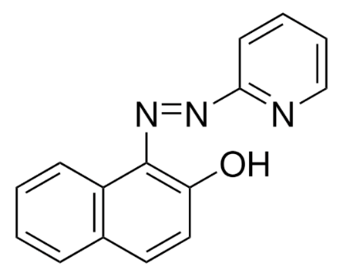
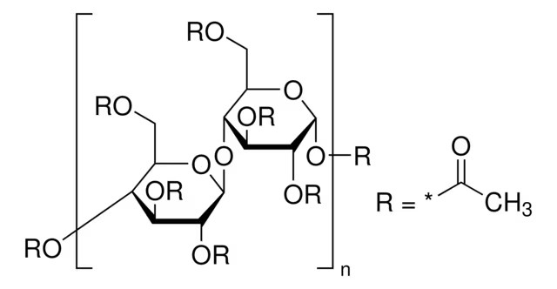

Cellulose Triacetate (CTA) 1-(2-pyridylazo)-2-naphthol (PAN)

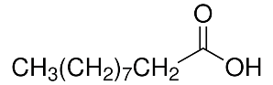
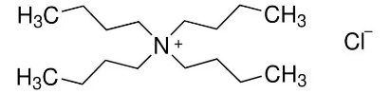

Tetrabutylammonium Chloride (TBACl) Decanoic Acid (DecA)
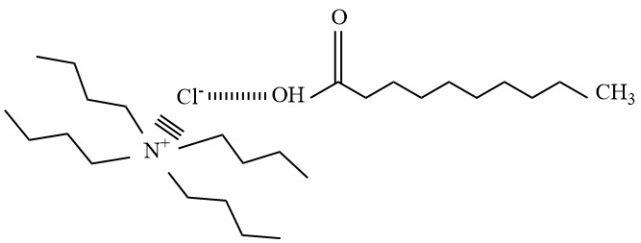

TBACl : DecA (1:1)
Fig. S2. Structure of the components used in the preparation of the optode.

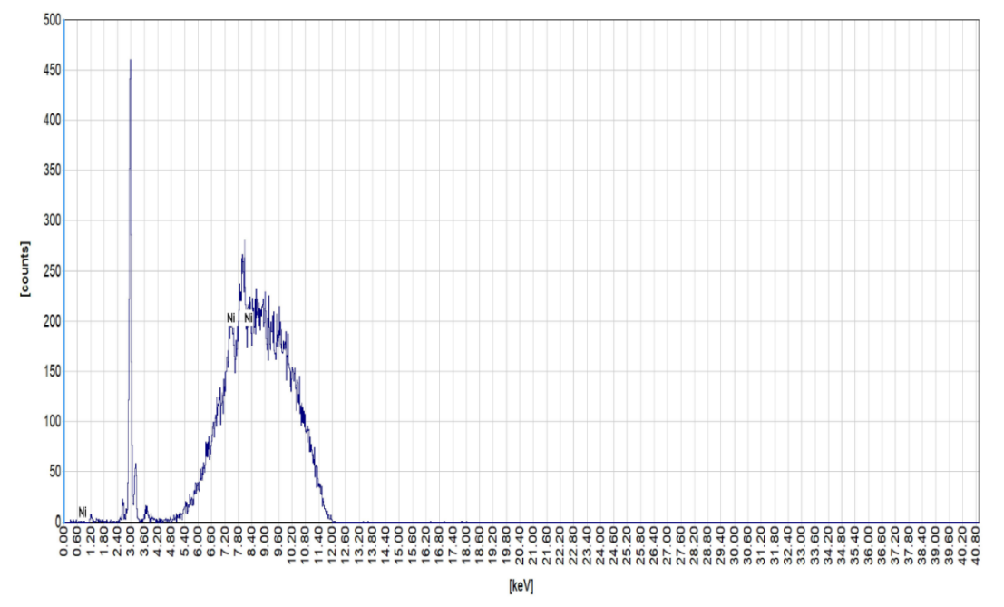
(a)

(b)
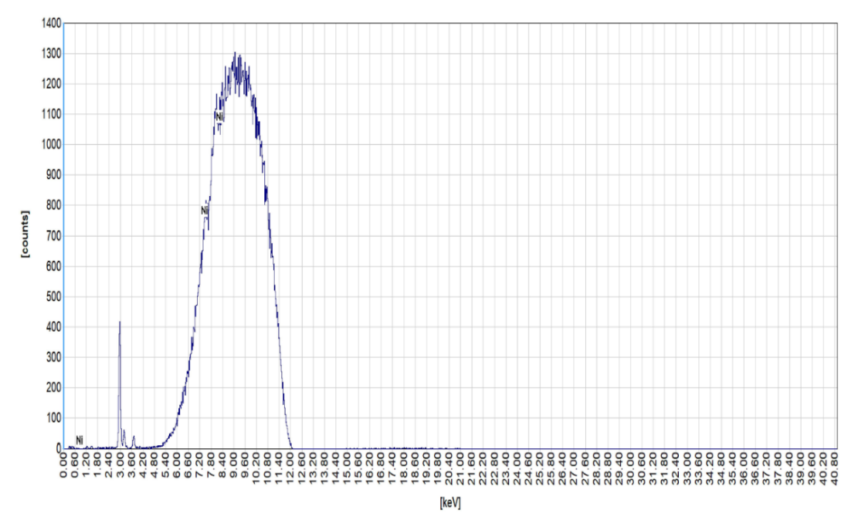

Fig. S3. EDXRF of the optode samples after equilibration in solutions containing Ni(II) having concentrations (a) 0.05 µg/mL and (b) 2.5 µg/mL.

(a)
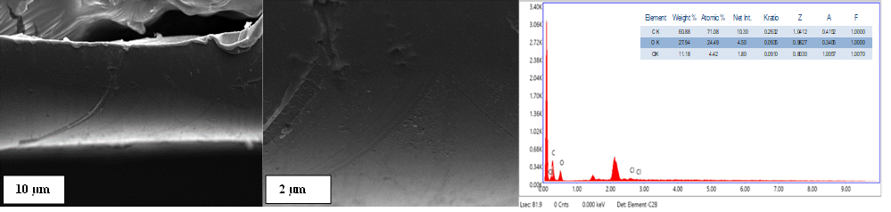
(b)
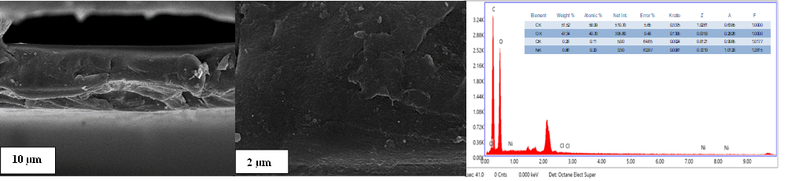

(c)
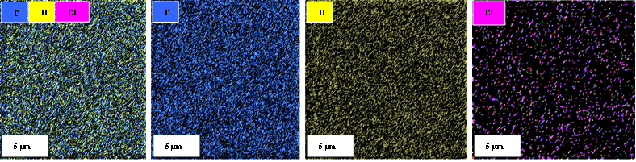

(d)
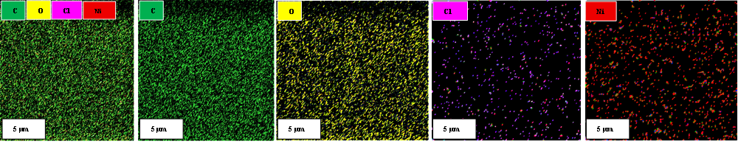
Fig. S4. Cross-sectional FESEM images and EDX spectra of DES-loaded (a) blank membrane optode, (b) membrane optode loaded with 2.5 µg/mL Ni(II) at pH 6, Elemental mapping for (c) blank membrane optode, (d) membrane optode loaded with 2.5 µg/mL of Ni(II) at pH 6.

Fig. S5. Adsorption isotherm of Ni(II) on the membrane optode

Fig. S6. Adsorption kinetics of Ni(II) on the membrane optode as a function of time
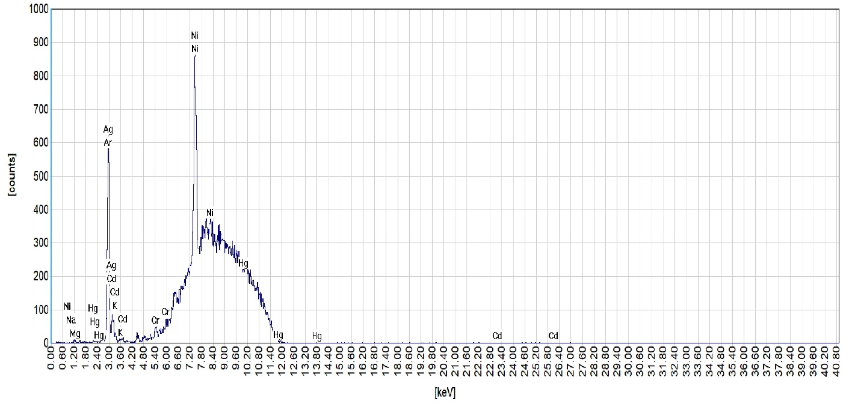
Fig. S7. EDXRF spectrum of the membrane optode equilibrated in a solution containing Ni(II) along with other interfering ions.

Table S1. Physical appearance of HDES prepared at different TBACl:DecA mole ratios
Mole Ratio of TBACl: DecA | Appearance
1:1 | Transparent, viscous liquid
1:2 | Transparent, viscous liquid
2:1 | Transparent, highly viscous liquid

Table S2. Response of optodes with different compositions towards Ni(II).
Optode | Composition |  |  | Response towards Ni(II) uptake
Optode | CTA (g) | PAN (g) | DES, g (mole ratio) | Response towards Ni(II) uptake
M1 | 0.2 | 0.001 | 0.2 (1:1) | Very fast response; rapid colour change from yellow to magenta
M2 | 0.2 | 0.002 | 0.2 (1:1) | Fast response, but absorbance exceeded 2
M3 | 0.2 | 0.001 | 0.2 (1:2) | Good response, but slower than M1
M4 | 0.2 | 0.001 | 0.2 (2:1) | Slow, unsatisfactory response
M5 | 0.2 | 0.001 | No DES | No response
Table S3. FTIR absorption bands and peak assignments for TBACl, DecA and the prepared DES (1:1). Δν = ν(DES) − ν(DecA); n.a. = not applicable (overlapping bands).
Functional group & peak assignment | DecA  (cm⁻¹) | TBACl  (cm⁻¹) | DES 1:1 (cm⁻¹) | Δν (cm⁻¹)
C-H stretching, asymmetric (CH₂, DecA) | 2917 | - | 2917 | 0
C-H stretching, symmetric (CH₂, DecA) | 2851 | - | 2861 | +10
C-H stretching (CH₃/CH₂, TBA⁺) | - | 2957, 2869 | Overlapped with DecA bands | n.a.
O-H stretching (carboxylic acid dimer) | 2500-3300 (broad) | - | Weakened & broadened | -
C=O Stretching | 1690 | - | 1716 | +26
O-H out-of-plane bending (dimer) | 928 | - | Not observed | -
Skeletal / C-N⁺ vibration (TBA⁺) | - | ≈880 | 884 | n.a.

Table S4. FTIR absorption bands, peak assignments and Δν values for the blank membrane optode and the optode loaded with 2.5 µg/mL Ni(II). Δν = ν(loaded) − ν(blank); all Δν values are within the spectral resolution.
Functional group & peak assignment | Blank membrane optode (cm⁻¹) | Membrane optode equilibrated with 2.5 µg/mL Ni(II) (cm⁻¹) | Δν (cm⁻¹)
C-H stretching (aliphatic) | 2926 | 2927 | +1
C=O stretching (ester) | 1739 | 1739 | 0
C-O stretching (ester) | 1216 | 1212 | -4
C-O stretching (ester) | 1034 | 1032 | -2
O-C=O deformation (acetate group of matrix) | 601 | 601 | 0

Table S5. AFM characterization of the membrane optode.
Membrane optode | Roughness, Ra (nm)
CTA, PAN without DES | 5.6
CTA, PAN with DES | 3.7
CTA, PAN with DES after equilibration with Ni(II) 2.5 µg/mL | 6.8

