Supplementary material
Loneliness and objective social isolation in observed depressive symptom transitions across six ageing cohorts
This supplement describes measurement, analytic denominators, complete-case selection and sensitivity analyses. CAR denotes the exponentiated complementary log-log coefficient, not an observed instantaneous hazard. Unless specified otherwise, models use a nominal-duration offset and participant-clustered standard errors. Onset and recovery denote endpoint symptom-state changes; repeated unobserved transitions remain possible.

Supplementary Table S1 Measurement definitions and harmonization
Cohort | Nominal window | Elevated symptom state | Loneliness score | High loneliness | Baseline severity without loneliness
CHARLS | 2011–2020 | CES-D-10 ≥10 | Single item, 1–4 | ≥3 | Total − (item−1)
ELSA | 2010–2018 | CES-D-8 ≥4 | Three-item mean  1–3 | ≥2 | Not available
HRS | 2008–2020 | CES-D-8 ≥4 | Three-item mean  1–3 | ≥2 | Not available
KLoSA | 2010–2020 | CES-D-10 ≥10 | Single item, 1–4 | ≥3 | Total − (item−1)
MHAS | 2012–2018 | Nine-item score ≥5 | Binary item, 0–1 | =1 | Total − binary item; corrected
SHARE | 2011–2020 | EURO-D ≥4 | Three-item mean  1–3 | ≥2 | Unchanged EURO-D

Across cohorts, objective isolation is unpartnered + living alone + no social participation (0–3); high isolation is ≥2. All three components must be observed for the common index. Loneliness standardization uses the cohort mean and sample SD of all nonmissing records in the harmonized dataset, not only the eligible analysis sample. Binary loneliness is standardized in the same way, so a one-SD increment is not the full binary contrast from 0 to 1. High-loneliness cut-offs are operational thresholds and do not establish equivalent clinical severity across instruments.
The primary state thresholds correspond to the cohort-specific score definitions shown above. Removing the loneliness item from CES-D-10 yields a nine-item score; the ≥9 outcome threshold used in Table S7 is exploratory rather than independently validated.
The ELSA/HRS/SHARE loneliness variables include half-point values such as 1.5 and 2.5, indicating that score construction may permit partial-item averaging or other source-specific rules. These rules differ across cohorts and could not be reconstructed uniformly from the harmonized dataset. SHARE wave 4 administered the three questions in a self-completed drop-off questionnaire, while administration mode differed in later waves. Such differences should be considered when interpreting cross-cohort measurement comparability.
Source documentation: Harmonized MHAS documentation, 2012 download path, printed pp. 625–626, explicitly includes RwFLONE in the nine-item RwCESD_M total and describes missing-item rules: https://www.mhasweb.org/Resources/DATA/Constructed_Imputed/HarmonizedData/2012/SAS/Harmonized_MHAS.pdf. SHARE wave 4 drop-off questionnaire, printed p. 7: https://share-eric.eu/fileadmin/user_upload/Questionnaires/Q-Wave_4/w4_en_dropoff_ques-Generic.pdf. Accessed 20 September 2026. Cut-off validation: Aguilar-Navarro et al. (2007), DOI 10.1590/S0036-36342007000400005, in a clinical sample aged ≥65; this does not establish universal equivalence across populations.

Supplementary Table S2 Selection and observed transition counts
Cohort | Master records | Eligible records | Eligible people | People with pairs | Observed intervals
CHARLS | 96,628 | 73,296 | 22,576 | 18,829 | 50,720
ELSA | 90,069 | 34,256 | 11,123 | 8,123 | 23,133
HRS | 208,674 | 44,022 | 21,042 | 13,632 | 22,980
KLoSA | 44,273 | 43,866 | 9,208 | 8,542 | 34,658
MHAS | 76,506 | 41,621 | 19,688 | 13,050 | 21,933
SHARE | 327,266 | 232,774 | 110,153 | 65,232 | 122,621

Cohort | Below → below | Onset | Elevated → elevated | Recovery | Onset, % | Recovery, %
CHARLS | 25,355 | 7,537 | 10,934 | 6,894 | 22.9 | 38.7
ELSA | 19,164 | 1,375 | 1,230 | 1,364 | 6.7 | 52.6
HRS | 18,728 | 1,524 | 1,329 | 1,399 | 7.5 | 51.3
KLoSA | 21,841 | 3,816 | 4,917 | 4,084 | 14.9 | 45.4
MHAS | 12,260 | 2,893 | 3,882 | 2,898 | 19.1 | 42.7
SHARE | 77,186 | 14,661 | 17,108 | 13,666 | 16.0 | 44.4

Counts precede model-specific covariate exclusions. Onset percentage = onset/(below→below + onset); recovery percentage = recovery/(elevated→elevated + recovery). Denominators are repeated intervals, not unique people, and observation gaps differ. Main Figure 3 displays these same values as conditional matrices. The 193,790 eligible people include 66,382 who do not contribute an interval.
The harmonized dataset includes additional ages and waves. Eligibility also depends on measured exposures at both endpoints, so this is not a full parent-cohort recruitment or attrition flow. Reasons for non-observation, death and study-specific exclusion cannot be exhaustively separated from the harmonized analytic dataset. The 373,581 excluded records fail one or more combined eligibility criteria rather than representing 373,581 unique people.

Supplementary Table S3 Adjustment sets and same-record expanded-model comparisons
Analysis | Transition | Exposure | k | Estimate (95% CI) | I², % | 95% PI
Demographic | Onset | Loneliness | 6 | 1.48 (1.30–1.69) | 98.0 | 0.92–2.39
Demographic | Onset | Isolation | 6 | 1.05 (1.00–1.10) | 85.3 | 0.90–1.23
Demographic | Recovery | Loneliness | 6 | 0.80 (0.77–0.83) | 83.9 | 0.70–0.91
Demographic | Recovery | Isolation | 6 | 0.96 (0.91–1.01) | 87.9 | 0.80–1.16
Primary | Onset | Loneliness | 6 | 1.43 (1.27–1.61) | 97.7 | 0.92–2.21
Primary | Onset | Isolation | 6 | 1.03 (0.98–1.08) | 89.1 | 0.87–1.23
Primary | Recovery | Loneliness | 6 | 0.82 (0.78–0.85) | 86.7 | 0.71–0.94
Primary | Recovery | Isolation | 6 | 0.98 (0.93–1.02) | 87.8 | 0.83–1.15
Expanded | Onset | Loneliness | 6 | 1.42 (1.26–1.60) | 97.3 | 0.92–2.19
Expanded | Onset | Isolation | 6 | 1.01 (0.96–1.06) | 85.8 | 0.83–1.22
Expanded | Recovery | Loneliness | 6 | 0.82 (0.79–0.85) | 84.8 | 0.71–0.94
Expanded | Recovery | Isolation | 6 | 1.00 (0.96–1.05) | 83.1 | 0.86–1.16

Demographic adjustment includes both exposures, age, sex, education and starting wave. Primary models add work, multimorbidity, ADL limitation and self-rated health. Expanded models add wealth rank, smoking, alcohol use and cognition. Different complete-case samples are used across the first three specifications.
Primary specification on the expanded-model complete-case sample
Analysis | Transition | Exposure | k | Estimate (95% CI) | I², % | 95% PI
Primary on expanded sample | Onset | Loneliness | 6 | 1.43 (1.27–1.60) | 97.3 | 0.93–2.19
Primary on expanded sample | Onset | Isolation | 6 | 1.04 (0.99–1.09) | 86.6 | 0.87–1.24
Primary on expanded sample | Recovery | Loneliness | 6 | 0.82 (0.78–0.85) | 85.3 | 0.71–0.94
Primary on expanded sample | Recovery | Isolation | 6 | 0.98 (0.94–1.03) | 86.0 | 0.83–1.16

Compare this same-record primary model with the expanded rows above to assess the incremental covariate adjustment. All estimates are CARs. No weighted or imputed analysis is presented.

Supplementary Table S4 Joint social phenotypes
Transition | Phenotype | CAR (95% CI) | I², % | 95% PI | k
Onset | High loneliness only | 2.06 (1.73–2.46) | 88.1 | 1.11–3.84 | 6
Onset | High isolation only | 1.06 (0.96–1.17) | 84.8 | 0.75–1.50 | 6
Onset | Both high | 1.78 (1.28–2.47) | 95.5 | 0.54–5.89 | 6
Recovery | High loneliness only | 0.65 (0.61–0.70) | 64.4 | 0.54–0.79 | 6
Recovery | High isolation only | 0.96 (0.87–1.07) | 68.4 | 0.69–1.36 | 6
Recovery | Both high | 0.63 (0.57–0.70) | 77.6 | 0.44–0.91 | 6

The reference is neither high loneliness nor high objective isolation, using Table S1 thresholds. Categories are entered jointly with primary covariates. Separate phenotype coefficients do not establish a statistically tested difference between those categories, and these contrasts should not be interpreted as additive-risk synergy. Supplementary Figure S1 displays the same estimates and uncertainty.

Supplementary Table S5 Corrected baseline depressive severity sensitivity
In the analytic dataset, the MHAS loneliness-excluded score was numerically identical to the full depression score in all 70,552 records with that field. The available binary CES-D loneliness item agreed exactly with the separate binary loneliness variable. Official MHAS documentation identifies that item as part of the nine-item total (Table S1 source). We therefore reconstructed an eight-item baseline severity score as depression_score minus cesd_loneliness_item; values ranged from 0 to 8. This correction addresses the derived score used for sensitivity analysis but does not establish equivalence to a separately validated instrument.
Analysis | Transition | Exposure | k | Estimate (95% CI) | I², % | 95% PI
Same-record primary, 4 | Onset | Loneliness | 4 | 1.31 (1.22–1.41) | 91.5 | 0.93–1.86
Same-record primary, 4 | Onset | Isolation | 4 | 1.04 (0.98–1.11) | 91.9 | 0.79–1.38
Same-record primary, 4 | Recovery | Loneliness | 4 | 0.84 (0.81–0.86) | 82.6 | 0.71–0.98
Same-record primary, 4 | Recovery | Isolation | 4 | 0.99 (0.93–1.06) | 90.4 | 0.74–1.33
Corrected severity, 4 | Onset | Loneliness | 4 | 1.23 (1.20–1.26) | 34.8 | 1.14–1.33
Corrected severity, 4 | Onset | Isolation | 4 | 1.04 (0.99–1.09) | 89.7 | 0.82–1.32
Corrected severity, 4 | Recovery | Loneliness | 4 | 0.87 (0.83–0.91) | 89.5 | 0.69–1.10
Corrected severity, 4 | Recovery | Isolation | 4 | 1.00 (0.94–1.06) | 90.9 | 0.74–1.34
Same-record primary, 3 | Onset | Loneliness | 3 | 1.33 (1.21–1.47) | 93.9 | 0.40–4.42
Same-record primary, 3 | Onset | Isolation | 3 | 1.05 (0.98–1.14) | 94.5 | 0.40–2.75
Same-record primary, 3 | Recovery | Loneliness | 3 | 0.85 (0.82–0.87) | 77.1 | 0.58–1.23
Same-record primary, 3 | Recovery | Isolation | 3 | 0.97 (0.91–1.04) | 92.2 | 0.43–2.19
Severity excluding MHAS, 3 | Onset | Loneliness | 3 | 1.23 (1.20–1.27) | 56.4 | 0.90–1.69
Severity excluding MHAS, 3 | Onset | Isolation | 3 | 1.05 (0.98–1.12) | 93.1 | 0.45–2.43
Severity excluding MHAS, 3 | Recovery | Loneliness | 3 | 0.89 (0.88–0.91) | 0.0 | 0.82–0.97
Severity excluding MHAS, 3 | Recovery | Isolation | 3 | 0.98 (0.91–1.04) | 92.5 | 0.44–2.18

Four cohorts: CHARLS, KLoSA, MHAS and SHARE. Three cohorts: CHARLS, KLoSA and SHARE. Within each comparison, primary and severity models use identical records. SHARE uses EURO-D unchanged because it lacks the corresponding CES-D loneliness item. Corrected four-cohort recovery heterogeneity was I²=89.5%, and its prediction interval crossed 1; the three-cohort analysis excluding MHAS is shown as a complementary sensitivity analysis.

Supplementary Table S6 Exploratory loneliness measurement strata
Transition | Measurement | CAR (95% CI) | I², % | 95% PI | k
Onset | single item | 1.32 (1.19–1.46) | 94.3 | 0.35–4.95 | 3
Recovery | single item | 0.83 (0.79–0.87) | 88.0 | 0.46–1.50 | 3
Onset | multi item | 1.54 (1.28–1.86) | 98.8 | 0.14–17.30 | 3
Recovery | multi item | 0.80 (0.75–0.86) | 90.3 | 0.34–1.91 | 3

Single-item cohorts are CHARLS, KLoSA and MHAS; multi-item cohorts are ELSA, HRS and SHARE. Grouping also tracks geography, instrument and administration differences, so it cannot isolate measurement type causally. Each stratum has only three cohorts; t-based prediction intervals are correspondingly wide. Similar directions do not demonstrate measurement equivalence or a formally tested absence of subgroup differences.

Supplementary Table S7 Exploratory outcomes excluding the loneliness item
Cohort | Transition | Intervals | Events | Loneliness CAR (95% CI) | Isolation CAR (95% CI)
CHARLS | Onset | 28,729 | 7,224 | 1.24 (1.20–1.28) | 1.04 (1.00–1.08)
CHARLS | Recovery | 17,732 | 6,712 | 0.85 (0.83–0.86) | 0.99 (0.95–1.03)
KLoSA | Onset | 24,971 | 4,022 | 1.49 (1.44–1.56) | 1.10 (1.05–1.15)
KLoSA | Recovery | 9,675 | 4,348 | 0.81 (0.79–0.84) | 0.92 (0.89–0.96)
SHARE | Onset | 91,761 | 14,643 | 1.30 (1.27–1.33) | 0.99 (0.97–1.00)
SHARE | Recovery | 30,745 | 13,657 | 0.85 (0.83–0.86) | 1.03 (1.01–1.05)

For CHARLS and KLoSA, loneliness-item removal gives a nine-item 0–27 score and the working elevated-symptom threshold is ≥9. This threshold is exploratory; simply scaling a CES-D-10 cut-off does not validate a new diagnostic instrument. SHARE keeps its primary EURO-D outcome and is an unchanged comparator, not an independent removal experiment. ELSA/HRS item-level scores were unavailable. No MHAS modified-outcome threshold is asserted.

Supplementary Table S8 Loneliness by objective isolation interaction
Transition | Interaction CAR (95% CI) | I², % | 95% PI | k
Onset | 0.94 (0.91–0.97) | 71.6 | 0.85–1.04 | 6
Recovery | 1.01 (1.00–1.02) | 8.0 | 0.99–1.03 | 6

The exponentiated interaction coefficient is the ratio of loneliness CARs associated with a one-component increase in objective isolation, conditional on main effects and primary covariates. It is not an interaction on the absolute-risk scale. Both prediction intervals encompass 1, and multiple exploratory comparisons were not multiplicity-adjusted.

Supplementary Table S9 Observation gaps and alternate statistical specifications
Cohort | Consecutive scheduled waves | Skipped-wave intervals | Skipped, % | Median gap (range), y
CHARLS | 47,519 | 3,201 | 6.3 | 2 (2–9)
ELSA | 21,425 | 1,708 | 7.4 | 2 (2–8)
HRS | 46 | 22,934 | 99.8 | 4 (2–12)
KLoSA | 34,162 | 496 | 1.4 | 2 (2–10)
MHAS | 21,545 | 388 | 1.8 | 3 (3–6)
SHARE | 91,807 | 30,814 | 25.1 | 2 (2–9)

The strict-wave analysis requires wave_to−wave_from=1 within the nominal schedule. It retains 216,504 eligible intervals before covariate exclusions. HRS supplies only 46 (37 onset-risk and nine recovery-risk intervals), below the fitting requirements of 200 observations and 20 events per outcome. Therefore strict-wave pooled analyses have five cohorts, not six. Skipped waves can reflect the measurement schedule, missing exposures or missed interviews; they do not all denote dropout. Supplementary Figure S4 displays the full duration distributions.
Analysis | Transition | Exposure | k | Estimate (95% CI) | I², % | 95% PI
Scheduled waves only | Onset | Loneliness | 5 | 1.40 (1.22–1.61) | 97.7 | 0.80–2.45
Scheduled waves only | Onset | Isolation | 5 | 1.05 (1.00–1.11) | 90.5 | 0.87–1.27
Scheduled waves only | Recovery | Loneliness | 5 | 0.82 (0.79–0.85) | 85.1 | 0.71–0.95
Scheduled waves only | Recovery | Isolation | 5 | 0.99 (0.94–1.04) | 86.8 | 0.82–1.19
Logistic endpoint | Onset | Loneliness | 6 | 1.51 (1.34–1.71) | 97.1 | 0.96–2.37
Logistic endpoint | Onset | Isolation | 6 | 1.04 (0.98–1.10) | 91.1 | 0.84–1.29
Logistic endpoint | Recovery | Loneliness | 6 | 0.76 (0.71–0.81) | 90.2 | 0.60–0.95
Logistic endpoint | Recovery | Isolation | 6 | 0.97 (0.91–1.03) | 85.8 | 0.79–1.20

Scheduled-wave estimates are CARs. Logistic estimates are odds ratios and include log nominal duration as an estimated covariate, alongside primary covariates and wave, without the cloglog offset. Effect sizes across these scales are not numerically interchangeable.

Supplementary Table S9 continued Meta analysis uncertainty
Transition | Exposure | CAR (normal CI) | Modified HK CI | τ² | k
Onset | Loneliness | 1.43 (1.27–1.61) | 1.22–1.67 | 0.02115 | 6
Onset | Isolation | 1.03 (0.98–1.08) | 0.97–1.10 | 0.00330 | 6
Recovery | Loneliness | 0.82 (0.78–0.85) | 0.77–0.86 | 0.00209 | 6
Recovery | Isolation | 0.98 (0.93–1.02) | 0.92–1.04 | 0.00300 | 6

For cohort j, let the estimated log coefficient be beta and its standard error be s. The REML weights and pooled log estimate are shown in Eq. (S1). Modified Hartung–Knapp confidence intervals use the Student t distribution with k−1 degrees of freedom and the variance multiplier in Eq. (S2), bounded below by 1.
$$w_{j} = \frac{1}{{s_{j}}^{2} + τ^{2}}, \hat{μ} = \frac{∑w_{j}{\hat{β}}_{j}}{∑w_{j}}$$ (S1)
$$q^{*} = \text{max}\{1, \frac{∑w_{j}{({\hat{β}}_{j}−\hat{μ})}^{2}}{k−1}\}$$ (S2)
$${SE}_{mHK} = \sqrt{\frac{q^{*}}{∑w_{j}}}$$ (S3)
$${CI}_{mHK} = \text{exp}[\hat{μ} ± t_{k−1,0.975}{SE}_{mHK}]$$ (S4)
Equations (S3) and (S4) give the modified standard error and confidence limits; exponentiation maps both log limits to the ratio scale. REML is evaluated at zero to permit an exact boundary estimate. Normal intervals are retained as the primary reporting convention for comparability; modified intervals describe sensitivity to small k. Prediction intervals are not a guarantee of the effect in another country or cohort (Röver et al., 2015, DOI 10.1186/s12874-015-0091-1).

Supplementary Table S10 Model-specific denominators and diagnostics
Cohort | Transition | Demographic N / E / P | Primary N / E / P | Expanded N / E / P
CHARLS | Onset | 32,892 / 7,537 / 15,300 | 30,200 / 6,898 / 14,511 | 22,382 / 5,209 / 12,655
CHARLS | Recovery | 17,828 / 6,894 / 9,973 | 16,261 / 6,341 / 9,439 | 12,548 / 4,861 / 8,080
ELSA | Onset | 18,844 / 1,259 / 6,940 | 18,837 / 1,258 / 6,940 | 18,333 / 1,218 / 6,870
ELSA | Recovery | 2,371 / 1,247 / 1,584 | 2,370 / 1,247 / 1,584 | 2,302 / 1,211 / 1,555
HRS | Onset | 20,248 / 1,524 / 12,336 | 20,225 / 1,521 / 12,327 | 20,123 / 1,516 / 12,265
HRS | Recovery | 2,728 / 1,399 / 2,284 | 2,720 / 1,395 / 2,277 | 2,700 / 1,387 / 2,262
KLoSA | Onset | 25,657 / 3,816 / 7,709 | 25,650 / 3,815 / 7,709 | 19,535 / 2,991 / 7,399
KLoSA | Recovery | 9,001 / 4,084 / 4,463 | 8,996 / 4,083 / 4,461 | 6,780 / 3,080 / 3,969
MHAS | Onset | 15,045 / 2,880 / 10,067 | 14,965 / 2,863 / 10,040 | 14,958 / 2,862 / 10,038
MHAS | Recovery | 6,739 / 2,877 / 5,162 | 6,679 / 2,849 / 5,129 | 6,676 / 2,847 / 5,127
SHARE | Onset | 91,847 / 14,661 / 53,080 | 91,761 / 14,643 / 53,047 | 59,553 / 9,406 / 44,872
SHARE | Recovery | 30,774 / 13,666 / 22,544 | 30,745 / 13,657 / 22,532 | 20,016 / 8,971 / 17,159

N, intervals; E, endpoint transition events; P, unique participants within that model. People may appear in both outcome strata and must not be double-counted. The primary total has 269,409 intervals/125,892 unique people; the expanded total has 205,906 intervals/115,856 people. Model_Sample_Summary.csv gives cohort-level combined counts.
All 154 fitted final models converged and had full-column-rank design matrices. Two HRS strict-wave models were omitted because they did not meet the prespecified minimum fitting criteria. Model-specific sample sizes and event counts are shown in this supplement.

Severity-analysis samples
Cohort | Transition | Intervals | Events | People
CHARLS | Onset | 30,200 | 6,898 | 14,511
CHARLS | Recovery | 16,261 | 6,341 | 9,439
KLoSA | Onset | 25,650 | 3,815 | 7,709
KLoSA | Recovery | 8,996 | 4,083 | 4,461
MHAS | Onset | 14,965 | 2,863 | 10,040
MHAS | Recovery | 6,679 | 2,849 | 5,129
SHARE | Onset | 91,761 | 14,643 | 53,047
SHARE | Recovery | 30,745 | 13,657 | 22,532

The same-record primary comparator uses exactly these observations. CHARLS, KLoSA and SHARE form the three-cohort exclusion sensitivity. Aggregate sample counts do not reconstruct full parent-cohort attrition.

Supplementary Table S11 Missing covariates in the eligible interval pool
Starting covariate | CHARLS | ELSA | HRS | KLoSA | MHAS | SHARE
Age | 0 (0.0) | 0 (0.0) | 0 (0.0) | 0 (0.0) | 0 (0.0) | 0 (0.0)
Sex | 0 (0.0) | 0 (0.0) | 0 (0.0) | 0 (0.0) | 0 (0.0) | 0 (0.0)
Education | 0 (0.0) | 1,918 (8.3) | 4 (0.0) | 0 (0.0) | 149 (0.7) | 0 (0.0)
Work | 560 (1.1) | 2 (0.0) | 18 (0.1) | 0 (0.0) | 42 (0.2) | 9 (0.0)
Multimorbidity | 3,825 (7.5) | 0 (0.0) | 0 (0.0) | 12 (0.0) | 119 (0.5) | 63 (0.1)
ADL | 188 (0.4) | 1 (0.0) | 0 (0.0) | 0 (0.0) | 9 (0.0) | 17 (0.0)
Self-rated health | 26 (0.1) | 7 (0.0) | 13 (0.1) | 0 (0.0) | 5 (0.0) | 32 (0.0)
Wealth rank | 9,350 (18.4) | 346 (1.5) | 0 (0.0) | 549 (1.6) | 4 (0.0) | 0 (0.0)
Smoking | 2,688 (5.3) | 15 (0.1) | 121 (0.5) | 0 (0.0) | 9 (0.0) | 31,911 (26.0)
Alcohol use | 16 (0.0) | 270 (1.2) | 1 (0.0) | 1 (0.0) | 2 (0.0) | 42,472 (34.6)
Cognition | 1,773 (3.5) | 13 (0.1) | 0 (0.0) | 7,856 (22.7) | 0 (0.0) | 598 (0.5)

Values are missing intervals n (%), before model-specific exclusions. Cohort denominators are CHARLS 50,720; ELSA 23,133; HRS 22,980; KLoSA 34,658; MHAS 21,933; SHARE 122,621. Missing counts overlap across variables and must not be summed. Exposures and states are complete by interval eligibility; their earlier missingness is not zero in the source data.
No multiple imputation, inverse-probability observation weights or joint dropout model was implemented. Available survey weights were not applied. Model-specific completeness does not establish missing-at-random selection. Expanding covariates changes the sample substantially, motivating the matched-sample comparison in Table S3. Participant-level reasons for missingness and death-specific losses require additional source information.

Supplementary Table S12 Derived-field verification and remaining provenance limits
Cohort | Depression threshold mismatches | Isolation sum mismatches | Eligible z mean | Eligible z SD | Eligible age range
CHARLS | 0 | 0 | 0.018 | 1.017 | 50–110
ELSA | 0 | 0 | -0.010 | 0.994 | 50–90
HRS | 0 | 0 | -0.007 | 0.996 | 50–104
KLoSA | 0 | 0 | 0.001 | 1.001 | 50–105
MHAS | 0 | 0 | -0.022 | 0.991 | 50–107
SHARE | 0 | 0 | -0.001 | 0.997 | 50–103

All primary depression states agreed with the corresponding total-score thresholds, all complete isolation scores agreed with their three component indicators, and no duplicate cohort/person/wave keys were present. Loneliness z scores reproduced to machine precision using all nonmissing records within cohort. CHARLS/KLoSA loneliness-excluded scores equal total−(item−1) and range 0–27. For MHAS, baseline severity excluding loneliness was reconstructed as the nine-item total minus the binary loneliness item; ELSA/HRS usable item-excluded totals were unavailable, and SHARE uses its unchanged 0–12 EURO-D score.
Cross-cohort harmonization may be affected by source-specific missing-item rules, partial scoring, categorical recoding and administration mode. SHARE wave 4 used a drop-off questionnaire whereas later administrations may differ. Eleven eligible MHAS records contained a year value of 1; models therefore used the prespecified nominal wave calendar rather than that field. Actual interview-date reconstruction was not available.

Supplementary Table S13 Single-exposure models without demographic or health adjustment
Analysis | Transition | Exposure | k | Estimate (95% CI) | I², % | 95% PI
Single exposure | Onset | Loneliness | 6 | 1.53 (1.35–1.75) | 98.3 | 0.95–2.48
Single exposure | Recovery | Loneliness | 6 | 0.79 (0.76–0.82) | 87.2 | 0.69–0.90
Single exposure | Onset | Isolation | 6 | 1.23 (1.14–1.32) | 94.1 | 0.95–1.59
Single exposure | Recovery | Isolation | 6 | 0.89 (0.85–0.93) | 85.8 | 0.75–1.05

These models contain only the named exposure and an intercept, retaining the log nominal-duration offset and participant-clustered standard errors. They contain no demographic or health covariates, wave effects or other social exposure. They are reported for comparison with adjusted associations and should not be interpreted as causal total effects. Because duration is still incorporated through an offset, they are not raw risk ratios. The complete-case samples can differ from primary models.
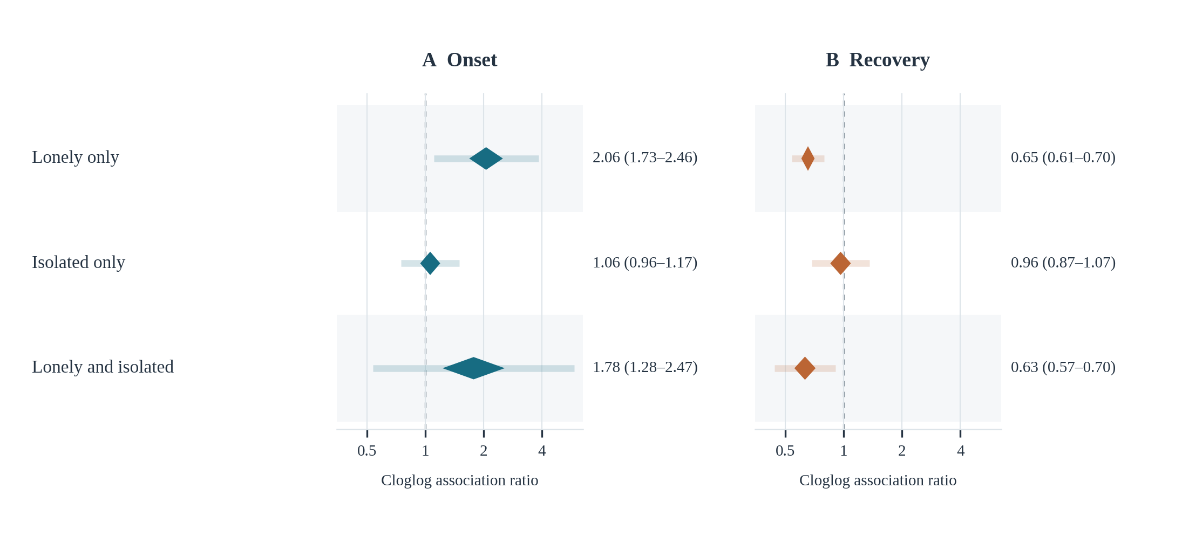
Supplementary Figure S1 Joint social-connection phenotypes and observed depressive symptom transitions
Pooled CARs for onset (A) and recovery (B), relative to neither high loneliness nor high objective isolation. Diamonds span 95% confidence intervals and light bars show 95% prediction intervals from six-cohort REML meta-analyses. Cohort-specific high-loneliness definitions were ≥3 on the 1–4 response scale in CHARLS and KLoSA, ≥2 on the three-item mean in ELSA, HRS, and SHARE, and an affirmative response in MHAS. High objective isolation was an index score ≥2. Models adjust for the primary covariates. These categories are descriptive and do not establish biological subtypes or an interaction effect.
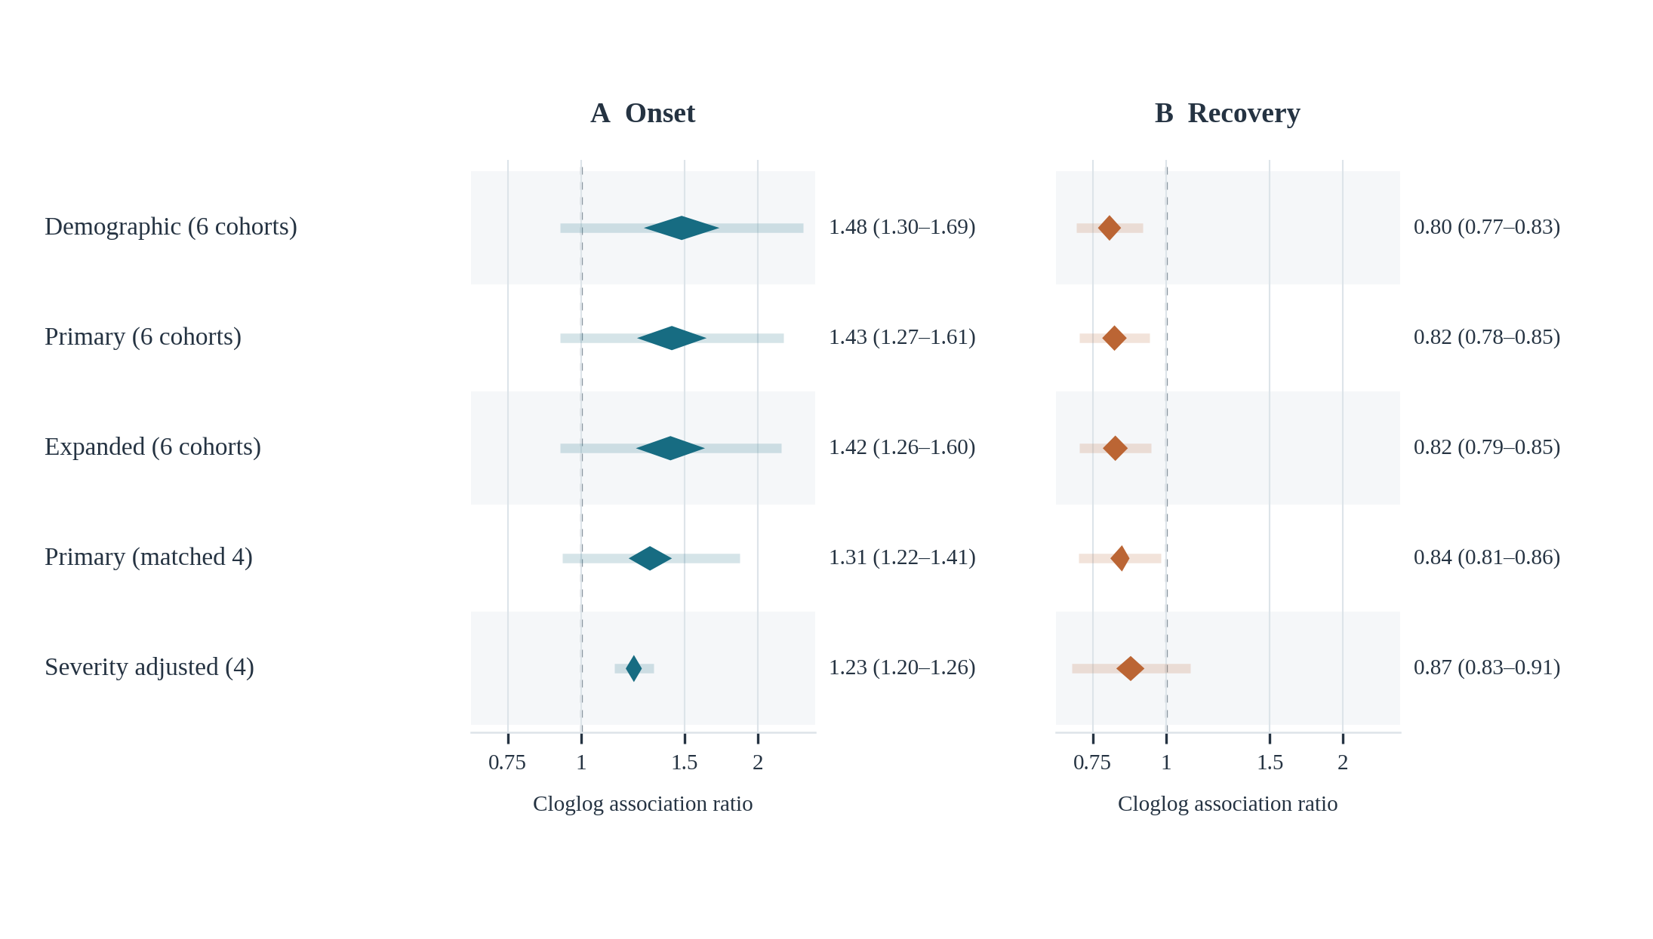
Supplementary Figure S2 Loneliness associations across adjustment sets and baseline-severity models
Pooled CARs per 1 within-cohort standard deviation higher loneliness for onset (A) and recovery (B). Demographic models adjust for both exposures, age, sex, education, and wave. Primary models additionally adjust for work, multimorbidity, activities-of-daily-living limitation, and self-rated health; expanded models additionally adjust for wealth rank, smoking, alcohol use, and standardized cognition. Diamonds span 95% confidence intervals and light bars show 95% prediction intervals. The first three models use six-cohort complete-case samples, so their differences can reflect both covariate adjustment and sample composition. The last two rows compare primary and baseline-severity-adjusted models within the same eligible sample from CHARLS, KLoSA, MHAS, and SHARE. Severity is the baseline depressive score excluding the loneliness item, reconstructed correctly for MHAS as the total score minus the binary loneliness item; SHARE uses its EURO-D score, which does not contain that CES-D item. The prediction interval for the severity-adjusted recovery association crosses 1.
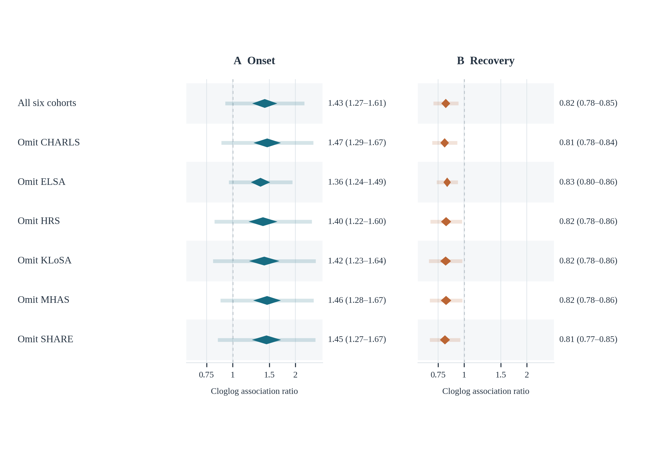
Supplementary Figure S3 Leave-one-cohort-out sensitivity analysis for loneliness
Pooled primary-model CARs per 1 within-cohort standard deviation higher loneliness for onset (A) and recovery (B). The first row includes all six cohorts; subsequent rows omit the named cohort and refit the random-effects meta-analysis using the remaining five. Diamonds span 95% confidence intervals and light bars show 95% prediction intervals. The underlying participant-level models are unchanged. This diagnostic assesses dependence of the pooled estimate on any single cohort; it does not remove shared measurement or modeling limitations.
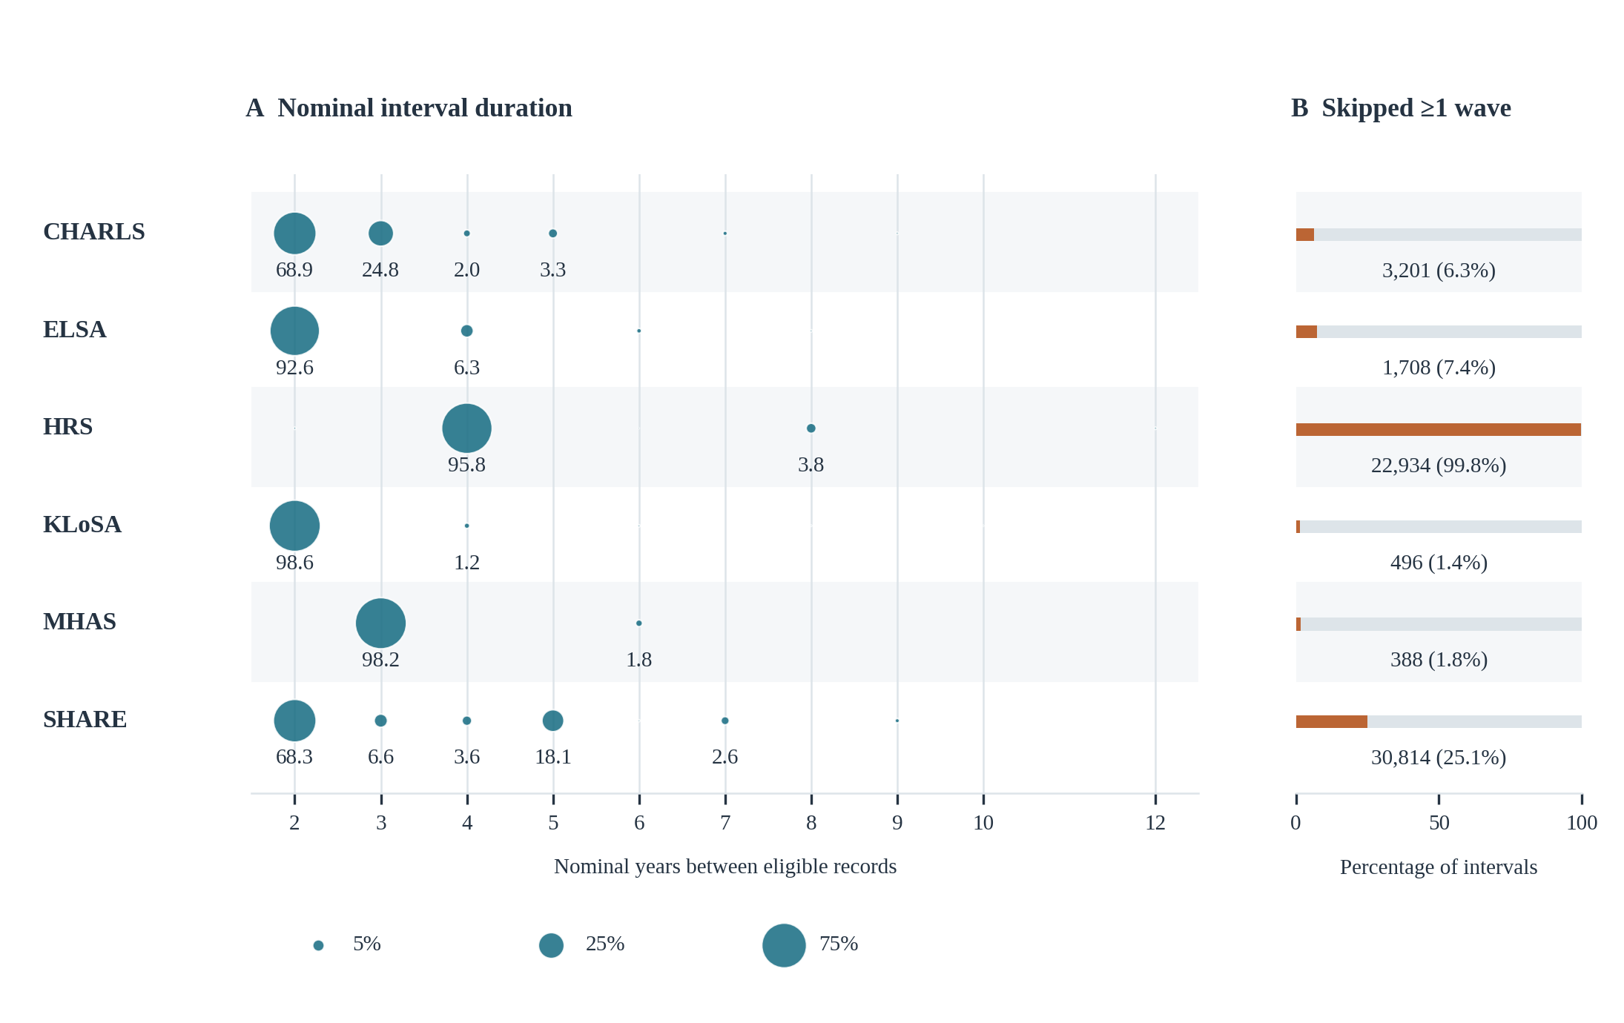
Supplementary Figure S4 Nominal observation spacing and skipped study waves
(A) Cohort-specific distributions of the nominal years between consecutive eligible records; circle area is proportional to the percentage of intervals within the cohort. Numerical labels are shown where a duration accounts for at least 1% of intervals. (B) Exact counts and percentages of intervals that bridge at least one scheduled study wave, based on a wave-index difference greater than one. All observed eligible intervals are included before additional covariate exclusions. Nominal durations follow the harmonized study calendar and do not represent exact interview dates. Skipped waves can arise from unavailable exposure or outcome measurements as well as missed interviews; in HRS, the distribution particularly reflects the psychosocial measurement schedule. These distributions explain why the primary analysis is described as consecutive eligible-record intervals rather than strictly adjacent study waves.

