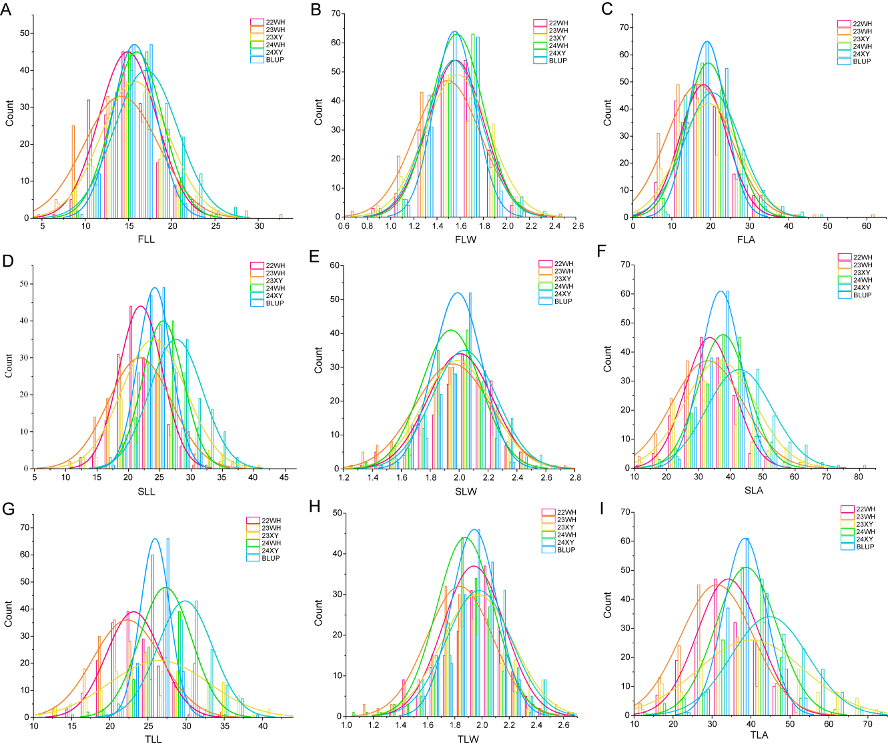
Figure S1.Normal distribution of leaf size related traits in RIL population under natural cultivation environment and BLUP.
A-C. Normal distribution of length, width and area of population flag leaves; D-F. Normal distribution of length, width and area of the second leaf of a population; G-I. Normal distribution of length, width and area of the third leaf of population

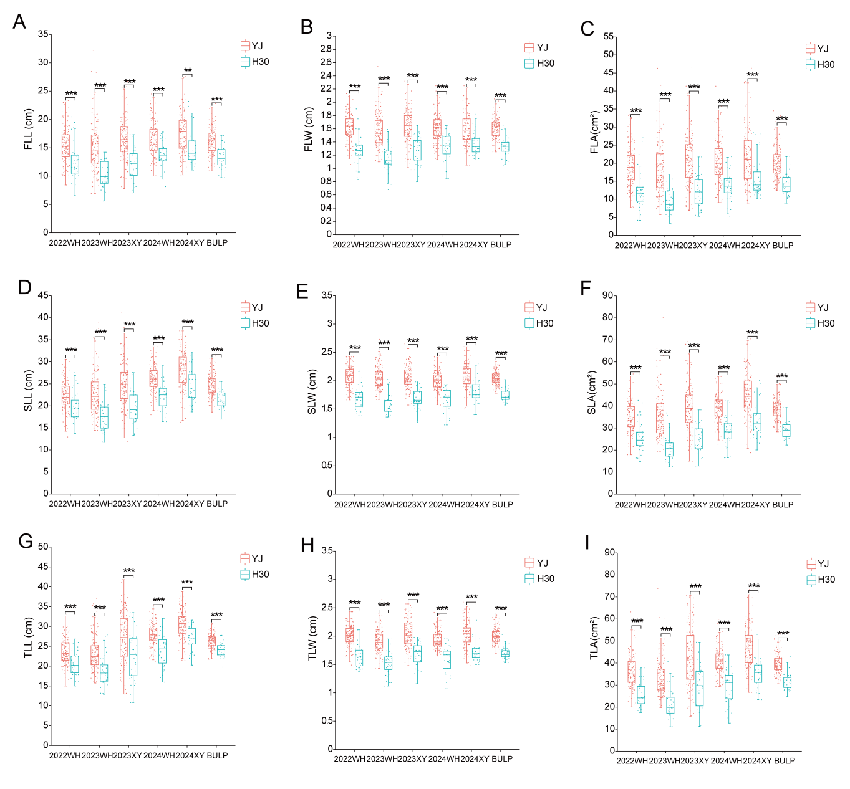
Figure S2. Effects of the major QTL on chromosome 5H on nine leaf-related traits.
Lines carrying the YJ allele and the H30 allele were compared under five environments and BLUP conditions. Traits: FLL, flag leaf length; FLW, flag leaf width; FLA, flag leaf area; SLL, second leaf length; SLW, second leaf width; SLA, second leaf area; TLL, third leaf length; TLW, third leaf width; TLA, third leaf area. Box plots show the median (central line), interquartile range (box), and range (whiskers). **P < 0.01, ***P < 0.001.

