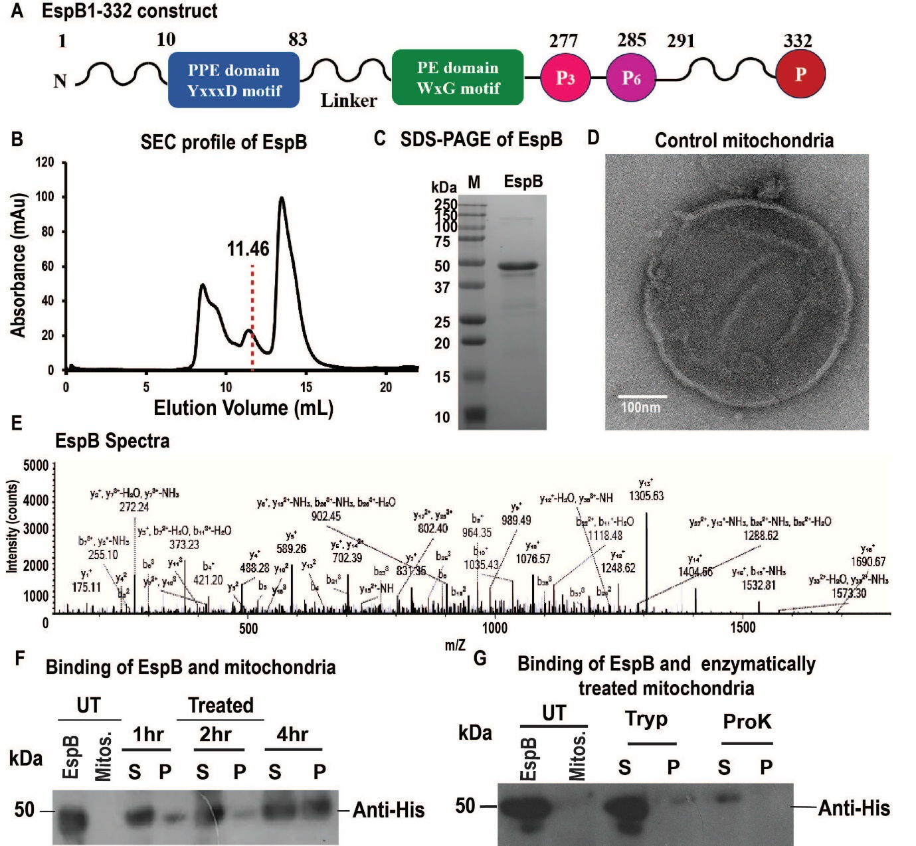
Supplementary Figure S1: Biochemical characterisation of EspB and its association with mitochondria
- Schematic diagram of the EspB construct used in this study highlights the annotated and structural domains. B. Size exclusion chromatography (SEC) of EspB shows three distinct peaks. The heptameric fraction used for subsequent analysis is marked in red dotted line. C. SDS PAGE analysis of purified EspB. D. Representative NS-TEM micrograph of control mitochondria. E. Orbitrap mass spectroscopy analysis of EspB. F. Immunoblot corresponding to Mito sedimentation assay showing association of EspB with mitochondria. It corresponds to the Fig 1A immunoblot taken at low exposure. G. Immunoblot corresponding to the sedimentation assay of EspB and enzymatically treated mitochondria for 1 hour. UT: untreated, treated: treated with EspB, S: supernatant and P: pellet. Tryp: Trypsin, ProK: Proteinase K
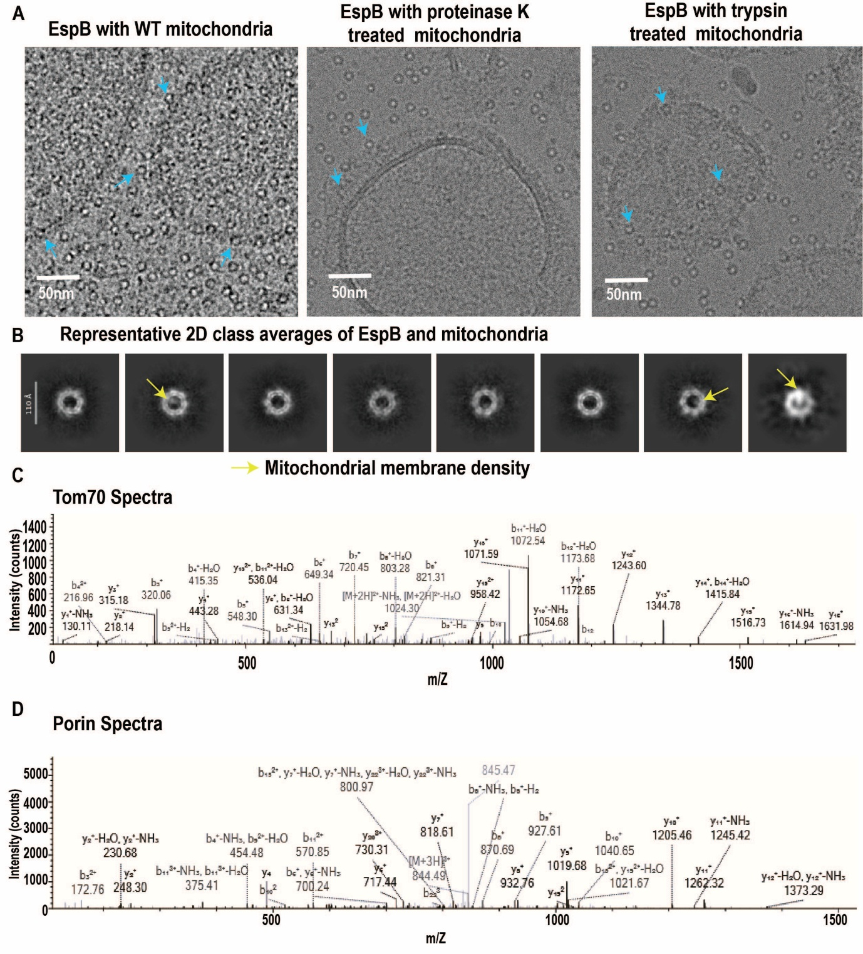
Supplementary Figure S2: Determination of mitochondrial receptor proteins involved in association with EspB

- Representative cryo-EM micrograph of EspB with mitochondria showed preferential association of EspB with wild-type mitochondria in the left panel. In the middle and right panels, EspB incubated with Proteinase K and Trypsin-treated mitochondria was shown. Bound EspB is highlighted in a blue arrow. B. Representative 2D class averages of EspB in the presence of mitochondria showed an additional density (yellow) blocking the hole. C, D. The Orbitrap mass spectroscopy profile of Tom70 and porin from the in-gel digestion of bands excised from SDS-PAGE corresponding to the co-immunoprecipitation assay of EspB and mitochondria. The spectra were analysed in Protrome Discover 2.0.
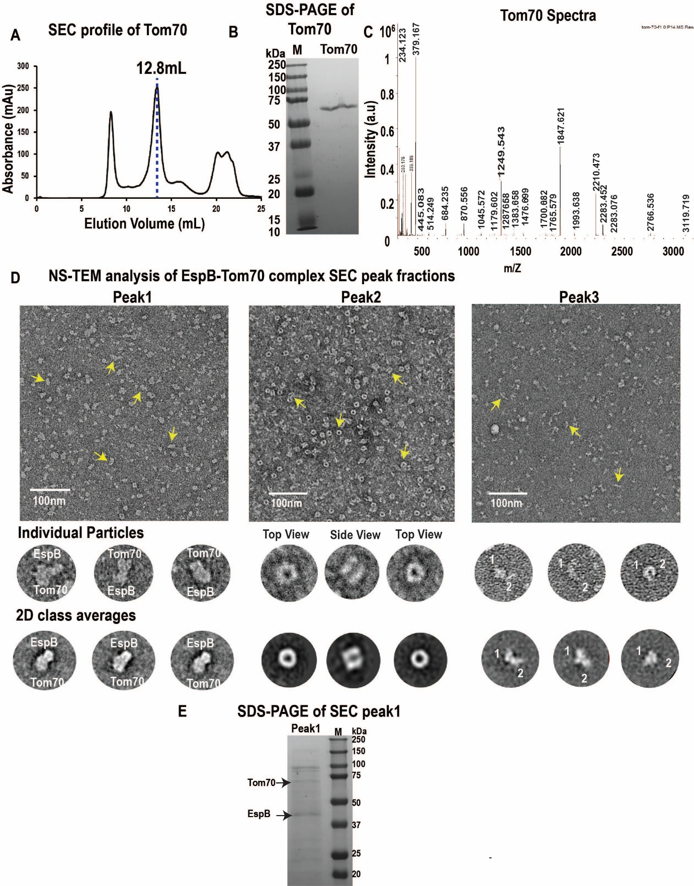
Supplementary Figure S3: Biochemical analysis of the Tom70-EspB complex. A. The size-exclusion chromatography (SEC) profile of purified Tom70 shows two distinct peaks at 8.8 mL and 12.8 mL. The dimeric peak eluting at 12.8 mL (marked in blue dotted line) was used for subsequent analysis. B. SDS-PAGE analysis of Tom70 showed a clear band at approximately 70 kDa. C. MALDI-TOF mass spectrometry analysis of Tom70, confirming the identity of the Tom70 protein. D. Size-exclusion chromatography (SEC) of EspB and Tom70 revealed three distinct peaks (Figure 2D). Each peak was further analysed by negative-stain transmission electron microscopy (NS-TEM). Representative NS-TEM micrographs of particles from the individual SEC peaks are shown. Enlarged views of the particles and their corresponding reference-free 2D class averages are also presented. Peak 1 contained larger complexes, likely corresponding to the Tom70–EspB complex; Peak 2 contained free EspB and Peak 3 contained free Tom70. E. SDS-PAGE analysis of the Tom70–EspB complex fraction (Peak 1) showed two distinct bands corresponding to Tom70 and EspB.
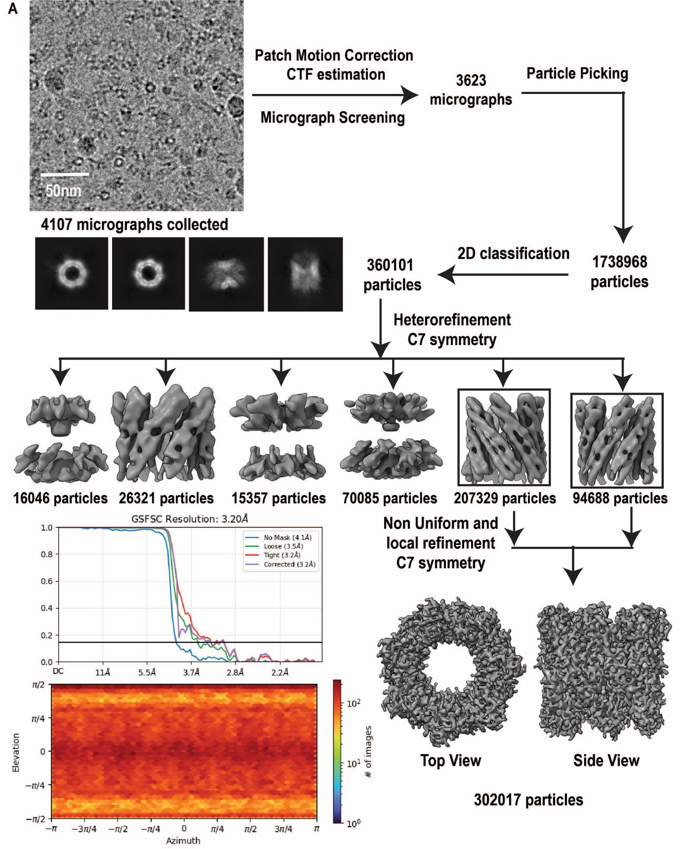
Supplementary Figure S4: Cryo-EM data processing workflow of EspB. The Cryo-EM data processing pipeline for EspB, showing a representative raw micrograph, reference-free 2D class averages, and 3D refinement classes. The Gold-Standard Fourier Shell Correlation (FSC) indicates a final resolution of 3.2 Å, and the angular distribution plot shows a uniform distribution of particles.
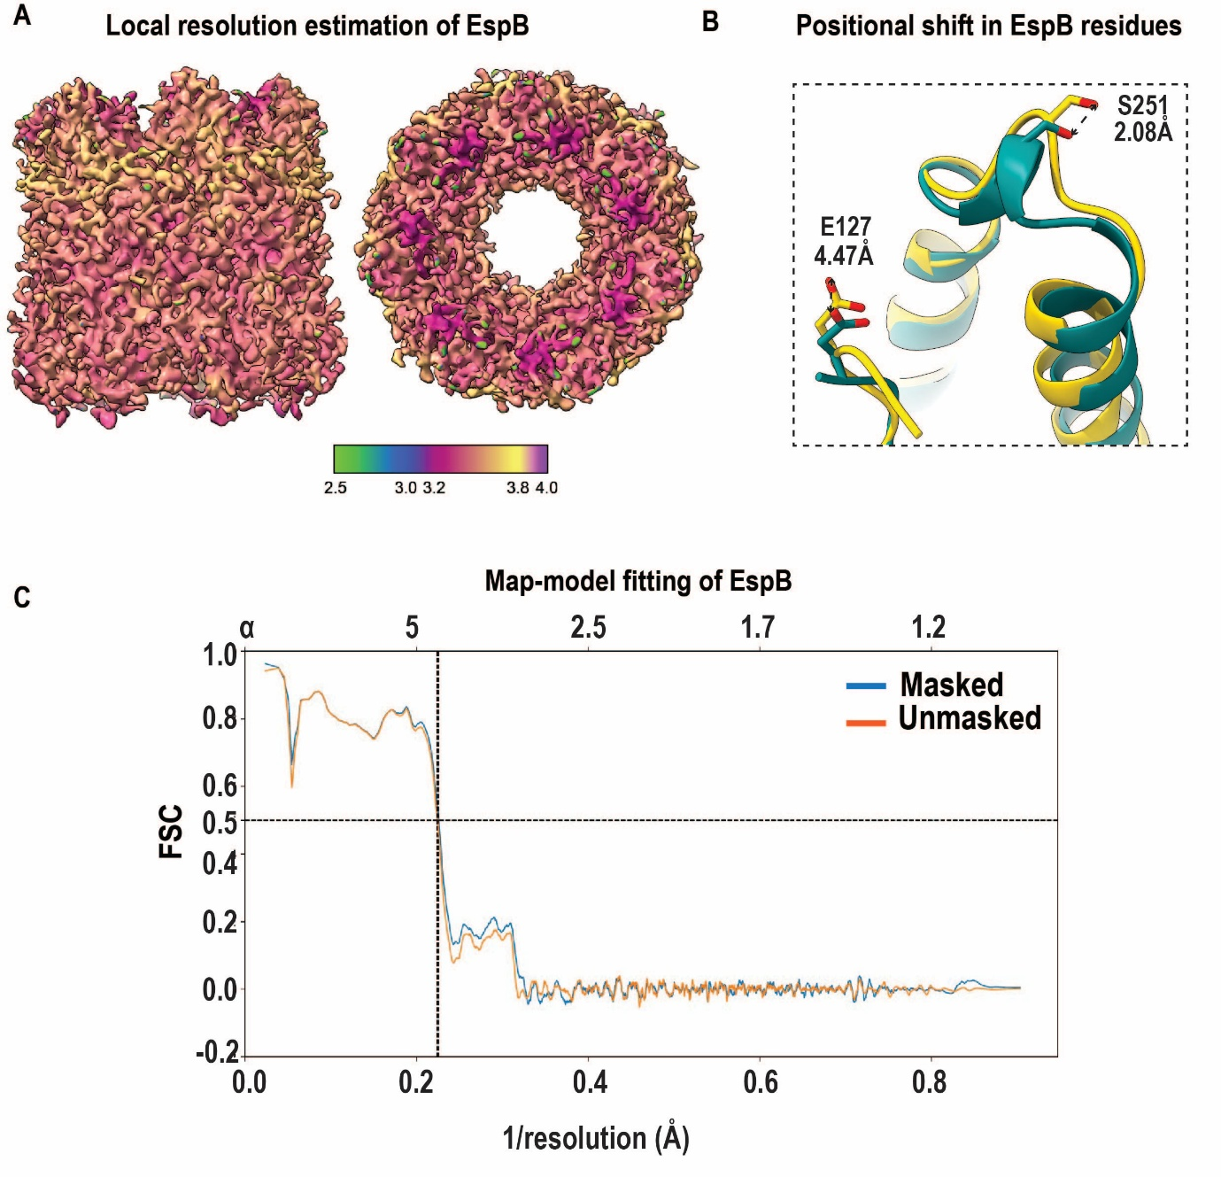
Supplementary Figure S5: Structural characterisation of EspB
- The local resolution map shows the structural reconstruction confidence with resolution ranging from 3.2-3.8Å. B. Comparison of the previously reported EspB (PDB-6XZC) structure with the model generated in this study (PDB-26UN) revealed minor displacement in the specific residues. C. Map-to-model fitting of EspB in Cryo-EM density map.
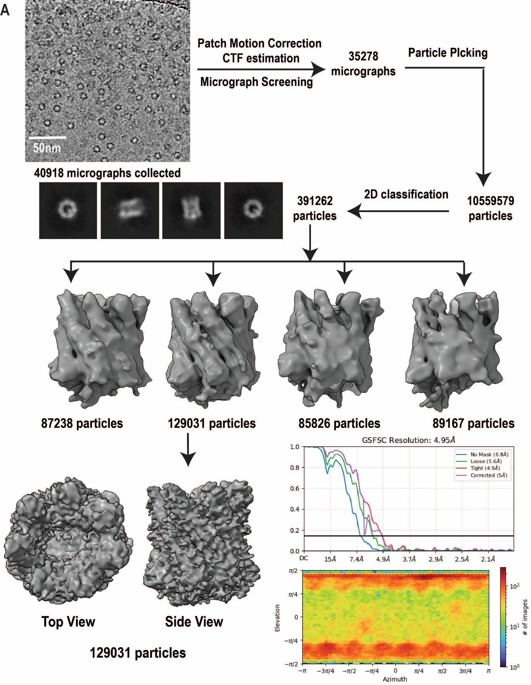
Supplementary Figure S6: Cryo-EM data processing workflow of EspB-Tom70 complex
The Cryo-EM data processing workflow for the reconstruction of EspB-Tom70, showing representative raw micrograph, 2D class averages and 3D refinement classes. The Gold-Standard Fourier Shell Correlation (FSC) of EspB-Tom70 indicates a final resolution of 5.08 Å. The angular distribution of the map is shown.
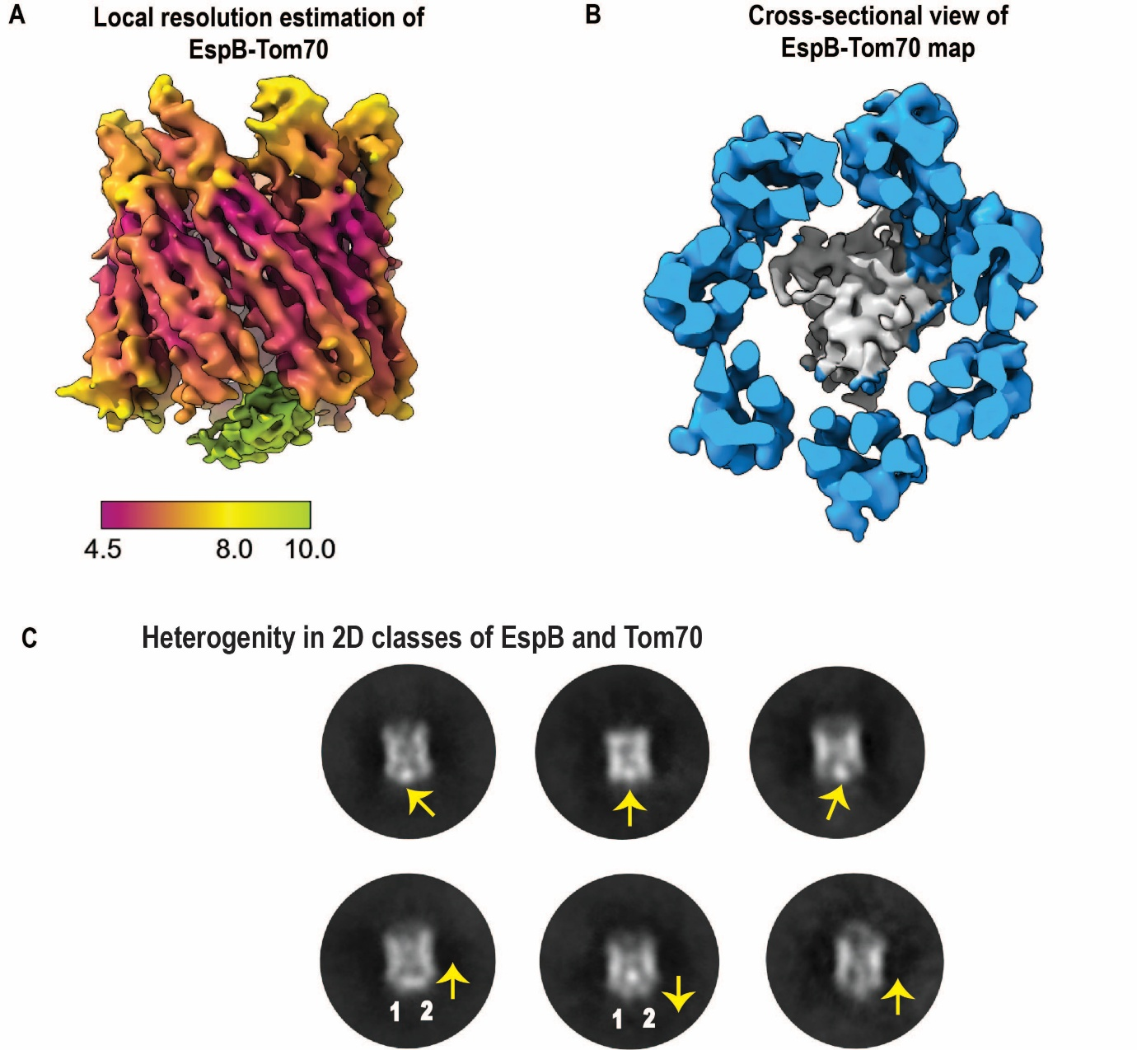
Supplementary Figure S7: Architecture of Tom70-EspB complex
- The local resolution estimation of the map is also depicted. B. A representative cross-sectional overview of the 3D-reconstructed map showing an additional density corresponding to Tom70 (grey) attached to EspB (blue). C. Reference-free 2D class averages of the EspB-Tom70 complex showed positional heterogeneity of Tom70 relative to EspB. The positional shifts are marked with a yellow arrow.
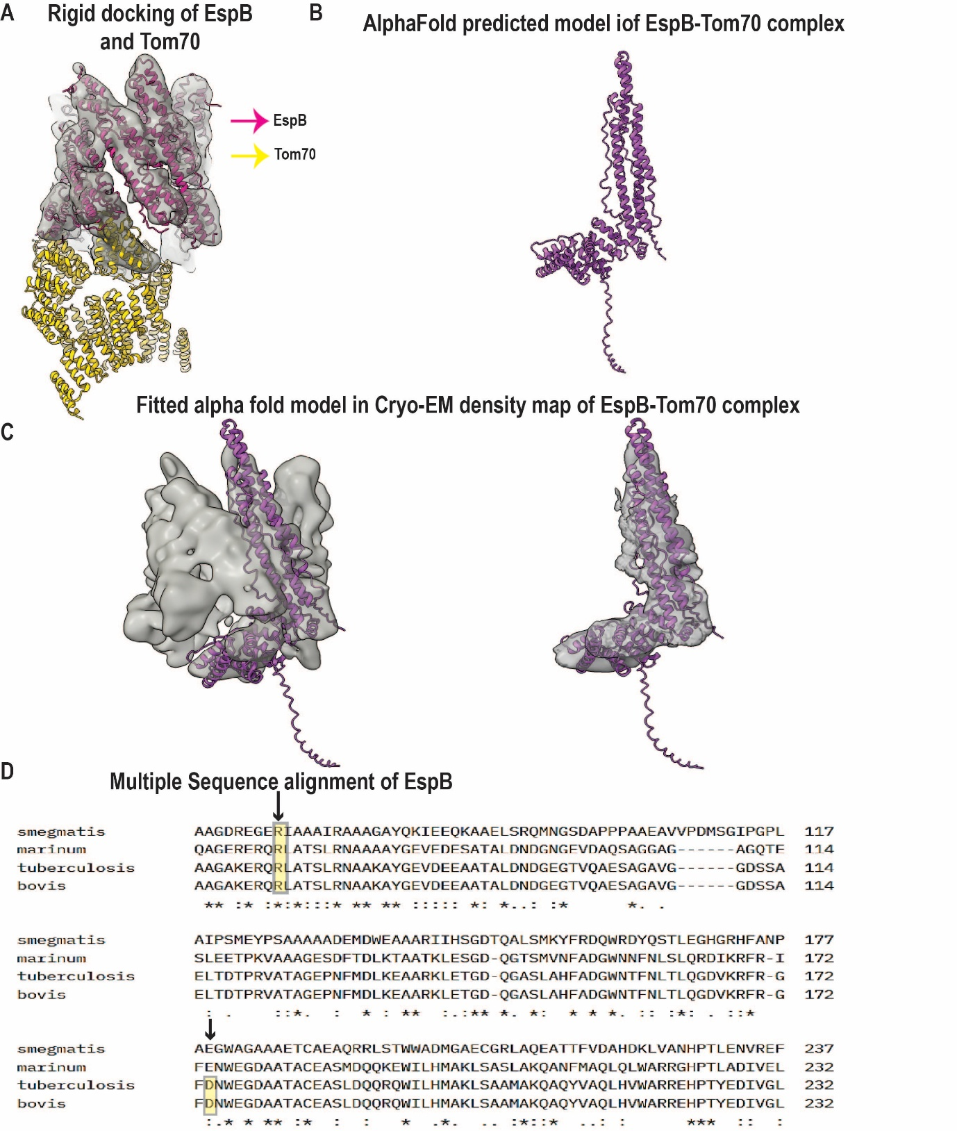
Supplementary Figure S8: Analysis of EspB-Tom70 complex
A. The rigid-body docking of EspB (PDB: 26UN) and Tom70 (PDB: 2GW1) in the EspB-Tom70 complex map shows the relative positioning of Tom70 with respect to EspB. B. The FASTA sequences of an EspB protomer and the TPR4-5 motif of Tom70 were used as input for AlphaFold3 to predict the three-dimensional structure of the EspB–Tom70 complex. C. The predicted model was subsequently used for rigid-body docking and was fitted directly into the cryo-EM density map of the EspB–Tom70 complex without any structural modifications. The excellent agreement between the AlphaFold3-predicted model and the cryo-EM density further validates the EspB–Tom70 interaction, as both approaches identified a similar binding interface and interaction geometry. D. The Multiple Sequence alignment of EspB from various Mycobacterium species showed that the residues (highlighted in yellow) are conserved throughout the Mycobacterium species. Based on our structural studies, it is predicted to mediate the interaction with Tom70.
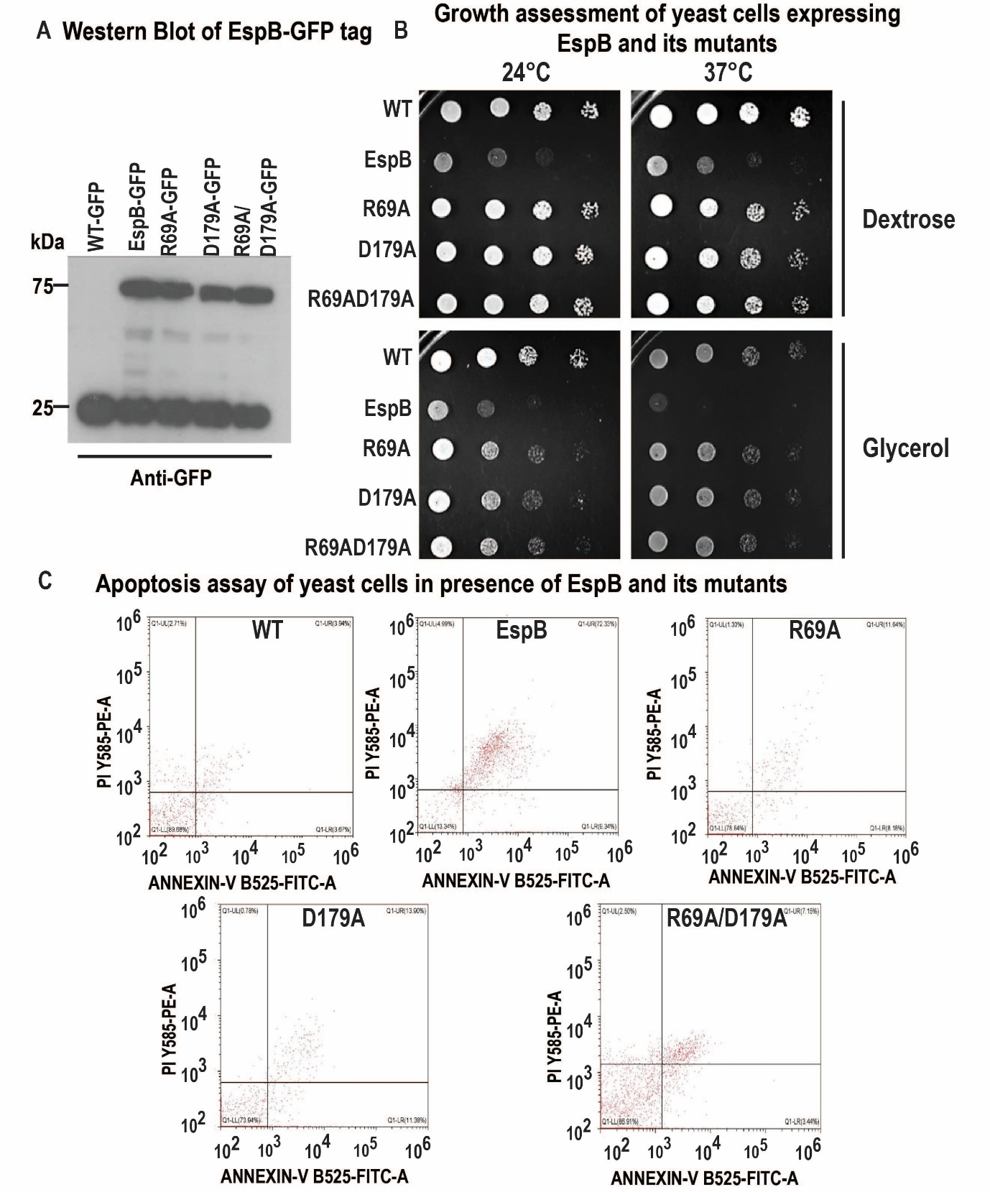
Supplementary Figure S9: Effect of EspB on the growth of yeast cells
- Expression of wild-type EspB and its mutants was confirmed by Western blotting using an anti-GFP antibody. B. Yeast cells harboring EspB₁₋₃₃₂ and its mutants, expressed under pRS415_{TEF} expression vectors, were grown in dextrose media till mid-log phase at 30°C. Spot tests were performed on both dextrose and glycerol media at non-permissive temperatures, as indicated, revealing a severe growth phenotype in yeast with EspB expression and restored growth in its mutants. Plate images were captured after 36-48h. C. Apoptosis profile diagram. Cells containing the endogenous EspB toxin and its mutants were cultured and harvested at mid-log phase. Annexin V/PI stains were used to separate the cell population, and analysis was performed using CytExpert software, as shown in the profile diagram. Consistent with the observed growth phenotypes, heterologous Expression of EspB induced apoptosis in yeast cells, whereas EspB mutations suppressed programmed cell death.
Supplementary Tables:
Supplementary Table 1: Cryo-EM data collection and data processing parameters
- Data Collection and Processing | EspB | EspB-Tom70
Magnification | 54,000 X | 54,000 X
Voltage | 200 | 200
Electron exposure (e⁻/Å) | 40 | 52
Defocus range (µm) | -1.25 to -2.75 | -1.25 to -2.75
Pixel Size (Å) | 0.92 | 0.92
Symmetry imposed | C1 | C1
Number of Micrographs | 4107 | 40918
Number of particles | 302017 | State1-129031  State2- 89167  State3- 87238
Map Resolution (Å) | 3.2 | State1- 5.08  State2- 7.97  State3- 7.21
FSC threshold | 0.143 | 0.143
Map Resolution Range (Å) | 3.2-.3.8 | 4.5-10

Supplementary Table 2: Cryo-EM map and model validation for EspB
Validation | EspB
MolProbity Score | 2.65
Clash Score | 11.69
Rotamer Outliners (%) | 6.71
Ramachandran Plot
Outliner (%) | 1.2
Allowed (%) | 5.58
Favored (%) | 93.22

Supplementary Table 3: Primer Information used in this study

Primer Name | Primer Sequence | Vector | Restriction Site
Tom70FP | 5’-CGCGGATCCATGAAGAGCTTCATTACAAGG-3’ | pET28a | BamHI/XhoI
Tom70RP | 5’-CCGCTCGAGTCATTACATTAAACCCTGTTC-3’ | pET28a | BamHI/XhoI
EspB(R69A) FP | 5’-GCGCTGGCGACCTCGCTGCGCAAC-3’ | pET28a | NdeI/HindIII
EspB(R69A) RP | 5’-CTGCCGCTCTTTGGCACCGG-3’ | pET28a | NdeI/HindIII
EspB(D179A) FP | 5’-GCGGCGGCTACCGCTTGCGAG-3’ | pET28a | NdeI/HindIII
EspB(D179A) RP | 5’-GCCTTCCCAGTTGTCAAACCCCCG-3’ | pET28a | NdeI/HindIII
Tom70-mCherry_{TEF-}FP | 5’-AAGGAAAAAAGCGGCCGCATGATTAGACAATCATTAATG-3’ | pRS416_{TEF} | Not1/BamH1
Tom70-mCherry_{TEF-} RP | 5’-CGCGGATCCCTAGATAGATGAATCTCTACCCAAGAAATAAACTTT-3’ | pRS416_{TEF} | Not1/BamH1
EspB-GFP_{TEF-} FP | 5’-ACGCGTCGACATGCTATTGTTTCCTGGCTTGAAG-3’ | pRS415-GFP_{TEF}  pRS415 _{TEF}-EspB | Sal1/Xho1  BamH1/Sal1
EspB-GFP_{TEF-} RP | 5’-CCGGAATTCTCAGTTTCTTCCAAATATATACAAATG-3’ | pRS415-GFP_{TEF}  pRS415 _{TEF}-EspB | Sal1/Xho1  BamH1/Sal1
GFP_{ADH}FP | 5’-CCCGAATTCCATGAGCAAAGGCGAAGAACTG-3’ | pRS413 _{ADH}-GFP | EcoR1/Sal1
GFP_{ADH} RP | 5’-CGCGTCGACTTATTTATACAGTTCATCCATGCC-3’ | pRS413 _{ADH}-GFP | EcoR1/Sal1
EspB_{ADH-}FP | 5’-CGCGGATCCATGACGCAGTCGCAGACCG-3’ | pRS413 _{ADH}-EspB | BamH1/EcoR1
EspB_{ADH} RP | 5’-CCCGAATTCCGGGAGGCCACCACCCGGCGATCCGG-3’ | pRS413 _{ADH}-EspB | BamH1/EcoR1
EspB_{R69A}-GFP_{TEF-} FP | 5’-GCGCTGGCGACCTCGCTGCGCAAC-3’ | pRS415-GFP_{TEF} | BamH1/Sal1
EspB_{R69A} -GFP_{TEF-} RP | 5’-CTGCCGCTCTTTGGCACCGG-3’ | pRS415-GFP_{TEF} | BamH1/Sal1
EspB_{D179A}-GFP_{TEF-}FP | 5’-GCGGCGGCTACCGCTTGCGAG-3’ | pRS415 _{TEF} | BamH1/Sal1
EspB_{D179A} -GFP_{TEF-} RP | 5’-GCCTTCCCAGTTGTCAAACCCCCG-3’ | pRS415 _{TEF} | BamH1/Sal1
EspB_{R69A/D179A} | - | pRS415 _{TEF} | BamH1/Sal1

Supplementary Table 4: Strains used in this study

Name | Genotype | Source
H37Rv | NA | Prof Amit Singh, IISc Bangalore, India
BY4742 WT | MATα his3Δ1 leu2Δ0 lys2Δ0 ura3Δ0 [ ρ⁺] | Dr Chandan Sahi, IISER Bhopal, India

Supplementary Table 5: Reagent and source information

Reagent | Source | Identifier
Bacterial Strains
Escherichia coli BL21(DE3) | Novagen | Cat# 69450-3CN
Antibodies
Anti-Tom70 | Elizabeth A. Craig lab | Ciesielski et. al., 2020(Ciesielski et al., 2013)
Anti-Porin | Elizabeth A. Craig lab | Ciesielski et. al., 2020
Anti-6x Histidine | ABclonal Technology | AE003
Anti-GFP | SantaCruz Biotechnology | (B-2) sc-9996
Anti-rabbit secondary antibody | Sigma Chemicals | Cat # A9169
Anti-mouse secondary antibody | Sigma Chemicals | Cat #A9044
Chemicals
Luria Broth | HiMedia | Cat# M575
Isopropyl ß-D-1-thiogalactopyranoside | Merck | Cat# I6758
Tris Base | HiMedia | Cat# TC072M
Sodium Chloride | Qualigens | Cat# Q15918
Phenylmethylsulfonyl fluoride | Sigma Chemicals | Cat # 329-98-6
Imidazole | Sigma Aldrich | Cat# 792527-500G
Nitrilotriacetic Acid agarose resin | Qiagen | Cat# 30210
Coomassie Brilliant blue R 250 | Merck | Cat# 1.12553
Precision Plus Protein™ Dual Color | Standards Bio-Rad | Cat# #1610374
Dithiothreitol | SRL | Cat #17315
Zymolase | US Biologicals | Cat # Z1004
Sorbitol | Sigma Chemical | Cas. No.-50-70-04
KH₂PO₄ | Rankem Chemical | Cas. No.-7778-77-0
Sodium dodecyl sulfate | Affymetrix USB | Cas# 15123
BSA | Sigma Chemical | Cas. No.-9048-46-8
MOPS KOH | Sigma Chemical | Cas. No.-1132-61-2
Sucrose | Sigma Chemical | Cas. No.-57-50-1
EDTA | SRL | Cas. No.-6381-92-6
PVDF membrane | Merck Milipore | IPFL00010
Glycine | SRL | Cat# 66327
Methanol | Loba Chemie Pvt. Ltd. | Cat# 67-56-1
Skimmed milk | HiMedia | Cat # GRM1254-500G
Tween20 | SRL | Cat # 23610
Quantifoil R 1.2/1.3, UT, 300 Mesh, Copper | Electron Microscopy Sciences | Cat# Q3100CR1.3 2nm
EM grid (Quantifoil R 1.2/1.3 300 Mesh, Copper) | Electron Microscopy Sciences | Cat# Q3100CR1.3
Uranyl Acetate 98% | ACS Reagent Polysciences Inc | Cat# 21447-25
Acetonitrile | Merck | Cas. No.-75-05-8
Ammonium Bicarbonate | SRL | Cat# 26757
Iodoacetamide | HiMedia | Cat# RM9637-25G
Trypsin | Promega | Cat # V5111
Trifluoroacetic acid | SRL | Cat # 40801
Glycerol | SRL | Cat # 77453
n-dodecyl-\(\beta \)-D-maltoside | Merck | Cat # 324355
Lysozyme | Sigma Aldrich | Cas No.: 12050-86-3
RED-NHS, a second-generation amine-reactive dye | Nanotemper | Cat # 210118
MST Monolith NT.115 capillaries | Nanotemper | Cat # MO-K022
Whatman filter paper | Cytiva | Cat #1441 125
Fluorinated Octyl Maltoside | Anatrace | Cas. No. 118680-70-9
Yeast nitrogen base without amino acids | US Biologicals | Cat # Y2025
Proteinase K | US Biologicals | Cas. No.-39450-01-6
RibonucleaseA | US Biologicals | Cat # 9001-99-4
Digitonin | Sigma Chemicals | Cat # No D5628
Yeast Extract | BD-DifcoTM | Cat # 210929-500G
Glycerol | HiMedia | Cas. No.-56-81-5
Dextrose | BD-DifcoTM | Cat # DF0155-17-4
Peptone | BD-DifcoTM | Cat # 21167-500G
Luria Bertani Agar | HiMedia | Cat # M1151-500G
Magnesium Chloride | HiMedia | Cat # MB40-500G
PMSF | Sigma Chemicals | Cat # 329-98-6
TMRE | Thermo Fisher Scientific | Cat # T669
JC-1 | Thermo Fisher Scientific | Cat # T3168
Softwares
Mascot | Matrix Science | NA
Proteome Discoverer 2.5 | Thermo Scientific | NA
MO. Control software | Nanotemper | NA
MO. Affinity analysis software version 2.2.5 | Nanotemper | NA
EMAN 2.1 | Baylor College of Medicine | NA
GraphPad Prism 8.4 | GraphPad | NA
LatitudeS software | Gatan Inc | NA
Cryosparc 4.5 | CryoSPARC | NA
DeepEMhancer | Cosmic-Cryo-EM | NA
UCSF ChimeraX | USCF RBVI | NA
CellSens software | Evident Scientific (Olympus) | NA
ImageJ | JAVA Compiler | NA
CytExpert software | Beckman Coulter | NA
Excel | Microsoft | NA
MultiGauge software | Fujifilm | NA
Coot | Emsley P et al., 2004 | NA
Phenix | Liebschner D et al., 2019 | NA
Instruments
Sonicator | Thermo Fisher Scientific | NA
Amicon Centrifugal Filters | Merck | Cat# UFC801024
High Speed vacuum concentrator | Labconco 7810010 CentriVap | NA
Centrifuge | Eppendorf | NA
Beckman Coulter Cytoflex flow cytometer | Beckman Coulter | NA
TECAN | Tecan Life Sciences | NA
Floview 3000 Olympus confocal microscope | Olympus | NA
200kV Talos Arctica TEM | Thermo Fisher Scientific | NA
FEI vitrobot Mark IV plunger | Thermo Fisher Scientific | NA
120kV Talos L120C transmission electron microscope | Thermo Fisher Scientific | NA
Monolith NT.115 pico instrument | Nanotemper | NA
S200 Increase 10/300 GL column on an AKTA-FPLC system | Cytiva | NA
LC-MS Orbitrap fusion mass spectrometer | Thermo Fisher Scientific | NA
RapifleX MALDI-TOF/TOF mass spectrometer | Bruker Daltonics, Germany | NA
PCR machine | Eppendorf | NA
SDS-PAGE gel setup | Biorad | NA
Kits
Qiagen PCR cleanup | Qiagen | Cat # 28104
Qiagen Plasmid Mini Prep | Qiagen | Cat # 27106
Qiagen Gel Extraction | Qiagen | Cat # 28704
FITC AnnexinV apoptosis detection kit | BD Pharmigen | Cat # 556547
Mitochondrial Tox-Glo | BD Pharmigen | Cat # G8000

