Supporting Information
Rethinking Radical Quantification Methods in VUV/UV Water Treatment Process: Alcohol Scavenging and Probe-Model Combining Strategy

Lan Li¹, Qiaoxia Han¹, Boqiang Li², Longjie Cheng¹, Baiyang Chen^{1*}
¹State Key Laboratory of Urban Water Resource and Environment, Shenzhen Key Laboratory of Organic Pollution Prevention and Control, Harbin Institute of Technology, Shenzhen, China, 518055.
² College of Environmental Science and Engineering, Tongji University, Shanghai 200092, P.R. China

* Corresponding author. Phone: 86-134-8072-7605; Email: chen.baiyang@hit.edu.cn

Number of Pages: 18
Number of Figures: 7
Number of Texts: 1
Number of Tables: 2

Text S1: Determination of radical concentrations and pathway contributions
To quantify HO•, nitrobenzene (NB) was used as a selective probe. Direct UV photolysis of NB was negligible under the experimental conditions (Fig. S5); therefore, its contribution was neglected in the calculation of HO• exposure. The HO• exposure over a given reaction interval was calculated from NB degradation according to Eq. (1):
$\int_{t_{1}}^{t_{2}}{[}HO•] dt=\frac{\ln\left(\frac{[NB]_{t_{1}}}{[NB]_{t_{2}}}\right)}{k_{HO^{∙},NB}}$ (1)
where $[NB]_{t1}$ and $[NB]_{t2}$ are the NB concentrations at the beginning and end of the selected reaction interval, respectively; $k_{H{O•}^{∙},NB}$ is the second-order rate constant for the reaction between HO• and NB. The integral represents the HO• exposure over the selected interval.
The interval-averaged HO• concentration was then calculated as:
${\overline{[HO•]}}_{t_{1}-t_{2}}=\frac{1}{t_{2}-t_{1}}\int_{t_{1}}^{t_{2}}{[}HO•] dt$ (2)
The modeled HO• concentrations were averaged over the same reaction interval before comparison with the experimentally determined values.
For pollutant $P$, the instantaneous degradation rate through reaction with a reactive species $R_{i}$ was calculated from the modeled radical concentration and the corresponding second-order rate constant:
$r_{i}(t)=k_{R_{i},P}[R_{i}](t)[P](t)$ (3)
where $k_{R_{i},P}$ is the second-order rate constant between reactive species $R_{i}$ and pollutant $P,[R_{i}](t)$ is the modeled concentration of the reactive species at time $t$, and $[P](t)$ is the modeled pollutant concentration.
For direct UV photolysis,
$r_{UV}(t)=k_{UV,P}[P](t)$ (4)
where $k_{UV,P}$ is the pseudo-first-order rate constant for direct UV photolysis of pollutant $P$.
The cumulative contribution of each reactive-species pathway to pollutant degradation from the beginning of irradiation to time $t$ was calculated by integrating the corresponding pathway-specific degradation rate:
$F_{i}(t)=\frac{\int_{0}^{t}{k_{R_{i},P}}[R_{i}](τ)[P](τ) dτ}{[P]_{0}}×100\%$ (5)
Similarly, the cumulative contribution of direct UV photolysis was calculated as:
$F_{UV}(t)=\frac{\int_{0}^{t}{k_{UV,P}}[P](τ) dτ}{[P]_{0}}×100\%$ (6)
In the complex-water system, $R_{i}$ included HO•, Cl•, Cl₂•⁻, Br•, Br₂•⁻, and CO₃•⁻. Therefore, the total cumulative degradation accounted for by the modeled pathways was:
$F_{total}(t)=F_{HO∙}+F_{Cl∙}+F_{Cl_{2}∙^{-}}+F_{Br∙}+F_{Br_{2}∙^{-}}+F_{CO_{3}∙^{-}}+F_{UV}$ (7)
and should satisfy the pollutant mass balance:
$F_{total}(t)=\frac{[P]_{0}-[P](t)}{[P]_{0}}×100\%$ (8)
The rate constants used for the radical–pollutant reactions are summarized in Table S1.

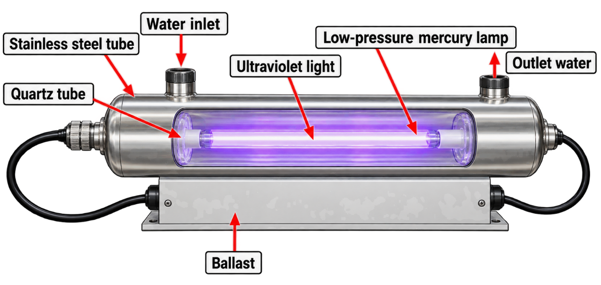
Fig. S1. Schematic of photoreactor used for the VUV/UV process.

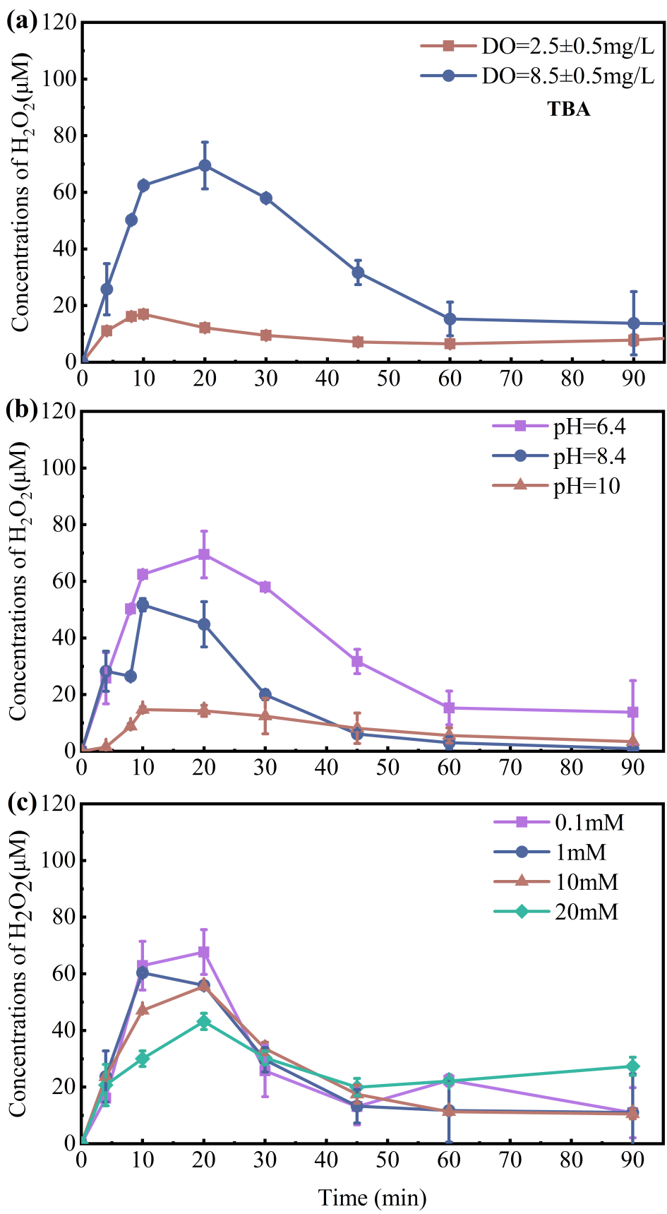
Fig. S2. Effects of DO (a), pH (b), and TBA dosage (c) on H₂O₂ evolution during the VUV/UV process (unless otherwise specified, [TBA]₀ = 1 mM, temperature = 25 ± 0.1 °C, initial DO = 8.5 ± 0.5 mg/L).
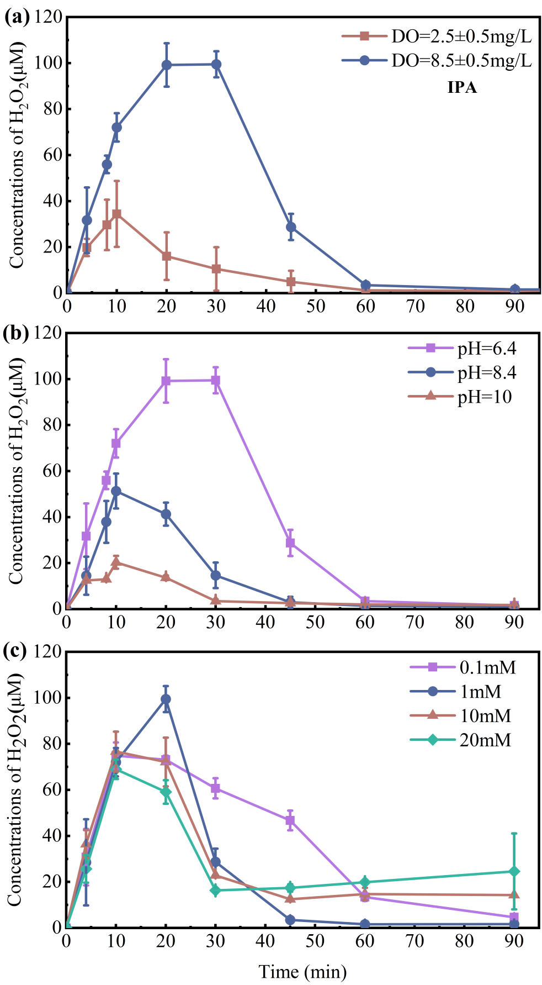
Fig. S3. Effects of DO (a), pH (b), and IPA dosage (c) on H₂O₂ evolution during the VUV/UV process (unless otherwise specified, [IPA]₀ = 1 mM, temperature = 25 ± 0.1 °C, initial DO = 8.5 ± 0.5 mg/L).
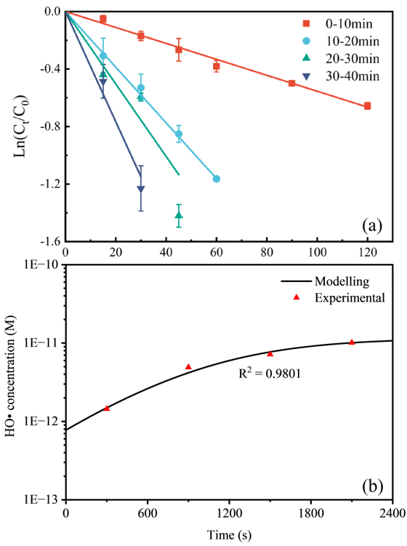
Fig. S4. Degradation of freshly introduced NB (a) during different irradiation intervals (0–10, 10–20, 20–30, and 30–40 min) and the corresponding interval-averaged HO• concentration (b) during the VUV/UV process. Reaction conditions: [DOM] = 5 mg-C/L, [NB] = 0.5 µM, initial pH = 7.5 ± 0.2, temperature = 25 ± 0.1 °C, initial DO = 8.5 ± 0.5 mg/L.
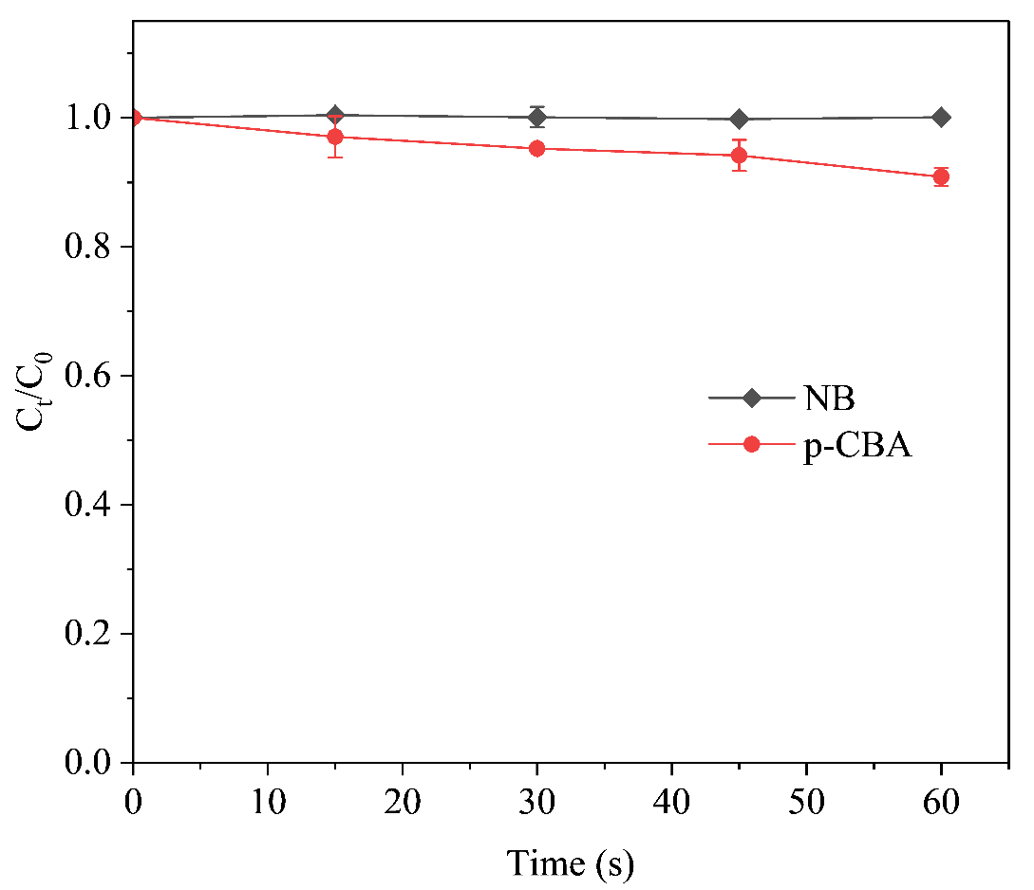
Fig. S5. Direct UV photolysis of NB and p-CBA. Reaction conditions: [probe]₀ = 0.5 μM, initial pH = 6.5 ± 0.5, and temperature = 25 ± 0.1 °C.
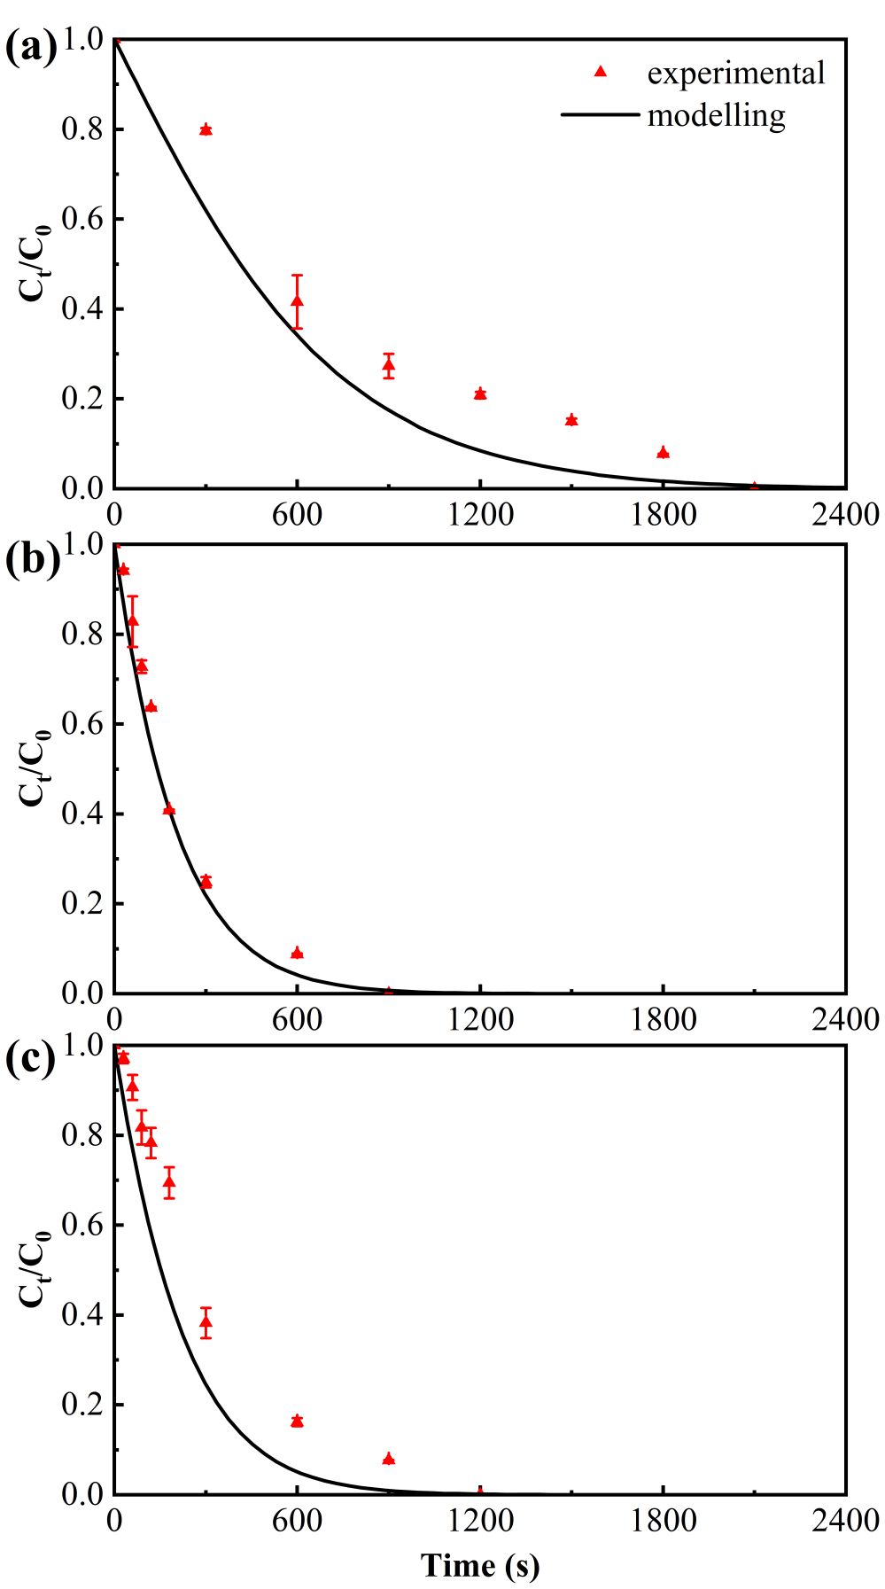
Fig. S6. Experimental and modeled degradations of (a) NB, (b) p-CBA, and (c) MTZ during the VUV/UV process in complex water. Reaction conditions: [DOM] = 5 mg-C/L, [Cl⁻] = 2 mM, [Br⁻] = 10 μM, [HCO₃⁻] = 2 mM, [probe] = 0.5 μM; initial pH = 7.5 ± 0.2, temperature = 25 ± 0.1 °C, initial DO = 8.5 ± 0.5 mg/L.
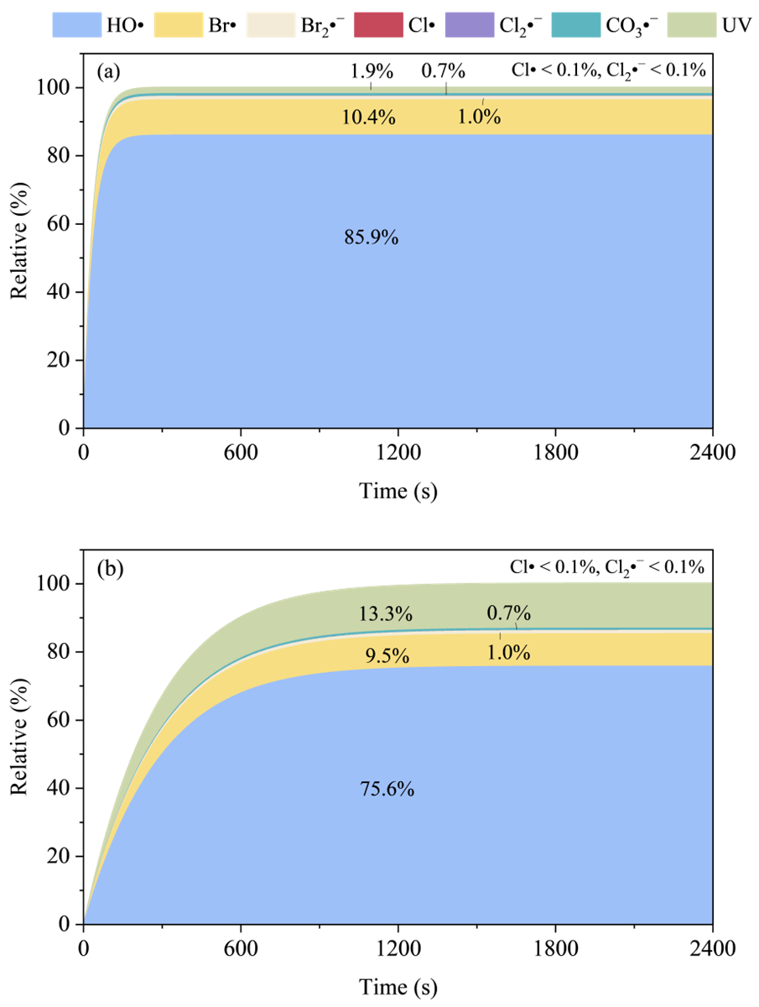
Fig. S7. Cumulative contributions of reactive species and direct UV photolysis to CBZ degradation during the VUV/UV process (a) without and (b) with consideration of Cl⁻ absorption at 185 nm. Reaction conditions: [CBZ] = 0.5 μM, [DOM] = 5.0 mg-C/L, [Cl⁻] = 2 mM, [Br⁻] = 10 μM, and [HCO₃⁻] = 2 mM, initial pH = 7.5 ± 0.2, temperature = 25 ± 0.1 °C, initial DO = 8.5 ± 0.5 mg/L.
Table S1. Reactions and rate constants used in the kinetic model for the VUV/UV process.
No. | Reaction | Rate constant | Unit | Reference
1 | H₂O₂ + hv→ 2HO• | 2.02E−04 | s⁻¹ | This studyª
2 | e_{aq}⁻ + e_{aq}⁻ → H₂ + 2OH⁻ | 5.50E+09 | M⁻¹ s⁻¹ | [1]
3 | e_{aq}⁻ + H⁺ → H• | 2.30E+10 | M⁻¹ s⁻¹ | [1]
4 | e_{aq}⁻ + H• → H₂ + OH⁻ | 2.50E+10 | M⁻¹ s⁻¹ | [1]
5 | e_{aq}⁻ + HO• → OH⁻ | 3.00E+10 | M⁻¹ s⁻¹ | [1]
6 | e_{aq}⁻ + H₂O₂ → HO• + OH⁻ | 1.10E+10 | M⁻¹ s⁻¹ | [1]
7 | e_{aq}⁻ + O₂ → O₂•⁻ | 1.90E+10 | M⁻¹ s⁻¹ | [1]
8 | e_{aq}⁻ + HO₂• → HO₂⁻ | 2.00E+10 | M⁻¹ s⁻¹ | [1]
9 | e_{aq}⁻ + HO₂⁻ → HO• + 2OH⁻ | 3.50E+09 | M⁻¹ s⁻¹ | [1]
10 | e_{aq}⁻ → H• + OH⁻ | 8.30E+02 | s⁻¹ | [1]
11 | H• + OH⁻ → e_{aq}⁻ | 2.00E+07 | M⁻¹ s⁻¹ | [1]
12 | H• + H• → H₂ | 7.80E+09 | M⁻¹ s⁻¹ | [1]
13 | H• + HO• → products | 2.00E+10 | M⁻¹ s⁻¹ | [1]
14 | H• + O₂ → HO₂• | 2.10E+10 | M⁻¹ s⁻¹ | [1]
15 | H• + O₂•⁻ → HO₂⁻ | 2.00E+10 | M⁻¹ s⁻¹ | [1]
16 | H• + HO₂• → H₂O₂ | 1.00E+10 | M⁻¹ s⁻¹ | [1]
17 | H• + H₂O₂ → HO• | 9.00E+07 | M⁻¹ s⁻¹ | [1]
18 | H₂O₂ → H⁺ + HO₂⁻ | 1.26E−01 | s⁻¹ | [2]
19 | H⁺ + HO₂⁻ → H₂O₂ | 5.00E+10 | M⁻¹ s⁻¹ | [2]
20 | HO• + H₂O₂ → HO₂• | 2.70E+07 | M⁻¹ s⁻¹ | [2]
21 | HO• + HO• → H₂O₂ | 5.50E+09 | M⁻¹ s⁻¹ | [2]
22 | HO₂• + H₂O₂ → O₂ + HO• | 3.00E+00 | M⁻¹ s⁻¹ | [2]
23 | O₂•⁻ + H₂O₂ → O₂ + HO• + OH⁻ | 1.30E−01 | M⁻¹ s⁻¹ | [2]
24 | HO₂• + HO₂• → O₂ + H₂O₂ | 8.30E+05 | M⁻¹ s⁻¹ | [2]
25 | HO₂• + O₂•⁻ → O₂ + HO₂⁻ | 9.70E+07 | M⁻¹ s⁻¹ | [2]
26 | HO• + HO₂• → O₂ | 6.60E+09 | M⁻¹ s⁻¹ | [2]
27 | HO• + O₂•⁻ → O₂ + OH⁻ | 7.00E+09 | M⁻¹ s⁻¹ | [2]
28 | HO• + HO₂⁻ → HO₂• + OH⁻ | 7.50E+09 | M⁻¹ s⁻¹ | [2]
29 | HO• + OH⁻ → O•⁻ | 1.20E+10 | M⁻¹ s⁻¹ | [2]
30 | HO₂• → H⁺ + O₂•⁻ | 1.00E+06 | s⁻¹ | [1]
31 | H⁺ + O₂•⁻ → HO₂• | 3.80E+10 | M⁻¹ s⁻¹ | [1]
32 | O•⁻ → HO• + OH⁻ | 1.80E+06 | s⁻¹ | [3]
33 | HO• + Cl⁻ → ClOH•⁻ | 4.30E+09 | M⁻¹ s⁻¹ | [2]
34 | ClOH•⁻ → Cl⁻ + HO• | 6.10E+09 | s⁻¹ | [2]
35 | ClOH•⁻ + H⁺ → Cl• | 2.10E+10 | M⁻¹ s⁻¹ | [2]
36 | Cl• → ClOH•⁻ + H⁺ | 2.50E+05 | s⁻¹ | [2]
37 | Cl• + OH⁻ → ClOH•⁻ | 1.80E+10 | M⁻¹ s⁻¹ | [2]
38 | Cl• + Cl⁻ → Cl₂•⁻ | 8.50E+09 | M⁻¹ s⁻¹ | [2]
39 | Cl₂•⁻ → Cl• + Cl⁻ | 6.00E+04 | s⁻¹ | [2]
40 | Cl₂•⁻ + OH⁻ → ClOH•⁻ + Cl⁻ | 4.50E+07 | M⁻¹ s⁻¹ | [2]
41 | Cl• + H₂O₂ → HO₂• + Cl⁻ + H⁺ | 2.00E+09 | M⁻¹ s⁻¹ | [2]
42 | Cl₂•⁻ + H₂O₂ → HO₂• + 2Cl⁻ + H⁺ | 1.40E+05 | M⁻¹ s⁻¹ | [2]
43 | HO• + Br⁻ → BrOH•⁻ | 1.10E+10 | M⁻¹ s⁻¹ | [2]
44 | BrOH•⁻ → HO• + Br⁻ | 3.30E+07 | s⁻¹ | [2]
45 | BrOH•⁻ → Br• + OH⁻ | 4.20E+06 | s⁻¹ | [2]
46 | BrOH•⁻ + H⁺ → Br• | 4.40E+10 | M⁻¹ s⁻¹ | [2]
47 | Br• + OH⁻ → BrOH•⁻ | 1.06E+10 | M⁻¹ s⁻¹ | [2]
48 | Br• + Br⁻ → Br₂•⁻ | 1.20E+10 | M⁻¹ s⁻¹ | [2]
49 | Br₂•⁻ → Br• + Br⁻ | 1.90E+04 | s⁻¹ | [2]
50 | BrOH•⁻ + Br⁻ → Br₂•⁻ + OH⁻ | 1.90E+08 | M⁻¹ s⁻¹ | [2]
51 | Br₂•⁻ + OH⁻ → BrOH•⁻ + Br⁻ | 2.70E+06 | M⁻¹ s⁻¹ | [2]
52 | Br• + H₂O₂ → HO₂• + Br⁻ | 4.00E+09 | M⁻¹ s⁻¹ | [2]
53 | Br₂•⁻ + H₂O₂ → HO₂• + 2Br⁻ + H⁺ | 5.00E+02 | M⁻¹ s⁻¹ | [2]
54 | Cl₂•⁻ + Br⁻ → ClBr•⁻ + Cl⁻ | 4.00E+09 | M⁻¹ s⁻¹ | [2]
55 | Cl• + Br⁻ → ClBr•⁻ | 1.20E+10 | M⁻¹ s⁻¹ | [2]
56 | Br• + Cl⁻ → ClBr•⁻ | 1.00E+08 | M⁻¹ s⁻¹ | [2]
57 | ClOH•⁻ + Br⁻ → ClBr•⁻ + OH⁻ | 1.00E+09 | M⁻¹ s⁻¹ | [2]
58 | BrOH•⁻ + Cl⁻ → ClBr•⁻ + OH⁻ | 1.90E+08 | M⁻¹ s⁻¹ | [2]
59 | ClBr•⁻ + Br⁻ → Br₂•⁻ + Cl⁻ | 8.00E+09 | M⁻¹ s⁻¹ | [2]
60 | Br₂•⁻ + Cl⁻ → ClBr•⁻ + Br⁻ | 4.30E+06 | M⁻¹ s⁻¹ | [2]
61 | ClBr•⁻ + Cl⁻ → Cl₂•⁻ + Br⁻ | 1.10E+02 | M⁻¹ s⁻¹ | [2]
62 | ClBr•⁻ → Br• + Cl⁻ | 6.10E+04 | s⁻¹ | [2]
63 | ClBr•⁻ → Cl• + Br⁻ | 1.98E+03 | s⁻¹ | [2]
64 | ClBr•⁻ + HO• → ClBr + OH⁻ | 1.00E+09 | M⁻¹ s⁻¹ | [2]
65 | Cl• + CO₃²⁻ → Cl⁻ + CO₃•⁻ | 5.00E+08 | M⁻¹ s⁻¹ | [4]
66 | Cl• + HCO₃⁻ → Cl⁻ + CO₃•⁻ + H⁺ | 2.20E+08 | M⁻¹ s⁻¹ | [4]
67 | Cl₂•⁻ + CO₃²⁻ → 2Cl⁻ + CO₃•⁻ | 1.60E+08 | M⁻¹ s⁻¹ | [5]
68 | Cl₂•⁻ + HCO₃⁻ → 2Cl⁻ + CO₃•⁻ + H⁺ | 8.00E+07 | M⁻¹ s⁻¹ | [5]
69 | BrO⁻ + CO₃•⁻ → CO₃²⁻ + BrO• | 4.30E+07 | M⁻¹ s⁻¹ | [6]
70 | CO₃•⁻ + CO₃•⁻ → products | 3.00E+07 | M⁻¹ s⁻¹ | [3]
71 | HO• + CO₃•⁻ → products | 3.00E+09 | M⁻¹ s⁻¹ | [3]
72 | HO• + DOM → products | 9.14E+08 | L mol-C⁻¹ s⁻¹ | This study
73 | HO• + CO₃²⁻ → CO₃•⁻ + OH⁻ | 3.90E+08 | M⁻¹ s⁻¹ | [3]
74 | HO• + HCO₃⁻ → CO₃•⁻ | 8.60E+06 | M⁻¹ s⁻¹ | [3]
75 | HO• + H₂CO₃ → CO₃•⁻ + H⁺ | 1.00E+06 | M⁻¹ s⁻¹ | [3]
76 | Br• + HCO₃⁻ → Br⁻ + CO₃•⁻ + H⁺ | 1.00E+06 | M⁻¹ s⁻¹ | [2]
77 | Br₂•⁻ + HCO₃⁻ → 2Br⁻ + CO₃•⁻ + H⁺ | 8.00E+04 | M⁻¹ s⁻¹ | [2]
78 | Cl• + DOM → products | 8.00E+08 | L mol-C⁻¹ s⁻¹ | [7]
79 | Br• + DOM → products | 2.10E+08 | L mol-C⁻¹ s⁻¹ | [7]
80 | Br₂•⁻ + DOM → products | 6.20E+05 | L mol-C⁻¹ s⁻¹ | [7]
81 | CO₃•⁻ + DOM → products | 2.50E+06 | L mol-C⁻¹ s⁻¹ | [7]
82 | CBZ + HO• → products | 4.04E+09 | M⁻¹ s⁻¹ | This study
83 | CBZ + Cl• → products | 3.30E+10 | M⁻¹ s⁻¹ | [9]
84 | CBZ + Cl₂•⁻ → products | 4.30E+07 | M⁻¹ s⁻¹ | [9]
85 | CBZ + Br• → products | 1E+08 | M⁻¹ s⁻¹ | This study
86 | CBZ + Br₂•⁻ → products | 9.70E+07 | M⁻¹ s⁻¹ | [11]
87 | CBZ + CO₃•⁻ → products | 1E+05 | M⁻¹ s⁻¹ | This study
88 | CBZ → products | 2.45E−03 | s⁻¹ | This study
89 | DMOB + HO• → products | 5.19E+09 | M⁻¹ s⁻¹ | This study
90 | DMOB + Cl• → products | 1.80E+10 | M⁻¹ s⁻¹ | [15]
91 | DMOB + Cl₂•⁻ → products | 7.30E+08 | M⁻¹ s⁻¹ | [16]
92 | DMOB + Br• → products | 1.00E+8 | M⁻¹ s⁻¹ | This study
93 | DMOB + Br₂•⁻ → products | 6.40E+07 | M⁻¹ s⁻¹ | This study
94 | DMOB + CO₃•⁻ → products | 1.00E+06 | M⁻¹ s⁻¹ | [16]
95 | DMOB → products | 2.40E−03 | s⁻¹ | This study
96 | NB + HO• → products | 3.90E+09 | M⁻¹ s⁻¹ | [3]
97 | MTZ + HO• → products | 3.50E+09 | M⁻¹ s⁻¹ | [2]
98 | MTZ + Cl• → products | 2.60E+09 | M⁻¹ s⁻¹ | [2]
99 | MTZ + Cl₂•⁻ → products | 1.20E+08 | M⁻¹ s⁻¹ | [2]
100 | MTZ + Br• → products | 1.40E+08 | M⁻¹ s⁻¹ | [2]
101 | MTZ + Br₂•⁻ → products | 3.60E+06 | M⁻¹ s⁻¹ | [2]
102 | MTZ + CO₃•⁻ → products | 3.40E+07 | M⁻¹ s⁻¹ | [2]
103 | MTZ → products | 1.06E−04 | s⁻¹ | [2]
104 | p-CBA + HO• → products | 5.00E+09 | M⁻¹ s⁻¹ | [15]
Additional calibrated DOM parameters used in the model were a DOM aging rate constant of 1.99492 × 10⁻³ s⁻¹ and a persistent DOM capacity fraction of 0.07386; both parameters were calibrated in this study.

Table S2. Molar absorption coefficients at 254 nm and second-order rate constants for the reactions of selected alcohols with HO•.
 | methanol | ethanol | n-propanol | n-butanol | iso-propanol | iso-butanol | tert-butanol
ԑ₂₅₄ (M⁻¹cm⁻¹) ª | 0.0005 | 0.0010 | 0.0014 | 0.0028 | 0.0015 | 0.0037 | 0.0185
k_{HO•} (M⁻¹s⁻¹) ª | 9.7×10⁸ | 1.9×10⁹ | 2.8×10⁹ | 4.2×10⁹ | 1.9×10⁹ | 3.3×10⁹ | 6.0×10⁸
a: Data were taken from Ref. [17].

References
- Garrett BC, Dixon DA, Camaioni DM, et al. Role of water in electron-initiated processes and radical chemistry: Issues and scientific advances. Chem Rev. 2005;105(1):355–390.
- Chuang YH, Parker KM, Mitch WA. Development of predictive models for the degradation of halogenated disinfection byproducts during the UV/H2O2 advanced oxidation process. Environ Sci Technol. 2016;50(20):11209–11217.
- Buxton GV, Greenstock CL, Helman WP, Ross AB. Critical review of rate constants for reactions of hydrated electrons, hydrogen atoms and hydroxyl radicals (·OH/·O⁻) in aqueous solution. J Phys Chem Ref Data. 1988;17(2):513–886.
- Mertens R, von Sonntag C. Photolysis (λ = 254 nm) of tetrachloroethene in aqueous solutions. J Photochem Photobiol A Chem. 1995;85(1–2):1–9.
- Anastasio C, Matthew BM. A chemical probe technique for the determination of reactive halogen species in aqueous solution: Part 2—chloride solutions and mixed bromide/chloride solutions. Atmos Chem Phys. 2006;6:2439–2451.
- Neta P, Huie RE, Ross AB. Rate constants for reactions of inorganic radicals in aqueous solution. J Phys Chem Ref Data. 1988;17(3):1027–1284.
- Xie P, Yue S, Ding J, Wan Y, Li X, Ma J, Wang Z. Degradation of organic pollutants by vacuum-ultraviolet (VUV): Kinetic model and efficiency. Water Res. 2018;133:69–78.
- Lian L, Yao B, Hou S, Fang J, Yan S, Song W. Kinetic study of hydroxyl and sulfate radical-mediated oxidation of pharmaceuticals in wastewater effluents. Environ Sci Technol. 2017;51(5):2954–2962.
- Lei Y, Cheng S, Luo N, Yang X, An T. Rate constants and mechanisms of the reactions of Cl• and Cl₂•⁻ with trace organic contaminants. Environ Sci Technol. 2019;53(19):11170–11182.
- Lei Y, Li X, Yang Y, et al. Rate constants and mechanisms for reactions of bromine radicals with trace organic contaminants. Environ Sci Technol. 2021;55(15):10502–10513.
- Guo K, Zhang Y, Wu S, Qin W, Wang Y, Hua Z, Chen C, Fang J. Comprehensive assessment of reactive bromine species in advanced oxidation processes: Differential roles in micropollutant abatement in bromide-containing water. Environ Sci Technol. 2023;57(48):20339–20348.
- Wols BA, Harmsen DJH, Wanders-Dijk J, Beerendonk EF, Hofman-Caris CHM. Degradation of pharmaceuticals in UV (LP)/H₂O₂ reactors simulated by means of kinetic modeling and computational fluid dynamics (CFD). Water Res. 2015;75:11–24.
- Chen C, Wu Z, Hua Z, Guo K, Zhou Y, Wang D, Xia B, Fang J. Mechanistic and kinetic understanding of micropollutant degradation by the UV/NH2Cl process in simulated drinking water. Water Res. 2021;204:117569.
- O'Neill P, Steenken S, Schulte-Frohlinde D. Formation of radical cations of methoxylated benzenes by reaction with hydroxyl radicals, thallium(2+), silver(2⁺), and peroxysulfate (SO₄•⁻) in aqueous solution. J Phys Chem. 1975;79(25):2773–2779.
- Lei Y, Yu Y, Lei X, Liang X, Cheng S, Ouyang G, Yang X. Assessing the use of probes and quenchers for understanding the reactive species in advanced oxidation processes. Environ Sci Technol. 2023;57(13):5433–5444.
- Alfassi ZB, Mosseri S, Neta P. Reactivities of chlorine atoms and peroxyl radicals formed in the radiolysis of dichloromethane. J Phys Chem. 1989;93(4):1380–1385.
- Guo Y, Zhang Y, Yu G, Wang Y. Revisiting the role of reactive oxygen species for pollutant abatement during catalytic ozonation: the probe approach versus the scavenger approach. Appl Catal B Environ. 2021;280:119418.

