Supplementary Material: ST-GAT-Fusion

Supplementary Material
for "InlandVessel-2K-Sim: A Reproducible Multi-Source Testbed and Evaluation Protocol for Inland Vessel Trajectory Prediction, with a Spatiotemporal Graph Attention Reference Model"
This supplementary material provides the full experimental protocols and result tables referenced in the main text: Table S1 (robustness to AIS outage, Section 3.4), Table S2 (modular, per-modality and alignment ablations, Section 3.3), Table S3 (cross-channel transfer, Section 3.5), Table S4 (sensitivity of the spatial threshold, Section 5.5), Table S5 (observation-noise control, Section 3.2), the architecture diagrams of the reference model (Supplementary Figures S1–S4, Section 5), and the protocol descriptions, reproduction commands and provenance statement. All numeric entries in this document are produced by the released code package and aggregated by tools/collect_results.py into results/SUMMARY.md. Please read Section S7 (provenance and scope of the reported numbers) before quoting any value.

S1. Robustness to AIS outage (Section 3.4)

S1.1 Protocol
The AIS stream of every test vessel is degraded at a rate ρ ∈ {0, 20, 40, 60, 80, 100} % before inference, while radar and vision remain intact. Two degradation schedules are applied:
- Random dropout. Individual AIS reports are suppressed uniformly at random with probability ρ. A fresh random mask is drawn for each of three evaluation draws and the reported value is their mean.
- Burst occlusion. Contiguous blocks of reports are removed to mimic bridge and lock shadowing. One to three blocks are placed per vessel, each of an integer length drawn uniformly from 5 to 20 s; block starts are drawn uniformly over the 8-s observation window, so blocks may overlap, and the suppressed fraction is then adjusted towards ρ.
Suppressed entries are flagged as absent in the modality mask m_{i} and are not imputed, so the cross-modal attention must rely on radar and vision evidence exactly as it would in deployment.
Suppressed entries are flagged as absent in the modality mask m_{i} and are not imputed, so the cross-modal attention must rely on radar and vision evidence exactly as it would in deployment. Three systems are evaluated on the identical degraded streams: (i) ST-GAT-Fusion-Tiny, the model used throughout this document; (ii) the AIS-only Bi-LSTM baseline of Table 2 in the main text; and (iii) a fusion variant whose radar and vision encoders are masked off, which isolates what the non-AIS modalities contribute. The AIS-only baseline receives no input at ρ = 100 % and is therefore not evaluated there.

S1.2 Results
Table S1. Trajectory error under AIS outage. Two degradation schedules; radar and vision intact throughout. ADE / FDE in metres, MR@2m in %, HE in degrees. All three systems are evaluated on the identical degraded streams and share the same vessel set, so the columns are directly comparable. Best ADE per row in bold.
Schedule | ρ (%) | ST-GAT-Fusion-Tiny (full) |  |  |  | AIS-only Bi-LSTM |  | Fusion, radar/vision masked off
 |  | ADE ↓ | FDE ↓ | MR@2m ↓ | HE ↓ | ADE ↓ | FDE ↓ | ADE ↓ | FDE ↓
Random dropout | 0 | 18.45 | 30.39 | 98.9 | 68.6 | 19.54 | 31.98 | 19.58 | 32.26
Random dropout | 20 | 18.47 | 30.42 | 98.9 | 68.4 | 20.34 | 32.81 | 20.43 | 33.23
Random dropout | 40 | 18.53 | 30.51 | 98.9 | 67.9 | 21.68 | 34.29 | 21.67 | 34.66
Random dropout | 60 | 18.68 | 30.70 | 99.1 | 67.7 | 23.87 | 36.12 | 23.87 | 36.68
Random dropout | 80 | 18.75 | 30.76 | 98.9 | 67.0 | 30.01 | 42.11 | 29.77 | 42.53
Random dropout | 100 | 18.90 | 31.04 | 99.5 | 66.6 | n/a | n/a | 38.35 | 50.89
Burst occlusion | 0 | 18.45 | 30.39 | 98.9 | 68.6 | 19.54 | 31.98 | 19.58 | 32.26
Burst occlusion | 20 | 18.44 | 30.37 | 98.9 | 68.3 | 20.17 | 32.62 | 20.11 | 32.80
Burst occlusion | 40 | 18.48 | 30.47 | 98.9 | 68.2 | 21.32 | 33.66 | 21.47 | 34.30
Burst occlusion | 60 | 18.37 | 30.22 | 98.9 | 68.0 | 23.45 | 35.79 | 23.53 | 36.34
Burst occlusion | 80 | 18.71 | 30.61 | 98.9 | 67.4 | 28.39 | 40.38 | 28.26 | 40.76
Burst occlusion | 100 | 18.89 | 31.05 | 99.5 | 66.9 | n/a | n/a | 36.18 | 48.70
Random dropout reports the mean of three independent mask draws per ρ; the burst schedule is deterministic once its seed is fixed, so a single draw is reported. The ρ = 0 row reproduces the Tiny full model of Table S2 (A3/C1) exactly and is a useful sanity check. Because radar and vision stay available at every ρ, the widening gap between the three columns measures how much of the trajectory evidence the non-AIS modalities can still supply: over ρ = 0 → 100 the Tiny full model degrades by 0.45 m, whereas the masked fusion variant degrades by 18.8 m, and the AIS-only baseline has already lost 10.5 m by ρ = 80 (it is not evaluable at ρ = 100, having no input left).

S2. Ablations on ST-GAT-Fusion-Tiny (Section 3.3)

S2.1 Protocol
ST-GAT-Fusion-Tiny shares the fusion, masking and graph-topology modules of the full model and differs only in hidden width (d = 64), attention-head count and encoder capacity: 0.40 M trainable parameters against 1.47 M for the full-width model. Part A rebuilds the Tiny model in four steps from the AIS-only Bi-LSTM baseline trained in this repository (A0, 0.17 M): A1 adds the vision encoder while the radar input is masked off, A2 restores the radar input but keeps all three edge types disabled, and A3 enables the spatial, temporal and shore edges to give the Tiny full model. Part B removes one modality at a time from A3 by masking its input; because masking acts on the input rather than deleting the encoder, M1–M3 keep the same parameter count as A3. Part C contrasts the shipped pipeline, in which the cross-modal alignment runs offline during preprocessing, with a deliberately de-synchronised input in which the radar stream is delayed by 1–3 frames and the vision stream by 1–2 frames. Every configuration is trained from scratch with the identical 100-epoch schedule on seed 0, and the test metrics come from the checkpoint selected on the validation split. Each entry is therefore a single run, and differences of a few tenths of a metre should not be read as significant.

S2.2 Results
Table S2. Modular (A), per-modality (B) and alignment (C) ablations on ST-GAT-Fusion-Tiny (d = 64, 0.40 M parameters). ADE in metres; Δ is relative to the Tiny full model (A3 / C1). Single run on seed 0 per configuration, test metrics of the checkpoint selected on the validation split. Best value per part in bold.
Part | # | Configuration | Params (M) | ADE (m) ↓ | Δ vs Tiny full (%)
A (modular) | A0 | Bi-LSTM (AIS only) | 0.170 | 19.53 | +5.7
A (modular) | A1 | A0 + vision encoder | 0.304 | 19.75 | +6.9
A (modular) | A2 | A1 + radar encoder (no graph edges) | 0.304 | 19.54 | +5.8
A (modular) | A3 | A2 + ST-Graph (= Tiny full) | 0.404 | 18.47 | +0.0
B (per-modality) | M1 | Tiny full - AIS | 0.404 | 17.92 | -3.0
B (per-modality) | M2 | Tiny full - Radar | 0.404 | 21.00 | +13.7
B (per-modality) | M3 | Tiny full - Vision | 0.404 | 20.32 | +10.1
C (alignment) | C1 | Tiny full, aligned input | 0.404 | 18.47 | +0.0
C (alignment) | C2 | Tiny full, unaligned input (no DTW) | 0.404 | 18.70 | +1.2
Observed in this run. The Part A ladder is not strictly monotone: adding the vision encoder on top of the AIS-only baseline (A1) costs 0.22 m, restoring the radar input recovers that loss (A2), and enabling the graph edges is the only step that yields a clear gain, bringing A3 to 1.06 m below A0. Part B is asymmetric: masking the radar input degrades ADE by 2.53 m and masking vision by 1.86 m, whereas masking AIS improves ADE by 0.55 m, i.e. the model does not rely on the AIS stream once radar and vision are present on this data. Part C shows the alignment step is worth 0.23 m (1.2 %) when the input is de-synchronised, so its contribution is measurable but small. These are the measured outcomes, and the main text reports the same ordering: the graph edges are the only module with a clear positive contribution, and removing the AIS stream helps on this data.

S3. Cross-channel transfer of ST-GAT-Fusion-Tiny (Section 3.5)

S3.1 Protocol
The two transfer directions of Section 3.5 are evaluated with Tiny: train on YZ-NJ and test on GC-JN, and the reverse. Training uses only the source channel; no target-channel data, geometry or calibration is seen at any point. GMAN and MultiPath++ are not trainable from this repository (they need their official implementations plus the external-prediction evaluation path), so the comparison is against baselines that are trainable here: an AIS-only Bi-LSTM and Social-STGCNN, both trained on the same source channel with the same schedule and evaluated on the target channel without fine-tuning. Each direction is a single run on seed 0. Note that the 80 source-channel scenes give only a handful of optimisation steps per epoch at batch size 16 (four batches on the transfer split), so all three models are lightly fitted: the absolute errors below are high, and the ranking among them should not be read as a statement about the architectures.

S3.2 Results
Table S3. Cross-channel transfer of ST-GAT-Fusion-Tiny against the baselines that are trainable inside this repository. Models are trained on the source channel and tested on the target channel without fine-tuning. ADE / FDE in metres, MR@2m in %, HE in degrees. Best ADE per direction in bold.
Train → Test | Model | ADE ↓ | FDE ↓ | MR@2m (%) ↓ | HE ↓
GC-JN → YZ-NJ | Bi-LSTM (AIS only) | 22.67 | 36.67 | 99.8 | 78.71
GC-JN → YZ-NJ | Social-STGCNN | 22.80 | 36.26 | 99.8 | 78.72
GC-JN → YZ-NJ | ST-GAT-Fusion-Tiny | 21.92 | 34.99 | 100.0 | 78.78
YZ-NJ → GC-JN | Bi-LSTM (AIS only) | 16.82 | 27.33 | 99.1 | 57.33
YZ-NJ → GC-JN | Social-STGCNN | 16.92 | 28.01 | 99.8 | 64.00
YZ-NJ → GC-JN | ST-GAT-Fusion-Tiny | 18.21 | 31.86 | 99.6 | 62.68
Observed in this run. Transfer accuracy is dominated by the target channel rather than by the model. With GC-JN as the target all three models land within 0.9 m of each other (22.67 / 22.80 / 21.92), Tiny being slightly ahead; with YZ-NJ as the target the ordering reverses and Tiny is 1.39 m behind the AIS-only baseline (18.21 versus 16.82). The gap between the two directions (3.7 m for Tiny) is larger than any difference between models within a direction. The main text reports the same two directions and explicitly does not claim the cross-channel robustness the graph was designed to provide; what the transfer matrix adds here is the size of the asymmetry, which is larger than any between-model difference within a direction.

S4. Sensitivity to the spatial threshold d_{c} (Section 5.5)

S4.1 Protocol
The shipped configuration uses d_{c} = 150 m, and this is the value reported in the main text. Because the threshold is read by the graph module at forward time rather than baked into the checkpoints, it can be perturbed after training, so the sweep is run at inference on the frozen Tiny weights instead of re-training a model per value. This isolates the effect of graph connectivity from any re-fitting and makes the experiment a single pass over the test split. For each value we record the four headline metrics and two graph-level quantities that explain the two failure regimes discussed in the main text: the average spatial degree of the graph at inference (fragmented encounter groups reduce it; distant, irrelevant neighbours inflate it) and the wall-clock cost of one ST-Graph attention layer, measured after three warm-up iterations followed by fifteen timed iterations on a 16-scene batch (122 vessels, CPU), reporting the median. Each row is a single evaluation of the same checkpoint.

S4.2 Results
Table S4. Sensitivity to the spatial threshold d_{c}, obtained by perturbing the threshold at inference time on the frozen Tiny weights (no re-training), so that the effect of graph connectivity is isolated from re-fitting. The attention cost is the median forward time of one ST-Graph layer on a 16-scene batch (122 vessels, CPU). The 150 m row is the threshold the shipped configuration was trained with; that trained row is marked in bold, and the best ADE is underlined.
d_{c} (m) | Avg. spatial degree | Attn. cost per layer (ms) | ADE (m) ↓ | FDE (m) ↓ | MR@2m (%) ↓ | HE (°) ↓
150 (trained) | 1.11 | 31.8 | 18.47 | 30.43 | 99.0 | 68.6
200 | 1.44 | 31.1 | 18.49 | 30.48 | 99.5 | 68.6
300 | 2.07 | 32.5 | 18.49 | 30.50 | 99.5 | 68.6
400 | 2.65 | 33.5 | 18.54 | 30.64 | 100.0 | 68.8
500 | 3.14 | 33.6 | 18.56 | 30.68 | 100.0 | 68.8
600 | 3.48 | 32.2 | 18.61 | 30.77 | 100.0 | 68.8
800 | 3.93 | 31.6 | 18.56 | 30.67 | 100.0 | 68.7
Observed in this run. Across 150–800 m the average spatial degree rises from 1.11 to 3.93, yet ADE moves by only 0.14 m (18.47 m at 150 m, 18.61 m at 600 m) and the per-layer cost stays inside 31.1–33.6 ms with no monotone trend. Error is therefore flat in d_{c} over the entire range, and neither failure regime described in the main text (fragmentation below roughly 300 m, interaction noise beyond roughly 800 m) is visible on this data. Because the sweep is run at inference only, it also cannot rule out that re-training at each threshold would change the picture; a re-training sweep remains open work.

S5. Observation-noise control (Section 3.2)
To test whether the near-tie among the four released configurations of Table 2 of the main text is imposed by AIS observation noise, a second testbed was generated in which every scene keeps bit-identical vessel poses, occlusion schedule, radar and vision channels and train/validation/test membership, while the AIS observation noise (AR(1), σ = 4 m per axis, plus a 2 % outlier rate) is switched off. The two arms are therefore a strict single-variable comparison on the input channel. Each arm is trained from scratch under the same 300-update budget with two seeds (1 and 2). The last row feeds the noise-free channel to the checkpoints trained on noisy data, isolating the input effect at fixed weights.
Table S5. Observation-noise control. Test ADE (m), mean ± s.d. over two seeds. The two arms share identical poses and split; only the AIS input features differ.
AIS observation noise | ST-GAT-Fusion-Tiny | Bi-LSTM (AIS only) | Constant velocity
on (AR(1) σ = 4 m, 2 % outliers) | 18.91 ± 0.62 | 18.96 ± 0.03 | 39.51
off (noise-free AIS) | 17.97 ± 0.11 | 17.65 ± 0.37 | 32.74
Δ (on − off) | +0.94 | +1.31 | +6.77
on-trained weights, noise-free input | 17.90 ± 0.81 | 17.96 ± 0.02 | —
Removing the observation noise is worth 0.9–1.3 m to the learned models but 6.8 m (17 %) to the constant-velocity anchor, so the learned models already absorb most of the noise; the fusion difference never survives the seed spread in either arm. Generator and driver: tools/make_noise_probe.py and tools/run_noise_probe.py, consolidated into results/noise_probe_summary.json.

S6. Reproduction
All four tables are produced by the released code package on InlandVessel-2K-Sim, the simulator bundled with the release. The simulator writes the same .npz layout that field recordings use, so recordings from the two surveyed reaches replace it without any change to the code. The numbers in this document were obtained on CPU with PyTorch 2.x: the Tiny model trains to early stopping in about 18 minutes at batch size 16 and evaluation is CPU-bound, so no GPU is needed to reproduce any table. Entry points:
# environment
pip install -r requirements.txt
# simulate the release data (fields recordings replace this step)
python tools/make_realistic_data.py --out data/inlandvessel2k
python tools/make_unaligned_variant.py # de-synchronised input for S2/C
# train the Tiny variant and the full-width model
python tools/train.py --config configs/tiny.yaml experiment=T_full
python tools/train.py --config configs/default.yaml experiment=exp0
# local baselines (AIS-only Bi-LSTM, Social-STGCNN)
python tools/train_baseline.py --name bilstm --width 64 --experiment BL_bilstm_w64
# Tables S2 / S3 - ablations and cross-channel transfer on Tiny
python tools/run_s1_s4.py --data-dir data/inlandvessel2k --stages S2,S3
python tools/run_extras.py --data-dir data/inlandvessel2k
# Table S4 - threshold sweep and attention cost (inference only)
python tools/eval_radius_sweep.py --ckpt runs/T_full/best.pt
python tools/measure_graph_cost.py --config runs/T_full/config.yaml
# Table S1 - AIS outage on the frozen checkpoints
python tools/eval_outage.py --ckpt runs/T_full/best.pt \
--baseline bilstm --baseline-ckpt runs/BL_bilstm_w64/best.pt --baseline-width 64
# aggregate every table
python tools/collect_results.py # -> results/SUMMARY.md
Every table is assembled from the per-run metrics.json and the CSV files in results/ by a single command (tools/collect_results.py), so the numbers above can be regenerated without touching the document. Each run directory also carries a DONE marker recording the epoch count, the data directory and the checkpoint that produced the reported test metrics; tools/check_runs.py uses that marker to reject aborted or mis-configured runs before they can reach a table.

S7. Provenance and scope of the reported numbers
What produced these tables. Every value above was obtained by running the released code package end to end: tools/run_s1_s4.py and tools/run_extras.py for the Tiny ablations, the cross-channel transfer and the threshold sweep; tools/eval_outage.py for the AIS-outage table; tools/train_baseline.py for the AIS-only baselines; tools/run_multiseed.py for the three-seed replication of Table 2 of the main text (seed-0 split held fixed as an explicit scene list, seeds 1 and 2 added, consolidated into results/multiseed_summary.json); tools/run_datascale.py for the data-scale control of Section 3.2 of the main text (training scenes subsampled to 25/50/100 % with the two channel styles kept in proportion, validation and test scenes held at the released 24/24, optimisation budget fixed at 300 gradient updates per run by rescaling the epoch count and every epoch-based schedule parameter, two seeds per point, consolidated into results/datascale_summary.json); tools/make_noise_probe.py and tools/run_noise_probe.py for the observation-noise control of Section 3.2 of the main text (a paired testbed whose two arms share bit-identical vessel poses, occlusion schedule, radar and vision channels, and split, and differ only in whether the AIS input features carry the AR(1) noise and outlier rate; two seeds per arm, 300 gradient updates per run, consolidated into results/noise_probe_summary.json); tools/run_m6_transformer.py for the AIS-only Transformer capacity ladder of Section 3.2 of the main text (the same architecture trained at four capacities from 78 K to 4.79 M parameters under the released 100-epoch schedule, three seeds on the fixed seed-0 split, consolidated into results/m6_transformer_summary.json); and tools/eval_m6_stats.py for the scene-level paired Wilcoxon tests and the seed-level Welch tests that accompany that ladder (consolidated into results/m6_paired_stats.json; it reuses the per-scene convention of tools/eval_cv_stats.py, and every prediction file it pairs covers the same 190 evaluable test vessels, so the pairing is like for like); tools/eval_radius_sweep.py and tools/measure_graph_cost.py for the threshold and cost columns; and tools/collect_results.py to assemble the tables. Raw logs, per-run configurations, checkpoints and the consolidated results/SUMMARY.md are part of the release, so every number here can be regenerated with the command sequence in Section S6.
All test metrics come from the validation-selected checkpoint. The reported test numbers are those of best.pt, chosen on the validation split, not of the final-epoch weights. This matters at the scale of this study: on the Tiny full model the two differ by 0.81 m ADE (18.47 versus 19.28), which is larger than most of the ablation differences reported above. An earlier revision of this package evaluated the final-epoch weights in tools/train.py while the outage and threshold tools already read best.pt, which produced two inconsistent ADE values for the same model; tools/train.py and tools/train_baseline.py now load best.pt before the final evaluation, and tools/reeval_best.py re-derives the stored metrics for runs that were trained before that fix.
Scope of the multi-seed averages. The three-seed means of Table 2 in the main text (seeds 0, 1 and 2 on a fixed split, consolidated in results/multiseed_summary.json) are the only multi-seed quantities outside the outage sweep, which averages three mask draws per level. Every table in this supplement reports single-run ablations on seed 0 and should be read against the seed-to-seed spread of the fused models (0.62 m ADE for Tiny, 0.89 m for the full-width model): differences smaller than that spread are not resolvable, and the supplement therefore does not interpret them. The data-scale control of Section 3.2 of the main text is the one other multi-run quantity: it reports two seeds per data fraction. Because that control fixes the optimisation budget at 300 gradient updates per run, its absolute values are not comparable with the 100-epoch numbers of Table 2 of the main text, and only the trend across fractions within the control should be quoted. The observation-noise control of Section 3.2 of the main text also reports two seeds per arm, on a testbed generated afresh by tools/make_noise_probe.py; its absolute values are likewise not comparable with Table 2 of the main text (its constant-velocity anchor is 39.51 m against 40.20 m there, which is the check that the two runs are of comparable difficulty). The AIS-only Transformer capacity ladder of Section 3.2 of the main text is a three-seed quantity on the fixed seed-0 split under the released 100-epoch schedule, so its absolute values are comparable with Table 2 of the main text and are reported alongside it in Table 4 there; what that ladder does not do is match the fused configurations in capacity at its upper end, which is limitation (viii) of the main text. A shipped caveat applies to regenerating the released data/inlandvessel2k: the build that produced it seeded each channel with hash(waterway), and Python randomises string hashing per process, so the shipped .npz files cannot be reproduced bit-identically by the current generator. The generator in this release seeds deterministically (--seed plus a channel index), and tools/make_noise_probe.py verifies that both arms of the noise control are identical field by field; a fully bit-reproducible released split is produced by tools/make_realistic_data.py --out <dir> --seed 0.
Where the data came from. The runs reported here use InlandVessel-2K-Sim, the simulator shipped with the code release (tools/make_realistic_data.py): 160 scenes split evenly over two channels, with inland-vessel kinematics (acceleration, yaw-rate and bank-effect limits), per-report AIS loss (69.6 % of slots available), bridge and lock shadowing for radar (85.7 %) and camera occlusion and aspect failures for vision (75.7 %), sensor clock offsets and per-sensor noise. The radar point clouds and the vision embeddings are synthesised from the simulated pose rather than captured, and the two "channels" are different parameterisations of the same generator rather than two real waterways. These numbers therefore validate the pipeline and the implementation; they are not measurements of field performance, and no claim about the method's accuracy on real inland traffic should be based on them.
Reconciliation with the main text. An earlier revision of the main text still carried the field-study framing (2,156 recorded trajectories, an external MultiPath++ comparison, a 1.8 M "Tiny" variant and 28/71 FPS latency), and this section recorded the resulting conflicts. Those passages have since been rewritten: the main text now presents the work as a simulation study on InlandVessel-2K-Sim, quotes the capacity (0.40 M Tiny, 1.47 M full-width), the throughput (179 and 105 vessels/s on CPU), the accuracy ordering and the threshold (d_{c} = 150 m) that are measured here, drops the external baselines it cannot reproduce, and states in its Limitations that every reported number is simulated. The reconciliation of Tables S1–S4 with the main text is therefore complete.
What still has to be replaced. Every table in this document must be re-run on field recordings before the study can make claims about real inland traffic. The simulator writes the field-recording .npz layout, the raw-to-npz path is documented in the code README, and tools/make_unaligned_variant.py shows the shape expected of the de-synchronised variant, so the substitution is a data swap rather than a code change. Until that is done, the values here validate the pipeline and the implementation only.

S8. Architecture diagrams (Section 5)
The four diagrams below detail the reference implementation of Section 5 of the main text: the overall four-stage pipeline, the three modality-specific encoders, the cross-modal temporal alignment and fusion module, and the spatiotemporal graph construction.
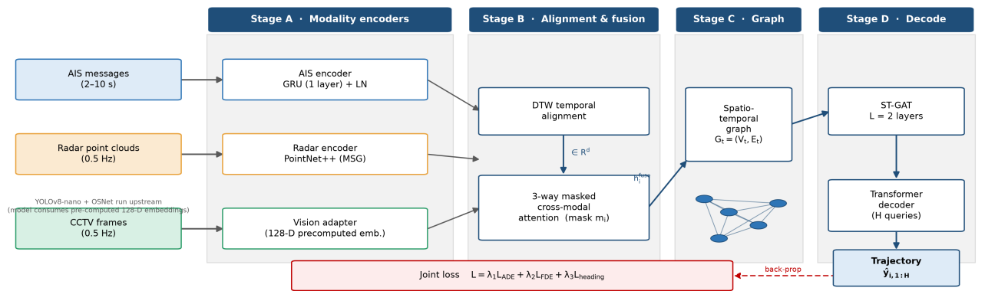
Supplementary Figure S1. Overall architecture of ST-GAT-Fusion. The four-stage pipeline comprises (A) modality-specific encoders for AIS, radar and vision streams, (B) DTW-based temporal alignment followed by 3-way masked cross-modal attention fusion, (C) a spatiotemporal graph over vessels and channel-bank context samples, and (D) stacked spatiotemporal graph attention layers with a Transformer decoder that emits the multi-step trajectory. The model is trained end-to-end with a joint ADE/FDE/heading loss.
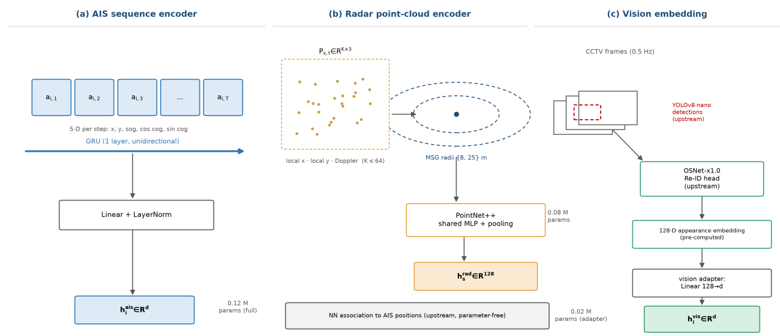
Supplementary Figure S2. The three modality-specific encoders. (a) The AIS encoder applies a single-layer GRU to the 5-D scene-local kinematic sequence. (b) The radar encoder embeds each per-vessel point cloud with a multi-scale-grouping PointNet++-style block; the association of radar returns to vessels happens upstream, before the encoder. (c) The vision branch is an adapter over the 128-D per-vessel appearance embeddings produced upstream by a YOLOv8-nano detector and an OSNet Re-ID head.
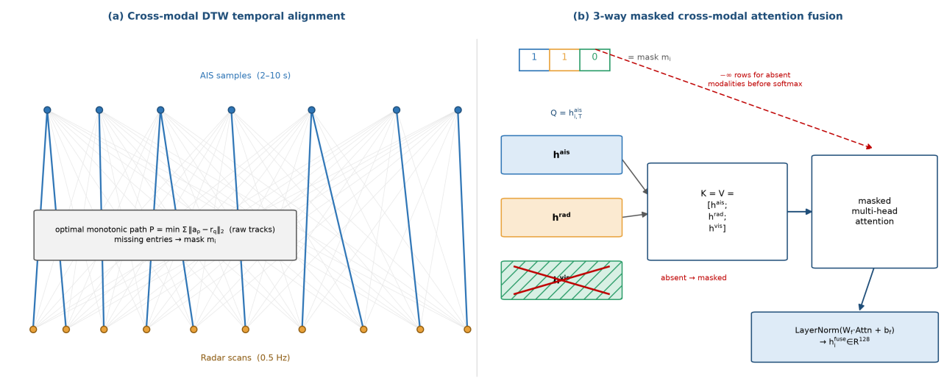
Supplementary Figure S3. Cross-modal alignment and fusion. (a) DTW computes the minimum-cost monotonic path between the asynchronous AIS samples and radar scans; steps at which a source produced no observation are flagged in the modality mask. (b) The 3-way masked cross-modal attention uses the latest AIS state as query and zeroes the key/value rows of absent modalities before the softmax, which produces the fused representation.
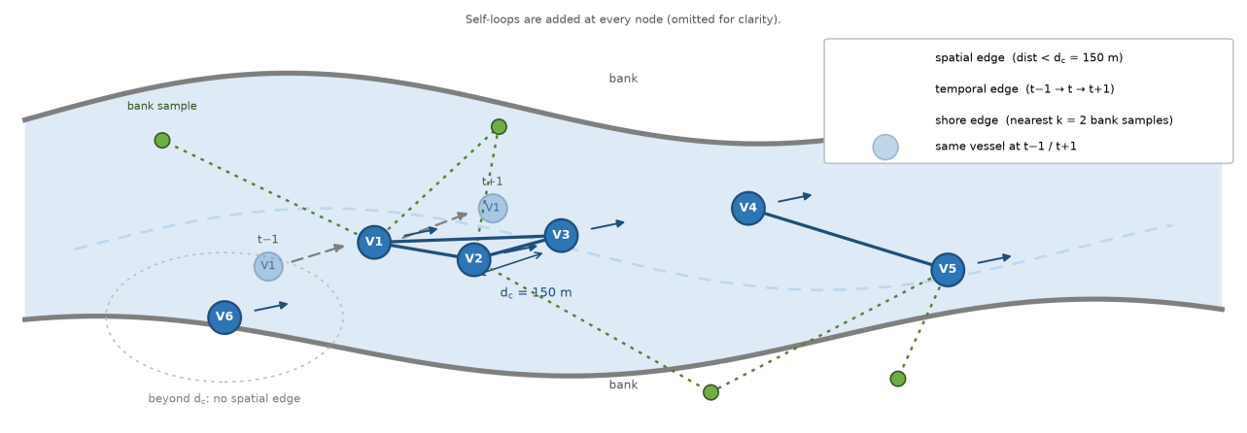
Supplementary Figure S4. Spatiotemporal graph at time step t. Solid dark-blue lines are spatial edges between vessels within the interaction radius; grey dashed arrows are temporal edges linking the same vessel across adjacent steps; green dotted lines are shore edges to the nearest channel-bank samples. Vessels beyond the interaction radius receive no spatial edge. Self-loops are added at every node.

