Appendix Figure S1. Study workflow diagram.
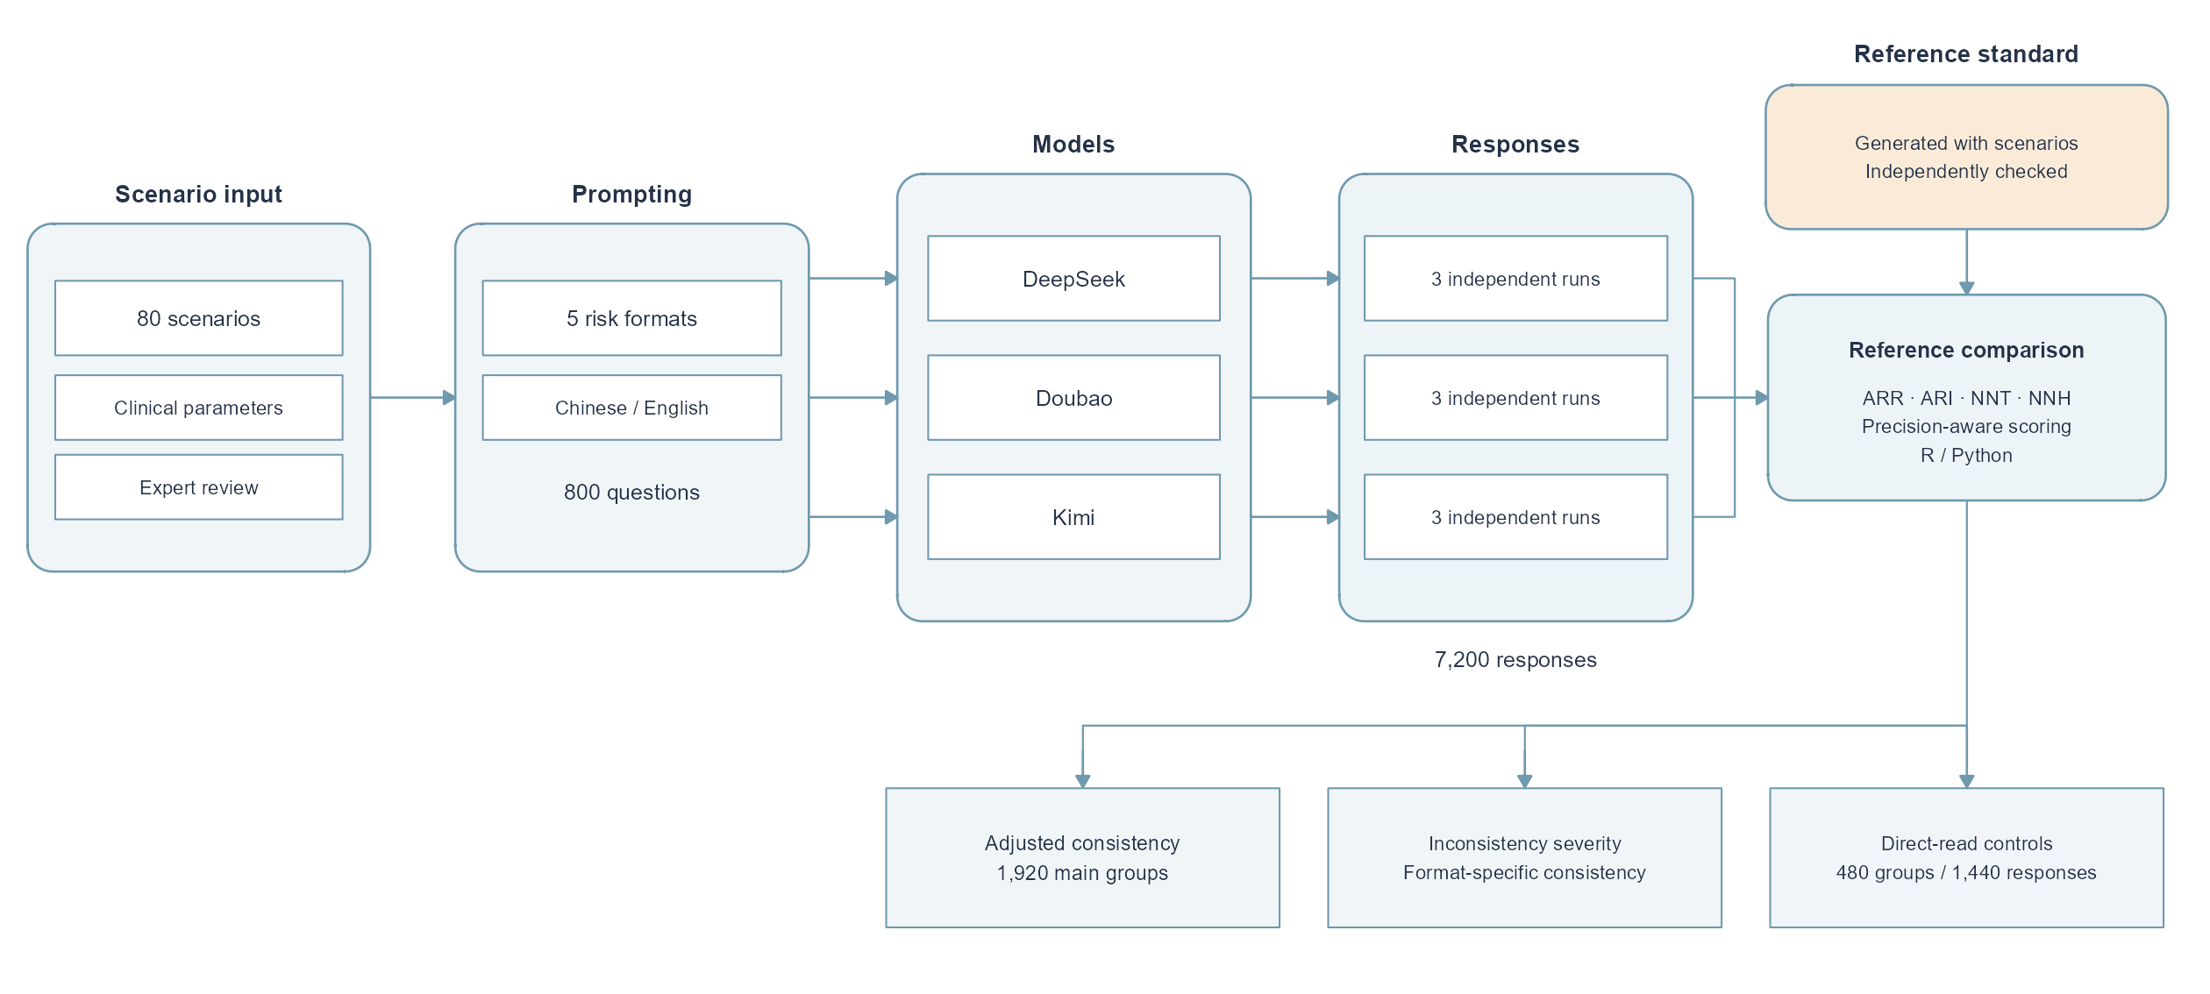
Eighty synthetic cardiovascular primary prevention scenarios were each rendered into five risk-presentation formats, administered in Chinese and English arms, and answered independently three times by each of the three LLMs (7,200 responses in total). Responses were scored against a locked gold standard by two independently implemented automated scorers (R and Python). ARR, absolute risk reduction; ARI, absolute risk increase; NNT, number needed to treat; NNH, number needed to harm.

