A Biologically Interpretable Multimodal Model for Prognostic Risk Stratification and Glucocorticoid-Associated Outcome Heterogeneity in Acute Respiratory Distress Syndrome (ARDS)

Mengna Lin^{1, †}, Su Lu^{1, †}, Yan Zeng^{2, †}, Na Zheng¹, Yumei Chen¹, Chen Chen¹, Xiaojing Zou³, Feixiang Xu¹, Zhiwei Chen⁴, Simeng Wu⁴, Chengjin Gao⁵, Xueling Wu⁶, Zhaocai Zhang⁷, Qi Liu⁸, Yao Shen⁹, Yiyan Lin¹⁰, Yiyu Deng¹⁰, Ran Ji⁷, Jianfeng Song¹¹, Lu Wang¹², Chengchao Peng³, Xue Tian³, Ruilan Wang^{13, *}, Lei Chen^{2, *}, Liying Zhan^{12, *}, Zhenju Song^{1, 14, 15, 16, *}, on behalf of SEpsis and ARDS Research collaborative network of CHina (SEARCH)

¹Department of Emergency Medicine, Zhongshan Hospital, Fudan University, Shanghai, China.
²Department of Research and Development, United Imaging Intelligence, Shanghai, China.
³Department of Critical Care Medicine, Union Hospital, Tongji Medical College, Huazhong University of Science and Technology, Wuhan, China.
⁴Department of Information and Intelligence Development, Zhongshan Hospital, Fudan University, Shanghai, China.
⁵Department of Emergency Medicine, Xinhua Hospital, Shanghai Jiao Tong University School of Medicine, Shanghai, China.
⁶Department of Respiratory and Critical Care Medicine, Renji Hospital, Shanghai Jiao Tong University School of Medicine, Shanghai, China.
⁷Department of Critical Care Medicine, The Second Affiliated Hospital, Zhejiang University School of Medicine, Hangzhou, China.
⁸Emergency Intensive Care Ward, The First Affiliated Hospital of Zhengzhou University, Zhengzhou, China.
⁹Department of Respiratory and Critical Care Medicine, Pudong Hospital, Fudan University, Shanghai, China.
¹⁰Department of Critical Care Medicine, Guangdong Provincial People’s Hospital, Guangdong Academy of Medical Sciences, Southern Medical University, Guangzhou, China.
¹¹Department of Emergency Medicine, Minhang Hospital, Fudan University, Shanghai, China.
¹²Department of Critical Care Medicine, Renmin Hospital of Wuhan University, Wuhan, China.
¹³Department of Emergency and Critical Care Medicine, Shanghai General Hospital, Shanghai Jiao Tong University School of Medicine, Shanghai, China.
¹⁴Department of Emergency and Critical Care Medicine, Xuhui Hospital, Fudan University, Shanghai, China.
¹⁵Institute of Emergency Rescue and Critical Care, Fudan University, Shanghai, China.
¹⁶Shanghai Key Laboratory of Lung Inflammation and Injury, Shanghai, China.

†Contributed equally as first authors.
*Contributed equally as senior authors.
Correspondence:
Zhenju Song
song.zhenju@zs-hospital.sh.cn
Phone: +86 13816607453; Fax: 021-64041990

Study population and ethical approval
The training cohort was established at two hospitals in China between June 2021 and October 2025: Zhongshan Hospital, Fudan University (Ethics No. B2022-175), and Shanghai General Hospital, Shanghai Jiao Tong University School of Medicine (Ethics No. 2021KY041). The internal testing cohort comprised patients from Renmin Hospital of Wuhan University (Ethics No. WDRY2021-K115) and Guangdong Provincial People’s Hospital, Guangdong Academy of Medical Sciences (Ethics No. KY-Z-2022-074-02). The external validation cohort was recruited from independent centres, including Union Hospital, Tongji Medical College, Huazhong University of Science and Technology (Ethics No. 0027-02); Renji Hospital, Shanghai Jiao Tong University School of Medicine (Ethics No. KY2021-102-B); Minhang Hospital, Fudan University (Ethics No. 2022-041-01K); Xinhua Hospital, Shanghai Jiao Tong University School of Medicine (Ethics No. XHEC-D-2022-252); the Second Affiliated Hospital, Zhejiang University School of Medicine (Ethics No. I2022941); and Pudong Hospital, Fudan University (Ethics No. SKWXZ-01). The study was conducted in accordance with the ethical approvals granted by the institutional review boards of all participating centres.

Clinical data acquisition and preprocessing
Clinical information for each medical centre was retrieved from electronic medical records and compiled into a standardized research database. Whenever possible, variables were extracted electronically; otherwise, trained study personnel manually abstracted the required data according to predefined procedures. ARDS diagnosis was independently reviewed by three experienced critical care physicians. A diagnosis was considered confirmed when at least two of the three adjudicators reached agreement. Clinical severity indices, including the Sequential Organ Failure Assessment (SOFA) score, were derived from the corresponding physiological and laboratory measurements recorded in the study database.

Harmonization of laboratory measurements
Variables reported in different units were converted to predefined common units using established conversion relationships. Values reported beyond an assay's measurable range were handled as boundary-censored observations. Measurements below the lower detection threshold were replaced by the reported lower limit, whereas measurements exceeding the upper analytical threshold were assigned the corresponding upper limit.

Serum proteomic profiling
Peripheral venous blood was collected into serum tubes. After clot formation under cooled conditions, samples were centrifuged and the serum fraction was separated, immediately stored at −80 °C, and subsequently transported to a central laboratory for proteomic analysis. Proteomic measurements were performed by Shanghai Biotechnology Corporation (Shanghai, China). Laboratory personnel were blinded to clinical information and study outcomes. Serum proteins were quantified using the Olink® Explore 384 Cardiovascular I and Inflammation I panel, which is based on proximity extension assay technology coupled with next-generation sequencing readout. Sequencing-derived signals were processed using the standard Olink analytical workflow. This included assay-level and sample-level quality assessment, normalization, and conversion to Normalized Protein eXpression (NPX) values. NPX is reported on a log2 scale and reflects relative protein abundance. Assay performance was monitored using multiple internal and external controls. Each sample contained incubation, extension, and amplification controls. Additional controls included two sample controls, three negative controls, and three plate controls. Plate controls were used to minimize technical variation between assay plates. Quality assessment was conducted at both the individual-sample and plate levels. Samples were flagged when the mean read count was below 500 or when the deviation of an internal control exceeded 0.3 NPX relative to the corresponding plate median. For plate and negative controls, the median values of triplicate measurements were required to remain within predefined quality limits for at least 90% of assays, corresponding to ≤5 standard deviations for plate controls and ≤3 standard deviations for negative controls. Assays not meeting these requirements were considered to have potential quality concerns. An assay plate was classified as failed when QC warnings were present in more than one-sixth of the samples together with a median absolute deviation >0.3 NPX for the incubation or amplification controls. Additional technical information on assay characteristics, including detection limits and intra- and inter-assay variability, is available from the Olink platform documentation. After removal of duplicated assays, assay controls, and assays failing quality-control criteria, 711 unique protein features remained and constituted the initial protein abundance matrix for downstream analysis.

Clinical predictive model construction
A total of 75 candidate clinical predictors were prespecified based on clinical relevance and previously reported prognostic factors in ARDS (Table S5). Candidate variables encompassed demographic characteristics, comorbidities, vital signs, respiratory and gas-exchange parameters, routine laboratory measurements, and indicators of extrapulmonary organ dysfunction. Continuous variables were standardized by z-score transformation using the mean and standard deviation estimated from the training cohort. Univariate logistic regression analyses were then performed for each candidate predictor with 30-day all-cause mortality as the outcome, and variables with a univariate P value < 0.05 were retained for subsequent feature selection. Least absolute shrinkage and selection operator (LASSO)-penalized logistic regression was subsequently performed exclusively in the training cohort. The elastic-net mixing parameter was fixed at α=1, corresponding to the LASSO penalty. Ten-fold cross-validation was used to determine the optimal regularization parameter, and variables with non-zero coefficients at the selected λ were retained and entered into the final multivariable logistic-regression model. Ten-fold cross-validation was used to determine the optimal regularization parameter, with the value associated with the minimum mean cross-validated binomial deviance selected (λ_{min}=0.0152). At this penalty level, 30 candidate predictors retained non-zero coefficients and were carried forward to the final prediction model.
The predictors selected by LASSO were subsequently entered into a multivariable logistic-regression model fitted in the training cohort. Regression coefficients estimated from this final logistic model were used to construct the clinical prognostic score (Clin-score):
$$Clin-score = β_{0} + \sum_{j=1}^{p}{β_{j}X_{j}}$$
where $X_{j}$ represents the value of the $j$th selected predictor, $β_{j}$ its corresponding coefficient estimated from the final multivariable logistic-regression model, and $β_{0}$ the model intercept. The probability of 30-day mortality for each patient was calculated using the logistic transformation:
$$P(30-day mortality) = \frac{exp(Clin-score)}{1 + exp(Clin-score)}.$$
All steps of predictor selection, hyperparameter tuning, and final model estimation were confined to the training cohort. Neither the internal-test nor the external-validation cohort was used during model development. After fitting the final model, the selected predictor set, regression coefficients, and intercept were fixed and applied unchanged to the internal-test and external-validation cohorts to generate patient-level predicted probabilities. The final predictors and corresponding regression coefficients are reported in Table S6.

Radiomics pipeline and radiomic‑model construction
Lung masks served as the regions of interest for radiomic feature extraction. CT volumes were resampled to isotropic 1 × 1 × 1 mm voxel resolution, and lung-window settings (WW 1500 HU, WL −600 HU) were applied for intensity normalization. Only original (unfiltered) images were used for feature extraction. A total of 104 radiomic features were extracted, including first-order statistics, shape-based features, and texture features derived from the gray-level co-occurrence matrix (GLCM), gray-level dependence matrix (GLDM), gray-level run-length matrix (GLRLM), gray-level size-zone matrix (GLSZM), and neighboring gray-tone difference matrix (NGTDM). Feature reproducibility was assessed using the intraclass correlation coefficient (ICC), and features with an ICC >0.85 were retained. After redundancy reduction, LASSO-penalized logistic regression was performed exclusively in the training cohort to select the final radiomic features. The retained features were subsequently entered into a multivariable logistic regression model to derive the Radscore and corresponding 30-day mortality probability. All feature-selection procedures and model parameters were determined using the training cohort and subsequently applied unchanged to the internal-test and external-validation cohorts.
The optimal penalty λ was determined as 0.00298, yielding 25 non‑zero radiomic features. These selected features were combined to construct the radiomic‑based prognostic score (Radscore). The full Radscore formula and corresponding coefficients are provided in Supplementary Table S7. The Radscore was further used to build the final radiomic logistic‑regression model for 30‑day mortality prediction, outputting patient‑level mortality probability. Radiomic‑model performance was assessed by ROC‑AUC, Hosmer‑Lemeshow test, calibration curves, and decision‑curve analysis.

ARDS‑Net deep‑learning model implementation
ARDS‑Net (ResidualNetUseMask) is a 3D ResNet‑based convolutional network for 30‑day mortality binary classification from chest CT volumes [1]. Input CT volumes were cropped to annotated lung masks, with input crop size set to 256 × 256 × 128 voxels and resampled to native spacing [1, 1, 3] mm. Intensity normalization was performed using FixedNormalizer with mean = −600, stddev = 750 with intensity clipping, matching lung‑window CT settings. The model accepted single‑channel volumetric input and output the probability of 30‑day mortality.
Multiple volumetric data‑augmentation strategies were applied during training: random z‑axis flip (probability = 0.5), random 3D rotation (probability = 0.5, ±15° around the z‑axis), isotropic random scaling (probability = 0.5, scale ratio ranging 0.75‑1.25), and mix‑up augmentation (probability = 0.5, alpha = 0.1). Random positional jitter of the crop center was enabled with box‑center random offset of [24, 24, 24] mm. Equal‑class sampling was adopted to balance positive and negative samples within each training batch. Focal loss was used as the primary classification loss (gamma = 0). Additional CAM‑related auxiliary loss was included with a CAM‑loss weight of 0.3 and Dice‑based CAM loss. The Adam optimizer was used with betas = (0.9, 0.999), ε = 1e^{‑8} and no weight decay. Initial learning rate was set to 1e^{‑4}. Step‑based learning‑rate decay (step_size = 100 epochs, gamma = 0.8) was applied, together with gradual warm‑up over the first 100 training epochs. The total training epoch was 2001, batch size = 8, with sixty‑four CPU threads for data loading. Models were saved every 5 epochs. Training was performed on a single GPU NVIDIA A40 48GB, starting from random initialization (no external transfer‑learning weights). All deep‑learning experiments were implemented in PyTorch. The full configuration file is available upon reasonable request. Key hyper‑parameters are summarized in Supplementary Table S8.

Proteomic model construction
Serum samples were prospectively collected at the time‑point of index‑CT acquisition. Sample quality control, protein quantification, normalization, and batch‑effect correction were performed following the manufacturer’s workflow. Samples with low‑quality metrics were excluded, yielding an initial 711‑dimensional protein abundance matrix. Minimum Redundancy‑Maximum Relevance (MRMR) algorithm was first applied for preliminary dimensionality reduction, reducing the feature set from 711 to 500 protein features. Subsequently, LASSO‑penalized logistic regression with ten‑fold cross‑validation was implemented on the training cohort. The optimal penalty λ was determined as 0.0242, resulting in 22 non‑zero protein features retained for modelling. These selected protein signatures were used to build the proteomic prognostic model, outputting patient‑level 30‑day mortality probability. The full list of 22 selected protein features is shown in Supplementary Table S9.

Model-level fusion
Two fusion models were developed. The clinical-imaging model integrated predicted probabilities from the clinical, radiomics, and deep-learning models, whereas the multimodal model additionally incorporated the proteomic model. Component-model probabilities were standardized using parameters estimated exclusively from the corresponding training data. Five candidate meta-classifiers, including decision tree, random forest, stochastic gradient descent (SGD), support vector machine (SVM), and logistic regression, were evaluated during model development. Based on discrimination, stability, and model parsimony within the training data, L2-penalized logistic regression was selected as the final fusion strategy (Figure S10).

Clinical-imaging fusion model
The clinical-imaging fusion model was developed in the full training cohort (n=1,715) using predicted probabilities from the clinical, radiomics, and deep-learning component models. Component-model probabilities were standardized by z-score transformation using the mean and standard deviation estimated exclusively from the training cohort. After model finalization, the component models, standardization parameters, and meta-classifier coefficients were fixed and applied unchanged to the internal-test and external-validation cohorts.

Multimodal fusion model
The multimodal fusion model was developed separately in the proteomics-matched training subset (n=554) using predicted probabilities from the clinical, radiomics, deep-learning, and proteomic component models. Component-model probabilities were standardized using parameters estimated exclusively from the corresponding training subset. The final L2-penalized logistic-regression meta-classifier used an inverse regularization strength of C=0.05 and a convergence tolerance of 1×10⁻⁵, with no class weighting.
After the meta-classifier was finalized, component models were refitted using their corresponding training data. Predictions for the internal-test and external-validation cohorts were then generated using the fixed preprocessing, standardization, and meta-classifier parameters. No information from either evaluation cohort was used for preprocessing decisions, feature selection, hyperparameter tuning, component-model fitting, or meta-classifier training.

Standardized ChatGPT prompt
“You are evaluating a patient with acute respiratory distress syndrome (ARDS). Based only on the clinical information and chest CT findings provided below, estimate the probability that this patient will die within 30 days. Do not assume any information that is not explicitly provided. Do not use knowledge of outcomes, treatment decisions, or predictions from other models. Assess the case independently. Please provide a single estimated mortality probability between 0% and 100%. Do not provide treatment recommendations.
Clinical information: [clinical variables]
Chest CT information: [CT images]
Output format: Mortality probability: XX%”

ChatGPT evaluation
ChatGPT5.4 (OpenAI, San Francisco, CA, USA) was independently evaluated in the same 326 patients included in the internal test cohort using the ChatGPT web interface. Each patient was assessed in a separate new conversation to minimize carry-over of information between cases. No information from previous cases, patient outcomes, physician assessments, or predictions from the clinical-imaging model was provided to ChatGPT.
Clinical information was presented using a standardized case template containing (refer to a supplementary Table S5). Chest CT information was provided as representative axial images showing the most extensive pulmonary involvement. For each patient, the image(s) demonstrating the greatest overall extent of parenchymal abnormalities, including ground-glass opacity and consolidation, were selected by the investigator who was blinded to patient outcomes and model predictions. Images were displayed using a standardized lung-window setting (window width, 1,500 HU; window level, −600 HU) and presented to ChatGPT in a consistent format across patients.
ChatGPT was instructed to estimate the probability of 30-day mortality and to provide a single numerical probability ranging from 0% to 100%. Each case was evaluated once, and the first valid numerical probability returned by the model was recorded for analysis without post hoc modification. All cases yielded a valid numerical probability. Investigators recording the model outputs were blinded to 30-day outcomes at the time of evaluation.

Reader study and comparative performance analysis
We compared the prognostic performance of the clinical-imaging model with that of clinicians and ChatGPT in a multi-reader, multi-case (MRMC) observer study conducted between December 2025 and March 2026. All 326 cases from the internal test cohort were reviewed in a predefined sequence. In the first session, readers evaluated chest CT images alone. CT examinations were presented as complete DICOM volume. Readers were allowed to scroll through the complete image series and allowed to adjust window settings. Radiology reports and outcome information were not provided. In the second session, readers were provided with clinical information available at the index CT time point (Supplementary Table S5). No post-index treatment or outcome information was provided. Readers then generated a second 30-day mortality estimate integrating clinical and CT information. For both sessions, readers reported a continuous mortality probability from 0% to 100% and a 5-point Likert risk score. For the primary statistical comparison with the clinical-imaging model, only the continuous 0-100 mortality probability scores were used.
ChatGPT5.4 (OpenAI, San Francisco, CA, USA) independently evaluated the same 326 cases using a standardized prompt used in the clinician assessment. Each case was assessed independently, without access to patient outcomes, predictions from the clinical-imaging model, or clinician ratings. ChatGPT was instructed to estimate mortality probability on a continuous scale from 0% to 100%, and the generated probability was recorded without post hoc modification.
Comparisons between the clinical-imaging model and physician readers were performed using a multi-reader multi-case (MRMC) analysis to account for variability and correlation across both readers and cases. Physician performance was summarized by the mean AUROC across readers, and the difference in AUROC between the clinical-imaging model and physician readers was evaluated using the Obuchowski-Rockette MRMC framework with reader and case effects incorporated into the variance estimation. Individual reader AUROCs with 95% confidence intervals were additionally reported descriptively. The comparison between the clinical-imaging model and ChatGPT, which involved a single set of predictions for the same cases, was assessed separately using paired patient-level bootstrap resampling with 2,000 replicates.

Single-cell transcriptomic data analysis
BALF single-cell RNA sequencing data from patients with ARDS were analysed using the Seurat framework [2]. Low-quality cells were excluded based on quality-control metrics including detected gene numbers, transcript counts, mitochondrial RNA proportion, and erythrocyte-associated transcript expression. Putative doublets were identified and removed using DoubletFinder [3], and ambient RNA contamination was assessed using decontX [4]. Following quality control, individual samples were normalized using log-normalization, and highly variable genes were identified for downstream dimensionality reduction. Principal component analysis was performed, followed by Harmony integration using sample identity as the batch variable to mitigate inter-sample variation [5]. Harmony-corrected dimensions were used for graph-based clustering and uniform manifold approximation and projection (UMAP) visualization. Major immune and epithelial compartments were annotated based on canonical marker genes and cluster-specific expression patterns. Selected major compartments were subsequently subjected to secondary clustering to identify finer cellular states.
Cellular composition was evaluated at the patient level, with each patient considered as an independent biological replicate. For each patient, the relative abundance of each cell population was calculated as the proportion of cells belonging to that population among all annotated cells. Differences in cell-type proportions between multimodal model-defined high- and low-risk groups were assessed using sample-level proportion analysis, with adjustment for multiple comparisons using the Benjamini–Hochberg procedure. To provide a complementary visualization of relative enrichment or depletion patterns, observed-to-expected ratios (Ro/e) were calculated for each cell population and risk group [6]. Expected cell numbers were derived from marginal totals under the assumption of independence between cell identity and risk group. Ro/e values greater than 1 indicated relative enrichment, whereas values below 1 indicated relative depletion. Ro/e analyses were used for descriptive visualization of cellular distribution patterns and were not considered the primary inferential analysis.
To preserve the patient as the unit of biological replication and avoid cell-level pseudoreplication, raw gene expression counts were aggregated within each patient and major cell type to generate pseudobulk expression profiles. Differential expression between high- and low-risk groups was performed separately for each major cell type using edgeR [7]. Lowly expressed genes were removed using filterByExpr, library sizes were normalized using the trimmed mean of M-values (TMM) method, and differential expression was modelled using robust quasi-likelihood negative-binomial generalized linear models [8]. The low-risk group was used as the reference group; therefore, positive log-fold changes represented higher expression in the high-risk group. Genes were considered differentially expressed after Benjamini–Hochberg correction for multiple testing.
Gene set enrichment analysis (GSEA) was performed independently for each major cell type using genes ranked according to signed differential-expression statistics derived from the pseudobulk analysis [9]. Ranked gene lists were interrogated against Kyoto Encyclopedia of Genes and Genomes (KEGG) pathways using clusterProfiler [10]. Gene sets containing 15–500 genes were included, and statistical significance was determined after Benjamini-Hochberg adjustment. Positive normalized enrichment scores (NES) indicated preferential enrichment in the high-risk group, whereas negative NES values indicated enrichment in the low-risk group.

Time-varying analysis of glucocorticoid-associated outcomes
For the glucocorticoid-associated outcome analysis, eligible patients from the training, internal-test, and external-validation cohorts were pooled. A new-user design was adopted by excluding patients with documented systemic glucocorticoid exposure before the index time point (T0). Patients were additionally required to have a valid model-defined risk-group assignment, positive follow-up time, available 30-day mortality status, and complete data for all covariates included in the multivariable model.
Follow-up began at T0 and continued until death, censoring, or 30 days, whichever occurred first. Systemic glucocorticoid initiation within 7 days after T0 was modelled as a time-varying exposure. For patients initiating glucocorticoids within the prespecified 7-day exposure window and before the end of observed follow-up, exposure status changed from unexposed to exposed at the recorded time of first glucocorticoid administration. These patients therefore contributed unexposed person-time from T0 until treatment initiation and exposed person-time thereafter. Patients who did not initiate glucocorticoids within 7 days after T0, including those whose first recorded initiation occurred after the prespecified exposure window, remained classified as unexposed throughout the primary analysis.
Associations between time-varying glucocorticoid initiation and 30-day all-cause mortality were estimated using Cox proportional-hazards models in counting-process format. Models were adjusted for prespecified baseline covariates, including PaO₂/FiO₂ ratio, C-reactive protein, procalcitonin, white blood cell count, lactate, body temperature, platelet count, albumin, creatinine, total bilirubin, SOFA score, age, sex, chronic obstructive pulmonary disease, asthma, interstitial lung disease, autoimmune disease, immunosuppressant use, solid-organ transplantation, hematologic malignancy, and solid tumor. Robust sandwich standard errors clustered by patient were used to account for the multiple time intervals contributed by individual patients. Ties were handled using the Efron method.
Heterogeneity in glucocorticoid-associated outcomes was evaluated by including a multiplicative interaction term between time-varying glucocorticoid exposure and model-defined risk group, with the low-risk group specified as the reference category. Risk-group-specific hazard ratios (HRs) and 95% confidence intervals (CIs) for glucocorticoid initiation were obtained from linear contrasts of the relevant model coefficients. Overall heterogeneity across risk groups was assessed using a joint Wald test of the glucocorticoid-by-risk-group interaction terms. All statistical tests were two-sided.

Continuous-risk interaction analysis
To assess whether treatment-associated heterogeneity was present across the full spectrum of predicted risk and to reduce dependence on prespecified categorical cutoffs, continuous interaction analyses were performed separately for the clinical-imaging and multimodal models. For each model, the predicted probability of 30-day mortality was entered as a continuous variable in the multivariable time-dependent Cox model together with a multiplicative interaction term between predicted risk and time-varying glucocorticoid exposure. Predicted risk was expressed in 10-percentage-point units to facilitate interpretation. Accordingly, the interaction hazard ratio (HR) represented the relative change in the glucocorticoid-associated HR for each 10-percentage-point increase in predicted 30-day mortality risk. Interaction estimates were reported with 95% CIs and two-sided P values.
Model-based glucocorticoid-associated HRs and corresponding 95% CIs were then estimated across the observed distribution of predicted risk using linear contrasts of the glucocorticoid exposure and exposure-by-risk interaction coefficients. These risk-specific HRs were plotted as a continuous function of predicted mortality risk, with the solid line representing the estimated HR and the shaded region representing the 95% CI. A horizontal reference line at HR=1 indicated no association, and the prespecified risk thresholds used to define low-, intermediate-, and high-risk groups were superimposed as vertical reference lines. The same modelling and visualization procedures were applied independently to the clinical-imaging and multimodal risk scores.

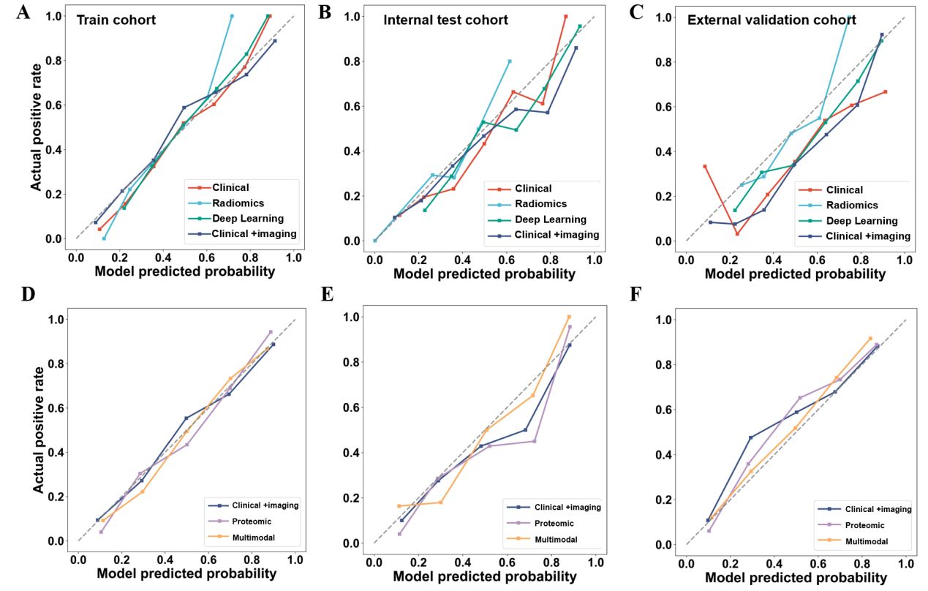
Figure S1. Calibration performance of clinical, imaging, proteomic, and multimodal models across the training, internal test, and external validation cohorts. (A–C) Calibration plots for the Clinical, Radiomics, Deep Learning, and Clinical-imaging models in the training cohort (A), internal test cohort (B), and external validation cohort (C). (D–F) Calibration plots comparing the Clinical-imaging, Proteomic, and Multimodal models in the training cohort (D), internal test cohort (E), and external validation cohort (F). The x-axis represents the model-predicted probability of the outcome, and the y-axis represents the observed event probability. The dashed diagonal line indicates perfect calibration, with predictions closer to this line reflecting better agreement between predicted and observed risks.

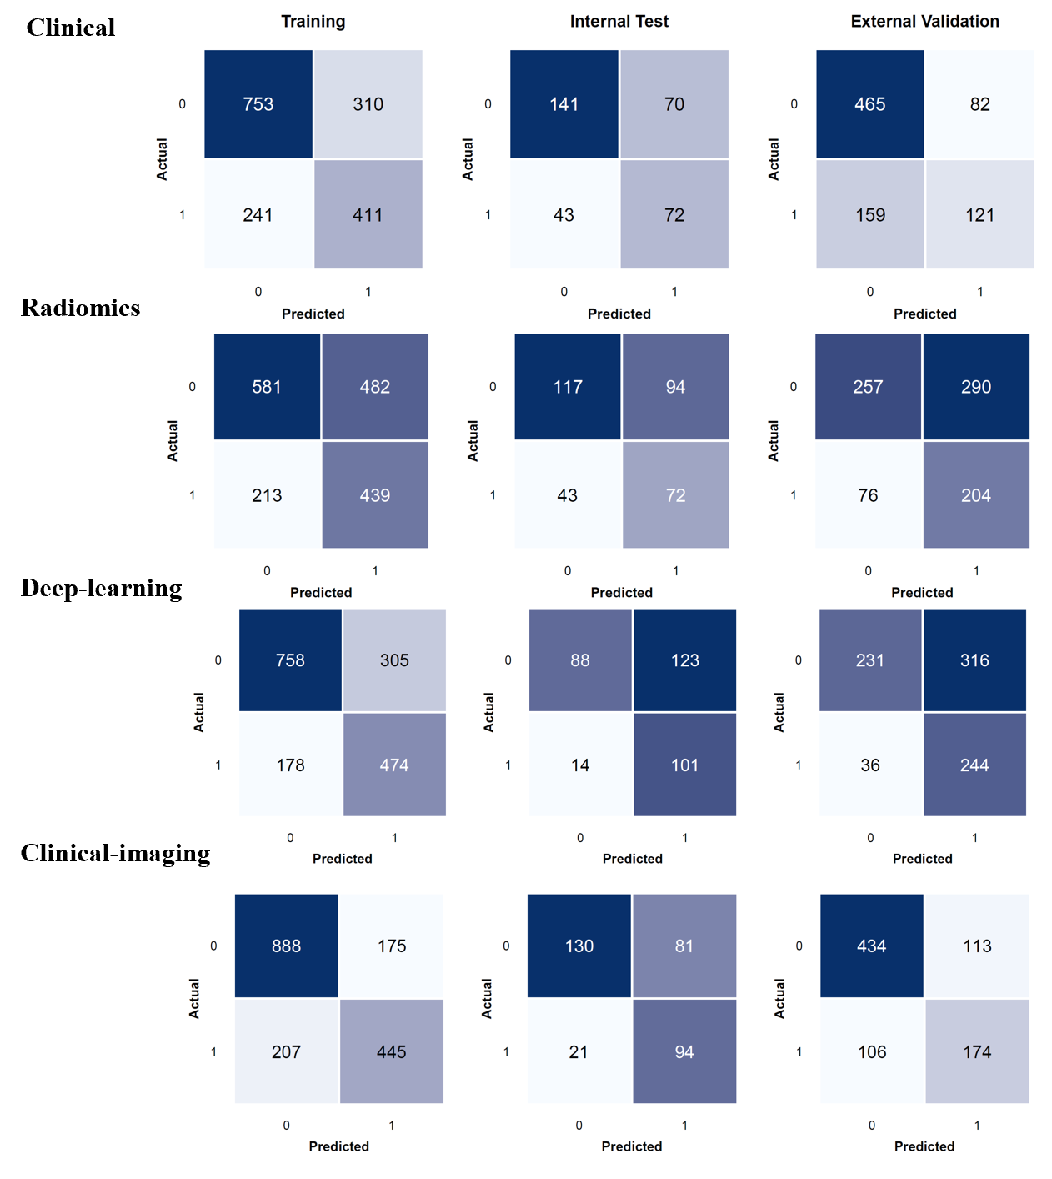
Figure S2. Confusion matrices of the clinical, radiomics, deep-learning, and clinical-imaging models across cohorts. Confusion matrices show the classification performance of the clinical, radiomics, deep-learning, and clinical-imaging models for 30-day mortality in the training (n=1,715), internal-test (n=326), and external-validation (n=827) cohorts. Rows represent the observed outcome and columns represent the model-predicted outcome, with 0 indicating survival and 1 indicating death within 30 days. Values within each cell indicate the number of patients classified as true negative, false positive, false negative, or true positive.

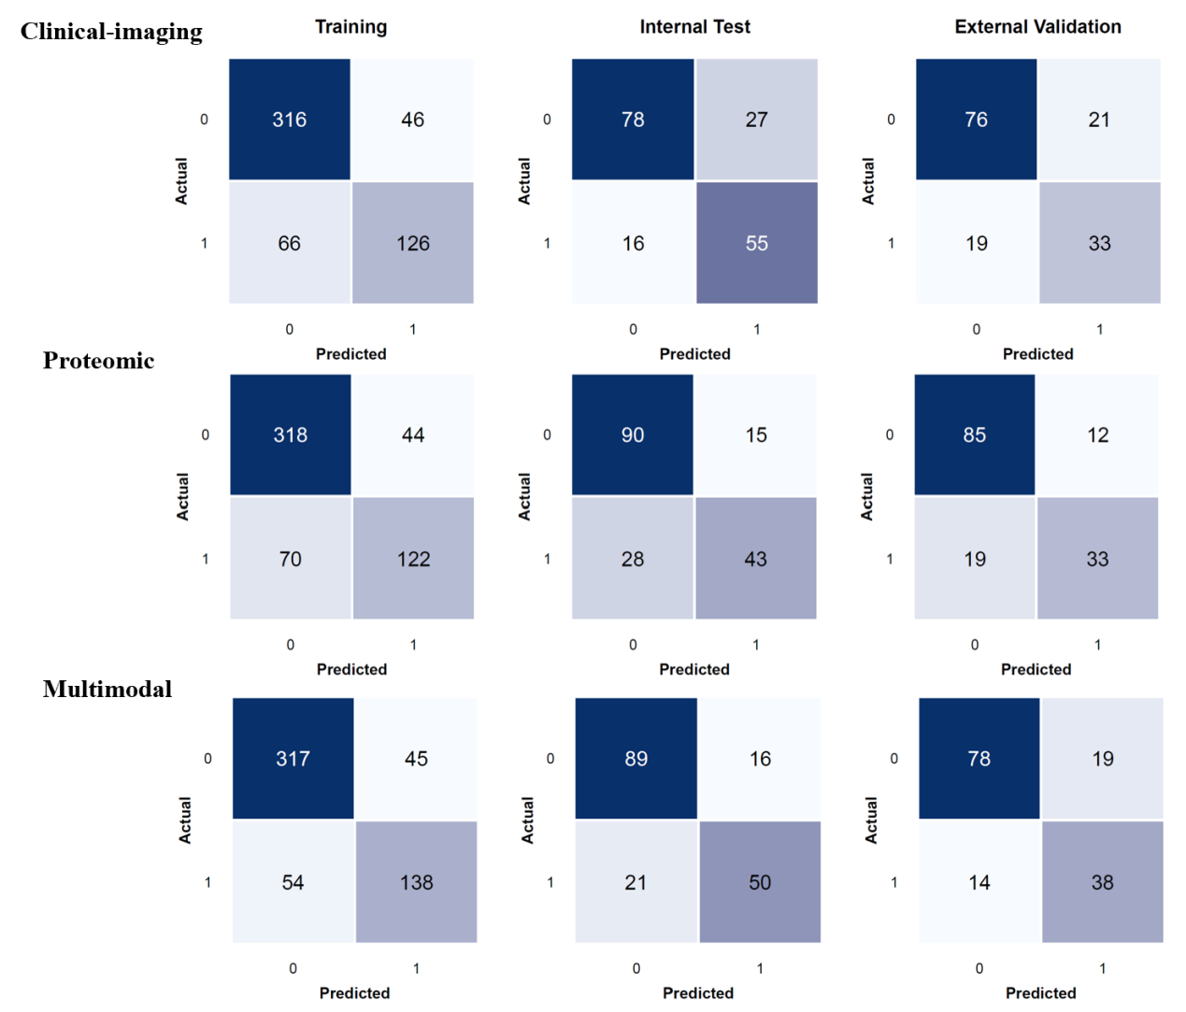
Figure S3. Confusion matrices of the clinical-imaging, proteomic, and multimodal models in the proteomics-matched cohorts. Confusion matrices show the classification performance of the clinical-imaging, proteomic, and multimodal models for 30-day mortality among patients with matched proteomic data in the training (n=554), internal-test (n=176), and external-validation (n=149) cohorts.
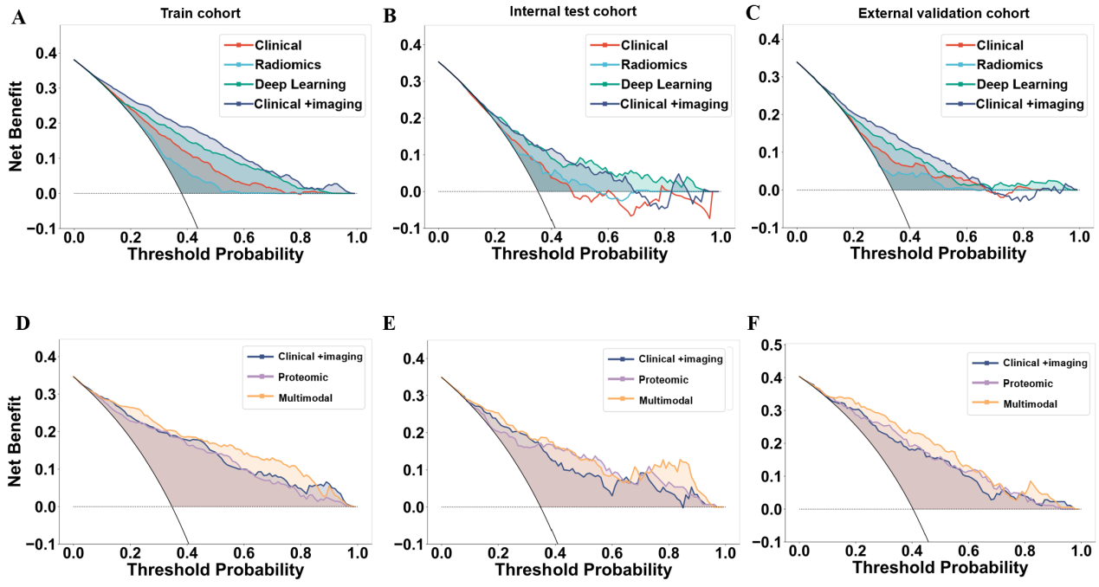
Figure S4. Decision curve analysis of clinical, imaging, proteomic, and multimodal models across the training, internal test, and external validation cohorts. (A–C) Decision curve analysis comparing the Clinical, Radiomics, Deep Learning, and Clinical-imaging models in the training cohort (A), internal test cohort (B), and external validation cohort (C). (D–F) Decision curve analysis comparing the clinical-imaging, Proteomic, and Multimodal models in the training cohort (D), internal test cohort (E), and external validation cohort (F). The x-axis represents the threshold probability, and the y-axis represents the net benefit. The horizontal line represents the strategy of treating no patients, whereas the diagonal reference line represents the strategy of treating all patients. A higher net benefit across a clinically relevant range of threshold probabilities indicates greater potential clinical utility.
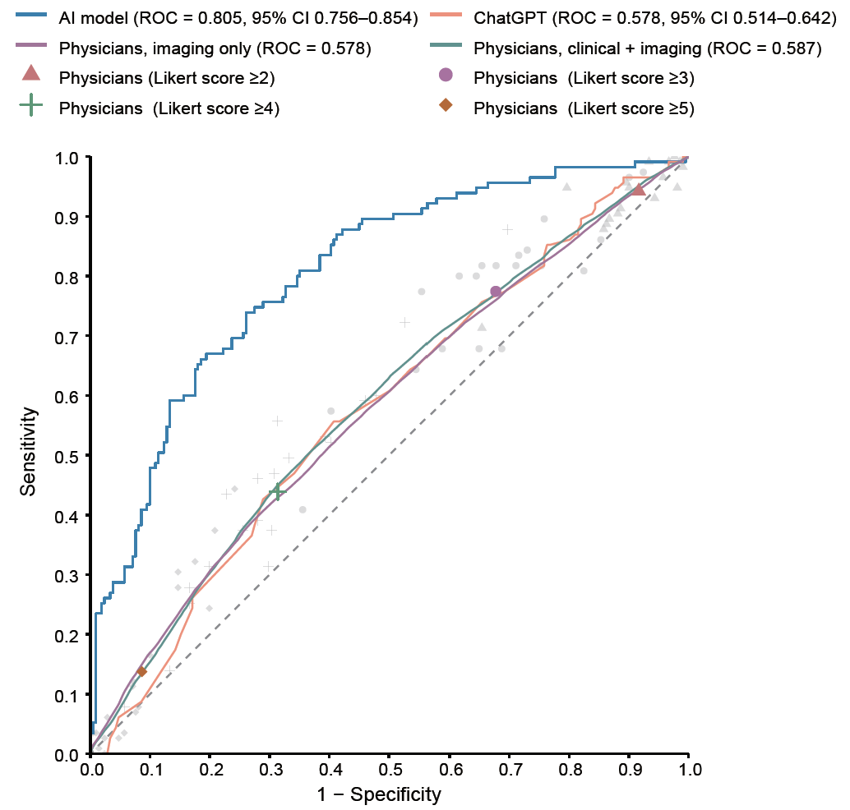
Figure S5. ROC curves comparing the discrimination of the clinical-imaging, ChatGPT, and physicians in the internal test cohort. Physician performance based on continuous probability estimates and predefined Likert-score thresholds is also shown. Likert operating points are represented by the corresponding symbols. AUCs with 95% confidence intervals are reported.

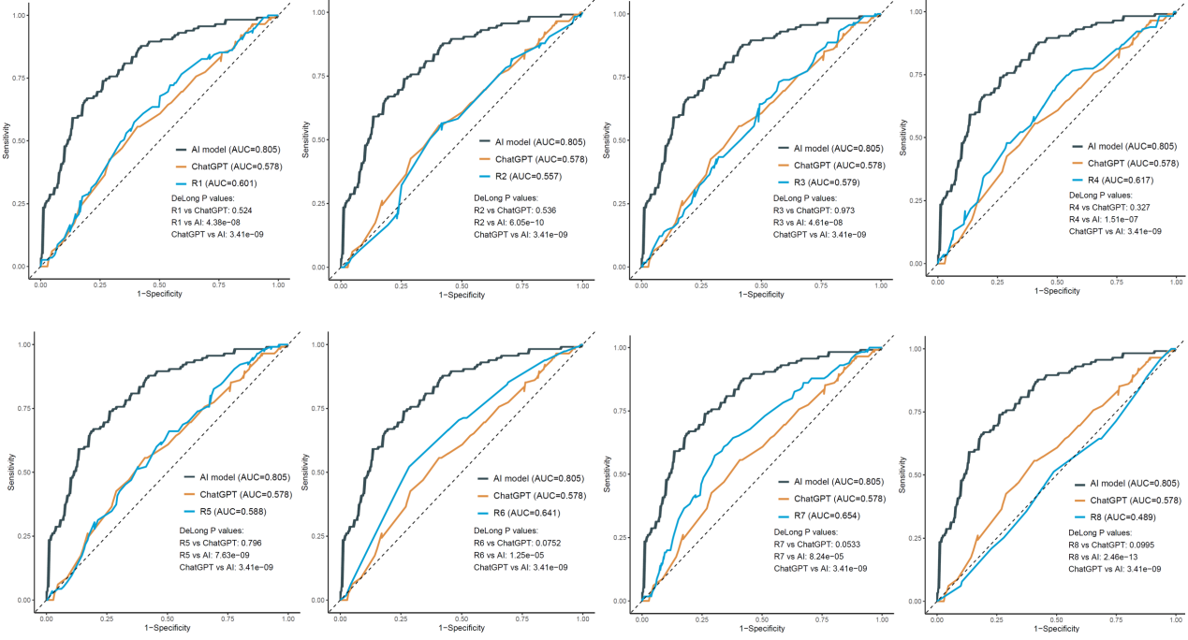
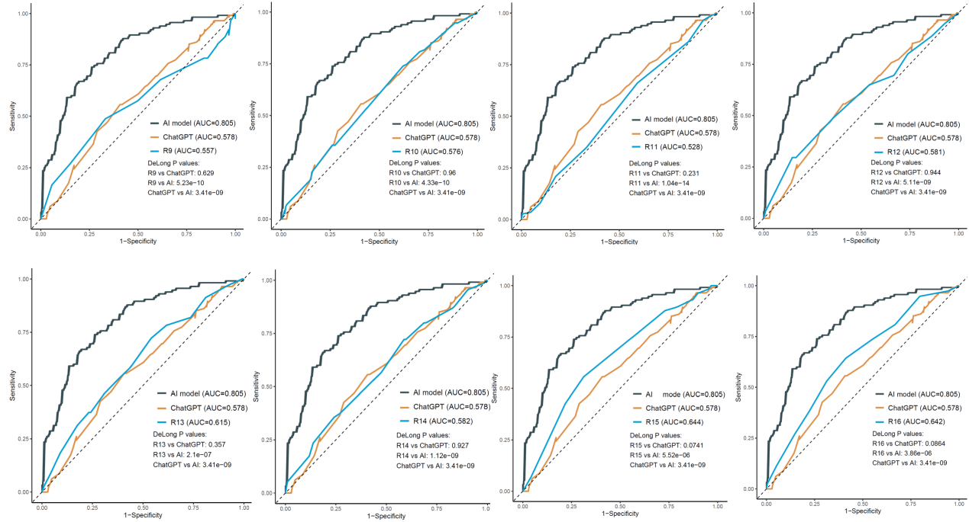
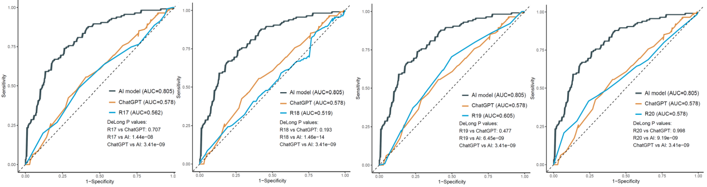
Figure S6. Comparison of prognostic performance between the clinical-imaging model, ChatGPT, and individual readers in the reader study. Receiver operating characteristic (ROC) curves compare the prognostic performance of the AI model, ChatGPT, and individual readers (R1–R20). Each panel corresponds to one reader and shows the ROC curves for the clinical-imaging model, ChatGPT, and that reader. The area under the ROC curve (AUC) is reported for each method. Pairwise comparisons of AUCs were performed using DeLong’s test, with corresponding P values shown within each panel. The dashed diagonal line represents performance expected by chance. Individual-reader comparisons are shown descriptively; the prespecified primary model-versus-reader comparison was performed using the MRMC framework.
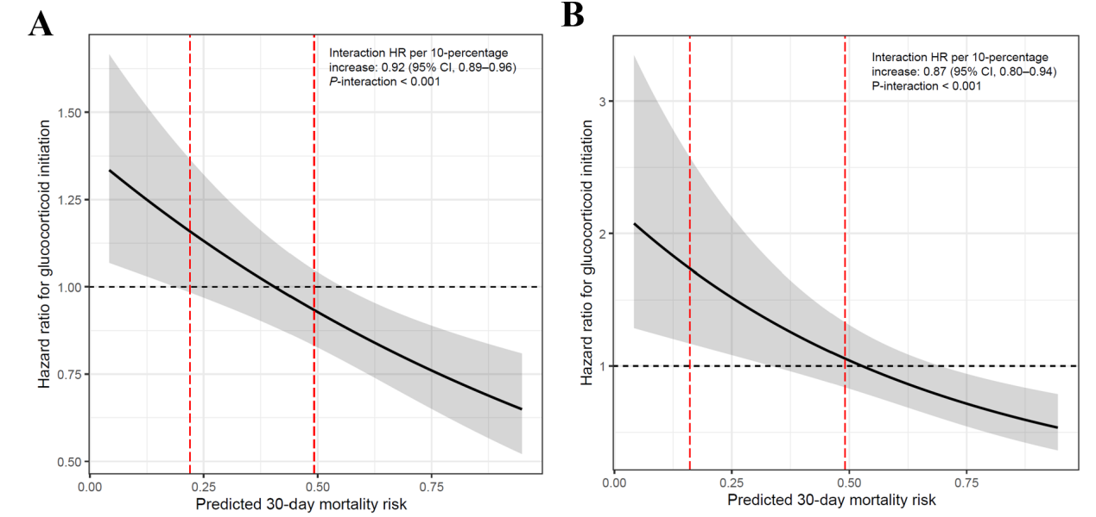
Figure S7. Continuous interaction between model-predicted mortality risk and glucocorticoid-associated 30-day mortality. (A) Clinical-imaging model. (B) Multimodal model. Solid black lines represent the estimated hazard ratio (HR) for glucocorticoid initiation across the continuous distribution of predicted 30-day mortality risk, with shaded areas indicating 95% confidence intervals. The horizontal dashed line denotes HR = 1. Red vertical dashed lines indicate the thresholds used to define low-, intermediate-, and high-risk groups. Interaction HRs per 10-percentage-point increase in predicted risk and corresponding P values for interaction are shown in each panel.

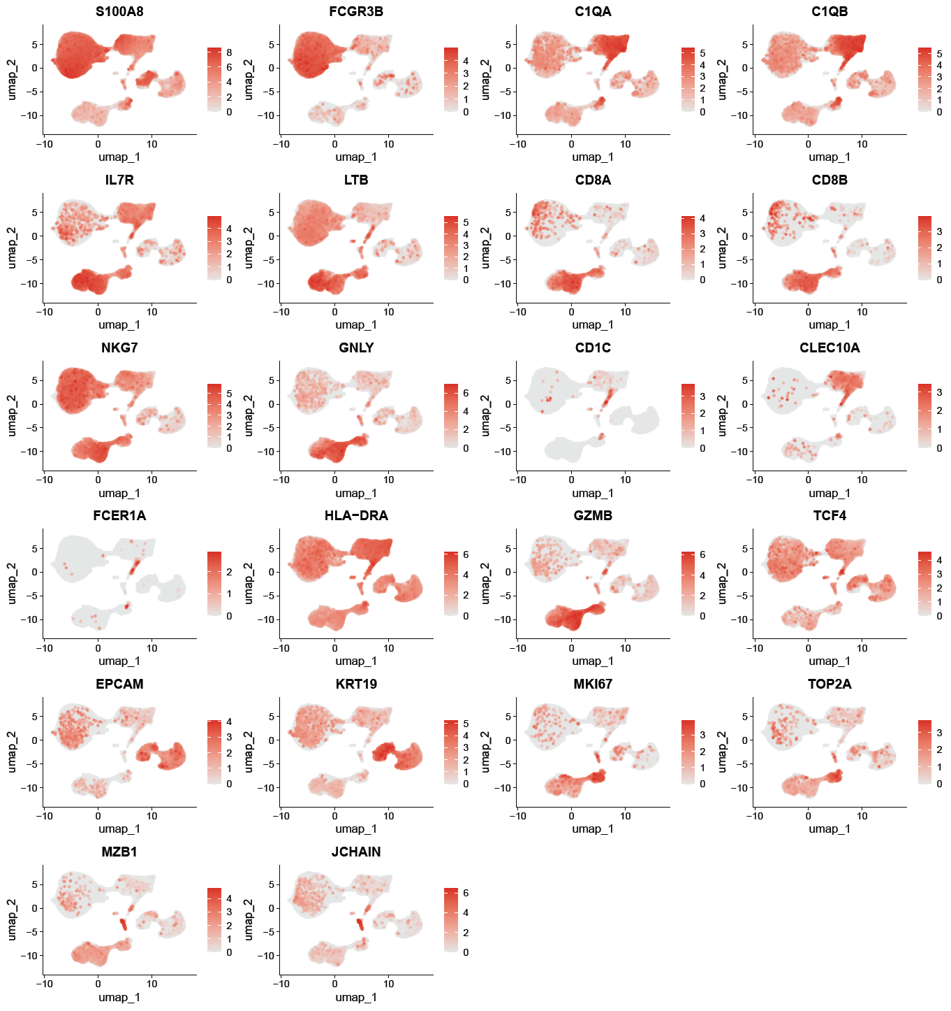
Figure S8. Canonical marker expression supporting major cell-type annotation in BALF scRNA-seq. Feature plots display the expression of representative canonical marker genes used to annotate major immune and epithelial cell populations in BALF. Marker genes included S100A8/FCGR3B for neutrophils, C1QA/C1QB for macrophages, IL7R/LTB for CD4⁺ T cells, CD8A/CD8B for CD8⁺ T cells, NKG7/GNLY for NK cells, CD1C/CLEC10A/FCER1A/HLA-DRA for dendritic cells, EPCAM/KRT19 for epithelial cells, MKI67/TOP2A for cycling cells, and MZB1/JCHAIN for plasma cells. Color intensity indicates normalized gene expression.
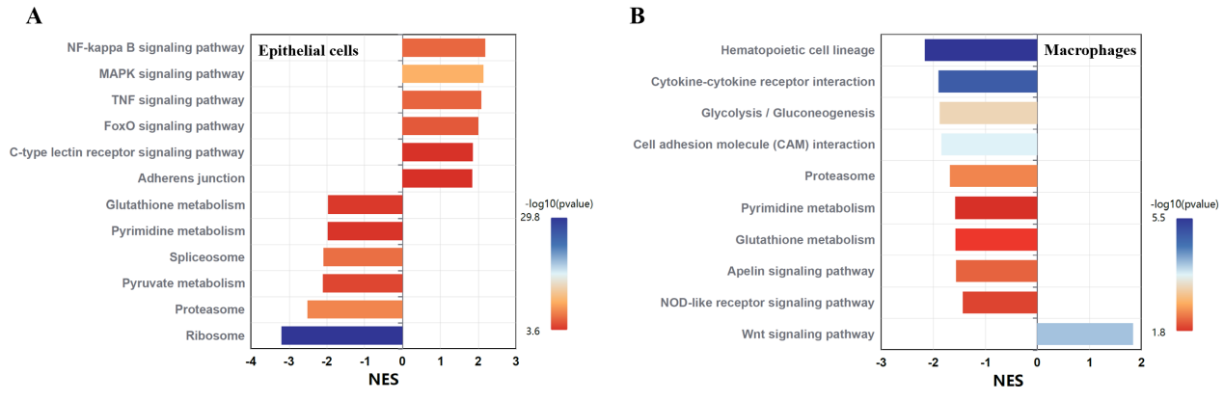
Figure S9. Gene set enrichment analysis of epithelial cells and macrophages across risk groups. Gene set enrichment analysis (GSEA) was performed to identify differentially enriched KEGG pathways between the high-risk and low-risk groups within major BALF cell populations. (A) Enriched pathways in epithelial cells. (B) Enriched pathways in macrophages. Bars represent the normalized enrichment score (NES), with positive NES values indicating pathway enrichment in the high-risk group and negative values indicating enrichment in the low-risk group. Bar color represents statistical significance based on −log10 (adjusted P value), with greater color intensity indicating stronger significance.
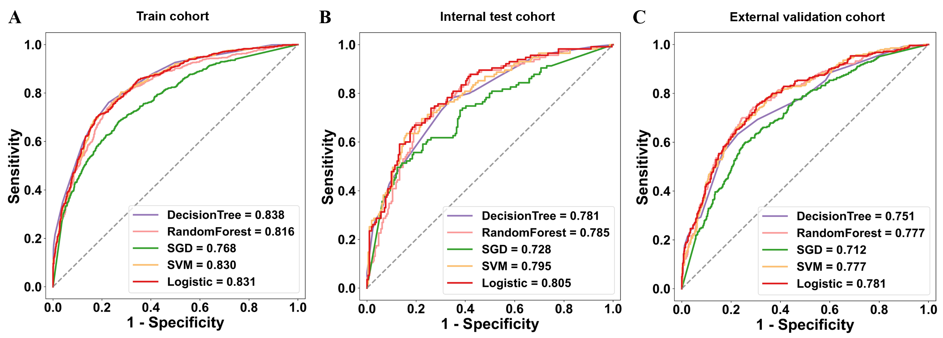
Figure S10. Comparison of candidate machine-learning algorithms for the clinical-imaging model. Receiver operating characteristic (ROC) curves show the discriminative performance of five candidate algorithms, including decision tree, random forest, stochastic gradient descent (SGD), support vector machine (SVM), and logistic regression, in the training cohort (A), internal test cohort (B), and external validation cohort (C).

Table S1. Model performance across cohorts.
Cohort | Model | SEN | SPE | PPV | NPV | ACC
Train | Clinical | 0.630 | 0.708 | 0.570 | 0.758 | 0.679
Train | Radiomics | 0.673 | 0.547 | 0.477 | 0.732 | 0.595
Train | Deep learning | 0.727 | 0.713 | 0.608 | 0.810 | 0.718
Train | Clinical-imaging | 0.683 | 0.835 | 0.718 | 0.811 | 0.777
Test | Clinical | 0.626 | 0.668 | 0.507 | 0.766 | 0.653
Test | Radiomics | 0.626 | 0.555 | 0.434 | 0.731 | 0.580
Test | Deep learning | 0.878 | 0.417 | 0.451 | 0.863 | 0.580
Test | Clinical-imaging | 0.817 | 0.616 | 0.537 | 0.861 | 0.687
Validation | Clinical | 0.432 | 0.850 | 0.596 | 0.745 | 0.709
Validation | Radiomics | 0.729 | 0.470 | 0.413 | 0.772 | 0.557
Validation | Deep learning | 0.871 | 0.422 | 0.436 | 0.865 | 0.574
Validation | Clinical-imaging | 0.621 | 0.793 | 0.606 | 0.804 | 0.735
SEN: sensitivity; SPE: specificity; PPV: positive predictive value; NPV: negative predictive value; ACC: accuracy.
Classification metrics were calculated using model-specific probability thresholds determined by maximizing the Youden index in the corresponding training dataset; thresholds were fixed and applied unchanged to the internal-test and external-validation cohorts.

Table S2. Calibration performance of prediction models in the training, internal test, and external validation cohorts.
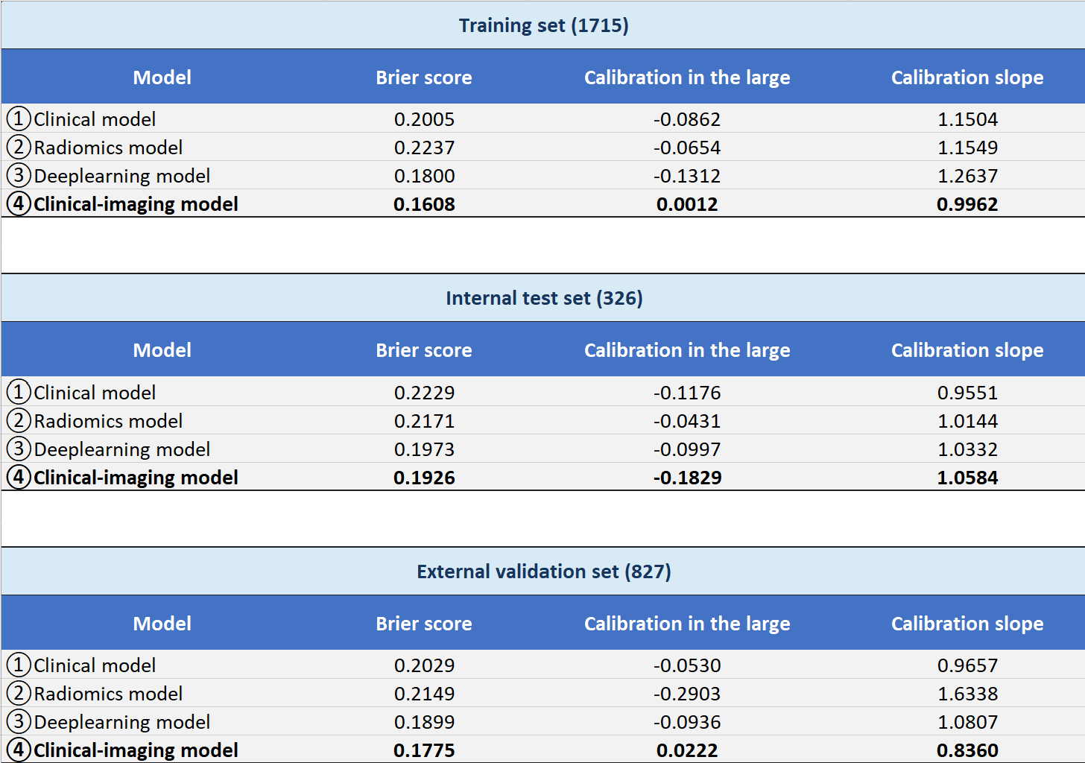

Table S3. Calibration performance of the clinical-imaging, proteomic, and multimodal models across the training, internal test, and external validation cohorts.
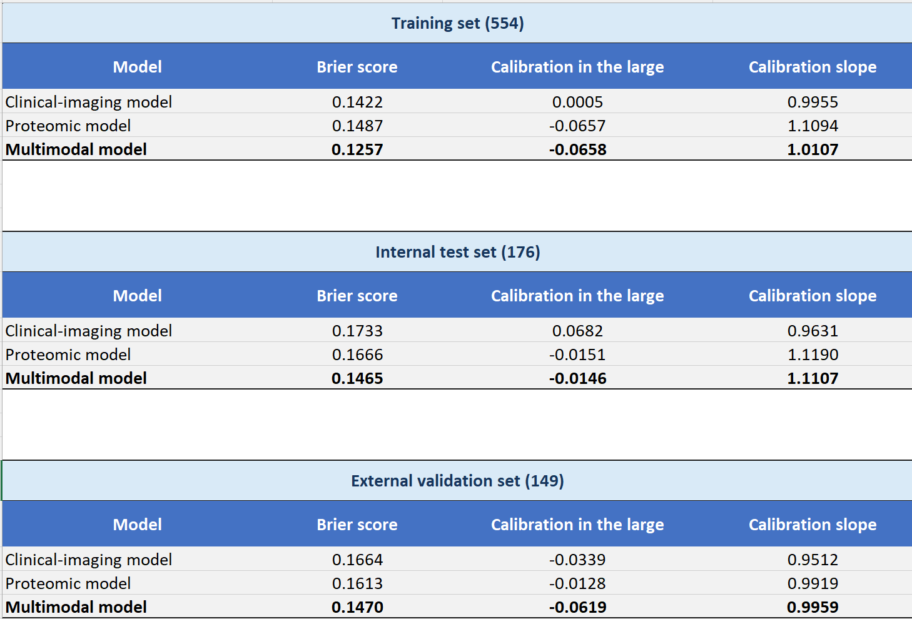

Table S4. Classification performance of the clinical-imaging, proteomic, and multimodal models in patients with matched proteomic data across the training, internal test, and external validation cohorts.
Cohort | Model | SEN | SPE | PPV | NPV | ACC
Train | Clinical-imaging | 0.656 | 0.873 | 0.733 | 0.827 | 0.798
Train | Proteomic | 0.635 | 0.878 | 0.735 | 0.820 | 0.794
Train | Multimodal | 0.719 | 0.876 | 0.754 | 0.854 | 0.821
Test | Clinical-imaging | 0.775 | 0.743 | 0.671 | 0.830 | 0.756
Test | Proteomic | 0.606 | 0.857 | 0.741 | 0.763 | 0.756
Test | Multimodal | 0.704 | 0.848 | 0.758 | 0.809 | 0.790
Validation | Clinical-imaging | 0.635 | 0.784 | 0.611 | 0.800 | 0.732
Validation | Proteomic | 0.635 | 0.876 | 0.733 | 0.817 | 0.792
Validation | Multimodal | 0.731 | 0.804 | 0.667 | 0.848 | 0.779
Classification metrics were calculated using model-specific probability thresholds determined by maximizing the Youden index in the corresponding training dataset; thresholds were fixed and applied unchanged to the internal-test and external-validation cohorts.

Table S5. Clinical variables used for development of the clinical prediction model
Abbreviation | Full name | Unit
P/F ratio | PaO₂/FiO₂ ratio | /
PaCO₂ | Partial pressure of arterial carbon dioxide | mmHg
pH | Arterial pH | unitless
BE | Base excess | mmol/L
HCO₃⁻ | Bicarbonate | mmol/L
Lac | Lactate | mmol/L
WBC | White blood cell count | ×10⁹/L
RBC | Red blood cell count | ×10¹²/L
Hb | Hemoglobin | g/L
HCT | Hematocrit | %
MCV | Mean corpuscular volume | fL
RDW-SD | Red cell distribution width–standard deviation | fL
RDW-CV | Red cell distribution width–coefficient of variation | %
PLT | Platelet count | ×10⁹/L
NEU_percent | Neutrophil percentage | %
Mono_percent | Monocyte percentage | %
LYM_percent | Lymphocyte percentage | %
EOS_percent | Eosinophil percentage | %
BASO_percent | Basophil percentage | %
Neu_count | Neutrophil count | ×10⁹/L
Lymph_count | Lymphocyte count | ×10⁹/L
Mono_count | Monocyte count | ×10⁹/L
Eos_count | Eosinophil count | ×10⁹/L
Baso_count | Basophil count | ×10⁹/L
MPV | Mean platelet volume | fL
Plateletcrit | Plateletcrit | %
P-LCR | Platelet large cell ratio | %
PDW | Platelet distribution width | fL
Glu | Glucose | mmol/L
Ca²⁺ | Calcium | mmol/L
Na⁺ | Sodium | mmol/L
K⁺ | Potassium | mmol/L
Mg²⁺ | Magnesium | mmol/L
BUN | Blood urea nitrogen | mmol/L
Cr | Creatinine | μmol/L
ALT | Alanine aminotransferase | U/L
AST | Aspartate aminotransferase | U/L
UA | Uric acid | μmol/L
D-dimer | D-dimer | mg/L FEU
INR | International normalized ratio | unitless
PT | Prothrombin time | s
APTT | Activated partial thromboplastin time | s
TT | Thrombin time | s
Fg | Fibrinogen | mg/dL
CRP | C-reactive protein | mg/L
PCT | Procalcitonin | ng/mL
NT-proBNP | N-terminal pro-B-type natriuretic peptide | pg/mL
cTnT | Cardiac troponin T | ng/L
STB | Serum total bilirubin | μmol/L
DB | Direct bilirubin | μmol/L
Alb | Albumin | g/L
Temp | Body temperature | °C
HR | Heart rate | beats/min
SBP | Systolic blood pressure | mmHg
DBP | Diastolic blood pressure | mmHg
RR | Respiratory rate | breaths/min
Urine volume | Urine output | mL/24 h
SOFA | Sequential Organ Failure Assessment score | /
Sex
Age
Hypertension
Coronary heart disease
Chronic heart failure
COPD
Asthma
Interstitial Lung Disease
Diabetes
Chronic kidney disease
Liver cirrhosis
Hematologic malignancy
Cerebrovascular disease
Autoimmune disease
Immunosuppressant use
Solid organ transplantation
Solid tumor

Table S6. Selected clinical features and corresponding logistic coefficients for clinical model
Feature name | Coefficient
Age | 0.251381657
Lactate | 0.149769376
Blood urea nitrogen | 0.115746088
Mean platelet volume | 0.0576547660
NT-proBNP | 0.0609522978
Creatinine | 0.0635194295
D-dimer | 0.0690941834
Liver cirrhosis | 0.0881346775
Sodium | 0.0789412711
SOFA score | 0.0492890747
Potassium | 0.0745834125
Direct bilirubin | 0.107738269
Mean corpuscular volume | 0.0932088064
Neutrophil percentage | 0.0776770821
Solid tumor | 0.111680116
Immunosuppressant use | 0.0654075386
Coronary heart disease | 0.0733937934
Hematologic malignancy | 0.0537810409
Heart rate | 0.0700259483
Solid-organ transplantation | -0.000238933773
Albumin | -0.0743513274
Diabetes mellitus | -0.0782733216
Fibrinogen | -0.0581226436
Asthma | -0.127920487
Eosinophil percentage | -0.179971609
Monocyte percentage | -0.0721661889
Arterial pH | -0.105012730
Platelet count | -0.0817739484
Urine output | -0.107257029
PaO₂/FiO₂ ratio | -0.201575927
Note: Total initial candidate clinical features = 75. After LASSO‑penalized logistic regression (λ = 0.0152), 30 non‑zero features were retained.
Clin‑score = sum (feature × coefficient) + intercept.

Table S7. Selected radiomic features and logistic coefficients for radiomics model.
Feature | Coefficient
original_firstorder_10Percentile | -0.143006225
original_firstorder_90Percentile | -0.199796355
original_firstorder_Kurtosis | -0.00201572842
original_firstorder_Maximum | 0.0566138703
original_firstorder_Minimum | -0.00623430823
original_firstorder_RobustMeanAbsoluteDeviation | -0.228109750
original_firstorder_Skewness | -0.477695825
original_shape_Maximum2DDiameterRow | 0.0294933538
original_shape_Maximum2DDiameterSlice | -0.181315262
original_shape_Maximum3DDiameter | 0.0959745811
original_shape_Sphericity | 0.0294365875
original_glcm_DifferenceVariance | 0.105633662
original_glcm_SumEntropy | 0.228922079
original_glrlm_LongRunLowGrayLevelEmphasis | -0.0189119086
original_glszm_GrayLevelVariance | -0.0172315423
original_glszm_LargeAreaEmphasis | 0.0142192835
original_glszm_LargeAreaHighGrayLevelEmphasis | -0.0605265283
original_glszm_SizeZoneNonUniformityNormalized | -0.170049991
original_glszm_ZoneVariance | 0.0142313074
original_gldm_DependenceEntropy | -0.0235762644
original_gldm_DependenceVariance | 0.101408323
original_gldm_GrayLevelNonUniformity | 0.000346427115
original_ngtdm_Busyness | -0.0421280436
original_ngtdm_Complexity | -0.0786800054
original_ngtdm_Contrast | 0.0794919585

Intercept = -0.48469257

Table S8. ARDS‑Net Hyper‑parameters
Parameter | Value
Network backbone | ResidualNetUseMask (3D ResNet-based)
Input crop size | 256 × 256 × 128
Voxel spacing [w,h,d] | 1 mm, 1 mm, 3 mm
Input channel | 1
Normalizer | FixedNormalizer(mean=-600, stddev=750, clip=True)
Loss function | Focal loss (γ = 0) + CAM auxiliary loss (weight = 0.3)
Optimizer | Adam, lr = 1e⁻⁴, betas=(0.9,0.999), ε=1e⁻⁸
LR scheduler | Step(step_size=100, gamma=0.8) + GradualWarmup (100 epochs)
Batch size | 8
Total training epochs | 2001
GPU | Single GPU
Augmentation | Random z-flip; random z-axis rotation; isotropic scaling; mix-up
Random seed | 42

Table S9. Selected protein features and corresponding coefficients for proteomic score
Feature | English full name | Coefficient | Main biological function
HEXIM1 | Hexamethylene Bisacetamide Inducible 1 | 0.33231604 | Transcriptional regulator that inhibits P-TEFb-dependent RNA polymerase II elongation; involved in cellular stress responses, proliferation, and inflammatory transcription [11].
KRT19 | Keratin 19 | 0.33809886 | Type I intermediate-filament protein expressed in epithelial cells; maintains epithelial structural integrity and is released during epithelial injury and cell death [12].
HLA-E | Major Histocompatibility Complex, Class I, E | 0.24992990 | Non-classical MHC class I molecule that regulates NK-cell and CD8⁺ T-cell activity through receptors including NKG2A and NKG2C [13].
LPL | Lipoprotein Lipase | 0.13255639 | Hydrolyzes triglycerides in circulating lipoproteins and regulates fatty-acid uptake, lipid metabolism, and energy utilization [14].
IL6 | Interleukin 6 | 0.16830461 | Pleiotropic inflammatory cytokine that regulates acute-phase responses, immune activation, hematopoiesis, and systemic inflammation.
CKMT1A/CKMT1B | Creatine Kinase, Mitochondrial 1A / Creatine Kinase, Mitochondrial 1B | 0.22934064 | Mitochondrial creatine kinases that mediate phosphocreatine-dependent energy transfer and contribute to cellular energy homeostasis.
TFRC | Transferrin Receptor | 0.26780320 | Cell-surface receptor for transferrin that mediates cellular iron uptake and contributes to iron homeostasis, proliferation, and oxidative metabolism [15].
CCL20 | C-C Motif Chemokine Ligand 20 | 0.12178602 | Chemokine ligand for CCR6 that recruits dendritic cells, memory T cells, and Th17 cells to sites of inflammation [16].
TSPAN1 | Tetraspanin 1 | 0.08869799 | Membrane tetraspanin involved in cell adhesion, proliferation, migration, and organization of membrane signalling complexes [17].
ALDH3A1 | Aldehyde Dehydrogenase 3 Family Member A1 | 0.16032345 | Detoxifies reactive aldehydes generated by oxidative stress and lipid peroxidation and contributes to cellular antioxidant defense [18].
IGFBP2 | Insulin-Like Growth Factor Binding Protein 2 | 0.19077518 | Regulates IGF bioavailability and signalling and participates in cellular growth, metabolism, migration, and tissue remodeling.
FCN2 | Ficolin 2 | -0.08904503 | Soluble pattern-recognition molecule of the lectin complement pathway that recognizes microbial carbohydrate structures and promotes complement activation [19].
TNFSF10 | Tumor Necrosis Factor Superfamily Member 10 (TRAIL) | -0.15158842 | Death-receptor ligand capable of inducing apoptosis and modulating immune surveillance and inflammatory responses [20].
IGFBP3 | Insulin-Like Growth Factor Binding Protein 3 | -0.13627487 | Major circulating IGF-binding protein that regulates IGF availability and also influences apoptosis, proliferation, and cellular stress responses [21].
BANK1 | B-Cell Scaffold Protein With Ankyrin Repeats 1 | -0.11618413 | B-cell adaptor/scaffold protein involved in B-cell receptor signalling, calcium mobilization, and regulation of humoral immune responses [22].
CD200R1 | CD200 Receptor 1 | -0.17109667 | Inhibitory immune receptor expressed predominantly on myeloid cells; suppresses inflammatory activation after binding CD200 [23].
NFATC1 | Nuclear Factor of Activated T Cells 1 | -0.19490920 | Calcium/calcineurin-regulated transcription factor controlling lymphocyte activation, cytokine production, differentiation, and immune responses [24].
CBLIF | Cobalamin Binding Intrinsic Factor | -0.27472119 | Gastric glycoprotein that binds vitamin B12 and enables its absorption in the terminal ileum.
SUSD1 | Sushi Domain Containing 1 | -0.15161157 | Cell-surface/secreted protein containing complement-control-like sushi domains; implicated in cell adhesion and extracellular protein interactions, although its physiological function remains incompletely characterized.
LGMN | Legumain | -0.16440012 | Lysosomal cysteine protease involved in protein processing, antigen presentation, extracellular-matrix remodeling, and inflammatory-cell functions.
DAPP1 | Dual Adaptor of Phosphotyrosine and 3-Phosphoinositides 1 | -0.13661323 | Intracellular adaptor protein involved in phosphoinositide-mediated signalling, particularly downstream of B-cell receptor and immune-cell activation pathways [25].
CHIT1 | Chitotriosidase 1 | -0.20107011 | Chitinase predominantly secreted by activated macrophages and other myeloid cells; marker and mediator of innate immune activation and macrophage-associated inflammation [26].
Intercept | — | -0.70251467

References
1. Zhang R, Wei Y, Shi F, Ren J, Zhou Q, Li W, Chen B. The diagnostic and prognostic value of radiomics and deep learning technologies for patients with solid pulmonary nodules in chest CT images. BMC Cancer 2022: 22(1): 1118.
2. Hao Y, Hao S, Andersen-Nissen E, Mauck WM, 3rd, Zheng S, Butler A, Lee MJ, Wilk AJ, Darby C, Zager M, Hoffman P, Stoeckius M, Papalexi E, Mimitou EP, Jain J, Srivastava A, Stuart T, Fleming LM, Yeung B, Rogers AJ, McElrath JM, Blish CA, Gottardo R, Smibert P, Satija R. Integrated analysis of multimodal single-cell data. Cell 2021: 184(13): 3573-3587 e3529.
3. McGinnis CS, Murrow LM, Gartner ZJ. DoubletFinder: Doublet Detection in Single-Cell RNA Sequencing Data Using Artificial Nearest Neighbors. Cell Syst 2019: 8(4): 329-337 e324.
4. Yang S, Corbett SE, Koga Y, Wang Z, Johnson WE, Yajima M, Campbell JD. Decontamination of ambient RNA in single-cell RNA-seq with DecontX. Genome Biol 2020: 21(1): 57.
5. Korsunsky I, Millard N, Fan J, Slowikowski K, Zhang F, Wei K, Baglaenko Y, Brenner M, Loh PR, Raychaudhuri S. Fast, sensitive and accurate integration of single-cell data with Harmony. Nat Methods 2019: 16(12): 1289-1296.
6. Xiao K, Cao Y, Han Z, Zhang Y, Luu LDW, Chen L, Yan P, Chen W, Wang J, Liang Y, Shi X, Wang X, Wang F, Hu Y, Wen Z, Chen Y, Yang Y, Yu H, Xie L, Wang Y. A pan-immune panorama of bacterial pneumonia revealed by a large-scale single-cell transcriptome atlas. Signal Transduct Target Ther 2025: 10(1): 5.
7. Robinson MD, McCarthy DJ, Smyth GK. edgeR: a Bioconductor package for differential expression analysis of digital gene expression data. Bioinformatics 2010: 26(1): 139-140.
8. Lun AT, Chen Y, Smyth GK. It's DE-licious: A Recipe for Differential Expression Analyses of RNA-seq Experiments Using Quasi-Likelihood Methods in edgeR. Methods Mol Biol 2016: 1418: 391-416.
9. Subramanian A, Tamayo P, Mootha VK, Mukherjee S, Ebert BL, Gillette MA, Paulovich A, Pomeroy SL, Golub TR, Lander ES, Mesirov JP. Gene set enrichment analysis: a knowledge-based approach for interpreting genome-wide expression profiles. Proc Natl Acad Sci U S A 2005: 102(43): 15545-15550.
10. Yu G, Wang LG, Han Y, He QY. clusterProfiler: an R package for comparing biological themes among gene clusters. OMICS 2012: 16(5): 284-287.
11. Dey A, Chao SH, Lane DP. HEXIM1 and the control of transcription elongation: from cancer and inflammation to AIDS and cardiac hypertrophy. Cell Cycle 2007: 6(15): 1856-1863.
12. Stern JB, Paugam C, Validire P, Adle-Biassette H, Jaffre S, Dehoux M, Crestani B. Cytokeratin 19 fragments in patients with acute lung injury: a preliminary observation. Intensive Care Med 2006: 32(6): 910-914.
13. Pump WC, Kraemer T, Huyton T, Ho GT, Blasczyk R, Bade-Doeding C. Between Innate and Adaptive Immune Responses: NKG2A, NKG2C, and CD8(+) T Cell Recognition of HLA-E Restricted Self-Peptides Acquired in the Absence of HLA-Ia. Int J Mol Sci 2019: 20(6).
14. Goldberg IJ, Eckel RH, Abumrad NA. Regulation of fatty acid uptake into tissues: lipoprotein lipase- and CD36-mediated pathways. J Lipid Res 2009: 50 Suppl(Suppl): S86-90.
15. Candelaria PV, Leoh LS, Penichet ML, Daniels-Wells TR. Antibodies Targeting the Transferrin Receptor 1 (TfR1) as Direct Anti-cancer Agents. Front Immunol 2021: 12: 607692.
16. Meitei HT, Jadhav N, Lal G. CCR6-CCL20 axis as a therapeutic target for autoimmune diseases. Autoimmun Rev 2021: 20(7): 102846.
17. Hou FQ, Lei XF, Yao JL, Wang YJ, Zhang W. Tetraspanin 1 is involved in survival, proliferation and carcinogenesis of pancreatic cancer. Oncol Rep 2015: 34(6): 3068-3076.
18. Estey T, Piatigorsky J, Lassen N, Vasiliou V. ALDH3A1: a corneal crystallin with diverse functions. Exp Eye Res 2007: 84(1): 3-12.
19. Garred P, Honore C, Ma YJ, Munthe-Fog L, Hummelshoj T. MBL2, FCN1, FCN2 and FCN3-The genes behind the initiation of the lectin pathway of complement. Mol Immunol 2009: 46(14): 2737-2744.
20. Cardoso Alves L, Corazza N, Micheau O, Krebs P. The multifaceted role of TRAIL signaling in cancer and immunity. FEBS J 2021: 288(19): 5530-5554.
21. Johnson MA, Firth SM. IGFBP-3: a cell fate pivot in cancer and disease. Growth Horm IGF Res 2014: 24(5): 164-173.
22. Gomez Hernandez G, Morell M, Alarcon-Riquelme ME. The Role of BANK1 in B Cell Signaling and Disease. Cells 2021: 10(5).
23. Vaine CA, Soberman RJ. The CD200-CD200R1 inhibitory signaling pathway: immune regulation and host-pathogen interactions. Adv Immunol 2014: 121: 191-211.
24. Rudolf R, Busch R, Patra AK, Muhammad K, Avots A, Andrau JC, Klein-Hessling S, Serfling E. Architecture and expression of the nfatc1 gene in lymphocytes. Front Immunol 2014: 5: 21.
25. Marshall AJ, Zhang T, Al-Alwan M. Regulation of B-lymphocyte activation by the PH domain adaptor protein Bam32/DAPP1. Biochem Soc Trans 2007: 35(Pt 2): 181-182.
26. Cho SJ, Weiden MD, Lee CG. Chitotriosidase in the Pathogenesis of Inflammation, Interstitial Lung Diseases and COPD. Allergy Asthma Immunol Res 2015: 7(1): 14-21.

