Supplementary Materials for

Extreme temperature gradient drives substantial thermoelectric current in additive manufacturing

Fengyuan Lin^{1,+}, Hui Chen^{1,+,*}, Yajing Sun¹, Haiou Yang¹, Meng Wang¹, Wentao Yan^{2,*}, Xin Lin^{1,*}
¹ State Key Laboratory of Solidification Processing, Northwestern Polytechnical University, Xi’an 710072, China
² Department of Mechanical Engineering, National University of Singapore, Singapore, 117575, Singapore

The PDF file includes:
Figs. S1 to S4
Tables S1 to S3
References

Other Supplementary Material for this manuscript includes the following:
Movies S1 and S2
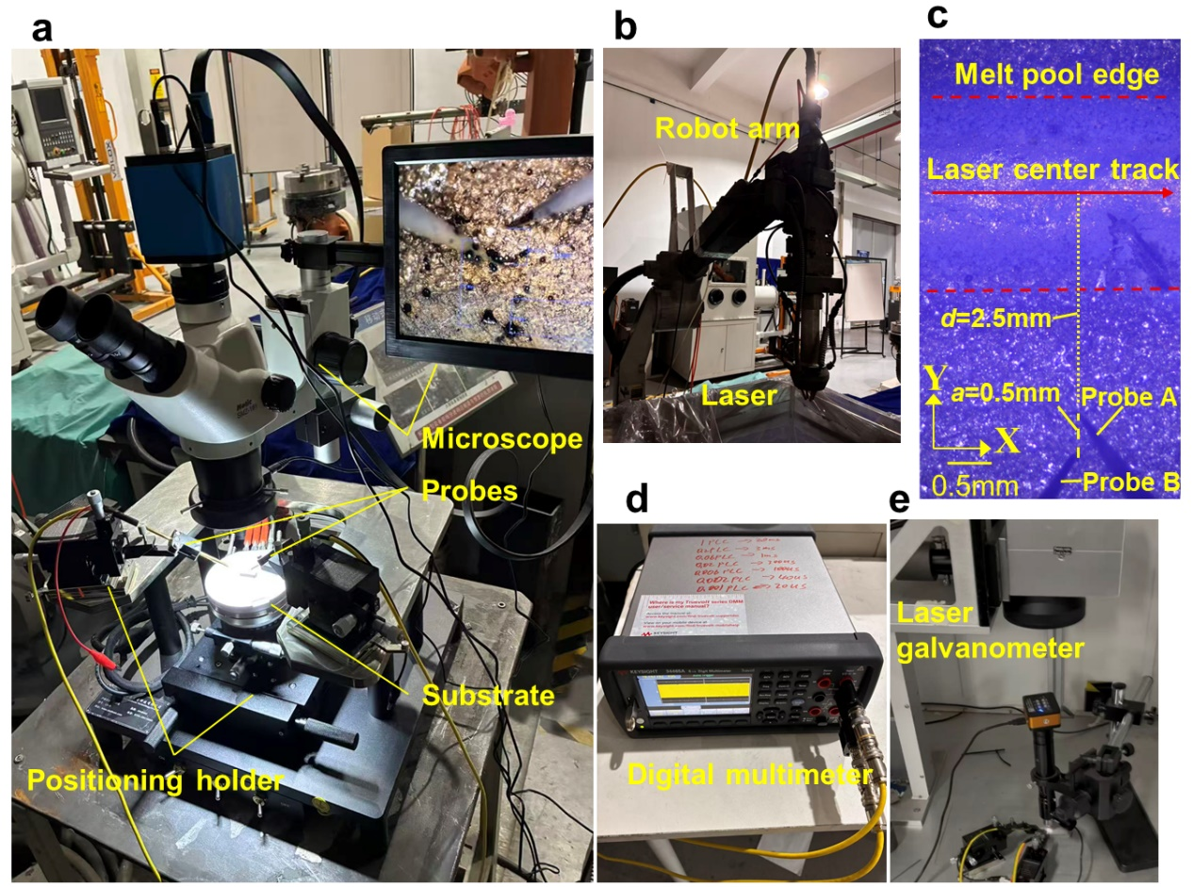
Fig. S1 Experimental setup for in situ thermoelectric potential measurements: (a) tungsten probe positioning system assisted by a microscope and positioning holders; (b) LDED laser scanning system; (c) positioning of the tungsten probe on the substrate; (d) high-precision digital multimeter; (e) LPBF system. During the measurements, a laser scan was first performed on the substrate to mark the profile of the melt track. The tungsten probe was then positioned outside the melt-track boundary to measure the response of thermoelectric potential near the outer edge of the melt pool (c).
Fig. S2 In situ measurement of the thermoelectric potential inside the melt pool: (a) probes positioned within the melt-pool track; and (b) evolution of potential gradient under different laser powers during LDED process.
Taking the LDED process as an example, we first scanned the substrate to generate a melt-track profile. The probe tip was then positioned within the molten region between the laser scanning centreline and the melt-track boundary, where a = 0.5 mm and d = 0.3 mm, to measure the potential response inside the melt pool during laser scanning (Fig. S2a). With the laser powder of 500–1,000 W, the peak strength of the potential gradient |∇Φ| within the melt pool reaches ~8.3–9.6 V m⁻¹ (Fig. S2b), which is approximately one order of magnitude higher than the corresponding thermoelectric potential gradients at the melt-pool periphery (~0.15–0.8 V m⁻¹, Fig. 1g). However, under these conditions, the probes are directly immersed in the melt pool and may even be exposed to the laser irradiation, resulting in a substantial temperature increase that inevitably introduces an additional thermoelectric voltage contribution. This probe-induced potential contribution is difficult to quantitatively identify and distinguish from the intrinsic melt-pool electrical response. Therefore, the potential response measured inside the melt pool should only be interpreted as qualitative evidence rather than an accurate quantitative measurement.
Fig. S3 Temperature dependence of the electrical conductivity of AlSi10Mg. The solidus and liquidus temperatures are 830 K and 870 K, respectively ^{1, 2}. As the melt pool undergoes the liquid-to-solid transition, the electrical conductivity increases sharply from ~3×10⁶ S/m to ~11×10⁶ S/m. This abrupt increase in conductivity leads to the formation of localized high-current-density regions near the solid–liquid transition zone at the melt-pool boundary, although the temperature gradient and thus the potential gradient are low (Fig. 2b,d).
Fig. S4 Temperature dependence of the Seebeck coefficient of AlSi10Mg. The solidus and liquidus temperatures are 830 K and 870 K, respectively ^{3, 4, 5, 6}.
Current direction correlated with Seekeck coefficient
As shown in Fig. S4, the Seebeck coefficient S of AlSi10Mg is always negative. Then, according to J ≈ −σS∇T, the principal current-density direction therefore tends towards the hot region (Fig. 3). However, for a material with a positive Seebeck coefficient, the current-density direction would be reversed.
Thermoelectric heat generation or absorption correlated with Seebeck coefficient
Joule heating Q_{J} originates from the conversion of electrical energy into heat due to the resistance encountered by the current. According to equation (9), ${\text{Q}}_{\text{J}}\text{=}\frac{{\text{J}}^{\text{2}}}{{\text{σ}}_{\text{c}}}$, it is always positive, corresponding to heat generation (Fig. 4a2,c2).
Thomson heating Q_{T} occurs when an electric current flows along a temperature gradient and is mainly distributed in the laser-irradiated region on the top surface of the melt pool and the solid–liquid interface region at the bottom of the melt pool (Fig. 4a1,c1). According to equation (10), ${\text{Q}}_{\text{T}}\text{=-}\text{T}\frac{\text{dS}}{\text{dT}}\text{J}\text{·▽}\text{T}$, the heating or cooling behaviour of Thomson heat is more complex than that of Joule heating. For AlSi10Mg, in the liquid-temperature region of the laser-irradiated melt pool (Fig. S4, T > 870 K), the Seebeck coefficient decreases with the temperature, i.e., $\frac{\text{dS}}{\text{dT}}$ < 0. Since the current flows in the same direction as the temperature gradient (Fig. 3d,h), resulting in $\text{J}\text{·▽}\text{T}$ > 0, the Thomson heat Q_{T} is then positive, indicating heat generation. However, in the solid–liquid interface temperature region at the bottom of the melt pool (Fig. S4, 830 K < T < 870 K), the Seebeck coefficient increases with the temperature, i.e., $\frac{\text{dS}}{\text{dT}}$ > 0, and therefore the Thomson heat Q_{T} becomes negative, corresponding to heat absorption (Fig. 4a1,c1).
Peltier heating Q_{P} occurs when an electric current passes through an interface between dissimilar phases or materials and therefore mainly occurs at the solid–liquid interface region at the bottom of the melt pool (Fig. 4a3,c3). It is calculated according to equation (11), ${\text{Q}}_{\text{P}}\text{=-}\left({\text{S}}_{\text{s}}\text{-}{\text{S}}_{\text{l}}\right)\text{TJ}\text{·▽}{\text{F}}_{\text{s}}$. For the solid–liquid interface of the AlSi10Mg melt pool, the Seebeck coefficient of the solid phase at T = 830 K is lower than that of the liquid phase at T = 870 K (Fig. S4), namely S_{s} − S_{L} < 0. In addition, because the current is directed towards the liquid region (Fig. 3d,h), i.e., $\text{J}\text{·▽}{\text{F}}_{\text{s}}$<0, Peltier heat Q_{P} is then negative, corresponding to heat absorption.
Therefore, whether Thomson and Peltier heat act as heat sources or heat sinks depends on the relationship between the Seebeck coefficient and temperature (Fig. S4), and their effects may vary among different materials.

Table S1 Physical properties of AlSi10Mg^{7, 8, 9, 10}.
Property | Value
Solidus temperature (T_{s}, K) | 830
Liquidus temperature (T_{l}, K) | 870
Boiling temperature (T_{b}, K) | 2743
Density (ρ, kg/m³) | 2680 (300K)  2558 (830K)  2380 (870K)  2261 (1300K)  2077 (2000K)
Latent heat of melting (L_{m}, J/kg) | 3.89×10⁵
Latent heat of evaporation (L_{v}, J/kg) | 1.07×10⁷
Saturated vapor pressure (P_{e}, Pa) | 1.013×10⁵
Dynamic viscosity (μ, Pa·s) | 0.0022 (870K)  0.0007 (1450K)  0.0005 (2000K)
Thermal conductivity (k,W/(m·K)) | 160 (300K)  110 (830K)  90 (870K)  118 (2000K)
Specific heat (C_{p}, J/(kg·K)) | 900 (300K)  1100 (830K)  1000 (870K)  1105 (2000K)
Surface tension coefficient (σ, N/m) | 1.02
Temperature sensitivity of surface tension (σ_{T}, N/(m·K)) | 3.1×10⁻⁴
Convective heat transfer coefficient (h_{c},W/(m·K)) | 82
Radiation emissivity | 0.4

Table S2 Comparison of current flux in in-situ electric field-assisted laser melting processes.
Materials | Cross-sectional area (mm²) | Laser power  (W) | Scanning speed  (mm/s) | Laser spot  (mm) | Peak current  (A) | Peak current density​(A/m²)
TC17¹¹ | 24x10 | 1500 | 3 | 0.8 | 50 | 2x10⁵
AISI9310¹² | 100x5 | 1200 | 10 | 0.7 | 40 | 8x10⁴
U71Mn¹³ | 60x6 | 1400 | 4 | 3 | 20 | 5x10⁵
Ni60¹⁴ | 100x20 | 3000 | 5 | 2 | 1800 | 9x10⁵
42CrMo¹⁵ | 100x10 | 2000 | 5 | 5 | 50 | 5x10⁴

Table S3 Thermoelectric parameters of various metals.
Materials | Electric conductivity (10⁶ S/m) | Seebeck coefficient (10⁻⁶ V/K)
Al ^{1, 3, 4, 6} | 2~20 | -1.5~-4.5
Ti ^{16, 17, 18, 19} | 0.43~2 | -3~-8
Cu ^{2, 5, 20, 21} | 3.3~62.5 | +2~+10
Ni ^{2, 21} | 1.1~14.3 | -20~-50
Fe ^{2, 22} | 0.71~10 | -3~-7

References
1. Brandt, R. & Neuer, G. Electrical Resistivity and Thermal Conductivity of Pure Aluminum and Aluminum Alloys up to and above the Melting Temperature. International Journal of Thermophysics 28, 1429–1446 https://doi.org/10.1007/s10765-006-0144-0 (2007).
2. Ho, C. Y., et al. Electrical Resistivity of Ten Selected Binary Alloy Systems. Journal of Physical and Chemical Reference Data 12, 183–322 https://doi.org/10.1063/1.555684 (1983).
3. Sklyarchuk, V., et al. Structure Sensitive Properties of Liquid Al–Si Alloys. International Journal of Thermophysics 30, 1400–1410 https://doi.org/10.1007/s10765-009-0585-3 (2009).
4. Gripshover, R. J., VanZytveld, J. B. & Bass, J. Thermopower of Pure Aluminum. Physical Review 163, 598–603 https://doi.org/10.1103/PhysRev.163.598 (1967).
5. Bretonnet, J.-L., Auchet, J. & Gasser, J.-G. Electrical transport properties of the liquid AlCu alloys. Journal of Non-Crystalline Solids 117-118, 395–398 https://doi.org/https://doi.org/10.1016/0022-3093(90)90961-K (1990).
6. Marwaha, A. S. & Cusack, N. E. The absolute thermoelectric power of liquid metals. Physics Letters 22, 556 https://doi.org/https://doi.org/10.1016/0031-9163(66)90650-0 (1966).
7. Hojjatzadeh, S. M. H., et al. Pore elimination mechanisms during 3D printing of metals. Nature Communications 10, 3088 https://doi.org/10.1038/s41467-019-10973-9 (2019).
8. Du, D., et al. Influence of static magnetic field on microstructure and mechanical behavior of selective laser melted AlSi10Mg alloy. Materials & Design 181, 107923 https://doi.org/https://doi.org/10.1016/j.matdes.2019.107923 (2019).
9. Wang, L. & Yan, W. Thermoelectric Magnetohydrodynamic Model for Laser-Based Metal Additive Manufacturing. Physical Review Applied 15, 064051 https://doi.org/10.1103/PhysRevApplied.15.064051 (2021).
10. Lange, A., Cramer, A. & Beyer, E. Thermoelectric currents in laser induced melts pools. Journal of Laser Applications 21, 82–87 https://doi.org/10.2351/1.3120213 (2009).
11. Liu, Z., Liu, P., Zhou, L. & Wang, L. Effects of Pulsed Current on the Microstructure and Properties of Laser Cladded TC17 Titanium Alloy (2024).
12. Xie, C., et al. Effect of In-Situ Pulse Current on Microstructure and Mechanical Properties of AISI 9310 Gear Steel by Laser Powder Directed Energy Deposition (2025).
13. Li, X., et al. Microscopic characteristics and properties of co-based coating by pulse current-assisted laser cladding on high carbon steel. Surface and Coatings Technology 494, 131367 https://doi.org/https://doi.org/10.1016/j.surfcoat.2024.131367 (2024).
14. Zhai, L., Wang, Q., Zhang, J. & Ban, C. Effect of alternating current electric field on microstructure and properties of laser cladding Ni–Cr–B–Si coating. Ceramics International 45, 16873–16879 https://doi.org/https://doi.org/10.1016/j.ceramint.2019.05.230 (2019).
15. Wang, D., Zhu, Y., Qu, G. & Zhou, X. Research on Dilution of Laser Cladding Assisted by Pulsed Current Based on Orthogonal Experiment. Journal of Physics: Conference Series 1965, 012087 https://doi.org/10.1088/1742-6596/1965/1/012087 (2021).
16. Seydel, U. & Fucke, W. Electrical resistivity of liquid Ti, V, Mo and W. Journal of Physics F: Metal Physics 10, L203 https://doi.org/10.1088/0305-4608/10/8/001 (1980).
17. Bel’skaya, E. A. An Experimental Investigation of the Electrical Resistivity of Titanium in the Temperature Range from 77 to 1600 K. High Temperature 43, 546–553 https://doi.org/10.1007/s10740-005-0096-2 (2005).
18. Carreon, H., San Martin, D., Caballero, F. G. & Panin, V. E. The effect of thermal aging on the strength and the thermoelectric power of the Ti-6Al-4V alloy. Physical Mesomechanics 20, 447–456 https://doi.org/10.1134/S1029959917040105 (2017).
19. Worner, H. W. Thermoelectric Properties of Titanium with Special Reference to the Allotropic Transformation. Australian Journal of Scientific Research Series A: Physical Sciences 4, 62–83 https://doi.org/10.1071/CH9510062 (1951).
20. Roberts, R. B. The absolute scale of thermoelectricity II. Philosophical Magazine B 43, 1125–1135 https://doi.org/10.1080/01418638108222579 (1981).
21. Abadlia, L., Gasser, F., Khalouk, K., Mayoufi, M. & Gasser, J. G. New experimental methodology, setup and LabView program for accurate absolute thermoelectric power and electrical resistivity measurements between 25 and 1600 K: Application to pure copper, platinum, tungsten, and nickel at very high temperatures. Review of Scientific Instruments 85, https://doi.org/10.1063/1.4896046 (2014).
22. MacInnes, W. M. & Huguenin, R. Thermoelectric power near magnetic critical points: Iron. Physics Letters A 44, 51–52 https://doi.org/https://doi.org/10.1016/0375-9601(73)90956-0 (1973).

Movie S1
The dynamic evolution of thermo-electric current (a) and its X component (b), Y component (c) and Z component (d), as well as Thomson heat (e), Joule heat (f) and Peltier heat (g) during the LPBF process. The model is set up using AlSi10Mg alloy, with a laser power of 250 W, a scanning speed of 1000 mm/s, and a laser spot diameter of 80 μm.
Movie S2
The dynamic evolution of thermo-electric current (a) and its X component (b), Y component (c) and Z component (d), as well as Thomson heat (e), Joule heat (f) and Peltier heat (g) during the LDED process. The model is set up using AlSi10Mg alloy, with a laser power of 2000 W, a scanning speed of 20 mm/s, and a laser spot diameter of 2 mm.

+ These authors contributed equally *Corresponding authors: Hui Chen, hchen1984@nwpu.edu.cn; Wentao Yan, mpeyanw@nus.edu.sg; Xin Lin, xlin@nwpu.edu.cn

