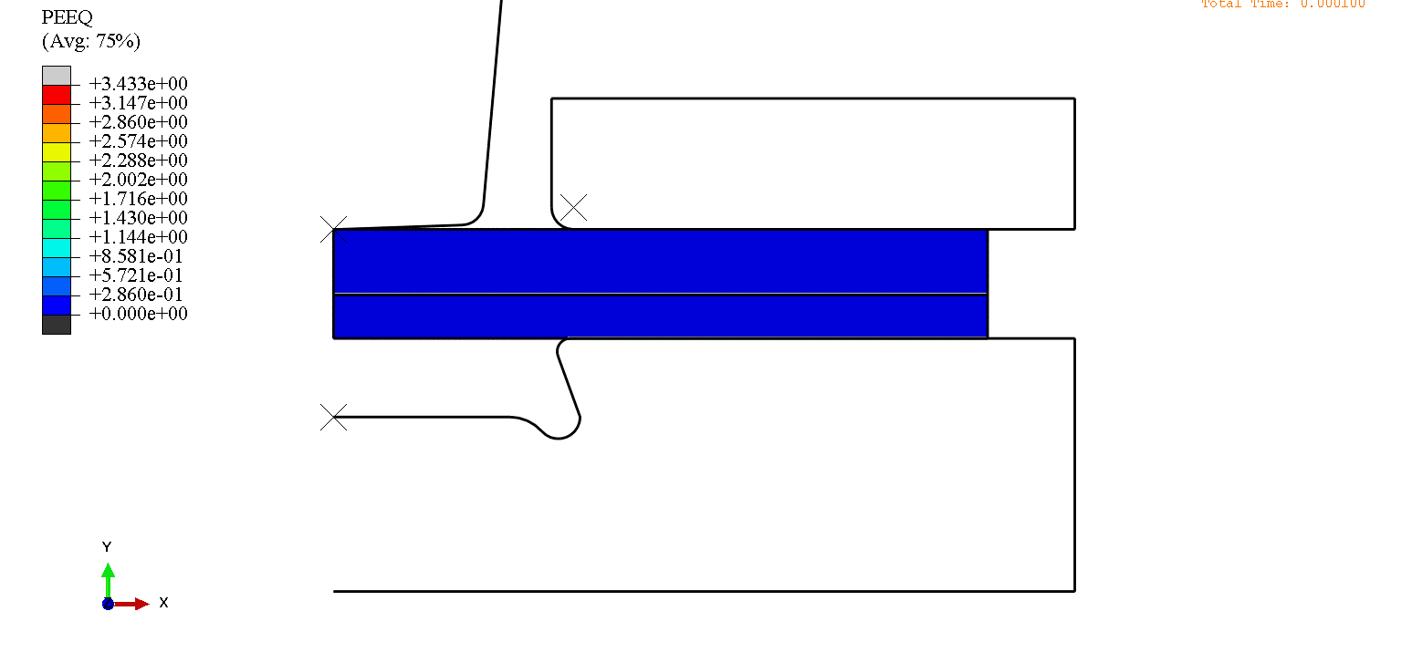
Fig. 1 Plastic strain change process

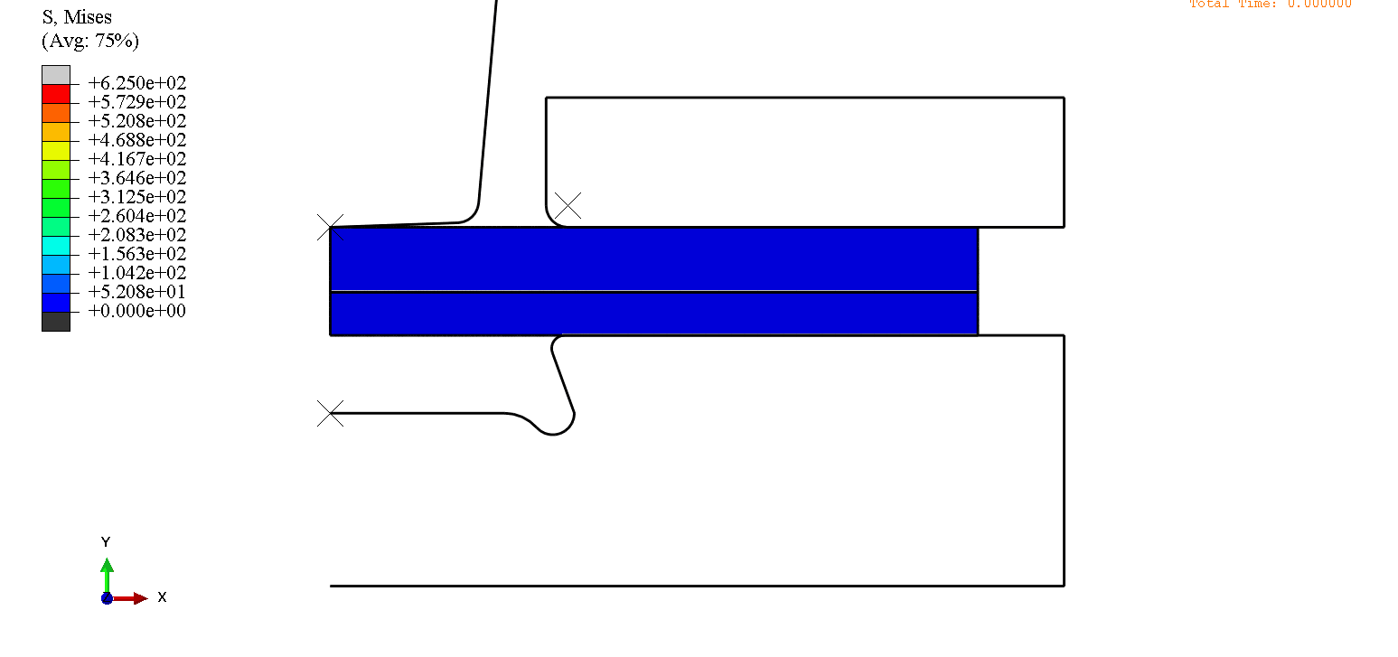
Fig. 2 Mises stress change process

