SUPPLEMENTAL INFORMATION
Shanshan Qiao^{1,2}, Chang Liu³, Li Sun^{1,2}, Tao Wang^{1,2}, Huanqin Dai^{1,2}, Kai Wang^{1,2}, Li Bao^{1,2}, Hantian Li^{1,2}, Shuang-Jiang Liu^{2,3,}*, Hongwei Liu^{1,2,}*
¹ State Key Laboratory of Mycology, Institute of Microbiology, Chinese Academy of Sciences, No. 1 Beichenxi Road, Chaoyang District, Beijing, 100101, P. R. China
² Savaid Medical School, University of Chinese Academy of Sciences, Beijing, 100049, P. R. China
³ State Key Laboratory of Microbial Resources, Institute of Microbiology, Chinese Academy of Sciences, No. 1 Beichenxi Road, Chaoyang District, Beijing 100101, P. R. China

Supplementary Figures
Graphical Abstract
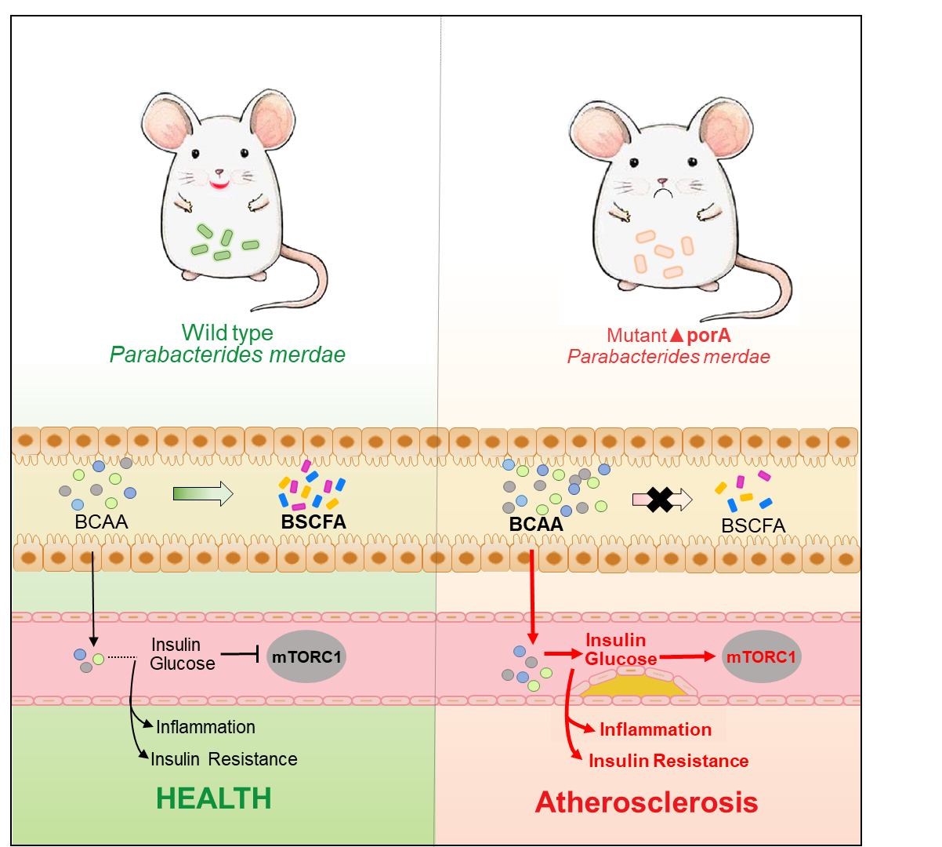

Supplementary Figures
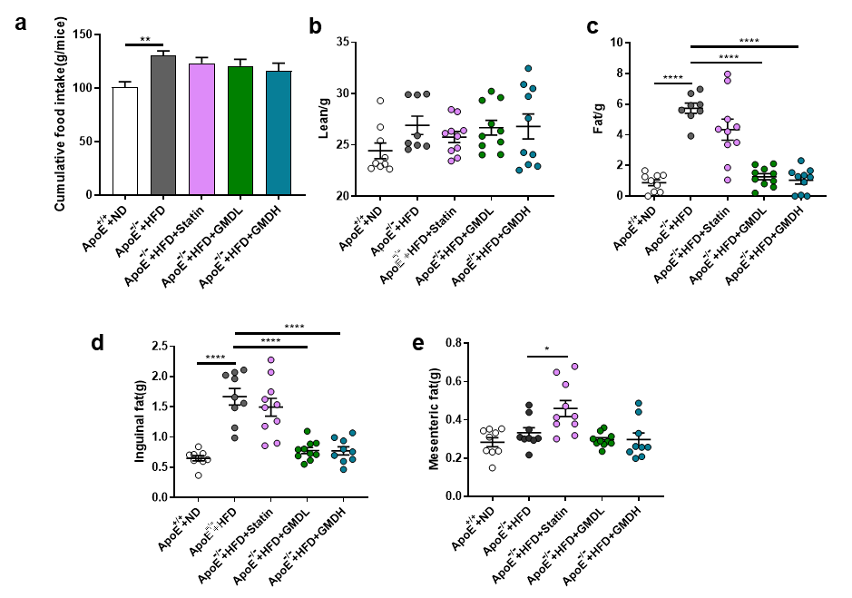
Extend Data Fig. 1 | Effects of GMD on food intake and body composition in HFD fed ApoE^{-/-} mice. a, Cumulative food intake. b, Lean. c, Fat. d, Inguinal fat. e, Mesenteric fat. Abbreviation: ApoE^{+/+}+ND, normal diet fed C57BL/6 mice; ApoE^{-/-}+HFD, high fat diet fed ApoE^{-/-} mice; ApoE^{-/-}+HFD+GMDL, GMD 5 mg/kg for high fat diet fed ApoE^{-/-} mice; ApoE^{-/-}+HFD+GMDH, GMD 10 mg/kg for high fat diet fed ApoE^{-/-} mice; ApoE^{-/-}+HFD+Statin, atorvastatin 10 mg/kg for high fat diet fed ApoE^{-/-} mice. Data are presented as the mean ±s.e.m. n= 9-10 per group. Statistical analysis was performed using one-way ANOVA followed by the Tukey post hoc test. * P<0.05; ** P<0.01; *** P<0.001; **** P<0.0001.

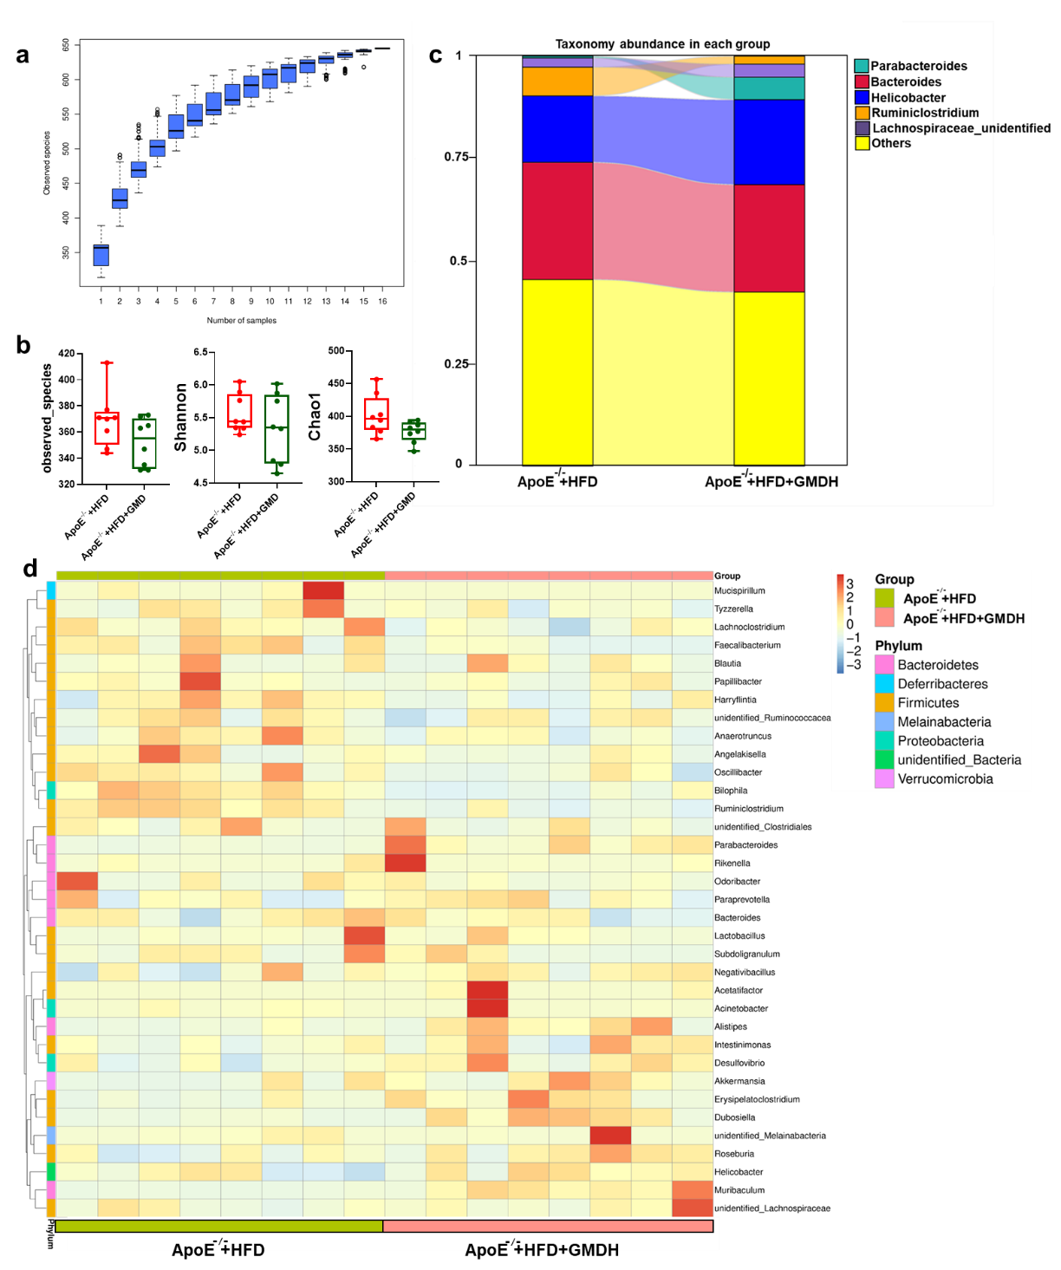
Extended Data Fig. 2 | GMD alters the gut microbiota in HFD fed ApoE^{-/-} mice. a, Species accumulation curve. b, α-diversity of the gut microbiota between ApoE^{-/-}+HFD and ApoE^{-/-}+HFD+GMDH groups, as indicated by the observed_species, Shannon and Chao1indices. c, Sankeydiagram showing the genus of contribution differently among two groups. d, A heatmap of the most abundant top 35 bacteria at the genus level among two groups. Blue denotes a low relative abundance across a taxon (row); red denotes a high relative abundance. The color key for the Z score indicates correspondence between the red-blue coloring and standard deviations from the mean abundance of each taxon. Abbreviation: ApoE^{-/-}+HFD, high fat diet fed ApoE^{-/-} mice; ApoE^{-/-}+HFD+GMDH, GMD 10 mg/kg for high fat diet fed ApoE^{-/-} mice.

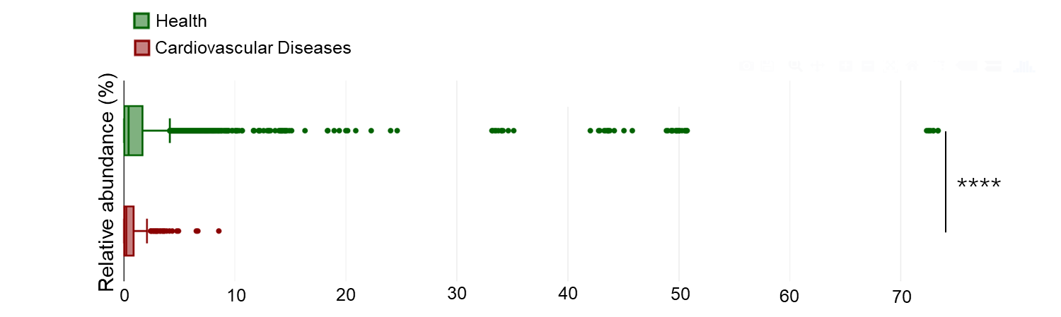
Extended Data Fig. 3 | The relative abundance in health or cardiovascular diseases cohorts

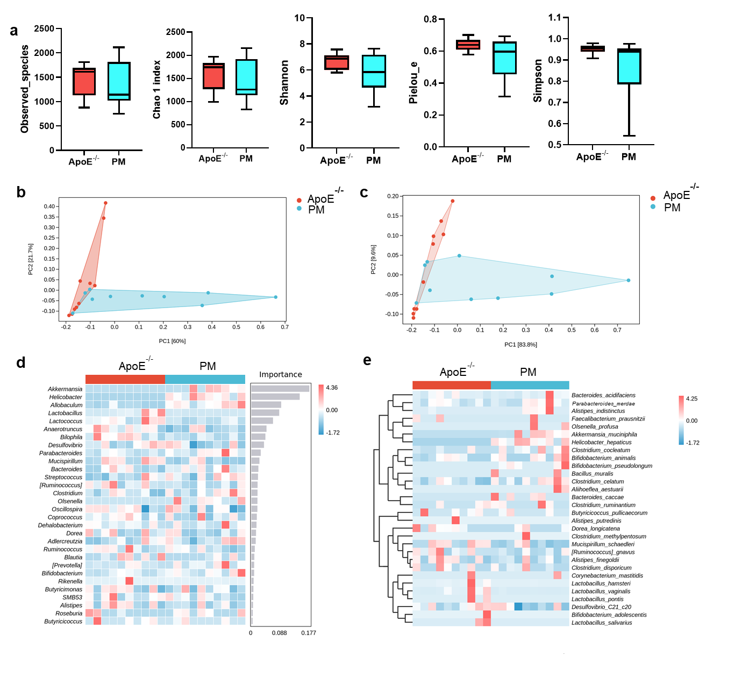
Extended Data Fig. 4 | Parabacteroides merdae alters the gut microbiota in HFD fed ApoE^{-/-} mice. a, α-diversity of the gut microbiota between ApoE^{-/-} and PM groups, as indicated by the observed_species, Chao1, Shannon, Pielou_e and Simpson indices. b, Principal coordinate analysis (PCoA) of all samples at the genus level among two groups. c, PCoA of all samples at the species level among two groups. d, A heatmap of the most abundant top 30 bacteria at the genus level among two groups and the importance of species to the model decreased from top to bottom, which could be considered as indicators of inter-group differences. e, A heatmap of the most abundant top 30 bacteria at the species level among two groups. Blue denotes a low relative abundance across a taxon (row); red denotes a high relative abundance. The color key for the Z score indicates correspondence between the red-blue coloring and standard deviations from the mean abundance of each taxon. Abbreviation: ApoE^{-/-}, high fat diet fed ApoE^{-/-} mice; PM, P. merdae (2×10⁸ CFU/day) for high fat diet fed ApoE^{-/-} mice. n = 10 mice per group.

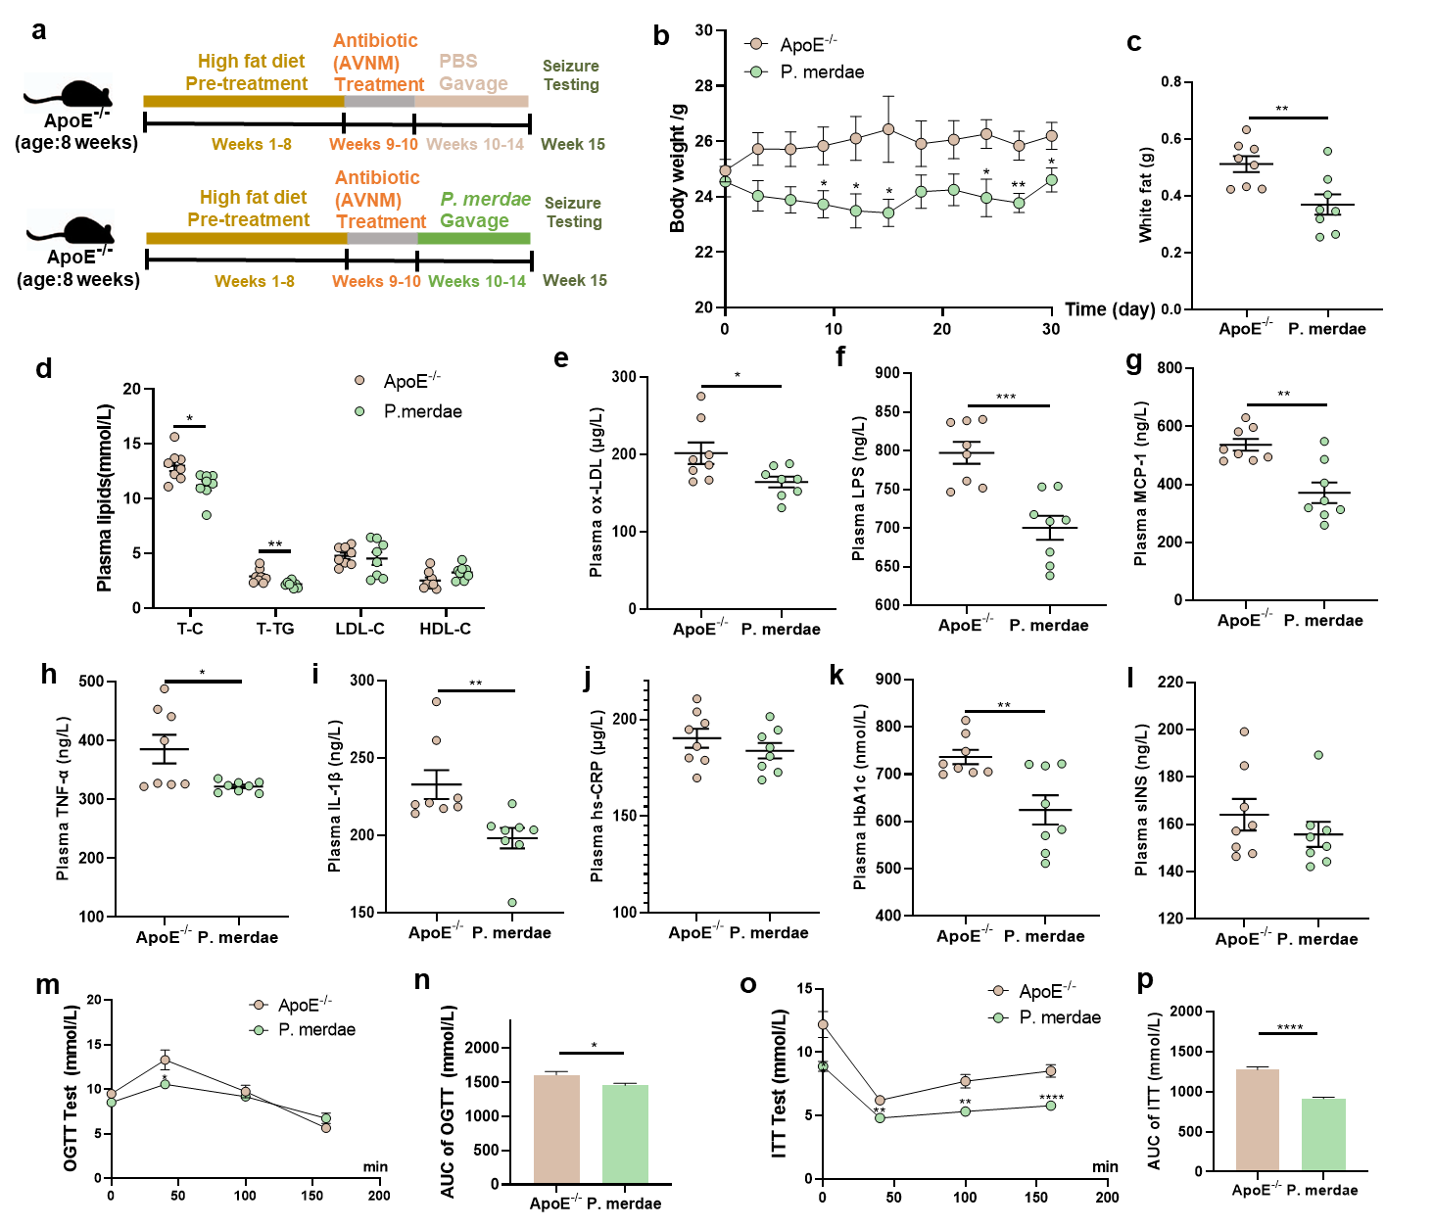
Extended Data Fig. 5 | Gavage with live P. merdae attenuates hyperlipidemia, hyperglycemia, or atherosclerosis biomarkers in Abx pre-treatment ApoE^{-/-} mice. a, Experimental design showing groups and durations. b, Body weight. c, White fat. d, Plasma T-C, T-TG, LDL-C and HDL-C levels. e, Plasma ox-LDL. f, Plasma LPS. g, Plasma MCP-1. h, Plasma TNF-α. i, Plasma IL-1β. j, Plasma hs-CRP. k, Plasma HbA1c. l, Plasma sINS. m, OGTT test. n, AUC of OGTT. o, ITT test. p, AUC of ITT. Data are presented as mean ± s.e.m. Statistical analysis was performed using one-way ANOVA followed by the Tukey post hoc test. * P<0.05; ** P<0.01; *** P<0.001; **** P<0.0001. Antibiotic (AVNM), antibiotics (ampicillin, vancomycin, neomycin, metronidazole).

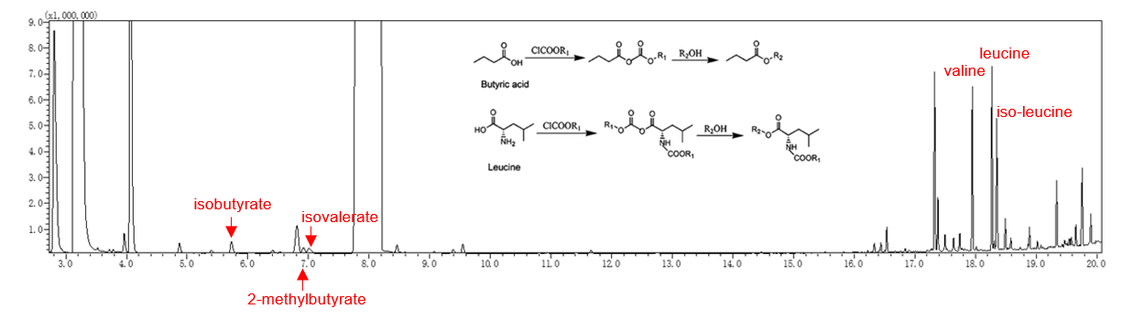
Extended Data Fig. 6 | The GC-MS chromatogram for BCAA and BSCFA determination

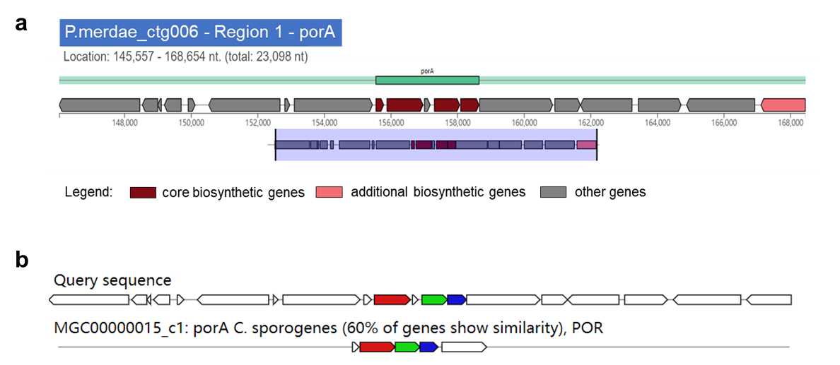
Extended Data Fig. 7 | Prediction and detection analysis of metabolic pathways in P. merdae.
a, PorA gene cluster for BCAAs metabolism predicted by gutSMASH in P. merdae genome. b, PorA gene cluster in P. merdae genome and its homologs-MGC00000015_c1 in Clostridium sporogenes.

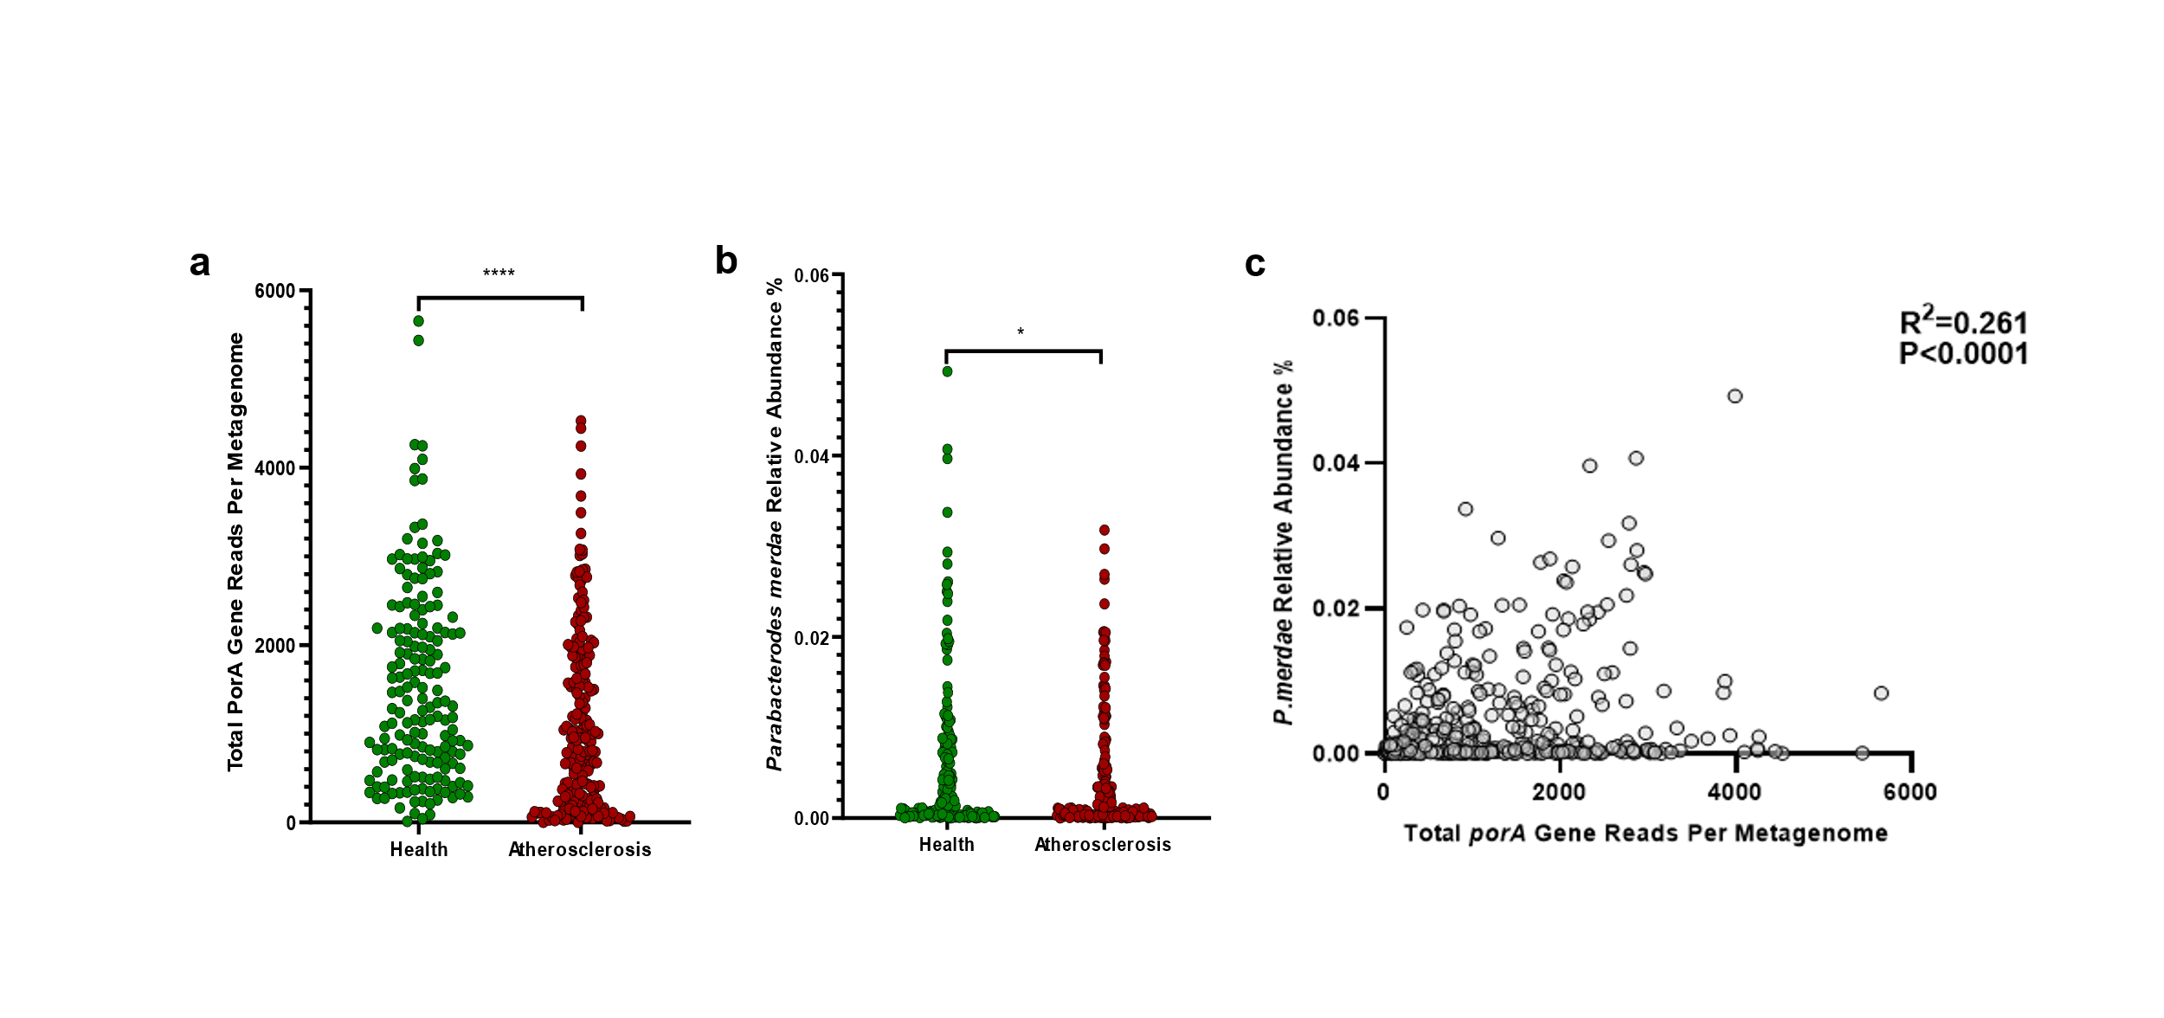
Extended Data Fig. 8 | Estimated abundance of porA gene reads across 405 human gut metagenomes and correlations with bacterial taxa. a, Total porA gene reads per metagenome. b, The relative abundance of Parabacteroides merdae. c, Correlation of total porA gene reads per metagenome and relative abundance Parabacteroides merdae relative abundance across 1,267 gut metagenomes (R²=0.22, P<0.0001).

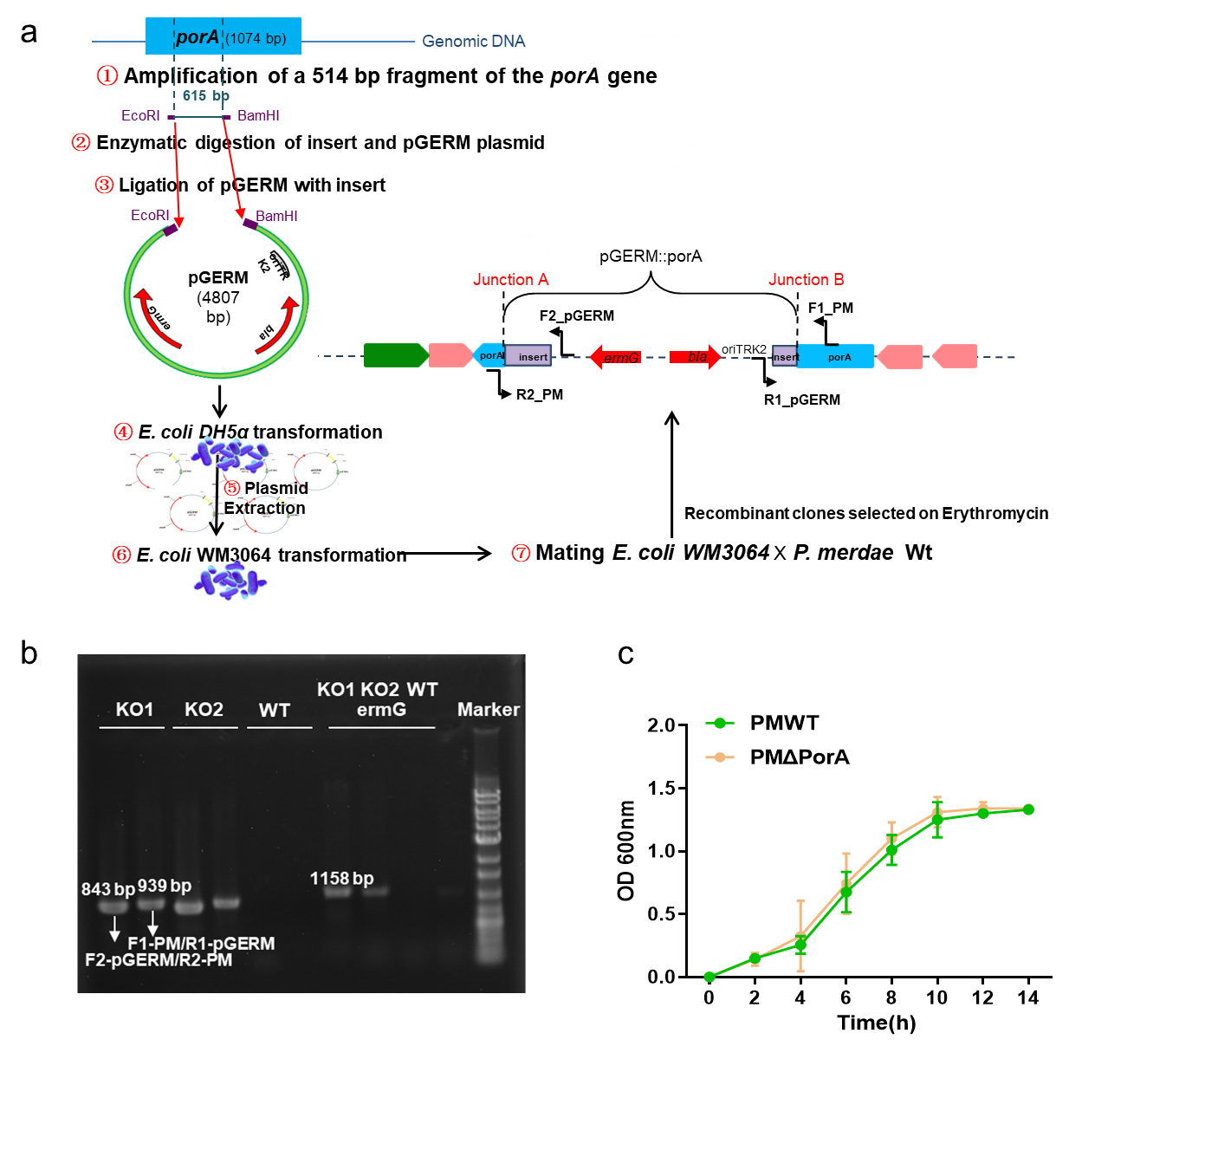
Extended Data Fig. 9 | Construction and validation of the BCAA catabolism deficient strain of Parabacteroides merdae. a, Schematic layout of mutant construction. b, Validation of pGERM::porA insertion into porA gene of P. merdae genome. c, Growth of PMΔporA and PMWT on Gifu anaerobic medium, mid log phases are pointed by gray arrows and late log phases by black arrows. n=3 per group.

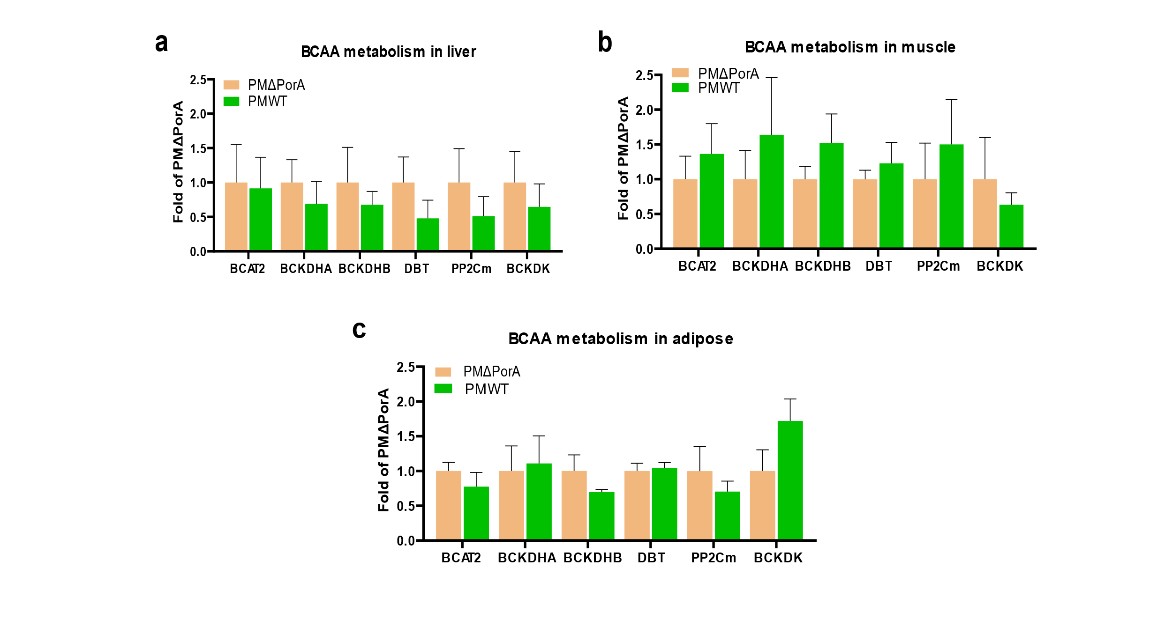
Extended Data Fig. 10 | BCAA catabolic in ApoE^{-/-} mice. Real-time RT-PCR result of specific genes using mRNA from (a) liver (b) muscle (c) adipose of PMΔporA (n=6) and PMWT (n=6). Abbreviation: PMΔPorA, P. merdae with knockout of porA gene; PMWT, wild type P. merdae. Data are presented as mean ± s.e.m.
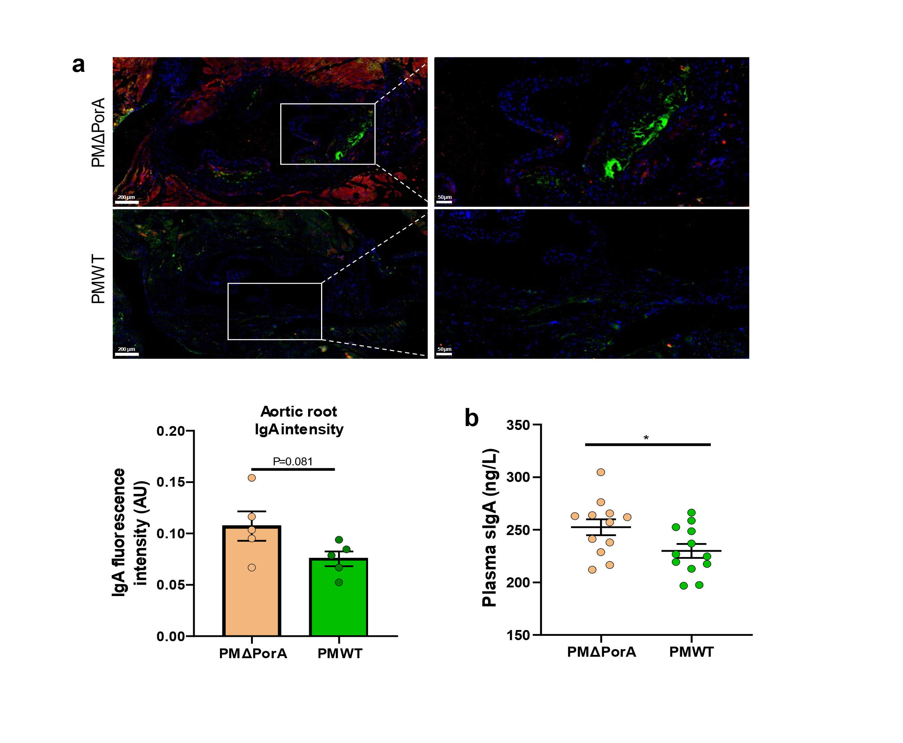
Extend Data Fig. 11 | IgA levels in atherosclerotic plaques and plasma. a, Immunostaining of IgA (red) levels and the macrophage marker CD68 (green) in atherosclerotic plaques. Representative images are shown on the left and quantification on the above. AU, arbitrary units. Scale bars, 100 μm (left), 50 μm (right). b, Plasma secreted-IgA. Abbreviation: PMΔPorA, P. merdae with knockout of porA gene; PMWT, wild type P. merdae. Data are presented as mean ± s.e.m. Statistical analysis was performed using Unpaired two-sided Student’s t-test (Gaussian model). * P<0.05.
Table S1. Computational identification of Parabacteroides merdae and porA gene
Upload as an attachment
Table S2. Animals used in this study.
Strain/type | Sample size | Diet intervention (length)  Treatment (length) | Subject | Data available
C57BL/6J | 9 | Normal diet (18 weeks)  Vehicle (9 weeks) | Efficacy evaluation of GMD | Tissue weight  Echocardiogram  Biochemical criterion  MOVAT stain  HE stain  Oil red O stain
ApoE^{-/-} | 8 | High fat diet (18 weeks)  Vehicle (9 weeks) | Efficacy evaluation of GMD | Tissue weight  Echocardiogram  Biochemical criterion  MOVAT stain  HE stain  Oil red O stain  Microbiome  BCAAs&BSCFAS content
ApoE^{-/-} | 10 | High fat diet (18 weeks)  Atorvastatin 10 mg/kg (9 weeks) | Efficacy evaluation of GMD | Tissue weight  Echocardiogram  Biochemical criterion
ApoE^{-/-} | 10 | High fat diet (18 weeks)  GMD 5 mg/kg (9 weeks) | Efficacy evaluation of GMD | Tissue weight  Echocardiogram  Biochemical criterion
ApoE^{-/-} | 9 | High fat diet (18 weeks)  GMD 10 mg/kg (9 weeks) | Efficacy evaluation of GMD | Tissue weight  Echocardiogram  Biochemical criterion  MOVAT stain  HE stain  Oil red O stain  Microbiome  BCAAs&BSCFAS content
C57BL/6J | 9 | Normal diet (14 weeks)  PBS (4 weeks) | Efficacy evaluation of P. merdae | Tissue weight  Biochemical criterion
ApoE^{-/-} | 10 | High fat diet (14 weeks)  PBS (4 weeks) | Efficacy evaluation of P. merdae | Tissue weight  Biochemical criterion  Masson stain  HE stain  Oil red O stain  Microbiome  BCAAs&BSCFAS content
ApoE^{-/-} | 9 | High fat diet (14 weeks)  Killed P. merdae (4 weeks) | Efficacy evaluation of P. merdae | Tissue weight  Biochemical criterion  Masson stain  HE stain  Oil red O stain  BCAAs&BSCFAS content
ApoE^{-/-} | 10 | High fat diet (14 weeks)  Live P. merdae (4 weeks) | Efficacy evaluation of P. merdae | Tissue weight  Biochemical criterion  Masson stain  HE stain  Oil red O stain  Microbiome  BCAAs&BSCFAS content
ApoE^{-/-} | 8 | High fat diet (15 weeks)  Antibiotic treatment (1 weeks)  PBS (4 weeks) | P. merdae treated pseudo-germ free mice | Tissue weight  Biochemical criterion
ApoE^{-/-} | 8 | High fat diet (15 weeks)  Antibiotic treatment (1 weeks)  P. merdae (4 weeks) | P. merdae treated pseudo-germ free mice | Tissue weight  Biochemical criterion
C57BL/6J | 10 | Normal diet (14 weeks)  PBS (4 weeks) | Efficacy evaluation of porA gene in P. merdae | Tissue weight  Biochemical criterion
ApoE^{-/-} | 12 | High fat diet (14 weeks)  PBS (4 weeks) | Efficacy evaluation porA gene in P. merdae | Tissue weight  Biochemical criterion  Masson stain  HE stain  Oil red O stain  BCAAs&BSCFAS content
ApoE^{-/-} | 12 | High fat diet (14 weeks)  Wild type P. merdae (4 weeks) | Efficacy evaluation porA gene in P. merdae | Tissue weight  Biochemical criterion  Masson stain  HE stain  Oil red O stain  Gene expression  Immunofluorescence section BCAAs&BSCFAS content
ApoE^{-/-} | 12 | High fat diet (14 weeks)  MutantΔporA P. merdae (4 weeks) | Efficacy evaluation porA gene in P. merdae | Tissue weight  Biochemical criterion  Masson stain  HE stain  Oil red O stain  Gene expression  Immunofluorescence section  BCAAs&BSCFAS content
Table S3. The number of reads per sample for 16S sequencing.
Group | Sequence Count
ApoE^{-/-}+HFD-1 | 80131
ApoE^{-/-}+HFD-2 | 80139
ApoE^{-/-}+HFD-3 | 84524
ApoE^{-/-}+HFD-4 | 80169
ApoE^{-/-}+HFD-5 | 78300
ApoE^{-/-}+HFD-6 | 80037
ApoE^{-/-}+HFD-7 | 75677
ApoE^{-/-}+HFD-8 | 80067
ApoE^{-/-}+HFD+GMDH-1 | 80173
ApoE^{-/-}+HFD+GMDH-2 | 80153
ApoE^{-/-}+HFD+GMDH-3 | 80153
ApoE^{-/-}+HFD+GMDH-4 | 80022
ApoE^{-/-}+HFD+GMDH-5 | 80151
ApoE^{-/-}+HFD+GMDH-6 | 81730
ApoE^{-/-}+HFD+GMDH-7 | 63173
ApoE^{-/-}+HFD+GMDH-8 | 80139
ApoE^{-/-}-1 | 55138
ApoE^{-/-}-2 | 63365
ApoE^{-/-}-3 | 63141
ApoE^{-/-}-4 | 58040
ApoE^{-/-}-5 | 59155
ApoE^{-/-}-6 | 58842
ApoE^{-/-}-7 | 72682
ApoE^{-/-}-8 | 72239
ApoE^{-/-}-9 | 72857
ApoE^{-/-}-10 | 64742
PM-1 | 72592
PM-2 | 60618
PM-3 | 55903
PM-4 | 66740
PM-5 | 51909
PM-6 | 70441
PM-7 | 66439
PM-8 | 69347
PM-9 | 71081
PM-10 | 64281

Table S4. Primers were used in this study.
Name | Sequence (5’3’)
Primers for mice
β-action-f | CCTTCCTTCTTGGGTATGGA
β-action-r | CTTGCTGATCCACATCTGCT
BCKDK-f | ACATCAGCCACCGATACACAC
BCKDK-r | GAGGCGAACTGAGGGCTTC
PP2Cm-f | ATGTTATCAGCGGCCTTCATTAC
PP2Cm-r | GTGGAGAAGTAGCAGGCAGG
BCAT2-f | CAGCCACACTAGGACAGGTCT
BCAT2-r | CAGCCTTGTTATTCCACTCCAC
DBT-f | AGACTGACCTGTGTTCGCTAT
DBT-r | GAGTGACGTGGCTGACTGTA
BCKDHA-f | CTCCTGTTGGGACGATCTGG
BCKDHA-r | CATTGGGCTGGATGAACTCAA
BCKDHB-f | AGCTATTGCGGAAATCCAGTTT
BCKDHB-r | ACAGTTGAAAAGATCACCTGAGC
Primers for bacteria
16S-f | WACGCGARGAACCTTACC
16S-r | TGACGGGCGGTGWGTAC
P. merdae-f | AGTGTGTTTGAGGTAGGCGG
P. merdae-r | ACGCTTTCGCTGTAGAGCTT
Primers used for directed mutagenesis into porA gene
Task | Primers | Sequences(5’-3’) | Product size(bp)
Amplication of folp insert to be cloned in pGERM | porA(EcoRI)-f | GCGGAATTCCTCTTCGTAGCGGACTTCAT |  | 615bp
Amplication of folp insert to be cloned in pGERM | porA(BamHI)-r | GCGGGATCCCCGTGGGAAACAACCGGAA |  | 615bp
Checking of pGERM insertion into folp of Bacteroides xylanisolvens | Erm-f | CGCTATATAATTTGGTGAATTGGAGT |  | 843bp
 | Erm-r | TAGTGATTACACCTTGTTATTGGACG |  | 843bp
 | pGERM-f | CCTCTTCGCTATTACGCCAG |  | 758bp
 | PM-r | TACGGTGTGGACGGTTACTT |  | 758bp
 | PM-f | TATTTCCACCACCTTCT |  | 939bp
 | pGERM-r | CAGGAAACAGCTATGAC |  | 939bp

