Supplementary Information

Evolution of Boreal-Summer Quasi-Stationary Rossby Waves on Daily Time Scales

Nakbin Choi¹, Myong-In Lee¹*, Eunkyo Seo^{2,3}, Fei Luo^{4,5,6}, Sunlae Tak^{3,7}, and Seungseok Lee¹
¹ Department of Civil, Urban, Earth, and Environmental Engineering, Ulsan National Institute of Science and Technology (UNIST), Ulsan, Republic of Korea.
² School of Environmental Atmosphere Science, Pukyong National University, Busan, Republic of Korea
³ Center for Ocean-Land-Atmosphere Studies, George Mason University, Fairfax, VA, United States
⁴ Centre for Climate Research Singapore (CCRS), Meteorological Service Singapore (MSS), Singapore, Singapore
⁵ Institute for Environmental Studies (IVM), Vrije Universiteit Amsterdam, Amsterdam, the Netherlands
⁶ Royal Netherlands Meteorological Institute (KNMI), De Bilt, the Netherlands
⁷ Institute of Sustainable Earth and Environmental Dynamics (SEED), Pukyong National University, Busan, Republic of Korea

*Corresponding author
E-mail: milee@unist.ac.kr

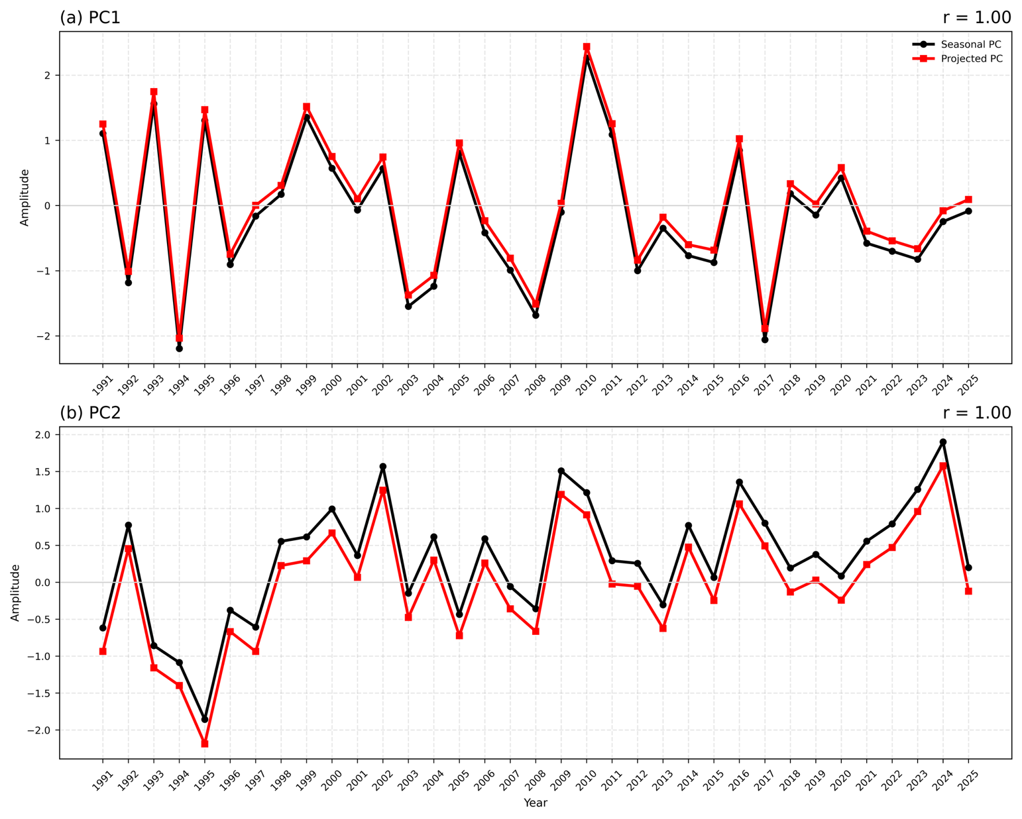
Supplementary Fig. 1. Comparison of seasonal PCs and daily projection indices. Comparison of the original seasonal principal components (PCs, black) and the JJA means of the corresponding daily projection indices (red) for (a) PC1 and (b) PC2 during 1991–2025. Values in the upper-right corners indicate the temporal correlation coefficients between the two time series.
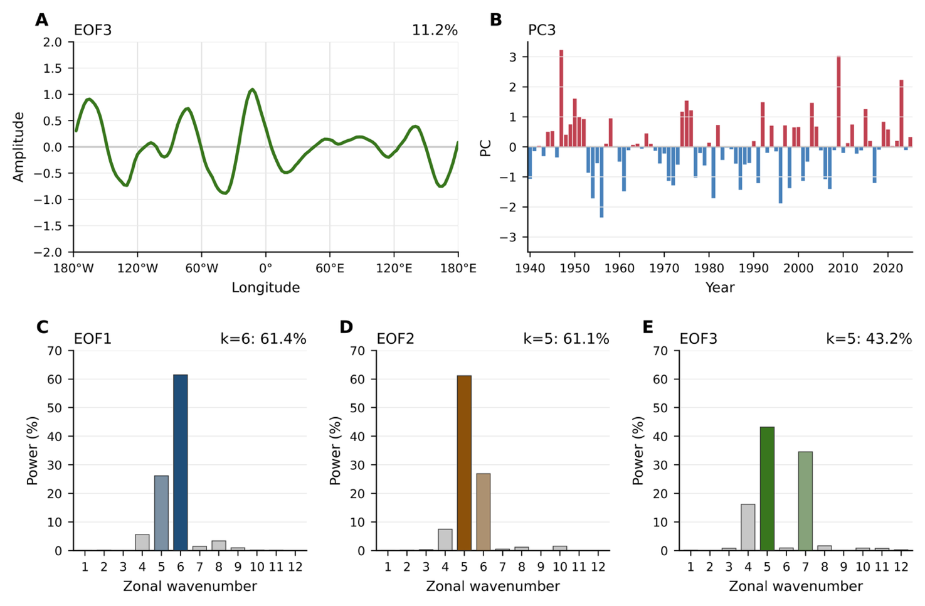
Supplementary Fig. 2. Third EOF mode and zonal-wavenumber spectra. (a) EOF3 pattern of JJA seasonal-mean 250-hPa meridional wind anomalies averaged over 20°–60°N during 1940–2025 (units: m s⁻¹) and (b) the corresponding normalized PC3 time series. (c–e) Zonal-wavenumber power spectra of EOF1, EOF2, and EOF3, respectively. The value in the upper-right corner of (a) indicates the variance explained by EOF3, while those in (c–e) indicate the fractional contribution of the dominant zonal wavenumber to the total spectral power.
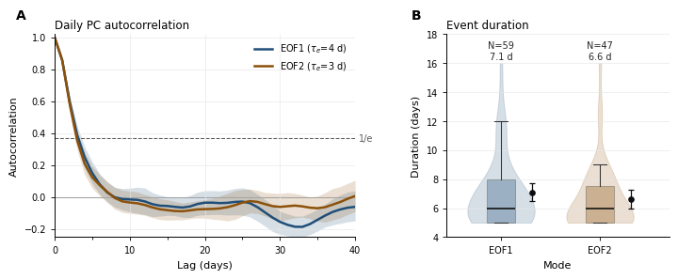
Supplementary Fig. 3. E-folding timescales and QSRW event durations. (a) Lag autocorrelations of the daily projection indices for EOF1 and EOF2. Shading denotes the 95% confidence intervals obtained from 10,000 bootstrap resamples across years, and the corresponding e-folding decorrelation times are given in the legend. The horizontal dashed line marks 1/e. (b) Distributions of QSRW event durations for EOF1 and EOF2. Boxes indicate the interquartile range and median, and black dots with error bars indicate the mean and its 95% bootstrap confidence interval based on 10,000 resamples. Labels above each distribution give the number of detected events and their mean duration.
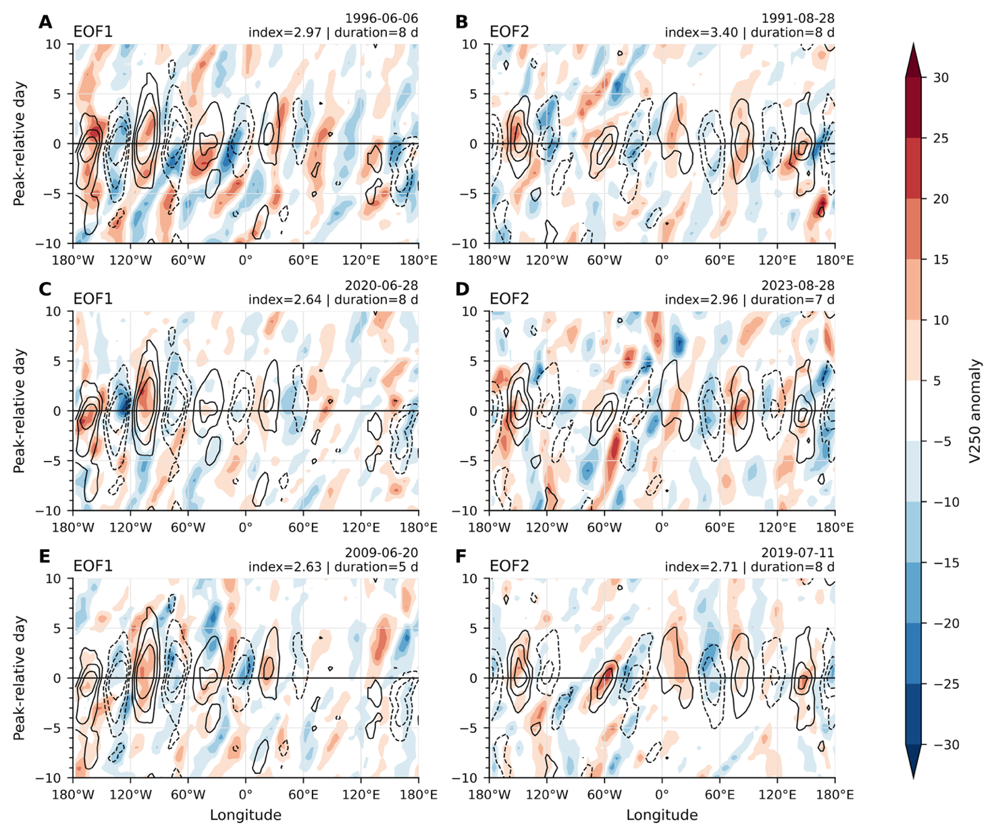
Supplementary Fig. 4. High-amplitude individual QSRW events. Peak-centered Hovmöller diagrams for the three highest-amplitude QSRW events associated with EOF1 (left column) and EOF2 (right column). Shading shows the sign-adjusted 250-hPa meridional wind anomalies of each individual event averaged over 20°–60°N, while black contours show the corresponding EOF-specific composite anomalies (units: m s⁻¹).

