Supplementary Material
Stress hyperglycemia identifies a high-mortality phenotype within lower triglyceride-glucose levels in critically ill adults: a MIMIC-IV landmark cohort study

Contents: Supplementary Tables S1–S2; Supplementary Figures S1–S4; STROBE checklist (provided separately).

Supplementary Table S1. Full baseline including body-mass index and lactate, by TyG–SHR group (N=3,877)
Characteristic | Overall | low TyG/low SHR | low TyG/high SHR | high TyG/low SHR | high TyG/high SHR
n | 3,877 | 1,210 | 728 | 728 | 1,211
Body-mass index, kg/m² † | 28.0 [24.6–32.3] | 27.2 [23.9–30.7] | 26.3 [23.3–29.8] | 28.8 [25.8–33.5] | 29.4 [25.5–34.0]
Lactate, peak, mmol/L ‡ | 1.8 [1.3–2.8] | 1.6 [1.1–2.2] | 1.9 [1.3–2.6] | 1.5 [1.2–2.3] | 2.2 [1.5–3.4]
Age, y | 68.5±15.3 | 71.3±15.6 | 69.8±15.7 | 65.3±15.2 | 66.9±14.4
Male, n (%) | 2145 (55.3) | 644 (53.2) | 398 (54.7) | 421 (57.8) | 682 (56.3)
SAPS-II | 31.6±11.9 | 30.9±11.0 | 32.1±11.0 | 28.6±11.1 | 33.9±13.3
SOFA | 3.1±2.7 | 2.7±2.3 | 3.2±2.5 | 2.6±2.3 | 3.8±3.2
Index glucose, mg/dL | 151.4±87.5 | 103.1±20.5 | 139.4±31.0 | 133.1±47.6 | 217.7±123.0
HbA1c, % | 6.3±1.7 | 5.9±0.9 | 5.5±0.6 | 7.1±2.2 | 6.7±2.0
Diabetes, n (%) | 1214 (31.3) | 225 (18.6) | 79 (10.9) | 338 (46.4) | 572 (47.2)
28-day death, n (%) | 557 (14.4) | 136 (11.2) | 131 (18.0) | 61 (8.4) | 229 (18.9)
Median [IQR] or mean±SD. † Body-mass index was missing in 58% and was not used in primary adjustment; it was imputed only in the multiple-imputation sensitivity analysis. ‡ Lactate (peak within 24 h) was missing in 69% and was likewise reserved for the multiple-imputation analysis. High and low denote position relative to the cohort median (TyG 8.814; SHR 1.050).

Supplementary Table S2. Prespecification status of each analysis
Analysis | Prespecified? | Added | Changed cohort/exposure/outcome/landmark/M3?
Primary four-group Cox (28-day mortality) | Yes | Original protocol | No
Stepwise adjustment M0–M3 | Yes | Original protocol | No
Additive and multiplicative interaction | Yes | Original protocol | No
Inverse-probability-of-being-measured weighting | Yes | Original protocol | No
Competing-risk analysis of incident AKI | Yes | Original protocol | No
90- and 365-day mortality | Yes | Original protocol | No
HbA1c-validity exclusions (anemia, CKD, ESRD, creatinine) | Basis prespecified | Executed this round | No
SHR vs absolute glucose comparison | Component idea prespecified | Present parameterization new | No
Decoupled log glucose + log eAG; residual of log glucose on eAG | No (post hoc) | After initial submission | No
Percentile-rank difference; residual discordance (linear, spline) | No (post hoc) | After initial submission | No
E-value | No (post hoc) | After initial submission | No
Glucometabolic characterization of low-TyG/high-SHR group (Figure 4) | No (post hoc descriptive) | After initial submission | No
The frozen cohort, 24-hour landmark, TyG and SHR definitions, median cut-points, M3 covariate set and 28-day mortality outcome were fixed before outcome modeling and were not altered by any analysis added after the initial submission, which was declined by the editor without external review. eAG, HbA1c-estimated average glucose.

Supplementary Figures

Supplementary Figure S1. TyG–SHR joint distribution and group-specific mortality
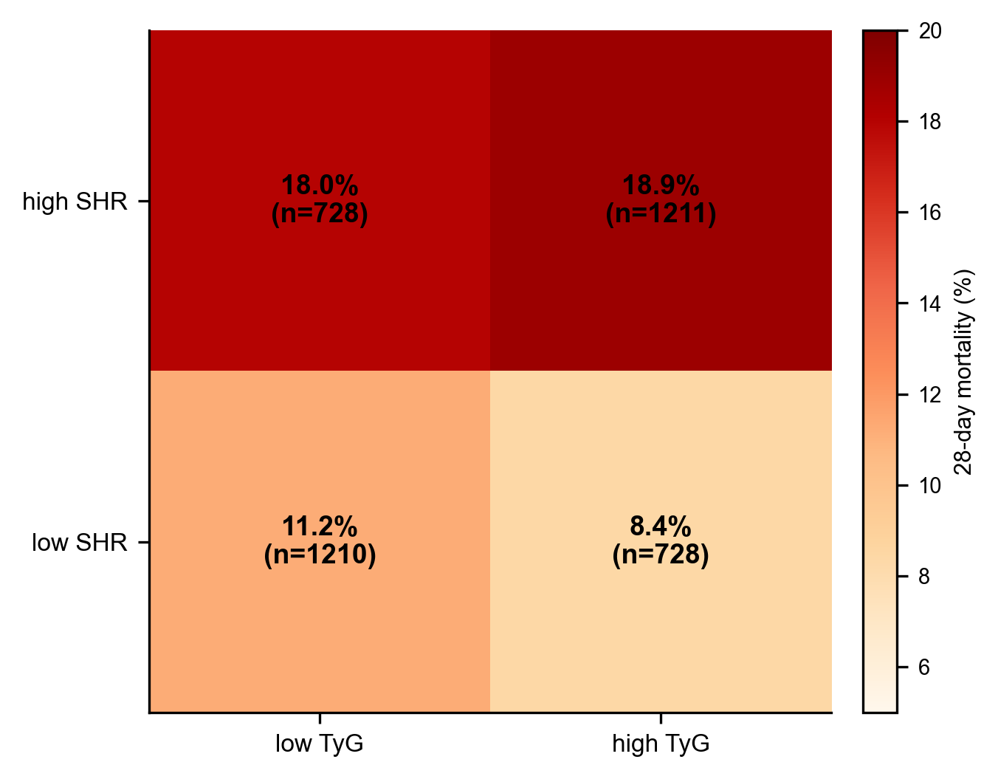
Supplementary Figure S1. Cross-classification of the cohort by median TyG and median SHR, with 28-day mortality in each cell. High and low denote position relative to the cohort median, not validated clinical thresholds.

Supplementary Figure S2. Index-glucose density by group
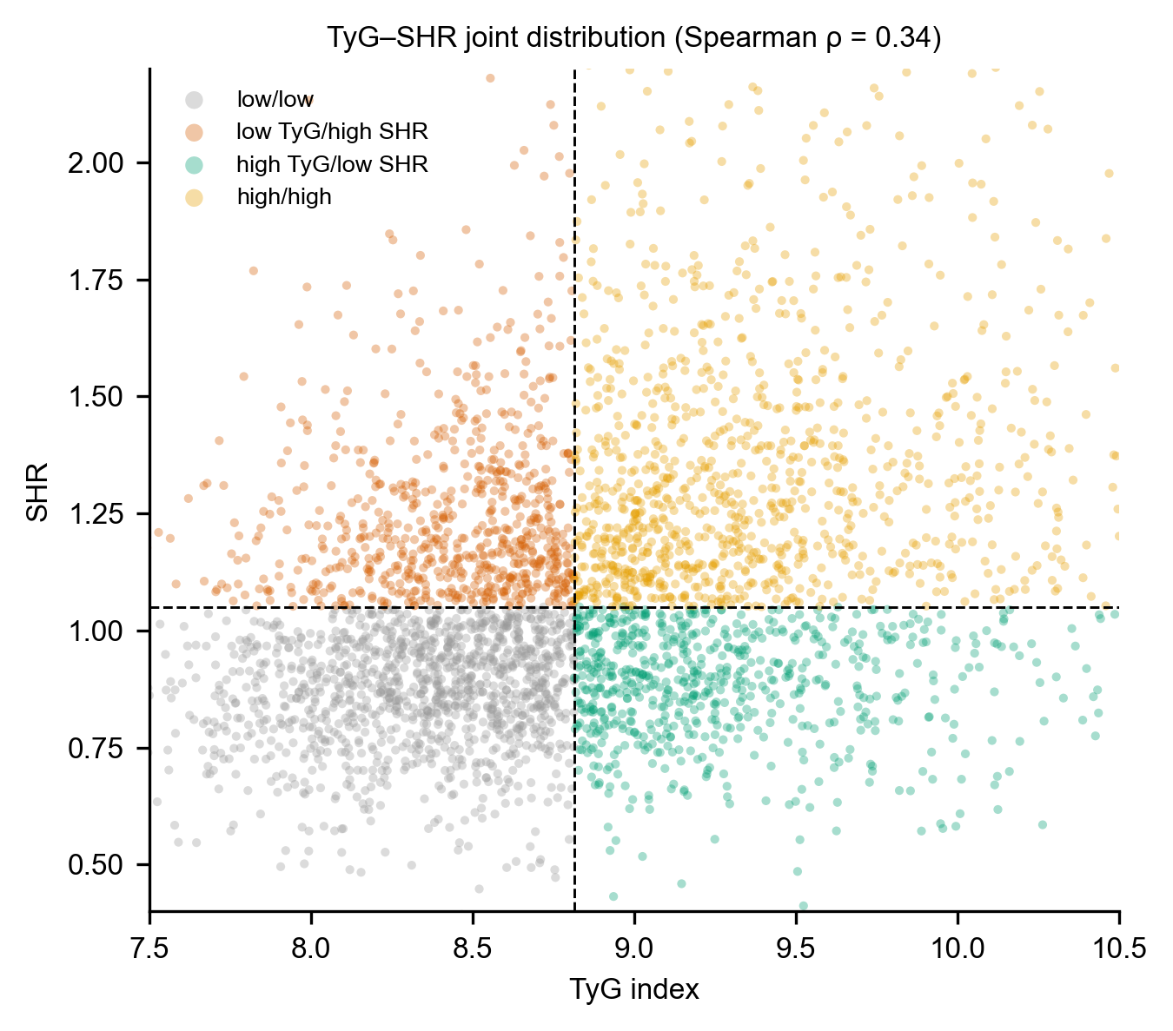
Supplementary Figure S2. Kernel density of admission glucose for each TyG–SHR group, showing that the low-TyG/high-SHR group has admission glucose that largely falls below conventional hyperglycemia thresholds.

Supplementary Figure S3. Cumulative incidence of acute kidney injury
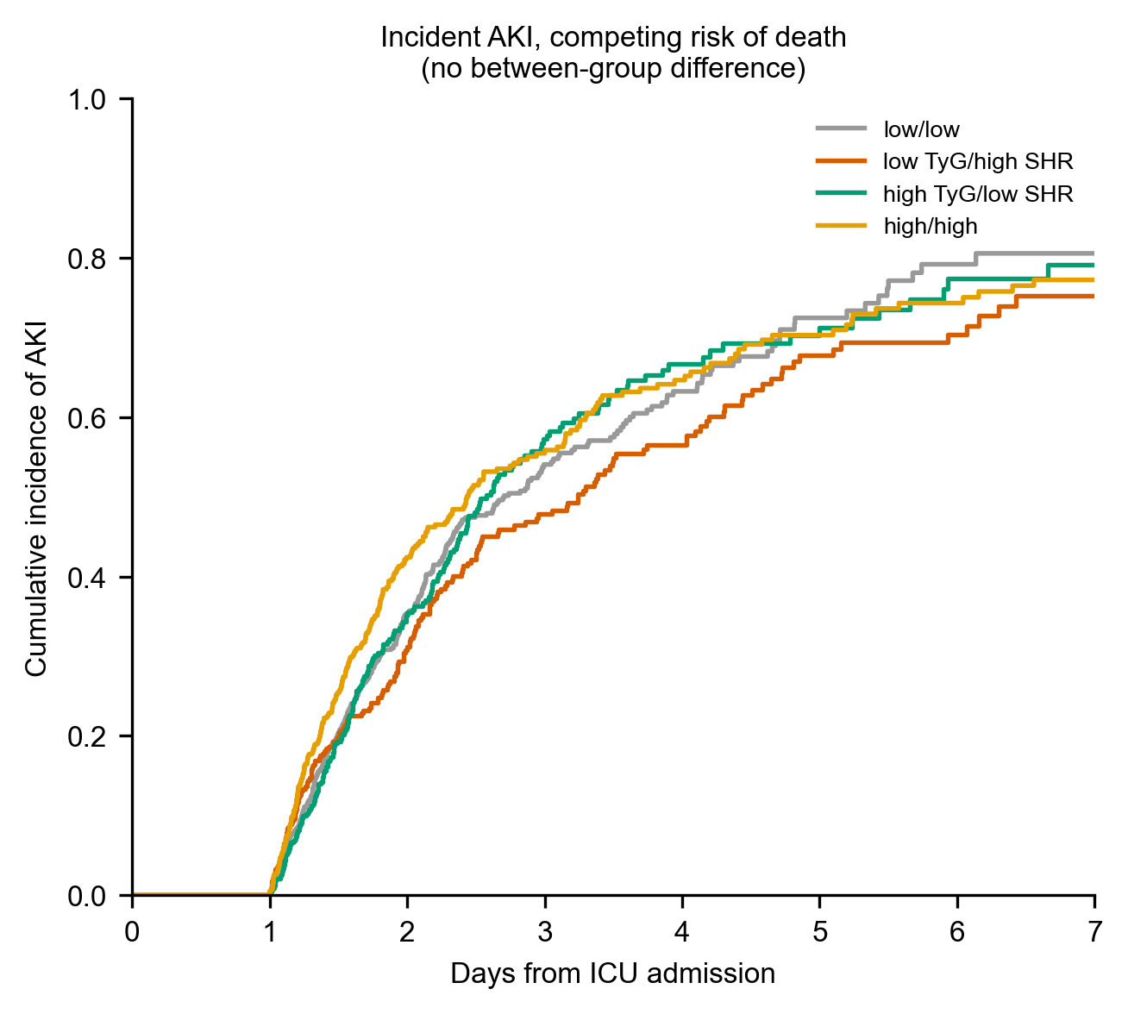
Supplementary Figure S3. Aalen–Johansen cumulative incidence of incident KDIGO acute kidney injury through day 7, with death as a competing event, by group. Incident AKI did not differ across groups.

Supplementary Figure S4. Restricted cubic spline of SHR versus 28-day mortality
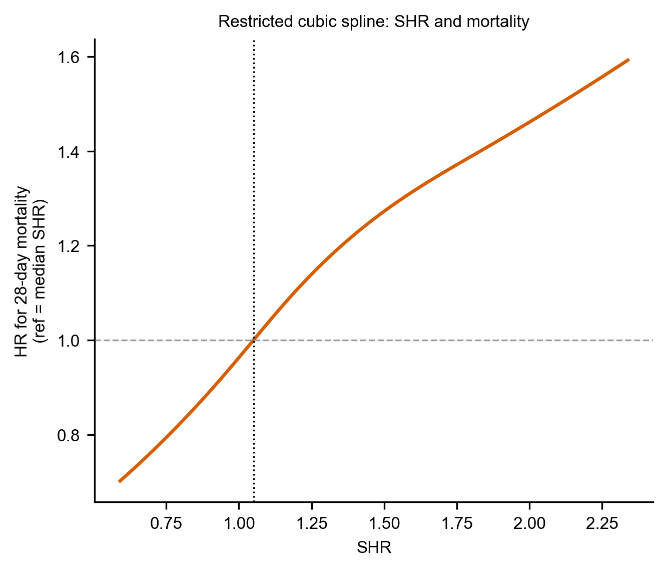
Supplementary Figure S4. Adjusted hazard ratio for 28-day mortality across the range of SHR (four-knot restricted cubic spline, M3-adjusted), with the cohort median as reference.

STROBE checklist
This observational cohort study is reported in accordance with the STROBE statement (von Elm et al. 2007). A completed item-by-item STROBE checklist is provided as a separate file with this submission.

