Supplementary Information
Synthesis, Proteolytic Stability, and Rapid Bactericidal Activity of Seven Synthetic Antimicrobial Peptides Against Selected Gram-Negative Bacteria
Olivier Ndogo Eteme¹,²*, Mbarga Opono Hermine Salome³, Esther Del Florence Moni Ndedi³, Patrick Hervé Betote Diboué³,⁴,⁵, Ernestine Nkwengoua Zondegoumba²
¹ Department of Chemistry, University of Pennsylvania, 231 S. 34th Street, Philadelphia, PA, USA
² Department of Organic Chemistry, Faculty of Science, University of Yaoundé I, P.O. Box 812, Yaoundé, Cameroon
³ Department of Microbiology, Faculty of Science, University of Yaoundé I, P.O. Box 812, Yaoundé, Cameroon
⁴ Department of Galenical Pharmacy and Pharmaceutical Law, Faculty of Medicine and Biomedical Sciences, University of Yaoundé I, P.O. Box 812, Yaoundé, Cameroon
⁵ Centre for Research on Medicinal Plants and Traditional Medicine, Institute of Medical Research and Medicinal Plants Studies (IMPM), P.O. Box 13033, Yaoundé, Cameroon
* Corresponding author: Olivier Ndogo Eteme, PhD; email: ndogoeteme@gmail.com
This supplementary file contains analytical HPLC/LC-MS characterization of peptides P1-P7 and the complete MIC/MBC dataset supporting the main article.

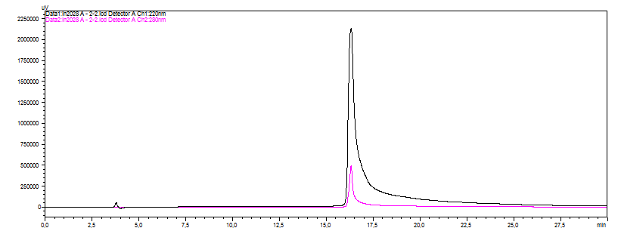
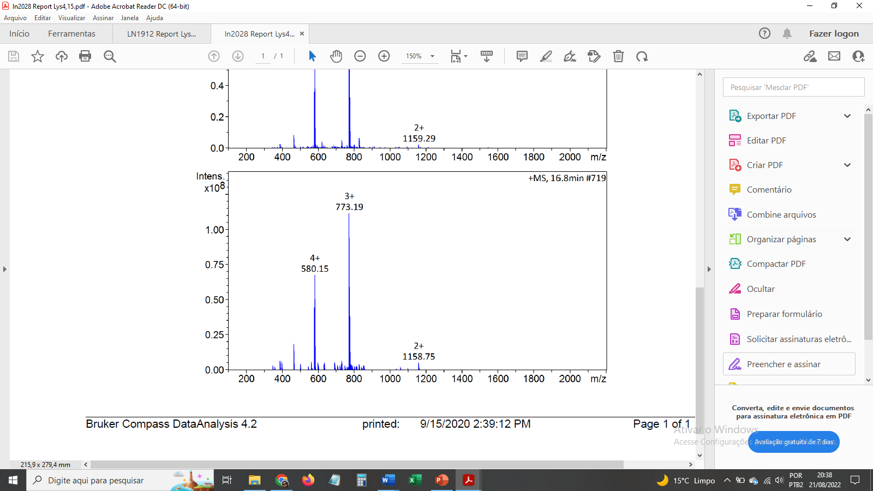
P1

P2

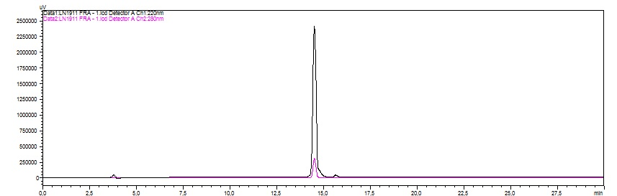
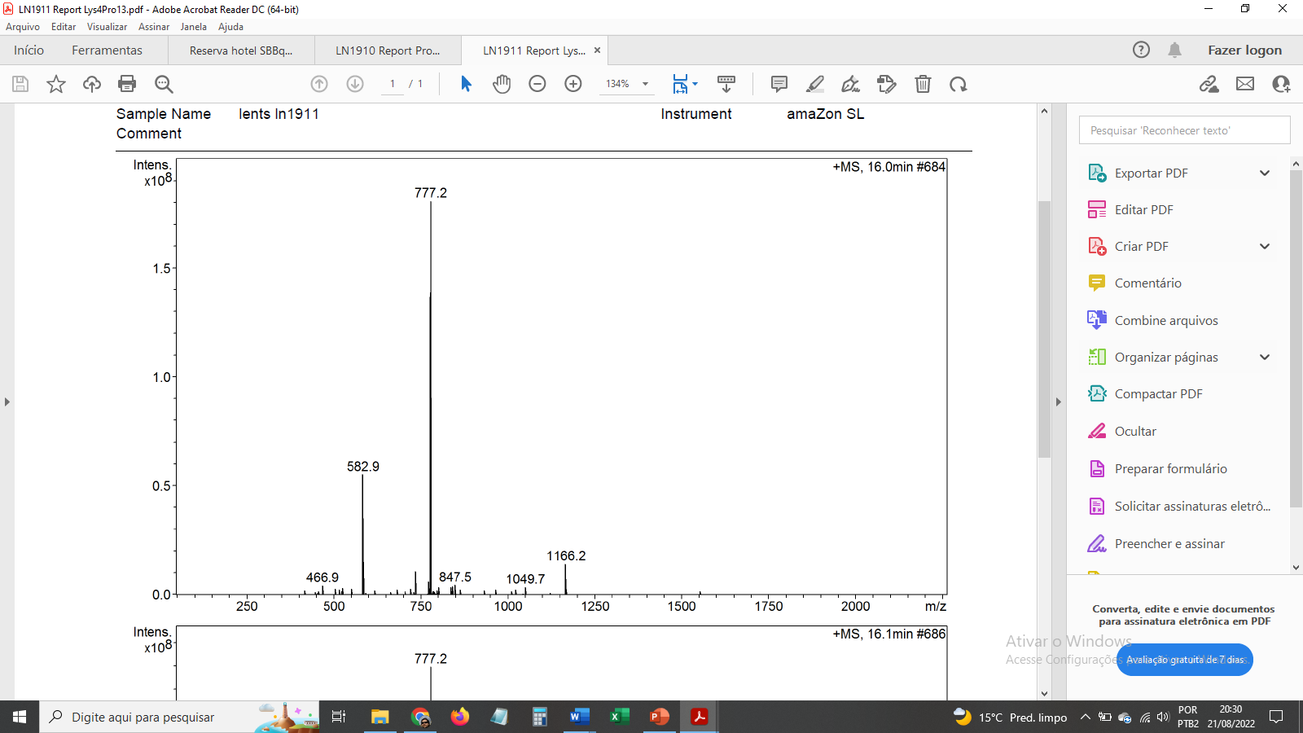

P4
P3

P6
P5

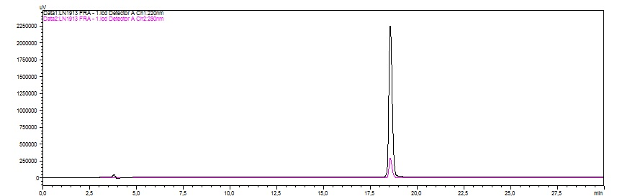
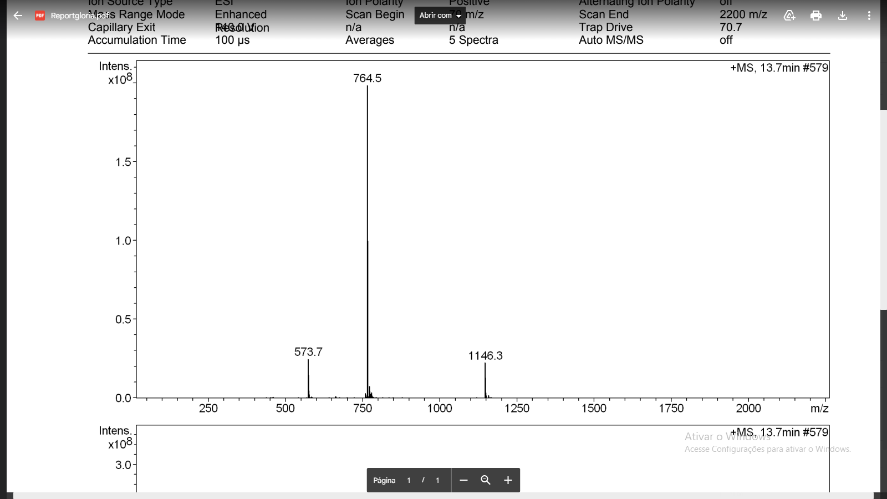

P7

Supplementary Figure S1. Analytical HPLC and LC-MS characterization of synthesized peptides P1-P7.
Analytical HPLC and LC-MS profiles of peptides P1-P7. The chromatograms show the dominant purified-peptide peaks, and the mass spectra support the expected molecular masses through the observed charge states. The preparations used for biological testing showed approximately 97% or higher chromatographic purity. The original analytical traces are presented without reinterpretation of instrument-specific peak annotations.

Supplementary Table S1. MIC and MBC values of peptides P1-P7 and reference antibiotics against the tested Gram-negative bacteria.
Peptide | Bacterium | MIC (µg/mL) | MBC (µg/mL) | MBC/MIC | Activity
P7 | Pseudomonas aeruginosa | 32.55 µg/mL (14.22 µM) | 65.11 µg/mL (28.44 µM) | 2 | Bactericidal
P7 | Salmonella Typhimurium | 8.14 µg/mL (3.56 µM) | 8.14 µg/mL (3.56 µM) | 1 | Bactericidal
P7 | E. coli isolate M/20-03 | 8.14 µg/mL (3.56 µM) | 8.14 µg/mL (3.56 µM) | 1 | Bactericidal
P7 | Shigella sp. | 16.28 µg/mL (7.11 µM) | 16.28 µg/mL (7.11 µM) | 1 | Bactericidal
P7 | E. coli isolate M/30-03 | 130.21 µg/mL (56.87 µM) | 260.42 µg/mL (113.73 µM) | 2 | Bactericidal
P1 | Pseudomonas aeruginosa | 2083.33 µg/mL (894.58 µM) | 2083.33 µg/mL (894.58 µM) | 1 | Bactericidal
P1 | Salmonella Typhimurium | 260.42 µg/mL (111.82 µM) | 520.83 µg/mL (223.64 µM) | 2 | Bactericidal
P1 | E. coli isolate M/20-03 | 65.11 µg/mL (27.96 µM) | 130.21 µg/mL (55.91 µM) | 2 | Bactericidal
P1 | Shigella sp. | 260.42 µg/mL (111.82 µM) | 260.42 µg/mL (111.82 µM) | 1 | Bactericidal
P1 | E. coli isolate M/30-03 | 520.83 µg/mL (223.64 µM) | 520.83 µg/mL (223.64 µM) | 1 | Bactericidal
P5 | Pseudomonas aeruginosa | 2083.33 µg/mL (899.63 µM) | 2083.33 µg/mL (899.63 µM) | 1 | Bactericidal
P5 | Salmonella Typhimurium | 260.42 µg/mL (112.46 µM) | 260.42 µg/mL (112.46 µM) | 1 | Bactericidal
P5 | E. coli isolate M/20-03 | 65.11 µg/mL (28.12 µM) | 130.21 µg/mL (56.23 µM) | 2 | Bactericidal
P5 | Shigella sp. | 260.42 µg/mL (112.46 µM) | 260.42 µg/mL (112.46 µM) | 1 | Bactericidal
P5 | E. coli isolate M/30-03 | 1041.67 µg/mL (449.82 µM) | 1041.67 µg/mL (449.82 µM) | 1 | Bactericidal
Peptide | Bacterium | MIC (µg/mL) | MBC (µg/mL) | MBC/MIC | Activity
P3 | Pseudomonas aeruginosa | 65.11 µg/mL (28.12 µM) | 260.42 µg/mL (112.46 µM) | 4 | Bacteriostatic
P3 | Salmonella Typhimurium | 65.11 µg/mL (28.12 µM) | 65.11 µg/mL (28.12 µM) | 1 | Bactericidal
P3 | E. coli isolate M/20-03 | 16.28 µg/mL (7.03 µM) | 32.55 µg/mL (14.06 µM) | 2 | Bactericidal
P3 | Shigella sp. | 32.55 µg/mL (14.06 µM) | 32.55 µg/mL (14.06 µM) | 1 | Bactericidal
P3 | E. coli isolate M/30-03 | 260.42 µg/mL (112.46 µM) | 520.83 µg/mL (224.91 µM) | 2 | Bactericidal
P4 | Pseudomonas aeruginosa | 520.83 µg/mL (223.64 µM) | 520.83 µg/mL (223.64 µM) | 1 | Bactericidal
P4 | Salmonella Typhimurium | 520.83 µg/mL (223.64 µM) | 520.83 µg/mL (223.64 µM) | 1 | Bactericidal
P4 | E. coli isolate M/20-03 | 130.21 µg/mL (55.91 µM) | 520.83 µg/mL (223.64 µM) | 4 | Bacteriostatic
P4 | Shigella sp. | 1041.67 µg/mL (447.29 µM) | 1041.67 µg/mL (447.29 µM) | 1 | Bactericidal
P4 | E. coli isolate M/30-03 | 520.83 µg/mL (223.64 µM) | 1041.67 µg/mL (447.29 µM) | 2 | Bactericidal
P6 | Pseudomonas aeruginosa | 2083.33 µg/mL (909.86 µM) | 8333.33 µg/mL (3639.45 µM) | 4 | Bacteriostatic
P6 | Salmonella Typhimurium | 2083.33 µg/mL (909.86 µM) | 4166.67 µg/mL (1819.73 µM) | 2 | Bactericidal
P6 | E. coli isolate M/20-03 | 260.42 µg/mL (113.73 µM) | 260.42 µg/mL (113.73 µM) | 1 | Bactericidal
P6 | Shigella sp. | 2083.33 µg/mL (909.86 µM) | 4166.67 µg/mL (1819.73 µM) | 2 | Bactericidal
P6 | E. coli isolate M/30-03 | 2083.33 µg/mL (909.86 µM) | 2083.33 µg/mL (909.86 µM) | 1 | Bactericidal
Peptide | Bacterium | MIC (µg/mL) | MBC (µg/mL) | MBC/MIC | Activity
P2 | Pseudomonas aeruginosa | 65.11 µg/mL (28.27 µM) | 260.42 µg/mL (113.09 µM) | 4 | Bacteriostatic
P2 | Salmonella Typhimurium | 130.21 µg/mL (56.54 µM) | 260.42 µg/mL (113.09 µM) | 2 | Bactericidal
P2 | E. coli isolate M/20-03 | 65.11 µg/mL (28.27 µM) | 130.21 µg/mL (56.54 µM) | 2 | Bactericidal
P2 | Shigella sp. | 65.11 µg/mL (28.27 µM) | 520.83 µg/mL (226.17 µM) | 8 | Bacteriostatic
P2 | E. coli isolate M/30-03 | 260.42 µg/mL (113.09 µM) | 1041.67 µg/mL (452.35 µM) | 4 | Bacteriostatic
Ciprofloxacin | Pseudomonas aeruginosa | 0.49 (1.48 µM) | 0.49 (1.48 µM) | 1 | Bactericidal
Ciprofloxacin | Salmonella Typhimurium | 0.49 (1.48 µM) | 0.49 (1.48 µM) | 1 | Bactericidal
Ciprofloxacin | E. coli isolate M/20-03 | 125 (377.24 µM) | 250 (754.49 µM) | 2 | Bactericidal
Ciprofloxacin | Shigella sp. | 0.49 (1.48 µM) | 0.49 (1.48 µM) | 1 | Bactericidal
Ciprofloxacin | E. coli isolate M/30-03 | 62.5 (188.62 µM) | 62.5 (188.62 µM) | 1 | Bactericidal
Colistin | Pseudomonas aeruginosa | 0.49 (0,43 µM) | 0.98 (0.85 µM) | 2 | Bactericidal
Colistin | Salmonella Typhimurium | 125 (108.18 µM) | 125 (108.18 µM) | 1 | Bactericidal
Colistin | E. coli isolate M/20-03 | 7.81 (6.76 µM) | 7.81 (6.76 µM) | 1 | Bactericidal
Colistin | Shigella sp. | 0.24 (0.21 µM) | 15.63 (13.53 µM) | 64 | Tolerant
Colistin | E. coli isolate M/30-03 | 0.24 (0.21 µM) | 0.24 (0.21 µM) | 1 | Bactericidal

Abbreviations: MIC, minimum inhibitory concentration; MBC, minimum bactericidal concentration; µM, micromolar. Activity classifications are based on the reported MBC/MIC ratios. MIC and MBC values were generated under the Middlebrook 7H9/OADC/PANTA conditions used in this study and should therefore be interpreted as study-specific endpoints.

