Supplementary Information

Deep-Subwavelength Plasmon Polariton Atomic Cavity Nano-detector for Polarimetric Terahertz Detection and Imaging
Shaojing Liu†, Hongjia Zhu†, Ningsheng Xu, Ximiao Wang, Runli Li, Hai Ou, Shangdong Li, Yanlin Ke, Runze Zhan, Huanjun Chen*, and Shaozhi Deng*

State Key Laboratory of Optoelectronic Materials and Technologies, Guangdong Province Key Laboratory of Display Material and Technology, School of Electronics and Information Technology, Sun Yat-sen University, Guangzhou 510275, China
*Corresponding author. E-mail: chenhj8@mail.sysu.edu.cn; stsdsz@mail.sysu.edu.cn.
†These authors contributed equally to this work.

This PDF file includes:
Supplementary Note S1 to S4
Figures S1 to S24
Table S1
References

CONTENTS

Supplementary Note 3
S1. Quasistatic coupled-mode theory (QCMT) model 3
S2. Diffusion dynamics of thermal energy induced by PPACs 5
S3. Extraction of simulated response times for PPAC nano-detectors 7
S4. Estimation of the RC-limited response time 8
Figures S1 to S24 9
Table S1 33
References 35

Supplementary Note
S1. Quasistatic coupled-mode theory (QCMT) model
The QCMT (quasistatic coupled-mode theory) model is used to fit the numerical results from FDTD. In QCMT, the incident waves at the PPACs are denoted as 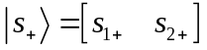, and the outgoing waves are defined by 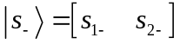. s₁₊ (s₁₋) and s₂₊ (s₂₋) are complex incident (outgoing) wave amplitudes at the air and the substrate side. The time-variant mode amplitude, a, of the PPACs can be expressed according to CMT as¹,
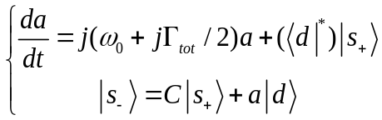 (S1)
where Г_{tot} represents the total decay rate, which is the sum of radiative decay rate Г_{rad} and absorption rate Г_{abs}. Г_{abs} is defined as the internal loss caused by the absorption of the PPACs, determined by the electron scattering rate of the graphene². 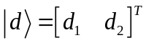 is the coupling vector with 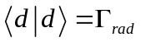. C is the background scattering matrix without the PPACs, which is stated as,
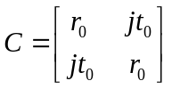 (S2)
where 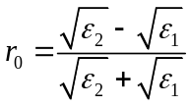 and 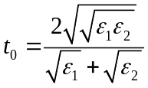 are the port reflection and transmission coefficients, respectively. ԑ₁ and ԑ₂ are permittivities of the substrate and air, respectively. Assuming the THz wave is illuminated from the air side, i.e., 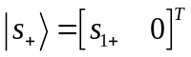 and considering the time reversal symmetry 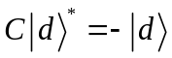, the reflection and transmission coefficients for the PPACs can be written as²,
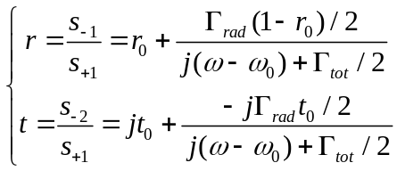 (S3)
Thus, the reflection and transmission of the PPACs are obtained as,
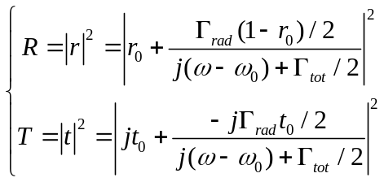 (S4)
By fitting the numerical results using Eq. (S4), the absorption rate Г_{abs}, radiative decay rate Г_{rad}, and resonance frequency ω₀ can be obtained.
S2. Diffusion dynamics of thermal energy induced by PPACs
To determine the diffusion length of thermal energy induced by PPACs, we simulated a single-row PPAC nano-detector with a channel length of 70 μm using COMSOL Multiphysics. Individual or multiple PPACs were activated to assess their impact on temperature distribution (Fig. ST1a, b). By activating the 1st, 10th, and 21st PPACs individually (Fig. ST1a), we analyzed the temperature distribution generated by the thermoelectric effect of each PPAC (Fig. ST1b). The temperature profile along the channel (Fig. ST1c) reveals that the first PPAC generates the highest temperature, while the 10th and 21st PPACs produce similar magnitudes. When each PPAC operates individually, the temperature decays to ambient temperature after a certain distance from the PPAC. The diffusion length (L_{D}) of the thermal energy is defined as the distance at which the temperature difference decreases to 1% of its maximum value, obtained by,
(S5)
According to Eq. (S5), the diffusion lengths for the three PPACs were calculated as 16.1 μm, 15.9 μm, and 15.6 μm, respectively. Critically, these values exhibit high consistency across PPAC positions. The average diffusion length of 15.9 µm indicates that the L_{D} induced by a specific PPAC is approximately 15.9 μm.
To investigate thermal diffusion interaction, we simultaneously activated the 1st and 21st PPACs, separated by 16 μm, exceeding the diffusion length. The resulting temperature distribution (Fig. ST1d) shows a temperature increase between the two PPACs, while temperatures at the PPAC locations remain comparable to those observed during individual activation. This confirms negligible thermal diffusion when PPAC separation exceeds L_{D}. Finally, we activated the 10th PPAC, situated between the 1st and 21st PPACs, while maintaining the activation of the 1st and 21st PPACs. The distance between the 10th PPAC and the other two PPACs is less than the diffusion length, resulting in elevated temperatures at the 1st and 21st PPACs (Fig. ST1e). This demonstrates that PPACs within one diffusion length mutually influence their temperatures. Thus, the channel length of the PPAC array below the L_{D} (~15.9 μm) results in a heightened temperature gradient across the device, while a stable temperature gradient at both ends of the device occurs when the channel length of the PPAC array exceeds the L_{D}.
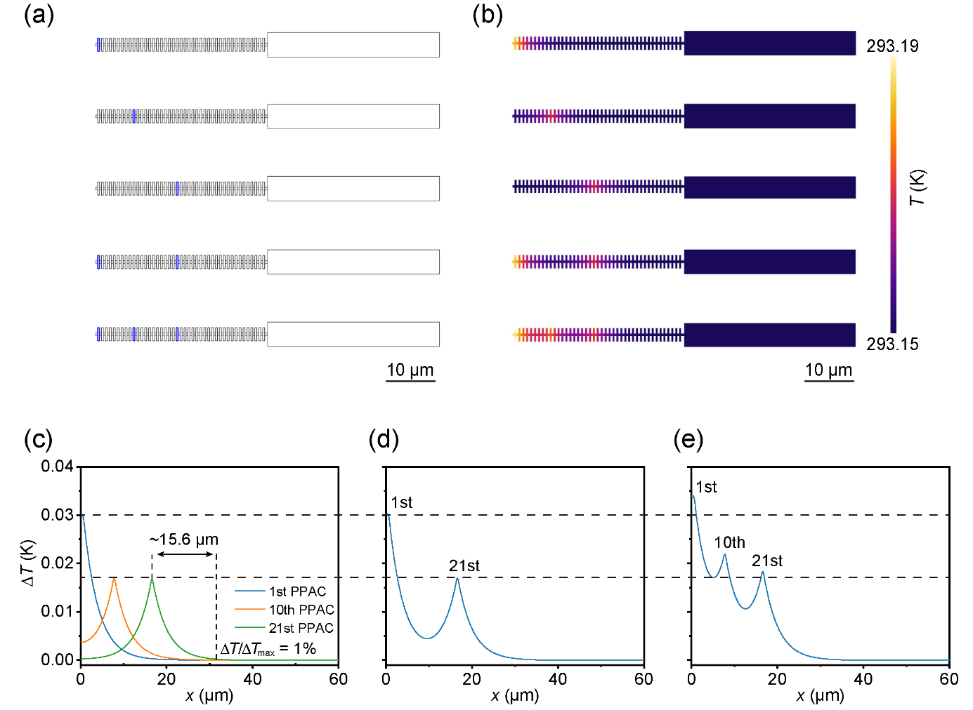
Fig. ST1 Diffusion dynamics of thermal energy induced by PPACs. a Schematic diagrams of PPAC nano-detectors with individual or multiple activated PPACs. b Temperature distribution of the device with individual or multiple activated PPACs. c Temperature profile along the channel during isolated activation of the 1st, 10th, and 21st PPACs. d Temperature profile along the channel width during simultaneous activation of the 1st and 21st PPACs. e Temperature profile along the channel width during simultaneous activation of the 1st, 10th, and 21st PPACs.

S3. Extraction of simulated response times for PPAC nano-detectors
To obtain the response times of PPAC nano-detectors with channel lengths from 2 μm to 50 μm, we simulated the time-resolved photocurrent responses using COMSOL Multiphysics (Fig. ST2). The response time is extracted as the duration between 10% and 90% of the rising edge of the photoresponse curve. As depicted in Figure ST2, the response times of PPAC nano-detectors with channel lengths of 2 μm, 5 μm, 10 μm, 20 μm, 30 μm, 40 μm and 50 μm are 60 ps, 135 ps, 97 ps, 142 ps, 200 ps, 162 ps and 166 ps, respectively.
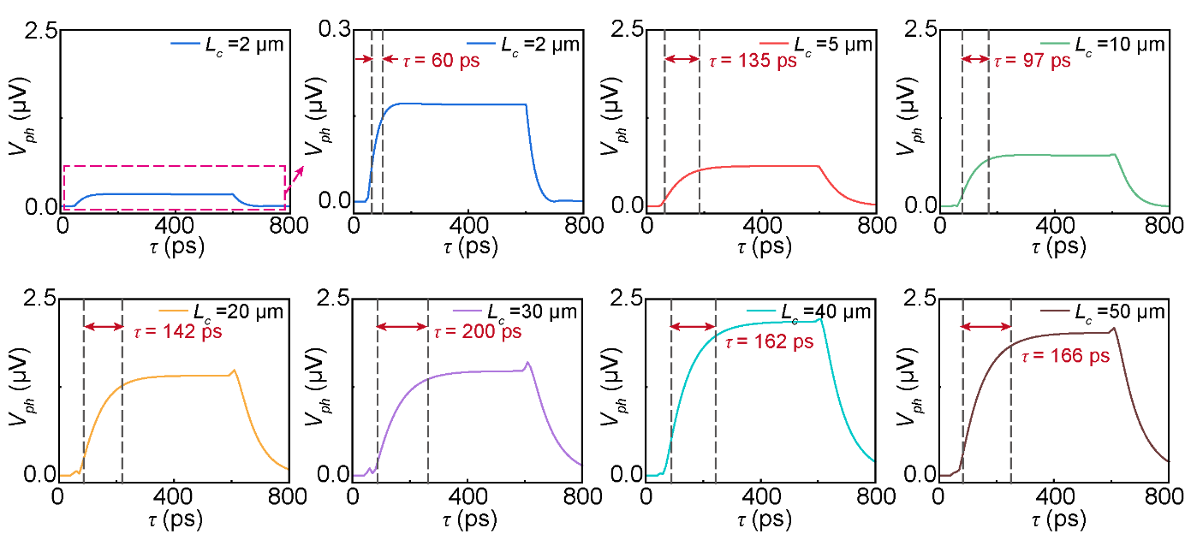
Fig. ST2 Time-resolved photocurrent responses of the PPAC nano-detector with channel lengths of 2 μm, 5 μm, 10 μm, 20 μm, 30 μm, 40 μm and 50 μm, respectively.

S4. Estimation of the RC-limited response time
To evaluate whether the electrical RC delay limits the response of the PPAC detector, the RC-limited bandwidth was estimated using the following equation as³,
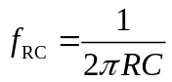 (S6)
where R is the device equivalent resistance and C is the lumped channel capacitance. The equivalent RC circuit consists of the device resistance, the device capacitance, and the external load of 50 Ω imposed by the measurement equipment. Considering that the device is connected to a standard 50 Ω radio-frequency transmission system during the response measurements, the equivalent resistance contributing to the RC delay is given by the parallel combination of the device resistance and the external load resistance, which can be obtained as³,
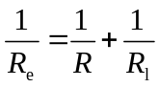 (S7)
where R_{e} is the equivalent resistance, R is the device resistances ranging from 1800 Ω to 8000 Ω corresponding to the channel lengths of 2 μm to 50 μm, respectively (Fig. S12), R_{l} is the external load of 50 Ω. The device capacitance was conservatively estimated using the parallel-plate capacitor model, C = ε₀ε_{r}S/d, which can provide a reasonably strict upper bound for the total device capacitance, including both the intrinsic and parasitic capacitances, thereby yielding a conservative upper-bound estimate of the RC delay. For the PPAC detectors with channel sizes from 2 μm × 16 μm to 50 μm × 16 μm, the measured resistance increases from 1800 Ω to 8000 Ω (Fig. S12), while the estimated capacitance of ~3.7−92.1 fF and the equivalent resistances of ~48.6−49.7 Ω. This gives RC-limited frequency, f_{RC}, ranging from ~35 GHz to ~885 GHz, equivalent to RC-limited response times of ~0.4−10 ps.

Figures S1 to S24
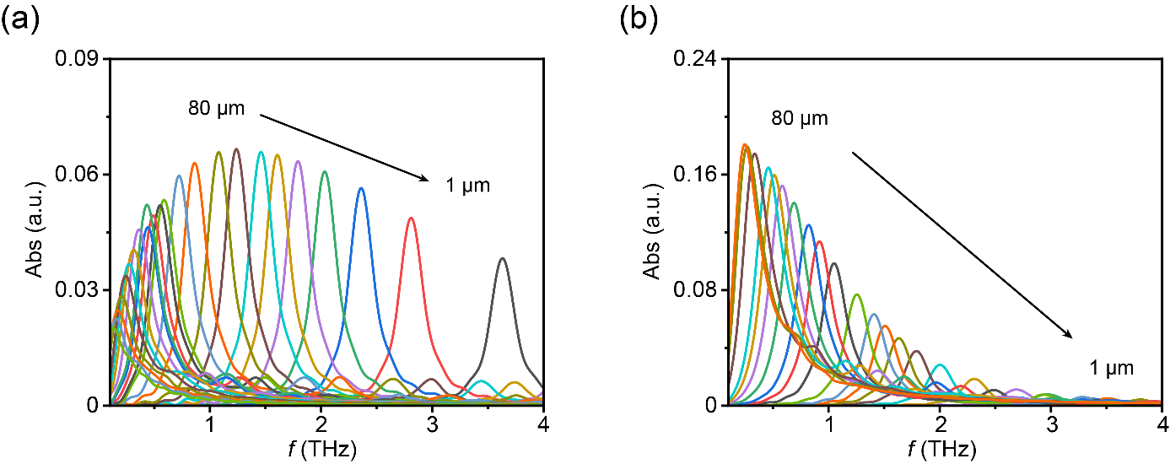
Fig. S1 a Simulated THz absorption spectra of the PPACs as a function of L_{r}. The aspect ratio is fixed at 4 (L_{r} = 4W_{r}). b Simulated THz absorption spectra of the PPACs as a function of aspect ratio, with a fixed W_{r} = 5 μm and aspect ratio varying from 0.22 to 16 (corresbonding to L_{r} ranging from 1 μm to 80 μm).

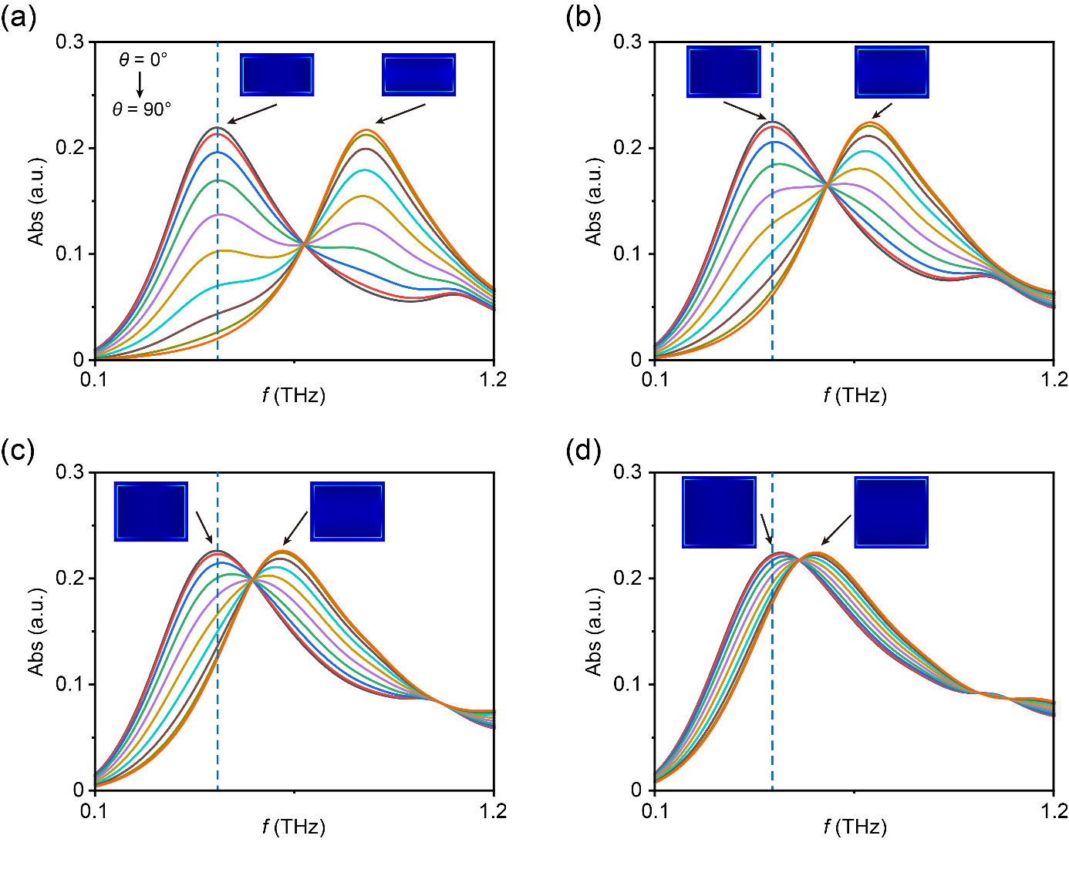
Fig. S2 Simulated THz absorption spectra of the PPACs with different aspect ratios as a function of polarization angle (θ). The dimensions of rectangle PPAC are 40 μm × 20 μm (a), 40 μm × 25 μm (b), 40 μm × 30 μm (c) and 40 μm × 35 μm (d), respectively. Insets: simulated near-field distributions at the peaks with polarization angle (θ) of 0° and 90°.

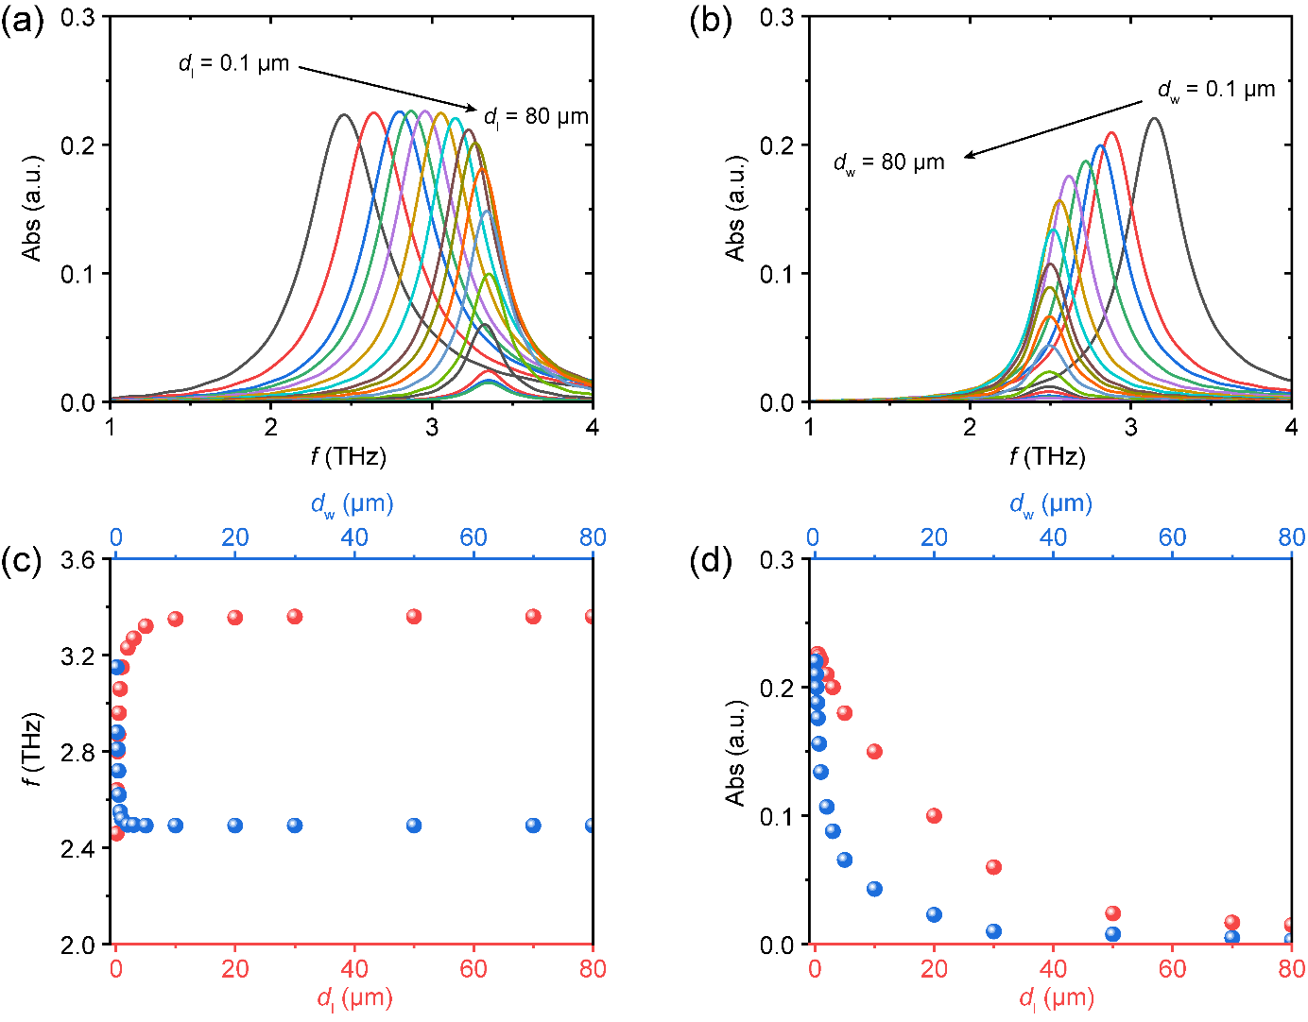
Fig. S3 a, b Simulated absorption spectra of the PPAC array varies with d_{l} (a) and d_{w} (b). c, d Simulated resonance frequency (c) and resonance intensity (d) of the PPAC array as a function of d_{l} and d_{w}.
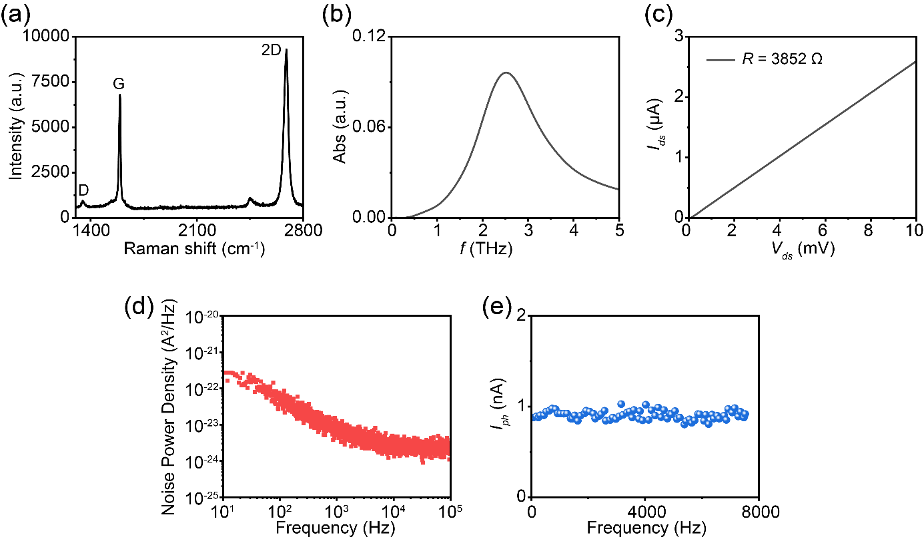
Fig. S4 Additional characterizations of the graphene PPAC and related nano-detector. a Raman spectrum of the PPACs. b Simulated absorption spectrum of the PPAC array with the nano-rectangle size of 2.5 μm × 400 nm. c Dependence of current on applied voltage of the device. d Current noise power density of the device. e Variation of the photocurrent with modulation frequency.

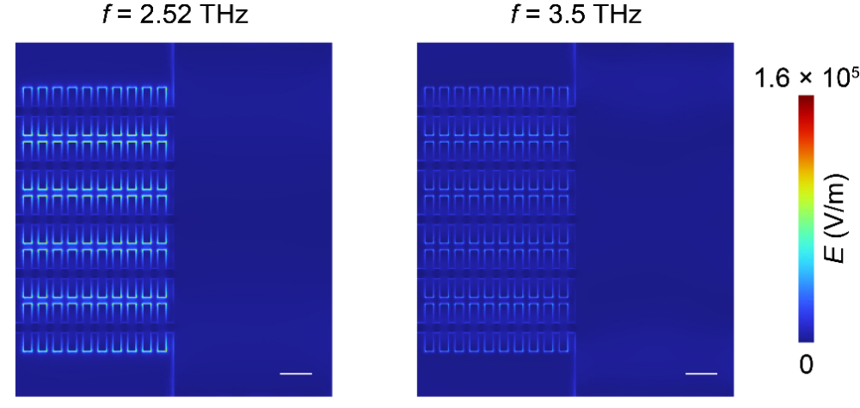
Fig. S5 Simulated electromagnetic field distributions of the device at a resonance frequency of 2.52 THz (left panel) and at a non-resonance frequency of 3.5 THz (right panel). Scale bar: 2 μm.

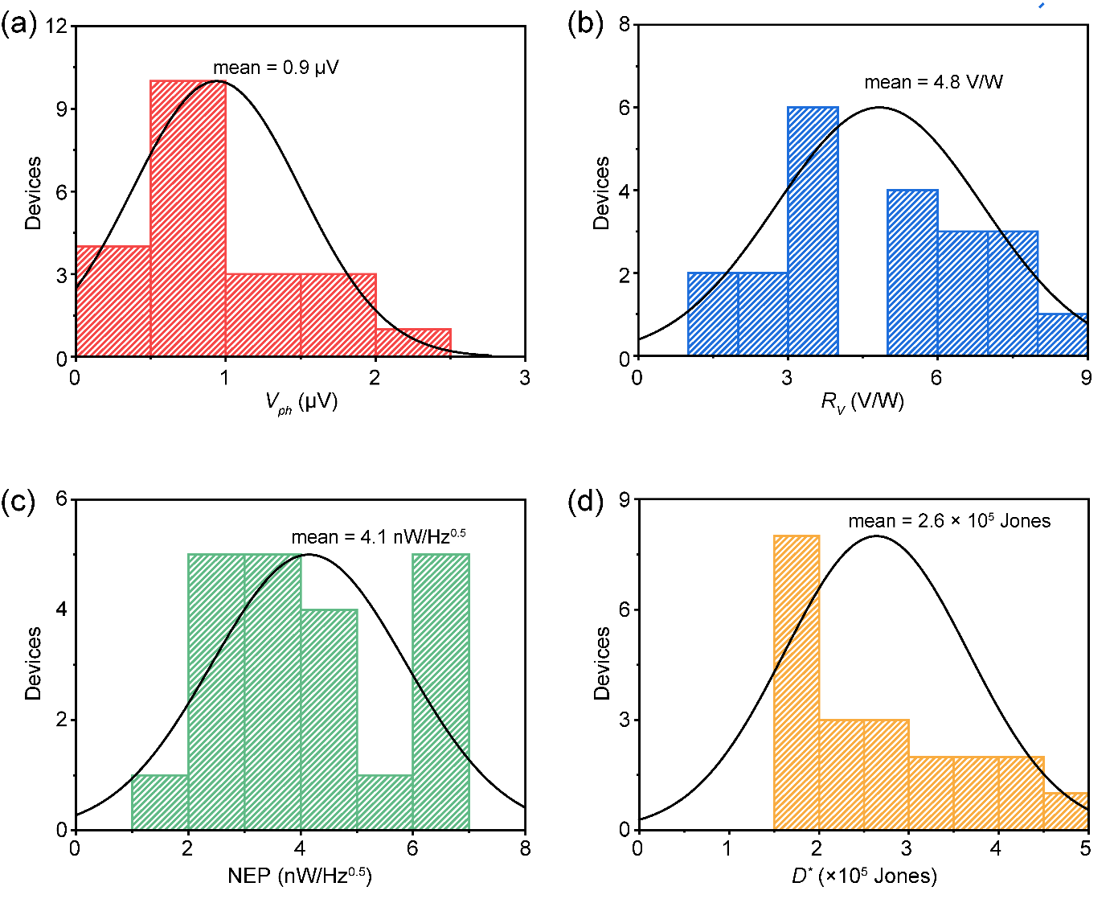
Fig. S6 Statistics on V_{ph} (a), R_{V} (b), NEP (c), and D* (d) of different devices.
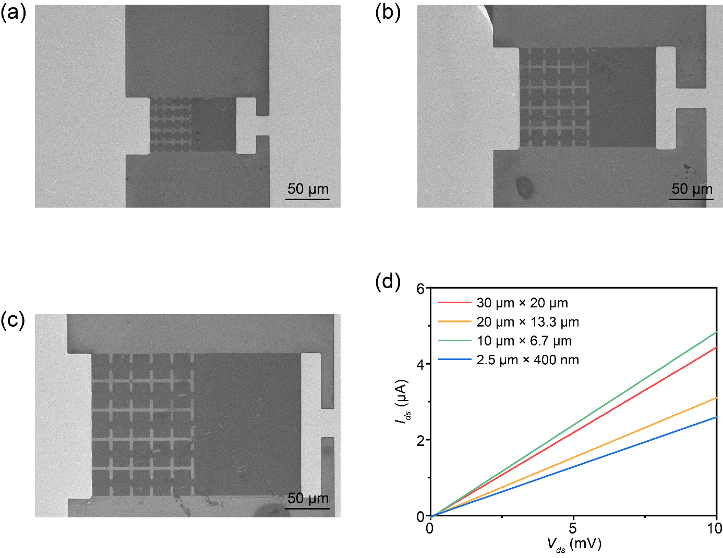
Fig. S7 Characterization of different PPAC detectors. a–c SEM images of devices with the PPAC unit sizes of 30 μm × 20 μm (a), 20 μm × 13.3 μm (b), 10 μm × 6.7 μm (c). d Current-voltage (I–V) characteristics of these devices.
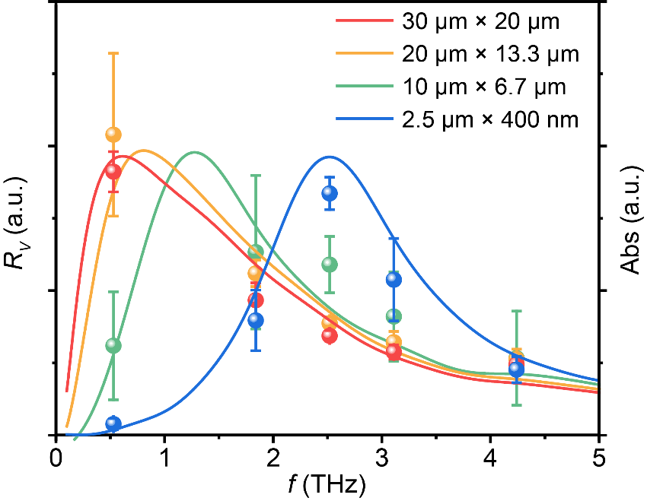
Fig. S8 Normalized frequency-selective photoresponses (dots) and simulated THz absorption (lines) of the devices with the PPAC unit sizes of 30 μm × 20 μm, 20 μm × 13.3 μm, 10 μm × 6.7 μm and 2.5 μm × 400 nm.

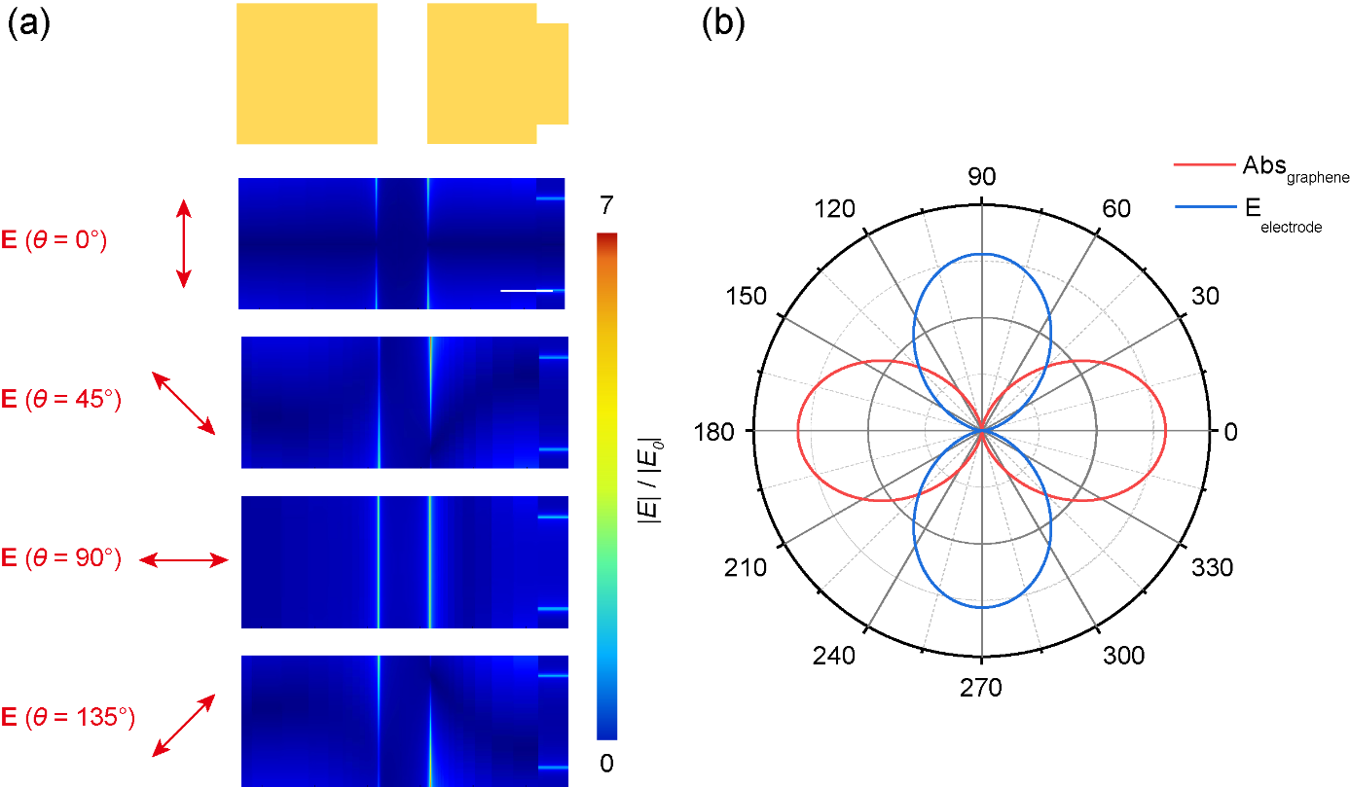
Fig. S9 Simulated polarization characteristics of electrodes and PPAC array. a Dependence of electromagnetic field distribution of the electrode on the polarization direction of the incident THz waves. Scale bar: 10 μm. b Polarization dependence of electrodes and PPAC array.

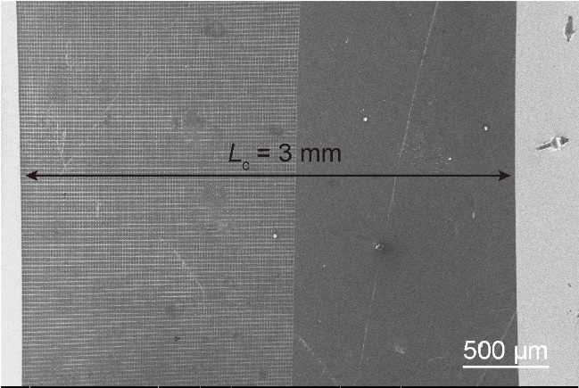
Fig. S10 The SEM image of PPAC detector with the channel length of 3 mm.

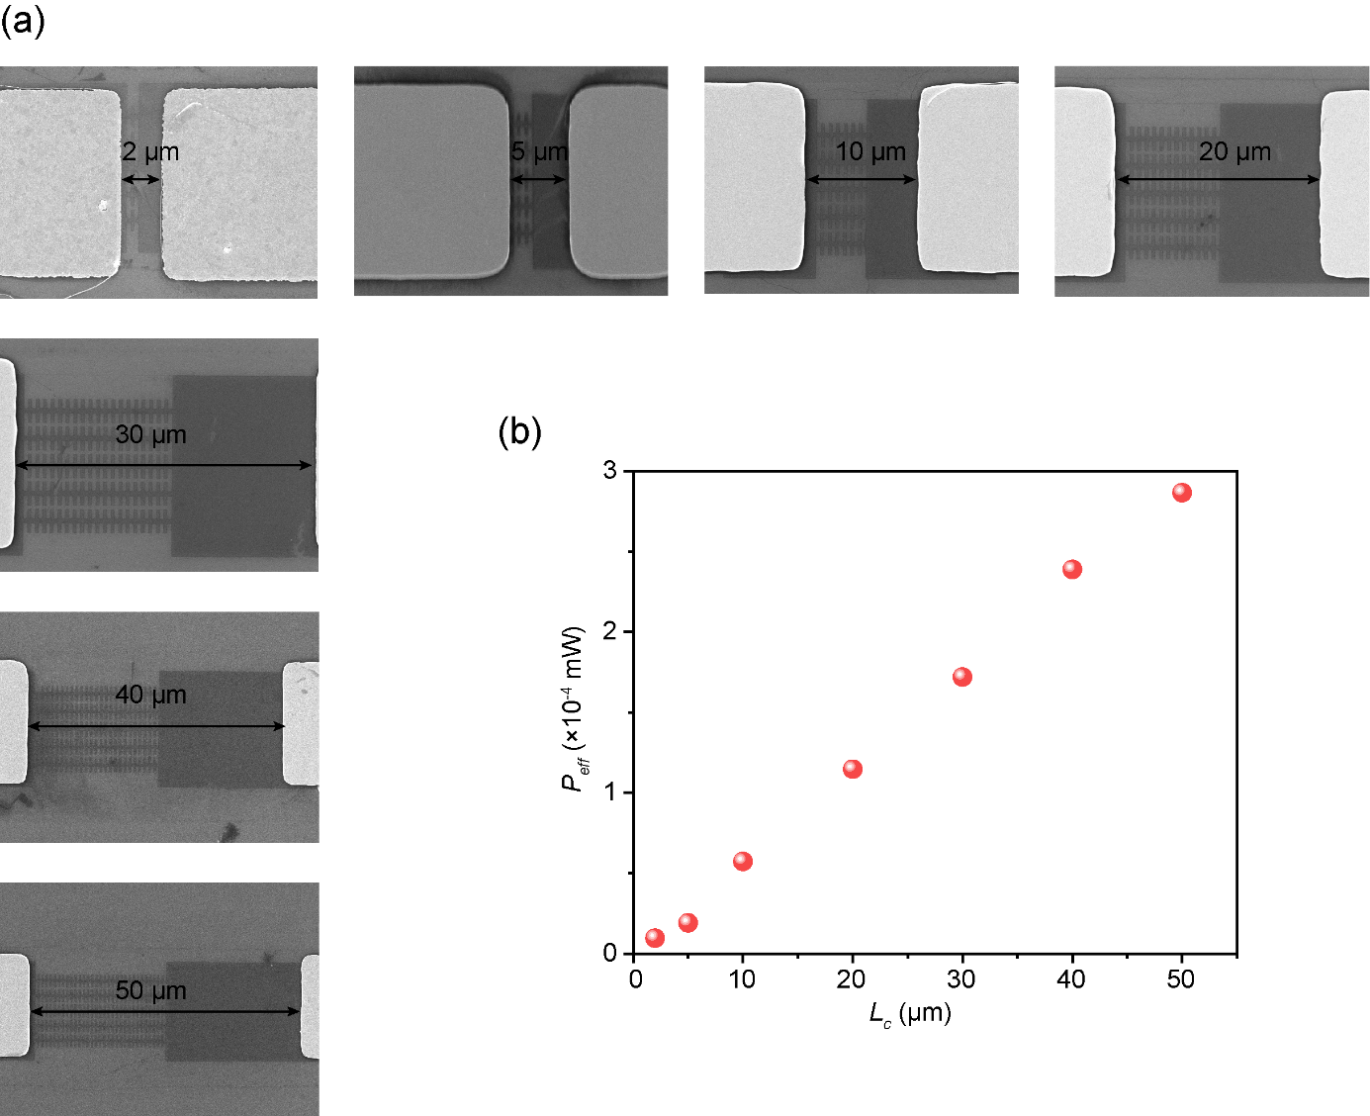
Fig. S11 a SEM images of PPAC nano-detectors with different channel lengths of 2 μm, 5 μm, 10 μm, 20 μm, 30 μm, 40 μm and 50 μm. b Effective power absorbed by PPAC nano-detectors with different channel lengths.

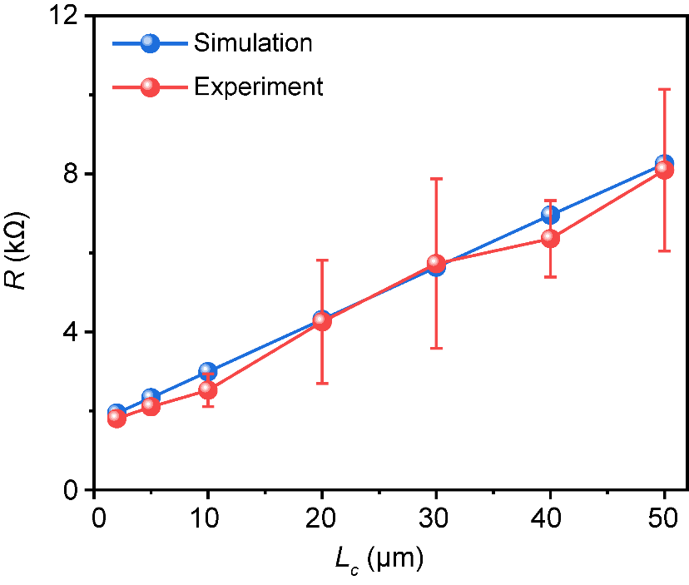
Fig. S12 Dependences of the resistance of PPAC nano-detectors on channel lengths. Red dots: experimental data. Blue dots: simulated data. Lines: guides for the eye.

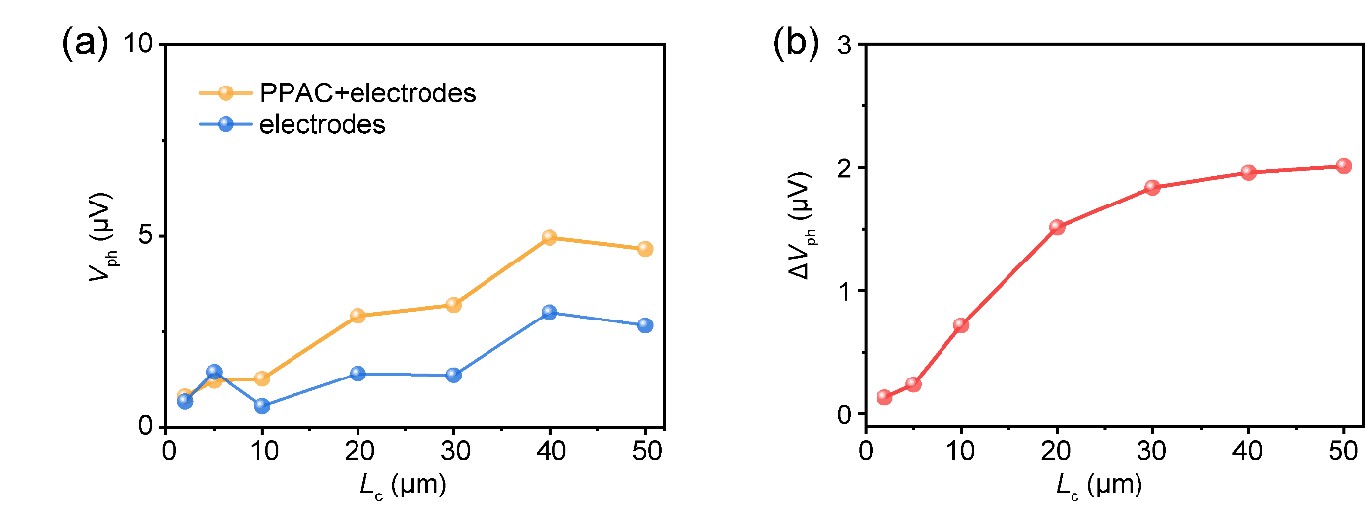
Fig. S13 a Dependences of simulated photovoltages of PPAC nano-detectors on channel lengths under configurations of electrodes combined with the PPAC array (orange dots) and electrodes only (blue dots). Lines: guides for the eye. b Dependences of simulated photovoltages difference obtained by subtracting the two curves in (a) on channel lengths.

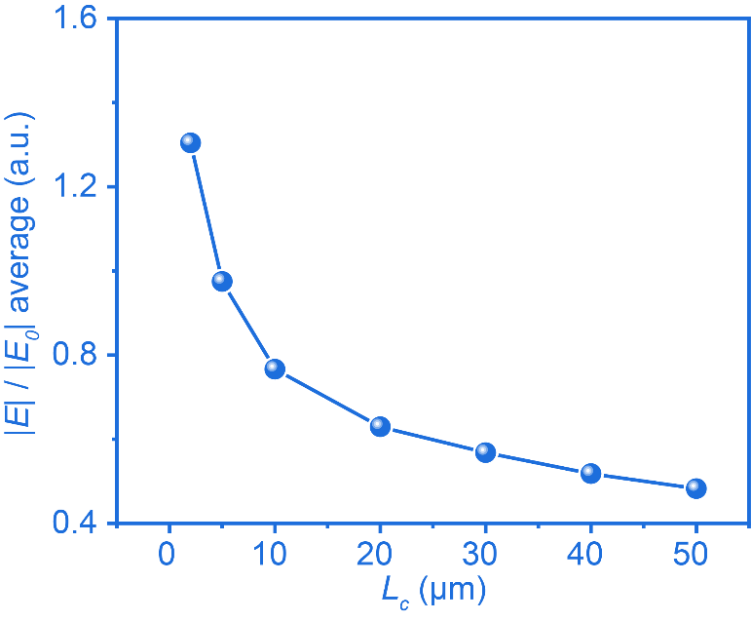
Fig. S14 Simulated electromagnetic field enhancements at different channel length at 2.52 THz. The average of localized field enhancement, |E|/|E₀|, is obtained by integrating the |E|/|E₀| over the entire channel area.

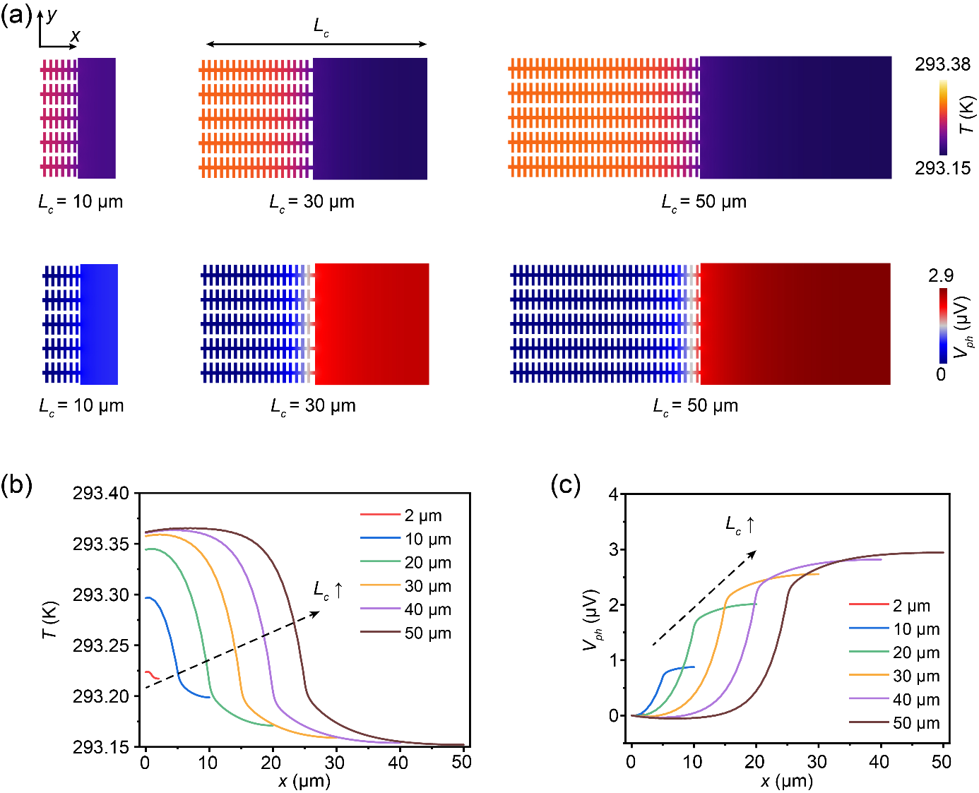
Fig. S15 a Simulated temperature distributions (top panel) and electric potential distributions (bottom panel) of the PPAC nano-detectors with different channel lengths of 10 μm, 30 μm, and 50 μm at 2.52 THz. b, c Position-dependent temperature (b) and electric potential (c) distributions of the devices with different channel lengths.

Fig. S16 Current noise power density of the PPAC nano-detector with channel lengths of 2 μm, 5 μm, 10 μm, 20 μm, 30 μm, 40 μm and 50 μm, respectively.

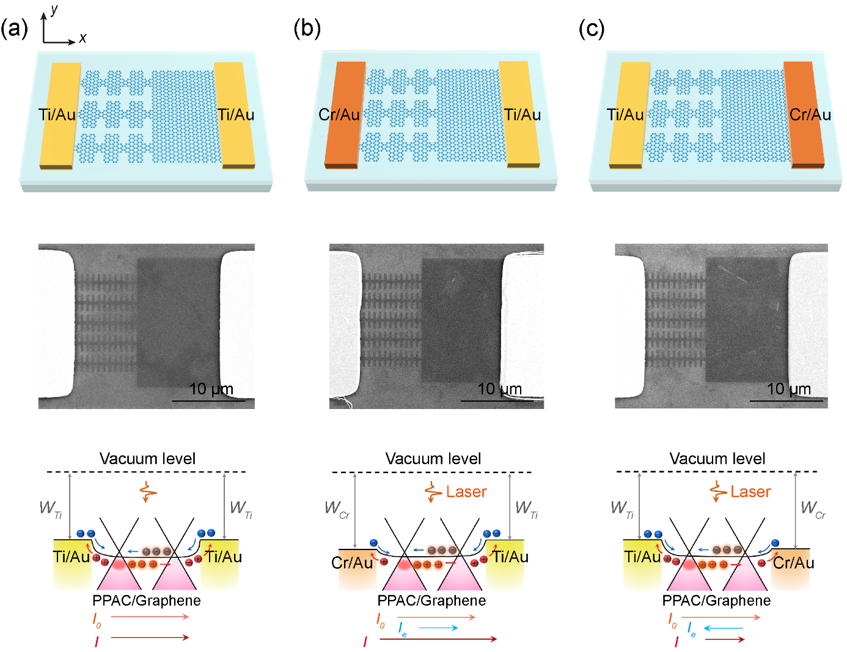
Fig. S17 Schematic diagrams (top panel), SEM images (middle panel) and band diagrams (bottom panel) of Ti/Au‒PPAC/graphene‒Ti/Au nano-detector (a), Cr/Au‒ PPAC/graphene‒Ti/Au nano-detector (b) and Ti/Au‒PPAC/graphene‒Cr/Au nano-detector (c).

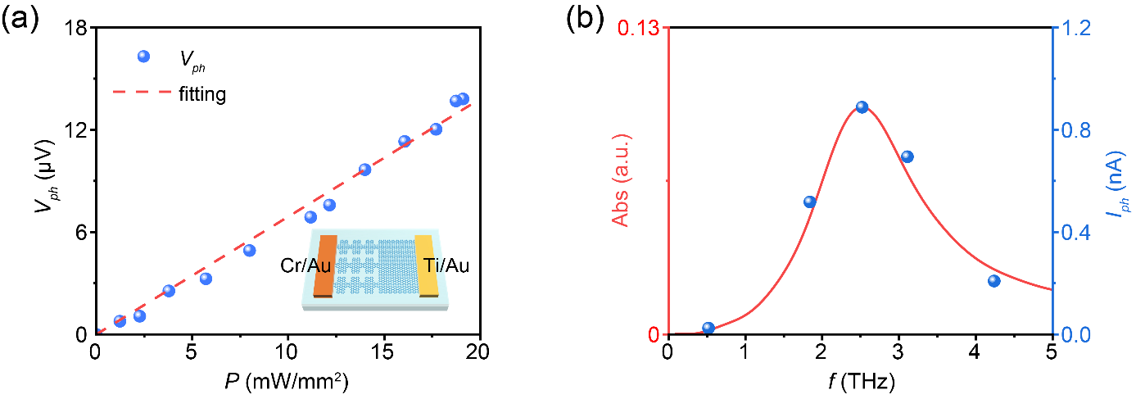
Fig. S18 a Dependence of the photovoltage on the illumination power of Cr/Au‒PPAC/graphene‒Ti/Au nano-detector. Dots: experimental results. Dashed lines: linear fittings. b Frequency-selective photoresponse (dots) and simulated THz absorption (lines) of the Cr/Au‒PPAC/graphene‒Ti/Au nano-detector.

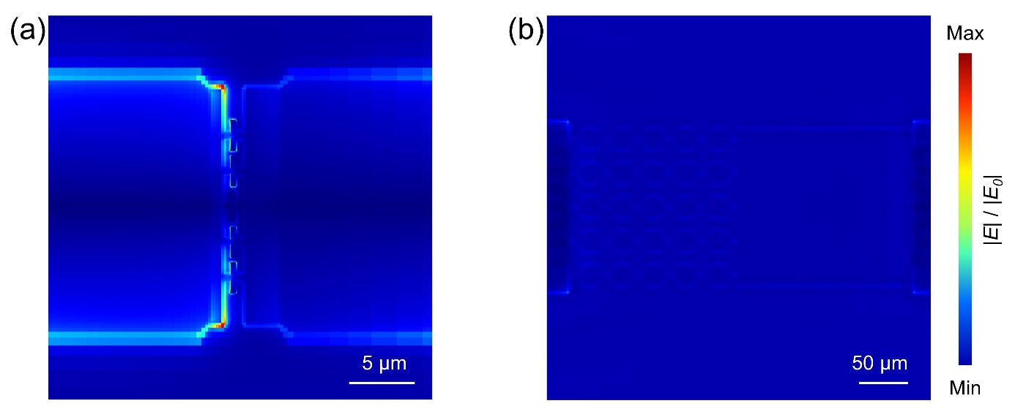
Fig. S19 Simulated electromagnetic field distributions of rectangle PPAC nano-detector (a) and disk-shaped PPAC detector we reported previously (b)⁴.

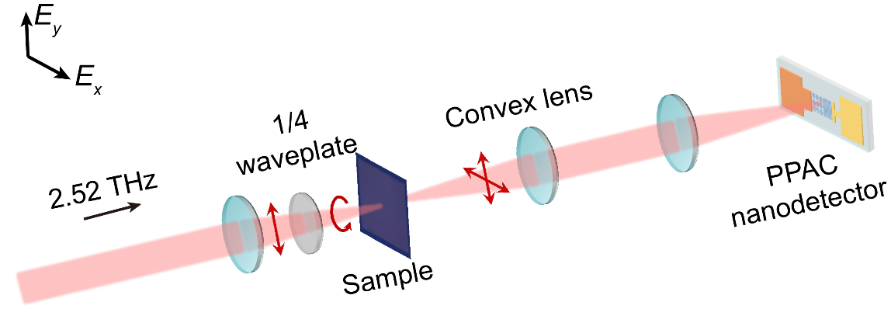
Fig. S20 Schematic showing the polarization-resolved dual-focus THz scanning imaging system.

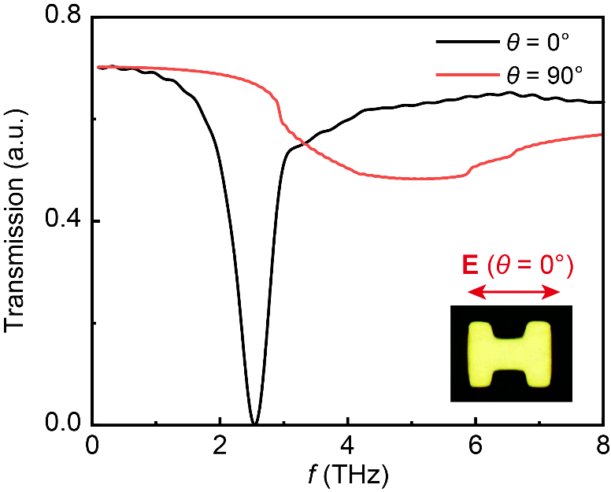
Fig. S21 Simulated transmission spectrum of the “H”-shaped microstructure array at the polarization angle θ of 0° and 90°.

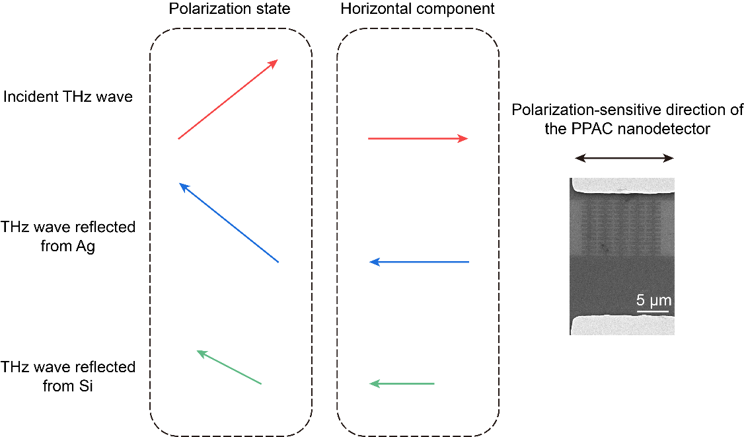
Fig. S22 Simulated polarization states and corresponding horizontal components at 2.52 THz for the incident wave and for the reflected waves from Ag and silicon surfaces.
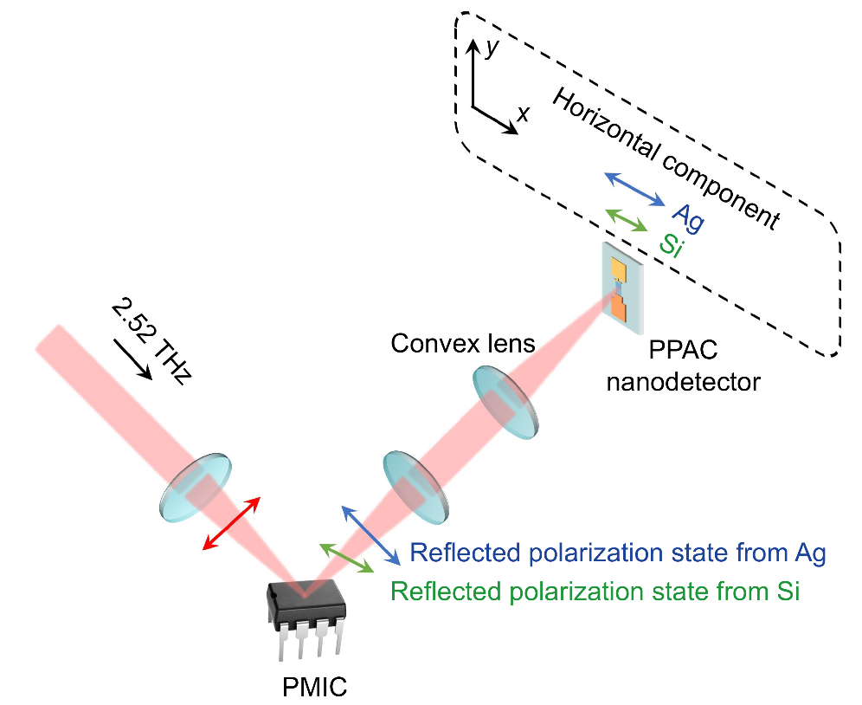
Fig. S23 Schematic showing the reflective dual-focus THz scanning imaging system.
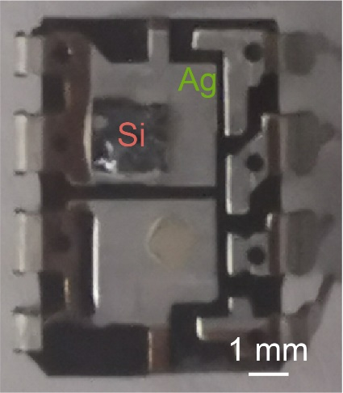
Fig. S24 Photograph of internal structure of the PMIC after removing the protected cap layer.

Table S1. Comparison of the photoresponse performances of the PPAC nano-detector with other THz detectors based on 2D materials.
Materials | Antenna/metamaterials | Frequency (THz) | Area  (μm²) | R_{V} (V/W) | NEP (W/Hz^{0.5}) | Polarization (PR_{device}) | Response time (s)
Graphene (This work) | No | 0.53–4.24 | 32 | 1007 (98) | 1.6 × 10⁻¹¹ (1.7 × 10⁻¹⁰) | Yes (9) | ~6.0 × 10⁻¹¹ (Simulated result)
Graphene (This work) | No | 0.53–4.24 | 320 | 7 (0.7) | 1.2 × 10⁻⁹ (1.2 × 10⁻⁸) | Yes (93) | 2.3 × 10⁻¹⁰
Graphene (Our previous work)⁴ | No | 0.22–4.24 | 209 | 12.7 | 2.8 × 10⁻⁹ | Yes (88) | 4.5 × 10⁻⁹
Graphene (Our previous work)⁵ | No | 0.25–3.11 | 600 | 0.396 | 8.6 × 10⁻⁹ | No | 8.0 × 10⁻⁴
Graphene⁶ | No | 2.52 | 9 | 715 (10) | 1.6 × 10⁻¹¹ (1.1 × 10⁻⁹) | No | 1.1 × 10⁻¹⁰
Graphene⁷ | No | 5.3, 7.4 | 4.0 × 10⁶ | - | - | Yes (-) | -
Graphene⁸ | Yes | 2.52 | 3.6 × 10⁵ | 0.364 | 1.3 × 10⁻⁸ | Yes (~1.4) | 3.8 × 10⁻⁴
Graphene⁹ | Yes | 2.52, 3.11 | ~4.9 × 10⁴ | 3.16 | 5.8 × 10⁻⁹ | Yes (115) | 2.5 × 10⁻⁵
Graphene¹⁰ | No | 1.63–3.11 | - | - | - | Yes (~11) | -
Graphene¹¹ | Yes | 2 | 1395 | 4.9 | 1.7 × 10⁻⁹ | Yes (~10) | -
Graphene¹² | Yes | 0.1−0.2 | - | 600 | 1.0 × 10⁻¹⁰ | No | 2.0 × 10⁻⁶
Graphene¹³ | Yes | 1.8−4.25 | ~8.9 × 10³ | 105 | 8.0 × 10⁻¹¹ | No | 3.0 × 10⁻⁸
Graphene¹⁴ | Yes | 3 | ~692 | 49 | 1.6 × 10⁻¹⁰ | Yes (-) | 3.3 × 10⁻⁹
Graphene¹⁵ | Yes | 2.8 | ~643 | 2 | 1.0 × 10⁻⁹ | No | 5.0 × 10⁻⁹
Graphene¹⁶ | Yes | 0.3 | ~1.6 × 10⁵ | 0.15 | 2.0 × 10⁻⁷ | Yes (~30) | -
Graphene¹⁷ | Yes | 0.29−0.38 | ~2.7 × 10⁵ | 1.2 | 2.0 × 10⁻⁹ | No | -
Graphene¹⁸ | Yes | 0.1−0.685 | ~2.3 × 10⁴ | 764 | 3.4 × 10⁻¹¹ | Yes (~10) | -
Graphene¹⁹ | Yes | 0.25−0.37 | ~2.5 × 10⁵ | 30 | 5.1 × 10⁻¹¹ | No | -
Graphene²⁰ | Yes | 0.13−2.0 | ~2.5 × 10⁵ | ~10 | 2.0 × 10⁻¹³ | No | -
Graphene²¹ | Yes | 0.3 | ~310 | ~4.75 | 6.7 × 10⁻¹⁰ | No | -
Graphene²² | Yes | 1.98, 4.4 | ~2.5 × 10⁵ | ~1.4 × 10⁻⁶ | - | Yes (~3) | 5.0 × 10⁻¹¹
Graphene²³ | Yes | 0.13 | ~2.7 × 10⁵ | 5.0 × 10⁴  (T = 25 K) | 3.6 × 10⁻¹⁴ | No | -
Graphene²⁴ | Yes | 0.13 | ~5.7 × 10⁵ | 4.0× 10³  (T = 10 K) | 2.0 × 10⁻¹³ | No | -
MoSe₂²⁵ | No | 0.29 | 2.3 × 10⁵ | 0.038 | 3.1 × 10⁻⁶ | No | -
MoS₂²⁶ | No | 2.52 | 5400 | ~76.56 | - | No | 5.12
1T-TaS₂²⁷ | No | 1.84‒3.11 | - | ~24‒480 | 4.0 × 10⁻¹⁰ | No | 1.5 × 10⁻⁹
1T-TiSe₂²⁸ | No | 0.14‒0.33 | 60 | 2.5 × 10⁶  (T = 70 K) | 3.6 × 10⁻¹⁴ | No | 5.5× 10⁻⁵
Bi₂Te₂₂Se_{0.8}  ²⁹ | Yes | 0.29‒0.33 | ~8.0 × 10⁵ | 3 | 1.0 × 10⁻⁸ | No | -
Bi₂Se₃³⁰ | Yes | 0.12‒0.3 | - | ~1.4 × 10⁵ | 3.6 × 10⁻¹³ | Yes (~1) | < 6.0 × 10⁻²
2H-TaSe₂³¹ | Yes | 0.12 | 1.8 × 10⁵ | 27 | 1.0 × 10⁻⁹ | No | 1.4 × 10⁻⁵
Sb₂Te₃³² | Yes | 0.02‒0.3 | 3.1 × 10⁴ | ~9.6 | 3.5 × 10⁻⁸ | Yes (1200) | 2.2 × 10⁻⁵
NbIrTe₄³³ | Yes | 0.1 | - | 5.7 × 10⁴ | 5.1 × 10⁻¹¹ | Yes (40.9) | 1.1 × 10⁻⁵
PtTe₂³⁴ | Yes | 0.12 | 4800 | 101 | - | No | ＜ 2.0 × 10⁻⁵
BP³⁵ | Yes | 0.12‒0.29 | 2.8 × 10⁴ | 297 | 5.8 × 10⁻¹¹ | Yes (120) | ＜ 8.0 × 10⁻⁴
PdTe₂³⁶ | Yes | 0.12‒0.3 | 1.3 × 10⁵ | ~2000 | < 2.0 × 10⁻¹² | Yes (6) | 1.0 × 10⁻⁶
WTe₂³⁷ | Yes | 0.1‒0.28 | 1.0 × 10⁶ | 1.5 × 10⁸ | 4.0 × 10⁻¹³ | No | 0.098
Bi₂O₂Se³⁸ | Yes | 0.17 | 8.0 × 10⁴ | 2.7 × 10⁴ | 2.0 × 10⁻¹¹ | Yes (117) | 4.8 × 10⁻⁹
Te³⁹ | Yes | 0.172‒0.305 | - | ~1.8 × 10⁵ | 7.6 × 10⁻¹⁴ | Yes (468) | 4.7 × 10⁻⁶
NbSe₂⁴⁰ | Yes | 0.165‒0.259 | 32 | 7.8 × 10⁶ | 4.6 × 10⁻¹⁴ | Yes (48) | ∼6.1 × 10⁻⁷
PtSe₂⁴¹ | Yes | 0.1‒0.3 | 1500 | ~7.2 × 10⁴ | 3.8 × 10⁻¹¹ | No | <2.0× 10⁻⁶
References
1. Haus, H. Prentice-Hall Series in Solid State Physical Electronics. Prentice-Hall, 1984.
2. Zhu, H., et al. A universal approach for maximizing terahertz wave absorption in graphene cut-wires. Front. Mater. 8, 737347 (2021).
3. Soundarapandian, K. P., et al. High-speed graphene-based sub-terahertz receivers enabling wireless communications for 6G and beyond. Nat. Commun. 17, 2627 (2026).
4. Chen, H., et al. Monolithic multiparameter terahertz nano/microdetector based on plasmon polariton atomic cavity. Adv. Mater. 37, 2410946 (2025).
5. Liu, S., et al. A flexible and wearable photodetector enabling ultra-broadband imaging from ultraviolet to millimeter-wave regimes. Adv. Sci. 11, 2401631 (2024).
6. Cai, X., et al. Sensitive room-temperature terahertz detection via the photothermoelectric effect in graphene. Nat. Nanotechnol. 9, 814–819 (2014).
7. Cai, X. et al. Plasmon-enhanced terahertz photodetection in graphene. Nano Lett. 15, 4295–4302 (2015).
8. Chen, M., Wang, Y. & Zhao, Z. Localized electromagnetic resonance enabled THz photothermoelectric detection in graphene. Front. Phys. 8, 216 (2020).
9. Chen, M., Wang, Y. & Zhao, Z. Monolithic metamaterial-integrated graphene terahertz photodetector with wavelength and polarization selectivity. ACS Nano 16, 17263–17273 (2022).
10. Muraviev, A. V. et al. Plasmonic and bolometric terahertz detection by graphene field-effect transistor. Appl. Phys. Lett. 103, 181114 (2013).
11. Tong, J. et al. Antenna enhanced graphene THz emitter and detector. Nano Lett. 15, 5295–5301 (2015).
12. Liu, C. et al. Room-temperature high-gain long-wavelength photodetector via optical-electrical controlling of hot carriers in graphene. Adv. Opt. Mater. 6, 1800836 (2018).
13. Castilla, S., et al. Fast and sensitive terahertz detection using an antenna-integrated graphene pn junction. Nano Lett. 19, 2765–2773 (2019).
14. Viti, L., et al. HBN-encapsulated, graphene-based, room-temperature terahertz receivers, with high speed and low noise. Nano Lett. 20, 3169–3177 (2020).
15. Asgari, M., et al. Chip-scalable, room-temperature, zero-bias, graphene-based terahertz detectors with nanosecond response time. ACS Nano 15, 17966–17976 (2021).
16. Vicarelli, L., et al. Graphene field-effect transistors as room-temperature terahertz detectors. Nat. Mater. 11, 865–871 (2012).
17. Spirito, D. et al. High performance bilayer-graphene terahertz detectors. Appl. Phys. Lett. 104, 061111 (2014).
18. Auton, G., et al. Terahertz detection and imaging using graphene ballistic rectifiers. Nano Lett. 17, 7015–7020 (2017).
19. Qin, H., et al. Room-temperature, low-impedance and high-sensitivity terahertz direct detector based on bilayer graphene field-effect transistor. Carbon 116, 760–765 (2017).
20. Bandurin, D. A., et al. Resonant terahertz detection using graphene plasmons. Nat. Commun. 9, 5392 (2018).
21. Delgado-Notario, J. A. et al. Enhanced terahertz detection of multigate graphene nanostructures. Nanophotonics 11, 519–529 (2022).
22. Mittendorff, M. et al. Ultrafast graphene-based broadband THz detector. Appl. Phys. Lett. 103, 021113 (2013).
23. Titova, E. et al. Ultralow-noise terahertz detection by p–n junctions in gapped bilayer graphene. ACS Nano, 17, 8223–8232 (2023).
24. Gayduchenko, I., et al. Tunnel field-effect transistors for sensitive terahertz detection. Nat. Commun. 12, 543 (2021).
25. Liu, H., et al. Terahertz photodetector arrays based on large scale MoSe₂ monolayer . J. Mater. Chem. C 4, 9399–9404 (2016).
26. Xie, Y., et al. Defect engineering of MoS₂ for room-temperature terahertz photodetection. ACS Appl. Mater. Interfaces 12, 7351–7357 (2020).
27. Wu, D. et al. Ultrabroadband photosensitivity from visible to terahertz at room temperature. Sci. Adv. 4, eaao3057 (2018).
28. Wu, T. et al. High sensitivity of semimetal photodetection via Bose–Einstein condensation. InfoMat 6, e12492 (2024).
29. Viti, L. et al. Plasma-wave terahertz detection mediated by topological insulators surface states. Nano Lett. 16, 80–87 (2016).
30. Tang, W. et al. Ultrasensitive room-temperature terahertz direct detection based on a bismuth selenide topological insulator. Adv. Funct. Mater. 28, 1801786 (2018).
31. Wang, J., et al. Tunable 2H–TaSe₂ room-temperature terahertz photodetector. Chin. Phys. B 28, 046802 (2019).
32. Zhang, S., et al. High-frequency enhanced response based on Sb₂Te₃ topological insulators. Photonics Res. 10, 2302–2308 (2022).
33. Zhang, J., et al. Colossal room-temperature terahertz topological response in type-II Weyl semimetal NbIrTe₄. Adv. Mater. 34, 2204621 (2022).
34. Xu, H., et al. PtTe₂-based type-II Dirac semimetal and its van der Waals heterostructure for sensitive room temperature terahertz photodetection. Small 15, 1903362 (2019).
35. Guo, W., et al. Sensitive terahertz detection and imaging driven by the photothermoelectric effect in ultrashort-channel black phosphorus devices. Adv. Sci. 7, 1902699 (2020).
36. Guo, C., et al. Anisotropic ultrasensitive PdTe₂-based phototransistor for room-temperature long-wavelength detection. Sci. Adv. 6, eabb6500 (2020).
37. Song, Q., et al. Large area flexible thin layer terahertz detector. Adv. Electron. Mater. 9, 2300149 (2023).
38. Chen, Y., et al. Broadband Bi₂O₂Se photodetectors from infrared to terahertz. Adv. Funct. Mater. 31, 2009554 (2021).
39. Ma, W. et al. Ultrabroadband tellurium photoelectric detector from visible to millimeter wave. Adv. Sci. 9, 2103873 (2022).
40. Li, J., et al. High performance of room-temperature NbSe₂ terahertz photoelectric detector. ACS Appl. Mater. Interfaces 14, 14331–14341 (2022).
41. Wang, L., et al. Hybrid Dirac semimetal-based photodetector with efficient low-energy photon harvesting. Light-Sci. Appl. 11, 53 (2022).

