Supplemental Figure 1. Longitudinal genus-level composition of Muribaculaceae during tacrolimus-associated microbiome succession. Muribaculaceae features aggregated at the genus level. Bars show relative abundance of individual Muribaculaceae genera at days 0, 3, 7, 14, 21, 28, 35, and 40 after cardiac transplantation under daily tacrolimus treatment.
Supplemental Figure 2. Longitudinal remodeling and taxonomic attribution of choline- and phosphatidylcholine-associated microbial functions during chronic tacrolimus treatment. Longitudinal fecal metagenomes from tacrolimus-only treated mice analyzed with HUMAnN4 to relate microbial functional profiles to taxonomic succession. (A) Longitudinal abundance trajectories of acetylcholinesterase, choline kinase, choline sulfatase, and phosphatidylcholine acyl editing across the post-transplant time course. (B) Stratified contributor analysis showing the microbial lineages contributing to each function. Bar length indicates abundance contributed by each taxonomic lineage to the indicated function.
Supplemental Figure 3. Longitudinal convergence of microbial functional and taxonomic profiles during chronic tacrolimus treatment. Bray-Curtis dissimilarities calculated from HUMAnN4 pathway profiles (left) and family-level taxonomic profiles (right) and visualized by principal coordinate analysis. Points represent day-specific community centroids, colored by sampling day, and connected in temporal order from day 0 through day 40.
Supplemental Figure 4. Time-dependent remodeling of the intestinal luminal and serum metabolomes after cardiac transplantation under chronic tacrolimus treatment. Unsupervised hierarchical clustering of normalized metabolite abundance in (A) ileal intraluminal contents and (B) serum collected at day 0, after antibiotic conditioning but before transplantation and tacrolimus initiation, and at days 3 and 40 after transplantation. Heatmap values show row-scaled normalized abundance, with red indicating higher and blue indicating lower relative abundance for each metabolite.
Supplemental Figure 5. Representative longitudinal metabolite changes in the intestinal lumen and circulation after cardiac transplantation under chronic tacrolimus treatment. Boxplots show normalized metabolite abundance at day 0, after antibiotic conditioning but before transplantation and tacrolimus initiation, and at days 3 and 40 after transplantation. (A) Ileal intraluminal metabolites. (B) Serum metabolites. Differences across time points assessed by one-way ANOVA with Tukey HSD post hoc pairwise comparisons and Benjamini–Hochberg correction across metabolites. Asterisks denote significant pairwise differences: *P < 0.05, **P < 0.01, ***P < 0.001.
Supplemental Figure 6. Ordination of gut microbial community structure after bacterial supplementation under chronic tacrolimus treatment. Principal coordinate analysis of Bray-Curtis dissimilarities performed on longitudinal fecal microbiome profiles from cardiac allograft recipients treated with chronic tacrolimus and gavaged with PBS control (Ctl), Bifido, or Desulfo. Each panel shows samples collected at the indicated time point from day 0 to day 40; each point represents an individual mouse. Colors and symbols denote treatment groups.
Supplemental Figure 7. Longitudinal microbiome remodeling after bacterial supplementation under chronic tacrolimus treatment. Species-level fecal microbiome profiles from cardiac allograft recipients treated with chronic tacrolimus and gavaged with PBS control (Ctl, tacrolimus-only), Bifido, or Desulfo shown as a longitudinal heatmap. Columns grouped by treatment and ordered by sampling day, rows represent bacterial species. Heatmap colors indicate scaled relative abundance; red and blue denoting higher and lower abundance, respectively.
Supplemental Figure 8. Longitudinal differential-abundance analysis identifies Bifido-associated remodeling of the tacrolimus-conditioned gut microbiome. Genus- and species-level differential abundance across longitudinal fecal metagenomes analyzed using MicrobiomeStat to fit taxon-specific mixed-effects models incorporating sampling time, treatment group, subject, and group × time effects. Pairwise treatment contrasts shown for (A) Bifido versus tacrolimus-only control (Ctl), and (B) Desulfo versus Bifido. Each point represents a microbial taxon; x-axis shows estimated coefficient; y-axis shows −log10(P value). Negative coefficients indicate enrichment in the first named group of each comparison, whereas positive coefficients indicate enrichment in the second named. Point size represents mean relative abundance; color intensity represents prevalence across samples. Selected taxa with significant group-associated effects are labeled.
Supplemental Figure 9. Reproducible microbiome remodeling after Bifido gavage under chronic tacrolimus treatment. (A–B) Longitudinal taxonomic profiles from two independent cardiac-transplant experiments showing genus-, family-, and order-level changes within Actinobacteriota, Bacteroidota, and Firmicutes after Bifido gavage. Performed in an independent mice cohort under identical transplantation, antibiotic-conditioning, and chronic tacrolimus conditions as in Figure 4A. (C) Relative abundance of selected bacterial taxa in mice gavaged with B. pseudolongum subsp globosum ATCC25526, UMB-MBP-01 (Bifido), Desulfo, or PBS control, adapted from our prior study with antibiotic-conditioned, non-transplanted mice receiving tacrolimus for two days [26].
Supplemental Figure 10. Spatial annotation of apical and basal intestinal compartments across all Visium tissue sections. All ileal and colonic sections included in the spatial transcriptomic analysis shown with Visium spots projected onto the matched tissue images; tissue, treatment group, and compartment assignments indicated. Unsupervised k-means clustering (k = 2) separated spots into two spatial transcriptomic clusters, assigned as apical layers (cluster 1, red) and basal layers (cluster 2, blue) based on their localization relative to the luminal and crypt/basal regions. These cluster assignments used for subsequent compartment-stratified gene-expression and pathway analyses.
Supplemental Figure 11. Variance partitioning of MSigDB Hallmark module scores across intestinal compartment, tissue, and treatment group. Mouse-level pseudobulk expression profiles used to score all 50 MSigDB Hallmark gene sets across 30 tissue and compartment samples. For each module, variance attributable to compartment, tissue, and treatment group estimated using a main-effects linear model and partial Type II sums of squares. Stacked bars show the percentage of variance attributed to compartment, tissue, group, and residual variation.
Supplemental Figure 12. Spatial and temporal transcriptional responses of sterol-bile acid-peroxisomal and antioxidant programs. Dot plots show gene-level differential expression for cholesterol homeostasis, peroxisome, bile acid metabolism, and reactive oxygen species (ROS) modules across ileal and colonic apical and basal compartments. Dot color represents log2 fold change; red indicating higher expression in TAC, blue indicating lower expression in TAC; dot size represents −log10 Benjamini–Hochberg-adjusted P value.
Supplemental Figure 13. STRING network of the cholesterol-homeostasis program in the colonic apical compartment at day 3. STRING functional-association analysis of cholesterol-homeostasis genes altered in TAC-versus-baseline (Abx) or TAC-versus-Bifido contrasts. Each node split to show log2 fold change for TAC versus Abx (left) and TAC versus Bifido (right); red indicates higher expression in TAC, blue indicates lower expression in TAC. Node size reflects −log10 adjusted P value for the more significant contrast, and edge width reflects STRING association confidence. STRING functional-association networks generated for significant module genes restricted to Mus musculus, retaining interactions with a combined confidence score ≥0.4.
Supplemental Figure 14. Spatially resolved transcriptional responses in signaling, fatty acid metabolism, and stromal-remodeling programs. Dot plots show gene-level differential expression for selected transcriptional modules in spatially defined intestinal compartments. (A) Protein secretion and PI3K-AKT-mTOR signaling modules in the colonic apical compartment at day 3. (B) Fatty acid metabolism in the ileal basal compartment at day 40. (C) EMT/extracellular matrix (ECM) stromal-remodeling program in the colonic basal compartment at day 3. For each panel, the two rows show tacrolimus-only PBS control (Ctl) versus Bifido and Ctl versus the post-antibiotic pretreatment baseline (Abx), respectively. Dot color represents log2 fold change, with red indicating higher expression in Ctl and blue indicating lower expression in Ctl relative to the indicated comparison group; dot size represents −log10 Benjamini–Hochberg-adjusted p value.
Supplemental Figure 15. (A) Representative immunohistochemistry sections of Foxp3⁺ Treg localization within pLN at day 3 and day 40. (B) Representative immunohistochemistry sections of Foxp3⁺ Treg localization within mLN at day 3 and day 40. (C) Representative immunohistochemistry sections of CD4⁺, Foxp3⁺, and CD8⁺ T-cell infiltration within cardiac allografts at day 3 and day 40. Scale bar, 42 μm. (D) Representative immunohistochemistry sections showing laminin α4 and laminin α5 organization within cardiac allografts from TAC control and Bifido-treated mice at day 3 and day 40. Scale bar, 42 μm.
Supplemental Figure 16. (A) Representative immunohistochemistry sections of CD4⁺, Foxp3⁺, and CD8⁺ T-cell infiltration within cardiac allografts. (B) Representative immunohistochemistry sections of laminin α4:α5 ratios in the pLN. Scale bar is 42 μm.
Supplemental Figure 17. Longitudinal taxonomic trajectories distinguish CAV-associated from non-CAV and healthy-control FMT microbiota. (A) Change in genus-level CAV enrichment or depletion from day 7 to day 60. Correlation effects with CAV calculated as log2 ratios of mean abundance in CAV-FMT recipients relative to the mean of non-CAV- and healthy-control-FMT recipients. Open points indicate day 7 and filled arrowheads day 60; positive values indicate CAV enrichment and negative values CAV depletion. Arrow color denotes strengthening or weakening of enrichment or depletion; gray indicates reversal across zero. Point size represents −log10 Benjamini–Hochberg-adjusted FDR. (B) Longitudinal trajectories of selected CAV-enriched genera identified by a group-by-time mixed-effects analysis. Displayed genera met prespecified criteria of FDR <0.05, >1.5-fold mean enrichment in CAV, and mean CAV abundance ≥0.1%. Thin lines show individual mice; thick lines show group means and error bars indicate mean ± SE. (C) Species-resolved Bifido trajectories across healthy-control-, non-CAV-, and CAV-FMT recipients at days 0, 7, 28, and 60. Thin lines represent individual mice and thick lines group means.
Supplemental Figure 18. Microbial pathways associated with CAV and non-CAV post-FMT functional states. (A) Microbial pathways associated with CAV-FMT recipients across post-FMT days 7, 28, and 60. For each HUMAnN pathway, log10-transformed relative abundance modeled using a mixed-effects model comparing CAV FMT with the combined non-CAV and healthy-control FMT groups, adjusting for sampling day and repeated measurements within mouse. The x-axis shows the adjusted post-FMT group effect; positive values indicate higher abundance in CAV-FMT recipients and negative values indicate lower abundance. (B) Microbial pathways associated with non-CAV-FMT recipients using the same mixed-effects framework, comparing non-CAV FMT with the combined CAV and healthy-control FMT groups. Positive and negative effects indicate higher and lower pathway abundance, respectively, in non-CAV-FMT recipients; point size represents −log10 Benjamini-Hochberg-adjusted FDR.
Supplemental Table 1. Longitudinal fecal microbiome profiles following cardiac transplantation under chronic tacrolimus treatment. Relative abundances of amplicon sequence variants (ASVs) in fecal samples collected longitudinally from tacrolimus-treated cardiac allograft recipients. (A) Sample-by-ASV relative abundance profiles; (B) taxonomic assignments from kingdom to species for the corresponding ASVs.
Supplemental Table 2. Longitudinal ileal intraluminal and serum metabolomic profiles after cardiac transplantation under chronic tacrolimus treatment. (A) Ileal intraluminal metabolite profiles at day 0, after antibiotic conditioning but before transplantation and tacrolimus treatment, and at days 3 and 40 after transplantation during daily tacrolimus treatment. (B) Corresponding serum metabolite profiles. (C) One-way ANOVA results comparing ileal intraluminal metabolite levels across day 0, day 3, and day 40, including the F statistic, df1 and df2, raw P value, and Benjamini-Hochberg false discovery rate (FDR)-adjusted P value. (D) Corresponding ANOVA results for serum metabolites. Tukey’s honestly significant difference (HSD) test was used for post hoc pairwise comparisons for (E) ileal intraluminal and (F) serum metabolites. Metabolites with FDR-adjusted P < 0.05 were considered significant.
Supplemental Table 3. Metabolomic profiles and longitudinal analysis following bacterial intervention under chronic tacrolimus treatment. (A) Ileal intraluminal metabolite profiles at days 3 and 40 after oral gavage with Bifidobacterium pseudolongum (Bifido), Desulfovibrio desulfuricans (Desulfo), or PBS control (tacrolimus-only, TAC) in cardiac allograft recipients maintained on daily tacrolimus. (B) Corresponding serum metabolite profiles, including the shared day 0 baseline after antibiotic conditioning and before bacterial gavage, transplantation, and tacrolimus treatment, and profiles at days 3 and 40 after treatment. (C) Longitudinal analysis of metabolites across the shared day 0 baseline and post-gavage days 3 and 40. Models tested the effects of treatment group, day, and the group-by-day interaction. Raw P values and Benjamini–Hochberg false discovery rate (FDR)-adjusted q values are reported for each effect.
Supplemental Table 4. Variance partitioning of Hallmark transcriptional module scores across intestinal spatial compartments, tissues, and treatment groups. (A) Metadata for each sample. (B) All 50 MSigDB Hallmark gene sets were scored using mouse-level pseudobulk spatial transcriptomic profiles. For each module, a linear model was used to partition the total variance in module score among epithelial compartment (apical versus basal), tissue (ileum versus colon), and treatment group, with the remaining variance reported as residual. Values indicate the percentage of total module-score variance attributable to each factor.
Supplemental Table 5. Primary antibodies and isotype controls used in this study.
Target Molecule | Clone | Catalog No. | Dilution
Anti-Goat IgG-Rhodamine RedX | Polyclonal | Jackson ImmunoResearch; 705-296-147 | 1:800
Anti-Rabbit IgG-AF647 | Polyclonal | Jackson ImmunoResearch; 711-606-152 | 1:800
Anti-Rat IgG AF488 | Polyclonal | Jackson ImmunoResearch; 712-546-153 | 1:800
Anti-Rat IgG-Rhodamine Red-X | Polyclonal | Jackson ImmunoResearch; 712-296-150 | 1:800
CD4 | GK1.5 | Biolegend; 100424 | 1:100
CD8 | 53-6.7 | Biolegend; 100723 | 1:100
ER-TR7 | Polyclonal | Santa Cruz; SC-73355 | 1:200
Foxp3 | NRRF-30 | eBioSci; 14-4771-37 | 1:200
Laminin 𝛼4 | Polyclonal | R&D; AF3837 | 1:200
Laminin 𝛼5 | Polyclonal | Sigma; SAB4501720 | 1:200

Supplemental Figure 1
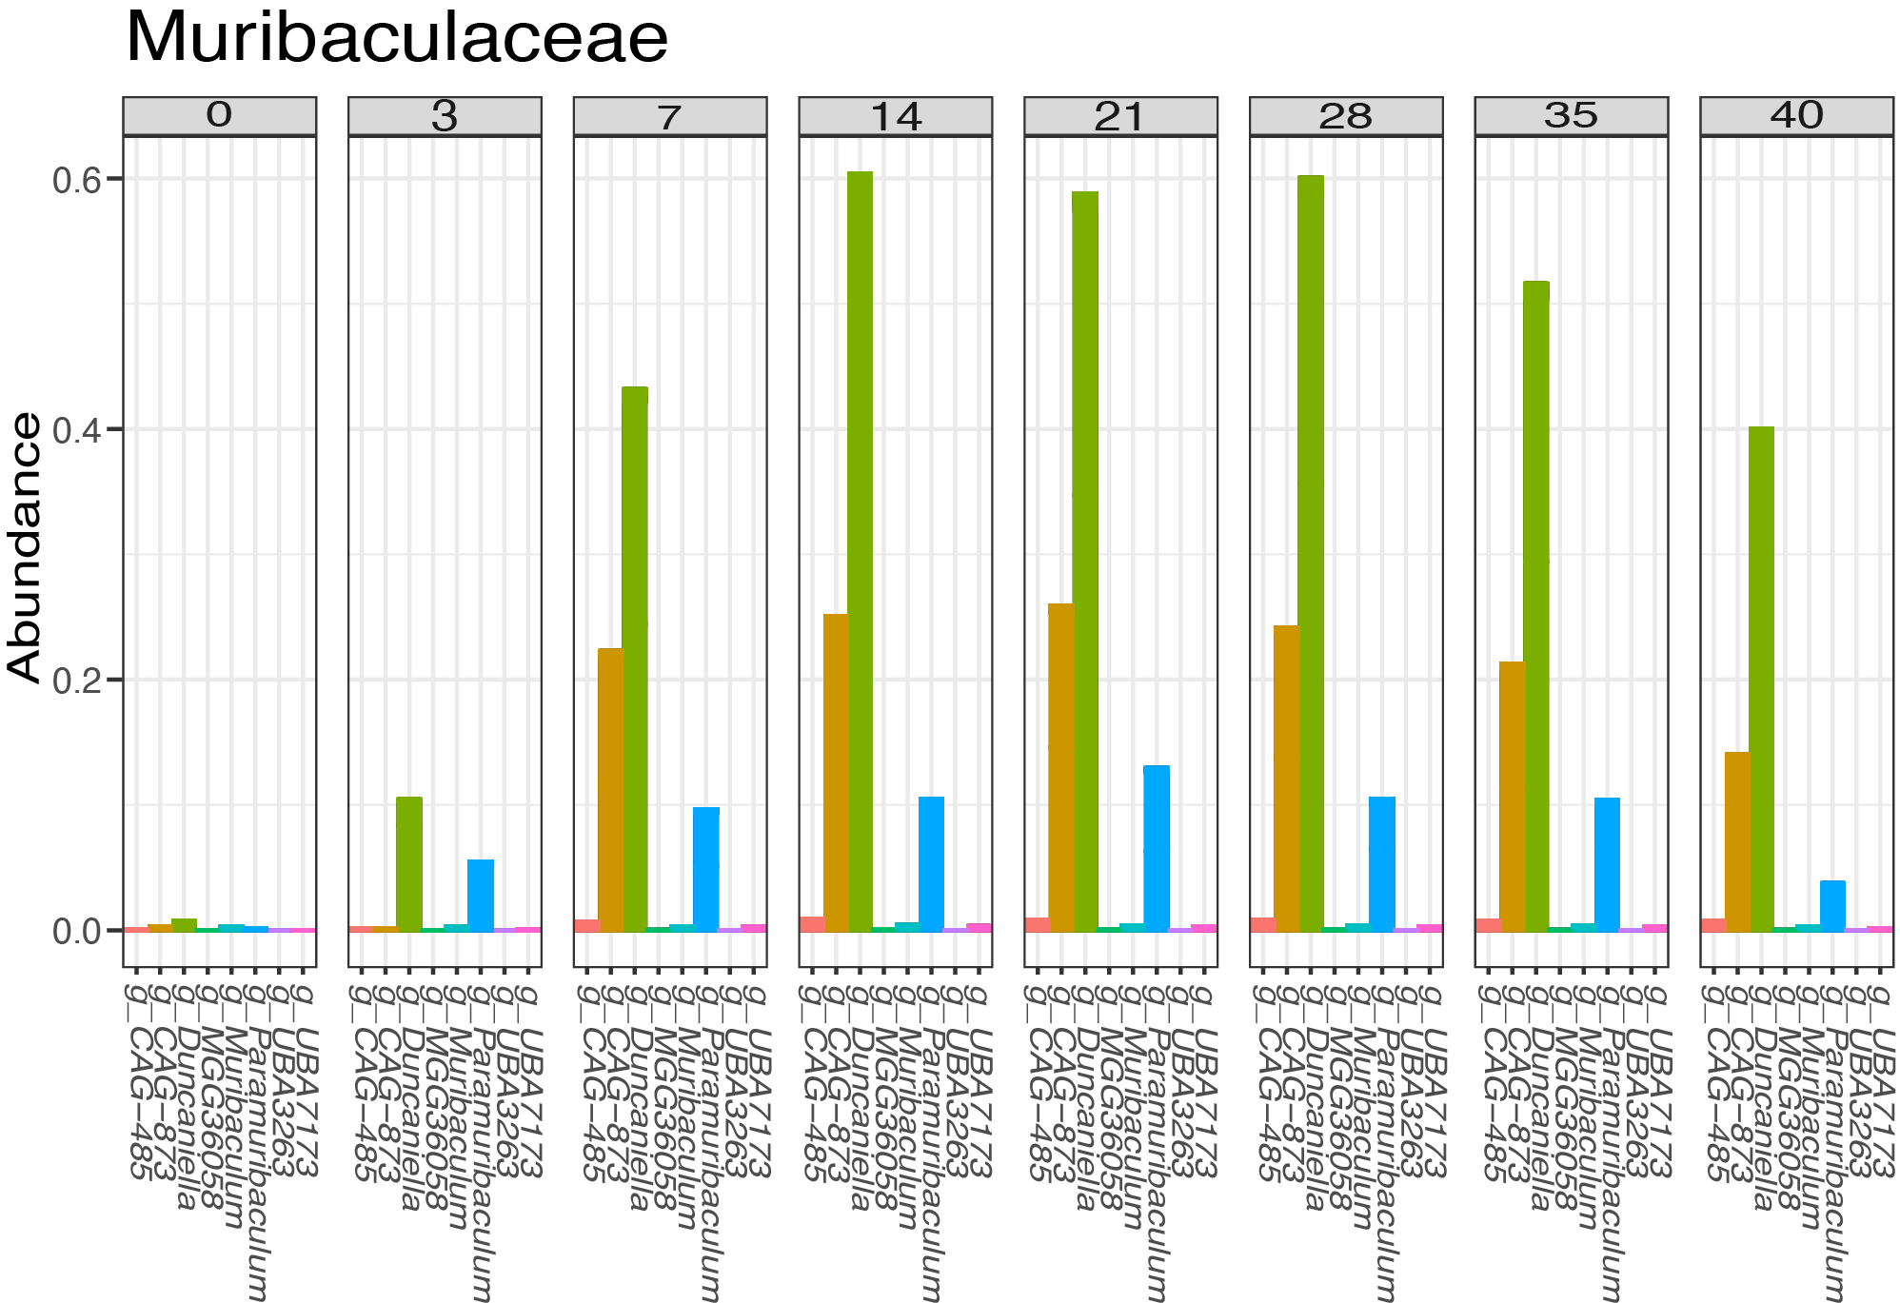

Supplemental Figure 2
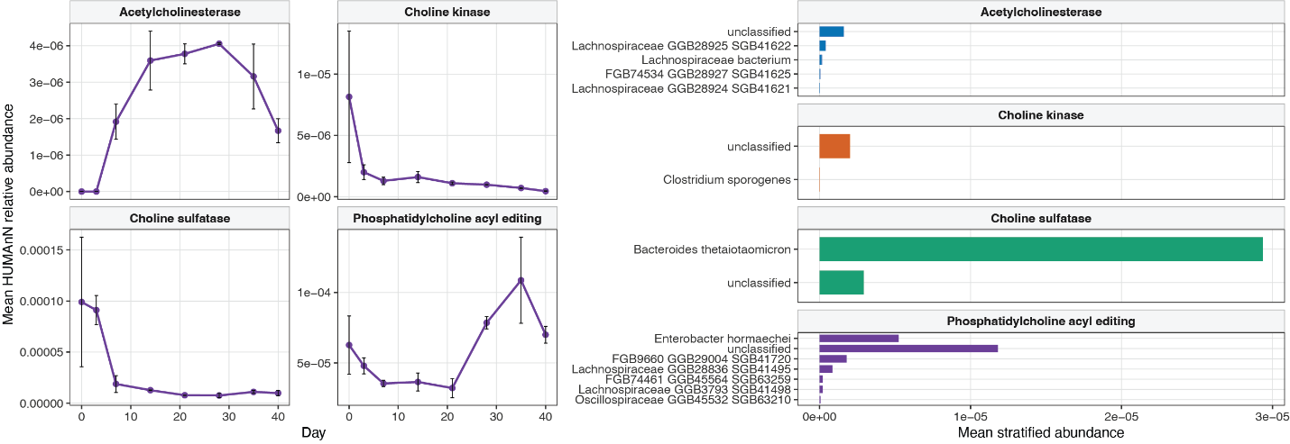

Supplemental Figure 3
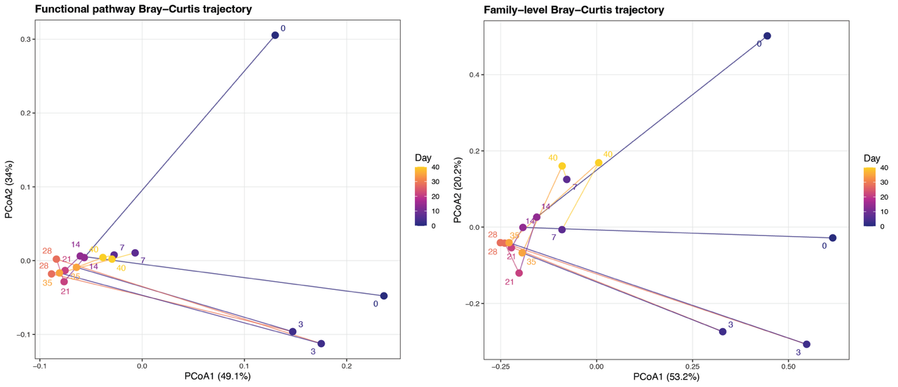

Supplemental Figure 4
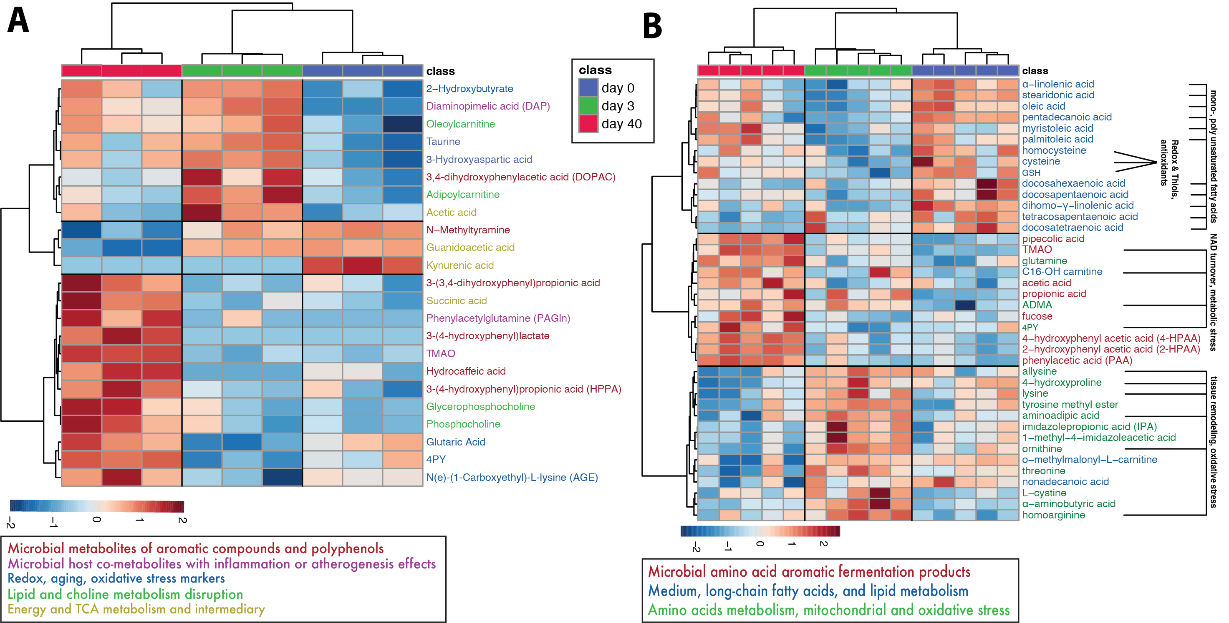

Supplemental Figure 5
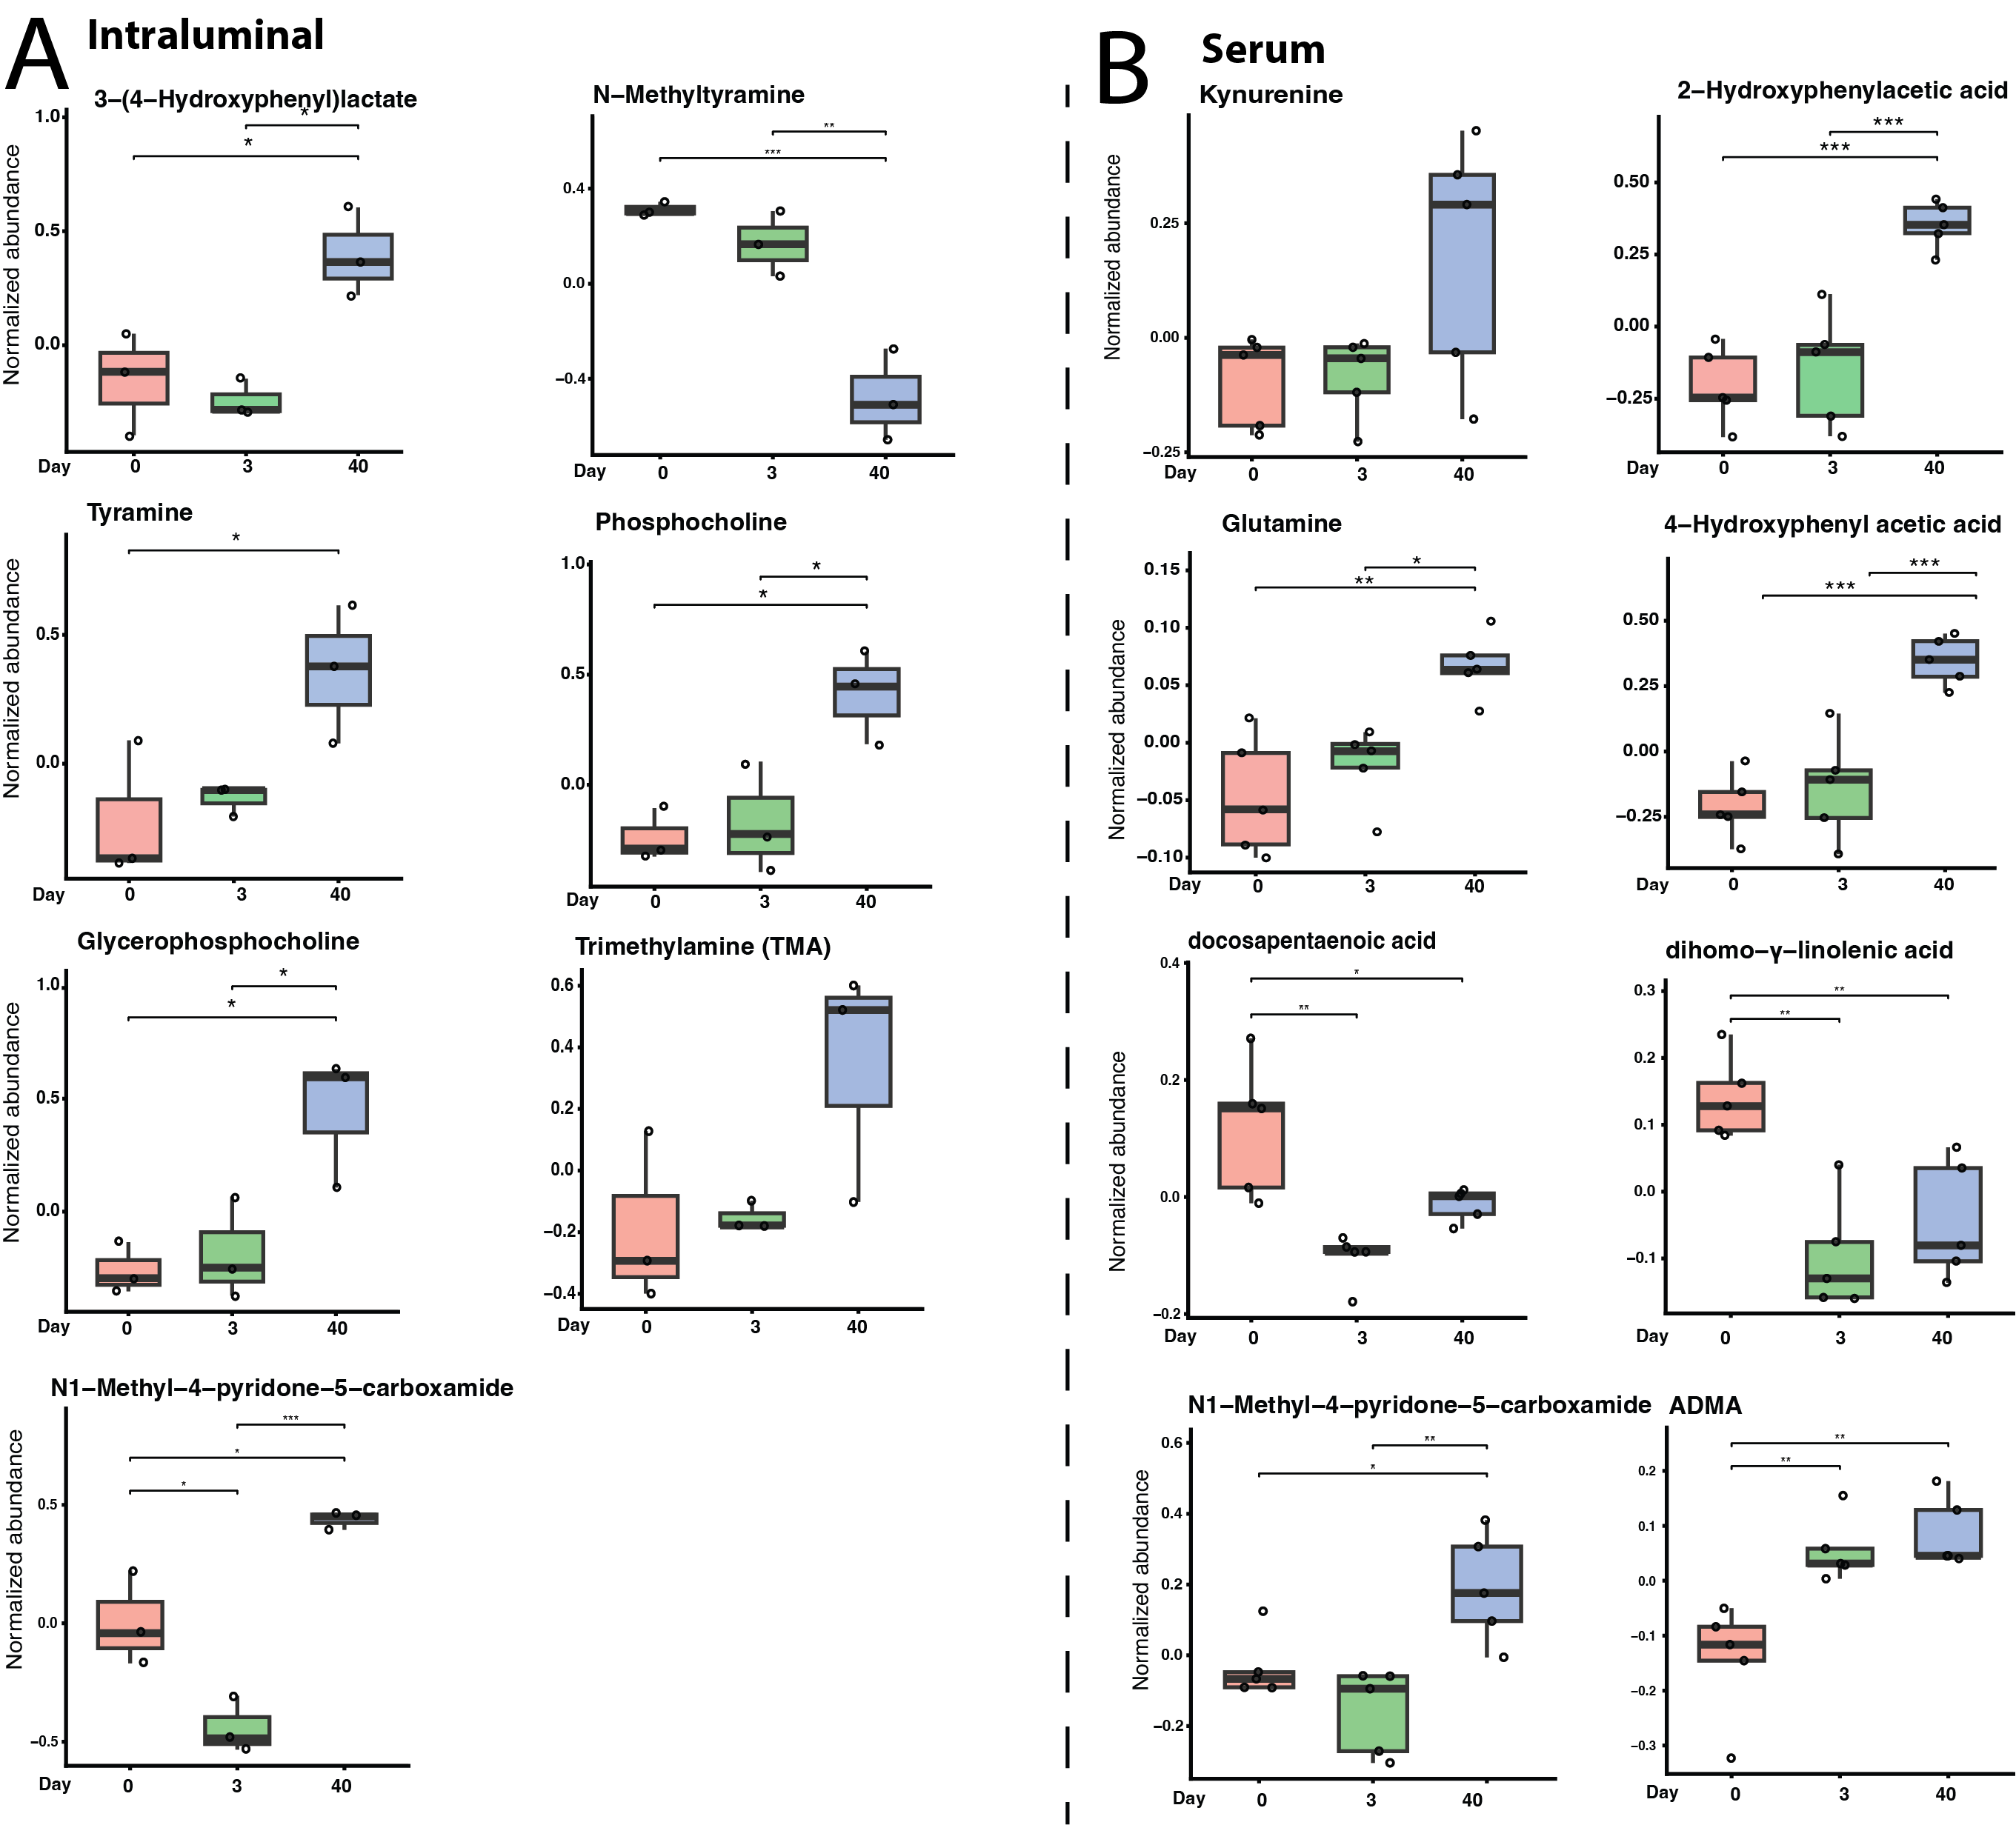

Supplemental Figure 6
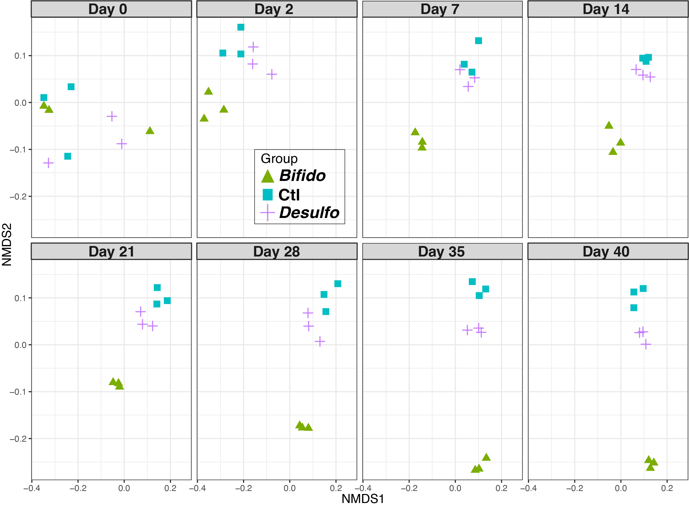

Supplemental Figure 7
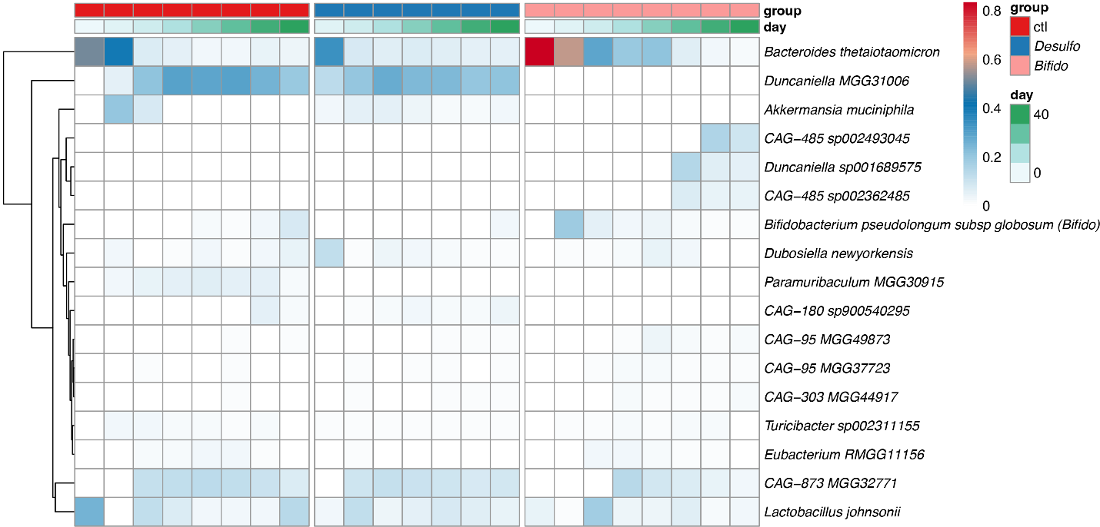

Supplemental Figure 8
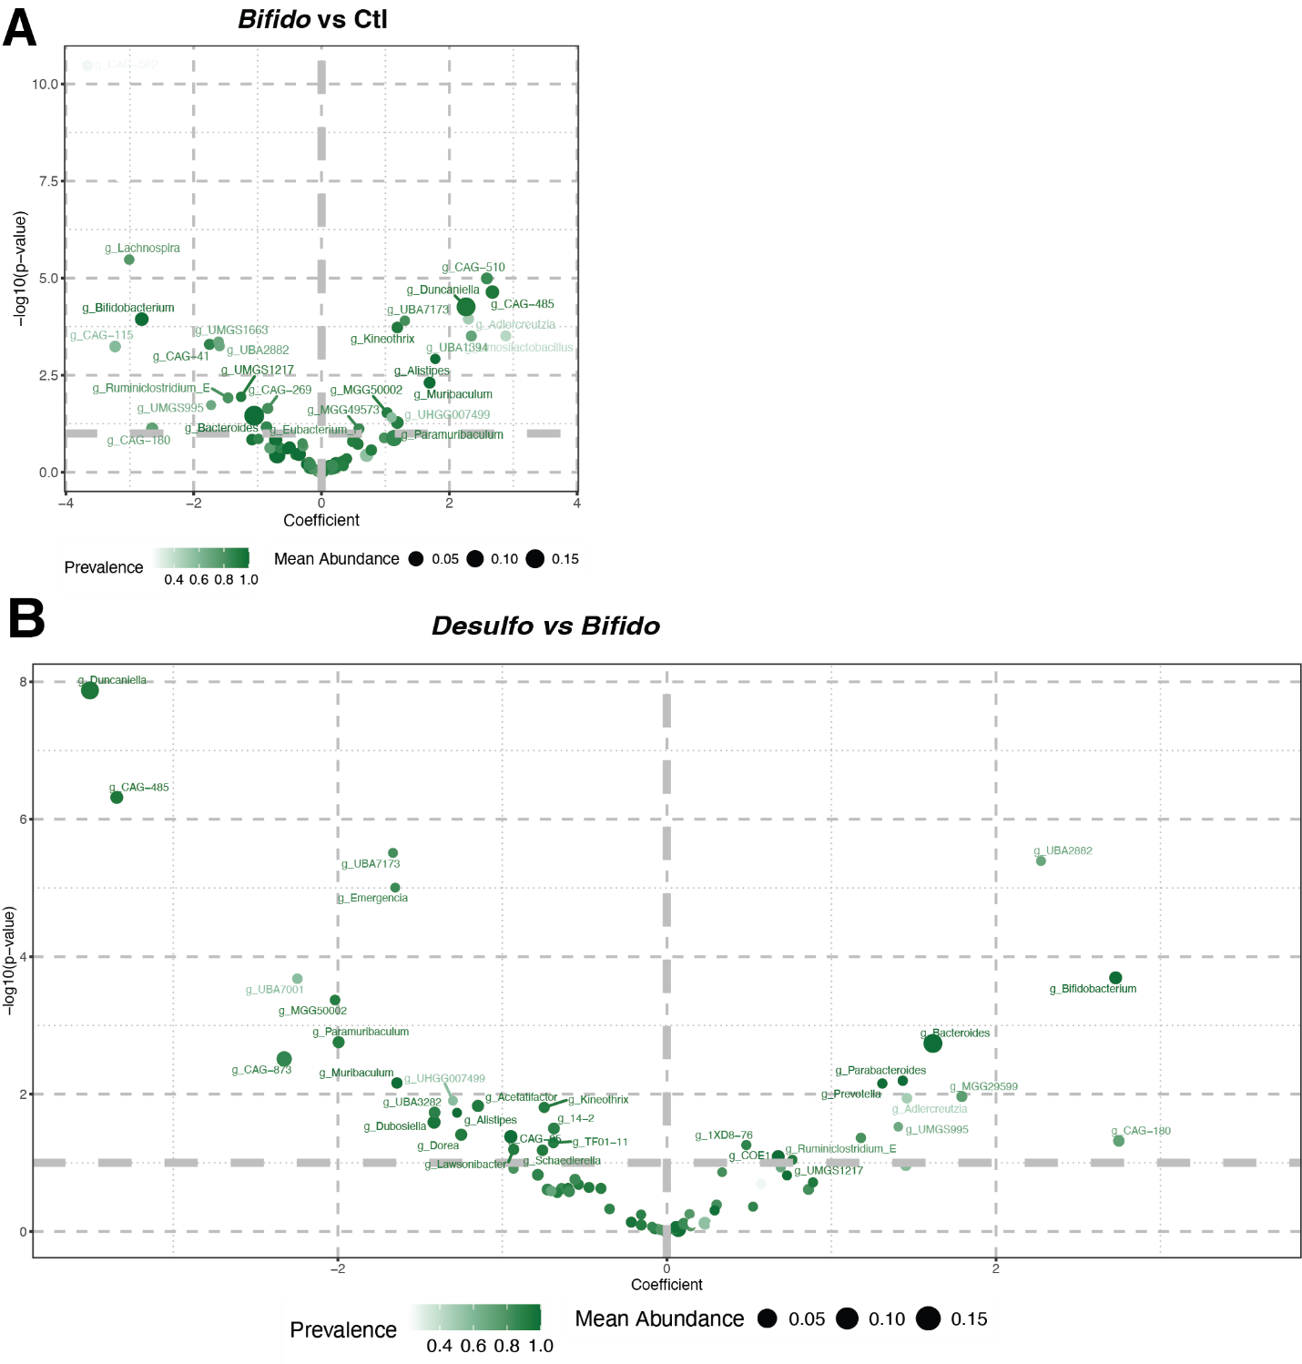

Supplemental Figure 9
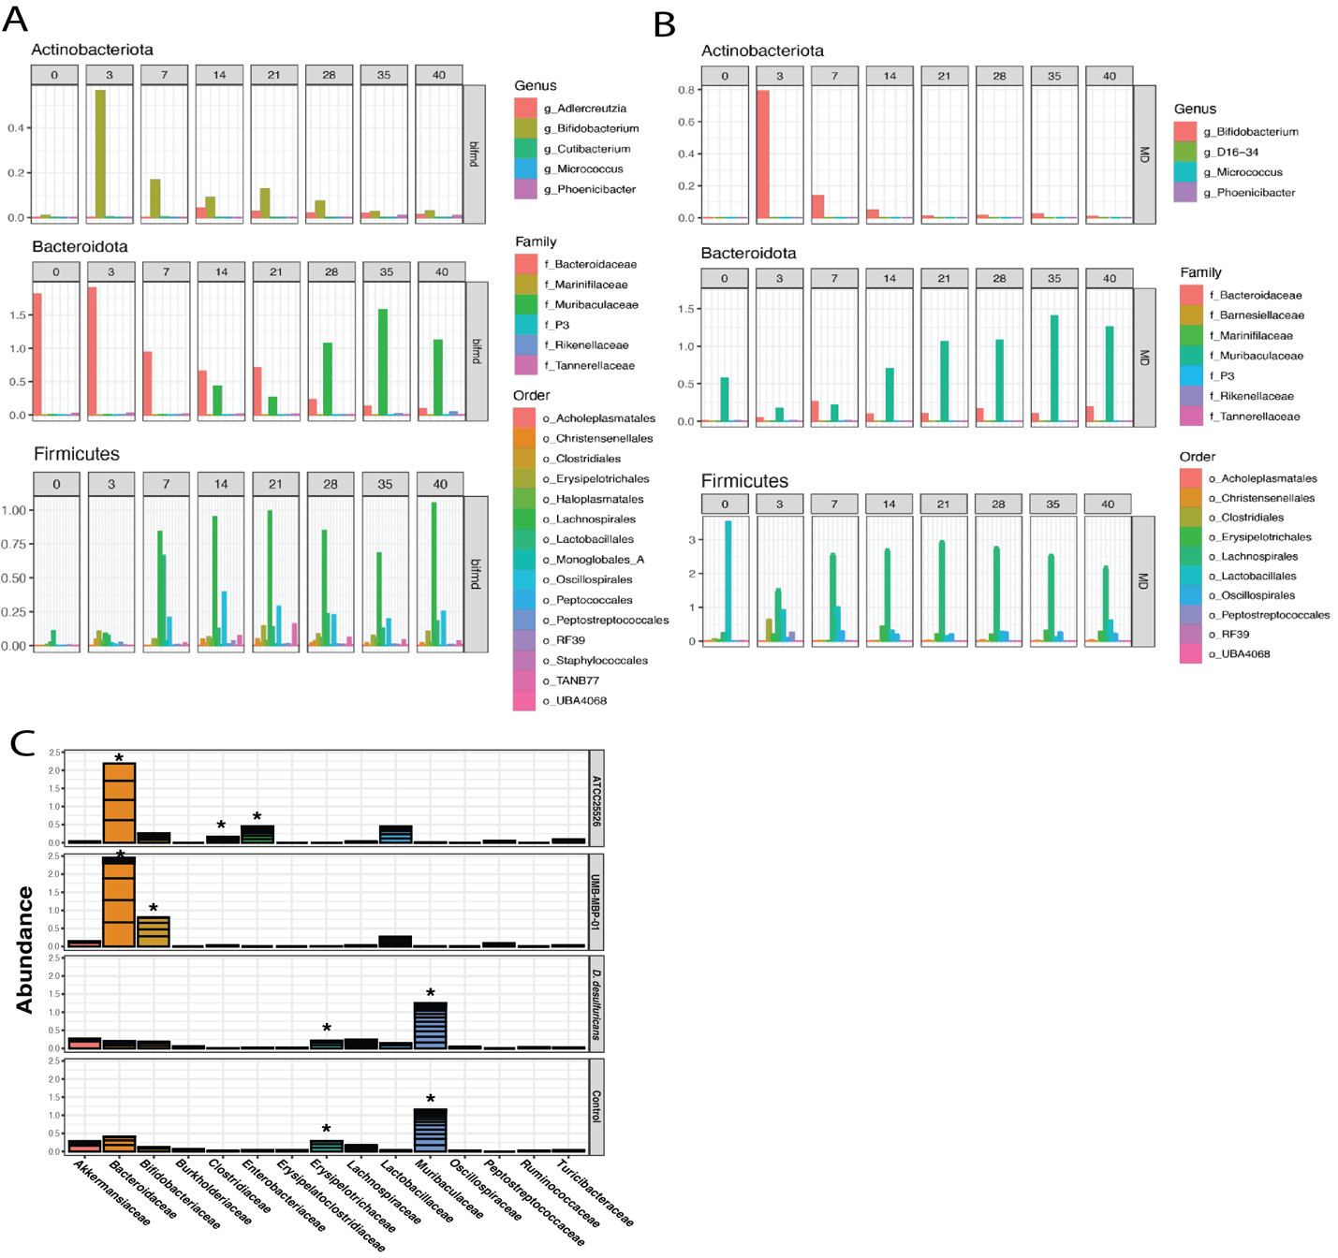

Supplemental Figure 10
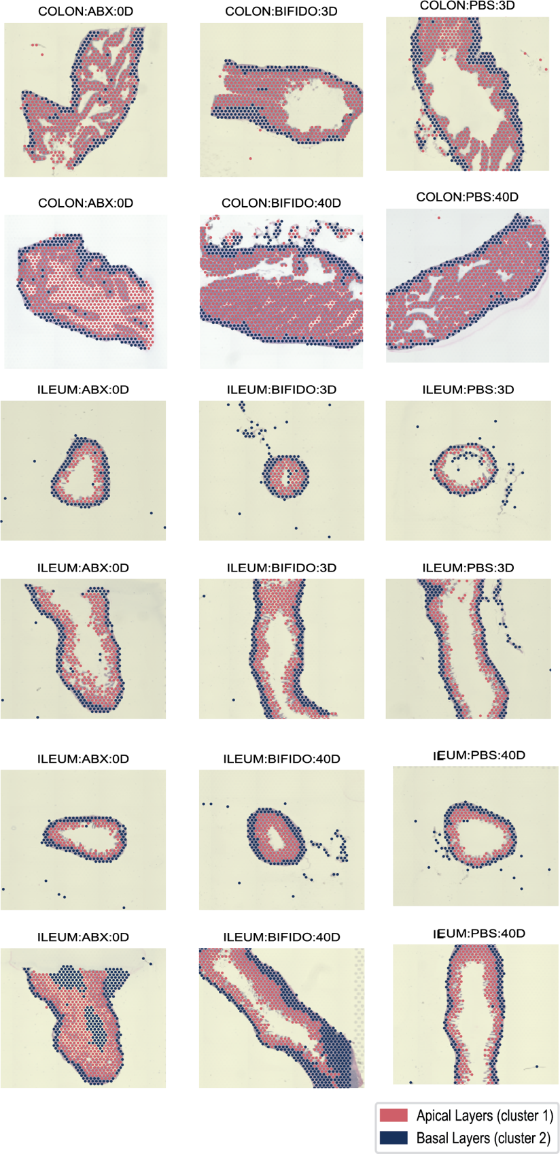

Supplemental Figure 11
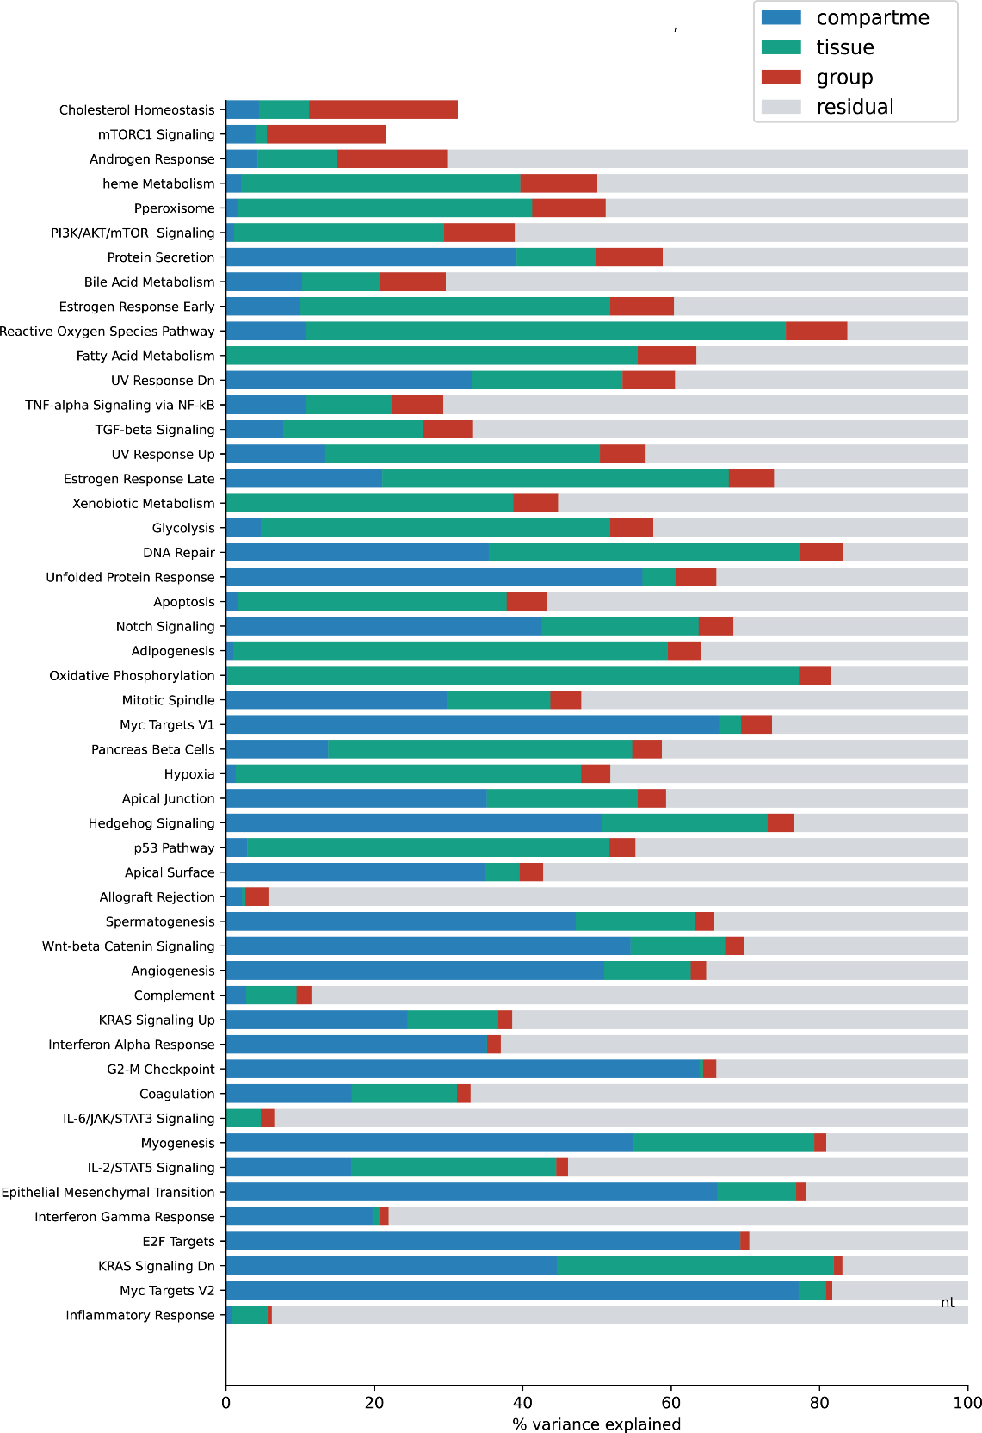

Supplemental Figure 12
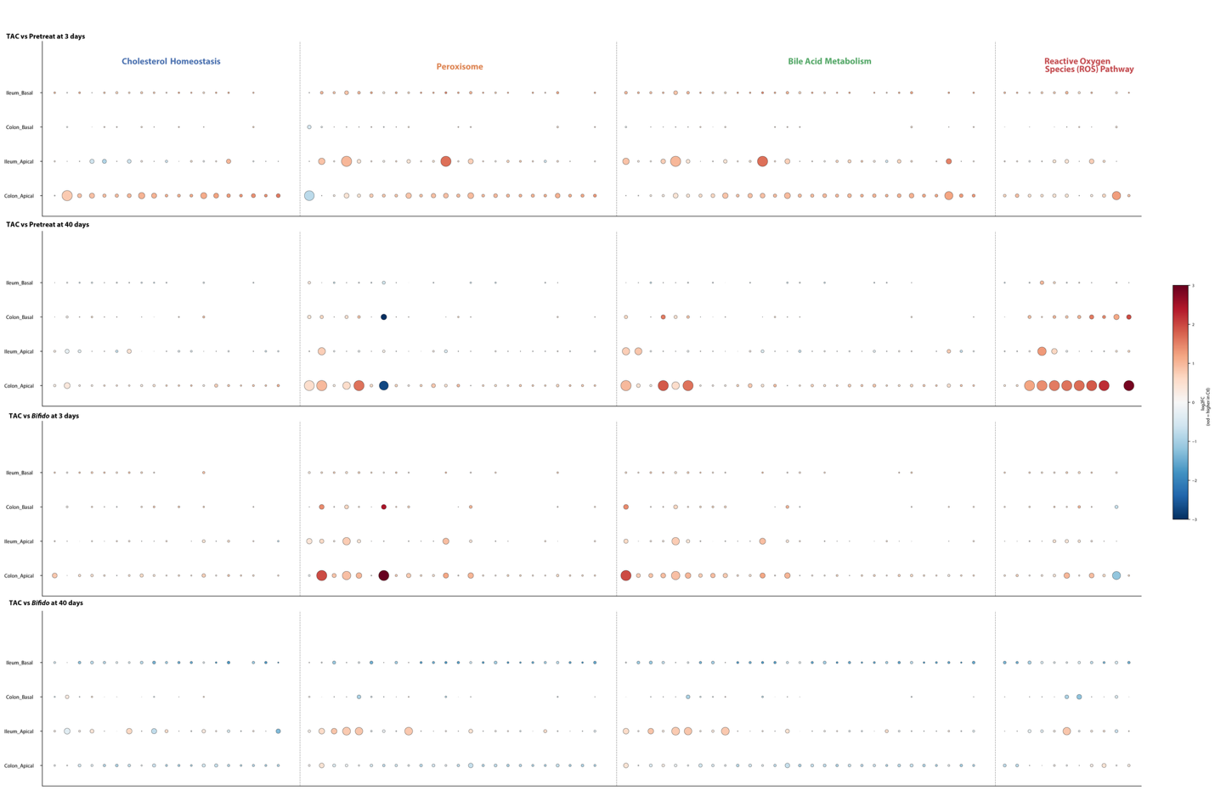

Supplemental Figure 13
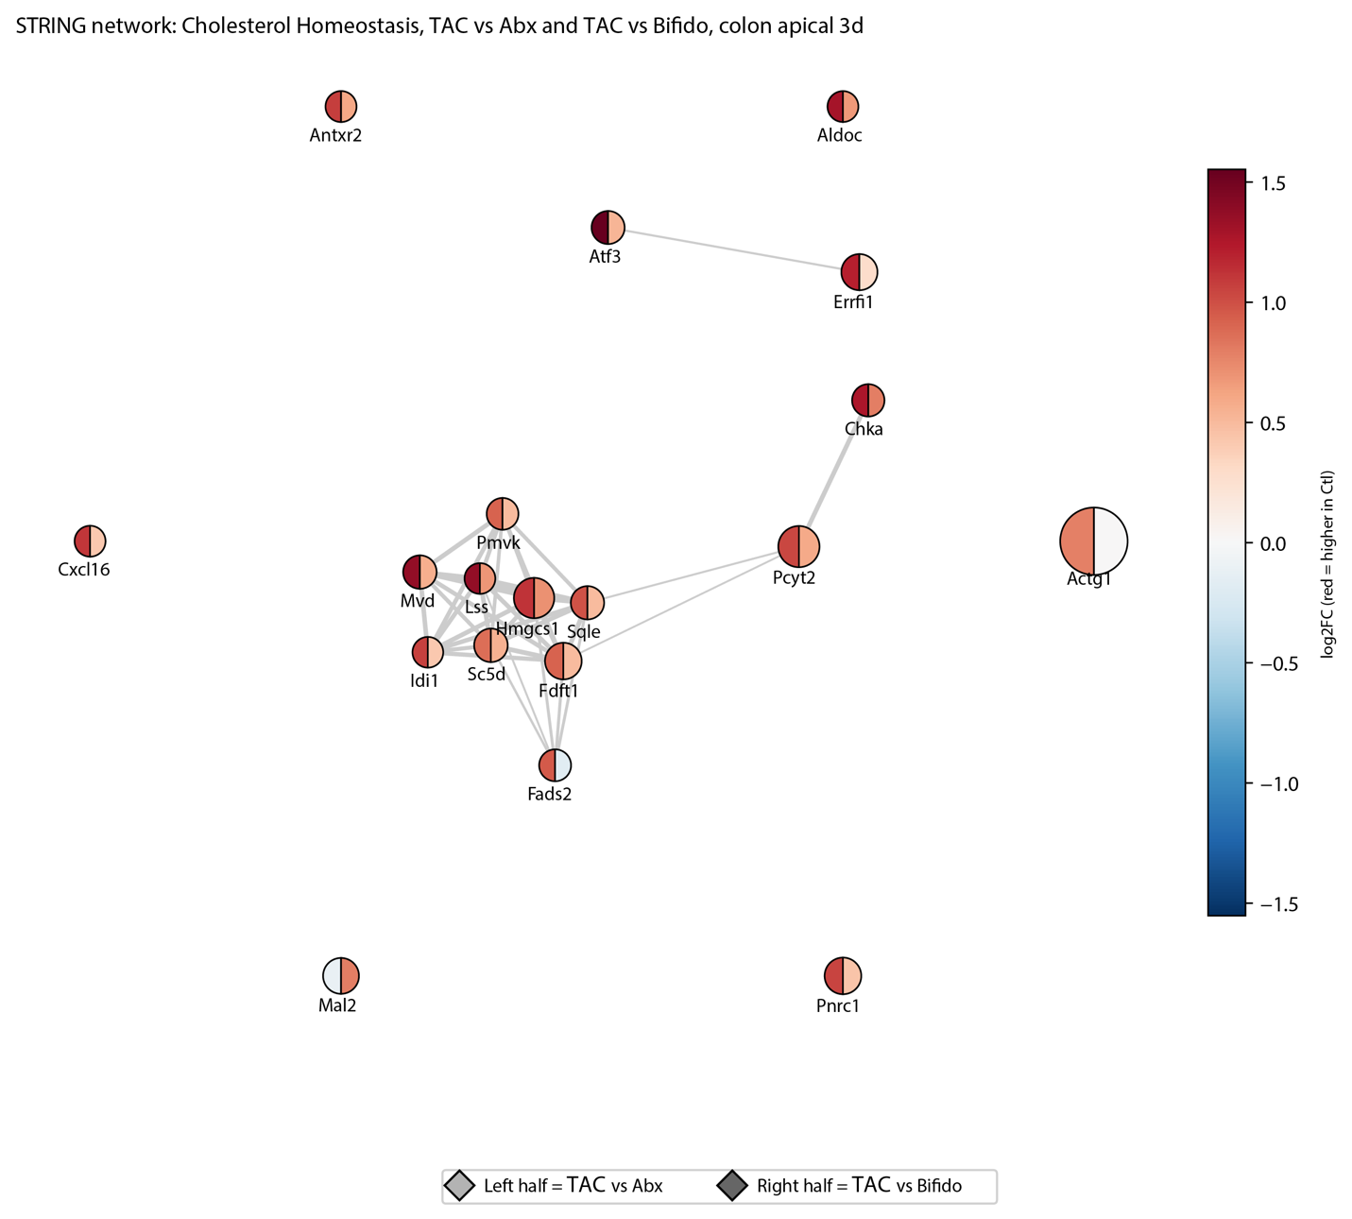

Supplemental Figure 14
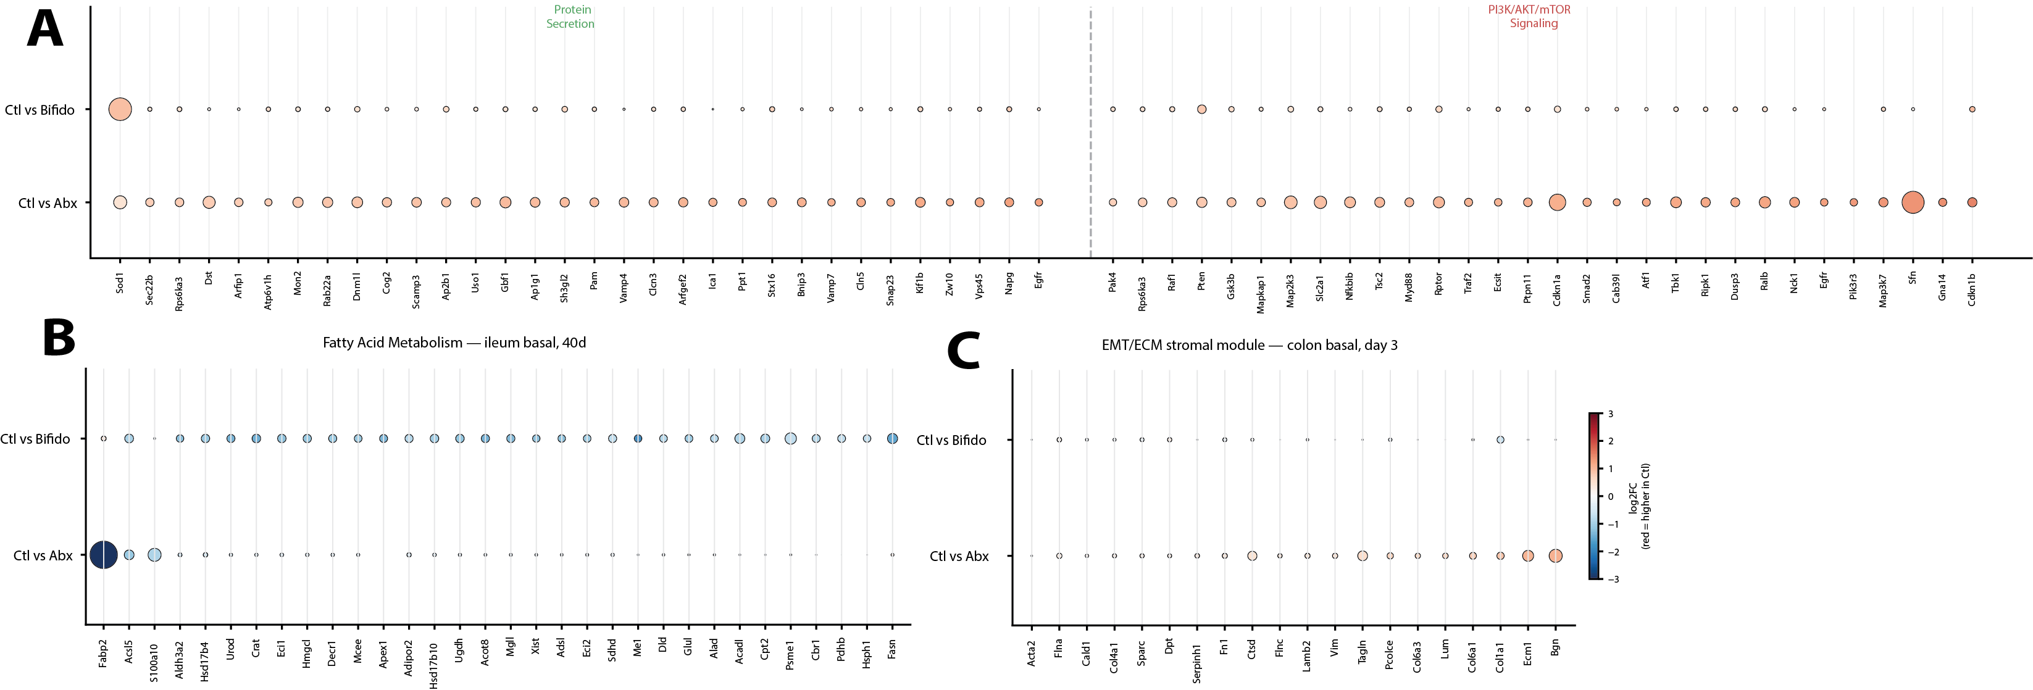

Supplemental Figure 15
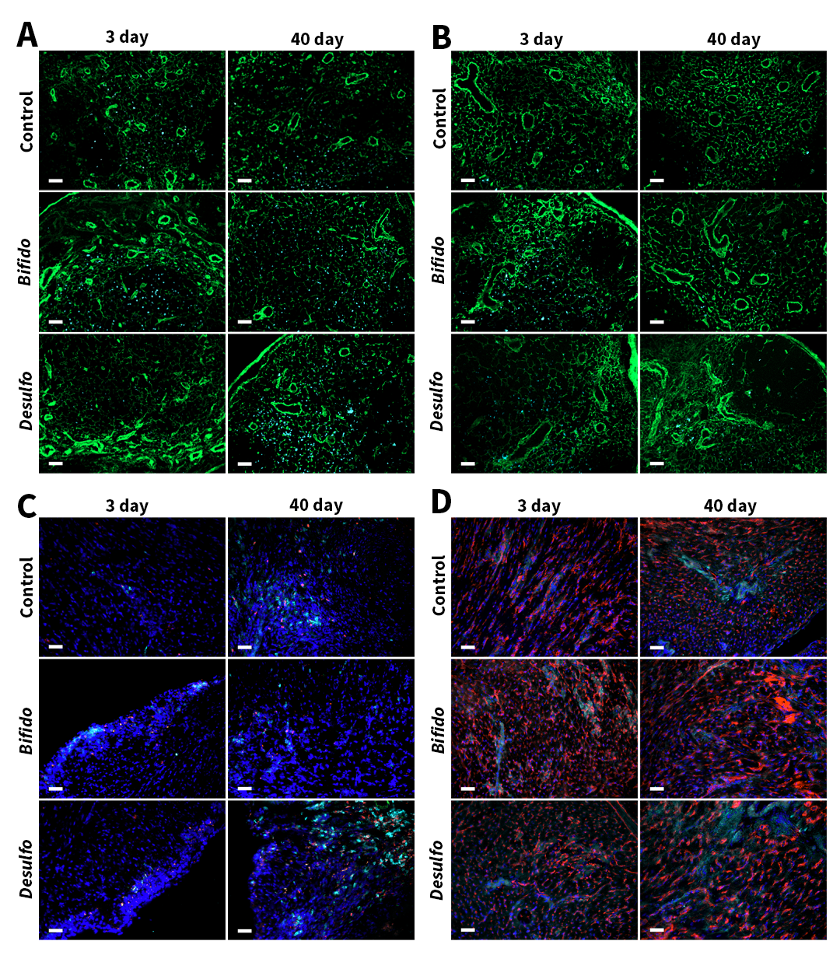

Supplemental Figure 16
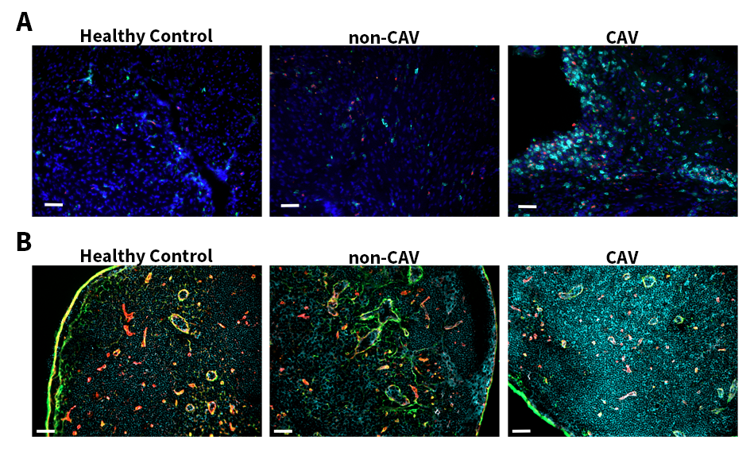

Supplemental Figure 17
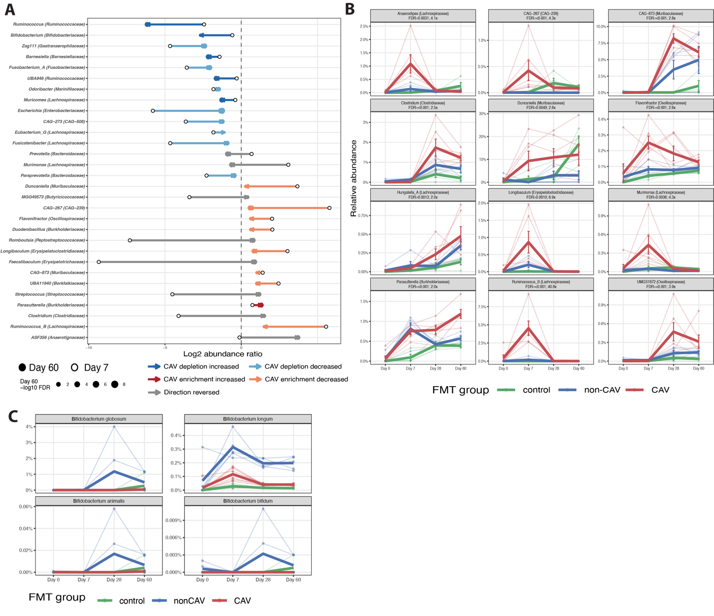
Supplemental Figure 18
