Supplementary Information
Mind the Gap: Autoimmune versus Infectious Encephalitis in Children. A Retrospective Cohort Study from a Tertiary Centre, Riyadh, Saudi Arabia (2020–2026)
Contents: Table S1 – Diagnostic pathway; Table S2 – Multivariable pre-diagnostic discrimination model; Table S3 – Sensitivity analyses; Figure S1 – Study flow diagram; Figure S2 – Annual case numbers; Figure S3 – Age at presentation; Figure S4 – Adjusted odds ratios from the primary model; Figure S5 – ROC curves of the primary and LASSO models; Figure S6 – Consistency of associations across analytical approaches; Figure S7 – Proposed institutional pathway.
Abbreviations used throughout: AE, autoimmune encephalitis; IE, infectious encephalitis; CSF, cerebrospinal fluid; KFMC, King Fahad Medical City; ROC, receiver operating characteristic; LASSO, least absolute shrinkage and selection operator; IQR, interquartile range.

Table S1: Diagnostic pathway — AE (n=70) vs IE (n=122)
Variable | AE | IE | p | Missing, n  (AE/IE)
Healthcare visits before correct diagnosis |  |  | 0.094 | 10/19
1 | 27 (45.0%) | 62 (60.2%) | 0.094 | 10/19
2 | 26 (43.3%) | 33 (32.0%) | 0.094 | 10/19
3 | 5 (8.3%) | 8 (7.8%) | 0.094 | 10/19
≥4 | 2 (3.3%) | 0 (0.0%) | 0.094 | 10/19
Time from onset to correct diagnosis |  |  | <0.001*** | 13/16
<1 week | 10 (17.5%) | 68 (64.2%) | <0.001*** | 13/16
1–2 weeks | 15 (26.3%) | 27 (25.5%) | <0.001*** | 13/16
2–4 weeks | 13 (22.8%) | 7 (6.6%) | <0.001*** | 13/16
1–3 months | 10 (17.5%) | 3 (2.8%) | <0.001*** | 13/16
>3 months | 9 (15.8%) | 1 (0.9%) | <0.001*** | 13/16
Diagnostic delay >2 weeks | 20 (30.8%) | 14 (12.3%) | 0.005** | 5/8
Any misdiagnosis before correct diagnosis | 19 (29.7%) | 27 (24.1%) | 0.527 | 6/10
Immunotherapy started before antibody result |  |  | <0.001*** | 0/0
Yes | 50 (71.4%) | 3 (2.5%) | <0.001*** | 0/0
No | 12 (17.1%) | 8 (6.6%) | <0.001*** | 0/0
Not applicable | 8 (11.4%) | 111 (91.0%) | <0.001*** | 0/0
Immunotherapy before antibody result is shown for both groups descriptively; it is clinically meaningful chiefly in AE, where it reflects empirical treatment ahead of serology.

Table S2: Multivariable logistic regression, pre-diagnostic discrimination of AE vs IE
Variable | OR | 95% CI | p
Age, years | 1.53 | 1.20–1.95 | <0.001
Subacute/insidious onset (vs acute/hyper-acute) | 0.90 | 0.15–5.54 | 0.912
Fever ≥38.0°C at/within 72 h | 0.40 | 0.08–2.03 | 0.270
Any psychiatric/behavioural symptom | 4.88 | 0.98–24.18 | 0.052
CSF pleocytosis (WBC ≥5 cells/mm³) | 0.01 | 0.00–0.18 | 0.001
MRI abnormal | 3.19 | 0.56–18.04 | 0.190
EEG abnormal | 2.13 | 0.46–9.92 | 0.335
Complete-case model, n=129 (47 AE / 82 IE) of 192 eligible. AUROC=0.970. Hosmer–Lemeshow χ²=3.83, p=0.87. LASSO-penalised sensitivity model (5-fold CV) retained 6 of 7 variables (dropping only onset tempo) with a similar AUROC (0.971).
Abbreviations: OR, odds ratio; CI, confidence interval; AUROC, area under the receiver operating characteristic curve; LASSO, least absolute shrinkage and selection operator; CV, cross-validation; EPV, events per variable. EPV (AE class) = 47/7 = 6.7, below the conventional threshold of 10; complete-case analysis excludes 63/192 patients (33%) with missing data on at least one candidate variable. Working-memory deficit and CSF Gram stain/culture positivity were excluded because of complete separation, and movement disorder because of low frequency.

Table S3: Sensitivity analyses: multiple imputation and pre-specified subgroup restrictions
(a) Multiple imputation (MICE, M=20, Rubin's rules; median of eight runs) — full sample, n=192 (70 AE / 122 IE):
Variable | OR | 95% CI | p
Age, years | 1.40 | 1.19–1.66 | <0.001*
Subacute/insidious onset | 1.11 | 0.29–4.24 | 0.881
Fever ≥38.0°C at/within 72 h | 0.22 | 0.06–0.78 | 0.019*
Any psychiatric/behavioural symptom | 3.96 | 0.99–15.88 | 0.052
CSF pleocytosis (WBC ≥5) | 0.06 | 0.01–0.33 | 0.002*
MRI abnormal | 2.52 | 0.66–9.63 | 0.176
EEG abnormal | 2.20 | 0.67–7.25 | 0.196
Age and CSF pleocytosis remained significant and fever reached significance; psychiatric or behavioural symptoms remained borderline (p=0.045–0.060 across eight imputation runs).
(b) Definite AE vs Confirmed IE only (reduced 2-variable model — the full model was not stable at this n):
Variable | OR | 95% CI | p
Age, years | 1.55 | 1.21–1.99 | <0.001*
CSF pleocytosis (WBC ≥5) | 0.03 | 0.00–0.22 | <0.001*
n=66 (28 definite AE, 38 confirmed IE). AUROC 0.951.
(c) Autoimmune panel performed only (reduced 2-variable model):
Variable | OR | 95% CI | p
Age, years | 1.37 | 1.07–1.76 | 0.014*
CSF pleocytosis (WBC ≥5) | 0.05 | 0.01–0.39 | 0.004*
n=67 (59 AE, 8 IE); the small IE denominator limits the weight of this analysis.
(d) LP performed only:
Identical to the primary complete-case sample (n=129); reported for completeness as pre-specified.
*p<0.05. Abbreviations: OR, odds ratio; CI, confidence interval; MICE, multiple imputation by chained equations; WBC, white cell count; LP, lumbar puncture.
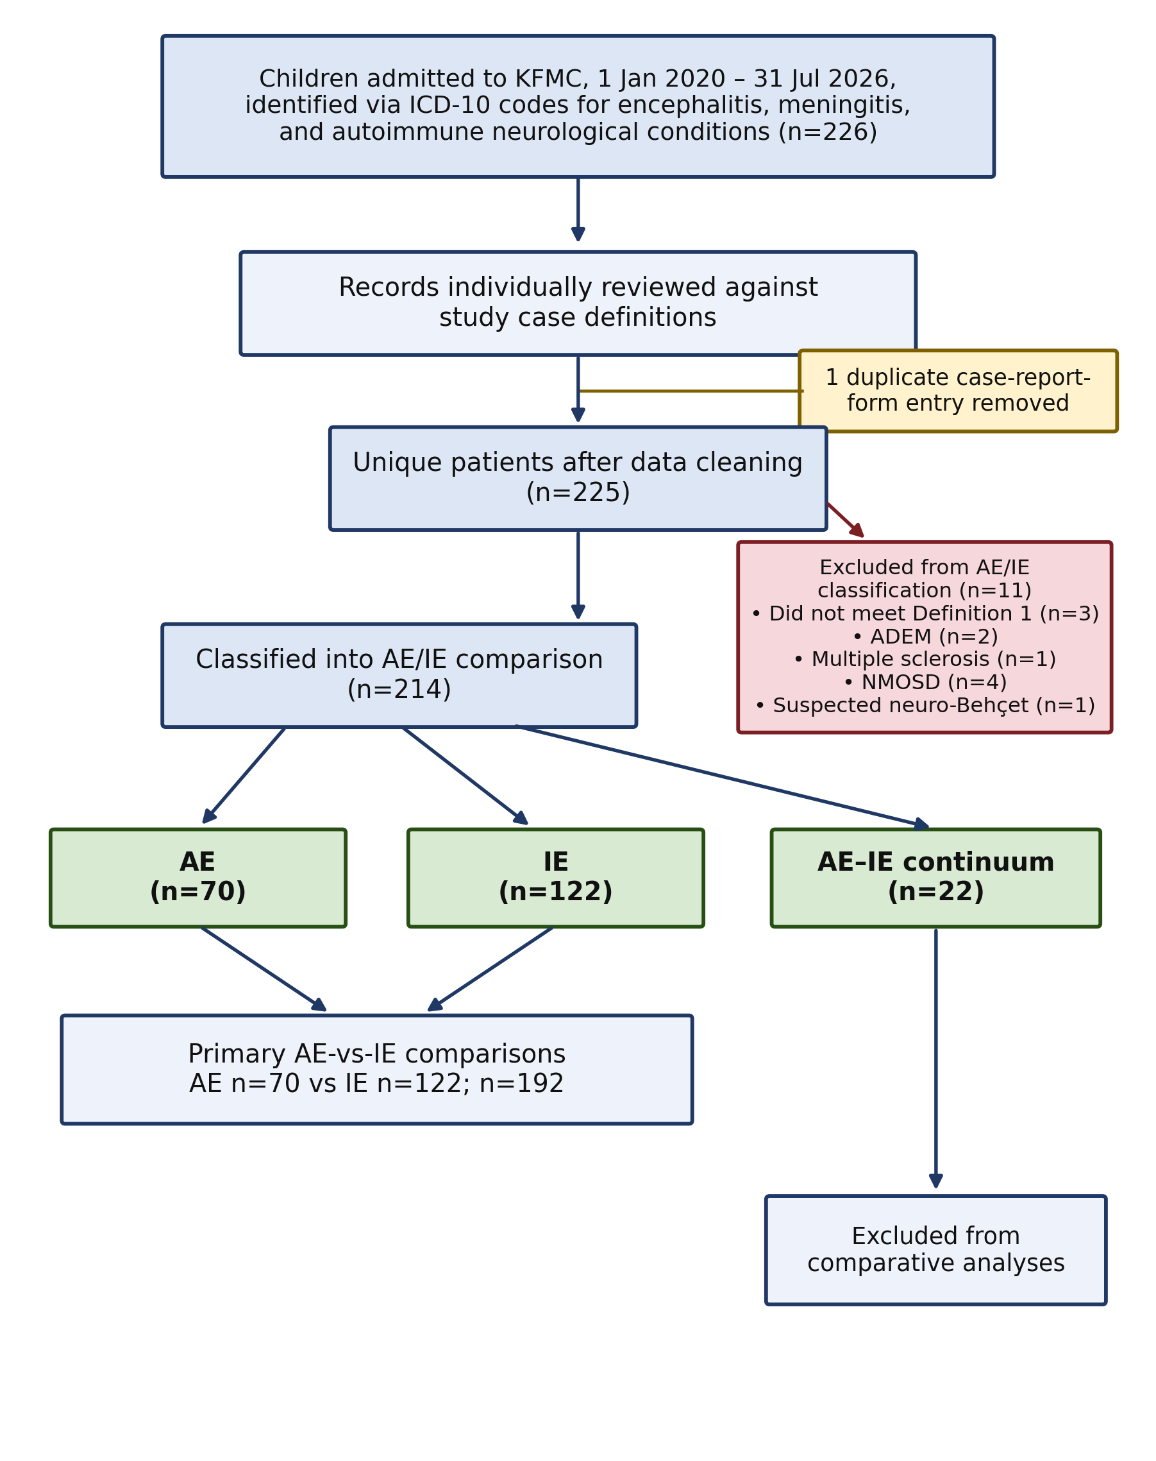
Figure S1: Study flow diagram: case identification, data cleaning, and derivation of the AE, IE, and AE–IE continuum groups.
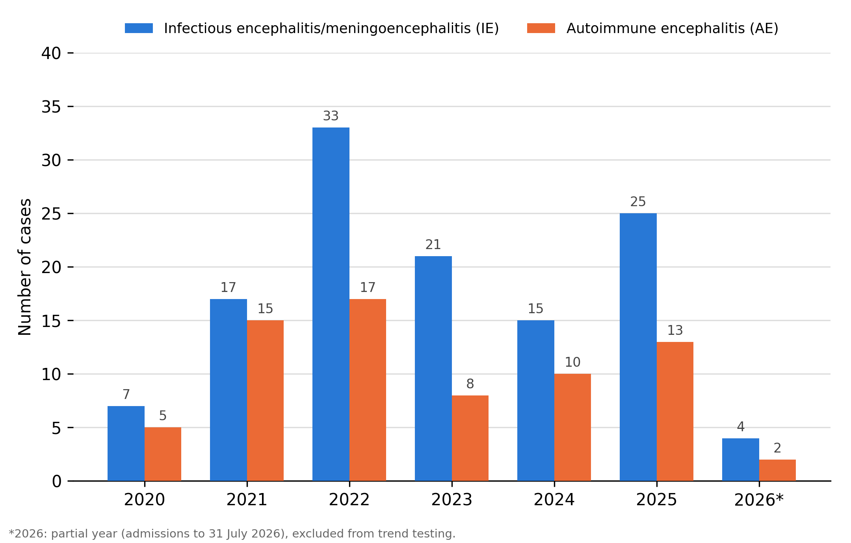
Figure S2: Annual number of pure AE and pure IE cases by year of hospital admission (2020–2026), restricted to the mutually exclusive n=192 classification used throughout Results; the 22 AE–IE continuum cases and 11 cases excluded from the AE–IE classification are not shown. 2026 reflects a partial year of data collection (admissions through 31 July 2026 only) and was excluded from trend testing. Negative-binomial regression on 2020–2025 showed no statistically significant year-on-year trend for either group (p>0.05; see Results). Totals across the full period (122 IE, 70 AE) match Table 1.
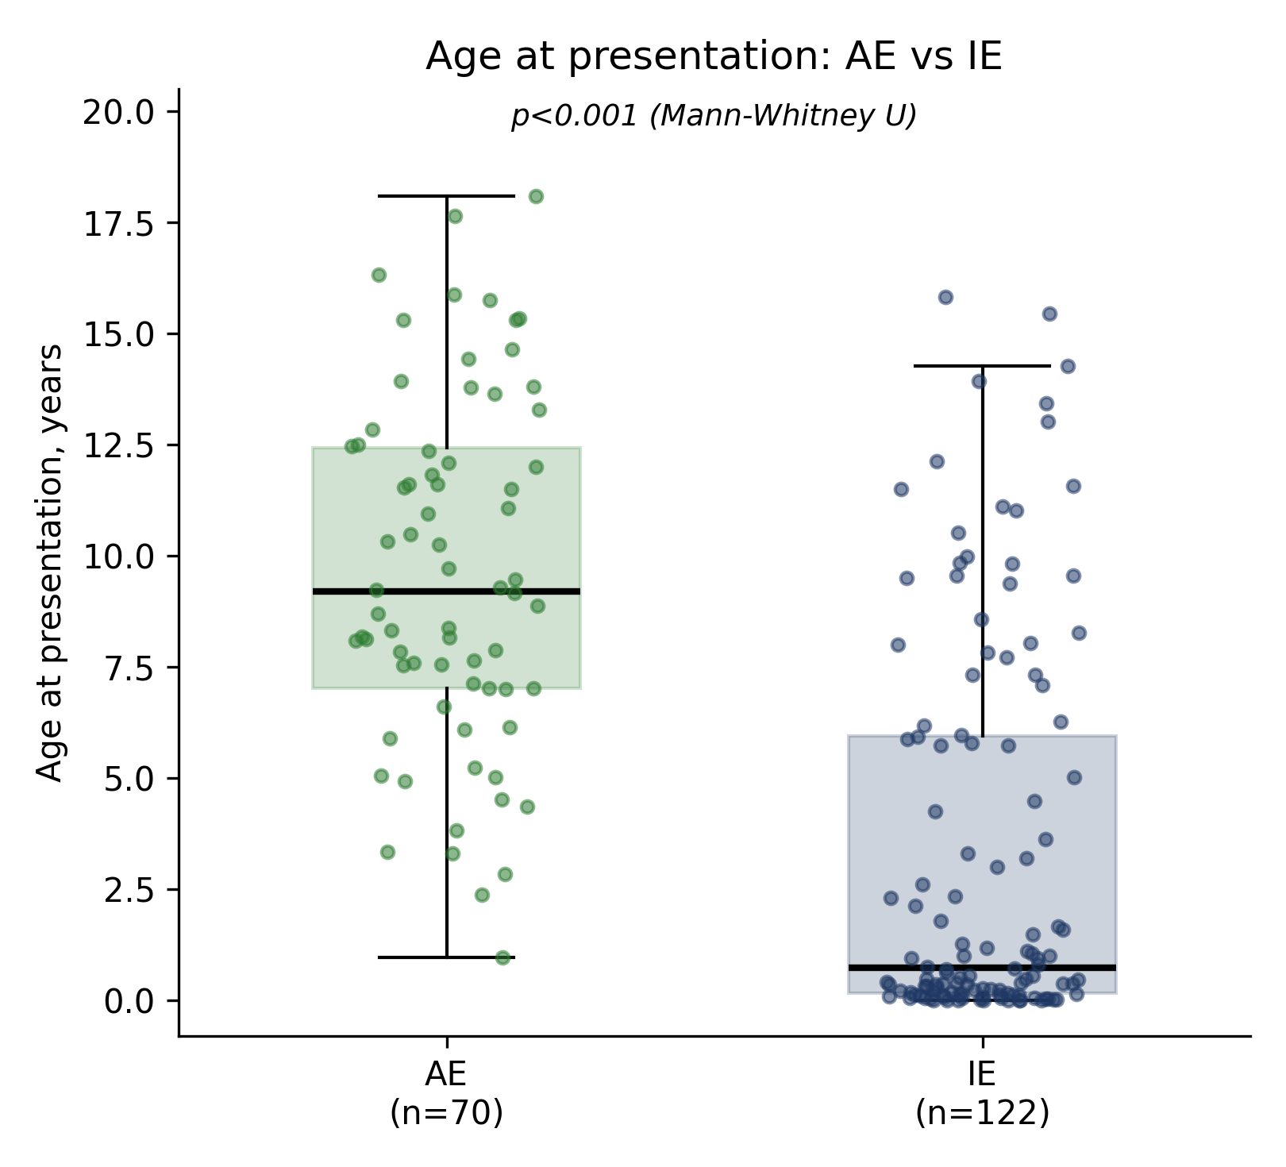
Figure S3: Age at presentation, AE vs IE. Box plots show the median and IQR, with whiskers extending to 1.5 times the IQR; individual patients are overlaid as jittered points.
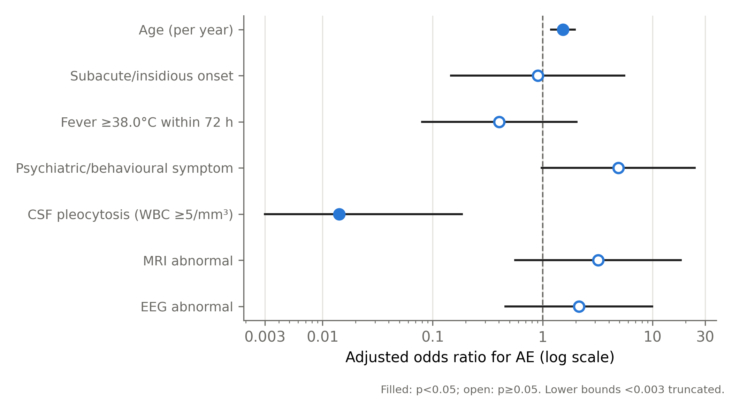
Figure S4: Adjusted odds ratios (95% CI) from the primary multivariable pre-diagnostic discrimination model (n=129: 47 AE, 82 IE).
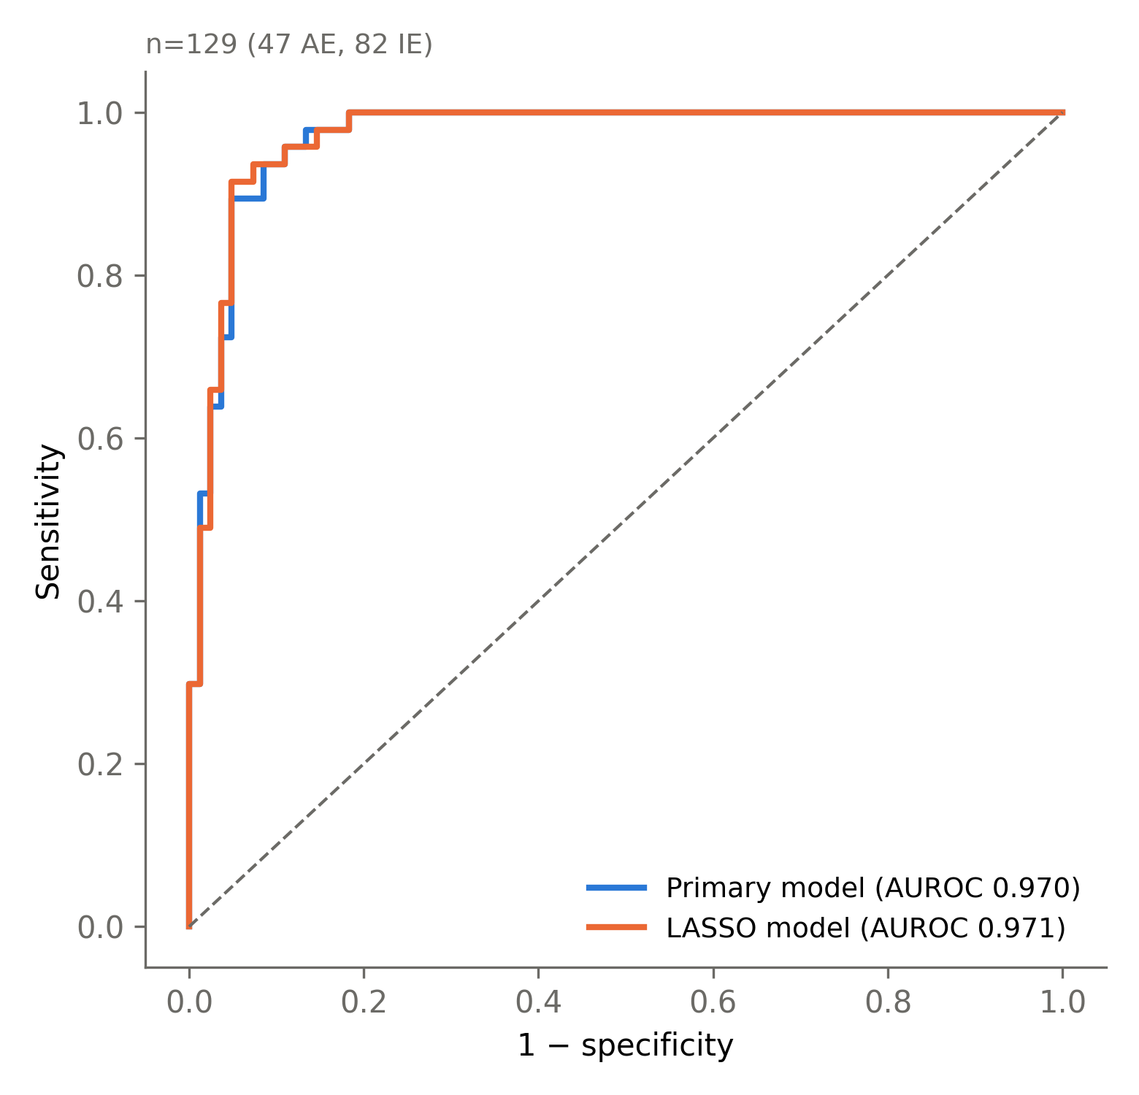
Figure S5: Receiver operating characteristic curves for the primary multivariable model and the LASSO-penalised sensitivity model (n=129: 47 AE, 82 IE).
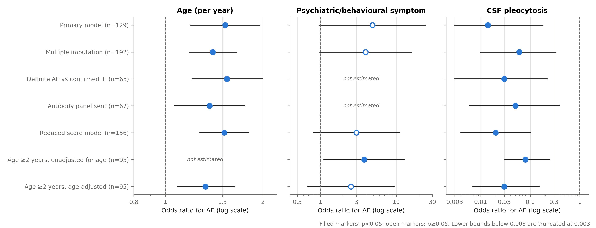
Figure S6: Consistency of associations with AE across analytical approaches. Odds ratios (95% CI, log scale) for age, psychiatric or behavioural symptoms, and CSF pleocytosis in the primary complete-case model, multiple imputation, restriction to definite AE and confirmed IE, restriction to children in whom the autoimmune panel was sent, the reduced three-variable score model, and children aged 2 years or older with and without adjustment for age. Filled markers, p<0.05; open markers, p≥0.05. Psychiatric or behavioural symptoms were not included in the two restricted two-variable models, and age was not included in the unadjusted model in children aged 2 years or older.
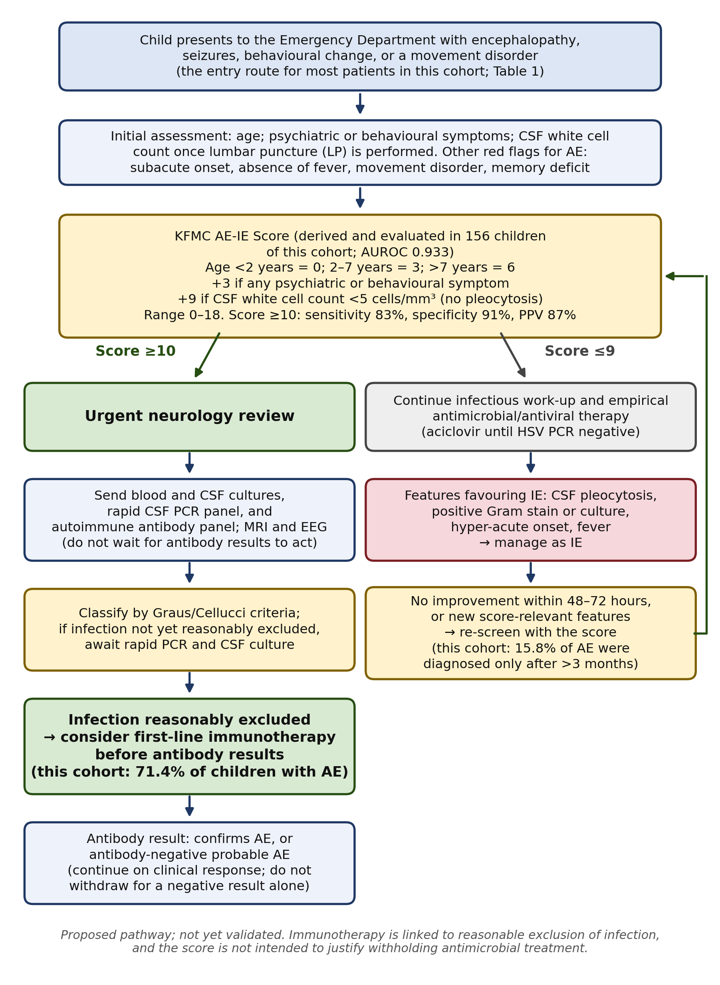
Figure S7: Proposed institutional pathway for triage from the Emergency Department and the timing of empirical immunotherapy, based on the KFMC AE-IE Score, this cohort’s diagnostic-pathway findings (Table S1), and Graus/Cellucci criteria. Not yet validated; presented as a hypothesis-generating proposal for prospective evaluation.

