α-Synuclein Seed Amplification Status Modifies the Relationship Between Plasma p-tau217, Amyloid and Fibrillar Tau

SUPPLEMENTARY MATERIAL
Figure S1. Participant flow diagram for the ADNI analytic sample
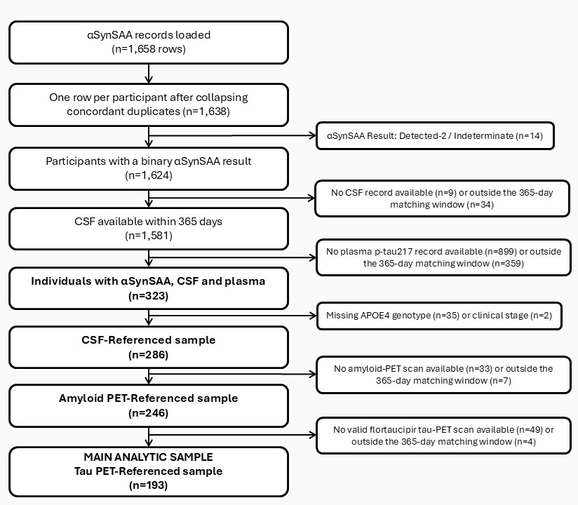
Figure S1. Participant flow diagram for the ADNI analytic sample. Non-binary αSynSAA results (Detected-2 / Indeterminate) were excluded. All measurements were matched to the αSynSAA sampling date using the temporally nearest available record within a ±365-day window. The CSF-referenced sample uses the CSF p-tau181/Aβ42 ratio as the reference measure of amyloid pathology; the PET-referenced sample additionally requires a quality-controlled amyloid-PET scan; the main analytic sample further requires a quality-controlled flortaucipir tau-PET scan, the primary measure of tau pathology in this study. Participants were also excluded for missing covariates required by the adjusted models (age, sex, APOE ε4 carrier status, cognitive stage). Abbreviations: αSynSAA, α-synuclein seed amplification assay (Amprion); CSF, cerebrospinal fluid; Aβ42, amyloid-beta 42; APOE4, apolipoprotein E ε4 allele; PET, positron emission tomography.
Figure S2. Amyloid burden and fibrillar tau by αSynSAA status, model-adjusted for the narrower covariate set
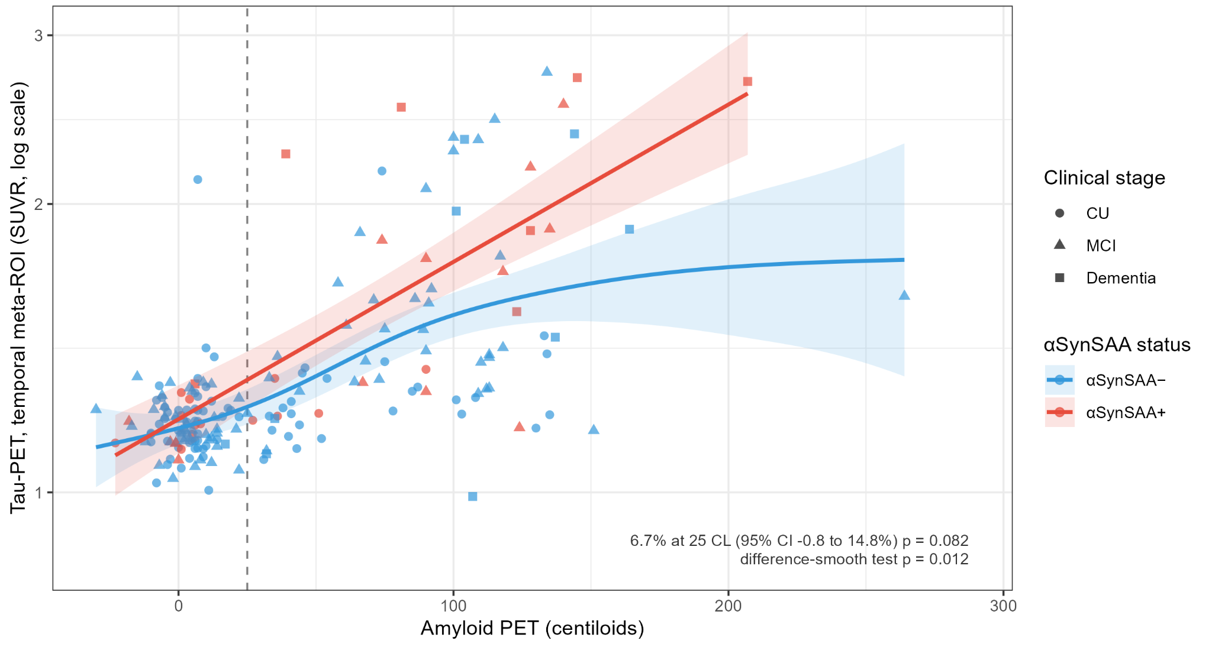
Lines and shaded bands are model-adjusted fits from the primary GAM using the narrower covariate set of Franzmeier et al. 2025 (age, sex and site held at reference levels; no adjustment for APOE ε4 carrier status or cognitive stage), with 95% confidence bands, fitted separately by αSynSAA status, as a sensitivity companion to Figure 3. Each group's curve is drawn only over the range of the x-axis variable observed in that group. The percentage difference, 95% CI, p-value and interaction p-value annotated in the panel refer to the formal contrast between the fitted curves at the amyloid positivity threshold and the difference-smooth test for shape, respectively, using this narrower covariate set. The dashed line marks the amyloid positivity threshold. Point colour indicates αSynSAA status (blue, αSynSAA−; red, αSynSAA+); point shape indicates cognitive stage (diamond, cognitively unimpaired; triangle, mild cognitive impairment; square, dementia). Tau-PET SUVR is shown on the log scale, matching the outcome scale used in the model. Abbreviations: CL, centiloids; CU, cognitively unimpaired; MCI, mild cognitive impairment; PET, positron emission tomography; SUVR, standardised uptake value ratio.

Table S1. Number and percentage of winsorised values for CSF Aβ42, CSF p-tau181 and plasma p-tau217, by lower and upper measuring-range limit
Reference sample | Variable | Capped at lower limit | Capped at upper limit | Total capped
CSF ratio (n=286) | CSF p-tau181 | 1 (0.3%) | 1 (0.3%) | 2 (0.7%)
CSF ratio (n=286) | CSF Abeta42 | 0 (0.0%) | 54 (18.9%) | 54 (18.9%)
CSF ratio (n=286) | Plasma p-tau217 | 4 (1.4%) | 0 (0.0%) | 4 (1.4%)
Amyloid PET (n=246) | CSF p-tau181 | 0 (0.0%) | 1 (0.4%) | 1 (0.4%)
Amyloid PET (n=246) | CSF Abeta42 | 0 (0.0%) | 52 (21.1%) | 52 (21.1%)
Amyloid PET (n=246) | Plasma p-tau217 | 4 (1.6%) | 0 (0.0%) | 4 (1.6%)
Tau PET (n=193) | CSF p-tau181 | 0 (0.0%) | 1 (0.5%) | 1 (0.5%)
Tau PET (n=193) | CSF Abeta42 | 0 (0.0%) | 46 (23.8%) | 46 (23.8%)
Tau PET (n=193) | Plasma p-tau217 | 4 (2.1%) | 0 (0.0%) | 4 (2.1%)
Values outside the assay measuring range were set to the range limit and retained in the analysis. Data are n (%), with the percentage calculated on the number of participants in each sample. Measuring ranges: CSF p-tau181, 8-120 pg/mL; CSF Abeta42, 200-1700 pg/mL; plasma p-tau217, 0.047-10.000 pg/mL. Abbreviations: Abeta42, amyloid-beta 1-42; CSF, cerebrospinal fluid; LOQ, limit of quantification (lower limit for plasma p-tau217); n, number of participants; PET, positron emission tomography; p-tau181, tau phosphorylated at threonine 181; p-tau217, tau phosphorylated at threonine 217.

Table S2. Days between seeding-assay sampling and each date-matched measurement
Interval | n | Median | Q1 | Q3 | Max
Seeding to CSF ratio | 286 | 0 | 0 | 0 | 0
Seeding to plasma | 286 | 0 | 0 | 51 | 365
Seeding to CDR | 286 | 42 | 22 | 72 | 362
Seeding to amyloid PET | 246 | 8 | 2 | 21 | 186
Seeding to tau-PET | 193 | 14 | 5 | 29 | 365
Median, interquartile range (Q1–Q3), and maximum number of days between αSynSAA seeding-assay sampling and each date-matched measurement, among participants with both measurements available. Abbreviations: αSynSAA, alpha-synuclein seed amplification assay; CDR, Clinical Dementia Rating; CSF, cerebrospinal fluid; PET, positron emission tomography; Q1/Q3, first/third quartile.

Table S3. Main analytic sample versus the rest of the CSF-referenced sample
Variable | CSF-referenced, not in main sample (n=93) | Main sample (αSynSAA, CSF, PET, tau-PET) (n=193) | p-value
Age, median [IQR] | 77.0 [72.3, 81.9] | 71.3 [66.8, 76.8] | <0.001
Female sex, n (%) | 24 (25.8%) | 103 (53.4%) | <0.001
White race, n (%) | 87 (93.5%) | 182 (94.3%) | 0.794
APOE ε4 carrier, n (%) | 57 (61.3%) | 83 (43.0%) | 0.005
Cognitively unimpaired, n (%) | 22 (23.7%) | 92 (47.7%) | <0.001
MCI, n (%) | 33 (35.5%) | 85 (44.0%) | 0.200
Dementia, n (%) | 38 (40.9%) | 16 (8.3%) | <0.001
Plasma p-tau217, pg/mL, median [IQR] | 0.493 [0.216, 0.744] | 0.153 [0.092, 0.382] | <0.001
CSF Abeta42, pg/mL, median [IQR] | 652.1 [465.2, 951.8] | 1011.0 [655.1, 1625.0] | <0.001
CSF p-tau181, pg/mL, median [IQR] | 28.6 [21.1, 38.2] | 22.1 [16.8, 29.4] | <0.001
CSF p-tau181/Abeta42, median [IQR] | 0.0466 [0.0321, 0.0689] | 0.0197 [0.0129, 0.0467] | <0.001
CSF amyloid positive (ratio ≥0.025), n (%) | 72 (77.4%) | 77 (39.9%) | <0.001
Plasma p-tau217 negative (<0.128 pg/mL), n (%) | 11 (11.8%) | 83 (43.0%) | <0.001
Plasma p-tau217 indeterminate (0.128–0.300 pg/mL), n (%) | 20 (21.5%) | 48 (24.9%) | 0.557
Plasma p-tau217 positive (>0.300 pg/mL), n (%) | 62 (66.7%) | 62 (32.1%) | <0.001
Continuous variables are shown as median [IQR]; categorical variables as n (%). Between-group differences were tested with the Wilcoxon rank-sum test (continuous) or Fisher's exact test (categorical); p-values are descriptive and not adjusted for multiple comparisons. Amyloid PET positivity is defined as ≥25 centiloids (Cousins et al. 2025); CSF amyloid positivity as p-tau181/Abeta42 ratio ≥0.025; plasma p-tau217 categories use the manufacturer's thresholds (negative <0.128 pg/mL, indeterminate 0.128–0.300 pg/mL, positive >0.300 pg/mL). Abbreviations: AD, Alzheimer's disease; APOE4, apolipoprotein E ε4; αSynSAA, alpha-synuclein seed amplification assay; CL, centiloids; CSF, cerebrospinal fluid; IQR, interquartile range; MCI, mild cognitive impairment; PET, positron emission tomography; SUVR, standardised uptake value ratio.

Table S4. Numerical values of attenuation across pathology measures
Model | β [95% CI] | SE | p | % Change [95% CI] | % Attenuation
No pathology adjustment | 0.31 [0.01, 0.61] | 0.152 | 0.042 | 36.6 [1.1, 84.4] | Ref.
Amyloid PET | 0.23 [0.03, 0.43] | 0.102 | 0.024 | 26.2 [3.1, 54.4] | 25.4
CSF ratio | 0.21 [0.02, 0.41] | 0.101 | 0.035 | 23.9 [1.5, 51.3] | 31.1
Tau PET | 0.14 [−0.10, 0.38] | 0.123 | 0.258 | 14.9 [−9.8, 46.4] | 55.4
All models fitted to identical participants (n=193). Every pathology measure enters as a natural cubic spline with 3 degrees of freedom, so that no measure is given more flexibility than another when comparing how much each attenuates the seeding-status association. Attenuation is computed on the log-scale coefficients and therefore does not equal the difference between the back-transformed percentages. Standard errors are heteroskedasticity-consistent (HC3). pct_attenuation is the percentage change in the SAA_bin coefficient relative to the no-pathology-adjustment reference model ('Ref.'). Abbreviations: CSF, cerebrospinal fluid; Ref., Reference; PET, positron emission tomography.

Table S5. Adjusted association between αSynSAA status and plasma p-tau217 in the maximum sample available
Model | n | β [95% CI] | SE | p | % Change [95% CI]
Amyloid PET-referenced | 246 | 0.21 [0.04, 0.37] | 0.083 | 0.014 | 23.0 [4.4, 44.9]
CSF p-tau181/Abeta42 ratio-referenced | 286 | 0.16 [0.02, 0.30] | 0.071 | 0.027 | 17.2 [1.8, 34.8]
Tau PET-referenced | 193 | 0.11 [−0.11, 0.34] | 0.113 | 0.313 | 12.1 [−10.3, 40.3]
All models adjust for age, sex, APOE ε4 carriage and cognitive stage in addition to the reference measure shown, entered as a penalised smooth term (generalised additive model) with standard errors from the model's asymptotic covariance matrix. Abbreviations: CI, confidence interval; CSF, cerebrospinal fluid; PET, positron emission tomography; SE, standard error.

Table S6. Sensitivity of the αSynSAA coefficient to renal function: sample restriction and adjustment
Reference | Original n | Original β_SAA (p) | Restricted n | Restricted β_SAA (p) | Δβ (restriction) | +eGFR β_SAA (p) | Δβ (adjustment) | β_eGFR (p)
Amyloid PET | 193 | 0.24 (0.015) | 120 | 0.37 (0.008) | +0.125 | 0.37 (0.007) | +0.005 | −0.004 (0.306)
CSF ratio | 193 | 0.21 (0.033) | 120 | 0.33 (0.013) | +0.125 | 0.33 (0.013) | −0.001 | −0.006 (0.129)
Tau PET | 193 | 0.11 (0.313) | 120 | 0.19 (0.141) | +0.079 | 0.18 (0.168) | −0.016 | −0.009 (0.014)
Models estimate the association between αSynSAA status and log-transformed tau-PET SUVR (temporal meta-ROI), adjusted for age, sex, APOE ε4 carrier status, cognitive stage, and site. "Original" refers to the full analytic sample; "Restricted" refers to the subsample with eGFR data available; "+eGFR" adds eGFR as a covariate to the restricted-sample model. Δβ (restriction) is the change in β_SAA between the original and restricted samples, reflecting the effect of the smaller, eGFR-available subsample alone; Δβ (adjustment) is the additional change after adjusting for eGFR within the restricted sample. β_eGFR (p) shows the association between eGFR and the outcome in the adjusted model. Abbreviations: αSynSAA, alpha-synuclein seed amplification assay; CSF, cerebrospinal fluid; eGFR, estimated glomerular filtration rate; PET, positron emission tomography; SAA, seed amplification assay; SUVR, standardised uptake value ratio.

Table S7. Sensitivity of the αSynSAA coefficient to body mass index: sample restriction and adjustment
Reference | Original n | Original β_SAA (p) | Restricted n | Restricted β_SAA (p) | Δβ (restriction) | +BMI β_SAA (p) | Δβ (adjustment) | β_BMI (p)
Amyloid PET | 193 | 0.24 (0.015) | 191 | 0.24 (0.016) | −0.000 | 0.24 (0.015) | +0.001 | −0.002 (0.795)
CSF ratio | 193 | 0.21 (0.033) | 191 | 0.21 (0.035) | −0.001 | 0.20 (0.041) | −0.007 | 0.009 (0.166)
Tau PET | 193 | 0.11 (0.313) | 191 | 0.11 (0.331) | −0.003 | 0.10 (0.371) | −0.009 | 0.009 (0.239)
Models estimate the association between αSynSAA status and log-transformed tau-PET SUVR (temporal meta-ROI), adjusted for age, sex, APOE ε4 carrier status, cognitive stage, and site. "Original" refers to the full analytic sample; "Restricted" refers to the subsample with BMI data available; "+BMI" adds BMI as a covariate to the restricted-sample model. Δβ (restriction) is the change in β_SAA between the original and restricted samples, reflecting the effect of the smaller, BMI-available subsample alone; Δβ (adjustment) is the additional change after adjusting for BMI within the restricted sample. β_BMI (p) shows the association between BMI and the outcome in the adjusted model. Abbreviations: αSynSAA, alpha-synuclein seed amplification assay; BMI, body mass index; CSF, cerebrospinal fluid; PET, positron emission tomography; SAA, seed amplification assay; SUVR, standardised uptake value ratio.

Table S8. Baseline characteristics by αSynSAA status, CSF-referenced (n=286) and amyloid PET-referenced (n=246) samples
Variable | CSF-referenced |  |  | Amyloid PET-referenced
 | αSynSAA− (n=220) | αSynSAA+ (n=66) | p-value | αSynSAA− (n=194) | αSynSAA+ (n=52) | p-value
Age, median [IQR] | 71.9 [67.0, 78.5] | 75.5 [71.0, 80.9] | 0.008 | 71.6 [66.8, 78.0] | 74.9 [71.0, 80.7] | 0.009
Female sex, n (%) | 107 (48.6%) | 20 (30.3%) | 0.011 | 99 (51.0%) | 20 (38.5%) | 0.120
White race, n (%) | 206 (93.6%) | 63 (95.5%) | 0.770 | 181 (93.3%) | 50 (96.2%) | 0.744
APOE ε4 carrier, n (%) | 105 (47.7%) | 35 (53.0%) | 0.485 | 87 (44.8%) | 26 (50.0%) | 0.534
Cognitively unimpaired, n (%) | 94 (42.7%) | 20 (30.3%) | 0.085 | 91 (46.9%) | 17 (32.7%) | 0.083
MCI, n (%) | 95 (43.2%) | 23 (34.8%) | 0.256 | 81 (41.8%) | 22 (42.3%) | 1.000
Dementia, n (%) | 31 (14.1%) | 23 (34.8%) | <0.001 | 22 (11.3%) | 13 (25.0%) | 0.023
Plasma p-tau217, pg/mL, median [IQR] | 0.172 [0.095, 0.465] | 0.518 [0.162, 0.787] | <0.001 | 0.160 [0.090, 0.398] | 0.485 [0.158, 0.729] | <0.001
CSF Abeta42, pg/mL, median [IQR] | 872.5 [599.5, 1406.0] | 689.3 [480.3, 1169.8] | 0.007 | 937.4 [652.2, 1630.2] | 741.8 [510.7, 1264.0] | 0.032
CSF p-tau181, pg/mL, median [IQR] | 23.1 [17.4, 30.8] | 27.6 [20.4, 34.9] | 0.012 | 22.8 [17.3, 30.8] | 27.8 [21.0, 42.3] | 0.004
CSF p-tau181/Abeta42, median [IQR] | 0.0227 [0.0132, 0.0492] | 0.0459 [0.0190, 0.0625] | <0.001 | 0.0208 [0.0129, 0.0483] | 0.0466 [0.0177, 0.0616] | 0.001
Amyloid PET, centiloids, median [IQR] | — | — | — | 18.5 [3.0, 82.5] | 78.5 [5.8, 118.2] | 0.006
Amyloid PET positive (≥25 CL), n (%) | — | — | — | 92 (47.4%) | 35 (67.3%) | 0.012
CSF amyloid positive (ratio ≥0.025), n (%) | 103 (46.8%) | 46 (69.7%) | 0.001 | 83 (42.8%) | 34 (65.4%) | 0.005
Plasma p-tau217 negative (<0.128 pg/mL), n (%) | 83 (37.7%) | 11 (16.7%) | 0.002 | 82 (42.3%) | 9 (17.3%) | 0.001
Plasma p-tau217 indeterminate (0.128–0.300 pg/mL), n (%) | 55 (25.0%) | 13 (19.7%) | 0.414 | 47 (24.2%) | 12 (23.1%) | 1.000
Plasma p-tau217 positive (>0.300 pg/mL), n (%) | 82 (37.3%) | 42 (63.6%) | <0.001 | 65 (33.5%) | 31 (59.6%) | <0.001
Continuous variables are shown as median [IQR]; categorical variables as n (%). Between-group differences were tested with the Wilcoxon rank-sum test (continuous) or Fisher's exact test (categorical); p-values are descriptive and not adjusted for multiple comparisons. Amyloid PET positivity is defined as ≥25 centiloids (Cousins et al. 2025); CSF amyloid positivity as p-tau181/Abeta42 ratio ≥0.025; plasma p-tau217 categories use the manufacturer's thresholds (negative <0.128 pg/mL, indeterminate 0.128–0.300 pg/mL, positive >0.300 pg/mL). Abbreviations: AD, Alzheimer's disease; APOE4, apolipoprotein E ε4; αSynSAA, alpha-synuclein seed amplification assay; CL, centiloids; CSF, cerebrospinal fluid; IQR, interquartile range; MCI, mild cognitive impairment; PET, positron emission tomography; SUVR, standardised uptake value ratio.

Table S9. Observed vs counterfactual plasma p-tau217 classification, by amyloid threshold and across the 95% CI of the αSynSAA effect
Reference | Scenario | Plasma non-positive | Plasma positive | True non-positive | True  positive | Sensitivity (%) | Specificity (%) | Accuracy (%)
CSF ratio (≥0.025) | Observed | 24 | 42 | 20 | 42 | 91.3 | 100 | 93.9
CSF ratio (≥0.025) | Counterfactual (point, 95% CI) | 25.0 (24.0–31.0) | 41.0 (35.0–42.0) | 20.0 (20.0–20.0) | 41.0 (35.0–42.0) | 89.1 (76.1–91.3) | 100.0 (100.0–100.0) | 92.4 (83.3–93.9)
Amyloid PET (≥20 CL) | Observed | 21 | 31 | 15 | 30 | 83.3 | 93.8 | 86.5
Amyloid PET (≥20 CL) | Counterfactual (point, 95% CI) | 24.0 (21.0–25.0) | 28.0 (27.0–31.0) | 15.0 (15.0–15.0) | 27.0 (26.0–30.0) | 75.0 (72.2–83.3) | 93.8 (93.8–93.8) | 80.8 (78.8–86.5)
Amyloid PET (≥25 CL) | Observed | 21 | 31 | 15 | 29 | 82.9 | 88.2 | 84.6
Amyloid PET (≥25 CL) | Counterfactual (point, 95% CI) | 24.0 (21.0–25.0) | 28.0 (27.0–31.0) | 16.0 (15.0–16.0) | 27.0 (26.0–29.0) | 77.1 (74.3–82.9) | 94.1 (88.2–94.1) | 82.7 (80.8–84.6)
Amyloid PET (≥30 CL) | Observed | 21 | 31 | 16 | 29 | 85.3 | 88.9 | 86.5
Amyloid PET (≥30 CL) | Counterfactual (point, 95% CI) | 24.0 (21.0–25.0) | 28.0 (27.0–31.0) | 17.0 (16.0–17.0) | 27.0 (26.0–29.0) | 79.4 (76.5–85.3) | 94.4 (88.9–94.4) | 84.6 (82.7–86.5)
"Counterfactual" removes the αSynSAA-associated increase in plasma p-tau217 from each αSynSAA+ participant, estimated from a model adjusting for the same reference measure the classification is judged against (CSF: 17.2% higher; amyloid PET: 23% higher). αSynSAA-negative counts are shown for context only and are unchanged by the counterfactual, which applies to αSynSAA+ participants alone. All performance metrics are computed in αSynSAA+ participants only. Reference thresholds are externally defined: CSF p-tau181/Abeta42 >= 0.025 (Hansson et al. 2018) and amyloid PET >= 25 centiloids (Cousins et al. 2025). This is a descriptive translation of an already-reported effect, not a new hypothesis test; no p-values are attached to the counts. Abbreviations: CSF, cerebrospinal fluid; PET, positron emission tomography.

