Mechanistic Insights into the Binding Stability and Covalent Inhibition of Lactone-Based Pancreatic Lipase Inhibitors Using Molecular Dynamics and Binding-Pose Metadynamics
- Sanjay Kottekad^{a,b}, Dandamudi Usharani^{a,b,}*
- ªDepartment of Food Safety and Analytical Quality Control Laboratory, CSIR-Central Food
- Technological Research Institute, Mysore, 570020, India,
- ^{b}Academy of Scientific and Innovative Research (AcSIR), Ghaziabad-201002, India.
- * ushad.cftri@csir.res.in
8 ORCID: 0000-0002-7247-573X (Sanjay Kottekad), 0000-0001-5728-9421 (Usharani Dandamudi)

9 Supplementary Information
10
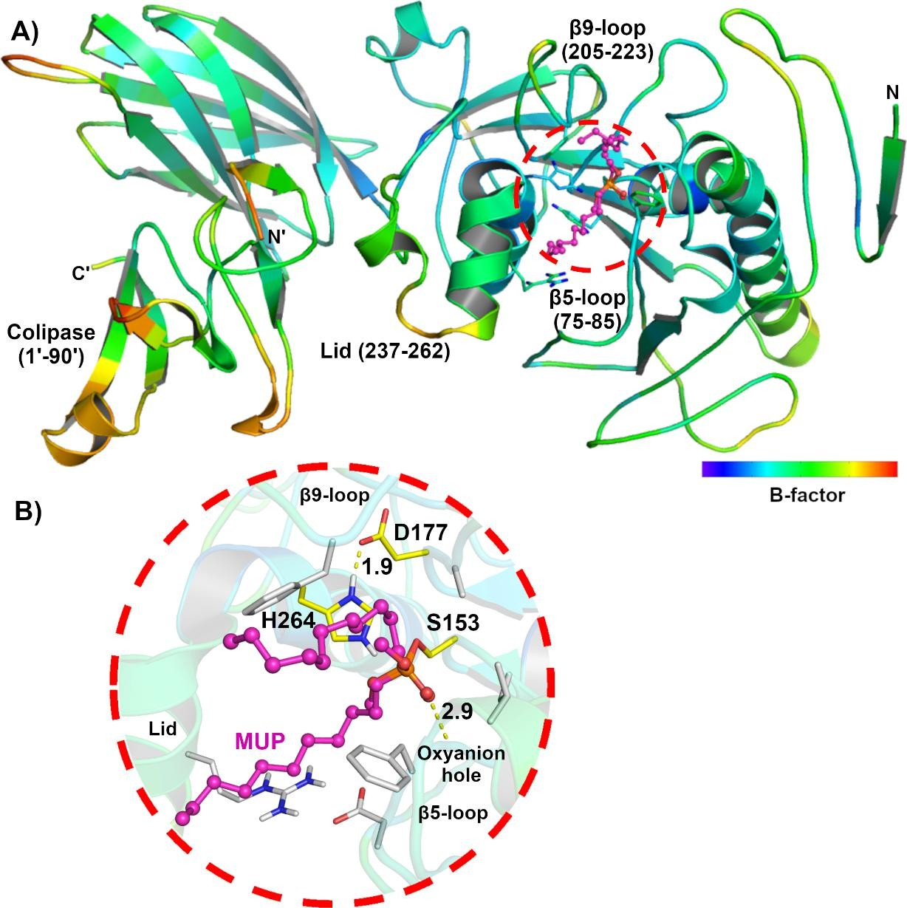
11

12
- Figure S1. (A) Pancreatic lipase (1LPB), shown in its B-factor, illustrating its active site pocket with
- methoxy undecyl phosphonic acid (MUP), in pink, covalently bound with S153. Active site region
- covers hydrophilic β-5 loop (residues 75-85), hydrophobic β-9 loop (206-223) and amphipathic lid
- region (residues 237-262). Colipase is represented by residues from 1’-90’. (B) MUP binds covalently
- to catalytic S153, shown along with H264 and D177, represented in yellow. Hydrogen bonds are
- measured in Å and represented by yellow dashes.

19
- 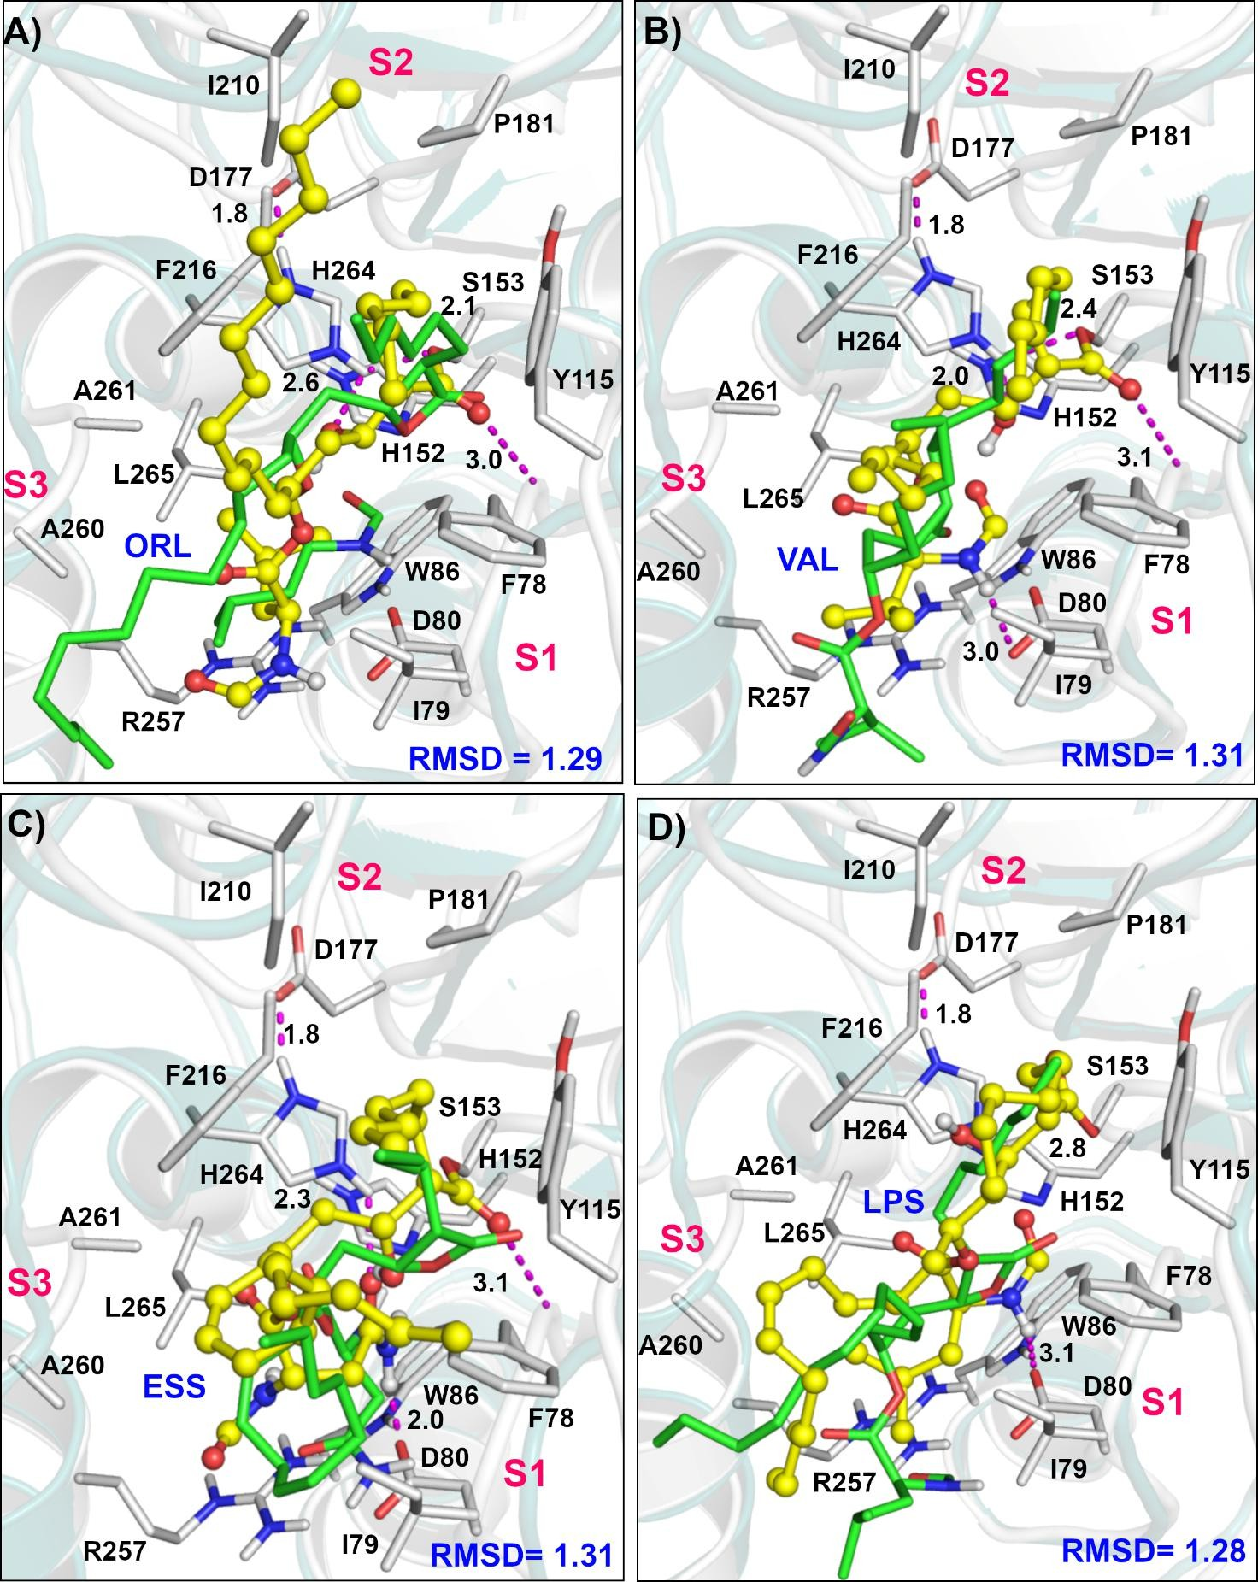
- Figure S2. The overlay of covalently bound (yellow ball and stick) and non-covalently bound (green
- sticks), lactones inhibitors of PL, ORL-Orlistat (A), VAL-Valilactone (B), ESS-Esterastin (C) and
- LPS-Lipstatin (D) in the active site pocket of pancreatic lipase (PL) after a 100 ns MD and
- metadynamics simulation, with the RMSD. Interacting residues of the pancreatic lipase protein are
- shown white sticks. Hydrogen bonding interactions are illustrated with light pink dotted lines. 26

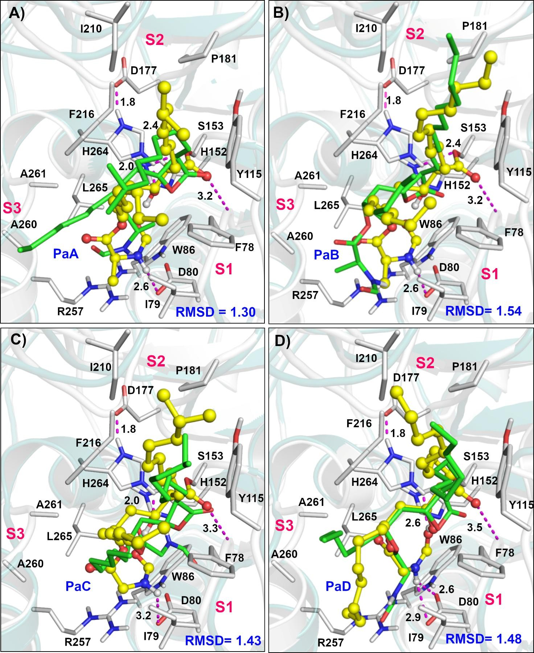
27
- Figure S3. The overlay of covalently bound (yellow ball and stick) and non-covalently bound (green
- sticks), lactones inhibitors of PL, PaA-Panclicin A (A), PaB-Panclicin B (B), PaC-Panclicin C (C),
- and PaD-Panclicin D (D) in the active site pocket of pancreatic lipase (PL) after a 100 ns MD and
- metadynamics simulation, with the RMSD. Interacting residues of the pancreatic lipase protein are
- shown white sticks. Hydrogen bonding interactions are illustrated with light pink dotted lines. 33

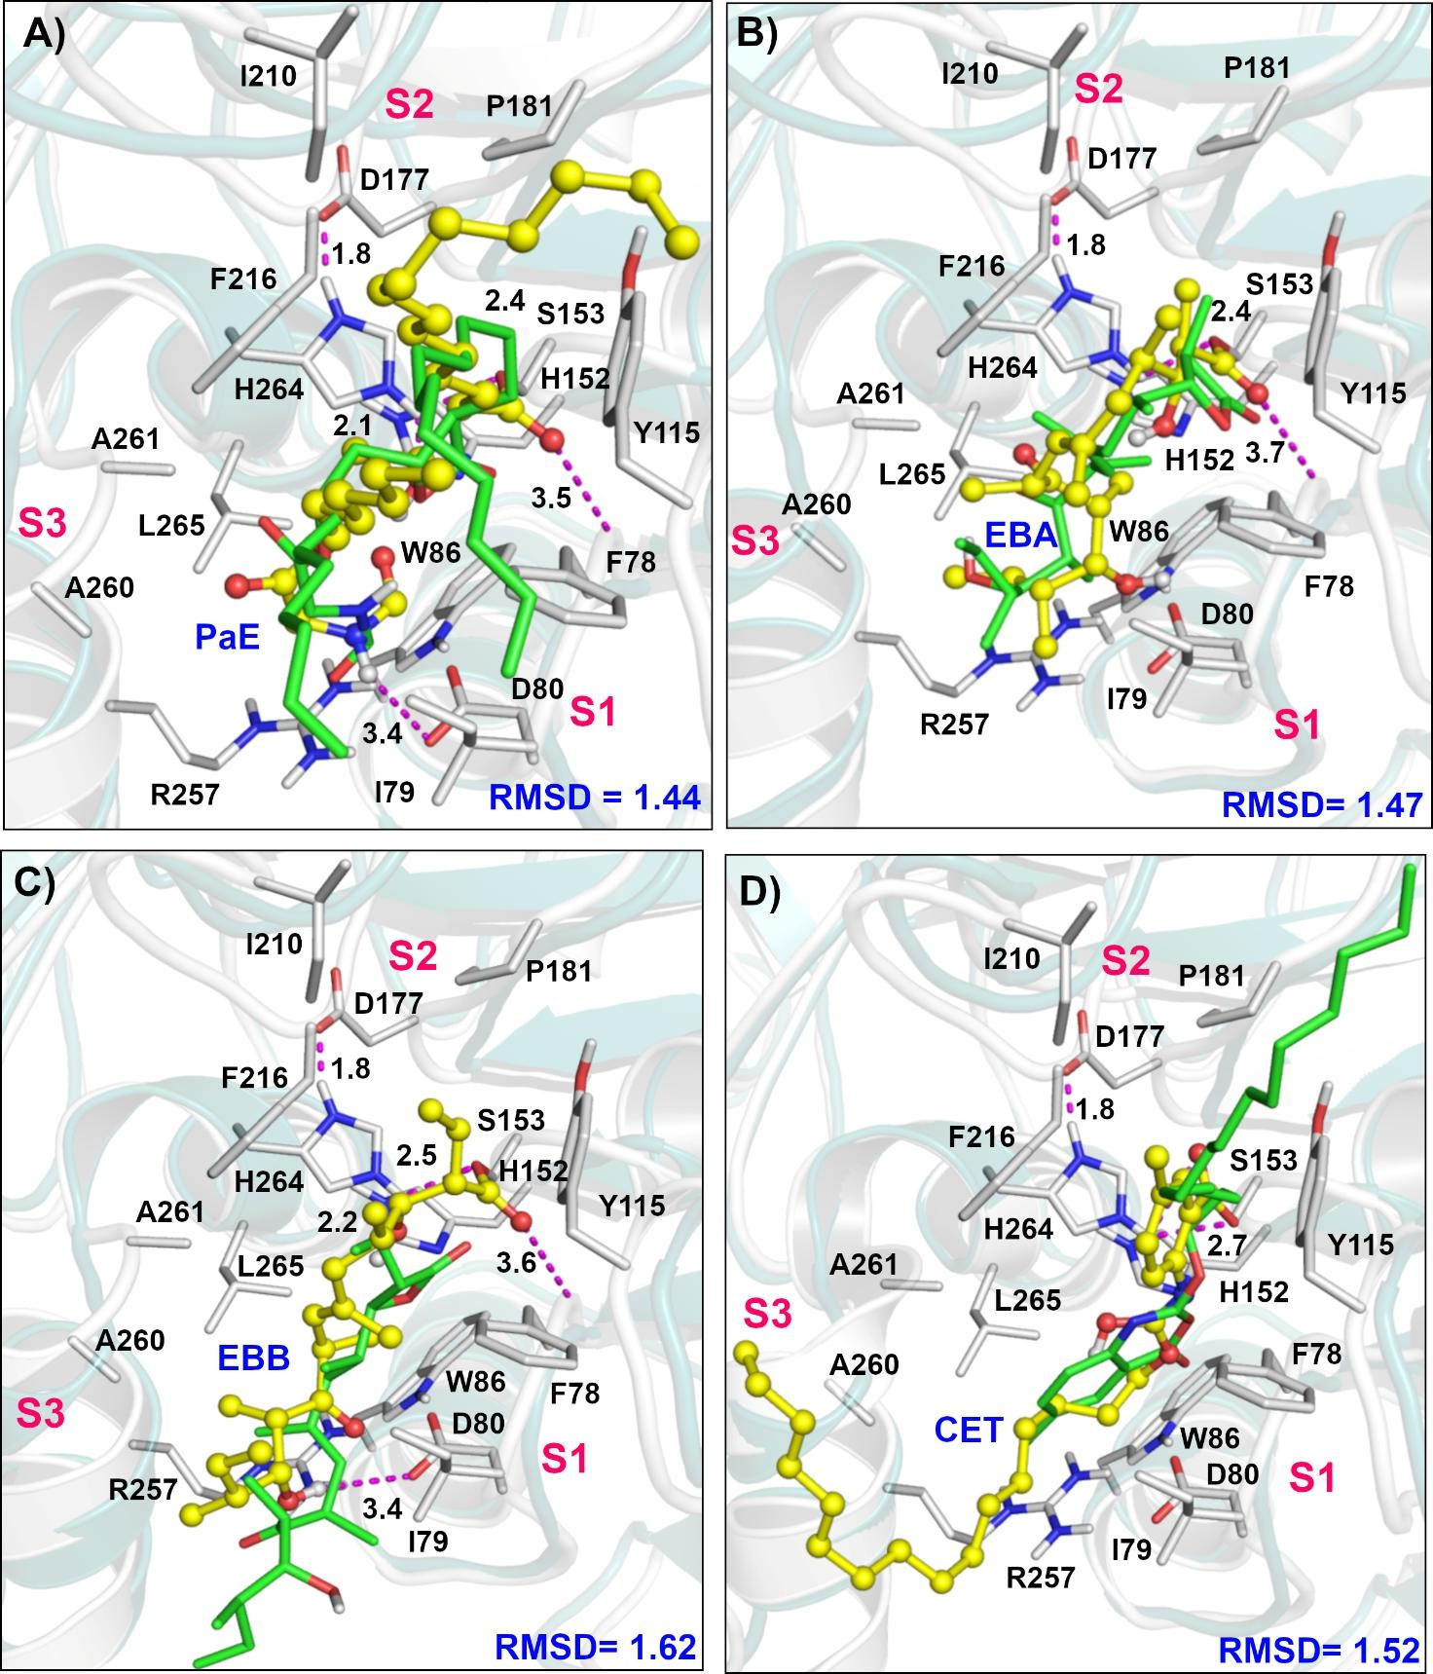
34
- Figure S4. The overlay of covalently bound (yellow ball and stick) and non-covalently bound (green
- sticks), lactones inhibitors of PL, PaE-Panclicin E (A), EBA-Ebelactone A (B), EBB-Ebelactone B
- (C), and CET-Cetilistat, in the active site pocket of pancreatic lipase (PL) after a 100 ns MD and
- metadynamics simulation, with the RMSD. Interacting residues of the pancreatic lipase protein are
- shown white sticks. Hydrogen bonding interactions are illustrated with light pink dotted lines. 40

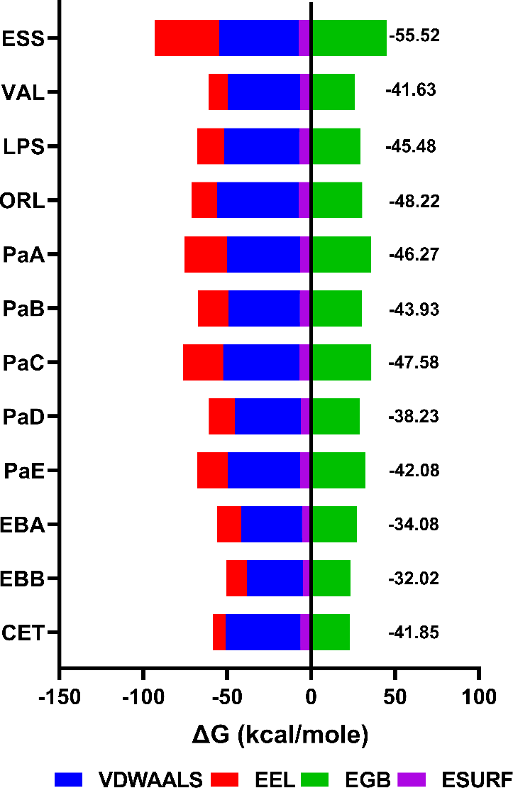
41
- Figure S5. The figure illustrates non-covalent binding energy (ΔG(MMGBSA) in kcal/mol) calculated
- in AMBER forcefield. The componenets, including electrostatic (EEL), van der Waals (VDWAALS),
- electrostatic contribution to the solvation free energy calculated GB (EGB), electrostatic contribution
- related to the solvent-accessible surface area of the inhibitor (ESURF), of lactone inhibitors of
- pancreatic lipase, ORL-Orlistat, VAL-Valilactone, ESS-Esterastin, LPS-Lipstatin, PaA-Panclicin A,
- PaB-Panclicin B, PaC-Panclicin C, PaD-Panclicin D, PaE-Panclicin E, EBA-Ebelactone A, EBB-
- Ebelactone B and CET-Cetilistat are shown. 49

