Appendix A. Data construction
Source files. TÜRKPATENT publishes the Official Patent Bulletin monthly. Issues from 2015_06 onwards are individual PDF files, and earlier issues are distributed as RAR bundles covering 2003 to 2010 and 2011 to 2015_04. Issue 2015_05 is missing from the office’s archive and the body of issue 2011_10 is missing from its bundle, which affects about 450 publications of mainly 2010 filings, many of which re-enter the data through later grant records. Issues from 2003 to 2005 are scanned images with unusable text layers, so filings from those years enter only through later publications and grants.
Parsing. The text of each issue was extracted page by page and split into records at each INID code 11 (document number). Fields were read from INID codes 12 (document type), 21 (application number), 22 (filing date), 30 to 33 (priority), 43 and 45 (publication and grant dates), 51 (IPC), 54 (title), 71 and 73 (applicants and owners with addresses), 72 (inventors with addresses), 74 (attorney) and 86 (PCT). Kind codes were harmonised, including the UA2 code used for utility-model publications in 2017. The notice index at the front of each issue, which lists every application number with its notice type, was parsed into a table of 929,050 events.
Recall. For each issue the set of parsed publication and grant records was compared with the application numbers listed in the notice index under the corresponding notice types. Publication recall has a median of 1.00 and a minimum of 0.989 for issues from 2011 onwards, and a median of 0.997 and a minimum of 0.923 for 2006 to 2010. Grant recall has a median of 0.997 and a minimum of 0.881.
Classification. Applicant types were assigned by ordered name rules. Universities were identified by the words Üniversitesi, University, Rektörlüğü and similar terms, public research institutes by the names of TÜBİTAK institutes, ministries and other public bodies, state-owned enterprises by a list of names, firms by legal-form suffixes, and the remaining applicants were classified as individuals. Inventor occurrences were classified as academic if the printed address matched university, faculty, department or campus patterns, after excluding residential estates named after universities, faculty housing and technopark firms, or if a university was a co-applicant on the application. The validation procedure is described in Section 5.2.
Disambiguation. Inventor names were upper-cased, Turkish characters were folded and academic titles were removed. Within each normalised name, occurrences were linked by union-find if they shared a co-inventor, a non-individual applicant, a university matched from the address, the first 35 characters of the normalised address, or a province for names that appear in fewer than three provinces and on fewer than 40 applications. Occurrences without addresses after March 2021 were attached to the single existing identifier of a non-common name. In total, 258,671 domestic inventor occurrences were grouped into 102,689 identifiers, and 0.5 percent of identifiers span more than one province.
Replication. The bulletin text archive, the parsed application, person, event and inventor files, the code for parsing, classification, disambiguation and estimation, and a codebook will be deposited in a public repository on acceptance.
Figure A1 compares the event-study paths of academics at universities with and without TTO support before 2017.
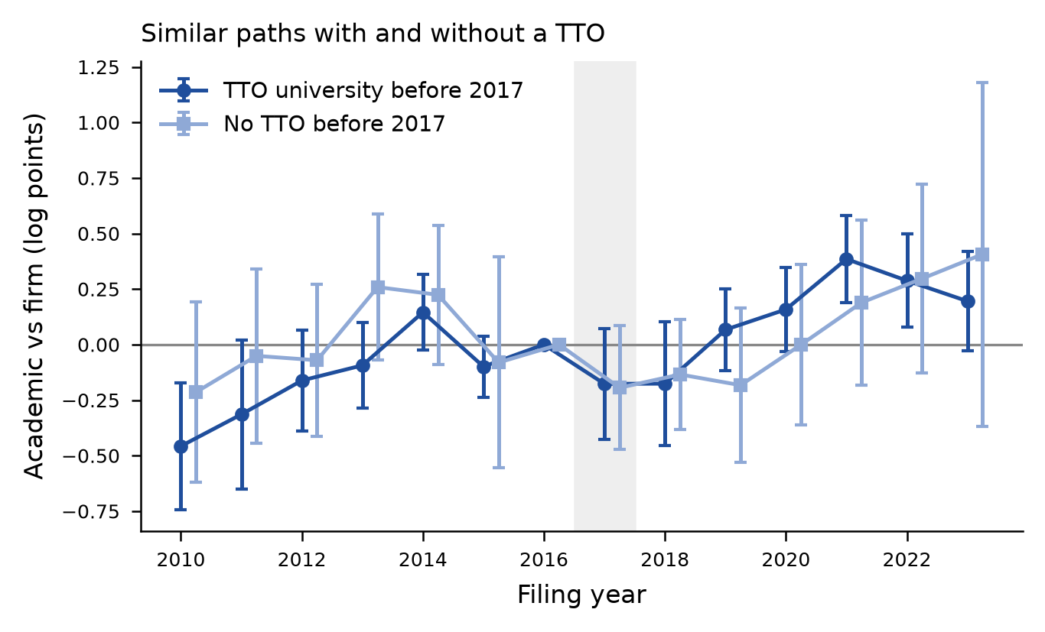
Figure A1. Event-study estimates for academics at universities with and without TÜBİTAK 1513 TTO support before 2017, relative to firm inventors. Specification as in Figure 2, panel a.

