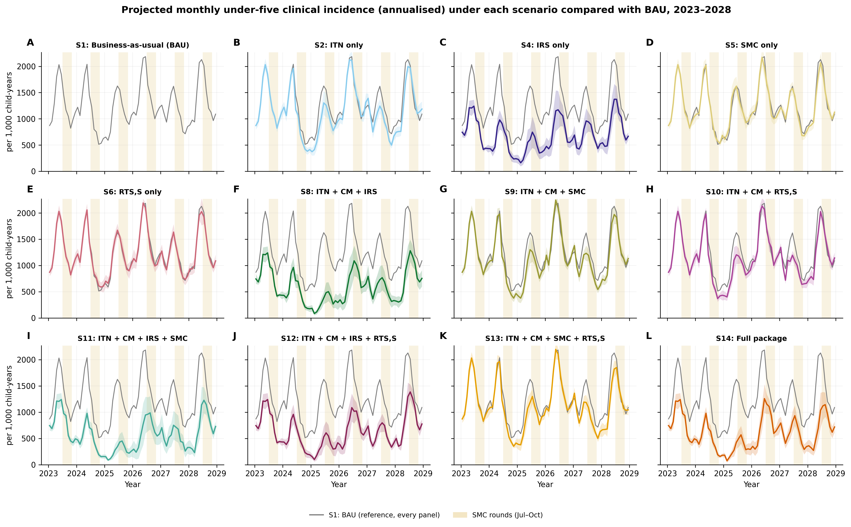
Supplementary Figure S1. Projected monthly under-five clinical incidence (annualised, per 1,000 child-years) under each scenario compared with BAU (grey), 2023–2028..
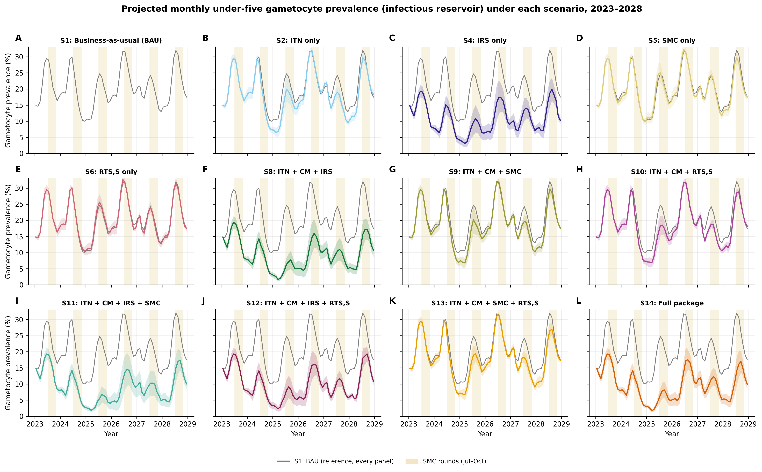
Supplementary Figure S2. Projected monthly under-five gametocyte prevalence (%) under each scenario compared with BAU, 2023–2028, indicating the infectious reservoir among young children.
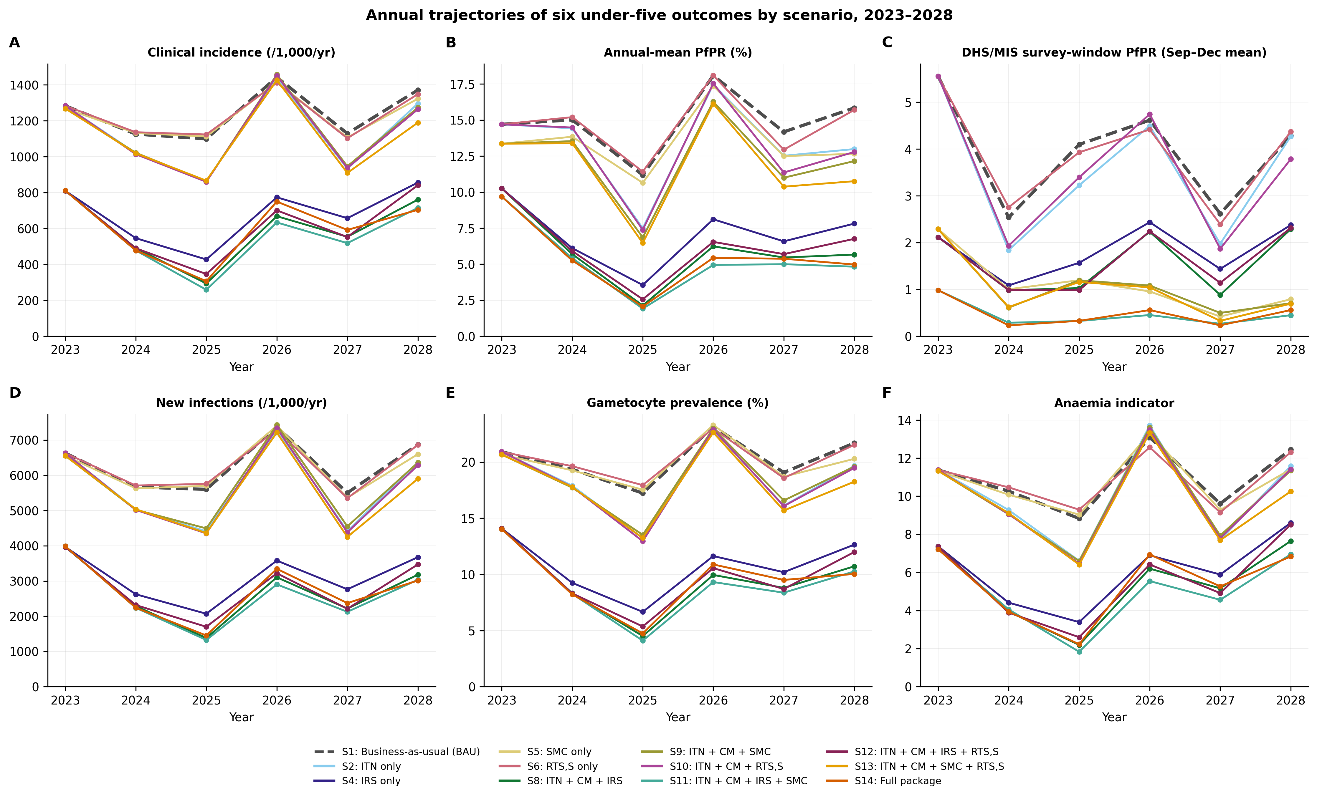
Supplementary Figure S3. Annual trajectories of (A) clinical incidence, (B) annual-mean PfPR, (C) DHS/MIS survey-window PfPR, (D) new infections, (E) gametocyte prevalence and (F) the anaemia indicator, by scenario (BAU dashed), 2023–2028.
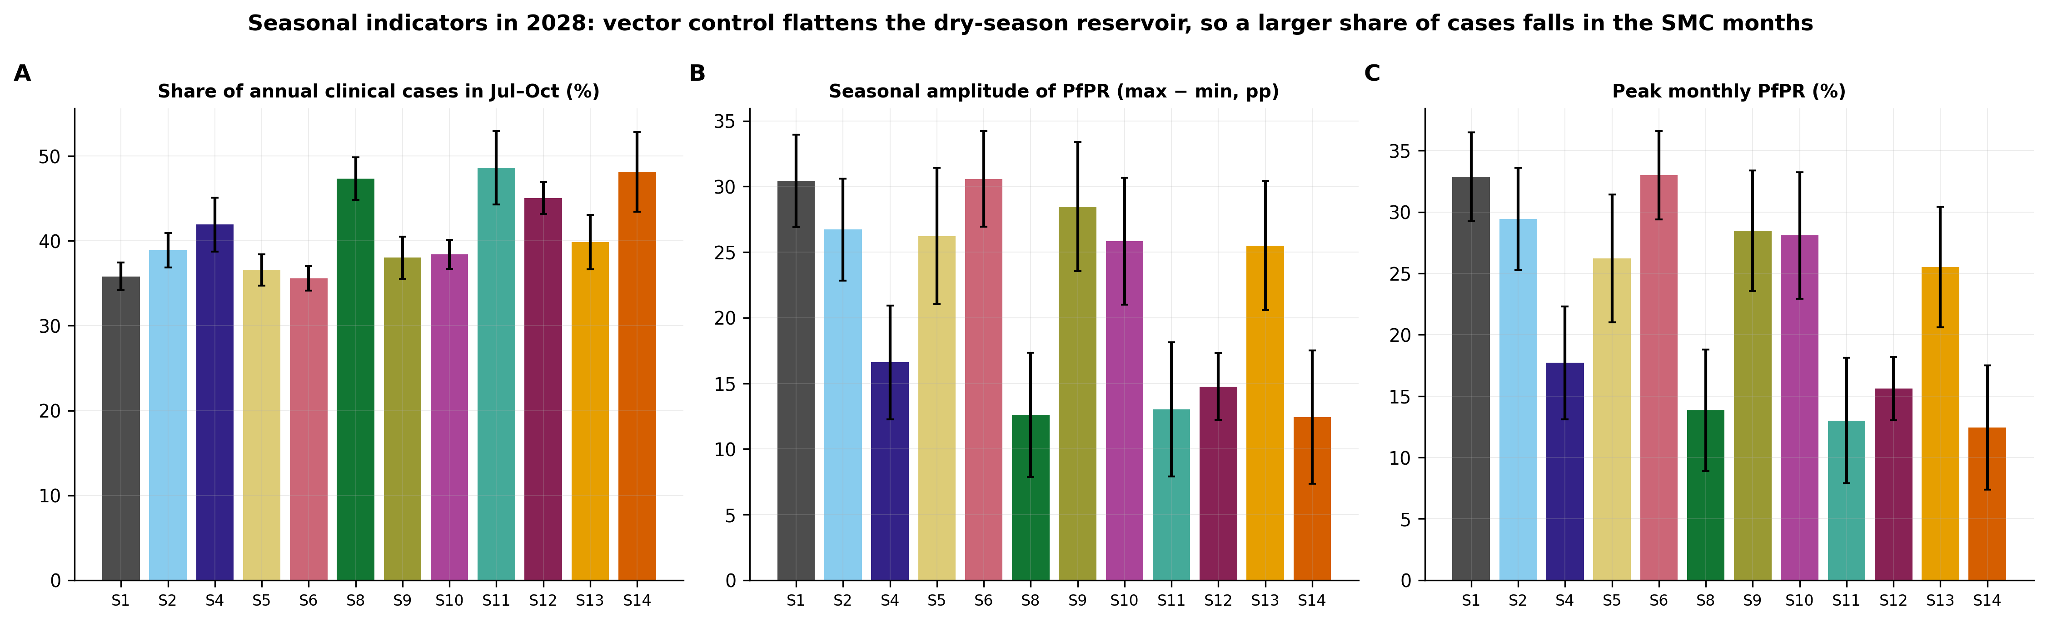
Supplementary Figure S4. Seasonal indicators in 2028 by scenario: (A) share of annual clinical cases in July–October, (B) seasonal amplitude of PfPR and (C) peak monthly PfPR (95% CI).
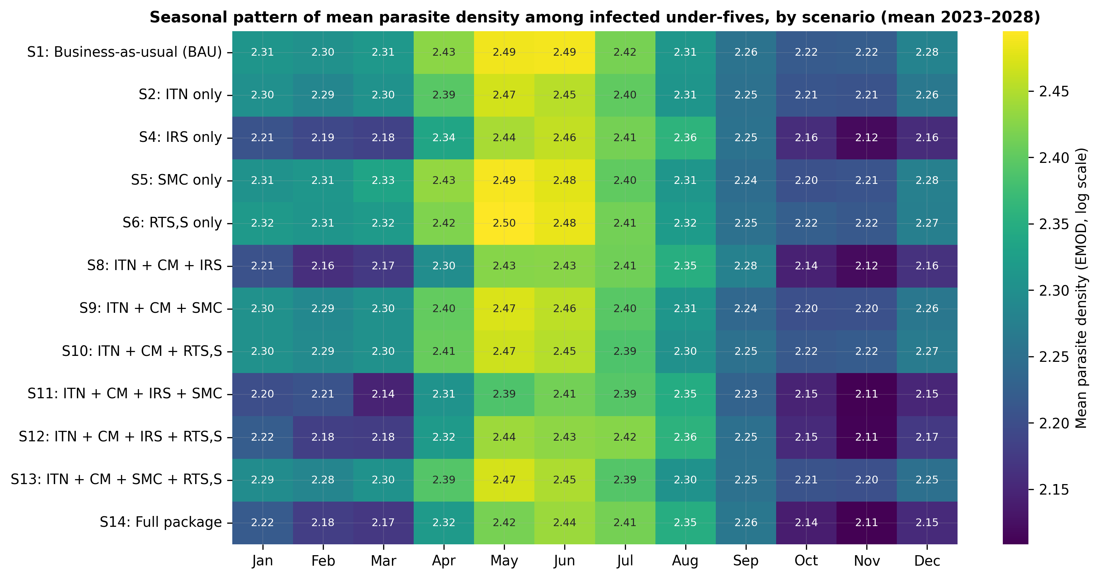
Supplementary Figure S5. Mean parasite density among infected under-fives by calendar month and scenario (mean 2023–2028; EMOD output, log scale). Density peaks in May–June and changes little across scenarios, indicating that interventions act mainly on the number of infections rather than their intensity.
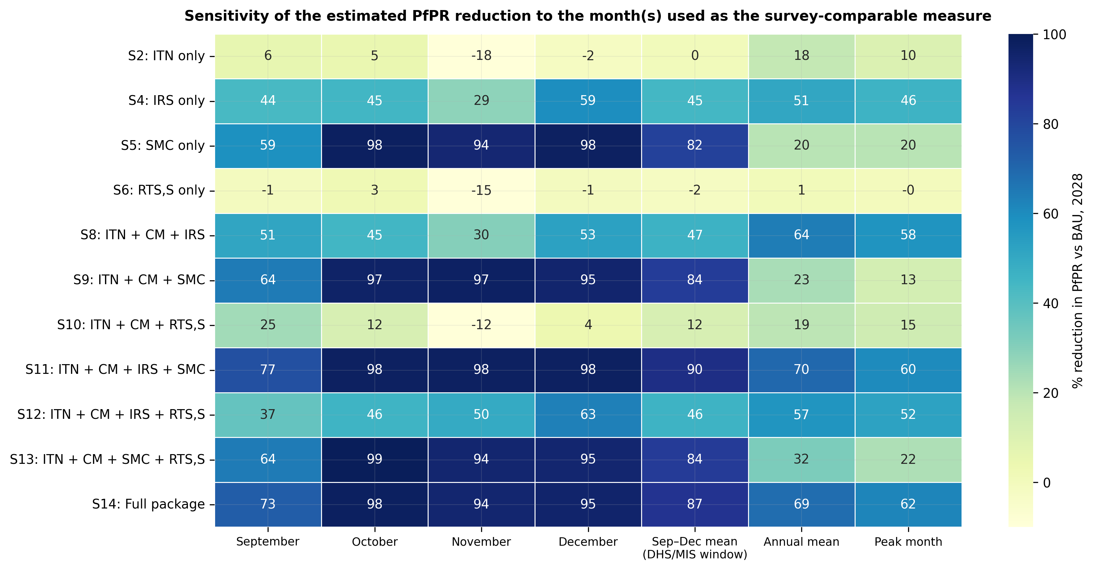
Supplementary Figure S6. Percent reduction in under-five PfPR relative to BAU in 2028 measured in September, October, November or December, as the September–December mean (DHS/MIS survey window), as the annual mean and at the peak month. SMC-containing scenarios show 59–99% reductions in single survey months but 20–70% on an annual basis.
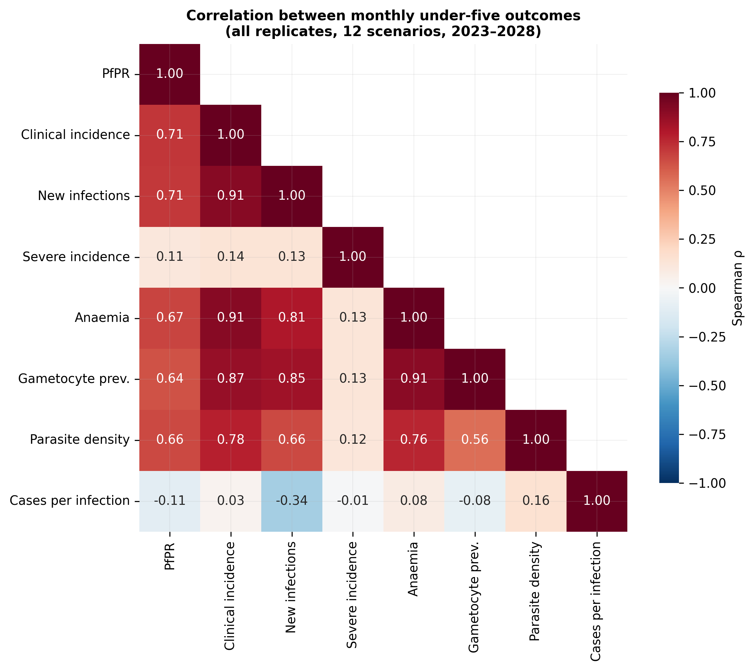
Supplementary Figure S7. Spearman correlations between monthly under-five outcomes across all replicates and the 12 scenarios, 2023–2028.
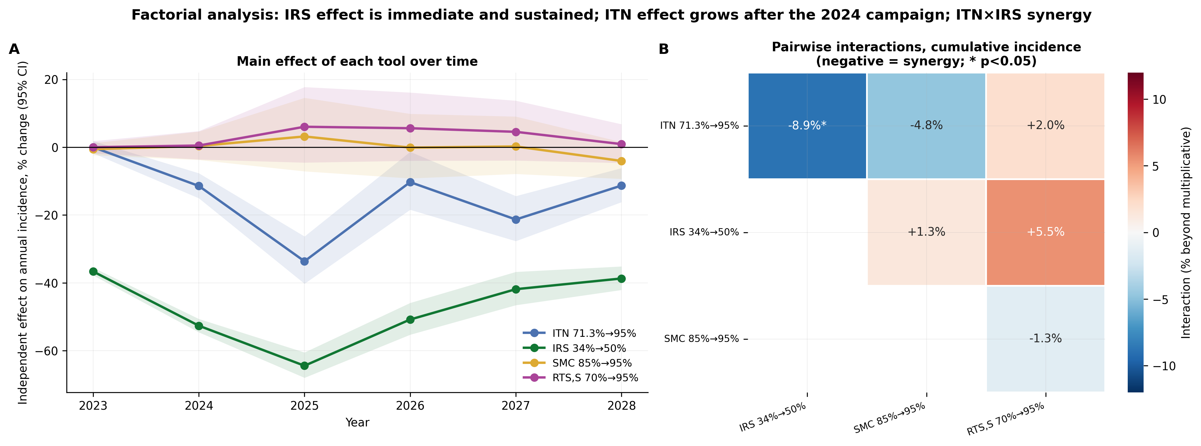
Supplementary Figure S8. Factorial analysis. (A) Independent effect of each tool’s scale-up on annual clinical incidence by year (log-linear model with replicate fixed effects; 95% CI). (B) Pairwise interactions for cumulative 2023–2028 incidence (negative = synergy; * p < 0.05).
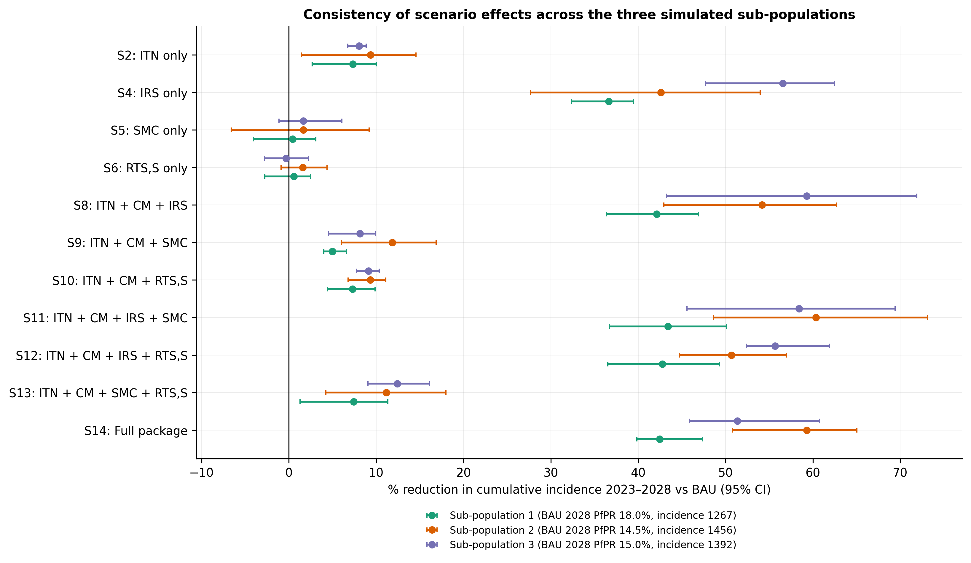
Supplementary Figure S9. Reduction in cumulative 2023–2028 incidence relative to BAU within each of the three simulated sub-populations (95% CI). Direction and ranking are consistent; reductions are smallest in the sub-population with the highest baseline prevalence.
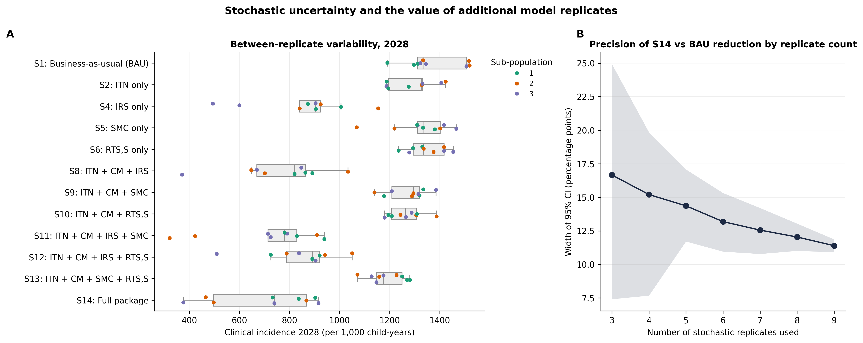
Supplementary Figure S10. Stochastic uncertainty. (A) Distribution of 2028 clinical incidence across the nine replicates, coloured by sub-population. (B) Width of the 95% CI for the S14-versus-BAU reduction in cumulative incidence as a function of the number of replicates used (mean and 10th–90th percentiles of 300 random subsets).
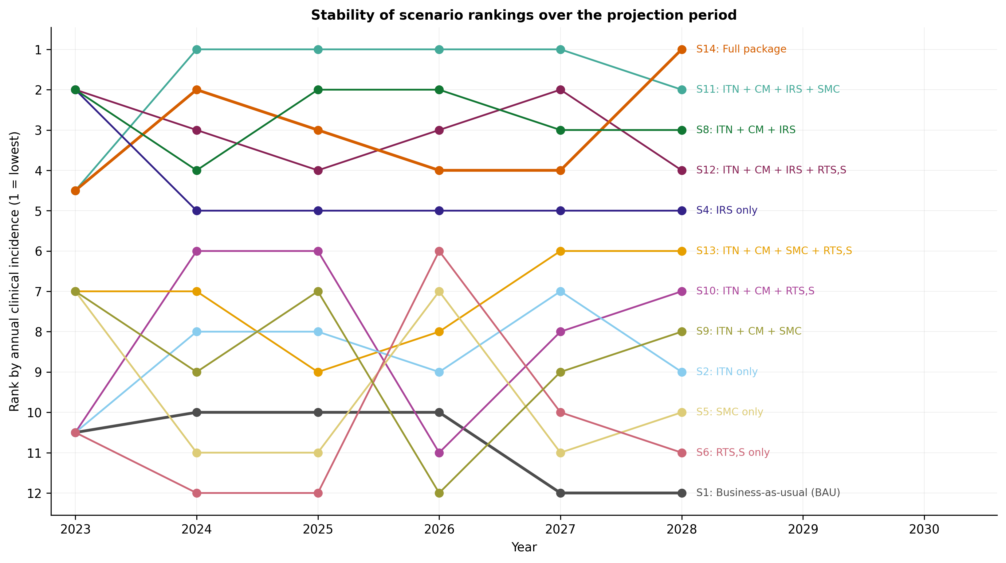
Supplementary Figure S11. Rank of each scenario by annual clinical incidence (1 = lowest), 2023–2028. IRS-containing scenarios occupy the top five ranks from 2024 onwards.
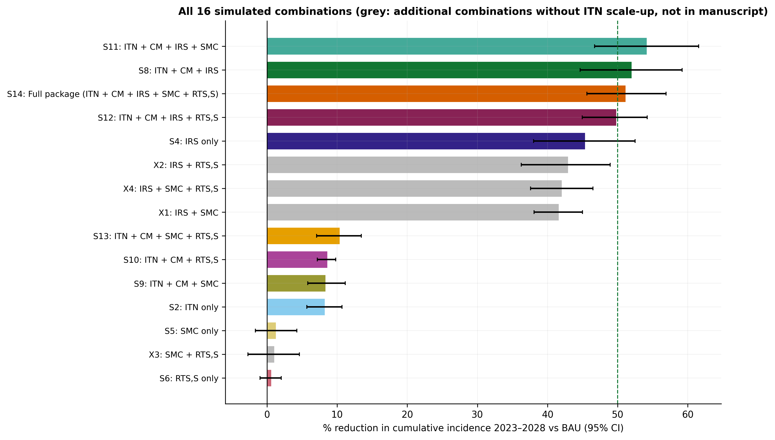
Supplementary Figure S12. Reduction in cumulative 2023–2028 incidence for all 16 simulated tool combinations, including four combinations without ITN scale-up that are not manuscript scenarios (grey). Dashed line = 50%.

Supplementary Table S1. DHS/MIS survey-window PfPR (Sep–Dec mean), % (mean, 95% CI), by scenario and year.
Scen. | Description | 2023 | 2024 | 2025 | 2026 | 2027 | 2028
S1 | Business-as-usual (BAU) | 5.55 (5.06–6.04) | 2.54 (2.00–3.08) | 4.10 (3.19–5.00) | 4.61 (3.89–5.34) | 2.62 (1.95–3.29) | 4.28 (3.60–4.97)
S2 | ITN only | 5.55 (5.06–6.04) | 1.84 (1.52–2.16) | 3.22 (2.41–4.03) | 4.49 (3.89–5.10) | 1.98 (1.70–2.26) | 4.27 (3.84–4.70)
S4 | IRS only | 2.12 (1.60–2.63) | 1.09 (0.69–1.49) | 1.57 (0.87–2.26) | 2.44 (1.70–3.17) | 1.44 (0.87–2.00) | 2.38 (1.64–3.11)
S5 | SMC only | 2.29 (1.75–2.83) | 1.01 (0.72–1.29) | 1.20 (0.92–1.47) | 0.96 (0.85–1.07) | 0.42 (0.31–0.54) | 0.79 (0.61–0.97)
S6 | RTS,S only | 5.55 (5.06–6.04) | 2.76 (2.36–3.15) | 3.93 (3.00–4.86) | 4.41 (3.82–5.01) | 2.39 (1.77–3.01) | 4.37 (3.97–4.77)
S8 | ITN + CM + IRS | 2.12 (1.60–2.63) | 0.98 (0.55–1.41) | 1.03 (0.57–1.49) | 2.23 (1.45–3.01) | 0.88 (0.51–1.26) | 2.29 (1.56–3.01)
S9 | ITN + CM + SMC | 2.29 (1.75–2.83) | 0.61 (0.42–0.81) | 1.20 (0.90–1.49) | 1.08 (0.91–1.26) | 0.50 (0.33–0.67) | 0.71 (0.52–0.89)
S10 | ITN + CM + RTS,S | 5.55 (5.06–6.04) | 1.93 (1.38–2.49) | 3.39 (2.76–4.03) | 4.74 (4.09–5.40) | 1.87 (1.42–2.32) | 3.78 (3.31–4.25)
S11 | ITN + CM + IRS + SMC | 0.98 (0.72–1.25) | 0.29 (0.18–0.40) | 0.33 (0.09–0.56) | 0.45 (0.25–0.66) | 0.27 (0.14–0.39) | 0.45 (0.27–0.63)
S12 | ITN + CM + IRS + RTS,S | 2.12 (1.60–2.63) | 0.99 (0.64–1.33) | 0.99 (0.49–1.49) | 2.24 (1.72–2.76) | 1.14 (0.76–1.53) | 2.31 (1.95–2.68)
S13 | ITN + CM + SMC + RTS,S | 2.29 (1.75–2.83) | 0.62 (0.45–0.80) | 1.16 (0.92–1.40) | 1.04 (0.87–1.22) | 0.33 (0.27–0.39) | 0.70 (0.50–0.89)
S14 | Full package (ITN + CM + IRS + SMC + RTS,S) | 0.98 (0.72–1.25) | 0.23 (0.17–0.30) | 0.33 (0.19–0.47) | 0.56 (0.45–0.67) | 0.23 (0.16–0.31) | 0.56 (0.30–0.82)
Supplementary Table S2. Annualised under-five clinical incidence per 1,000 child-years (mean, 95% CI), by scenario and year.
Scen. | Description | 2023 | 2024 | 2025 | 2026 | 2027 | 2028
S1 | Business-as-usual (BAU) | 1284 (1242–1326) | 1126 (1085–1167) | 1100 (1009–1190) | 1443 (1391–1495) | 1129 (1098–1160) | 1372 (1296–1447)
S2 | ITN only | 1284 (1242–1326) | 1020 (984–1056) | 865 (742–988) | 1440 (1370–1510) | 933 (863–1004) | 1296 (1237–1356)
S4 | IRS only | 810 (766–854) | 546 (462–631) | 428 (293–563) | 774 (595–953) | 658 (536–780) | 856 (726–986)
S5 | SMC only | 1269 (1237–1301) | 1132 (1098–1166) | 1113 (1020–1206) | 1415 (1346–1484) | 1107 (1076–1139) | 1323 (1245–1401)
S6 | RTS,S only | 1284 (1242–1326) | 1137 (1101–1172) | 1124 (1051–1197) | 1412 (1361–1463) | 1103 (1041–1164) | 1349 (1301–1396)
S8 | ITN + CM + IRS | 810 (766–854) | 491 (419–563) | 294 (195–393) | 669 (497–840) | 554 (432–676) | 761 (637–885)
S9 | ITN + CM + SMC | 1269 (1237–1301) | 1022 (982–1063) | 862 (758–965) | 1458 (1415–1500) | 947 (897–997) | 1274 (1221–1326)
S10 | ITN + CM + RTS,S | 1284 (1242–1326) | 1014 (975–1053) | 860 (778–942) | 1452 (1399–1506) | 938 (912–963) | 1265 (1222–1308)
S11 | ITN + CM + IRS + SMC | 812 (759–864) | 478 (419–537) | 259 (175–343) | 634 (429–839) | 519 (347–690) | 715 (578–852)
S12 | ITN + CM + IRS + RTS,S | 810 (766–854) | 490 (411–569) | 347 (223–470) | 701 (566–836) | 553 (473–633) | 841 (740–943)
S13 | ITN + CM + SMC + RTS,S | 1269 (1237–1301) | 1019 (977–1062) | 867 (776–958) | 1426 (1375–1478) | 910 (860–960) | 1190 (1143–1236)
S14 | Full package (ITN + CM + IRS + SMC + RTS,S) | 812 (759–864) | 478 (423–533) | 307 (219–395) | 750 (634–867) | 592 (483–701) | 704 (570–839)
Supplementary Table S3. Secondary under-five outcomes in 2028 (mean, 95% CI).
Scen. | Description | Severe incidence /100,000 child-yrs† | New infections /1,000/yr | Peak monthly PfPR, % | Gametocyte prevalence, % | Mean parasite density (log)
S1 | Business-as-usual (BAU) | 109 (35–182) | 6871 (6434–7307) | 32.9 (29.3–36.5) | 21.7 (20.9–22.6) | 2.37 (2.35–2.39)
S2 | ITN only | 68 (-13 to 148) | 6366 (5857–6876) | 29.4 (25.2–33.6) | 19.7 (18.7–20.6) | 2.36 (2.34–2.39)
S4 | IRS only | 109 (45–174) | 3676 (2916–4437) | 17.7 (13.1–22.3) | 12.7 (10.4–14.9) | 2.33 (2.32–2.35)
S5 | SMC only | 80 (41–120) | 6602 (5872–7332) | 26.2 (21.0–31.4) | 20.3 (18.9–21.7) | 2.36 (2.35–2.37)
S6 | RTS,S only | 134 (35–232) | 6864 (6428–7299) | 33.0 (29.4–36.6) | 21.5 (21.0–22.1) | 2.36 (2.35–2.38)
S8 | ITN + CM + IRS | 27 (-8 to 63) | 3179 (2469–3888) | 13.9 (8.9–18.8) | 10.7 (8.6–12.8) | 2.35 (2.32–2.37)
S9 | ITN + CM + SMC | 53 (-27 to 133) | 6362 (5697–7027) | 28.5 (23.6–33.4) | 19.6 (18.6–20.6) | 2.36 (2.34–2.38)
S10 | ITN + CM + RTS,S | 54 (12–97) | 6286 (5680–6892) | 28.1 (22.9–33.3) | 19.5 (18.5–20.5) | 2.36 (2.35–2.37)
S11 | ITN + CM + IRS + SMC | 39 (-15 to 94) | 3035 (2273–3797) | 13.0 (7.9–18.1) | 10.3 (7.9–12.7) | 2.34 (2.32–2.36)
S12 | ITN + CM + IRS + RTS,S | 80 (24–137) | 3471 (2952–3990) | 15.6 (13.0–18.2) | 12.0 (10.5–13.5) | 2.35 (2.33–2.38)
S13 | ITN + CM + SMC + RTS,S | 96 (8–185) | 5903 (5146–6659) | 25.5 (20.6–30.4) | 18.3 (16.8–19.7) | 2.35 (2.33–2.37)
S14 | Full package (ITN + CM + IRS + SMC + RTS,S) | 55 (12–97) | 3014 (2264–3765) | 12.4 (7.4–17.5) | 10.0 (7.8–12.3) | 2.32 (2.31–2.34)
† Few simulated severe events; estimates imprecise and lower bounds truncated.
Supplementary Table S4. Percent reduction in under-five PfPR relative to BAU in 2028 by survey month or averaging period.
Scen. | Description | Sep | Oct | Nov | Dec | Sep–Dec mean | Annual mean | Peak month
S2 | ITN only | 6 | 5 | -18 | -2 | 0 | 18 | 10
S4 | IRS only | 44 | 45 | 29 | 59 | 45 | 51 | 46
S5 | SMC only | 59 | 98 | 94 | 98 | 82 | 20 | 20
S6 | RTS,S only | -1 | 3 | -15 | -1 | -2 | 1 | -0
S8 | ITN + CM + IRS | 51 | 45 | 30 | 53 | 47 | 64 | 58
S9 | ITN + CM + SMC | 64 | 97 | 97 | 95 | 84 | 23 | 13
S10 | ITN + CM + RTS,S | 25 | 12 | -12 | 4 | 12 | 19 | 15
S11 | ITN + CM + IRS + SMC | 77 | 98 | 98 | 98 | 90 | 70 | 60
S12 | ITN + CM + IRS + RTS,S | 37 | 46 | 50 | 63 | 46 | 57 | 52
S13 | ITN + CM + SMC + RTS,S | 64 | 99 | 94 | 95 | 84 | 32 | 22
S14 | Full package (ITN + CM + IRS + SMC + RTS,S) | 73 | 98 | 94 | 95 | 87 | 69 | 62
Supplementary Table S5. Percent reduction in cumulative 2023–2028 incidence relative to BAU within each simulated sub-population (95% CI).
Scen. | Description | Sub-pop 1 (BAU PfPR 18.0%) | Sub-pop 2 (BAU PfPR 14.5%) | Sub-pop 3 (BAU PfPR 15.0%)
S2 | ITN only | 7 (3–10) | 9 (1–15) | 8 (7–9)
S4 | IRS only | 37 (32–39) | 43 (28–54) | 57 (48–62)
S5 | SMC only | 0 (-4–3) | 2 (-7–9) | 2 (-1–6)
S6 | RTS,S only | 1 (-3–2) | 2 (-1–4) | -0 (-3–2)
S8 | ITN + CM + IRS | 42 (36–47) | 54 (43–63) | 59 (43–72)
S9 | ITN + CM + SMC | 5 (4–7) | 12 (6–17) | 8 (5–10)
S10 | ITN + CM + RTS,S | 7 (4–10) | 9 (7–11) | 9 (8–10)
S11 | ITN + CM + IRS + SMC | 43 (37–50) | 60 (49–73) | 58 (46–69)
S12 | ITN + CM + IRS + RTS,S | 43 (37–49) | 51 (45–57) | 56 (52–62)
S13 | ITN + CM + SMC + RTS,S | 7 (1–11) | 11 (4–18) | 12 (9–16)
S14 | Full package (ITN + CM + IRS + SMC + RTS,S) | 42 (40–47) | 59 (51–65) | 51 (46–61)

