Supplementary Figures
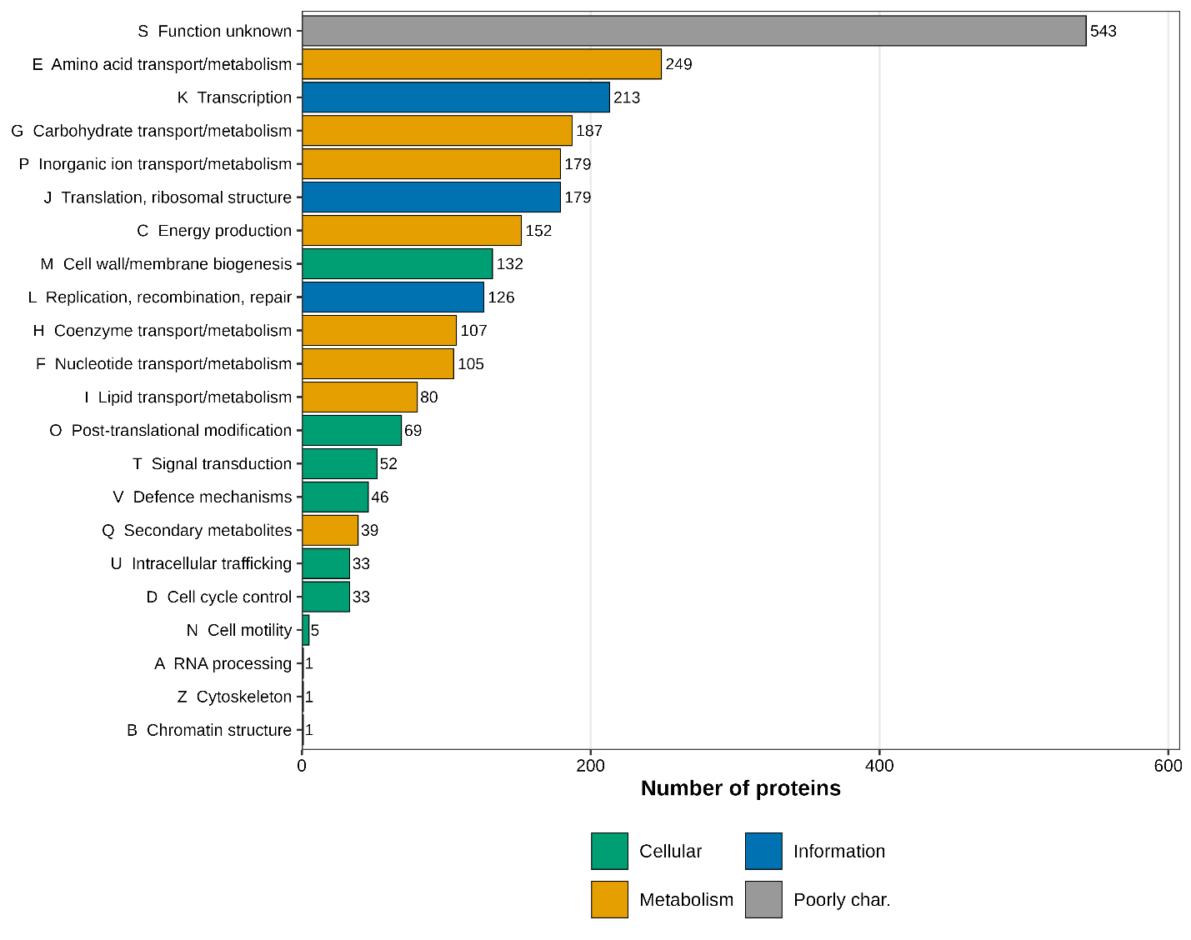
Fig. S1. COG functional-category profile of the Mammaliicoccus sciuri 30RR proteome (eggNOG-mapper), coloured by broad functional group.
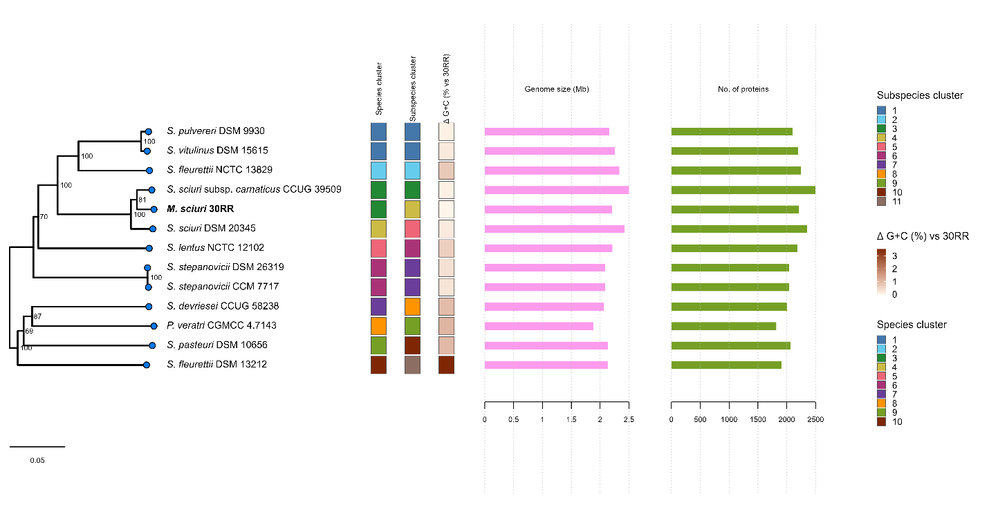
Fig. S2. TYGS whole-genome phylogeny of Mammaliicoccus sciuri 30RR and related type strains, inferred by the Type Strain Genome Server (TYGS) from whole-genome distances. 30RR falls within the M. sciuri species cluster (highest dDDH d4 value 75.4% against S. sciuri subsp. carnaticus CCUG 39509).

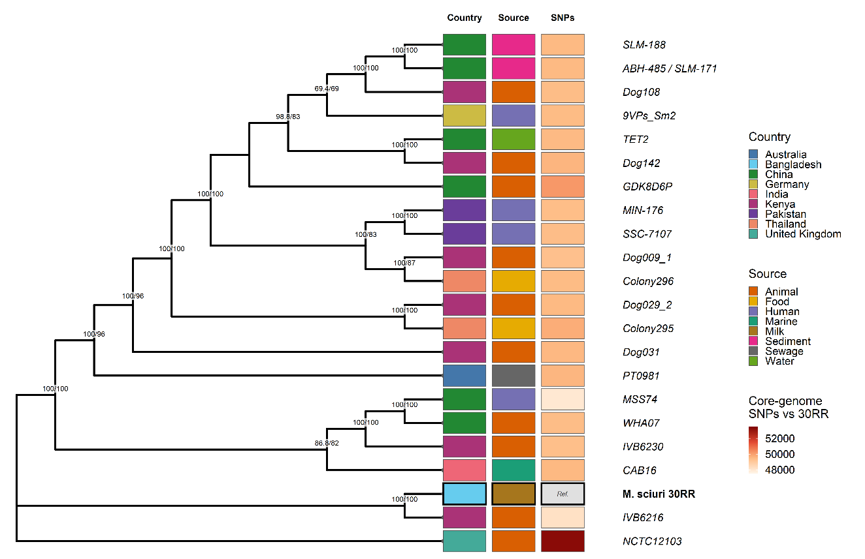
Fig. S3. Reference-based core-genome single-nucleotide-polymorphism (SNP) phylogeny of Mammaliicoccus sciuri 30RR and 22 reference genomes. The tree was inferred with Parsnp v2.1.3 using M. sciuri NCTC12103 as the reference genome (-r), forcing inclusion of all 23 genomes in the core alignment (-c). Node labels show SH-aLRT / ultrafast-bootstrap support (%). Tip annotation tracks show (left to right) country of origin, source/host group and core-genome SNP distance from 30RR (colour scale; 30RR marked “Ref.”). Strain 30RR (bold) again occupies an early-diverging position, clustering with the camel isolate IVB6216 with maximal support (100/100), concordant with the core-genome maximum-likelihood phylogeny (Fig. 3); the alignment reference NCTC12103 branches at the base and is the most divergent genome from 30RR (~52,000 core SNPs). The Chinese lake-sediment isolates ABH-485 and SLM-171, indistinguishable across the core SNP alignment, are shown as a single combined tip; the remaining genomes cluster in agreement with sequence type, host group and country of origin.

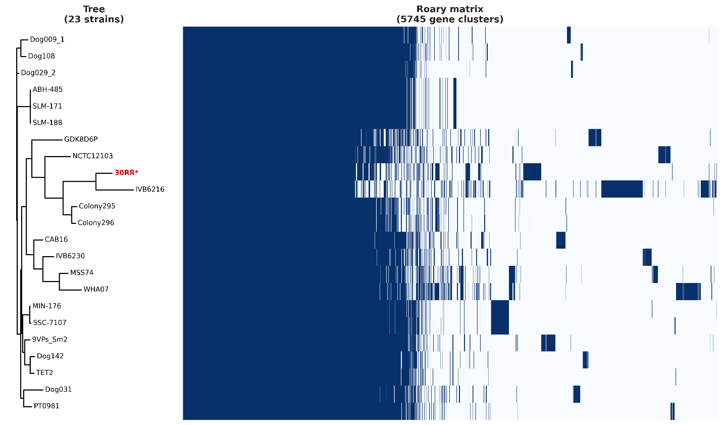
Fig. S4. Pangenome presence/absence matrix of Mammaliicoccus sciuri (n = 23 genomes). Columns are the 5,745 gene clusters and rows are the 23 genomes, ordered by the core-genome phylogeny shown at left; coloured blocks indicate gene presence. Strain 30RR is marked with a red asterisk.
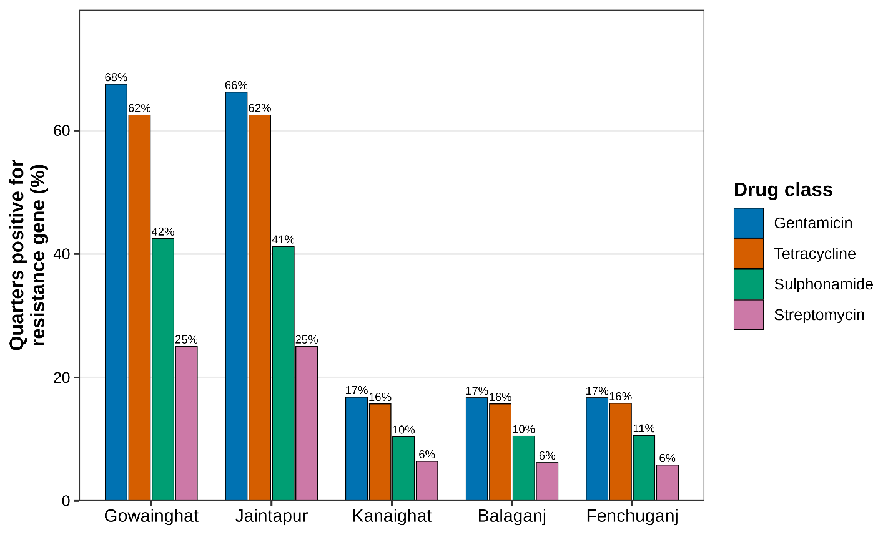
Fig. S5. Epidemiological context: antimicrobial-resistance-gene positivity in milk quarters across five locations of Sylhet district, Bangladesh (n = 1,540 complete quarter records), by drug class.

