Supplementary Materials for

Cholinergic signals regulate acute myeloid leukemia and chemotherapy response
Yexuan Zhu^{1-3,11}†, Michelle Buri^{4-6,11}†, Claire Fielding¹⁻³, Xiaochi Ma⁴⁻⁶, José A. Bejarano-García^{1-3,7-8}, Benian Uzun⁴⁻⁶, Thomas G. Henderson⁷⁻⁸, Harpreet Mandhair^{4,5}, Julius Schmiegelow¹, Carina Stoll^{4,5}, Agathe Chédeville⁷⁻⁸, Myrtha Arnold⁹, Ryan Collinson^{1-3,7}, Chantal Bachmann⁴⁻⁶, David Cabrerizo-Granados⁷⁻⁸, Joana Carlevaro Fita¹⁰, Xining Wang¹⁻³, Remy Bruggmann¹⁰, José Quesada-Salas⁷⁻⁸, Ramin Radpour^{4,5}, Adrian F. Ochsenbein^{4,5}, Carsten Riether^{4,5,12}*† and Simón Méndez-Ferrer^{1-3,7-8,12}*†

Corresponding authors: carsten.riether@unibe.ch (C.R.); smendez@us.es (S.M.-F.).

The PDF file includes:

Materials and Methods
Supplementary Text
Extended Data Figs. 1 to 6
Extended Data Tables 1 to 3
Supplementary References

Materials and Methods
Patient samples
Blood samples, BM aspirates and serum from untreated, newly diagnosed AML patients at the Department of Haematology and Central Haematology Laboratory, Inselspital, Bern University Hospital and University of Bern, Switzerland, were obtained after written informed consent. BM from healthy donors was collected from orthopedic patients who underwent Vertebroplasty. Patient characteristics are listed in Extended Data Table 1. Patient were characterized using the ELN guidelines 2022 ⁵¹. Analysis of blood, BM and serum samples was approved by the local ethical committee of the Canton of Bern, Switzerland (KEK 122/14 and 2019-01627).
Animals
Age and sex-matched Gfra2^{-/- 52}, Nes-Gfp ⁵³ (generously provided by G.E. Enikolopov), Nes-Cre^{ERT2 (REF54)} (generously provided by G. Fishell), Cxcl12-floxed mice ⁵⁵ (generously provided by D.-M. Lai), Doxycycline-inducible rtTA;MLL-AF9 mice ⁵⁶ (generously provided by J. Schwaller); the following lines from Jackson Laboratories: B6.129S7-Chrna7tm1Bay/J (Stock number 003232), B6(Cg)-Chrna7^{tm1.1Ehs}/YakelJ (Stock number 026965), B6.129(Cg)-Leprtm2(cre)Rck/J (Stock number 008320), B6.FVB-Tg(Acta2-DsRed)1Rkl/J (Stock number 031159); and congenic CD45.1 and CD45.2 C57BL/6J mice (Charles River) were used in this study. Mice were housed in specific pathogen free facilities. All experiments using mice followed protocols approved by the Animal Welfare Ethical Committees at the University of Cambridge (PPL 70/8406 and PPL P0242B783), the University of Seville (NTS-ES-062531) and the local experimental animal committee of the Canton of Bern and performed according to Swiss laws for animal protection (License BE75/17, BE30/21 and BE58/21).
MLL-AF9 AML mouse models
The results were independently confirmed in two different MLL-AF9 AML mouse models. In a retroviral model ⁵⁷, AML was induced as previously described⁵⁸. FACS-purified HSPCs (Lin-Sca1+ckit+ cells) were cultured overnight in RPMI supplemented with 10% FBS, 1% Penicillin‐ Streptomycin, 100ng/mL murine stem cell factor (mSCF, Miltenyi) and 10ng/mL rm‐TPO (Biolegend). In this AML model ⁵⁷, the oncogene fusion protein was incorporated by spin transduction with the GFP-MLL-AF9 retroviral construct with an MOI = 0.5 on two consecutive days ⁵⁸. After a minimum of 4 h after the second spin transduction, 5x10⁴ cells were injected into the tail vein of non-irradiated syngeneic recipients. Progression was monitored by blood collection from the tail vain and subsequent FACS analysis of CD11b+GFP+ cells. At the endpoint, animals were sacrificed with CO₂ according to guidelines imposed by the local experimental animal committee of the Canton of Bern. Long bones, blood and spleen were collected for subsequent analysis.
For independent confirmation in a different MLL-AF9 model, an inducible primary rtTA;MLL-AF9 model ⁵⁶ was used. Briefly, this transgenic doxycycline-inducible strain expresses rtTA in the ROSA26 locus and the MLL-AF9 fusion of human origin under the control of the tetracycline-response element. Upon induction, both the primary rtTA;MLL-AF9 (iMLL-AF9) mice and WT recipients of iMLL-AF9 BM cells develop a similar type of AML (M4/5) which recapitulates the human disease. To follow the development of normal and leukemic hematopoiesis simultaneously in the same animals, we competitively transplanted lethally irradiated recipients (12 Gy whole body irradiation, split dose 6.0 + 6.0 Gy, 3 h apart) with non-induced, iMLL-AF9 BM (10⁶ cells) and WT BM (10⁶ cells). Two weeks after transplant, mice were kept with doxycycline (pellet food 400 mg/kg) to induce transgene expression. Disease progression was monitored every week in tail peripheral blood samples using an automated blood counter. Mice were considered as leukemic once peripheric white blood counts were over 15 x 10³/uL. Mice were sacrificed at the appropriate endpoints described in the experimental design. Hematopoietic reconstitution was assessed in the peripheral blood of recipient mice at several times after transplantation by measuring blood, spleen and bone marrow CD45.2 or DsRed (depending on the experimental design) and CD45.1 chimerism.
In vivo treatments
Ara-C (Cytarabine Cayman Chemical, CAY16069) was administered to the mice at 100 mg/kg/day (i.p.), at time and frequency indicated in the experimental design in the legend. Doxorubicin (Sigma, D1515) was administered to the mice by i.p. at 3 mg/kg/day at time and frequency indicated. To induce CXCL12 depletion in Nestin-expressing cells, recipient Cxcl12^{f/f};Nes-Cre^{ERT2} mice were administrated 3 doses of tamoxifen (1 dose a day, on 3 consecutive days from day 14 post-transplant), at 140mg/kg/day (i.p.) 14mg/ml solution in corn oil (Sigma, C8267). Hexamethonium Bromide (Merck Life Science Limited, H0879) was administrated (i.p.) at 20mg/kg/day at time and frequency indicated.
Vagotomy
Bilateral Sub-Diaphragmatic Vagotomy: Prior to surgery, all animals were solid food-deprived (2–4 h), while access to water was provided ad libitum. All animals were anesthetized with isoflurane (induction 5%, 600 ml/min; maintenance 1.5–2%, 400 ml/min) and their body temperature was maintained at 37◦C with a heating pad. The procedure was as described⁵⁹. Briefly, following adequate depth of anesthesia a midline abdominal incision (∼1 cm) was made along the linea alba running ∼1 cm caudal from the xiphisternum. The liver was retracted and the stomach was lifted out of the peritoneal cavity while the esophagus was held in an exposed position. All identifiable vagal afferent and efferent fibers were exposed and excised. In addition, all neural tissue surrounding the esophagus immediately beneath the diaphragm was excised to capture any residual vagal branches. Pyloroplasty was performed to assure similar defecation patterns between sham operated and vagotomized animals. For sham-operated animals, the vagus nerve was similarly exposed but left uncut. Post-surgery, both groups received the same analgesic treatment listed below regardless of pyloroplasty.
Pyloroplasty: A pyloroplasty was performed to facilitate gastric drainage and relieve pyloric stenosis. The gastric antro-pyloro-duodenal region was gently exposed and a longitudinal incision (∼2–4mm) was made through the pylorus, extending from the distal antrum to the proximal duodenum. Four (5-0 Vicryl) sutures were placed in the pyloric tissue such that by closing the incision transversely, the outlet diameter of the pylorus was increased. The duodenum/stomach was then placed back in the peritoneal cavity and the abdominal incision closed in a two-step procedure using a 5-0-vicryl suture. Postsurgical medication consisted of Baytril (5mg/kg SC) and Rimadyl (5mg/kg SC). Right after surgery and for the following 3 days, glucosaline (5 % glucose in NaCl, 700 µL) and Rimadyl (Caprofen, 100-fold dil. with NaCl (0.1 mL /10 mL), 10µL/g BW) were provided. The animals were monitored by weight and mobility assessment.
Tracer based confirmation: Fluoro-Gold™ was injected intraperitoneally 3 days before the sacrifice. The analgesic Temgesic (buprenorphine 0.1 mg/kg) was co-administered subcutaneously. At the day of sacrifice, whole mouse heads were directly transferred into a cold 4 % paraformaldehyde (PFA) solution.
BM extraction, flow cytometry and fluorescence-activated cell sorting
For BM hematopoietic cell isolation, bones were crushed in a mortar and filtered through a 40-μm strainer to obtain single cell suspensions. Tissues were depleted of red blood cells by commercial lysis (BioLegend, 420301) for 8 min at 4ºC. Blood samples were directly lysed. Cells were incubated with the appropriate dilution (2-5 µg/ml) of fluorescent antibody conjugates and 4',6-diamidino-2-phenylindole (DAPI, 1:2000) for dead cell exclusion, and analyzed on BD LSRFortessa or BD FACS Aria III flow cytometer (BD Biosciences, Franklin Lakes, NJ) equipped with FACSDiva Software (BD Biosciences). FACS purification was performed on BD FACS Aria III or BD Influx cell sorter. Data was analyzed using FlowJo software v.10.6 – v10.8 (TreeStar) or Beckman Coulter Kaluza software.
We isolated HSPCs from bone-associated and non-associated marrow fractions as previously described⁶⁰. Briefly, long bones were flushed gently to obtain hematopoietic cells less tightly associated with the bone and the flushed-bones were then crushed in a mortar to obtain hematopoietic cells of the endosteal compartment. Cells were stained with the above-detailed antibodies and analyzed by flow cytometry or sorted (FACS Aria cell sorter, BD Bioscience). HSCs were immunophenotypically defined as lin- CD48- sca-1+ c-kit+ CD150+ cells.
To analyze stromal cells, bones were cleaned off surrounding tissue, crushed and flushed as described above in a mortar with a pestle, and digested with collagenase (catalogue number 7902, StemCell Technologies; 0.25% collagenase type I in PBS supplemented with 20% fetal bovine serum) in water bath at 37ºC for 30 min with agitation. Cells were filtered through a 40-μm strainer and erythrocytes were lysed as described above. The resulting cell suspensions were pelleted, washed and resuspended in PBS containing 2% FCS for further analyses. The following antibodies were used: CD45-biotin (BD biosciences, 553078), CD31-biotin (BioLegend, 102504), TER119-biotin (BioLegend, 116204), CD140a APC (BioLegend, 135908), Sca1 BV711 (BD biosciences, 108131) were used. Different stromal populations were analyzed: PDGFRα⁺Sca1⁻ skeletal stem cells (SSC), PDGFRα⁺Sca1⁺ (PαS) cells, PDGFRα⁻CD51⁺Sca1⁺ bone-lining osteoprogenitors (OPCs) or PDGFRα⁻CD51⁺Sca1⁻ osteoblast precursors (OBPs). Cell cycle analysis was performed through Hoechst 33442 (H42)/ ki67. Briefly, single cell suspensions were obtained and stained for cell surface markers and fixed cytofix/cytoperm (BD Biosciences, 554714) for 10min at RT. Cells were then washed in permwash (BD Biosciences, 554714) and resuspended in ki67 (Abcam, AB15580, 1:100) at 4°C overnight. Cells were washed and resuspended in goat anti rabbit AF488 (Thermo fisher scientific, A-11008) at 1:200 for 20 min on ice and subsequently in Hoechst at 1:2000 for 12min at 4°C. A final wash was carried out and cells resuspended in 300ml permwash for analysis.
The following antibodies were used:
Human: APC anti-CD34 (clone 561) and PE-Cy7 anti-CD38 (clone HIT2) and APC-Cy7 anti-CD90 (clone 5E10) were purchased from Biolegend. PE anti-CD45 (clone HI30) was purchased from eBioscience. Biotin-conjugated antibodies against CD2 (clone RPA-2.10), CD3 (clone OKT3), CD14 (clone HCD14), CD16 (clone 3G8), CD19 (clone HIB19), CD56 (clone HCD56) and CD235a (clone HIR2) were also purchased from Biolegend and FITC-conjugated streptavidin (Biolegend) was used for secondary staining. All antibodies were used according to the manufacturer’s guidelines.
Mouse: Biotin Mouse Lineage Panel (CD11b, Gr-1, Ter119, B220, CD3e) (BD Biosciences, 559971), CD45.1 (Clone A20, Insight Biotechnology, 60-0453-U100), CD45.2 (Clone 104, BioLegend UK Ltd, 109823 ), Ckit (Clone 2B8, BioLegend, 105825), Sca-1 PE Cy7 (Clone E13-161.7, BioLegend UK Ltd, 108113 ), CD150 (Clone TC15-12F12.2, BioLegend UK Ltd, 115909), CD48 (Clone HM48-1, BioLegend UK Ltd, 103439), Rabbit anti ki67 (Abcam, AB15580), Goat anti rabbit AF488 (Thermo Fisher Scientific, A-11008), Hoechst 33342 Solution (20 mM) (Thermo Fisher Scientific, 62249), Biotinylated antibodies were detected with fluorochrome-conjugated streptavidin (BD Biosciences, 554061). All antibodies were used at 1:200 except for biotinylated lineage antibody mix and rabbit anti ki67 at 1:100, cells incubated in 300ul for staining. BV650 anti-CD4 (clone RM4-5), APC anti-CD4 (clone GK1.5), AF700 anti-CD8 (clone 53-6.7), APC-Cy7 anti-CD44 (clone IM7), AF700 anti-CD62L (clone MEL-14), PE-Cy7 anti-CD19 (clone 6D5), APC-Cy7 anti-CD19 (clone 6D5), APC anti-CD11b (clone M1/70), BV605 anti-NK1.1 (clone NK-L1), PerCP-Cy5.5 anti-Ly6C (clone HK1.4), Pacific Blue anti-Ly6C (clone 1A8), PerCP-Cy5.5 anti-Sca-1 (clone D7), PE anti-c-kit (clone 2B8), BUV395 anti-c-kit (clone 2B8), PE-Cy7 anti-CD16/32 (FcγRIII, clone 93), APC anti-CD48 (clone HM48-1), PE anti-CD150 (clone TC15-12.2) and BV605 anti-CD127 (clone A7R349) were purchased from Biolegend. PE anti-CD11b (clone M1/70) was purchased from eBioscience and AF700 anti-CD135 (clone A2F10) was purchased from Novus. Biotin-conjugated antibodies against CD19 (clone 6D5), CD3e (clone 145-2C11), Gr-1 (clone RB6-8C5) and TER119 (clone Ter-119) were also purchased from Biolegend and BD Horizon V500-conjugated Streptavidin (BD Bioscience) was used for secondary staining. If a magnetic cell separation was performed, magnetic anti-biotin beads (Miltenyi) were used instead. Magnetic cell separation was performed with an AutoMACS® Pro Separator (Miltenyi) using the “Deplete” program. All stainings; for either FACS‐purifications or flow cytometric measurements were performed in staining buffer (PBS supplemented with 1:19 FBS and 2.5mM EDTA) except if fixable viability dyes (Thermo Fisher) were used. In that case, staining was performed in PBS only.
Superior cervical ganglion neuronal culture
The superior cervical ganglia of neonatal mice were microdissected on postnatal day 3 (P3) and processed as described⁶¹ with some modifications. Briefly, the ganglia were incubated with collagenase I (StemCell Technologies, Cat. No. 07902) for 20 minutes at 37ºC with agitation, followed by digestion with 5% trypsin (Sigma, Cat. No. 59427C) in HBSS (ThermoFisher, Cat. No. 14175095) for 25 minutes at 37ºC with agitation. Cells were washed with Ham’s F12 medium (ThermoFisher, Cat. No. 11765054) supplemented with 10% horse serum (ThermoFisher, Cat. No. 26050070), and mechanically dissociated with 200 µl pipette until a single cell solution was obtained. Cells were washed (300xg), counted using hemo-cytometer slides, and plated on 24-well plates, with glass coverslips when used for immunofluorescence, pre-coated with poly-L-ornithine (Sigma, Cat. No. P4957) and 2% laminin (Sigma, Cat. No. L2020). Cells were plated at a density of 1x10⁵ cells per well in F14 medium (BioWest, Cat. No. L0138) supplemented with 1% penicillin/streptomycin, 40ng/ml NGF (R&D systems, Cat. No. 256-GF-100), and 2% Albumax (ThermoFisher, Cat. No. 11020-021)—a BSA solution supplemented with 60 mg/ml progesterone (Cat. No. P8783), 16 mg/ml putrecine (Cat. No. P5780), 400 ng/ml L-thyroxine (Cat. No. T2501), 38 ng/ml sodium selenite (Cat. No. S5261) and 340 ng/ml triiodothyronine (Cat. No. T6397; all from Sigma). Medium was half-changed every other day. SCG cultures were co-cultured with iMLL-AF9 blasts at 500,000 cells/ml in transwell or treated with iMLL-AF9 blast-conditioned medium from 500,000 cell/ml after 24h of culture, with or without Anti-mIL-6-IgG (sIL-6 inhibitor; Invivogen, Cat. No. mabg-mil6-3). iMLL-AF9 blasts or conditioned medium were replaced at the time of medium change.
iMLL-AF9 blast culture
iMLL-AF9 blasts were maintained in cell culture flasks in RPMI 1640 (Invitrogen) and supplemented with 10% charcoal-stripped FBS (Gibco), recombinant murine IL3, recombinant murine SCF and recombinant human IL-6 (10 ng/mL) (Peprotech), 1% Penicillin-Streptomycin, 1 μg/ml doxycycline. iMLL-AF9 blasts were seeded at 500,000 cells/ml and passaged every other day.
AML Cell Lines
MV4-11 were purchased from ATCC and were split the day before the experiments according to the sellers’ recommendations.
Long Term Culture L-GMPs
Primary FACS-purified MLL-AF9 AML LSCs were cultured at a density of 100,000 cells/ml in a tissue‐culture treated 48‐well plate (Falcon). LSCs were cultured in RPMI 1640 supplemented with 10 % FBS, 1 % Penicillin‐Streptomycin, 100 ng/mL murine stem cell factor (mSCF, Miltenyi), and 10 ng/mL recombinant murine granulocyte‐monocyte stimulating factor (rmGM‐CSF, ProSpec). 1 µM acetylcholine was added to cultures directly after FACS purification. The cells were kept for 72 h and counted at 24 h, 48 h and 72 h. BrdU incorporation and cell surface differentiation markers were assessed after 24 h and 48 h.
Mesensphere culture, and co-culture with L-GMPs or iMLL-AF9 blasts
Mesenspheres were cultured from mouse primary BM cells in the following way. Clean mouse bones were crushed in a mortar with 2 ml of a solution containing collagenase Type I (0.25%) (Stem Cell Technologies). The suspension was incubated for 45 min at 37°C in agitation. After addition of PBS+ 2% FBS and passage through a 40 μm cell strainer, erythrocytes were lysed by incubation on ice with RBC Lysis Buffer. After this, erythroid, endothelial and hematopoietic cells were removed by magnetic depletion after incubation with biotin-conjugated primary antibodies against CD45, Ter119 and CD31 (BD Biosciences, 1:100) and subsequent incubation with streptavidin-conjugated magnetic beads (BD Biosciences). For sphere formation, the cells immunomagnetically depleted of hematopoietic (CD45+), erythroid (Ter119+) and endothelial (CD31+) cells were plated at low density (<500,000 cells/cm2) in ultralow-adherence 35 mm dishes (StemCell Technologies) after treatment with Poly-Hema (Sigma). The growth medium for spheres contained 0.1 mM β-mercaptoethanol; 1% nonessential amino acids (Sigma); 1% N2 and 2% B27 supplements (Invitrogen); recombinant human fibroblast growth factor (FGF)-basic, recombinant human epidermal growth factor (EGF), recombinant human platelet-derived growth factor (PDGF-AA), recombinant human oncostatin M (227 aa OSM, 20 ng/mL) and recombinant human IGF-1 (40 ng/mL; Peprotech) in Dulbecco’s modified Eagle’s medium (DMEM)/F12 (1:1)/human endothelial (1:2) serum-free medium (Invitrogen). Mesensphere medium was supplemented with 15% CEE prepared as described by Lisi-Vega et al. The cultures were incubated at 37°C with 5% CO2, 20% O2 in a water-jacketed incubator and left untouched for 1 week. Afterwards, half-medium changes were performed twice a week. For passage, spheres were enzymatically dissociated with 100μL Trypsin (EDTA-free) for 10 min at 37°C, applying mechanical dispersion every 10 min. The cells were washed with PBS once and replated with mesensphere medium in ultralow-adherence 35mm dishes (StemCell Technologies).
Co-cultures of mesenspheres and L-GMPs were set up with 10,000 cell/ml L-GMPs and 200/ml mesenspheres in L-GMP medium.
RNA isolation, reverse transcription and quantitative real-time PCR (Q-PCR)
Total RNA extraction was performed with TRIzol (Invitrogen), followed by treatment with DNase to eliminate contaminating genomic DNA with RNase-free DNase Set (Qiagen) and RNA clean-up with RNeasy mini kit (Qiagen). Alternatively, for small cell numbers, RNA was isolated using the Dynabeads® mRNA DIRECT™ Micro Kit (Invitrogen). Reverse transcription was performed using the Reverse Transcription System (Promega), following the manufacturer’s recommendations. The expression level of Neurturin (Nrtn) and GDNF Family Receptor Alpha 2 (Gfra2) was determined by the relative standard curve method, using a standard curve prepared from serial dilutions of a mouse or human reference total RNA (Clontech).
The expression level of each gene was calculated by interpolation from the standard curve. All values were normalized to Gapdh as the endogenous control. Sequences of the primers are:
Gapdh
Forward : CAGCAAGGACACTGAGCAA
Reverse : TATTATGGGGGTCTGGATG)
Nrtn
Forward : CAGCGGAGGCGCGTGCGCAGAGAGCG
Reverse : TAGCGGCTGTGCACGTCCAGGAAGGACACCT
Gfra2
Forward : TTTAACATGATCTTGGCAAACG
Reverse: AGCGGAGGGTTTCGTCTAA
TH
Forward: GTGCCAGAGAGGACAAGGTTC
Reverse: CGATACGCCTGGTCAGAGA
ELISA
CXCL12 protein levels were measured by conventional ELISA. Briefly, 96-well plates were coated overnight at 4ºC with 2 µg/ml of monoclonal CXCL12/SDF-1 antibody (MAB350, R&D Systems). After blocking, BM extracellular fluids were incubated with the antibody for 2h at room temperature, followed by addition of biotinylated anti-human and mouse CXCL12/SDF-1 antibody (BAF310, RD). Streptavidin-horseradish peroxidase conjugate (RPN1231V, Dako) was used to detect the signal, and the reaction was developed with horseradish peroxidase substrate (TMB, ES001-500ML, Chemicon, Millipore). Standard curve was performed with recombinant SDF-1 alpha (350-NS, R&D).
ACh determination in human serum and mouse serum
Obtained serum samples were assessed for ACh concentration using the Acetylcholine ELISA Kit from Novus. Human serum samples were diluted 1:10 and mouse samples 1:4 with sample dilutant. According to the manufacturer’s guidelines, standards and serum samples were added to the wells and the competing biotinylated detection antibody was supplied to the wells immediately after. The plate was incubated for 45 min at 37°C to allow binding. After washing, horse radish peroxidase (HRP) solution was added to each well and the plate was incubated for 30 min at 37°C. The plate was washed again and substrate reagent was added to each well and a plate sealer was used to protect the plate from light. Then, the plate was incubated for 15 min at 37 °C and stop solution was added to each well. The optical density (OD) was acquired with a Tecan Spark plate reader (Tecan) at 450nm.
Immunostaining
Freshly dissected femurs from aged-matched AML or WT control were fixed in PBS, 2% PFA overnight at 4°C. After 2 washes with PBS, bones were incubated overnight in PBS, 30% sucrose overnight at 4°C. The bones were embedded in OCT (Fisher) and frozen. The OCT blocks were longitudinally cut with a cryostat (Leica), and washed several times to remove the OCT. The sections were permeabilised and blocked using 0.1% Triton X-100 (Sigma) and 5% donkey serum in Tris-NaCl-blocking (TNB) buffer (0.1M Tris-HCl, pH 7.5, 0.15M NaCl, 0.5% blocking reagent, Perkin Elmer) for 1 hour at room temperature. Samples were then blocked for peroxidase by incubating with 0.4% hydrogen peroxide in PBS for 2 hours at 4°C. Tissues were washed with PBS, and endogenous biotin was blocked at RT by incubating for 30 minutes with Avidin, washing, and incubating for another 30 minutes with biotin (Vector Laboratories, SP-2001). Samples were washed again before incubating with primary antibodies in TNB+0.05% Triton: Goat anti GFRα2 at 1:200 (AF429, R&D), Rabbit anti TH at 1:200 (AB152, Millipore), overnight at 4°C. The following day, samples were washed with PBS+0.05% Triton and incubated with secondary antibodies in TNB+0.05% Triton: Biotin Donkey anti goat, 1:200, AF488 Donkey anti rabbit (Thermo fisher scientific) at 1:200 for 2 hours at RT. Samples were washed and blocked with 2 mg/ml BSA/PBS for 2 hours at RT. Samples were then incubated with Vectastain Elite ABC Kit for 1 hour at RT and washed in PBS. Samples were then incubated with Cy3-Tyramide (Perkin Elmer) at 1:200 in diluent reagent for 6 minutes at RT. Samples were quick washed, stained with DAPI at 1:2000 for 5 minutes, washed again, and mounted with DAKO mounting medium. Sections were imaged using a Zeiss Axioscanner or Leica SP8 confocal microscopy. To quantify GFRα2+ fibres in femur sections, HALO image analysis software (Indica labs) was used by creating algorithms for batch analysis. TH+ and skull GFRa2+ immunofluorescence was quantified using Image J (Java).
SCG neurons grown on glass coverslips were gently fixed for 10 minutes with 2% PFA, and blocked and permeabilised using 0.1% Triton X-100 (Sigma) and 5% donkey serum in Tris-NaCl-blocking (TNB) buffer (0.1M Tris-HCl, pH 7.5, 0.15M NaCl, 0.5% blocking reagent, Perkin Elmer) for 1 hour at room temperature. They were stained with primary antibodies overnight at 4C, stained with secondary antibodies for 1-2 hours at RT, followed by 5 min DAPI stain and acquisition on Leica SP8 confocal microscopy. Image quantification was performed using Image J (Java).
BrdU staining
In vivo
BrdU solution (ThermoFisher) was injected (intraperitoneally, 100 mg/kg) 48 hours prior to sacrifice. BrdU staining was performed using the BD Pharmigen APC BrdU kit (BD Biosciences), according to the manufacturer’s instructions. Briefly, after cell surface markers staining, whole BM cells were fixed and permeabilized by incubation in BD Cytofix/Cytoperm buffer. Next, cells were incubated with 300 μg/mL DNase for 1 hour at 37 °C to expose incorporated BrdU and then stained with an APC anti-BrdU antibody. Samples were acquired on an LSRII (BD Biosciences) flow cytometer.
In vitro
3 µl of BrdU stock solution (10 mg/ml, BD Bioscience) were added to 1 ml of cultured cells for 4 h. Next, surface marker staining was performed and subsequently proceeded as described above.
c-Fos immunohistochemistry
Collected brains were dehydrated after fixation using a Histokinette (Leica) and subsequently embedded in paraffine (Sigma). Tissues were then cut at the Department of Pathology, University of Bern and stained using a recombinant rabbit anti-c-fos antibody (EPR20769 Abcam). Antigen retrieval was performed using a 10 mM sodium citrate buffer (pH 6.0). Following antigen retrieval, endogenous peroxidase activity was blocked in 3% H₂O₂-methanol for 15 minutes at room temperature. After washing, slides probed with the c-fos antibody diluted in 3% BSA-PBS at a dilution of 1:800 overnight at 4°C in a humidified chamber followed by incubation with an HRP-conjugated secondary antibody and colorimetric detection using a DAB kit. Tissues were counterstained with hematoxylin and dehydrated with ethanol and xylene to prepare for mounting.
Colony-forming Unit assay
Human: 3x10³ FACS-purified SSC^{lo} lin⁻CD45^{dim}CD34⁺.AML stem and progenitor cells from bone marrow and peripheral blood of AML patients were cultured overnight in 96-well V-bottom plates (Corning) in Stem Span Medium (STEMCELL Technologies) supplemented with 1x Stem Span Cytokine Cocktail (STEMCELL Technologies) in the presence or absence of 1 µM acetylcholine (Sigma-Aldrich) or PBS. The next day, cells were plated into semi-solid methylcellulose (MethoCult™ H4435 Enriched, STEMCELL Technologies or Enriched Human Methylcellulose, R&D Systems). Colony numbers (≥ 30 cells/colony) were assessed using a bright field microscope (Nikon) 14 days after each plating. For the second plating, total cells were dislodged from the methylcellulose by washing with PBS, collected and counted, followed by replating of 10-fold higher cell number into methylcellulose, without any treatment.
Mouse: For the iMLL-AF9 model, BM cells were resuspended in IMDM with 2% FBS at 10,000 cells/ml, and then further diluted in MethoCult™ GF M3534 (STEMCELL Technologies) to 1,000 cells/ml. Doxycycline was added to the medium at 1μg/ml. The cells were then mixed and plated into using an 18-gauge needle and syringe into SmartDish™ (STEMCELL Technologies) at 1ml/well. After 14 days of incubation at 37 C and 5% CO2, the number of CFU-GMs were counted and annotated using STEMvision™ Hematopoietic Colony Counter (STEMCELL Technologies). For replating, the colonies were resuspended in IMDM with 2% FBS at 10,000 cells/ml, and then incubated in 37 C and 5% CO2 for 14 days in new methylcellulose-based medium at 1,000 cells/ml/well. For the rMLL-AF9 model, 5x10³ total bone marrow cells from AML mice were plated into semi-solid methylcellulose. Number of MLL-AF9-GFP⁺ (≥ 30 cells/colony) was assessed after 7 days by fluorescence microscopy. For testing the effect of acetylcholine on LSCs colony-forming capacity, 1x10³ FACS-purified GFP⁺lin⁻Sca-1⁻c-kit^{high}CD34^{+/-}Fcγ⁺ leukemic GMPs⁵⁷ from the bone marrow of AML mice were cultured overnight in 96-well V-bottom plates (Corning) in RPMI 1640 medium supplemented with 10% FCS, 100 U/ml penicillin, 100 µg/ml streptomycin and 100 ng/ml recombinant mouse (rm)-SCF (Miltenyi) in the presence or absence of 1 µM acetylcholine chloride (Sigma). The next day, cells were plated in semi-solid methylcellulose. Number of colonies was assessed by bright field microscopy 7 days after each replating. For the second plating, total cells were dislodged from the methylcellulose by washing with PBS and subsequently 1x10³ cells were plated into fresh methylcellulose.
In both assays, the semi-solid methylcellulose used was (Hydroxypropyl)methylcellulose (Merck), supplemented with 15% FCS, 20% BIT (50 mg/ml BSA in IMDM, 1.44 U/ml rh-insulin [Actrapid; Novo Nordisk], and 250 ng/ml human holo transferrin [Prospec]), 100 µM 2-mercaptoethanol, 100 U/ml penicillin, 100 µg/ml streptomycin, 2 mM L-glutamine, and 50 ng/ml rm-SCF, 10 ng/ml rm-IL-3, 10 ng/ml rm-IL-6, and 50 ng/ml rm-Flt3-ligand (Miltenyi).
High-throughput transcriptome analysis using next generation RNA sequencing
Total RNA was extracted from FACS-sorted L-GMPs from sham or vagotomized mice, hexamethonium-treated mice or cultured L-GMPs treated with ACh using the RNeasy Micro Kit (Qiagen). RNA purity was checked using the NanoPhotometer® spectrophotometer (Implen). RNA integrity and quantity were assessed using the RNA Nano 6000 Assay Kit of the Bioanalyzer 2100 system (Agilent Technologies). A total amount of 1 μg RNA per sample was used as input material for the libraries preparations. Sequencing libraries were generated using NEBNext® UltraTM RNA Library Prep Kit for Illumina® (New England Biolabs Inc.) and index codes were added to attribute sequences to each sample. Library quality was assessed on the Agilent Bioanalyzer 2100 system (Agilent Technologies). The clustering of the index-coded samples was performed on a cBot Cluster Generation System using PE Cluster Kit cBot-HS (Illumina). After cluster generation, the libraries were sequenced on an Illumina Hiseq 2500 platform and paired-end reads were generated.
RNA-seq analysis and Gene Set Enrichment Analysis
The quality of the RNA-seq data was assessed using fastqc v. 0.11.9 (http://www.bioinformatics.babraham.ac.uk/projects/fastqc/) and RSeQC v. 4.0.0⁶². The reads were mapped to the GRCm38 reference genome using HiSat2 v. 2.2.1⁶³ FeatureCounts v. 2.0.1⁶⁴ were used to count the number of reads overlapping with each gene as specified in the genome annotation (Ensembl build 100 and mus musculs GRCm39).
The gene counts were normalised using trimmed mean of M-Values (TMM, edgeR) log2 transformation.
Analysis of gene ontology, pathways and gene set enrichment
TopGo v2.44.0 was used to identify gene ontology terms containing unusually many differentially expressed genes.
Gene set enrichment analysis (GSEA) was run with ClusterProfiler v4.0.2⁶⁵, using gene sets from the Broad Institute’s Molecular Signatures Database (MSigDB Hallmarks collection, available at gsea-msigdb.org), Pathcards database (available at https://pathcards.genecards.org/) and KEGG database (available at https://www.genome.jp/kegg/pathway.html). Further visualization was performed using R version 4.1.0.
ATAC-seq
Raw ATAC-seq data were processed using the nf-core/atacseq pipeline (v2.1.2)⁶⁶ using the following specified settings, and default otherwise: reads were aligned to Mus musculus reference genome (GRCm38), read length specified for MACS2 was 75, biological replicates were treated as independent samples, peak calling was performed in "narrowPeak" mode, and peaks were retained if they were detected in at least two biological replicates (≥2). Downstream analysis and visualizations were performed in R (v4.2.1). For differential accessibility analysis, low-signal peaks were filtered out by retaining only those with ≥50 reads in at least two samples⁶⁷. Gene ontology (GO) enrichment analysis was conducted using the clusterProfiler R package (v4.6.2)⁶⁵. Genes overlapping differentially accessible (DA) peaks at transcription start sites (TSS; defined as −5,000 bp to +2000 bp) were used as the test set. The background set (universe) consisted of all genes having at least one peak overlapping their TSS region. If several peaks overlap a TSS region, the peak with the smallest adjusted p-value was taken for GSEA analysis.
Statistical analysis and Reproducibility
We used similar response variables for the calculation of sample size. For each hypothesis, the total cell number and composition of the different cell populations was determined by flow cytometry, in peripheral blood (after each treatment) and in the bone marrow (at the end of the experiment). The compared groups were set similarly in all procedures. For each scenario, we established the number of conditions in which to test the hypothesis, and two groups were randomly assigned to each condition (control group and experimental group). Results were scored blindly. Data shown in figures are means ± SEM; n and p values are indicated in each single figure. One Way ANOVA and Bonferroni comparison were used for multiple group comparisons, unpaired two-tailed t tests for two-group comparisons. For survival experiments, Mantel-Cox tests were performed. Significance of differences in Kaplan-Meier survival curves was determined using the log-rank test (two-tailed). Multivariate analysis was performed using Cox Regression. LSC frequencies with 95% confidence intervals (CI) were estimated with ELDA software (http://bioinf.wehi.edu.au/software/elda/) and significant differences in LSC frequency were calculated by χ2 test in limiting dilution assay. The data met the assumptions of the tests. Significant statistical differences between groups were indicated as: *P < 0.05; **P < 0.01; ***P < 0.001. Statistical analyses and graphics were carried out with GraphPad Prism software and Microsoft Excel. Details on the quantification, normalization and statistical tests used in every experiment can be found in the corresponding figure legend and represents the number of independent replicates in each experiment.

Data and code availability
All RNA-seq and ATAC-seq data compiled for this study are made publicly available on the Gene Expression Omnibus (GEO) website (https://www.ncbi.nlm.nih.gov/geo/) under the accession number GSE334436 and GSE334542. This study does not include the development of new code. Any additional information required to re-analyze the data reported is available from the lead contacts upon request.

Methods references
51. Dohner, H., Wei, A.H., Appelbaum, F.R., Craddock, C., DiNardo, C.D., Dombret, H., Ebert, B.L., Fenaux, P., Godley, L.A., Hasserjian, R.P., et al. (2022). Diagnosis and management of AML in adults: 2022 recommendations from an international expert panel on behalf of the ELN. Blood 140, 1345-1377. 10.1182/blood.2022016867.
52. Rossi, J., Luukko, K., Poteryaev, D., Laurikainen, A., Sun, Y.F., Laakso, T., Eerikainen, S., Tuominen, R., Lakso, M., Rauvala, H., et al. (1999). Retarded growth and deficits in the enteric and parasympathetic nervous system in mice lacking GFR alpha2, a functional neurturin receptor. Neuron 22, 243-252. S0896-6273(00)81086-7 [pii].
53. Mignone, J.L., Kukekov, V., Chiang, A.S., Steindler, D., and Enikolopov, G. (2004). Neural stem and progenitor cells in nestin-GFP transgenic mice. The Journal of comparative neurology 469, 311-324.
54. Balordi, F., and Fishell, G. (2007). Mosaic removal of hedgehog signaling in the adult SVZ reveals that the residual wild-type stem cells have a limited capacity for self-renewal. J Neurosci 27, 14248-14259.
55. Tzeng, Y.S., Li, H., Kang, Y.L., Chen, W.C., Cheng, W.C., and Lai, D.M. (2010). Loss of Cxcl12/Sdf-1 in adult mice decreases the quiescent state of hematopoietic stem/progenitor cells and alters the pattern of hematopoietic regeneration after myelosuppression. Blood 117, 429-439. blood-2010-01-266833 [pii]10.1182/blood-2010-01-266833.
56. Stavropoulou, V., Kaspar, S., Brault, L., Sanders, M.A., Juge, S., Morettini, S., Tzankov, A., Iacovino, M., Lau, I.J., Milne, T.A., et al. (2016). MLL-AF9 Expression in Hematopoietic Stem Cells Drives a Highly Invasive AML Expressing EMT-Related Genes Linked to Poor Outcome. Cancer Cell 30, 43-58. 10.1016/j.ccell.2016.05.011.
57. Somervaille, T.C., and Cleary, M.L. (2006). Identification and characterization of leukemia stem cells in murine MLL-AF9 acute myeloid leukemia. Cancer Cell 10, 257-268. 10.1016/j.ccr.2006.08.020.
58. Rubino, V., Huppi, M., Hopner, S., Tortola, L., Schnuriger, N., Legenne, H., Taylor, L., Voggensperger, S., Keller, I., Bruggman, R., et al. (2024). IL-21/IL-21R signaling renders acute myeloid leukemia stem cells more susceptible to cytarabine treatment and CAR T cell therapy. Cell Rep Med 5, 101826. 10.1016/j.xcrm.2024.101826.
59. Dezfuli, G., Gillis, R.A., Tatge, J.E., Duncan, K.R., Dretchen, K.L., Jackson, P.G., Verbalis, J.G., and Sahibzada, N. (2018). Subdiaphragmatic Vagotomy With Pyloroplasty Ameliorates the Obesity Caused by Genetic Deletion of the Melanocortin 4 Receptor in the Mouse. Frontiers in neuroscience 12, 104. 10.3389/fnins.2018.00104.
60. Garcia-Garcia, A., Korn, C., Garcia-Fernandez, M., Domingues, O., Villadiego, J., Martin-Perez, D., Isern, J., Bejarano-Garcia, J.A., Zimmer, J., Perez-Simon, J.A., et al. (2019). Dual cholinergic signals regulate daily migration of hematopoietic stem cells and leukocytes. Blood 133, 224-236. 10.1182/blood-2018-08-867648.
61. Horton, A.R., Barlett, P.F., Pennica, D., and Davies, A.M. (1998). Cytokines promote the survival of mouse cranial sensory neurones at different developmental stages. Eur J Neurosci 10, 673-679. 10.1046/j.1460-9568.1998.00079.x.
62. Wang, L., Wang, S., and Li, W. (2012). RSeQC: quality control of RNA-seq experiments. Bioinformatics 28, 2184-2185. 10.1093/bioinformatics/bts356.
63. Kim, D., Langmead, B., and Salzberg, S.L. (2015). HISAT: a fast spliced aligner with low memory requirements. Nat Methods 12, 357-360. 10.1038/nmeth.3317.
64. Liao, Y., Smyth, G.K., and Shi, W. (2014). featureCounts: an efficient general purpose program for assigning sequence reads to genomic features. Bioinformatics 30, 923-930. 10.1093/bioinformatics/btt656.
65. Yu, G., Wang, L.G., Han, Y., and He, Q.Y. (2012). clusterProfiler: an R package for comparing biological themes among gene clusters. OMICS 16, 284-287. 10.1089/omi.2011.0118.
66. Ewels, P.A., Peltzer, A., Fillinger, S., Patel, H., Alneberg, J., Wilm, A., Garcia, M.U., Di Tommaso, P., and Nahnsen, S. (2020). The nf-core framework for community-curated bioinformatics pipelines. Nat Biotechnol 38, 276-278. 10.1038/s41587-020-0439-x.
67. Love, M.I., Huber, W., and Anders, S. (2014). Moderated estimation of fold change and dispersion for RNA-seq data with DESeq2. Genome biology 15, 550. 10.1186/s13059-014-0550-8.

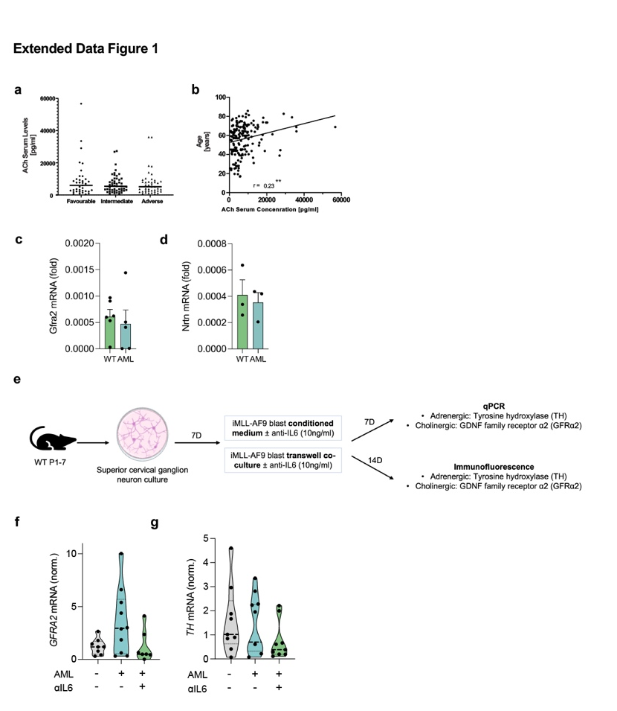

Extended Data Fig. 1. Cholinergic signaling in AML.
a, Serum ACh levels in AML patients stratified by cytogenetic risk category (n = 177). One-way-ANOVA with Tukey’s multiple comparisons. b, Correlation between serum ACh levels and age (n=177). Pearson correlation. c-d, GFRα2 (c, n=5-6) and neurturin (d, n=3) mRNA expression in BM cells from primary WT and AML mice. e, Experimental design. SCG neurons were co-cultured with iMLL-AF9 blasts with/without anti-IL6 in transwells. f, Trend towards increased GFRα2 mRNA expression in sympathetic neurons co-cultured with AML blasts in transwell was reversed by IL6 blockade (n = 4-12). g, Unchanged TH mRNA expression in sympathetic neurons co-cultured with AML blasts in transwell with/without IL6-blocking antibody (n = 4-12). a-d, f-g, Each dot represents a biological replicate. a, f-g, One-way ANOVA with multiple comparisons. b, Pearson’s correlation. c-d, Student’s t test.

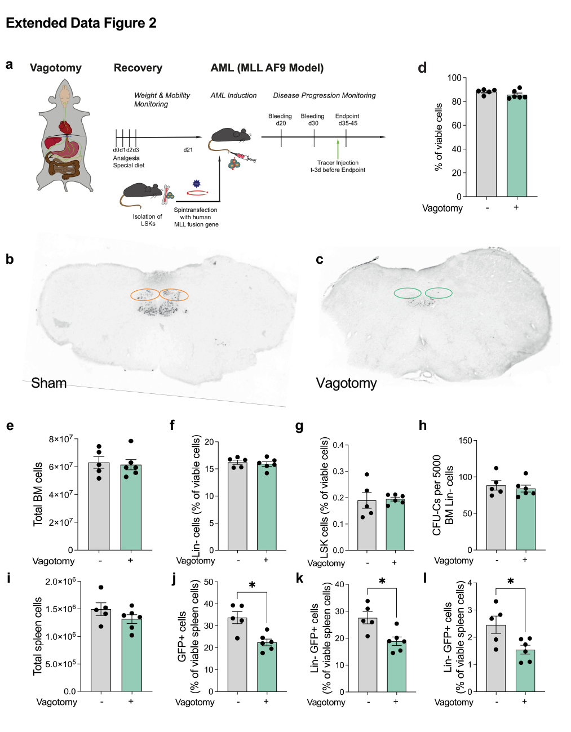

Extended Data Fig. 2. AML promotes cholinergic signaling.
a, Schematic representation of the vagotomy surgery and AML induction. b-c, Representative image of brain sections from (b) sham operated and (c) vagotomized mice (n=9-10). The absence of FluoroGold™ staining in the dorsal motor nucleus of the vagus indicates successful vagotomy. d-h, BM cell viability (d), total BM cells (e), frequency of lin- cells (f), Lin-Sca1+ckit+ HSPCs (g) and number of colonies formed from 5,000 lin- whole BM cells 6 months after sham-operation or vagotomy (h) (n=5-6). i-l, Total spleen cells (i), frequency of GFP+ spleen cells (j), Lin-GFP+ spleen cells (k), and L-GMPs (l) in the spleen after sham operation or vagotomy (n=5-6). Each dot represents a mouse. d, e-l, Data are means ± SEM. * = P < 0.05. d-l, Student’s t-test with Welch’s correction.

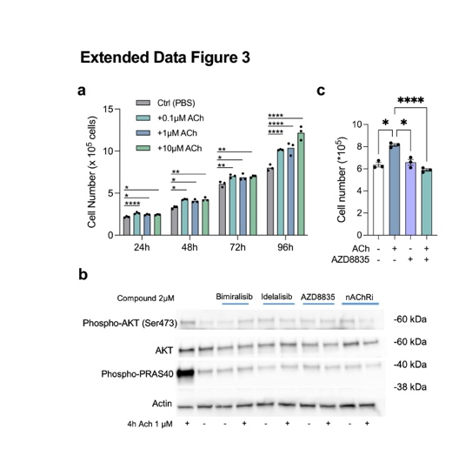
Extended Data Fig. 3. Cholinergic signals promote growth of AML cells via PI3K
a, Growth of MV4-11 AML cells after 24-96h of ACh exposure (n = 3). b, Western plot for phospho-Akt and Akt in PI3K-inhibitor pre-treated MV4-11 after exposure to ACh for 4h. c, Cell numbers of PI3K-inhibitor AZD8835 pre-treated MV4-11 after exposure to ACh for 72h (n = 3). a-b, Data are means ± SEM. (a, c) One-way-ANOVA with Tukey’s multiple comparisons. Pooled data of three independent experiments run in triplicates are shown. * = P < 0.05; **** = P < 0.0001.

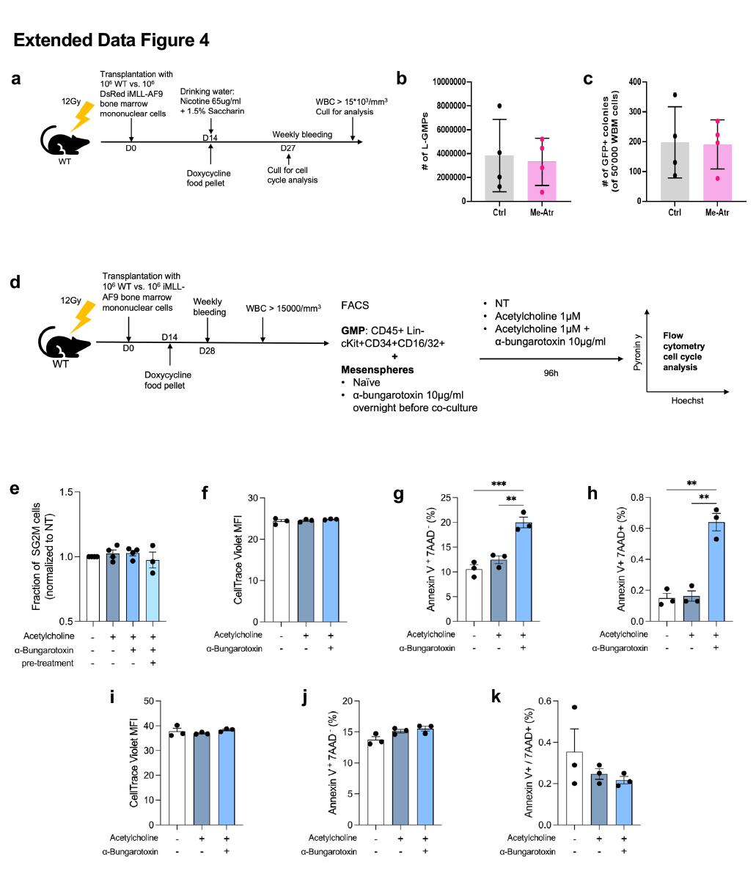

Extended Data Fig. 4. Cholinergic signals differentially regulate AML and its BM niche.
a, Scheme showing lethally irradiated WT mice were transplanted with 10⁶ iAML (rtTA;MLL-AF9) CD45.2+ BM nucleated cells and 10⁶ CD45.1+ WT BM nucleated cells. Doxycycline (400mg/kg) was administered at day 14 to induce leukemia, together with 65μg/ml nicotine in drinking water with 1.5% saccharin. Mice were culled for analysis at 13 days post leukemic induction, or at AML development (WBC >15*10³/mm³). b-c, Unchanged BM L-GMP frequency and colony-forming ability in AML mice treated with the muscarinic receptor inhibitor methyl-atropin (10mg/kg) for 20 days, starting at day 20 after AML induction (n = 4). d, Experimental workflow of L-GMP and mesensphere co-culture. e, Fraction of L-GMPs sorted from AML mice in S/G2/M phases of the cell cycle 4d after co-culture with mesenspheres in presence/absence of ACh and the α7nAChR inhibitor bungarotoxin (n = 4-6). f-h, Co-culture of iMLL-AF9 blasts and mesenspheres, treated with cholinergic modulators. Quantification of blast proliferation (CellTrace violet retention) (f), fraction of early apoptosis (g), and late apoptosis (h). i-k, iMLL-AF9 blast monoculture treated with cholinergic modulators. Quantification of blast proliferation (CellTrace violet retention) (i), fraction of early apoptosis (j), and late apoptosis (k). b-c, e-k, Data are mean of biological replicates ± SEM. *P < 0.05, **P < 0.01,***P < 0.001. b-c, Student’s t-test. e-k, One-way ANOVA followed by Tukey’s multiple comparisons.

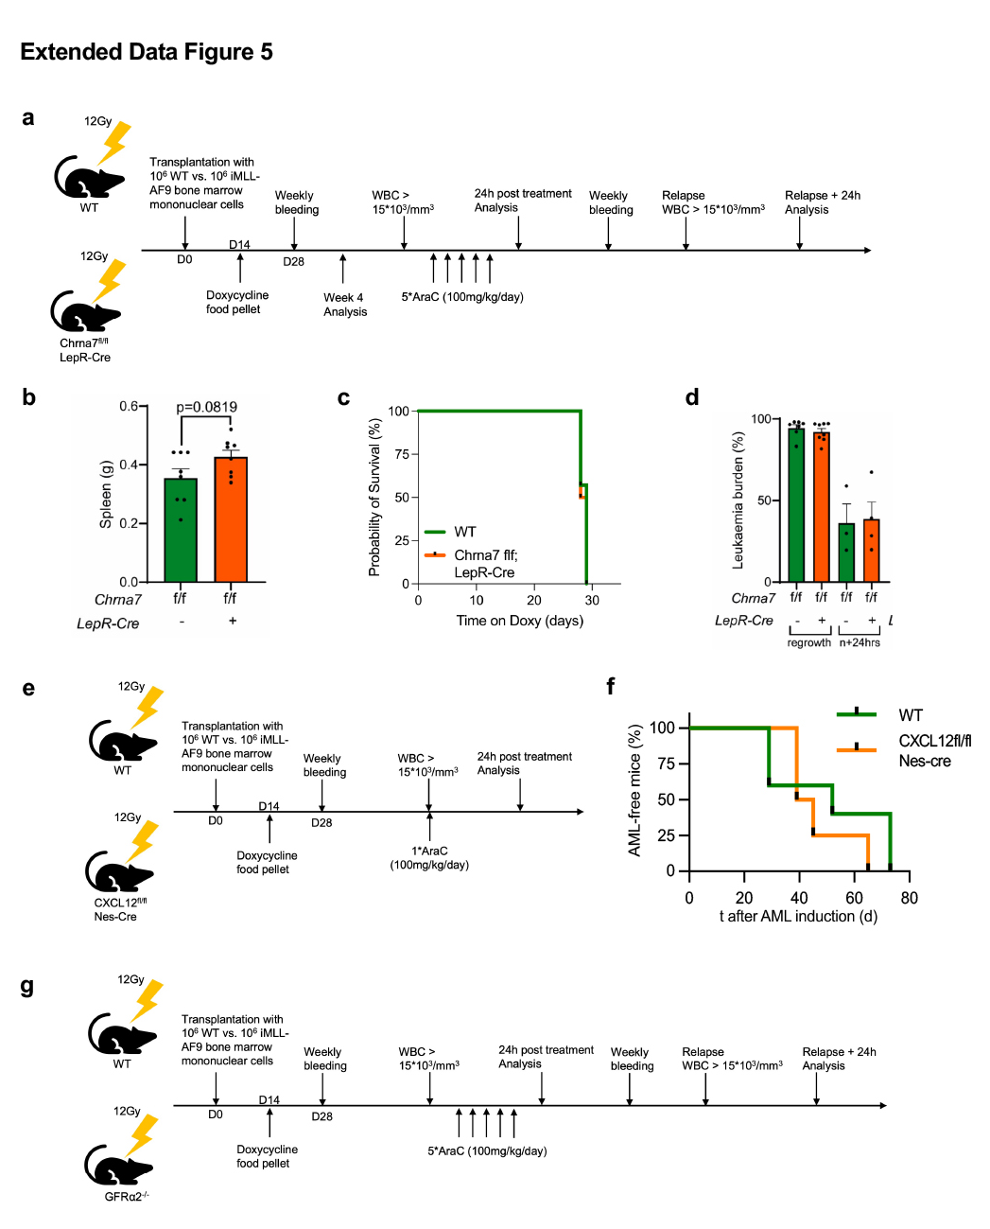

Extended Data Fig. 5. Experimental paradigms for in vivo studies of cholinergic niche-dependent AML regulation.
a, Scheme showing the experimental paradigm. Lethally-irradiated CD45.2 control mice or Chrna7f/f;LepR-Cre mice were transplanted with 10⁶ iAML (rtTA;MLL-AF9) CD45.2+ BM nucleated cells and 10⁶ CD45.1+ WT BM nucleated cells. Doxycycline (400mg/kg) was administered on day 14 to induce leukemia. Mice were culled for analysis at 4 weeks post AML induction or at AML development. Alternatively, upon leukemia development (WBC >15*10³/mm³), mice were injected with 1 dose of AraC per day, for 5 consecutive days (100mg/kg) and culled either 24h later for analysis or upon relapse. Related to Fig. 5c-i. b, Spleen weight in control (green) or LepR-Cre;Chrna^{fl/fl} (orange) mice at AML development (n = 7-8). c, AML relapse-free survival of control (green) or LepR-Cre;Chrna^{fl/fl} (orange) mice after 5 doses of Ara-C (100mg/kg/day) (n = 7-8). d, Leukemia burden in the bone marrow of control or LepR-Cre;Chrna^{fl/fl} mice after 5 doses of AraC (100mg/kg/day) or at relapse (n=3-8). e, Scheme showing the experimental paradigm. Lethally-irradiated CD45.2 control mice or CXCL12f/f;Nes-Cre mice were transplanted with 10⁶ iAML (rtTA;MLL-AF9) CD45.2+ BM nucleated cells and 10⁶ CD45.1+ WT BM nucleated cells. Doxycycline (400mg/kg) was administered on day 14 to induce leukemia. Upon leukemia development (WBC >15*10³/mm³), the mice were injected with 1 dose of Ara-C (100mg/kg) and culled either 24h later for analysis. Related to Fig. 5j. f, AML kinetics in control group (green) or Nes-Cre^{ERT2};CXCL12^{fl/fl} mice (orange). g, Scheme showing the experimental paradigm. Lethally irradiated CD45.2 control mice or Gfra2^{-/-} mice were transplanted with 10⁶ iAML (rtTA;MLL-AF9) CD45.2+ BM nucleated cells and 10⁶ CD45.1+ WT BM nucleated cells. Doxycycline (400mg/kg) was administered at day 14 to induce leukemia. Upon leukemia development (WBC >15*10³/mm³), mice were treated with 1 dose of AraC per day, for 5 consecutive days (100mg/kg) (related to Fig. 5l-n). Mice were culled 24 hours post last dose of treatment or AML regrowth. B, Student’s t-test. c,f, Mantel-Cox (Log-rank) test. d, One way ANOVA followed by Tukey’s multiple comparisons.

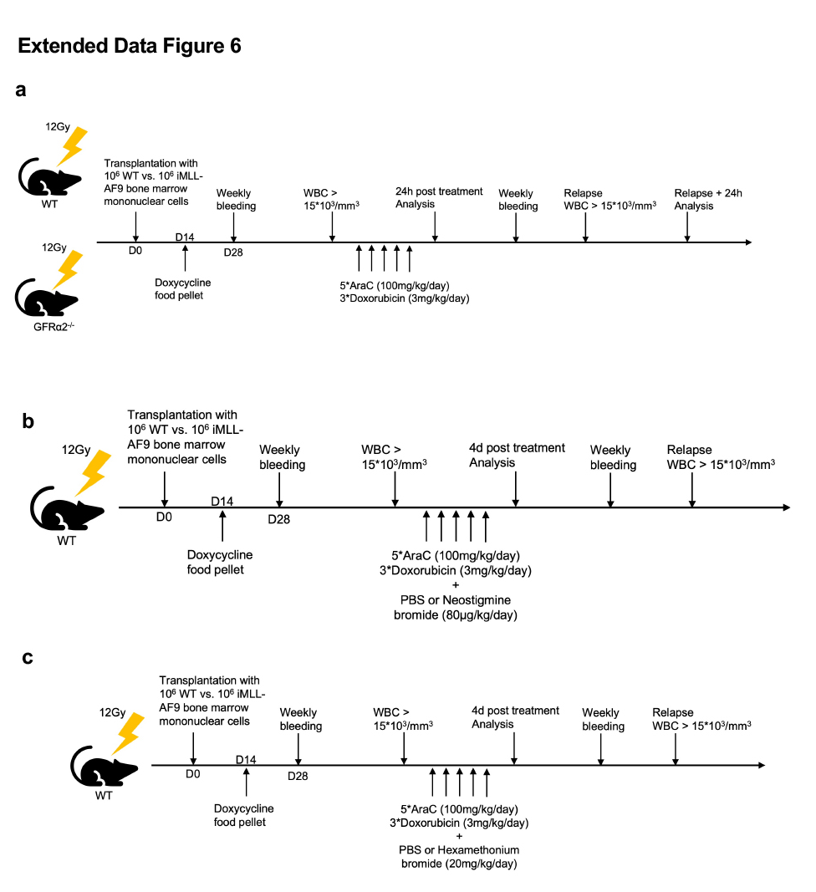

Extended Data Fig. 6. Experimental paradigms for combined therapies in AML.
a, Scheme showing the experimental design. Lethally irradiated CD45.2 control mice or GFRa2^{-/-} mice were transplanted with 10⁶ iAML (rtTA;MLL-AF9) CD45.2+ BM nucleated cells and 10⁶ CD45.1+ WT BM nucleated cells. Doxycycline (400mg/kg) was administered at day 14 to induce leukemia. Upon leukemia development (WBC >15*10³/mm³), mice were treated with induction chemotherapy (related to Fig. 5o-q). Mice were culled 24 hours post last dose of treatment or AML regrowth. b, Scheme showing the experimental paradigm. Lethally-irradiated CD45.2 control mice were transplanted with 10⁶ iAML (rtTA;MLL-AF9) CD45.2+ BM nucleated cells and 10⁶ CD45.1+ WT BM nucleated cells. Doxycycline (400mg/kg) was administered on day 14 to induce leukemia. Upon leukemia development (WBC >15 10³/mm³), the mice were injected with 1 dose of AraC per day, for 5 consecutive days (100mg/kg), combined with Doxorubicin the first 3days (3mg/kg), with Neostigmine Bromide (1dose per day for 5days every day, 80μg/kg) or PBS and culled upon relapse or 4days after the end or treatment. Related to Fig. 5r-s. c, Scheme showing the experimental paradigm. Lethally-irradiated CD45.2 control mice were transplanted with 10⁶ iAML (rtTA;MLL-AF9) CD45.2+ BM nucleated cells and 10⁶ CD45.1+ WT BM nucleated cells. Doxycycline (400mg/kg) was administered on day 14 to induce leukemia. Upon leukemia development (WBC >15 10³/mm³), the mice were injected with 1 dose of AraC per day, for 5 consecutive days (100mg/kg), combined with Doxorubicin the first 3days (3mg/kg), with Hexamethonium Bromide (1dose per day for 5days every day, 20mg/kg) or PBS and culled upon relapse or 4days after the end or treatment. Related to Fig. 6.

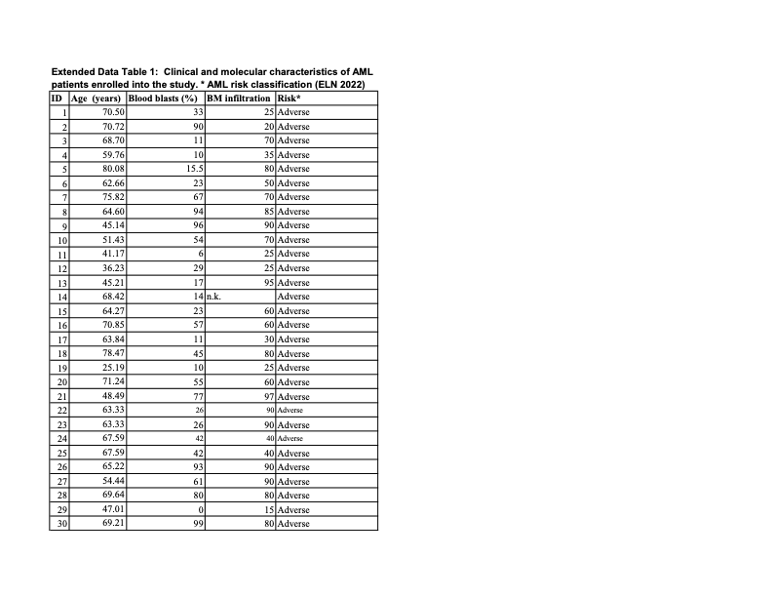

Extended Data Table 1. Clinical and molecular characteristics of AML patients enrolled into the study, according to ENL 2022 risk classification.

Parameter | HR (95% CI) | p-value
ACh | 1.00 (1.00 -1.00) | 0.00242954
Age at diagnosis | 1.04 (1.02 - 1.06) | 6.03E-06
AML risk group | 0.65 (0.47 - 0.91) | 0.0125567
BM infiltration (% blasts) | 0.99 (0.98 - 1.00) | 0.490522
Blood blasts (%) | 0.99 (0.99 - 1.00) | 0.917118

Extended Data Table 2. Multivariate analysis of AML risk including ACh levels in plasma.

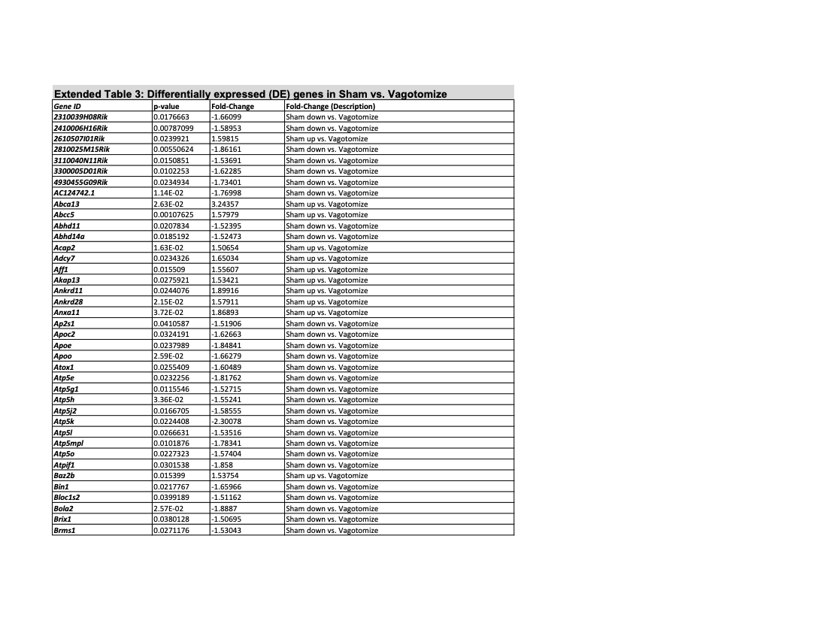

Extended Data Table 3. Differentially-expressed genes in L-GPMs from vagotomized animals.

