Supplemental Materials
Supplementary Figure 1 | Distribution of per-comment Text2Emotion intensity scores across the five emotion categories, January 2024 – December 2025. Box plots show the per-comment T2E intensity distribution for each of the five emotion categories (Happy, Angry, Surprise, Sad, Fear) across the 42,957 Reddit comments in the study window.
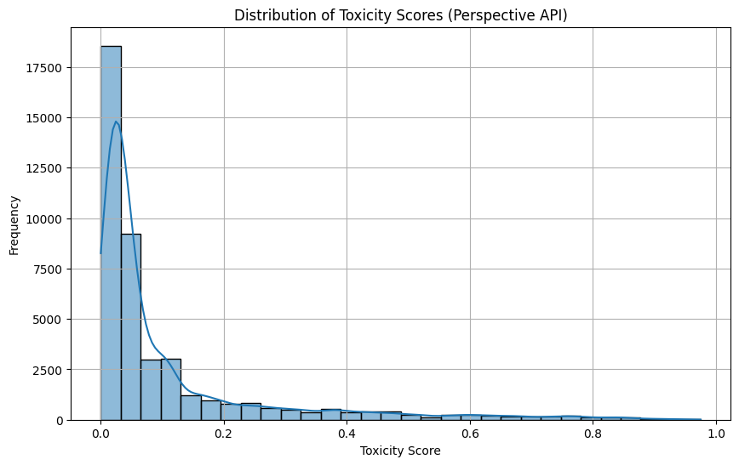
Supplementary Figure 2 | Distribution of per-comment toxicity scores from the Google Perspective API. Histogram of per-comment Perspective API toxicity scores across the 42,957 Reddit comments in the study window. As with the ToxicBERT analysis (Figure 3 of the main text), the distribution is heavily concentrated near zero with a long but sparse upper tail, confirming that the discourse in the three H5N1-focused subreddits is overwhelmingly civil.
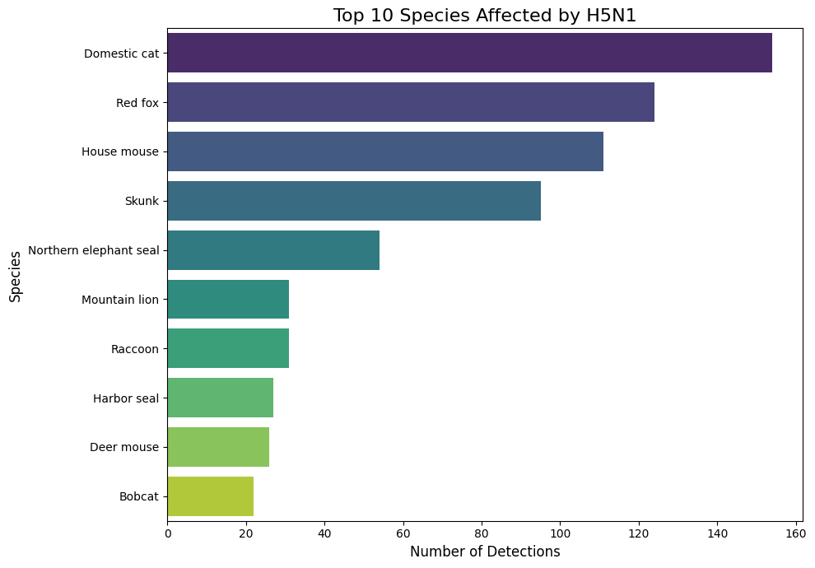
Supplementary Figure 3 | Top 10 mammal species with confirmed H5N1 cases during the study window. Counts of confirmed HPAI cases by non-livestock mammal species (USDA APHIS, 2026), aggregated across the January 2024 – December 2025 study window. Domestic cats account for the largest single-species share (n = 154 cases), followed by red fox (n = 124) and house mouse (n = 90). The dominance of domestic cats motivates the separate analysis of cat cases versus other non-livestock mammal cases in the ARIMAX modeling reported in the main text.

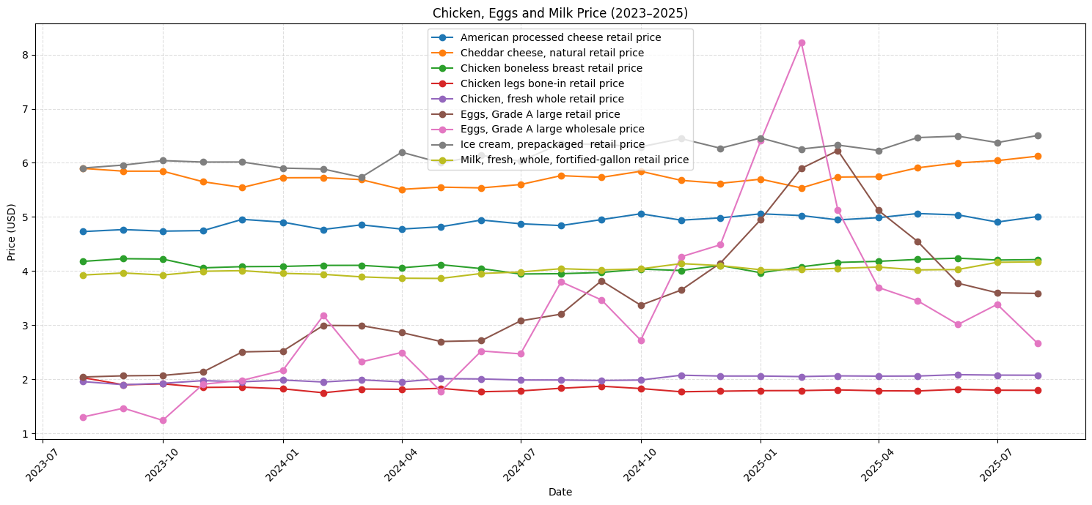
Supplementary Figure 4 | Monthly prices of animal-origin food products from the USDA Meat Price Spreads dataset, July 2023 – July 2025. Time series of retail prices for the animal-based food categories tracked in the USDA Economic Research Service Meat Price Spreads dataset (Vaiknoras, 2026). Of all categories examined, only retail egg prices showed substantial movement across the study window; all other tracked products remained essentially flat. This pattern motivated the inclusion of retail egg prices as the sole economic candidate variable in the ARIMAX exogenous-variable analysis (Table 1 of the main text). The comparison uses a shifted two-year analytical window (July 2023 – July 2025) because the dataset is available only through July 2025.

Supplementary Figure 5 | Weekly trends across all seven candidate exogenous variables, January 2024 – December 2025. The figure displays Reddit comment volume together with the seven candidate exogenous variables evaluated in the ARIMAX analysis. The three exogenous variables ultimately retained by the ARIMAX analysis (cases reported for cats, cattle herds, and wild mammals) — together with Reddit comments — are emphasized in bold; the four context variables not retained as ARIMAX predictors (cases reported for poultry flocks, wild bird cases, news article volume, and retail egg prices) are shown in lighter tones for comparison. All series were log1p-transformed (matching the transformation applied in the ARIMAX modeling), smoothed with a 4-week centered rolling mean, and min–max normalized to the interval [0, 1]. Shaded grey regions mark the two active outbreak windows: the spring 2024 dairy cattle spillover (March–June 2024) and the winter 2024–2025 surge (October 2024 – February 2025).

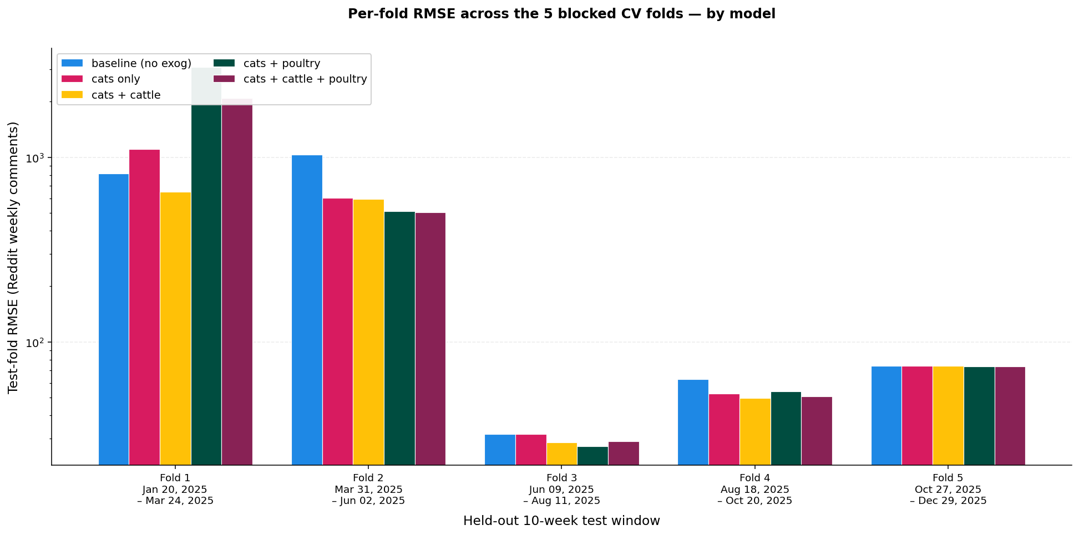

Supplementary Figure 6 | Per-fold RMSE for the five comment-volume ARIMAX specifications under blocked cross-validation. Bars show the test-fold root-mean-square error on the back-transformed comment-count scale (log y-axis) for each of the five candidate specifications — baseline (no exogenous variables), cats only, cats + cattle, cats + poultry, and cats + cattle + poultry — evaluated across the five non-overlapping 10-week blocked-cross-validation folds (January – December 2025). The cats + cattle specification, identified in the main text as the best-performing model by mean RMSE (Table 1), exhibits the lowest worst-case fold RMSE (650.6 in Fold 1, January – March 2025), while the poultry-inclusive specifications produce worst-fold RMSEs 3.2× to 4.7× larger in the same fold. The log y-axis is used because fold-level RMSEs span roughly two orders of magnitude across the study window, from approximately 25 (Fold 3) to over 3,000 (Fold 1).

Supplementary Figure 7 | Per-fold RMSE for the per-emotion ARIMAX comparison under blocked cross-validation. Each panel shows test-fold root-mean-square error on the back-transformed comment-count scale (log y-axis) for one of the five emotion-dominant comment-volume series (Happy, Angry, Surprise, Sad, Fear), across the same five 10-week blocked-CV folds used in the comment-volume analysis (Supplementary Figure 5; test-window dates in the lower-right panel). Within each panel, bars show the five candidate specifications: baseline (no exogenous variables), cats + wild mammals, cats + cattle, cats + wild mammals + cattle, and cats + wild mammals + poultry. The cats + cattle and cats + wild mammals + cattle specifications, identified in the main text (Table 3) as statistically indistinguishable co-winners, achieve the lowest worst-fold RMSE across all five emotions, alternating narrowly between them with differences of ≤ 3.3 RMSE units (≤ 5.5% relative). The cats + wild mammals + poultry specification produces worst-fold values 1.7× to 3.5× larger in the surge-tail fold (Fold 1, January – March 2025), reflecting the multicollinearity-driven degradation described in the main text. The log y-axis is used because fold-level RMSEs span roughly two orders of magnitude across the study window.
Supplementary Figure 8 | Weekly Reddit comment volume with blocked cross-validation test folds and the near-zero threshold, January 2024 – December 2025. Weekly Reddit comment counts (blue line) across the study window, with the five non-overlapping 10-week blocked cross-validation test folds (F1–F5) shaded and classified as active (green) or burnout (red) based on whether the mean weekly comment count within the fold exceeds the ~50 comments/week near-zero threshold (dashed grey line). Mean weekly volumes within each test window are: F1 (January 20 – March 24, 2025) = 635 comments/week; F2 (March 31 – June 2, 2025) = 101; F3 (June 9 – August 11, 2025) = 37; F4 (August 18 – October 20, 2025) = 1; F5 (October 27 – December 29, 2025) = 44. The empirical partition of F1–F2 (active) versus F3–F5 (burnout) defines the active-fold subset used in the sensitivity analysis reported in Supplementary Note 2.

Dataset | Variant tested | Lag | Spearman ρ | Spearman p-value | Coef | Coef p-value | Verdict
Egg prices | retail | 0 | 0.063 | 0.56 | +0.08 | 0.920 | Null
Egg prices | wholesale | 0 | 0.202 | 0.060 | +0.21 | 0.485 | Null
Egg prices | retail + wholesale | 0 | — | — | −0.20 / +0.26 | 0.812 / 0.472 | Null
News articles | volume | 1 | 0.134 | 0.173 | +0.05 | 0.563 | Null
Poultry | log count | 5 | 0.157 | 0.109 | +0.24 | 0.153 | Null
Cattle | log count | 1 | 0.677 | <0.001 | +0.25 | 0.118 | Borderline
Non-livestock mammals — total | log count | 1 | 0.407 | <0.001 | +0.16 | 0.151 | Borderline
Mammals — domestic cats | log count | 1 | 0.470 | <0.001 | +0.34 | 0.008 | Significant
Mammals — wild | log count | 3 | 0.283 | 0.003 | +0.06 | 0.721 | Null
Wild birds — total | log count | 1 | −0.048 | 0.628 | +0.00 | 0.995 | Null
Supplementary Table 1 | Per-variable in-sample evidence for candidate ARIMAX exogenous regressors. Each row reports a single candidate exogenous variable evaluated in isolation. Spearman ρ and its p-value reflect the pairwise rank correlation between the log-transformed exogenous series and weekly Reddit comment volume at the indicated lag. The ARIMAX coefficient and its p-value reflect in-sample fit when the variable is added as a single exogenous regressor to the ARIMA(0,1,1) baseline structure. Only domestic cats at lag 1 reached statistical significance in the ARIMAX coefficient test (p = 0.008; shown in bold), motivating its inclusion as the headline predictor in the multivariate ARIMAX specifications evaluated in Table 1 of the main text. Cattle cases and total non-livestock mammal cases show strong rank correlations with Reddit volume (Spearman ρ = 0.677 and 0.407, respectively, both p < 0.001) but do not produce significant ARIMAX coefficients, indicating that these variables share a long-arc temporal trend with Reddit volume without contributing week-to-week predictive structure surviving first-differencing.

Animal Category | Keyword List
Cats | cat, cats, kitten, kittens, kitty, kitties, feline, felines, housecat, housecats
Cattle (strict) | cattle, cow, cows, bovine, calf, calves, heifer, heifers, steer, steers, bull, bulls
Cattle (broad) | Strict cattle set ∪ {dairy, dairies, raw milk, milk}
Wild mammals | fox, foxes, skunk, skunks, raccoon, raccoons, deer, coyote, coyotes, opossum, opossums, possum, possums, bobcat, bobcats, mountain lion, cougar, cougars, mink, minks, otter, otters, beaver, beavers, weasel, weasels, seal, seals, sea lion, sea lions, black bear, grizzly, polar bear, wild mammal, wild mammals, wild animal, wild animals, wildlife
Supplementary Table 2 | Regex keyword lists for the four topically-matched comment subsets used in the mechanism analysis. The standalone token "bear" was excluded to avoid false positives from common non-animal usage (e.g., "bear with me"). Cattle (broad) extends the strict set with dairy/milk food-system terms to capture the food-system framing prominent in the corpus's bigram analysis.

Supplementary Note 1. Robustness of ARIMAX results to min-max scaling of model inputs.
To verify that the min-max normalization used in the cross-variable visualization (Figure 4 and Supplementary Figure 4) does not affect the modeling conclusions, the comment-volume and per-emotion ARIMAX blocked-cross-validation pipelines were rerun with min-max scaling applied on top of the existing log1p transformations to all input variables. To keep the comparison fair, forecasts from the scaled models were converted back to the original comment-count scale before RMSE was computed — first reversing the min-max scaling, then reversing the log transformation. The resulting percentage improvements relative to baseline matched the original unscaled results to within 0.1 percentage points across all 25 model × outcome combinations tested (Supplementary Table 1). These tiny differences are numerical noise from the model's optimizer reaching slightly different precision on the rescaled inputs, not real differences in model fit. This check confirms that the visualization scale and the modeling scale are mutually consistent. They serve different purposes — visual comparison across heterogeneous units versus interpretable error reporting — but produce the same conclusions about which animal-case variables predict weekly Reddit engagement.

Supplementary Note 2 | Sensitivity analysis of the Friedman and pairwise Wilcoxon tests with burnout folds excluded.
To empirically verify the dilution argument, the mean weekly Reddit comment count within each fold's test window was computed and compared against the near-zero threshold noted in the main text (Supplementary Figure 6). Folds 1 and 2 exceeded the threshold (635 and 101 comments/week respectively), while Folds 3, 4, and 5 fell below (37, 1, and 44 comments/week respectively) — a data-driven partition of the folds into active and burnout periods that coincides with a June 1, 2025 cutoff. Re-running the Friedman and pairwise Wilcoxon tests on the active-fold subset (n = 2) reduced sample size below the Friedman requirement (n ≥ 3) and raised the Wilcoxon p-value floor from 2/2⁵ = 0.0625 to 2/2² = 0.5000. The pairwise Wilcoxon for cats + cattle vs. baseline hit this floor (W = 0, p = 0.5000), because cats + cattle again outperformed baseline in every retained active fold — the strongest pairwise evidence possible at this sample size. This structural inability to reach formal significance at reduced fold count directly confirms that the burnout folds were carrying the sample-size weight of the omnibus and pairwise tests, rather than obscuring a substantively different effect in the active period.

Supplementary Note 3 | Interaction tests for the comment-volume and per-emotion ARIMAX models.
Following the standard epidemiological practice of testing first-order interactions after identifying the best additive specification, cats × cattle was tested in the comment-volume ~ cats + cattle ARIMAX and all possible first-order interactions were tested in both per-emotion co-winner specifications (5 tests in cats + cattle, 15 in cats + wild + cattle, plus the comment-volume test — 21 tests total). Each test compared the extended model against its additive baseline via an in-sample likelihood-ratio test and blocked cross-validation (identical protocol to the main model comparisons). No interaction reached significance at the family-wise Bonferroni-corrected threshold. Seven tests reached raw α = 0.05 — one from the comment-volume model and six from the per-emotion models (Happy, Angry, and Surprise in each of the two per-emotion specifications), all involving cats × cattle with LRT p between 0.014 and 0.037 — but each of these degraded blocked cross validation mean RMSEs substantially differed compared to its additive baseline (+30.4% to +62.4%; every fold degraded in every case). This pattern identifies cats × cattle as a systematic overfitting artifact of the moderate rank correlation between the two variables (Spearman ρ = 0.25), inflating in-sample fit without generalizing. Consistent with the main text's blocked-cross validation-primary model-selection rule, all additive specifications are retained without interaction terms.

