Supplement
Supplement to Computational Growth Modeling: Assessing Longitudinal Change with Joint Models in Perspectives on Behavior Science by Jeremy M. Haynes, Nathaniel Haines, Holly Sullivan-Toole, and Thomas M. Olino. Correspondence regarding the article or supplemental information should be addressed to Jeremy Haynes (jmhaynes@georgiasouthern.edu) or Thomas Olino (thomas.olino@temple.edu).

Simulation

Diagnostics for Simulation Models
Here we summarize diagnostic information for the models fit in the simulation, used to compare between the two-stage and computational growth modeling (CGM) approaches. As noted in the main text, we sampled each model for 1000 iterations (500 warmup & 500 post-warmup). The two-stage approach took an average of 3.67 minutes to fit per simulation (SD = 0.27) whereas the CGM approach took an average of 8.55 minutes to fit per simulation (SD = 1.78). These times will vary depending on the processing speed of the device used for fitting. Both approaches showed adequate convergence of target distributions. For the CGM approach, R-hat values were below 1.1 for over 99.89% of all parameters across simulations. For the two-stage approach, R-hat values were below 1.1 for over 99.56% of all parameters across simulations. Thus, the CGM approach takes longer to fit longer to fit than the two-stage approach (~5 min on average) but did not result in major issues with convergence. It is important to recognize, however, that sampling time and convergence will depend heavily on the complexity of both the behavioral and statistical models used.

Simulation-Based Calibration
Simulation-based calibration is method for assessing bias in Bayesian models that involves sampling model parameters from the prior distribution, generating observations (e.g., IGT choice data) with each set of sampled parameters, and then fitting the model to the observations repeatedly. For each iteration, the percentiles (or ranks) of the true parameter values (i.e. the values sampled from the prior and used to generate observations) within the corresponding posterior distributions are calculated to assess model calibration (Talts et al., 2018). We performed a variant of simulation-based calibration where we fixed the growth model parameters $γ_{0}$, $γ_{1}$, and $ρ$ parameters to values of interest while sampling all other parameters directly from the prior distribution. We performed this simulation-based calibration procedure using both the two-stage approach and the computational growth modeling approaches, shown in Figure S1 (Two-Stage) and Figure S2 (CGM) for the group-level parameters and Figure S3 (Two-Stage) and Figure S4 (CGM) for the person-level parameters.
The two-stage approach showed relatively more bias than the CGM approach for the group-level parameters. For example, the strong left skewness for the intercept and slope standard deviations as well as the residual standard deviations indicate strong underestimation of these parameters (also shown in Figure 1). The CGM approach showed less bias such that the percentile plots are relatively more uniformly distributed. One systematic finding, however, is that the percentiles of some parameters (e.g., the intercept-slope correlations; ρ) estimated from the CGM approach tend to be bell-shaped, indicating that the correlations were estimated with less certainty (i.e., more conservatively) resulting in greater spread of the posterior distributions.
The two-stage approach also showed more bias in estimating the person-level growth parameters. For example, Figure S3 shows right skewness for the person-level intercepts estimated from the two-stage approach, indicating systematic overestimation. In addition, person-level slopes showed a bias systematically related to the magnitude of the group-level slope (γ₁) such that lower group-level slopes (γ₁ = -.3) were associated with overestimating the person-level slopes (right skewness in Figure S3) and higher group-level slopes (γ₁ = +.3) were associated with underestimating the person-level slopes (left skewness in Figure S3). The CGM showed a slight bias towards estimating the person-level growth parameters with too much certainty (U-shape), but in general, there were no major issues with estimating the person-level growth parameters using the CGM approach. Finally, learning rates were estimated with little bias across both approaches. Overall, however, the simulation-based calibration results support the findings of the main text in which the CGM approach outperforms the two-stage approach.

Method for Real-Data Application
The parent project was a 3-year study focused on various facets of adolescent risk for psychopathology, examining parental history of psychopathology, adolescent reward sensitivity and neural structure and function as factors influencing risk. Here, we examined parents’ behavioral performance on the play-or-pass Iowa Gambling Task (IGT; described below), assessed across 5 timepoints, each separated by approximately 9 months. All data from the first 2 timepoints (prior to the Covid-19 pandemic) were collected in-person using E-Prime Stimulus Presentation Software (Schneider et al., 2002). Data from the latter three timepoints were collected during the Covid-19 pandemic; thus, we collected data remotely through E-Prime until the task was programmed in Pavlovia (https://pavlovia.org, 2020). Data from baseline have been presented elsewhere (Haynes et al., 2025, 2026); however, the full dataset was not considered in those studies. All procedures were approved by the Temple University institutional review board (IRB Protocol #23174 originally approved on 08/31/2015). All participants provided informed consent.

Participants
Youth participants and their parents were recruited from the community within a 30-mile radius of a metropolitan university in the northeastern United States. English-speaking families with a child between 9-10 or 12-13 years with at least one biological parent serving as their caregiver were eligible to participate. The present study focused on 293 parents from 226 families that had full diagnostic data from the Structured Clinical Interview for the DSM-5 (SCID; First et al., 2016), and data from the initial baseline assessment of the play-or-pass IGT. Families were excluded from the larger study if their children were taking any psychotropic medications (except for ADHD medication), met diagnostic criteria for a serious neurological illness, or had learning or developmental disabilities at baseline due to the focus of the broader study. In addition, families with parental history of bipolar or psychotic spectrum disorder were excluded. Intellectual ability of adolescent children was examined at baseline using the Kaufman Brief Intelligence Test (KBIT-2; Naugle et al., 1993), and families with children whose estimates of overall intelligence levels fell two or more standard deviations below the mean were also excluded (KBIT-2 FSIQ < 70).

Play-or-Pass Iowa Gambling Task
We used the play-or-pass version of the IGT (Peters & Slovic, 2000). All outcomes in the task were hypothetical. Participants began the task with a “bank” of $2000 and were presented with four decks of cards. On each trial, a single deck was highlighted, and participants had the opportunity to “play” or “pass” on the highlighted deck. If a participant played on the deck, they would receive either a monetary gain, loss, or neither (i.e., $0 change) from the drawn card. If a participant passed on the deck, they moved onto the next trial. Each deck was associated with a different distribution of gains and losses such that the long-run average expected value was -$25 for Decks A and B (i.e., the disadvantageous/bad decks) and $20 and $25 for Decks C and D, respectively (i.e., the advantageous/good decks). We used two versions of the task that differed only in the order in which cards were presented. Each version was associated with a fixed sequence of cards, and the assignment of participants was counterbalanced across task versions. Participants were not informed of the payout distribution nor the sequence of decks and cards that would be presented. Thus, participants needed to sample cards from each deck to learn the outcomes associated with each deck. Trials ended if participants did not respond within 4 seconds, which were scored as passing on the card. Participants completed 120 trials and were told that their earnings in the task would be exchanged for a real cash bonus; however, all participants received $10 for completing the behavioral tasks.

Generation of Posterior Predictive Growth Trajectories
Figures 6 and 8 in the manuscript show posterior predictive growth trajectories for the level 2 component of the unconditional and conditional growth ORL models. We generated these posterior predictions by simulating forward Equation 11 after fitting the models, including the level 1 error ($E_{1}$) and then averaging over the simulated draws. That is, for each parameter and posterior MCMC sample, we simulated forward Equation 11 to obtain person- and session-level model parameters, generating a total of 10,000 person-session level parameter values. We then took the average across these 10,000 samples. By iterating this procedure across each posterior MCMC sample, we are effectively able to marginalize over the level 1 error to obtain an accurate estimate of the expected person-level growth curves. Without such marginalization, the learning rate growth curves would mis-represent the mean growth curve due to their non-linear transformation.

Figures

Figure S1
Percentiles for Two-Stage Group-Level Growth Parameters
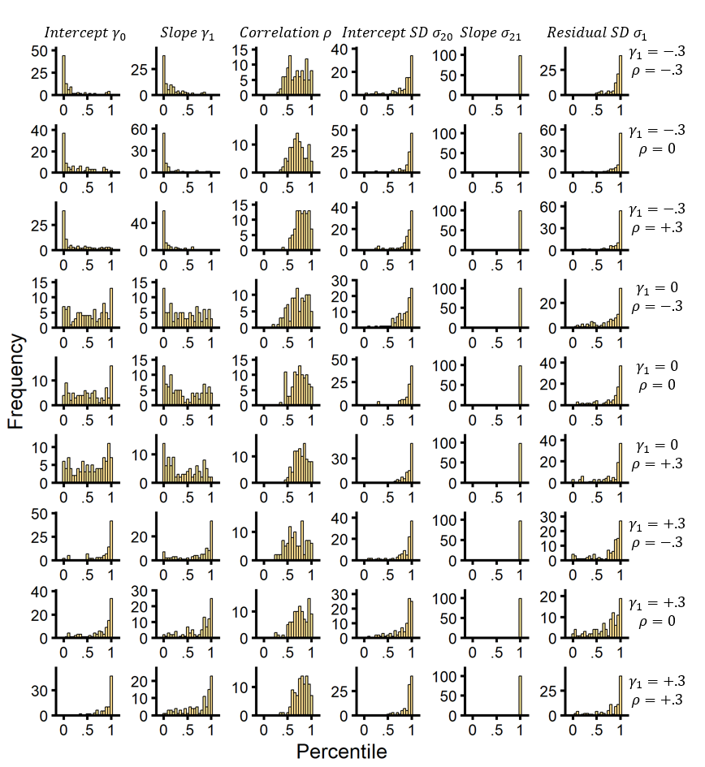
Note. Percentiles across simulations for group-level growth parameters (columns) from the two-stage approach for each condition (rows). Percentiles are the percent of posterior samples below the true parameter value which is functionally equivalent to calculating ranks of the true parameter value in the posterior distributions, used in simulation-based calibration (Talts et al., 2018). Several instances of bias are shown; for example, both intercept and slope standard deviations show a bias towards underestimation (left skewness).

Figure S2
Percentiles for CGM Group-Level Growth Parameters
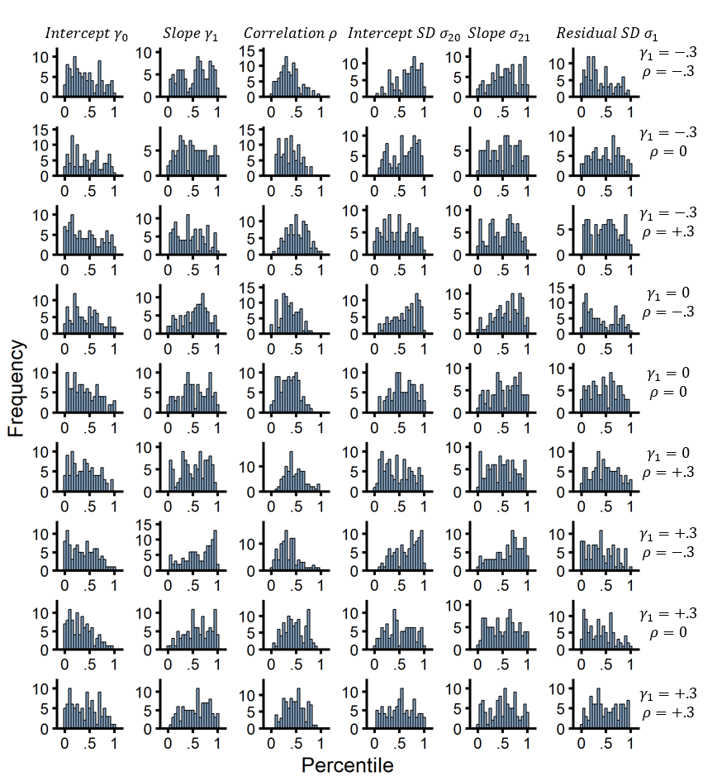
Note. Percentiles across simulations for group-level growth parameters (columns) from the computational growth modeling approach for each condition (rows). Percentiles are the percent of posterior samples below the true parameter value which is functionally equivalent to calculating ranks of the true parameter value in the posterior distributions, used in simulation-based calibration (Talts et al., 2018). There are little signs of major estimations biases. Intercept-slope correlations tended to be bell-shaped, indicating a greater spread in the posterior distribution and that the correlations were estimated with less certainty (i.e., more conservatively).

Figure S3
Percentiles for Two-Stage Person-Level Parameters
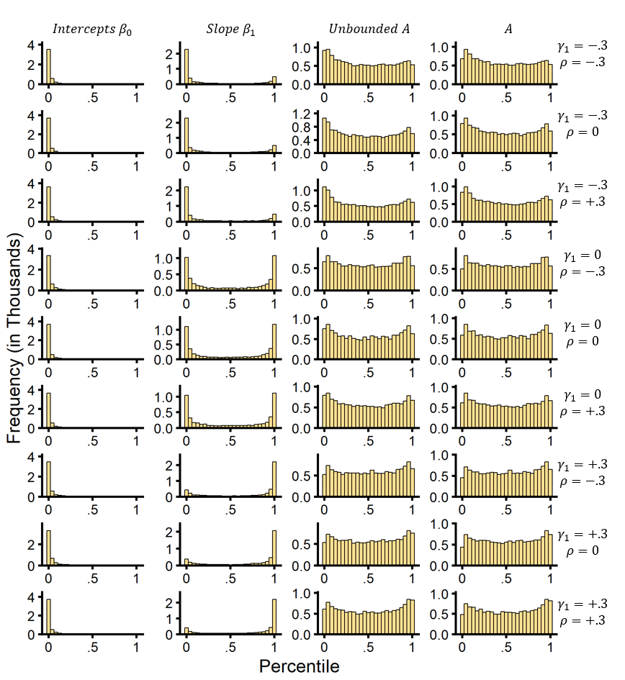
Note. Percentiles across simulations for person-level growth parameters (columns) from the two-stage approach for each condition (rows). Percentiles are the percent of posterior samples below the true parameter value which is functionally equivalent to calculating ranks of the true parameter value in the posterior distributions, used in simulation-based calibration (Talts et al., 2018). Person-level intercepts were strongly underestimated. Person-level slopes were underestimated at the low group-level slopes (i.e., γ₁ = -.3) and overestimated at higher group-level slopes (i.e., γ₁ = +.3). Learning rates (A) showed little bias.

Figure S4
Percentiles for CGM Person-Level Parameters
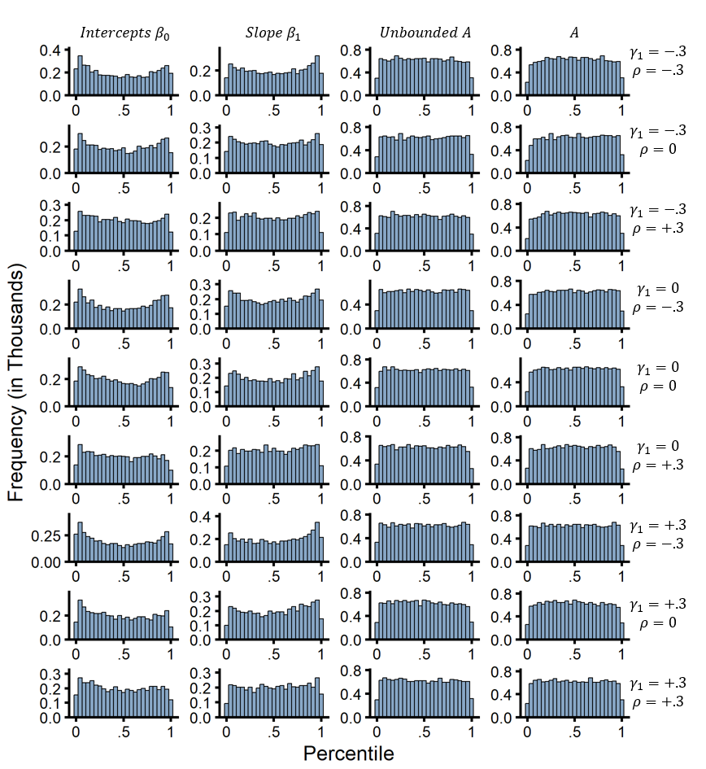
Note. Percentiles across simulations for person-level growth parameters (columns) from the CGM approach for each condition (rows). Percentiles are the percent of posterior samples below the true parameter value which is functionally equivalent to calculating ranks of the true parameter value in the posterior distributions, used in simulation-based calibration (Talts et al., 2018). Generally, there were no major signs of estimation bias, although the person-level intercepts and slopes showed a small tendency to be estimated with too much certainty (i.e., too narrow posterior distributions).

Figure S5
Net Earnings Across Time
Note. Group and person level net earnings (in thousands) across the 5 waves of assessment on the play-or-pass Iowa Gambling Task. In general, participants did better on the task across the repeated assessments.

Table

Table S1
Priors Distributions for CGM Parameters
Group-Level Parameter | Single-Parameter RL |  | PP-ORL
Intercept: | γ₀ | ~Normal(0,1) | γ₀ | ~Normal(-1,1)
Slope: | γ₁ | ~Normal(0,1) | γ₁ | ~Normal(0,.5)
Standard Deviation of Intercepts: | σ₂₀ | ~Half-Normal(0,1) | σ₂₀ | ~Half-Normal(0,.2)
Standard Deviation of Slopes: | σ₂₁ | ~Half-Normal(0,1) | σ₂₁ | ~Half-Normal(0,.2)
Intercept-Slope Correlation: | $ρ$ | ~LKJcorr(1) | $ρ$ | ~LKJcorr(1)
Standard Deviation of Residuals: | σ₁ | ~Half-Normal(0,1) | σ₁ | ~Half-Normal(0,.2)
Note. Priors for the computational growth models (CGMs) for the single-parameter reinforcement learning (RL) model used for the simulation data and the Outcome Representation Learning (ORL) model used for the real data. To ensure differences in priors did not account for differences in parameter recovery for the simulation, we used the same priors across the two-stage and CGM approaches.

