Contents
Supplementary Figure 1. Regions of local genetic correlation between AD and BP 1
Supplementary Figure 2. Cross-trait enrichment between AD and SBP 6
Supplementary Figure 3. Cross-trait enrichment between AD and DBP 7
Supplementary Figure 4. Cross-trait enrichment between AD and PP 8
Supplementary Figure 5. Regions with conjFDR < .001 between AD and at least one BP trait 9

Supplementary Figure 1. Regions of local genetic correlation between AD and BP
A. chr19q13.32
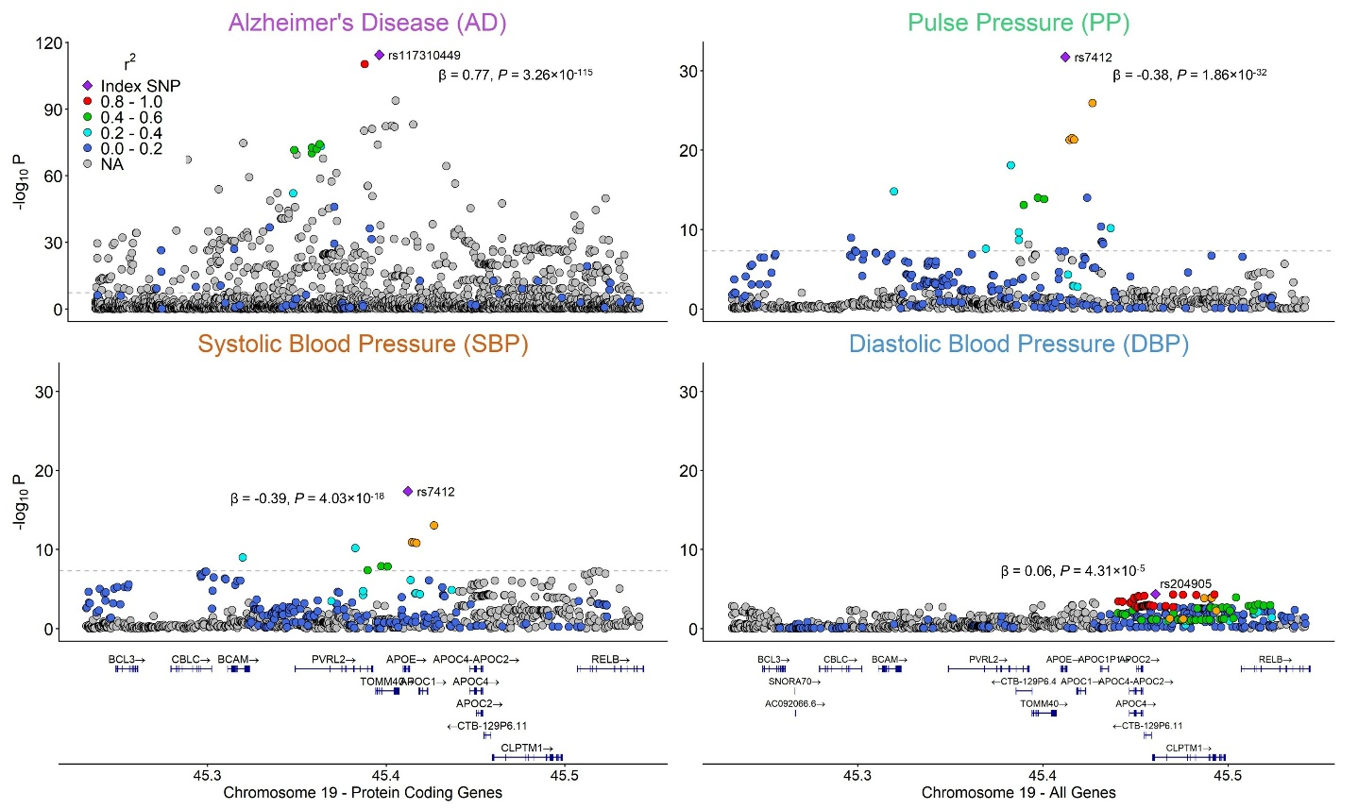
B. chr8q22.1
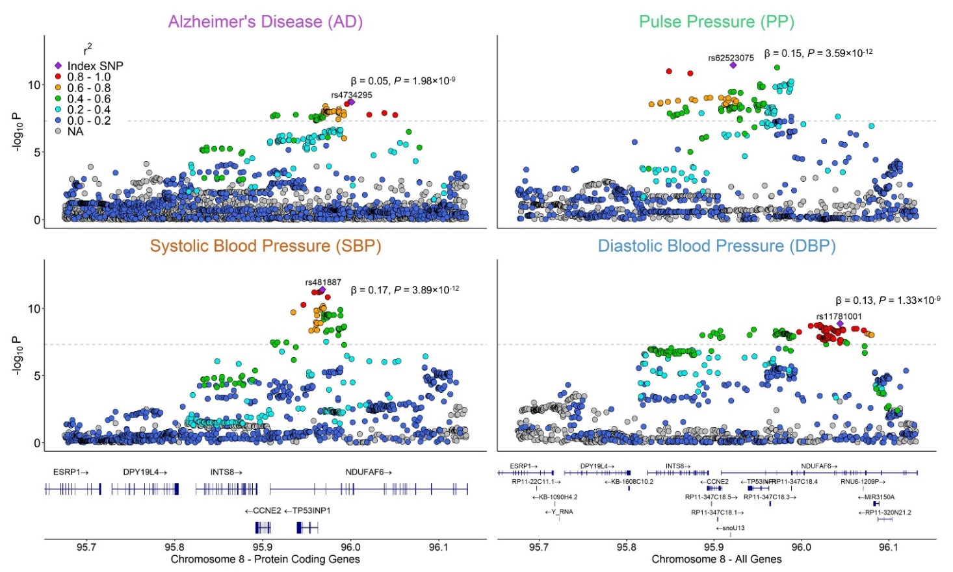

C. chr2q33.2
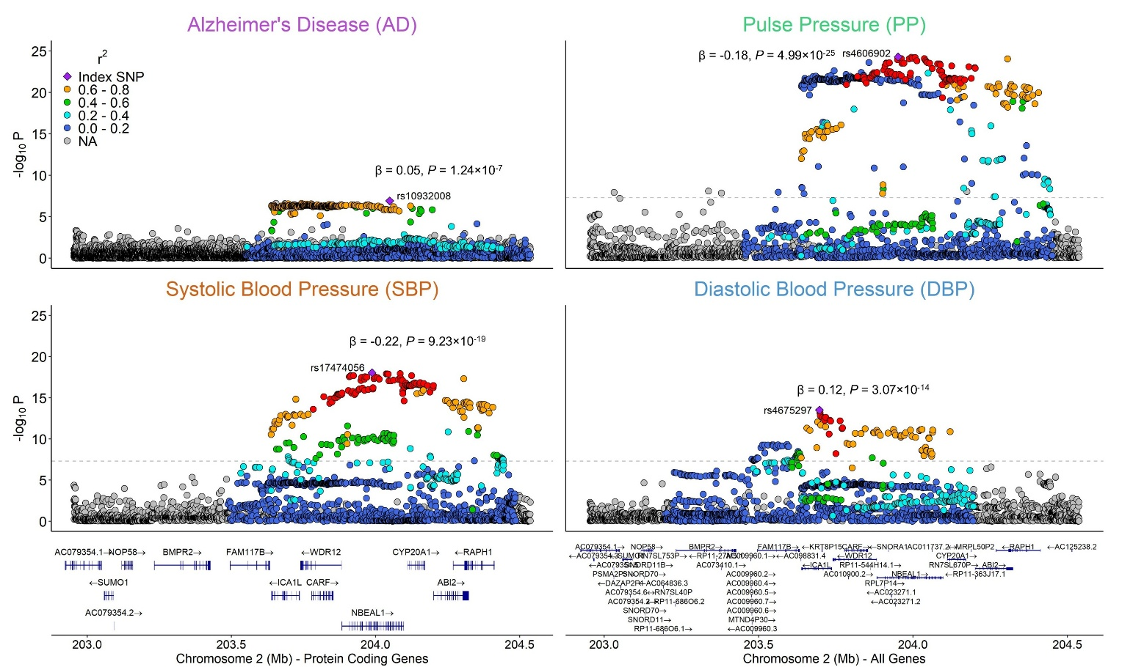

D. chr11q24.3
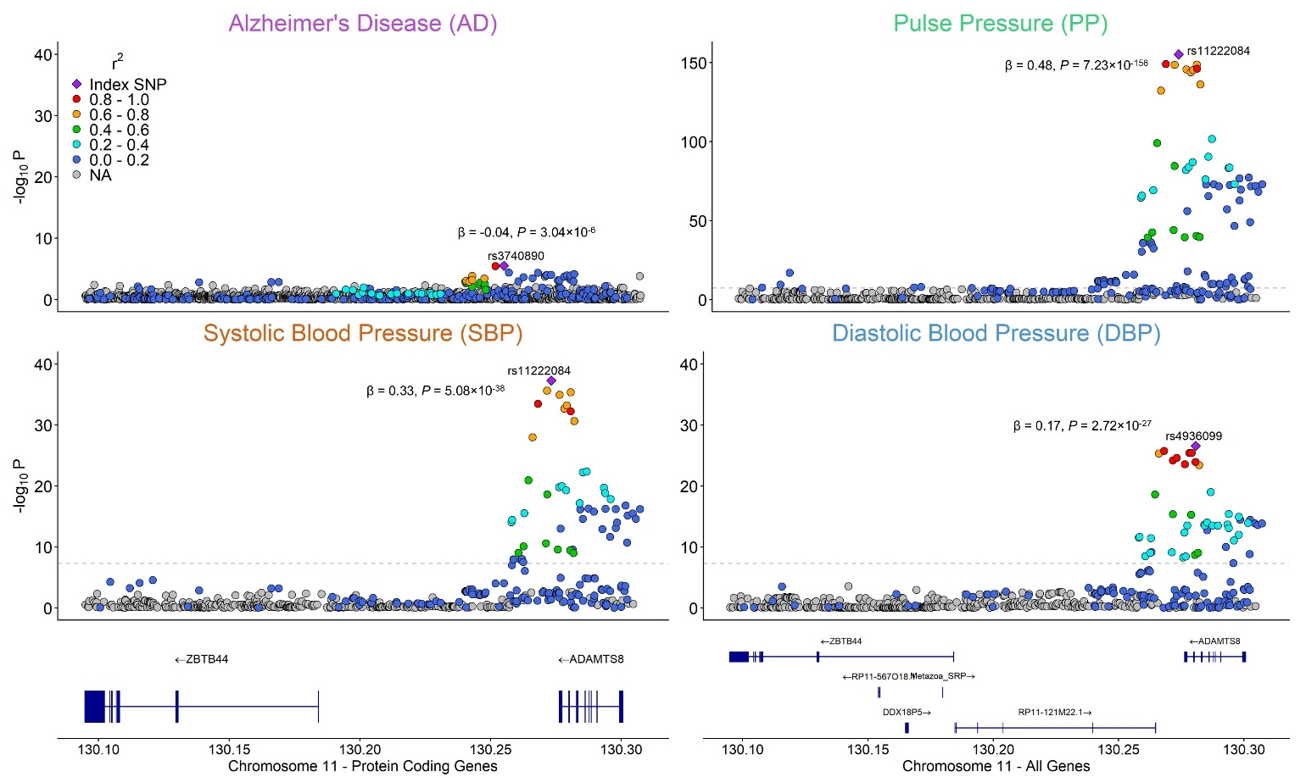

E. chr2p22.2
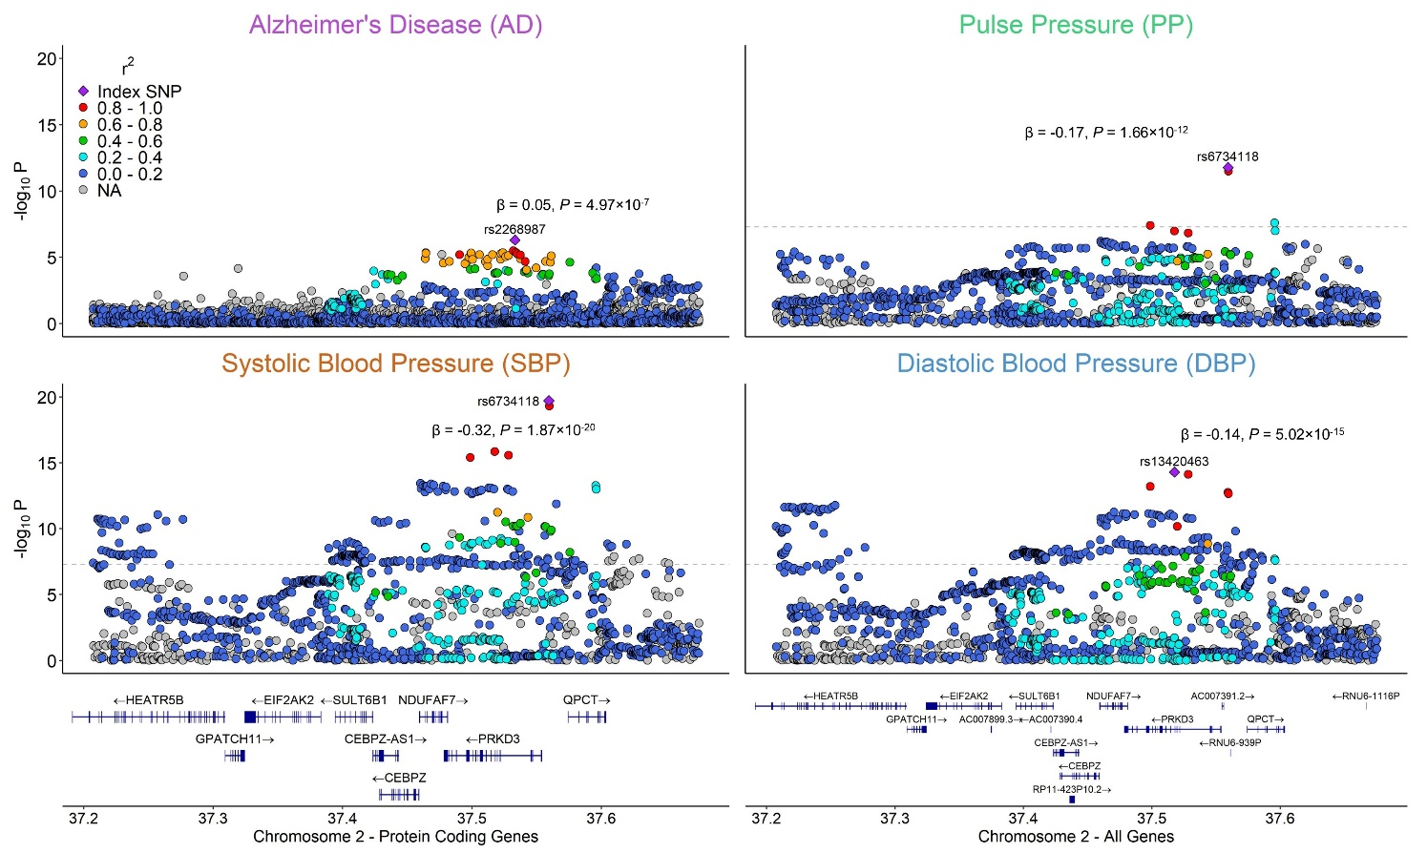

F. chr7p15.1
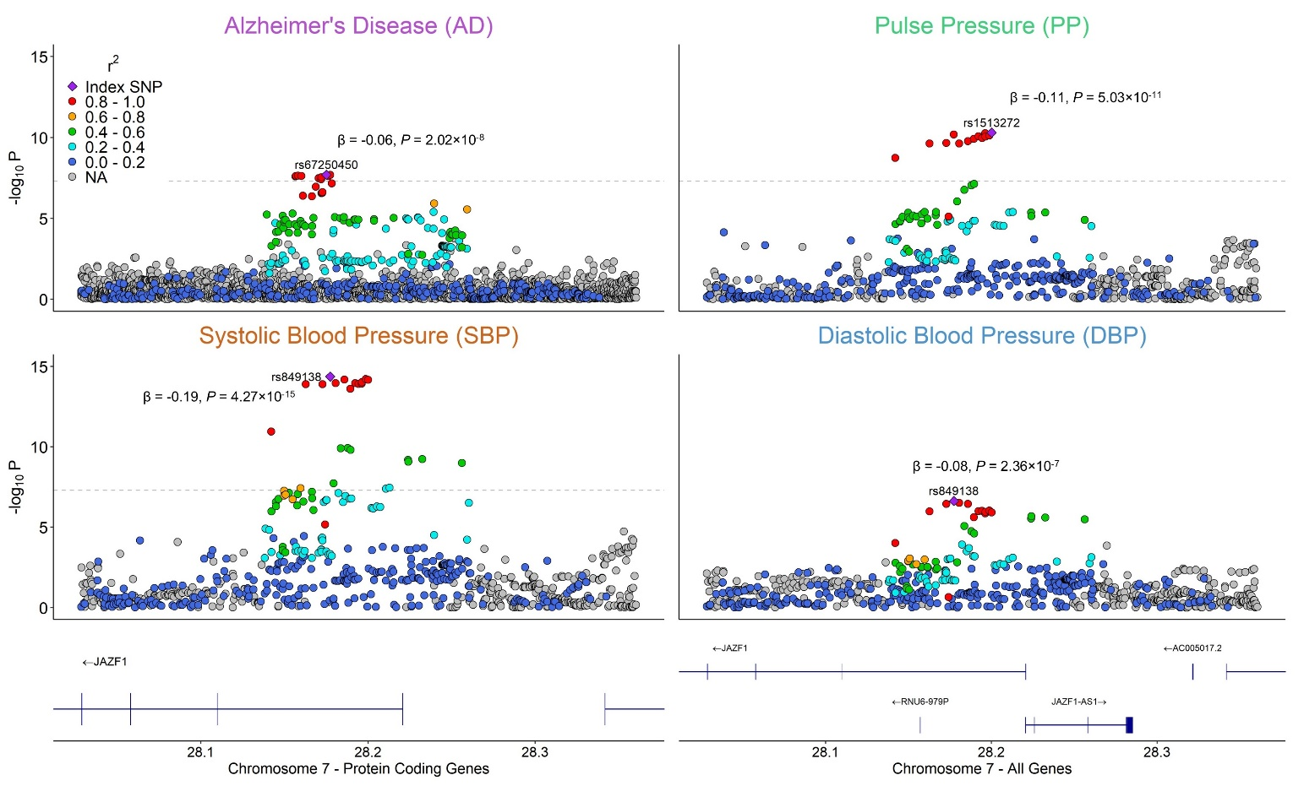

G. chr11p11.2
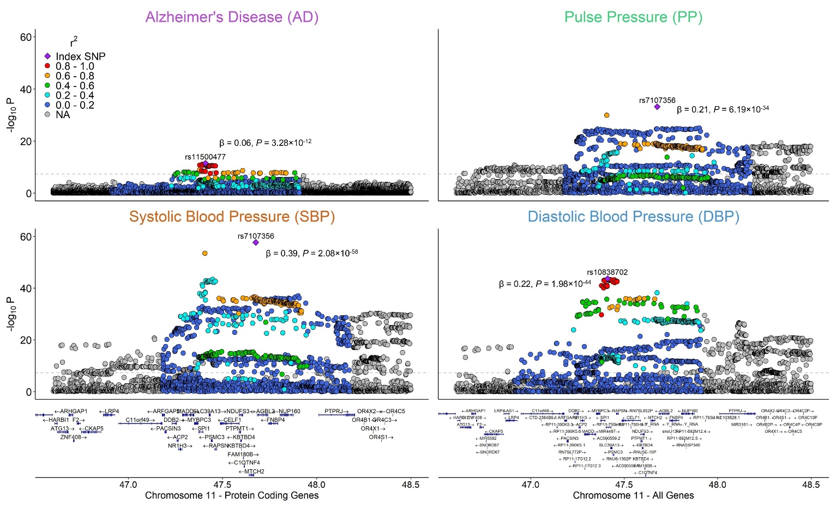

H. chr8p21.1
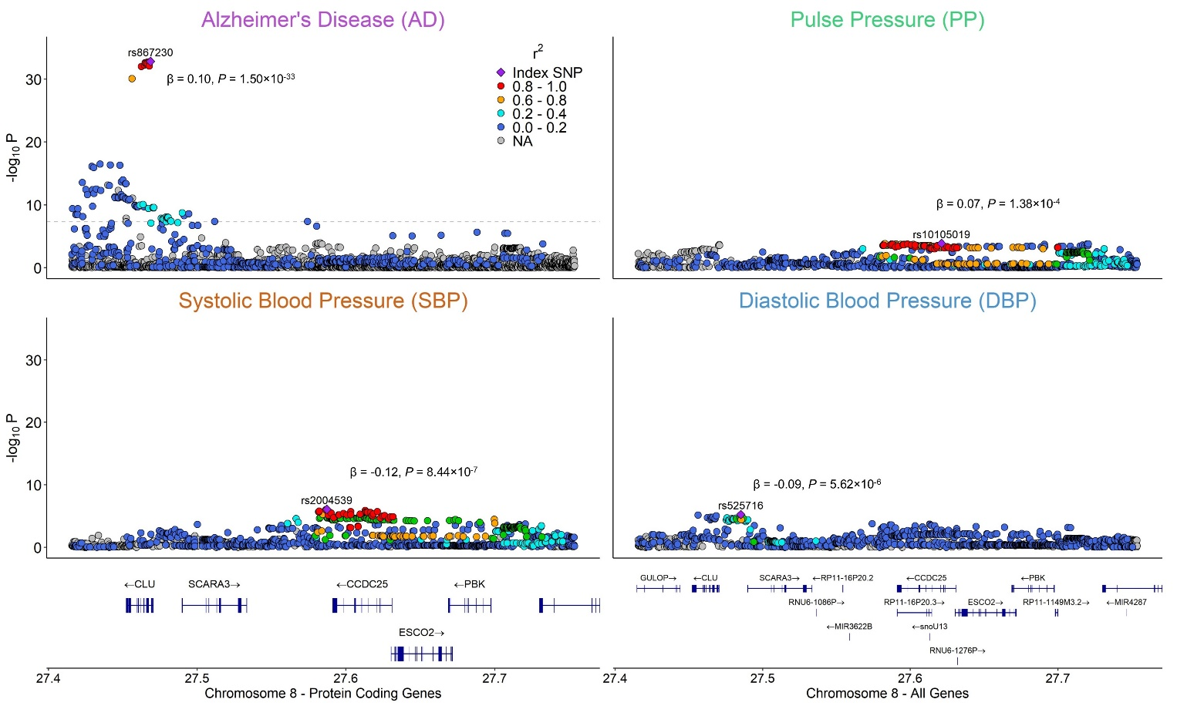

Local association plots from AD (Bellenguez et al., 2022) and BP (Keaton et al., 2024) GWAS with the -log10 transformed P-value for each SNP displayed on the y-axis and base-pair position in genome build GRCh37 on the x-axis. Dashed lines indicate the genome-wide significance threshold of P < 5×10⁻⁸. The color indicates LD in relation to the labeled top hits from each GWAS. Higher r² values are indicated by warmer colors (reds) and lower r² values are indicated by cooler values (blues). The RSID of the top SNP from each trait is displayed, as is the β and P-value for that SNP from each trait’s GWAS summary statistics. To refine the significant regions of genetic correlation resulting from the LAVA analyses, visual inspection of each locus was conducted to determine areas of overlap between AD and the blood pressure traits. LD with the most significant variant in the area of overlap was calculated for each trait using LDlink, and refined regions of local genetic correlation were then defined using an LD cutoff of r² >= .10.

Supplementary Figure 2. Cross-trait enrichment between AD and SBP
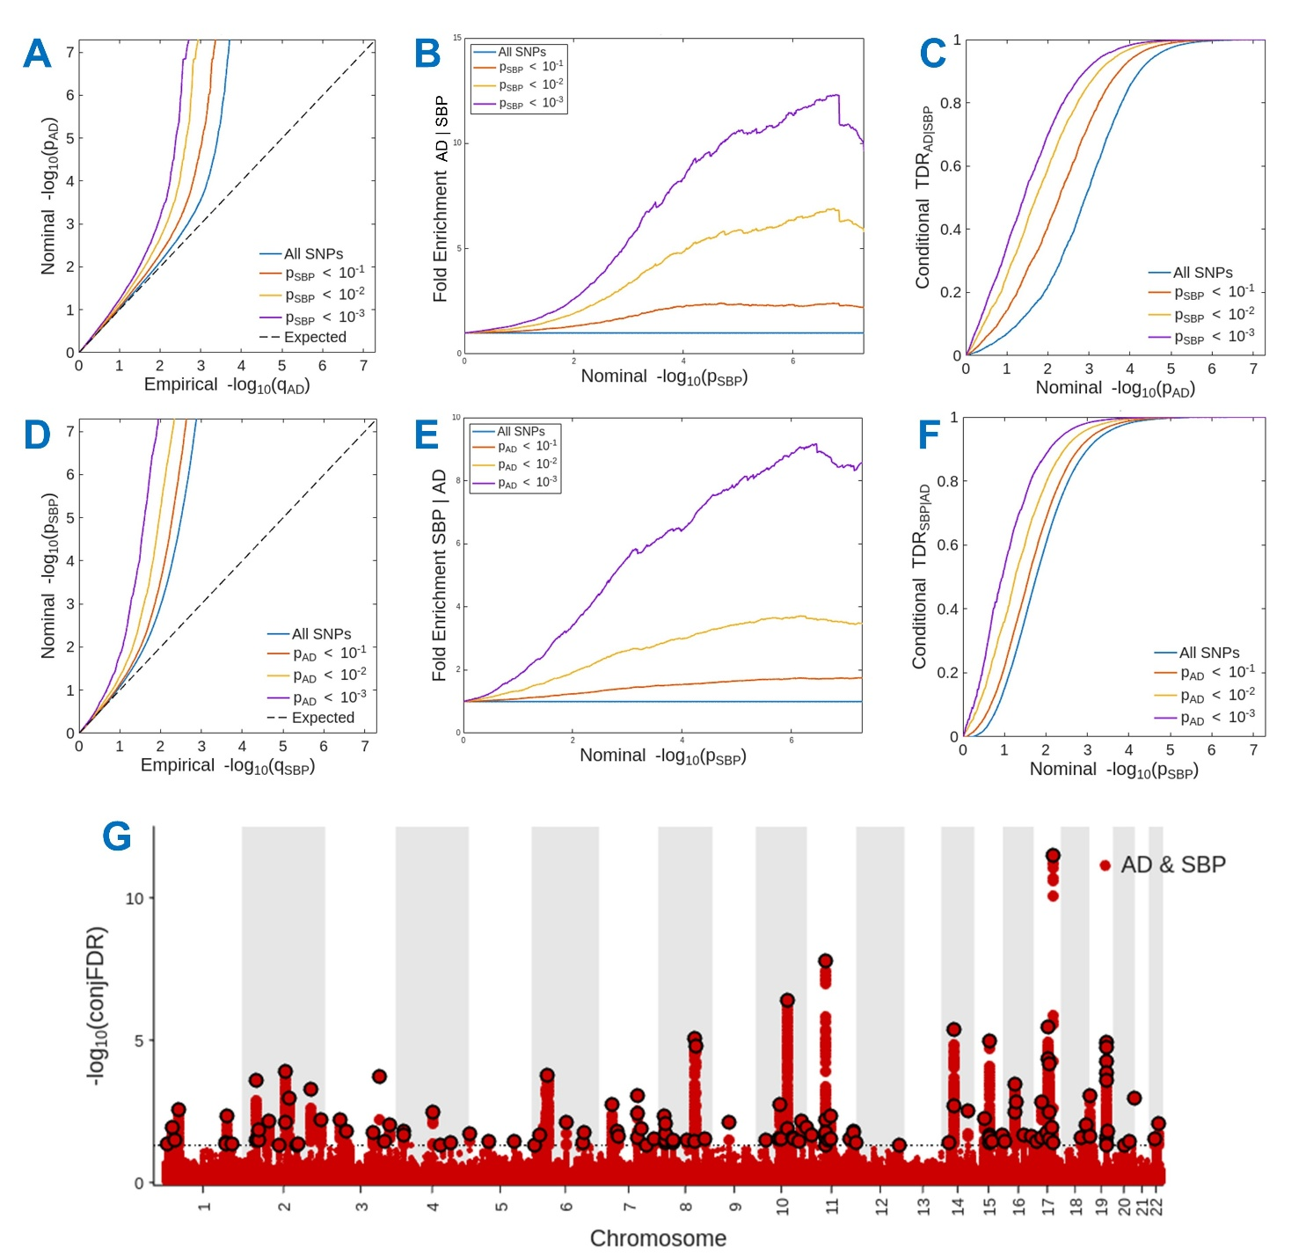
A) Conditional Q-Q plot displaying the nominal -log10 P-values of the single SNP association statistics versus their empirical distribution in AD below the standard GWAS threshold of P < 5×10⁻⁸ as a function of significance of association with SBP at the level of P ≤ 0.1 (red line), P ≤ 0.01 (yellow line), and P ≤ 0.001 (purple line). The blue line indicates all SNPs and the dashed line indicates the null hypothesis. Evidence of enrichment is indicated by leftward deflections in conditional Q-Q plots with increasing auxiliary phenotype association strength, directly interpretable as true discovery rate (1-FDR). B) Fold-enrichment plot of enrichment versus nominal -log10 P-values in AD as a function of association with SBP. C) Conditional true discovery rate (TDR) plot illustrating the increase in TDR associated with increased enrichment in AD conditioned on SBP. D) Conditional Q-Q plot displaying the nominal -log10 P-values of the single SNP association statistics versus their empirical distribution in SBP below the standard GWAS threshold of P < 5×10⁻⁸ as a function of significance of association with AD. E) Fold-enrichment plot of enrichment versus nominal -log10 P-values in SBP as a function of association with AD. F) Conditional true discovery rate (TDR) plot illustrating the increase in TDR associated with increased enrichment in SBP conditioned on AD. G) Genome-wide association plot showing the -log10 transformed conjFDR between AD and SBP on the y-axis and the chromosome and base-pair position of SNPs (indicated by red dots) on the x-axis.

Supplementary Figure 3. Cross-trait enrichment between AD and DBP
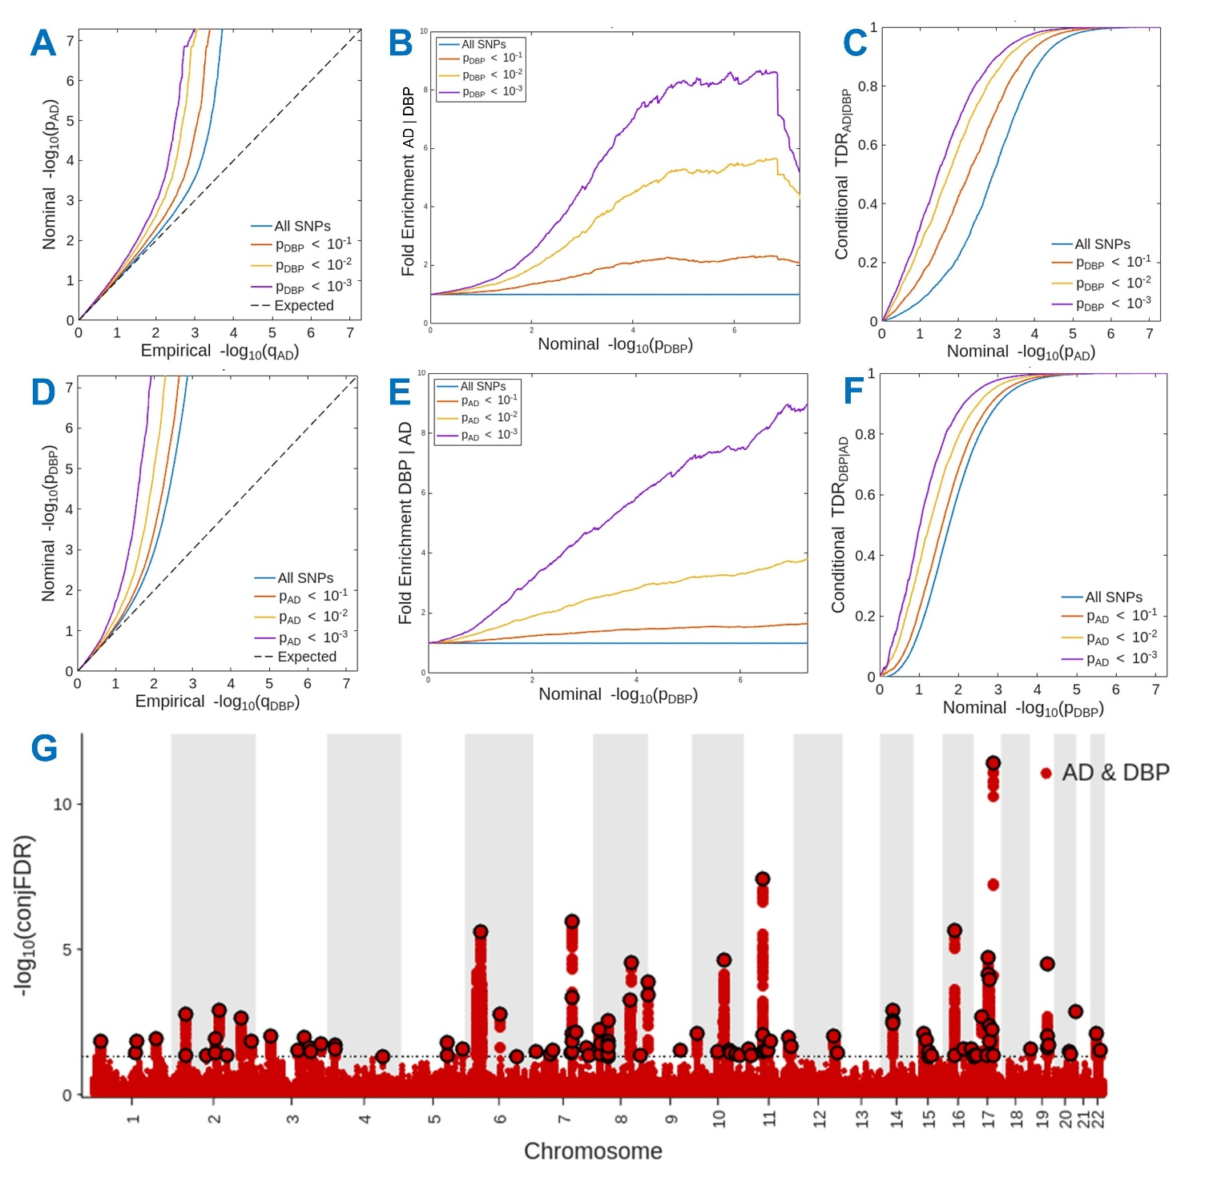
A) Conditional Q-Q plot displaying the nominal -log10 P-values of the single SNP association statistics versus their empirical distribution in AD below the standard GWAS threshold of P < 5×10⁻⁸ as a function of significance of association with DBP at the level of P ≤ 0.1 (red line), P ≤ 0.01 (yellow line), and P ≤ 0.001 (purple line). The blue line indicates all SNPs and the dashed line indicates the null hypothesis. Evidence of enrichment is indicated by leftward deflections in conditional Q-Q plots with increasing auxiliary phenotype association strength, directly interpretable as true discovery rate (1-FDR). B) Fold-enrichment plot of enrichment versus nominal -log10 P-values in AD as a function of association with DBP. C) Conditional true discovery rate (TDR) plot illustrating the increase in TDR associated with increased enrichment in AD conditioned on DBP. D) Conditional Q-Q plot displaying the nominal -log10 P-values of the single SNP association statistics versus their empirical distribution in DBP below the standard GWAS threshold of P < 5×10⁻⁸ as a function of significance of association with AD. E) Fold-enrichment plot of enrichment versus nominal -log10 P-values in DBP as a function of association with AD. F) Conditional true discovery rate (TDR) plot illustrating the increase in TDR associated with increased enrichment in DBP conditioned on AD. G) Genome-wide association plot showing the -log10 transformed conjFDR between AD and DBP on the y-axis and the chromosome and base-pair position of SNPs (indicated by red dots) on the x-axis.

Supplementary Figure 4. Cross-trait enrichment between AD and PP
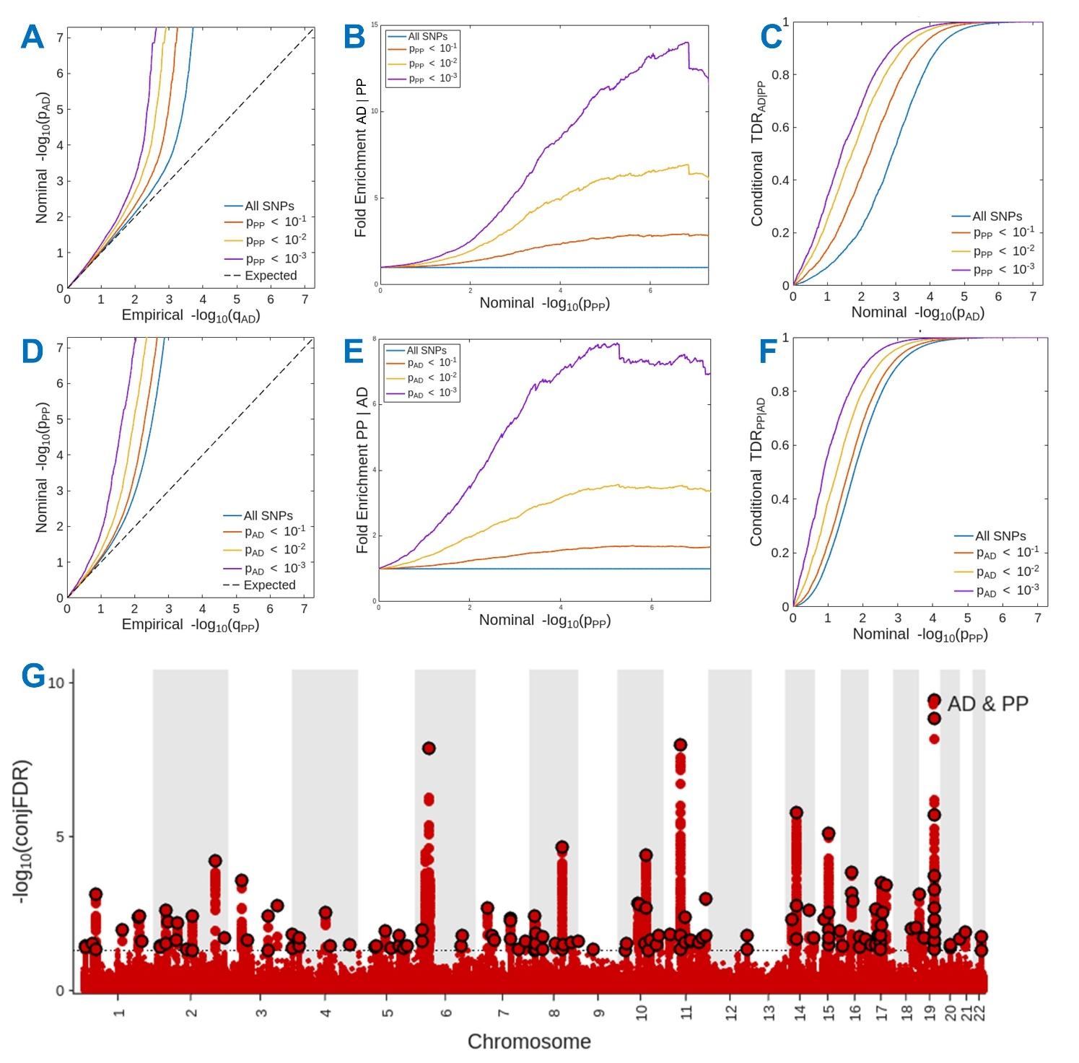
A) Conditional Q-Q plot displaying the nominal -log10 P-values of the single SNP association statistics versus their empirical distribution in AD below the standard GWAS threshold of P < 5×10⁻⁸ as a function of significance of association with PP at the level of P ≤ 0.1 (red line), P ≤ 0.01 (yellow line), and P ≤ 0.001 (purple line). The blue line indicates all SNPs and the dashed line indicates the null hypothesis. Evidence of enrichment is indicated by leftward deflections in conditional Q-Q plots with increasing auxiliary phenotype association strength, directly interpretable as true discovery rate (1-FDR). B) Fold-enrichment plot of enrichment versus nominal -log10 P-values in AD as a function of association with PP. C) Conditional true discovery rate (TDR) plot illustrating the increase in TDR associated with increased enrichment in AD conditioned on PP. D) Conditional Q-Q plot displaying the nominal -log10 P-values of the single SNP association statistics versus their empirical distribution in PP below the standard GWAS threshold of P < 5×10⁻⁸ as a function of significance of association with AD. E) Fold-enrichment plot of enrichment versus nominal -log10 P-values in PP as a function of association with AD. F) Conditional true discovery rate (TDR) plot illustrating the increase in TDR associated with increased enrichment in PP conditioned on AD. G) Genome-wide association plot showing the -log10 transformed conjFDR between AD and PP on the y-axis and the chromosome and base-pair position of SNPs (indicated by red dots) on the x-axis.

Supplementary Figure 5. Regions with conjFDR < .001 between AD and at least one BP trait
A. chr1p34.2

B. chr2p22.2
C. chr2q14.3

D. chr2q33.2

E. chr3p22.2

F. chr3q25.2

G. chr6p21.32

H. chr7q22.1

I. chr8q22.1

J. chr8q22.2

K. chr8q24.3

L. chr10q23.1

M. chr11p11.2

N. chr14q22.1

O. chr15q22.2

P. chr16p11.2a

Q. chr16p11.2b

R. chr17q21.31

S. chr17q21.32

T. chr17q23.3

U. chr19p13.3

V. chr19q13.32
Local association plots from AD (Bellenguez et al., 2022) and BP (Keaton et al., 2024) GWAS with the -log10 transformed P-value for each SNP displayed on the y-axis and base-pair position in genome build GRCh37 on the x-axis. Dashed lines indicate the genome-wide significance threshold of P < 5×10⁻⁸. The color indicates LD in relation to the labeled top hits (indicated by a purple diamond) from each GWAS. Higher r² values are indicated by warmer colors (reds) and lower r² values are indicated by cooler values (blues). Two independent loci were identified within 16p11.2 (16p11.2a and 16p11.2b), represented by lead variants rs4788203 and rs7185007, respectively.

