MATERIALS AND METHOD-

RT details:

Simultaneous integrated boost (SIB) technique used to irradiate the disease in three volumes:

1.High risk volume- 70Gy/33# dose prescribed to gross tumor and gross node

2.Intermediate risk volume- 59Gy/33# prescribed to ipsilateral cervical neck nodal levels

3.Low risk volume- 54Gy/33# prescribed to contralateral cervical neck nodal levels

Pre test questionnaire for patient screening:
- For Deep breathing test (DBT) rule out Acute respiratory disease and illness
- For Valsalva manoeuvre rule out Diabetic retinopathy, Papilledema and Proliferative degenerative retinopathy (patient asked to get a screening fundoscopy from ophthalmology department), tracheostomy tube
- Isometric hand grip test: None
- For Cold pressure test rule out coronary artery disease and severe hypertension (BP>180, DBP>110) (Baseline Blood pressure recorded for all patients)
- For Lying to standing test rule out Severe orthostatic hypotension i.e. fall in SBP>35-40mmHg, unstable cardiovascular disease and pregnancy
Patient orientation and practice session for the battery of tests:
- Breathing at the rate off 6 breaths/minute on signal with respirator belt around the chest
- Valsalva practice of holding 40 mm Hg pressure for 15 second with open glottis (therefore tracheostomy patients contraindicated)
- 3 steps standing from the lying to standing position in 3 seconds
- Maximum voluntary contraction (MVC) calculation and holding the hand grip at 30% of MVC for 4 minutes
- No practice for HRV lying and cold immersion test required

Patient set-up:
After taking written consent patients were taken up for AFT. Patient was asked to expose their upper body (naked preferred, otherwise maximum a thin sleeveless vest allowed). Patient was asked to lie supine on the couch and then set-up is done for the following -
- 3 ECG (electrocardiogram) electrodes are placed (2 in bilateral supraclavicular region, 1 in right inguinal region)
- Respirator belt is tied around the chest at nipple level
- Blood pressure cuff (sphygmomanometer) is tied in preferably non-dominant arm at heart level
- Finna press cuff (non-invasive finger plethysmograph) is tied in finger of non-dominant hand (index/middle/thumb finger whichever fits better)

AFT Stressor tests steps in details:
- Deep Breathing test:
  - Slow, smooth and deep breath at 6 cycles per minute for 1 minute with help of hand movement
  - Inspiration and expiration of 5 second duration each
  - Complete record of 6 complete breath cycles must
  - Calculation of outcome parameter:
    - Delta heart rate: average difference of maximal and minimal heart rate during inspiration and expiration, of 6 cycles
      - Normal value:>15 bpm
      - 11-14 bpm borderline
      - <10 bpm abnormal
    - E:I ratio: Average ratio of longest and shortest R-R interval over 6 cylce
      - >1.21 normal

- Valsalva test:
  - 2-minute rest post DBT
  - Test in supine position
  - Blow into mouth piece attached to manometer and generate a pressure of 40 mmHg for 15 Second with open glottis (small air leak is good)
  - Release of pressure after 15 Second
  - No deep breath before and after the manoeuvre
  - Calculation of following outcome parameter:

    - Valsalva ratio
    - Tachycardia ratio
    - Bradycardia ratio

- Lying to standing test:
  - 2 min rest post Valsalva
  - Instruction to stand still in 3 steps in 3 seconds and remain standing for 5 minutes
  - Recording of blood pressure and heart rate at base line and serially at 0.5, 1, 2, 2.5, 5 minutes
  - During the standing one staff ready to handle the potential impending fall
  - Calculation of following outcome parameter:
    - 30:15 ratio between longest RR interval at around 30 beat and shortest RR interval around 15 beats with following cut-off of 1.04 value normal, 1.01-1.03 value borderline and 1.0 value abnormal
    - Fall in SBP- With following cut-off of <10 mmHg reading normal, 11-29mmHg borderline, and >30 mm Hg abnormal

- Isometric grip test/ Hand grip test:
  - 2 minutes rest post LST
  - Record of maximum force 3 time with dominant hand during practice session
  - Sustained grip at 30% of MVC for the 4 minutes during test
  - Measurement of BP on contralateral arm at 1, 2, 4 minute (any time just before the release of grip it is less than 4 minute) and 2 minutes post release of grip
  - Calculation of following outcome parameter:
    - Highest DBP during the test – baseline DBP
    - Test values:
      - Increase in DBP>16 mmHg considered normal
      - >11-15 mmHg borderline
      - <10 mmHg abnormal

- Cold pressor test:
  - 2 minutes rest post HGT
  - Immersion of hand in cold water at 10 degrees Celsius up-to the wrist without touching the bottom for 1 minute.
  - BP recording at midway of immersion, end of 1 minute immersion, 1.5 minute and 4 minutes after the hand is withdrawn.
  - If subject feel the severe pain hand should be withdrawn before 1 minute. After the test hand should be wrapped with dry towel
  - Calculation of following outcome parameter:
    - Highest DBP during the test – baseline DBP, of which Normal value:

Increase in DBP>10 mmHg considered normal

Equipment used for AFT:

1. PowerLab- Data acquisition Hardware:

This is a data acquisition (DAQ) device designed for acquiring external signals, such as those from ECG electrodes, a finometer, and a respiratory belt. The specific model used is the PowerLab 8/30, featuring eight analog inputs on its front panel (eight BNC connectors labeled as Input 1 – 8) and four alternative pod (DIN) connectors for inputs 1 – 4. Input 1 is linked to ECG electrodes, Input 2 to the finometer, and Input 3 to the respiratory belt. A USB port on the back panel connects the PowerLab to a computer via a USB cable, enabling data transfer. It can record up to 200,000 samples per second and includes a bioamplifier and internal processor with low and high pass filters. The hardware integrates with LabChart software for recording and analyzing acquired data sets.

The back panel of the PowerLab features ports for connecting to the computer and power outlet. It includes a USB port for PC connection running LabChart 8.0 software and a digital input port for receiving markers from a separate PC, used for initiating and terminating maneuvers.
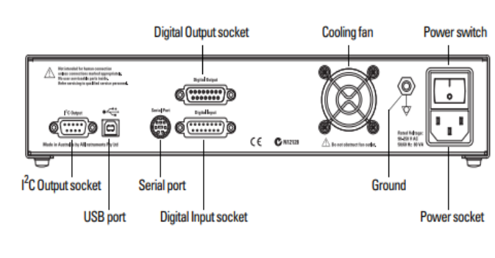
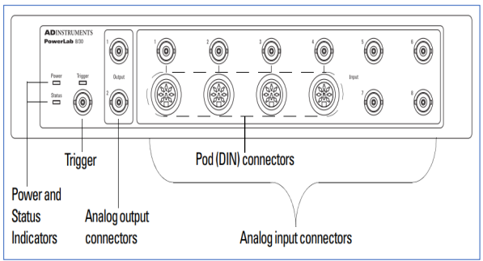
Fig. 4- Power Lab 8/30 ⁽²⁰⁾ with its front (left) and back (right) panel respectively.

2. FinaPRES Medical System:

The Finometer Midi is an instrument used for continuous monitoring of finger arterial pressure (FinaPres). It employs the arterial volume-clamp method developed by Czech physiologist Penaz to measure blood pressure in the finger. The device comprises four components:

1. Main Unit: The central component of the system.

2. Front End Unit: Connects the finger cuff to the main unit.

3. Finger Cuff: Measures beat-to-beat blood pressure based on the arterial volume-clamp method. Available in three sizes (small, medium, and large) and is applied to the middle or ring finger.

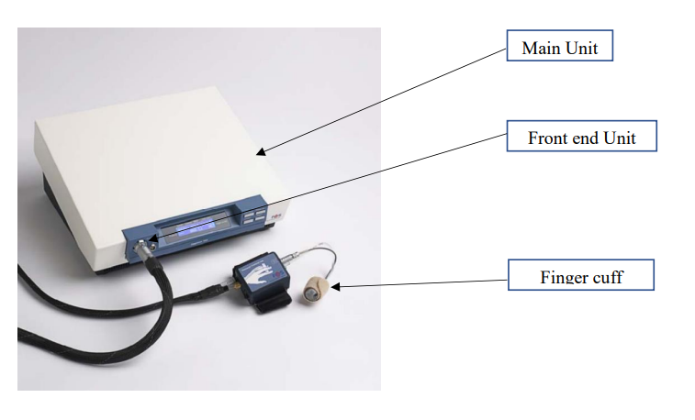
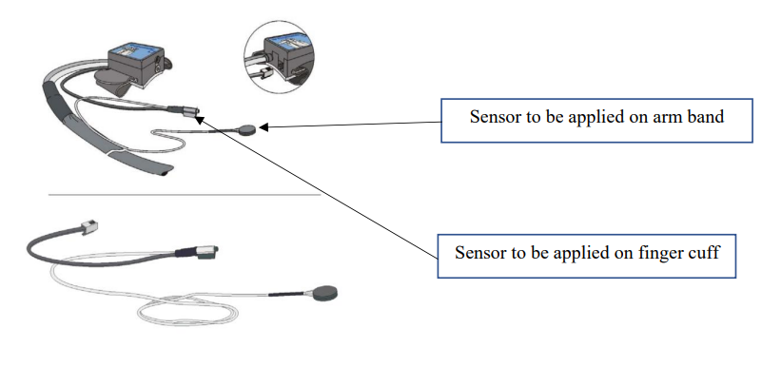
4. Height Correction Unit: This unit enables the measurement of blood pressure at heart level. It consists of two sensors—one applied to the finger cuff and the other to an arm band wrapped around the arm at heart level. These sensors measure the height difference between the finger and the heart and adjust for the hydrostatic pressure difference accordingly.
Fig. 5 (21) -- FinoMeter MiDi and it’s components (left) and Height correction unit (right)

3. LabChart - Analyzing software for various Physiological signals:

This software serves as a platform for simultaneously recording various signals from different instruments, such as ECG, continuous blood pressure, and respiratory rate.

Lead-2 is used to obtain ECG signals from the PowerLab data recording device at a sample rate of 200/s and a gain of x2,000. A notch filter set to 50 Hz is used to remove power line noise. Amplification of physiological signals is used to guarantee precise R-peak detection. Once the ECG acquisition is finished, R-peaks can be found with the integrated adaptive fuzzy-R-peak detection tool. We then construct heart rate variability measurements from both the temporal and frequency domains using the normal-to-normal R-R interval.

The Finometer gathers finger plethysmography data, which is then used to calculate beat-to-beat systolic, diastolic, and mean blood pressures with the help of PowerLab and LabChart. The transfer function filters the finger blood pressure waveform, removing pulse propagation distortion, and a level correction based on regression is used to account for the pressure gradient.

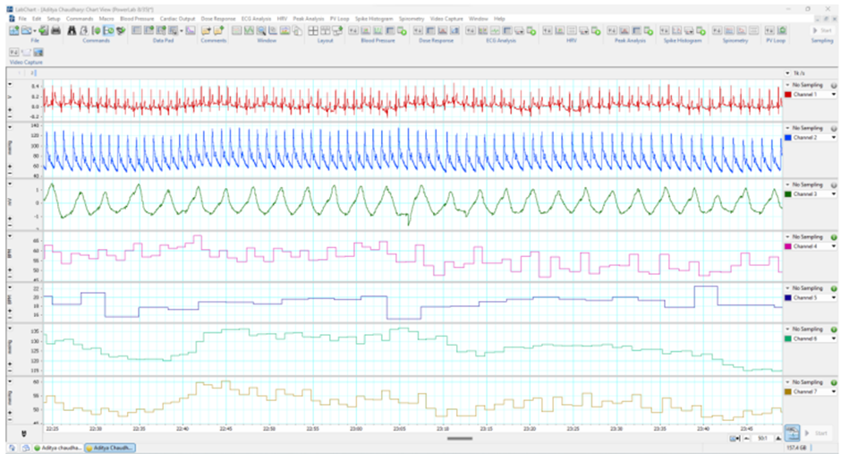
Fig. 6- LabChart 8.0 software is utilized for acquiring data on heart rate and blood pressure. The LabChart window consists of seven panels ^{(7):}
Panel 1- displays the ECG signal.
Panel 2- shows the continuous blood pressure waveform measured by FinaPres.
Panel 3- displays respiratory movements recorded by the respiratory belt.
Panel 4- shows the heart rate derived from the ECG signal.

4. Nevrokard analysis module for HRV and BPV:
HRV analysis was done for the normal-to-normal R–R interval data from the ECG records of the patients measured at rest for 10 minutes. A .csv file (named whole.csv) was exported from the LabChart for the recordings. Data from whole.csv was imported into the MATLAB R2021a software and a code was used to extract data in .csv format for the domains we wanted to analyze. Nevrokard software tool used for HRV analysis by importing the RRI data in prepared format (PreDBT.csv. DBT.csv etc.). We have used Nevrokard HRV analysis module version 9.1.0 for this purpose. In the time domain analysis average R-R interval, SDNN, average heart rate (HR), SDHR, RMSDD and PRR50 count was selected for the statistical analysis. In Frequency domain based: LF (low frequency) power, HF (high frequency) power, LF/HF ratio was analysed.
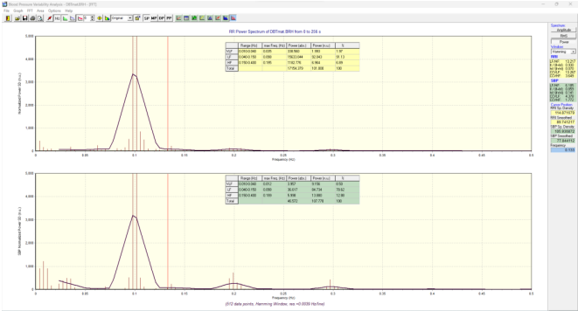
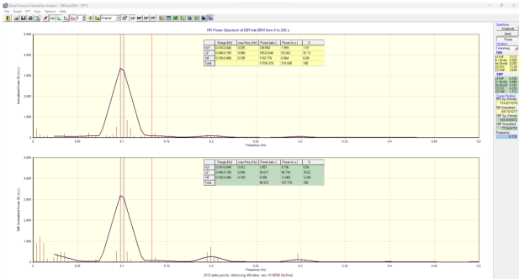
Similarly, for BPV, analysis was done for the SBP, DBP and MBP interval data from beat-to-beat blood pressure records measured at rest for 10 minutes. Rest the steps of file exporting, MATLAB R2021 a software for data extraction and Nevrokard software for data analysis was same as that of HRV. In the time domain analysis average SBP, average DBP, average MBP, SD (for SBP, DBP and MBP), SDSD (for SBP, DBP and MBP) and RMSDD (for SBP, DBP and MBP) were selected for the statistical analysis. In Frequency domain based: LF power, HF power, LF/HF ratio (for SBP, DBP and MBP) was analyzed.
Fig. 7- Nevrokard analysis ⁽⁸⁾ - HRV analysis mode (left), BPV analysis mode (right)

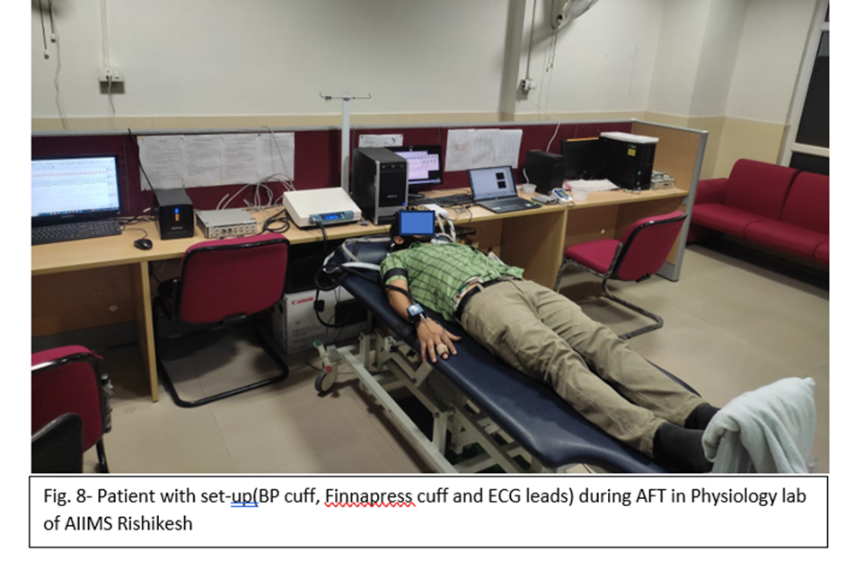

RESULTS-
Patient, tumor and treatment characteristics:
A total of 31 patients were included in this time bound study. Only 1 out of 31 was female, rest were males. 28 patients were aged less than 65 years and 3 patients were >65 years of age. Baseline ECOG PS was 0 in 7 patients, 1 in 20 patients and 2 in 4 patients.
Out of the 31 subjects, 19 had malignancy of oropharynx, 5 of larynx, 5 of hypopharynx and 2 of oral cavity. Of these 23 subjects had moderately differentiated squamous cell carcinoma, 5 had poorly differentiated squamous cell carcinoma and 3 had well differentiated squamous cell carcinoma histology. As per AJCC 8th edition for tumor stage T2 were 6, T3 were 9, T4a 13 were and T4b were 3 subjects. For nodal stage N0 were 6, N1 were 9, N2a were 4, N2b were 2, N2c were 5 and N3b were 5 subjects. Overall disease stage was III in 8, stage IVA in 17 and stage IVB in 6 subjects.
Subjects were treated on Halcyon LINAC of our institute. 25 patients received dose 70Gy/33# and rest 6 patients received 66Gy/30# with SIB technique. Dosing was 5#/ week on consecutive days except on Saturday and Sunday in a period of 6.5-7 weeks. Patients also received concurrent chemotherapy with Cisplatin (@40mg/m2, weekly regime, maximum 6 cycles and max dose of 60mg) or Carboplatin (if cisplatin ineligible, AUC 2, weekly). Out of 31 subjects 21 received chemo and 10 patients didn’t receive any chemo. Of the 21, 15 received cisplatin and 6 received carboplatin. >4 cycles of chemo received by 13 patients and <4 by 8 patients.

Time-domain analysis parameters include:

SDNN represents overall heart rate variability by measuring both prolonged and brief NN intervals' variability. SDNN (standard deviation of normal-to-normal (NN) intervals) - captures both long- and short-term variability, reflecting overall HRV.

5-minute SDANN intervals of a 24-hour ECG recording assess the slower elements of heart rate variability. SDANN (standard deviation of the average NN intervals calculated over successive 5-minute periods of a 24-hour recording) - evaluates slow-changing components of HRV.

The square root of the mean squared differences of successive NN intervals (rMSSD) represents short-term variations associated with parasympathetic activity. rMSSD (square root of the mean squared differences of successive NN intervals) - describes short-term variation, reflecting parasympathetic activity.

The significance of pNN50, which is the proportion of NN interval differences larger than 50 ms, is alike to that of rMSSD. pNN50 (proportion of differences in consecutive NN intervals longer than 50 ms) - significance similar to rMSSD.

Frequency domain parameters:

The low-frequency range (LF, 0.04–0.15 Hz) is influenced by both the sympathetic and parasympathetic nervous systems and related to baroreceptor activity. LF (low-frequency range, 0.04–0.15 Hz) - modulated by both the sympathetic and parasympathetic nervous systems, also associated with baroreceptor activity.

The parasympathetic nervous system modulates the HF (0.15-0.4 Hz) range, associated with respiration and blood pressure fluctuations. HF (high-frequency range, 0.15–0.4 Hz) - modulated by the parasympathetic nervous system, linked to respiration and blood pressure changes.

The LF/HF ratio signifies the interplay between sympathetic and parasympathetic influences on the autonomic nervous system. LF/HF ratio - reflects the interaction of both types of autonomic modulation.

The very low frequency (VLF) component (below 0.04 Hz) is estimated less often, as its interpretation in short recordings (5 minutes or less) is unclear. Therefore, interpreting the VLF component from short fragments is not recommended. Over longer periods, it likely reflects baroreceptor activity.

DISCUSSION-
Factors influencing HRV-

Non-linear dynamics techniques for HRV analysis have recently been developed ⁽²²⁾ . Still, scientific study still makes the most use of these techniques. Even though frequency-domain HRV analysis is more well-understood, research uses predominate. The most widely used HRV analysis in regular clinical evaluation is time-domain, and many of its indices are established independent risk factors for cardiovascular events. Age-related variations in HRV are notable, and they can be impacted by a variety of parameters, including body posture, level of physical and mental activity, body mass index, sex, and even nutrition ⁽²³⁾ .

BPV analysis explained-

Similar to HRV, blood pressure variability, or BPV, interprets blood pressure data in terms of both systolic and diastolic blood pressure in addition to heart rate. One of the most recent and proven methods for evaluating arterial baroreflex and autonomic functions is blood pressure variability (BPV) ⁽²⁴⁾. These factors supplement the information provided by HRV by offering a thorough understanding of autonomic function and the short-term regulation of blood pressure (BP). Assessing both HRV and BPV simultaneously provides a deeper and broader understanding of autonomic and some vascular processes than HRV alone since autonomic failure can result in BP dysregulation ⁽²⁵⁾.

BPV was computed using statistical concepts akin to HRV analysis in both the time and frequency domains. NevrokardTM software calculated all the metrics for systolic, mean, and diastolic blood pressure, in both frequency and time domain respectively.

DBT-
Deep breathing as we know is a very powerful tool of relaxation. Studies have established that young, healthy adults, doing slow, deep breathing exercises for a month lowers blood pressure and increases heart rate variability ⁽¹⁵⁾ . The decrease in breathing frequency brought on by breathing training may have contributed to the rise in HRV by allowing the respiration to influence both the vagal and sympathetic cardiac outflows. According to a study by Pal et al., whereas doing fast deep breathing exercises for the same amount of time has no effect on HRV, doing slow deep breathing exercises for three months improves parasympathetic dominance. This corroborates the idea that practicing slow, deep breathing exercises affects the vagal and sympathetic output, leading to an increase in heart rate ⁽¹⁶⁾. In our study the subject was taught to sit and breathe deeply at a pace of six breaths per minute. Following a five-minute rest interval, the heart rate (HR) was continually recorded using a typical ECG for at least one minute. The mean of the variations between the maximal and minimal HR in at least six cycles was then used to express the HR change (A HR) with breathing. According to Clarke et al. ⁽¹⁷⁾ , a deviation of 15 beats/min or more is considered normal; less than 10 beats/min is abnormal, and anything in the range of 10 to 14 beats/min is borderline.

VALSALVA-
The Valsalva manoeuvre is a test that evaluates parasympathetic and sympathetic adrenergic functions concurrently, through the measurement of the sympathetic adrenergic effect on blood pressure and the parasympathetic effect on heart rate. Press and maintain a 30-40 mmHg expiratory pressure for 15 seconds against resistance while opening the glottis. During the Valsalva manoeuvre, the hemodynamic changes occur in four distinct phases ⁽¹⁸⁾.
LST-
The lying to stand is an additional test for parasympathetic and sympathetic adrenergic function. Following at least five minutes of baseline blood pressure recording, the active stand is executed. heart rate while lying down and at rest. The patient shifts from a supine to a standing position as soon as possible—ideally in three seconds—and maintains this posture steadily and motionless for five minutes. The patient's everyday experiences with postural change are reflected in this test. The blood volume shifts from the core intravascular compartment to the peripheral vascular system by 300–800 mL when one is standing ⁽¹⁹⁾ . The heart rate increases rapidly with the abrupt shift of blood volume, peaking at roughly 3 s. This sudden, transient tachycardia results from vagal tone inhibition due to muscle contraction, known as the exercise reflex. Following the initial spike in heart rate, there is an additional spike in heart rate mediated by the baroreflex that lasts from 3 to 12 seconds. This occurs in reaction to a drop in blood pressure brought on by a decrease in vasoconstrictor tone. After about 30 seconds, there's a new baseline due to the brief drop in blood pressure and rise in heart rate. Thirty seconds after standing starts, there is a baroreflex-mediated bradycardia and a brief blood pressure overshoot period before blood pressure returns to normal.
IGT-
IGT was performed initially by explain patient to apply full force on the pressure measuring device with his/her dominant hand. After noting the maximum reading, patient was asked to hold the device for 4 minutes with 30% value of MVC (maximum voluntary contraction). Readings of BP were then recorded at baseline, 1st, 2nd,4th and 6th minute respectively and from these readings’ delta DBP was noted.

CPT-
For CPT patient was asked to immerse their hand upto wrist level into iced water with a temperature of 10 degree Celsius for a duration of 10 minutes. BP recordings were noted at baseline, 1st, 2.5th and 5th minutes respectively and the change in DBP was calculated.

RESULT TABLES-

Table 1- Tests of Within-Subjects Effects
Frequency domain |  | Type III Sum of Squares | df | Mean Square | F-value | p-value
SBP | SBP | 8703.493 | 2 | 4351.747 | 3.547 | .041*
SBP | Error(SBP) | 39262.819 | 32 | 1226.963
Median_SBP | SBP | 12026.750 | 2 | 6013.375 | 3.527 | .041*
Median_SBP | Error(SBP) | 54556.668 | 32 | 1704.896
SD SBP | SBP | 83.596 | 2 | 41.798 | .214 | .808
SD SBP | Error(SBP) | 6239.495 | 32 | 194.984
Variance SBP | SBP | 795340.576 | 2 | 397670.288 | .479 | .624
Variance SBP | Error(SBP) | 26576272.977 | 32 | 830508.531
CV SBP | SBP | .091 | 2 | .046 | 1.648 | .208
CV SBP | Error(SBP) | .885 | 32 | .028
SDSD | SBP | 92.730 | 2 | 46.365 | .328 | .723
SDSD | Error(SBP) | 4529.653 | 32 | 141.552
RMSSD | SBP | 470.596 | 2 | 235.298 | .590 | .560
RMSSD | Error(SBP) | 12755.540 | 32 | 398.611
Time domain
TP | SBP | 213985633.715 | 2 | 106992816.857 | 2.194 | .128
TP | Error(SBP) | 1560215872.392 | 32 | 48756746.012
VLF | SBP | 12005.247 | 2 | 6002.623 | .681 | .513
VLF | Error(SBP) | 281910.322 | 32 | 8809.698
LF | SBP | 2881.998 | 2 | 1440.999 | 4.442 | .020*
LF | Error(SBP) | 10380.879 | 32 | 324.402
HF | SBP | 360.113 | 2 | 180.057 | .704 | .502
HF | Error(SBP) | 8183.070 | 32 | 255.721
LF/HF | SBP | .761 | 2 | .380 | .318 | .730
LF/HF | Error(SBP) | 38.273 | 32 | 1.196

Table 2-  Frequency domain |  | N | Mean | Std. Deviation | t-value | p-value
SBP | Baseline | 29 | 115.89 | 26.42 | 2.598 | .015*
SBP | Ist | 29 | 139.34 | 39.38
Median_SBP | Baseline | 29 | 112.92 | 31.59 | 2.517 | .018*
Median_SBP | Ist | 29 | 139.27 | 40.13
SD SBP | Baseline | 29 | 13.57 | 15.37 | .517 | .609
SD SBP | Ist | 29 | 12.20 | 12.56
Variance SBP | Baseline | 29 | 412.18 | 953.62 | .704 | .487
Variance SBP | Ist | 29 | 301.04 | 661.91
CV SBP | Baseline | 29 | 0.14 | 0.19 | 1.926 | .064
CV SBP | Ist | 29 | 0.08 | 0.06
SDSD | Baseline | 29 | 8.50 | 13.70 | .881 | .386
SDSD | Ist | 29 | 6.75 | 10.01
RMSSD | Baseline | 29 | 13.25 | 22.16 | 1.240 | .225
RMSSD | Ist | 29 | 9.30 | 13.08
Time domain
TP | Baseline | 29 | 60.26 | 89.56 | .692 | .495
TP | Ist | 29 | 92.99 | 237.85
VLF | Baseline | 29 | 91.81 | 107.71 | .439 | .664
VLF | Ist | 29 | 102.51 | 83.60
LF | Baseline | 29 | 37.72 | 23.54 | 3.155 | .004**
LF | Ist | 29 | 49.46 | 16.41
HF | Baseline | 29 | 32.06 | 22.06 | .638 | .529
HF | Ist | 29 | 34.84 | 14.21
LF/HF | Baseline | 29 | 1.94 | 2.32 | .890 | .381
LF/HF | Ist | 29 | 2.19 | 2.23

Table 3-  Frequency domain |  | N | Mean | Std. Deviation | t-value | p-value
SBP | Baseline | 17 | 119.62 | 26.30 | 1.037 | .315
SBP | IInd | 17 | 126.57 | 24.40
Median_SBP | Baseline | 17 | 114.87 | 35.12 | 1.013 | .326
Median_SBP | IInd | 17 | 123.74 | 31.10
SD SBP | Baseline | 17 | 17.12 | 19.18 | .014 | .989
SD SBP | IInd | 17 | 17.21 | 20.97
Variance SBP | Baseline | 17 | 639.29 | 1205.36 | .167 | .869
Variance SBP | IInd | 17 | 710.16 | 1387.28
CV SBP | Baseline | 17 | 0.18 | 0.24 | .198 | .846
CV SBP | IInd | 17 | 0.17 | 0.25
SDSD | Baseline | 17 | 12.04 | 17.03 | .071 | .944
SDSD | IInd | 17 | 12.43 | 18.70
RMSSD | Baseline | 17 | 19.07 | 27.68 | .002 | .998
RMSSD | IInd | 17 | 19.05 | 29.92
Time domain
TP | Baseline | 17 | 77.82 | 108.93 | 1.487 | .157
TP | IInd | 17 | 4453.37 | 12111.45
VLF | Baseline | 17 | 96.98 | 127.92 | 1.074 | .299
VLF | IInd | 17 | 61.55 | 49.81
LF | Baseline | 17 | 30.30 | 24.15 | 1.742 | .101
LF | IInd | 17 | 43.76 | 17.51
HF | Baseline | 17 | 31.25 | 23.29 | 1.099 | .288
HF | IInd | 17 | 37.38 | 11.08
LF/HF | Baseline | 17 | 1.24 | 1.32 | .361 | .723
LF/HF | IInd | 17 | 1.40 | 1.02

Table 4- Tests of Within-Subjects Effects
Frequency domain |  | Type III Sum of Squares | df | Mean Square | F-value | p-value
DBP | DBP | 2283.545 | 2 | 1141.773 | 2.963 | .066
DBP | Error(DBP) | 12332.694 | 32 | 385.397
Median_DBP | DBP | 2102.581 | 2 | 1051.290 | 2.881 | .071
Median_DBP | Error(DBP) | 11675.279 | 32 | 364.852
SD DBP | DBP | 93.510 | 2 | 46.755 | 1.148 | .330
SD DBP | Error(DBP) | 1303.039 | 32 | 40.720
Variance DBP | DBP | 211570.185 | 2 | 105785.093 | 1.340 | .276
Variance DBP | Error(DBP) | 2526020.828 | 32 | 78938.151
CV DBP | DBP | 37.108 | 2 | 18.554 | 2.458 | .102
CV DBP | Error(DBP) | 241.521 | 32 | 7.548
SDSD | DBP | 29.316 | 2 | 14.658 | .605 | .552
SDSD | Error(DBP) | 775.527 | 32 | 24.235
RMSSD | DBP | 15.561 | 2 | 7.780 | .195 | .824
RMSSD | Error(DBP) | 1275.703 | 32 | 39.866
Time domain
TP | DBP | 49812.652 | 2 | 24906.326 | 1.052 | .361
TP | Error(DBP) | 757610.148 | 32 | 23675.317
VLF | DBP | 52666.481 | 2 | 26333.241 | 1.213 | .311
VLF | Error(DBP) | 694943.903 | 32 | 21716.997
LF | DBP | 4391.759 | 2 | 2195.879 | 7.355 | .002**
LF | Error(DBP) | 9554.082 | 32 | 298.565
HF | DBP | 149.215 | 2 | 74.608 | .268 | .766
HF | Error(DBP) | 8896.084 | 32 | 278.003
LF/HF | DBP | 25.026 | 2 | 12.513 | 5.321 | .010**
LF/HF | Error(DBP) | 75.254 | 32 | 2.352

Table 5-  Frequency domain |  | N | Mean | Std. Deviation | t-value | p-value
DBP | Baseline | 29 | 50.891 | 18.899 | 2.401 | .023*
DBP | Ist | 29 | 62.038 | 19.236
Median_DBP | Baseline | 29 | 50.307 | 19.957 | 2.424 | .022*
Median_DBP | Ist | 29 | 60.830 | 16.238
SD DBP | Baseline | 29 | 5.664 | 4.178 | 1.318 | .198
SD DBP | Ist | 29 | 8.622 | 11.788
Variance DBP | Baseline | 29 | 48.938 | 78.295 | 1.484 | .149
Variance DBP | Ist | 29 | 208.507 | 570.447
CV DBP | Baseline | 29 | 0.237 | 0.428 | 1.553 | .132
CV DBP | Ist | 29 | 0.127 | 0.129
SDSD | Baseline | 29 | 3.215 | 3.687 | .213 | .833
SDSD | Ist | 29 | 3.493 | 5.931
RMSSD | Baseline | 29 | 4.459 | 4.778 | .398 | .694
RMSSD | Ist | 29 | 5.128 | 7.647
Time domain
TP | Baseline | 29 | 19.597 | 52.919 | 1.057 | .300
TP | Ist | 29 | 58.792 | 187.834
VLF | Baseline | 29 | 95.585 | 181.154 | .167 | .869
VLF | Ist | 29 | 102.072 | 94.621
LF | Baseline | 29 | 38.644 | 21.017 | 3.330 | .002**
LF | Ist | 29 | 53.732 | 17.606
HF | Baseline | 29 | 29.075 | 15.780 | .221 | .827
HF | Ist | 29 | 30.091 | 15.824
LF/HF | Baseline | 29 | 1.569 | 1.137 | 2.599 | .015*
LF/HF | Ist | 29 | 2.653 | 2.085

Table 6-  Frequency domain |  | N | Mean | Std. Deviation | t-value | p-value
DBP | Baseline | 17 | 49.798 | 22.006 | .246 | .809
DBP | IInd | 17 | 48.384 | 25.141
Median_DBP | Baseline | 17 | 48.819 | 23.500 | .031 | .976
Median_DBP | IInd | 17 | 48.635 | 25.134
SD DBP | Baseline | 17 | 6.542 | 4.991 | .462 | .651
SD DBP | IInd | 17 | 7.127 | 4.871
Variance DBP | Baseline | 17 | 66.238 | 97.175 | .263 | .796
Variance DBP | IInd | 17 | 73.138 | 91.988
CV DBP | Baseline | 17 | 0.341 | 0.539 | 1.460 | .164
CV DBP | IInd | 17 | 2.046 | 4.761
SDSD | Baseline | 17 | 4.146 | 4.420 | 1.154 | .266
SDSD | IInd | 17 | 5.876 | 5.838
RMSSD | Baseline | 17 | 5.585 | 5.919 | .803 | .434
RMSSD | IInd | 17 | 6.938 | 6.246
Time domain
TP | Baseline | 17 | 28.126 | 68.397 | 1.280 | .219
TP | IInd | 17 | 93.170 | 191.862
VLF | Baseline | 17 | 108.071 | 224.956 | 1.259 | .226
VLF | IInd | 17 | 36.748 | 29.260
LF | Baseline | 17 | 32.891 | 21.641 | 1.791 | .092
LF | IInd | 17 | 45.138 | 22.026
HF | Baseline | 17 | 27.458 | 16.069 | .658 | .520
HF | IInd | 17 | 31.468 | 14.324
LF/HF | Baseline | 17 | 1.215 | 0.742 | 1.744 | .100
LF/HF | IInd | 17 | 2.314 | 2.696

Table 7- Tests of Within-Subjects Effects
Frequency domain |  | Type III Sum of Squares | df | Mean Square | F-value | p-value
RRI | HRV | 1236534.04 | 2 | 618267.02 | 2.305 | .116
RRI | Error(HRV) | 8582773.06 | 32 | 268211.66
Median_RR | HRV | 47142.16 | 2 | 23571.08 | 1.924 | .163
Median_RR | Error(HRV) | 392077.28 | 32 | 12252.42
SDRR | HRV | 35175568.53 | 2 | 17587784.26 | 1.957 | .158
SDRR | Error(HRV) | 287642069.79 | 32 | 8988814.68
Variance RR | HRV | 3786425312496620.00 | 2 | 1893212656248310.00 | 1.519 | .234
Variance RR | Error(HRV) | 39872479912763500.00 | 32 | 1246014997273860.00
CV RR | HRV | 15.74 | 2 | 7.87 | 3.337 | .048*
CV RR | Error(HRV) | 75.47 | 32 | 2.36
Heart Rate | HRV | 196.27 | 2 | 98.13 | .052 | .949
Heart Rate | Error(HRV) | 60054.97 | 32 | 1876.72
SDHR | HRV | 26446.08 | 2 | 13223.04 | 1.708 | .197
SDHR | Error(HRV) | 247714.33 | 32 | 7741.07
SDSD | HRV | 63070771.98 | 2 | 31535385.99 | 1.929 | .162
SDSD | Error(HRV) | 523037883.23 | 32 | 16344933.85
RMSSD | HRV | 65385858.18 | 2 | 32692929.09 | 1.910 | .165
RMSSD | Error(HRV) | 547691892.50 | 32 | 17115371.64
PRR50 | HRV | 102.80 | 2 | 51.40 | .084 | .920
PRR50 | Error(HRV) | 19652.34 | 32 | 614.14
Time domain
TP | HRV | 18829726573625.00 | 2 | 9414863286812.49 | 3.314 | .049*
TP | Error(HRV) | 90911636699691.90 | 32 | 2840988646865.37
VLF | HRV | 596.66 | 2 | 298.33 | .819 | .450
VLF | Error(HRV) | 11659.11 | 32 | 364.35
LF | HRV | 808.04 | 2 | 404.02 | 1.031 | .368
LF | Error(HRV) | 12539.61 | 32 | 391.86
HF | HRV | 3573.08 | 2 | 1786.54 | 6.248 | .005**
HF | Error(HRV) | 9150.06 | 32 | 285.94
LF/HF | HRV | 1.66 | 2 | 0.83 | 1.573 | .223
LF/HF | Error(HRV) | 16.88 | 32 | 0.53

Table 8-  Frequency domain |  | N | Mean | Std. Deviation | t-value | p-value
RRI | Baseline | 29 | 761.95 | 172.31 | 1.551 | .132
RRI | Ist | 29 | 857.56 | 261.07
Median_RR | Baseline | 29 | 731.27 | 140.69 | 1.646 | .111
Median_RR | Ist | 29 | 776.15 | 139.77
SDRR | Baseline | 29 | 385.18 | 1086.65 | 1.497 | .146
SDRR | Ist | 29 | 1260.47 | 2978.80
Variance RR | Baseline | 29 | 1288453.48 | 6410722.37 | 1.652 | .110
Variance RR | Ist | 29 | 10156043.74 | 27805371.49
CV RR | Baseline | 29 | 0.42 | 0.87 | 1.408 | .170
CV RR | Ist | 29 | 1.00 | 2.17
Heart Rate | Baseline | 29 | 93.30 | 30.54 | .024 | .981
Heart Rate | Ist | 29 | 93.08 | 47.32
SDHR | Baseline | 29 | 32.35 | 46.49 | .020 | .984
SDHR | Ist | 29 | 32.64 | 66.44
SDSD | Baseline | 29 | 407.00 | 1052.99 | 1.667 | .107
SDSD | Ist | 29 | 1657.73 | 3961.02
RMSSD | Baseline | 29 | 426.80 | 1063.63 | 1.675 | .105
RMSSD | Ist | 29 | 1690.04 | 3983.34
PRR50 | Baseline | 29 | 19.64 | 24.08 | .284 | .779
PRR50 | Ist | 29 | 20.86 | 18.42
Time domain
TP | Baseline | 29 | 48922.47 | 149252.17 | .128 | .899
TP | Ist | 29 | 53546.12 | 100896.03
VLF | Baseline | 29 | 25.26 | 23.67 | .412 | .683
VLF | Ist | 29 | 28.23 | 34.32
LF | Baseline | 29 | 27.32 | 20.11 | .719 | .478
LF | Ist | 29 | 30.46 | 17.29
HF | Baseline | 29 | 33.51 | 18.58 | 2.151 | .040*
HF | Ist | 29 | 44.94 | 17.17
LF/HF | Baseline | 29 | 0.94 | 0.81 | .532 | .599
LF/HF | Ist | 29 | 0.83 | 0.82

Table 9-  Frequency domain |  | N | Mean | Std. Deviation | t-value | p-value
RRI | Baseline | 17 | 730.34 | 135.67 | 1.799 | .091
RRI | IInd | 17 | 1111.46 | 841.26
Median_RR | Baseline | 17 | 722.12 | 136.96 | .635 | .534
Median_RR | IInd | 17 | 746.36 | 106.19
SDRR | Baseline | 17 | 192.68 | 216.52 | 1.554 | .140
SDRR | IInd | 17 | 1769.07 | 4138.38
Variance RR | Baseline | 17 | 81247.20 | 131058.25 | 1.500 | .153
Variance RR | IInd | 17 | 19248380.36 | 52647563.92
CV RR | Baseline | 17 | 0.30 | 0.36 | 1.294 | .214
CV RR | IInd | 17 | 0.72 | 1.26
Heart Rate | Baseline | 17 | 98.65 | 36.90 | .350 | .731
Heart Rate | IInd | 17 | 103.01 | 40.88
SDHR | Baseline | 17 | 41.01 | 54.24 | 1.593 | .131
SDHR | IInd | 17 | 91.80 | 119.23
SDSD | Baseline | 17 | 217.75 | 272.18 | 1.533 | .145
SDSD | IInd | 17 | 2330.22 | 5627.84
RMSSD | Baseline | 17 | 240.67 | 286.78 | 1.532 | .145
RMSSD | IInd | 17 | 2432.09 | 5839.06
PRR50 | Baseline | 17 | 23.29 | 27.71 | .282 | .781
PRR50 | IInd | 17 | 20.29 | 33.60
Time domain
TP | Baseline | 17 | 47182.60 | 176646.13 | 1.839 | .085
TP | IInd | 17 | 1352670.33 | 2900138.37
VLF | Baseline | 17 | 23.03 | 20.75 | .915 | .374
VLF | IInd | 17 | 17.20 | 18.56
LF | Baseline | 17 | 25.98 | 21.90 | 1.297 | .213
LF | IInd | 17 | 35.73 | 17.80
HF | Baseline | 17 | 28.50 | 18.20 | 2.826 | .012*
HF | IInd | 17 | 40.91 | 16.74
LF/HF | Baseline | 17 | 0.97 | 0.78 | .626 | .540
LF/HF | IInd | 17 | 1.13 | 0.85

Table 10- Tests of Within-Subjects Effects
Source | Type III Sum of Squares | df | Mean Square | F-value | p-value
Change_HR | 991.342 | 2 | 495.671 | 1.841 | .175
Error(Change_HR) | 8615.354 | 32 | 269.230 |  | .175

Table 10- Descriptive Statistics
 | Mean | Std. Deviation | N
DBT-Change HR | 16.413 | 17.686 | 17
DBT-change HR-1 | 15.532 | 10.028 | 17
DBT-change HR-2 | 25.294 | 21.736 | 17

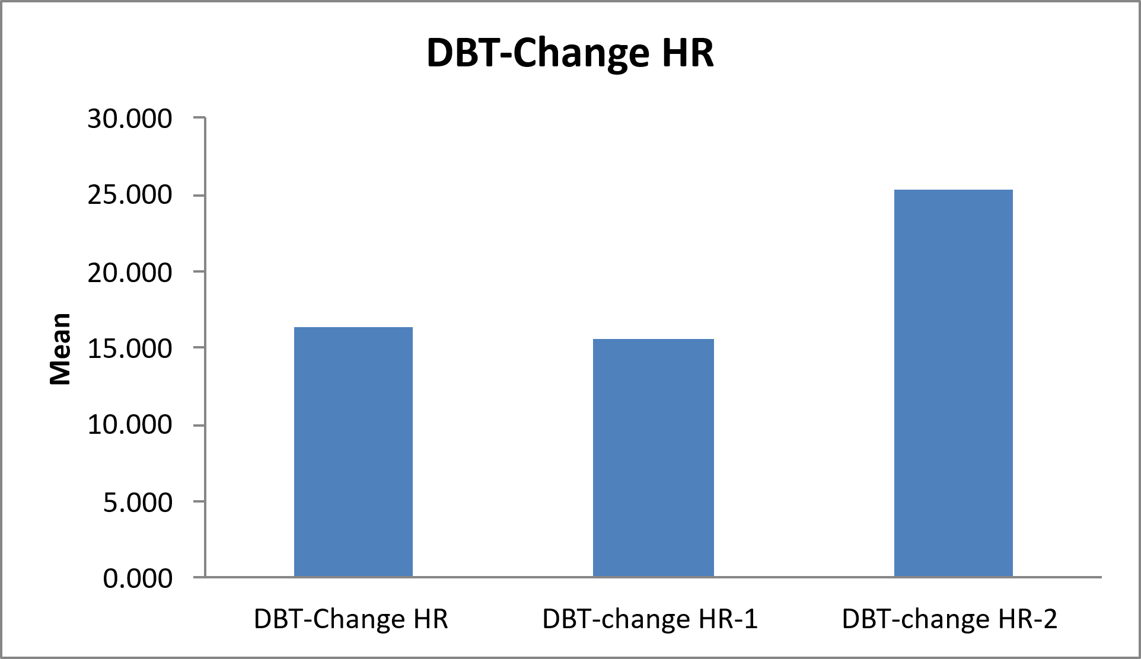

Table 11- Tests of Within-Subjects Effects
Source | Type III Sum of Squares | df | Mean Square | F-value | p-value
DBT_ratio | 1.087 | 2 | .544 | 1.591 | .219
Error(DBT_ratio) | 10.931 | 32 | .342 |  | .219

Table 11- Descriptive Statistics
 | Mean | Std. Deviation | N
DBT-ratio | 1.334 | 0.577 | 17
DBT-ratio-1 | 1.410 | 0.364 | 17
DBT-ratio-2 | 1.675 | 0.765 | 17

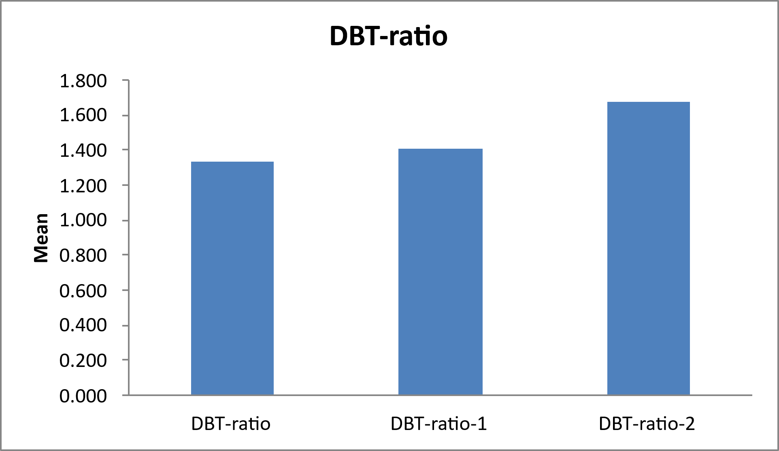

Table 12- Tests of Within-Subjects Effects
Source | Type III Sum of Squares | df | Mean Square | F-value | p-value
Valsalva | 2.595 | 2 | 1.297 | 1.242 | .302
Error (Valsalva) | 33.425 | 32 | 1.045 |  | .302

Table 12- Descriptive Statistics
 | Mean | Std. Deviation | N
Valsalva | 2.412 | 1.612 | 17
Valsalva-1 | 1.863 | 0.529 | 17
Valsalva-2 | 2.082 | 0.698 | 17

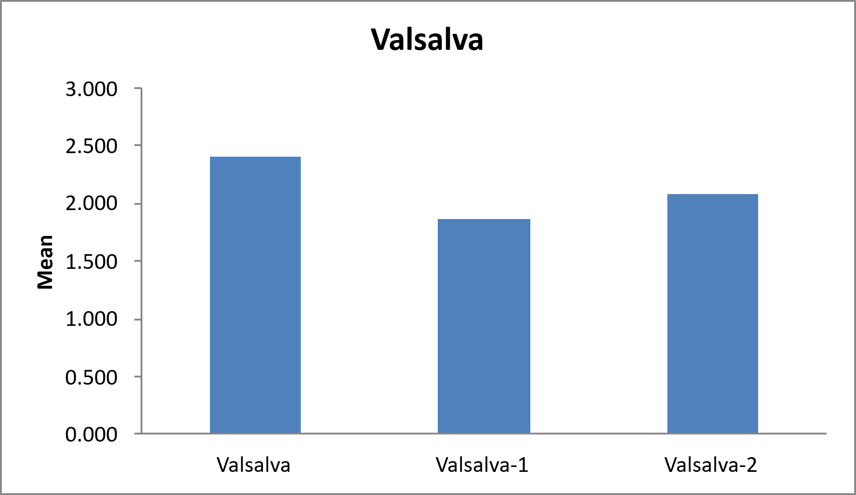

Table 13- Tests of Within-Subjects Effects
Source | Type III Sum of Squares | df | Mean Square | F-value | p-value
LST_Change_SBP | 1312.745 | 2 | 656.373 | .861 | .432
Error (LST_Change_SBP) | 24391.255 | 32 | 762.227 |  | .432

Table 13- Descriptive Statistics
 | Mean | Std. Deviation | N
LST-Change SBP | 9.824 | 20.265 | 17
LST-Change SBP-1 | 4.824 | 13.301 | 17
LST-Change SBP-2 | 17.176 | 41.181 | 17

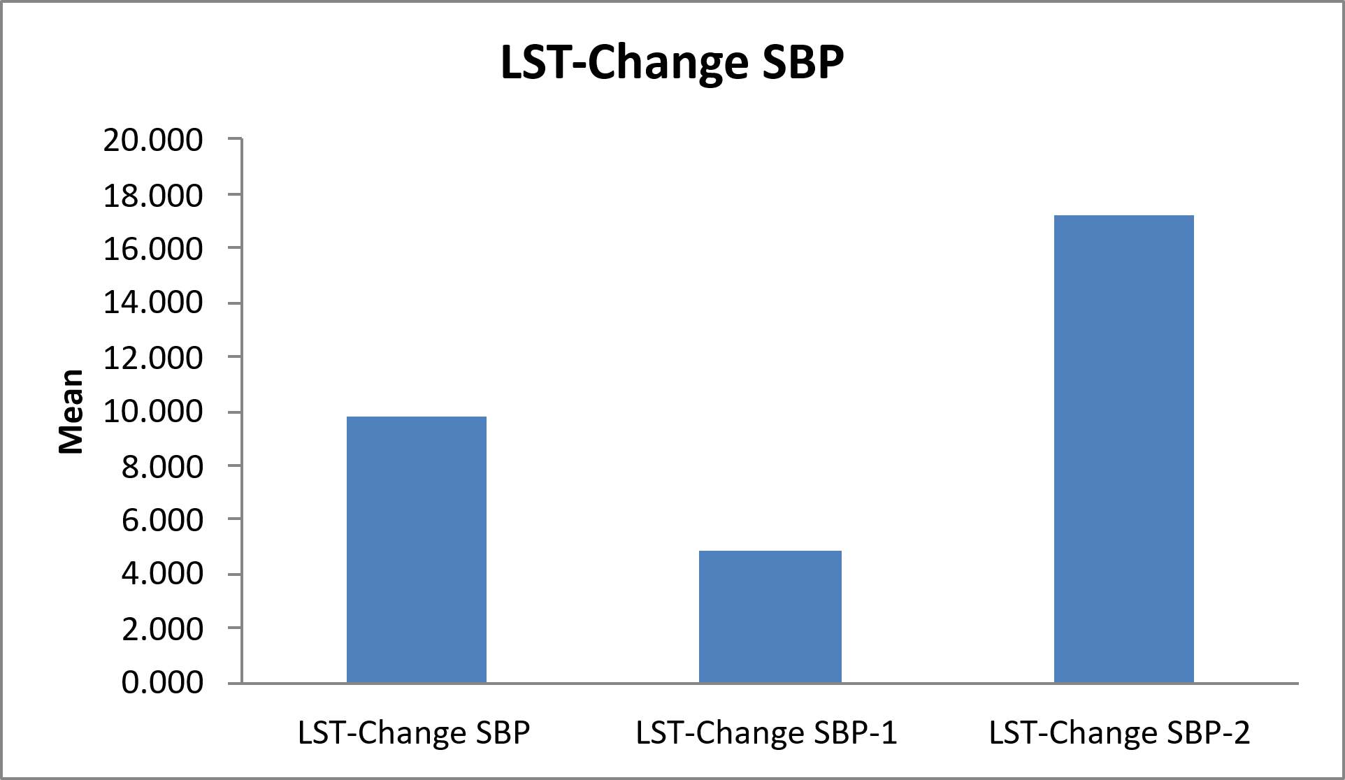

Table 14- Tests of Within-Subjects Effects
Source | Type III Sum of Squares | df | Mean Square | F-value | p-value
LST_ratio | 1.758 | 2 | .879 | 1.599 | .218
Error (LST_ratio) | 17.585 | 32 | .550 |  | .218

Table 14- Descriptive Statistics
 | Mean | Std. Deviation | N
LST-ratio | 1.579 | 0.628 | 17
LST-ratio-1 | 1.765 | 0.872 | 17
LST-ratio-2 | 2.032 | 0.910 | 17

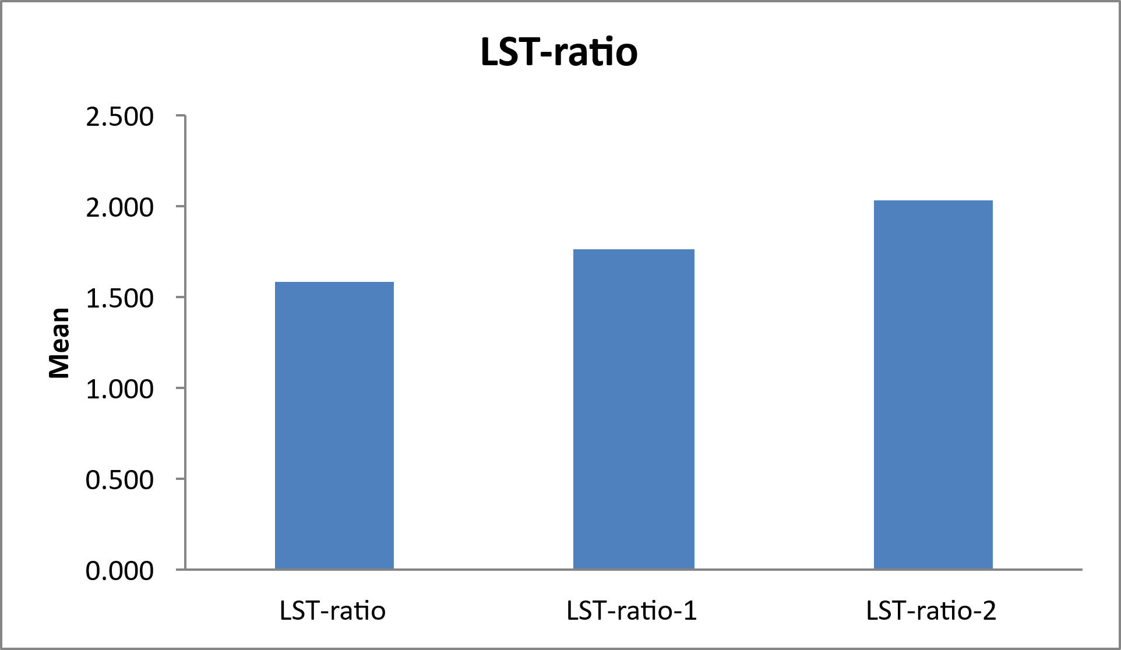

Table 15- Tests of Within-Subjects Effects
Source | Type III Sum of Squares | df | Mean Square | F-value | p-value
CPT | 419.922 | 2 | 209.961 | 2.559 | .093
Error(CPT) | 2625.412 | 32 | 82.044 |  | .093

Table 15- Descriptive Statistics
 | Mean | Std. Deviation | N
CPT | 12.941 | 9.947 | 17
CPT-1 | 7.765 | 11.233 | 17
CPT-2 | 6.235 | 8.273 | 17

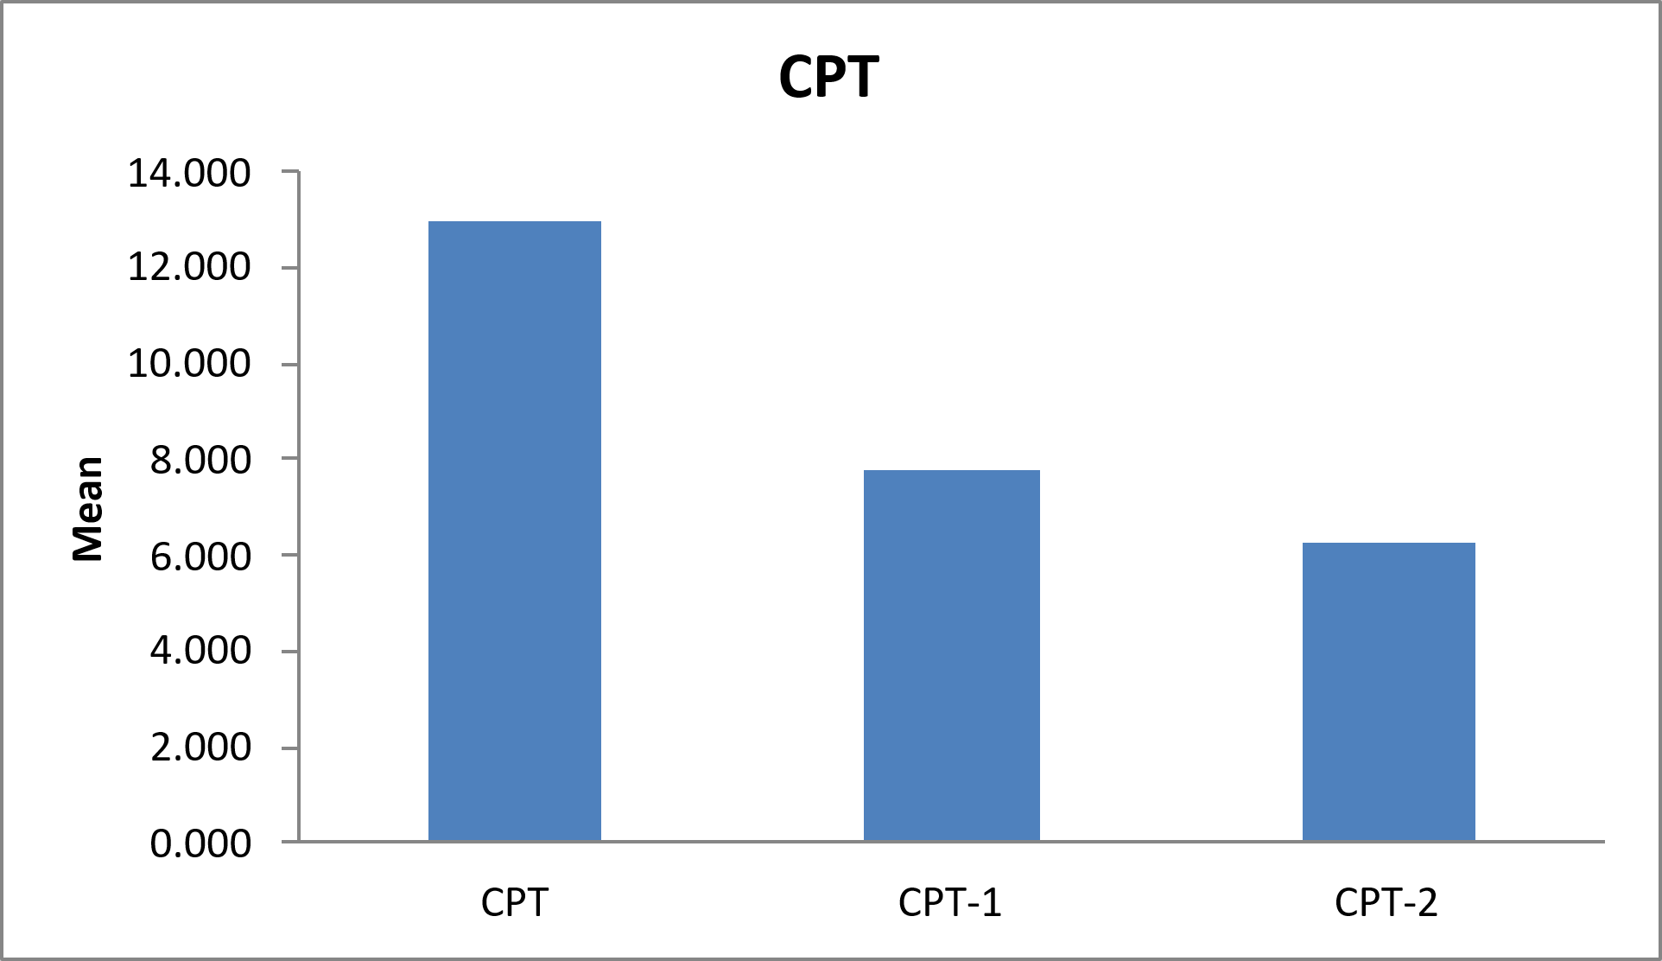

Table 16- Tests of Within-Subjects Effects
Source | Type III Sum of Squares | df | Mean Square | F-value | p-value
IGT | 217.529 | 2 | 108.765 | .426 | .656
Error(IGT) | 8161.137 | 32 | 255.036 |  | .656

Table 16- Descriptive Statistics
 | Mean | Std. Deviation | N
IGT | 20.000 | 8.185 | 17
IGT-1 | 17.471 | 12.630 | 17
IGT-2 | 22.529 | 23.313 | 17

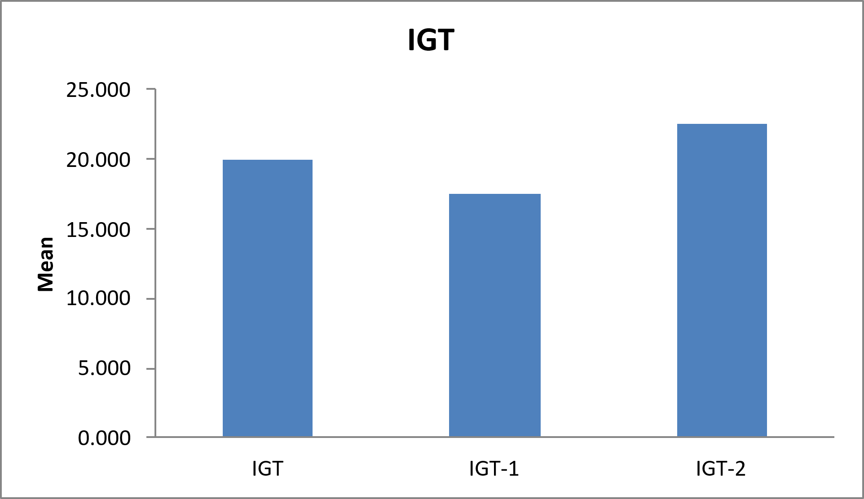

Table 17 | Paired t test | N | Mean | Std. Deviation | t-value | p-value
1 | DBT-Change HR | 29 | 15.707 | 17.250 | .485 | .631
 | DBT-change HR-1 | 29 | 16.720 | 12.537 |  | .631
2 | DBT-Change HR | 17 | 16.413 | 17.686 | 1.249 | .230
 | DBT-change HR-2 | 17 | 25.294 | 21.736 |  | .230

Table 18 |  | N | Mean | Std. Deviation | t-value | p-value
1 | DBT-ratio | 29 | 1.374 | 0.654 | .045 | .965
1 | DBT-ratio-1 | 29 | 1.379 | 0.379 |  | .965
2 | DBT-ratio | 17 | 1.334 | 0.577 | 1.345 | .197
2 | DBT-ratio-2 | 17 | 1.675 | 0.765 |  | .197

Table 19 |  | N | Mean | Std. Deviation | t-value | p-value
1 | Valsalva | 29 | 2.189 | 1.329 | .418 | .679
1 | Valsalva-1 | 29 | 2.073 | 0.962 |  | .679
2 | Valsalva | 17 | 2.412 | 1.612 | .733 | .474
2 | Valsalva-2 | 17 | 2.082 | 0.698 |  | .474

Table 20 |  | N | Mean | Std. Deviation | t-value | p-value
1 | LST-Change SBP | 29 | 7.069 | 23.107 | 1.427 | .165
1 | LST-Change SBP-1 | 29 | 1.207 | 18.382 |  | .165
2 | LST-Change SBP | 17 | 9.824 | 20.265 | .598 | .558
2 | LST-Change SBP-2 | 17 | 17.176 | 41.181 |  | .558

Table 21 |  | N | Mean | Std. Deviation | t-value | p-value
1 | LST-ratio | 29 | 1.750 | 0.965 | .140 | .889
1 | LST-ratio-1 | 29 | 1.779 | 0.748 |  | .889
2 | LST-ratio | 17 | 1.579 | 0.628 | 1.709 | .107
2 | LST-ratio-2 | 17 | 2.032 | 0.910 |  | .107

Table 23 |  | N | Mean | Std. Deviation | t-value | p-value
1 | IGT | 29 | 18.655 | 7.513 | .509 | .614
1 | IGT-1 | 29 | 17.207 | 11.854 |  | .614
2 | IGT | 17 | 20.000 | 8.185 | .460 | .652
2 | IGT-2 | 17 | 22.529 | 23.313 |  | .652

Mastersheet
