Comparative performance analysis of direct-coupled DC and variable-frequency AC photovoltaic water pumping systems under tropical climatic conditions
Felix Ngangoum Welaji,^{1,2} Ariel Teyou Ngoupo,^{1,*}, Bertrand Bodo¹, Yaouba², Venant Sorel Chara-Dackou^{3,*}, Charles Bertrand Gubong Takam², Lyse Vanessa Ngansop², Antoine Fanyep Nana², Elie Bertrand Kegne Signe²
¹University of Yaoundé I, Faculty of Science, Department of Physics, P.O. Box: 812, Yaoundé, Cameroon
²Research Centre for Renewable Energy, Institute of Geological and Mining Research, P.O. Box 4110, Yaoundé, Cameroon
³Carnot Energy Laboratory (CEL), Department of Physics, Faculty of Science, University of Bangui, P.O. Box 1450, Bangui, Central African Republic

*Corresponding author: A. Teyou Ngoupo (arielteyou@yahoo.fr), V. S. Chara-Dackou (chav7@yahoo.com)

Supplementary materials
Table S1: Simulation program modules and their role in the calculation chain.
Module | Role in the simulation
mod_constantes | Physical constants and system parameters (PV module, DC/AC pumps, tank, motor, costs, emission factors)
mod_controle | Anti-bounce hysteresis filter for realistic engine start counting
mod_pv | Electrical model of the PV array (one diode, 5 parameters), cell temperature, efficiency
mod_mppt | Adaptive stepping MPPT Perturb & Observe algorithm for the AC branch
mod_pompe | Centrifugal pump flow laws and efficiencies, DC and AC branches
mod_hydraulique | Total dynamic head (TDH), reservoir update, hydraulic power
mod_dynamique | Electromechanical dynamics of the DC motor, integrated by Runge-Kutta 4
mod_dimensionnement_moteur | Determining the electromechanical parameters of the motor from its nameplate
mod_vieillissement | PV array time degradation, motor/inverter replacement schedule
mod_economie | CAPEX, OPEX and levelized cost of pumped water (LCOW)
mod_empreinte_carbone | Carbon footprint: manufacturing, replacements, emissions avoided
mod_fiabilite | Hydraulic reliability indicators (LWSP, resilience, vulnerability), reservoir optimization
mod_postprocessing | Statistical sorting and selection of representative days

Table S2: Electrical parameters of the photovoltaic field ( Suniva OPT270-60-4-100 module) under STC (1000 W/m², 25 °C).
Setting | Value | Unit | Comment
Isc_ref | 9.15 | A | STC
Voc_ref | 38.50 | V | STC
Vmp_ref | 31.20 | V | STC
Pmax_ref | 270.82 | Wc | STC ( Vmp×Imp )
N_cells | 60 | - | cells in series / module
NOCT | 49.20 | °C | manufacturer's data
alpha_Isc | 0.000960 | /°C | coeff. temp. Isc
beta_Voc | -0.003650 | /°C | coeff. temp. Voc
Rs_mod | 0.200 | Ω | resistance new module series
Rp_mod | 1200.0 | Ω | new shunt resistor module
A_module | 1,576 | m² | Surface
n1 | 1.3 | - | postman of ideality
A_total | 18,912 | m² | = N_series×N_parallel×A_module
P_max_champ | 3250 | W | Reference power for normalization of the MPPT step size (=12×270.82)

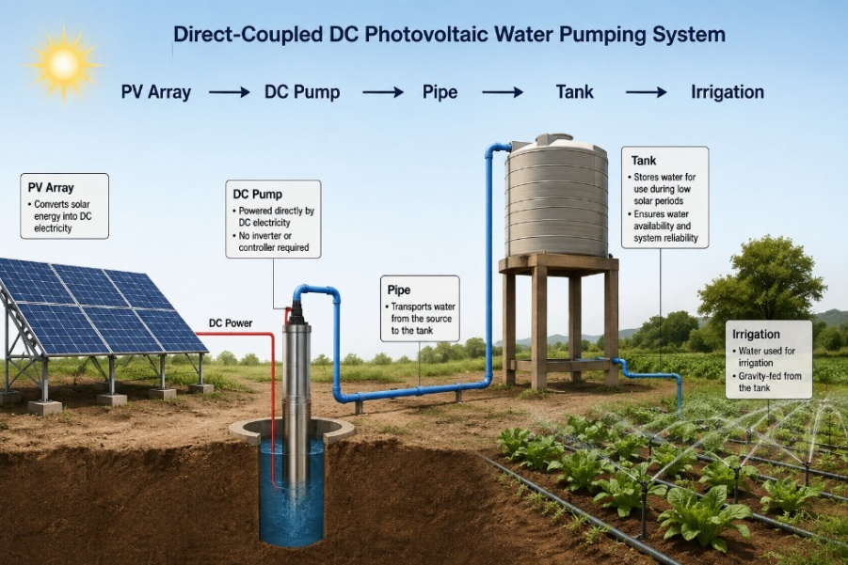
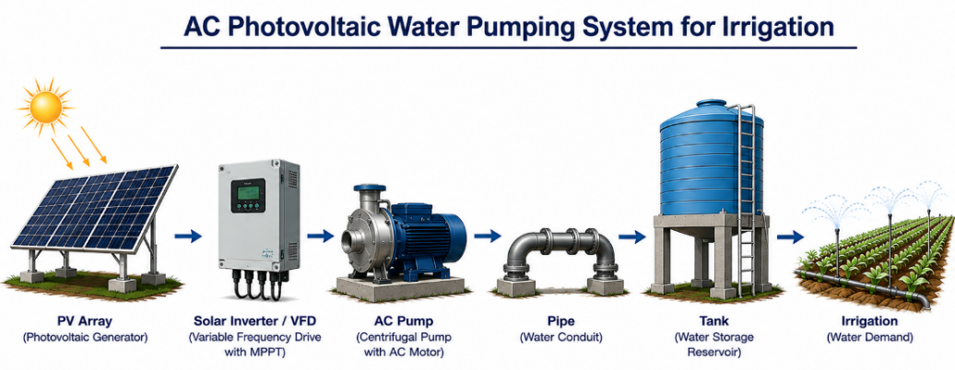
Figure S1: Comparative architectures of direct-coupled DC pumping and variable-frequency AC pumping with inverter/VFD and MPPT.
Table S3: Conversion parameters, yields and coefficients used in the simulation.
Setting | Fortran symbol | Value | Unit | Source / justification
Inverter/VFD efficiency (AC) | eta_onduleur | 0.96 | — | Typical value for a three-phase inverter: 1.5 kW
Inverter power threshold | P_seuil_onduleur | 50 | W | Minimum starting power
Rated power DC motor pump | P_nom_dc | 1,500 | W | Technical data sheet (1.5 kW, HMT = 40 m, Q = 8 m³/h)
Rated power AC motor pump | P_nom_ac | 1,500 | W | Equivalent to DC for controlled comparison
DC starting threshold | P_demarr_dc | 300 | W | 20% of P_nom_dc
AC starting threshold | P_demarr_ac | 350 | W | 23% of P_nom_ac
Rated efficiency of DC motor | eta_nom_motor | 0.85 | / | Sign plate
DC Armature Resistance | R_a | 1.44 | Ω | engine_sizing_mod
DC armature inductance | L_m | 7.2 × 10⁻³ | H | Idem
DC torque constant | K_m | 0.3247 | N·m/A | Idem
Moment of inertia | J_m | 2.58 × 10⁻³ | kg·m² | Idem
Quadratic coefficient of friction | K_p | 4.11 × 10⁻⁵ | N·m·s²/rad² | Idem
Static HMT | HMT_statique | 38.0 | m | /
Nominal pressure losses | HMT_pertes | 2.0 | m | Additional losses
Nominal flow rate of motor pumps | Q_nom | 8.0 | m³/h | Common Nominal Point
Consumption rate | Q_conso | 49 | m³/jour | Methodological Note S1
Tank volume | V_reservoir | 50 | m³ | Battery life ≈ 1 day
Nominal efficiency of PV module | eta_STC | 0.172 | / | Suniva OPT270-60-4-100
Diode ideality factor | n1 | 1.3 | / | Adjusted according to manufacturer's specifications
Number of modules in series | N_serie | 4 | / | MPPT/inverter voltage window
Number of parallel channels | N_paral | 3 | / | Target peak power (3.25 kWp)

Methodological Note A: Justification of the consumption rate $Q_{conso}$
The consumption rate is set at a single value of 49 m³/day for the four sites (Meskine, Agola, Mbé, Soa), in accordance with the single-factor experimental design adopted in our study. The calculation of this value follows the FAO crop balance method [1, 2] :
- Reference evapotranspiration: ${ET}_{0} = 6.0 mm/day$ (maximum value corresponding to the Sahelian climate of Meskine),
- Cultural coefficient: $K_{c} = 1.0$ (mid-season market gardening),
- Irrigation efficiency: $E_{g} = 0.85$ (drip irrigation),
- Net requirement: $BN = {ET}_{0}×K_{c} = 6.0 mm/day$,
- Gross requirement: $BB ={BN}/{E_{g}}= 7.06 mm/day = 70.6 m^{3}/ha/day$,
- Reference surface: $0,70 ha$,
- Daily demand: $Q_{conso}= 70.6 ×0.70 = 49 m^{3}/day$

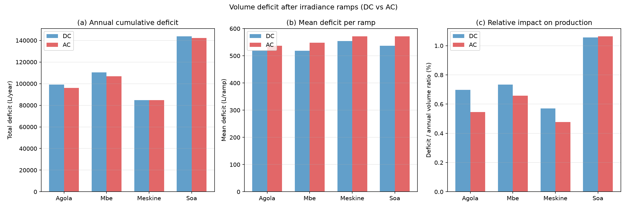
Figure S2: Volume deficit after irradiance ramps. (a) Annual cumulative deficit per site. (b) Mean deficit per ramp. (c) Ratio of deficit to annual pumped volume.
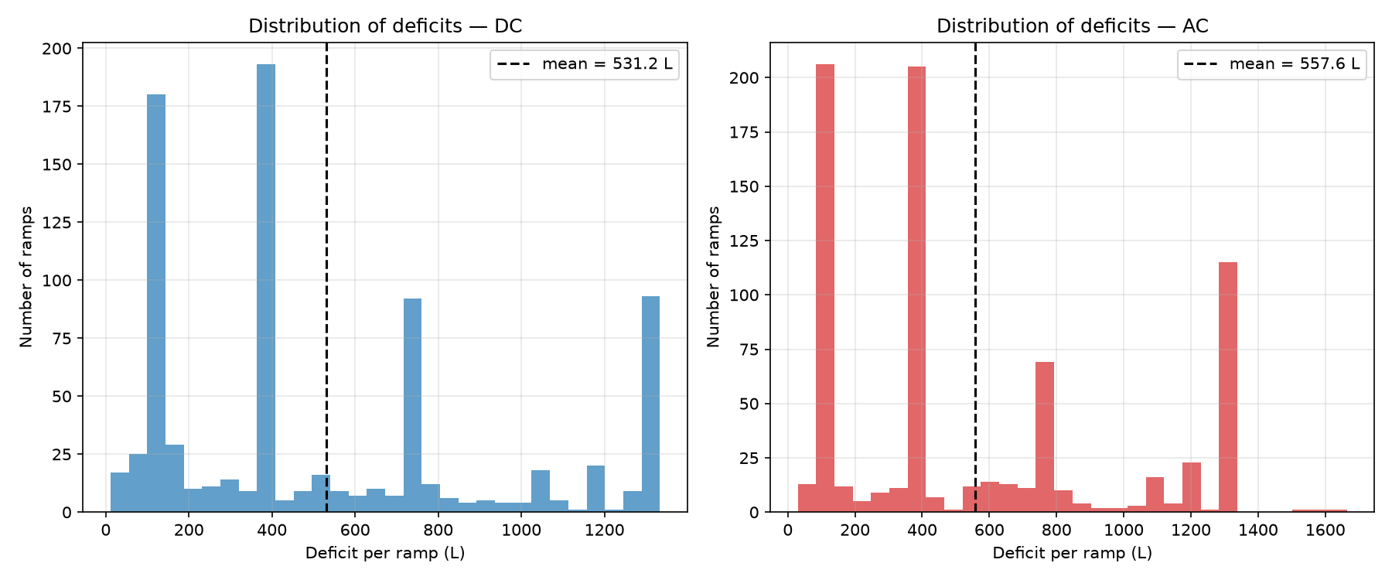
Figure S3: Distribution of volume deficit per ramp for DC and AC architectures, across all sites. The dashed line indicates the mean. The multimodal distribution reflects the variability of detected ramps (duration, amplitude, pump state prior to the ramp).

References

[1] | J. Doorenbos and W. O. Pruitt, "Les besoins en eau des cultures.," in FAO Irrigation and Drainage Paper No. 24., Rome, 1977.
[2] | R. G. Allen, L. S. Pereira, D. Raes and M. Smith, "Crop evapotranspiration — Guidelines for computing crop water requirements," in FAO Irrigation and Drainage Paper No. 56, Rome, 1998.

