Supplementary Information

Impact of metformin treatment during pregnancy on maternal outcomes: a systematic review/meta-analysis.

Authors: Jane L. TARRY-ADKINS, BSc, Susan E. OZANNE, PhD, Catherine E. AIKEN, MB/BChir, PhD
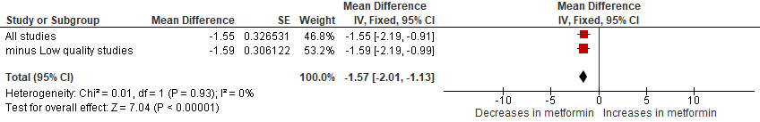
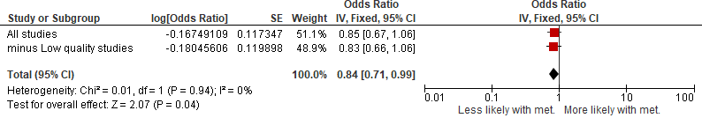
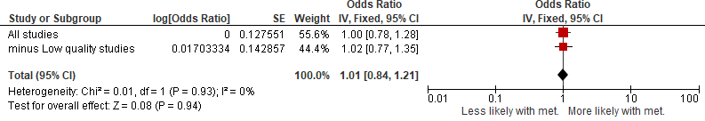
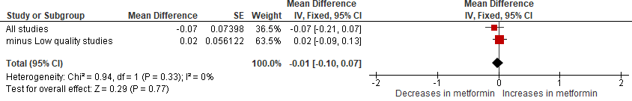
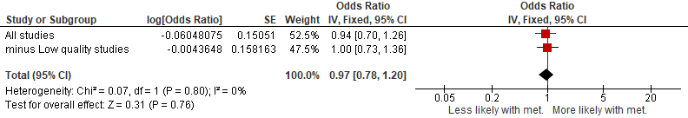
Supplementary Fig. S1: Sensitivity Analysis: Leave low-quality studies out
c) Preeclampsia: Metformin vs. all interventions
a) Gestational weight gain (throughout pregnancy): Metformin vs. all interventions
b) Pregnancy induced hypertension: Metformin vs. all interventions
d) Gestational age at delivery: Metformin vs. all interventions
e) Preterm: Metformin vs. all interventions
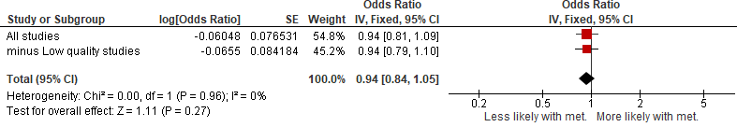
Supplementary Fig. S1: Sensitivity Analysis: Leave low-quality studies out (continued)
g) Development of GDM: Metformin vs. all interventions
No studies reporting this outcome were low quality
f) C-section rates: Metformin vs. all interventions
Sensitivity analysis of outcome measures when low-quality studies were removed.
C-section=ceserean-section; GDM=gestational diabetes mellitus; met=metformin.
Odds Ratio or mean difference (where appropriate) ± 95% CI. Fixed or random-effect models where appropriate.
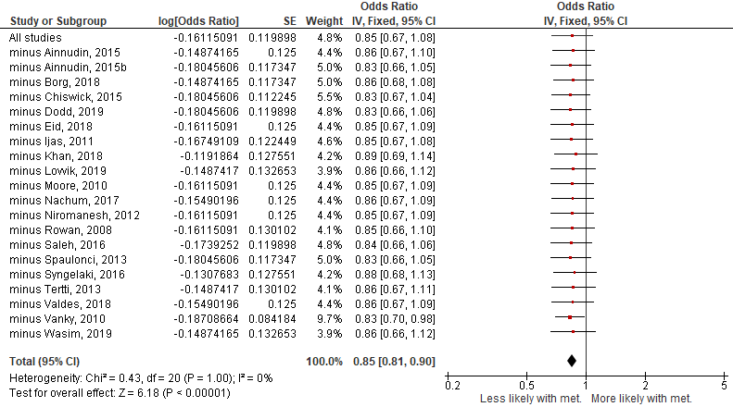
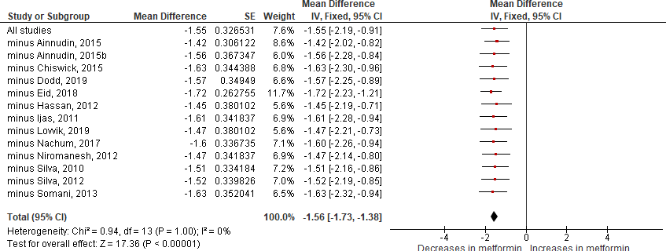
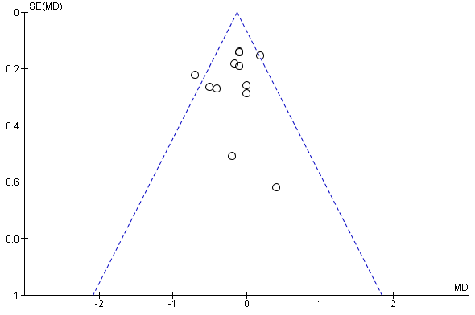
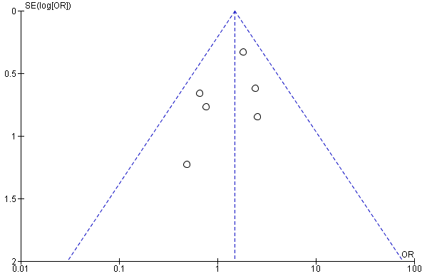
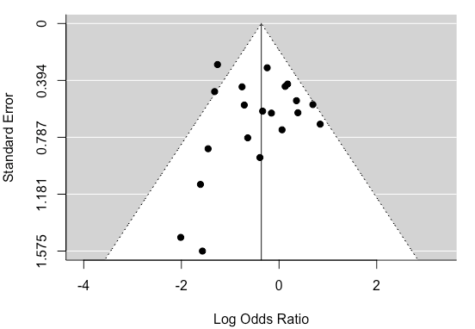
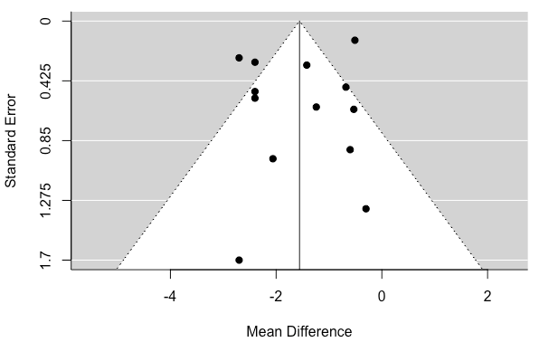
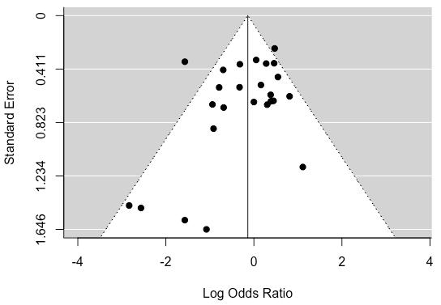
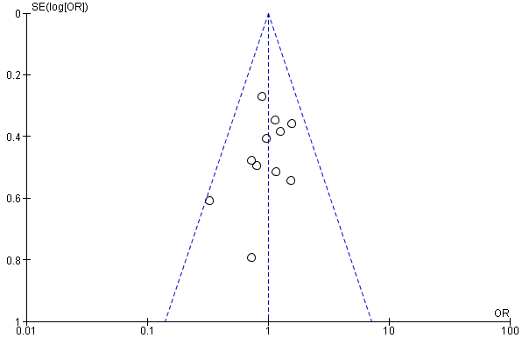
Supplementary Fig S2: Sensitivity analysis: Leave-one-out
b) Pre-eclampsia: Metformin vs. all interventions
a) Gestational weight gain: Metformin vs. all interventions
a) Gestational weight gain (throughout pregnancy)
b) Pregnancy-induced hypertension
c) Pre-eclampsia
d) Gestational age at delivery
e) Preterm (all causes)
f) Preterm (spontaneous)
Supplementary Fig S3: Funnel Plots
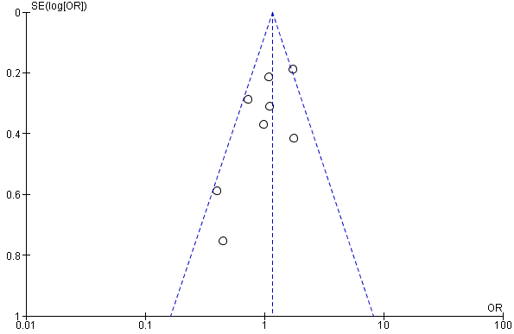
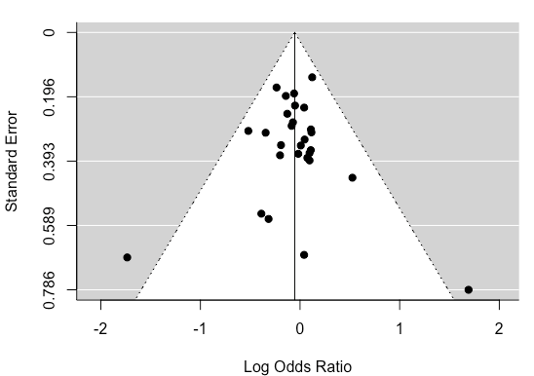
g) Ceserean section rate
h) Incidence of GDM
Supplementary Fig. S3: Funnel Plots (continued)
Funnel Plot analysis
C-section=ceserean-section; GDM=gestational diabetes mellitus; met=metformin.
Odds Ratio or mean difference (where appropriate) ± 95% CI. Fixed or random-effect models where appropriate.
Primary maternal outcomes of metformin treatment during pregnancy
Patient or population: Women prescribed metformin for any indication during pregnancy
Setting:
Intervention: Metformin
Comparison: Any comparator
Outcomes | № of participants  (studies)  Follow up | Certainty of the evidence  (GRADE) | Relative effect  (95% CI) | Anticipated absolute effects
 |  |  |  | Risk with any comparator | Risk difference with Metformin
Pregnancy-induced hypertension (all studies) | 4189  (14 RCTs) | ⨁⨁⨁⨁  HIGH | OR 0.97  (0.77 to 1.22) | 78 per 1,000 | 2 fewer per 1,000  (17 fewer to 16 more)
Gestational age at delivery | 3081  (17 RCTs) | ⨁⨁⨁◯  MODERATE ª | - | The mean gestational age at delivery was 38.2 weeks | MD 0.07 weeks lower  (0.21 lower to 0.06 higher)
GWG (through pregnancy) | 2522  (13 RCTs) | ⨁⨁⨁◯  MODERATE ^{b} | - | The mean GWG (through pregnancy) was 10.5 kg | MD 1.55 kg lower  (2.19 lower to 0.91 lower)
Preterm: All causes (all studies) | 6959  (27 RCTs) | ⨁⨁⨁◯  MODERATE ^{c} | OR 0.91  (0.67 to 1.22) | 96 per 1,000 | 8 fewer per 1,000  (29 fewer to 19 more)
*The risk in the intervention group (and its 95% confidence interval) is based on the assumed risk in the comparison group and the relative effect of the intervention (and its 95% CI).
CI: Confidence interval; OR: Odds ratio; MD: Mean difference
Supplementary Fig S4: GRADE analysis – primary outcomes
Supplementary Fig S4: GRADE analysis – primary outcomes (continued)

GRADE Working Group grades of evidence
High certainty: We are very confident that the true effect lies close to that of the estimate of the effect
Moderate certainty: We are moderately confident in the effect estimate: The true effect is likely to be close to the estimate of the effect, but there is a possibility that it is substantially different
Low certainty: Our confidence in the effect estimate is limited: The true effect may be substantially different from the estimate of the effect
Very low certainty: We have very little confidence in the effect estimate: The true effect is likely to be substantially different from the estimate of effect

Explanations
a. The data set indicates a modest heterogeneity throughout studies as evidenced by the I2 value of 47%, with accompanying modest p value of 0.02.
b. The data set indicates a very high heterogeneity throughout studies as evidenced by the I2 value of 87%, with accompanying p value of <0.00001.
c. The data set indicates a fairly high heterogeneity throughout studies as evidenced by the I2 value of 58%, with accompanying p value of <0.0001.
GRADE analysis for all primary outcomes
GWG=gestational weight gain; RCTs=randomised controlled trials.
Odds Ratio or mean difference (where appropriate) ± 95% CI. Fixed or random-effect models where appropriate.

Supplementary Fig S5: GRADE analysis – secondary outcomes
Metformin compared to any comparator for women prescribed metformin for any indication during pregnancy: Secondary outcomes
Patient or population: women prescribed metformin for any indication during pregnancy
Setting:
Intervention: Metformin
Comparison: Any comparator
Outcomes | № of participants  (studies)  Follow up | Certainty of the evidence  (GRADE) | Relative effect  (95% CI) | Anticipated absolute effects
 |  |  |  | Risk with any comparator | Risk difference with Metformin
C-section (all reasons) | 6122  (29 RCTs) | ⨁⨁⨁◯  MODERATE ª | OR 0.86  (0.73 to 1.01) | 425 per 1,000 | 36 fewer per 1,000  (75 fewer to 2 more)
Development of GDM | 2063  (7 RCTs) | ⨁⨁⨁◯  MODERATE ^{b} | OR 1.07  (0.87 to 1.33) | 208 per 1,000 | 11 more per 1,000  (22 fewer to 51 more)
Glycaemic control: FBS | 3673  (19 RCTs) | ⨁⨁⨁◯  MODERATE ^{c} | - | The mean glycaemic control: FBS was 90.23 mg/dL | MD 0.45 mg/dL lower  (2.26 lower to 1.36 higher)
Glycaemic control: RBS | 3610  (18 RCTs) | ⨁⨁⨁◯  MODERATE ^{d} | - | The mean glycaemic control: RBS ranged from 115.47 mg/dL | MD 1.18 mg/dL lower  (2.64 lower to 0.28 higher)
Maternal hypoglycaemia | 1149  (6 RCTs) | ⨁⨁⨁◯  MODERATE ^{e} | OR 0.47  (0.28 to 0.80) | 78 per 1,000 | 40 fewer per 1,000  (55 fewer to 15 fewer)

*The risk in the intervention group (and its 95% confidence interval) is based on the assumed risk in the comparison group and the relative effect of the intervention (and its 95% CI).
CI: Confidence interval; OR: Odds ratio; MD: Mean difference
GRADE Working Group grades of evidence
High certainty: We are very confident that the true effect lies close to that of the estimate of the effect
Moderate certainty: We are moderately confident in the effect estimate: The true effect is likely to be close to the estimate of the effect, but there is a possibility that it is substantially different
Low certainty: Our confidence in the effect estimate is limited: The true effect may be substantially different from the estimate of the effect
Very low certainty: We have very little confidence in the effect estimate: The true effect is likely to be substantially different from the estimate of effect

Explanations
a. The data set has a fairly high level of heterogeneity across the studies as evidenced by the I2 value (46%) and the accompanying significant p value (0.004).
b. Only n=7 studies were found for this outcome, most of which had large 95% CI intervals (related to small participant sizes).
c. The data set has a very high level of heterogeneity across the studies as evidenced by the I2 value (92%) and the accompanying p value (<0.00001).
d. The data set has a very high level of heterogeneity across the studies as evidenced by the I2 value (83%) and the accompanying significant p value (<0.00001)
e. Only n=6 studies were found for this outcome, most of which had large 95% CI intervals (related to relatively small participant sizes).

C-section=ceserean-section; FBS=fasting blood glucose; RBS=random blood glucose; GDM=gestational diabetes mellitus; met=metformin; RCTs=randomised controlled trials.
Odds Ratio or mean difference (where appropriate) ± 95% CI. Fixed or random-effect models where appropriate.

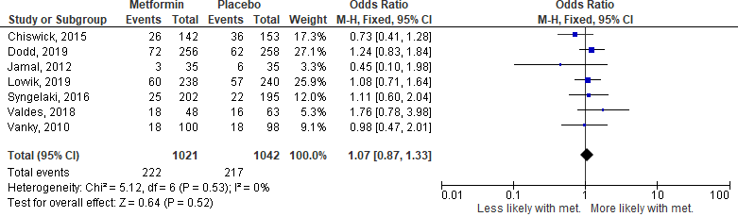
Supplementary Fig S6: New GDM development
New GDM development
GDM=gestational diabetes mellitus; met=metformin.
Odds Ratio ± 95% CI. Fixed or random-effect model.

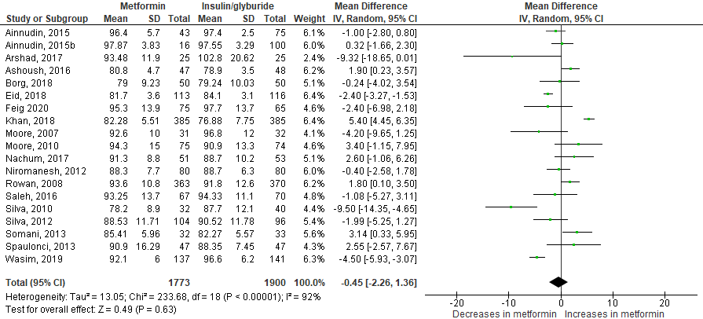
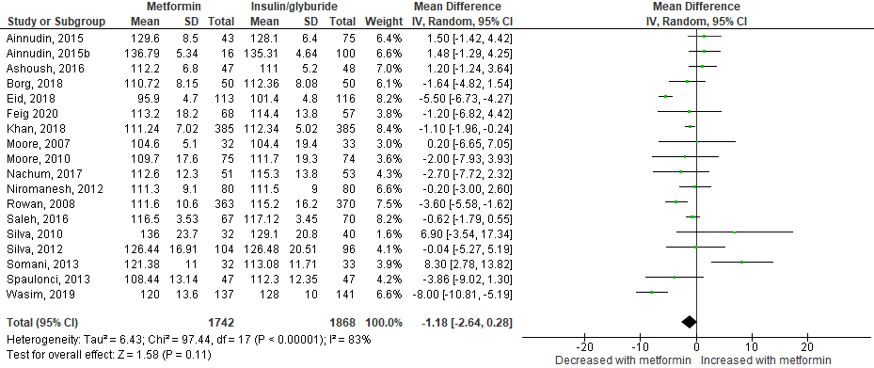
Supplementary Fig S7: Glycaemic control
a) FBS
b) RBS

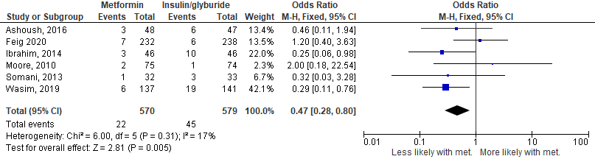
c) Maternal hypoglycemia
Maternal glycaemic control (including FBS, RBS and maternal hypoglycaemia)
Mean differences and Odds Ratios (where appropriate) ± 95% CI.
FBS=fasting plasma glucose; RBS=random blood glucose; met=metformin

Supplementary Table S1: Inclusion/Exclusion table
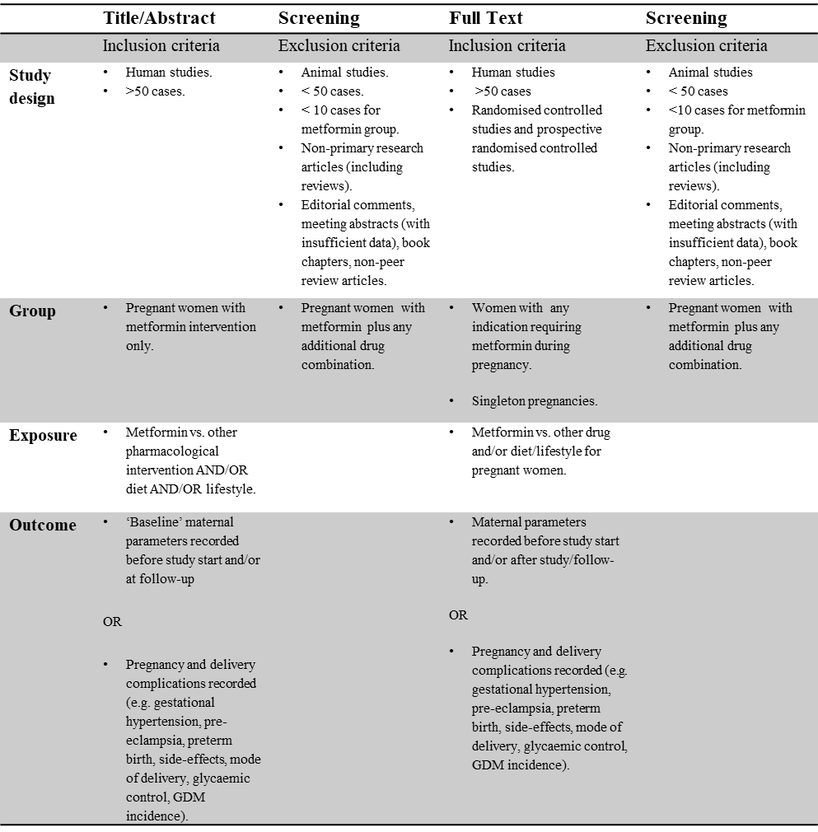
Inclusion/exclusion criteria
GDM=gestational diabetes mellitus

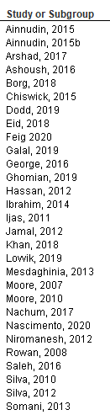
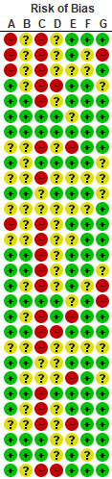

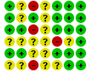
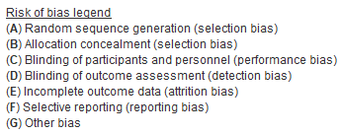
Supplementary Table S2: Risk of Bias
Risk of Bias analysis
Green circles=low risk of bias; yellow circles=unknown risk of bias; red circles=high risk of bias

Supplementary Table S3: Study characteristics table
Separate excel spread-sheet
Supplementary Table S4: GDM/PCOS/maternal obesity diagnosis criteria
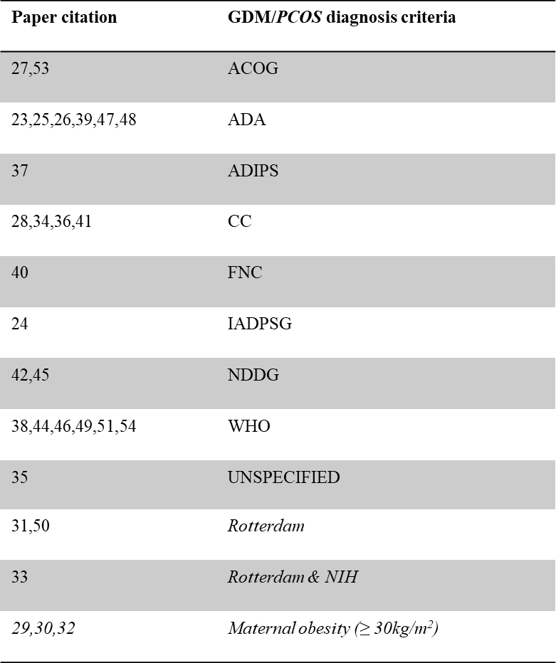
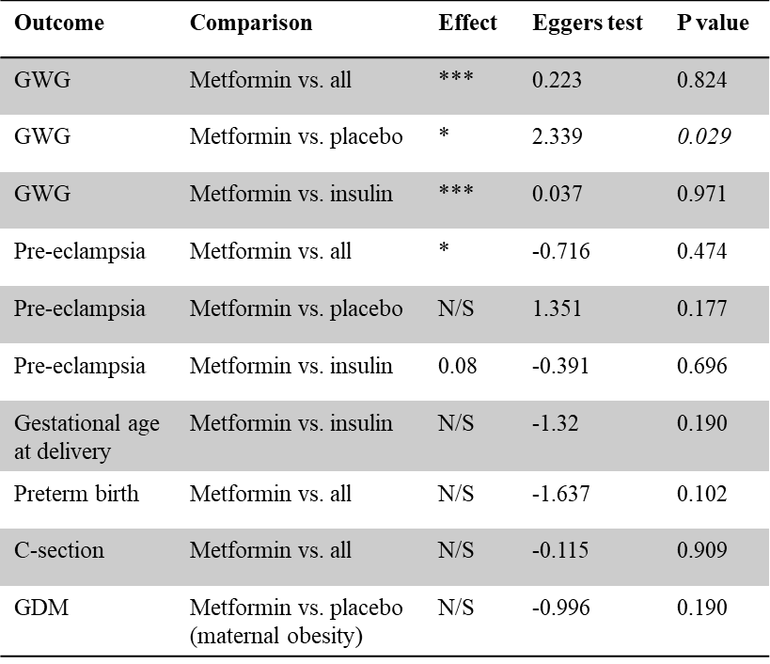
Heterogeneity diagnosis for GDM/PCOS/maternal obesity diagnosis
ADA=American Diabetes Association; ADIPS=Australasian Diabetes in Pregnancy Society; CC=Carpenter-Coustan; FNC=Finnish National Criteria; GDM=gestational diabetes mellitus; IADPSG= International Association of Diabetes and Pregnancy Study Groups; NDDG= National Diabetes Diagnosis Group; NIH=National Institute of Health; PCOS=polycystic ovary syndrome; WHO=World Health Organisation
Eggers Testing for publication bias
C-section=Cesarean-section; GDM=Gestational Diabetes Mellitus; GWG=gestational weight gain
Supplementary Table S5: Eggers Test

Supplementary Table S6: Effect of metformin treatment upon side effects (vs. placebo: PCOS and maternal obesity)

Outcome |  | Unadjusted OR  (95% CI) | P value | Studies | N | Het. I₂ | Het. P value
Nausea | Placebo | 1.44 (1.13-1.84) | .003 | 4 | 1441 | 0% | .51
Vomiting | Placebo | 1.42 (1.10-1.84) | .008 | 4 | 1441 | 7% | .36
Diarrhoea | Placebo | 2.73 (1.59-4.68) | .0003 | 4 | 1441 | 68% | .02
Abdominal pain | Placebo | 1.00 (0.75-1.33) | .98 | 4 | 1242 | 0% | .45
Bloating | Placebo | 1.32 (0.73-2.38) | .36 | 1 | 240 | N/A | N/A
Constipation | Placebo | 1.11 (0.76-1.63) | .59 | 2 | 797 | 15% | .28
Headache | Placebo | 1.17 (0.82-1.69) | .39 | 2 | 797 | 69% | .07

Likelihood of side effects in PCOS and maternal obesity pregnancies treated with metformin
OR= Odds Ratio ± 95% CI. Het=Heterogeneity

Supplementary Table S7: Gastrointestinal side effects in women with diabetes in pregnancy randomised to metformin.
First Author |  | Raw averages (%) | N
Ainnudin, 2015 | GI side effects | 7 (8) | 93
Ainnudin, 2015 | Stopped medication | 6 (6) | 93
Ashoush, 2016 | GI side effects | 14 (30) | 47
Ashoush, 2016 | Stopped medication | 0 (0) | 47
Ijas, 2011 | GI side effects | 3 (6) | 50
Ijas, 2011 | Stopped medication | 3 (6) | 50
Niromanesh, 2012 | GI side effects | 6 (8) | 80
Niromanesh, 2012 | Stopped medication | 3 (4) | 80
Rowan, 2008 | GI side effects | 32 (9) | 363
Rowan, 2008 | Stopped medication | 7 (2) | 363
Spaulonci, 2013 | GI side effects | 21 (46) | 46
Spaulonci, 2013 | Stopped medication | 1 (2) | 46
Tertti, 2013 | GI side effects | 2 (2) | 110
Tertti, 2013 | Stopped medication | 2 (2) | 110
Wasim, 2020 | GI side effects | 4 (3) | 137
Wasim, 2020 | Stopped medication | 4 (3) | 137
Weighted average | GI side effects | 12.5 | 929
Incidence (%) | Stopped medication | 14.3 | 929

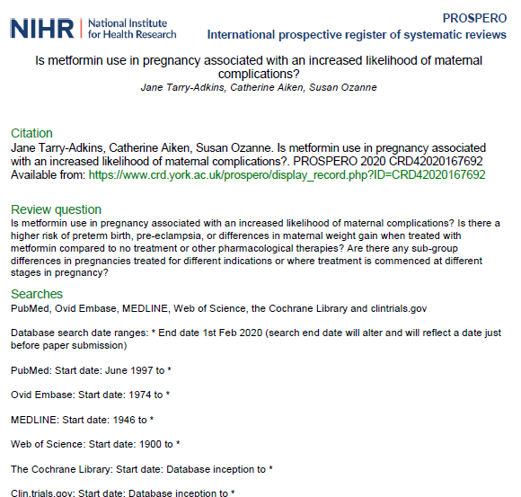
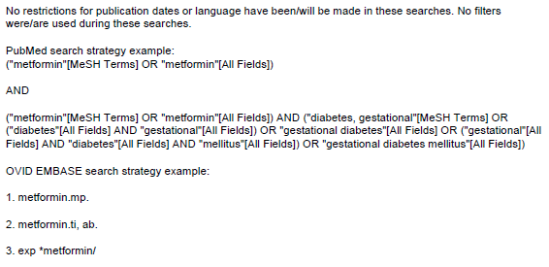
Supplementary S1 Text
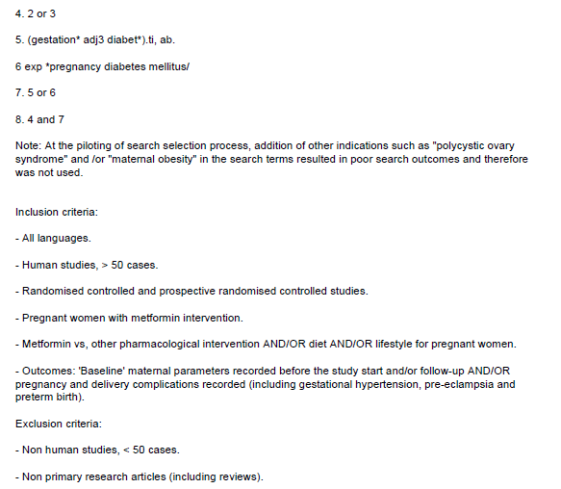
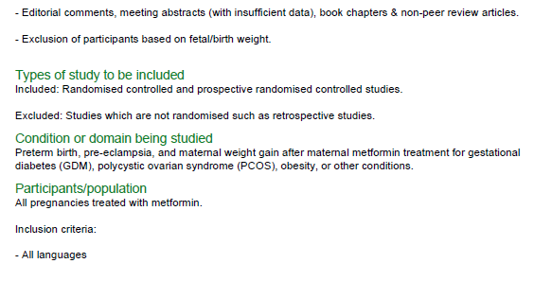
Supplementary S1 Text (continued)
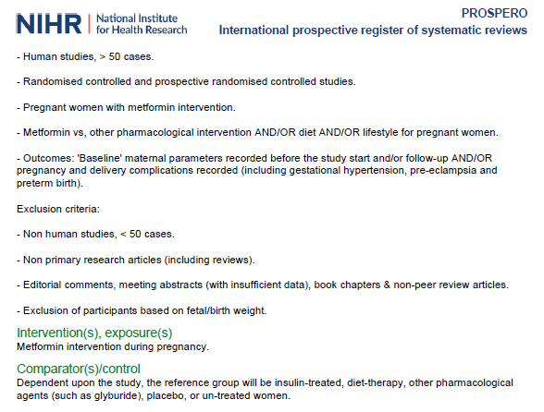
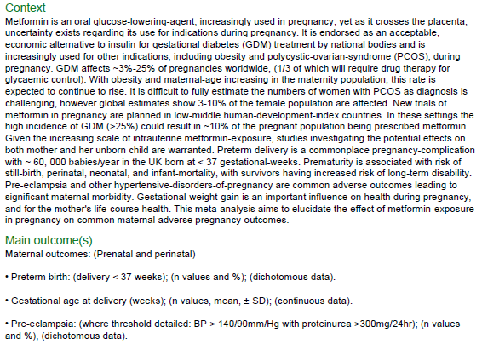
Supplementary S1 Text (continued)
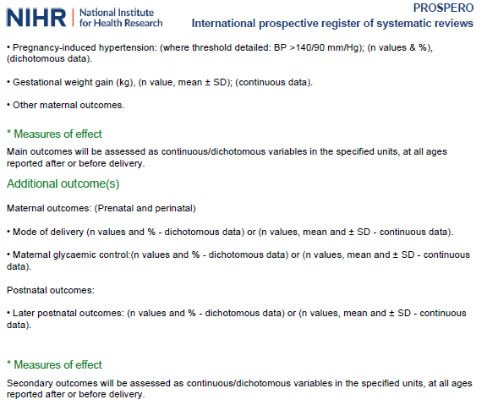
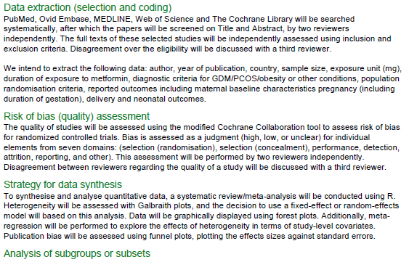


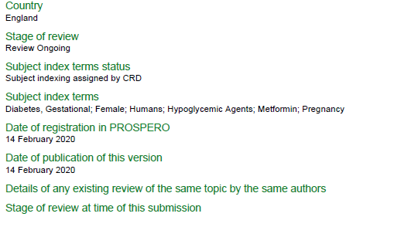
Supplementary S1 Text (continued)
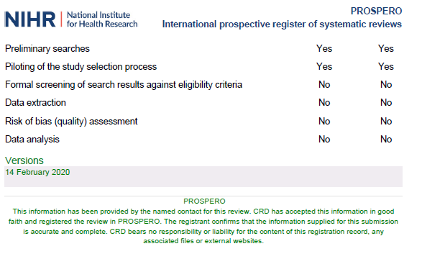
Supplementary S1 Text (continued)
PubMed:
Initial search date: 19.11.19. (Search date range: June 1997 to 19.11.19).
Basic search terms: Metformin AND Gestational diabetes mellitus
("metformin"[MeSH Terms] OR "metformin"[All Fields]) AND ("diabetes, gestational"[MeSH Terms] OR ("diabetes"[All Fields] AND "gestational"[All Fields]) OR "gestational diabetes"[All Fields] OR ("gestational"[All Fields] AND "diabetes"[All Fields] AND "mellitus"[All Fields]) OR "gestational diabetes mellitus"[All Fields])
Web of Science:
Initial search date: 19.11.19. (Search date range: 1900 to 19.11.19).
Basic search terms: Metformin AND Gestational diabetes mellitus
OVID EMBASE
Search date range: 1974 to 19.11.19.
metformin.mp.
metformin.ti,ab.
exp*metformin/
2 or 3
(gestation*adj3 diabet*).ti,ab.
exp*pregnancy diabetes mellitus/
5 or 6
4 and 7
OVID MEDLINE
Search date range: 1946 to 19.11.19.
metformin.mp.
metformin.ti,ab.
exp*metformin/
2 or 3
(gestation*adj3 diabet*).ti,ab.
4 and 5
The Cochrane Database
Search date range: Database inception to 19.11.19.
Basic search terms: Metformin AND Gestational diabetes mellitus
www.clinical trials.gov
Search date range: Database inception to 19.11.19.
Basic search terms: Metformin AND gestational diabetes
Supplementary S2 Text: Database search terms

