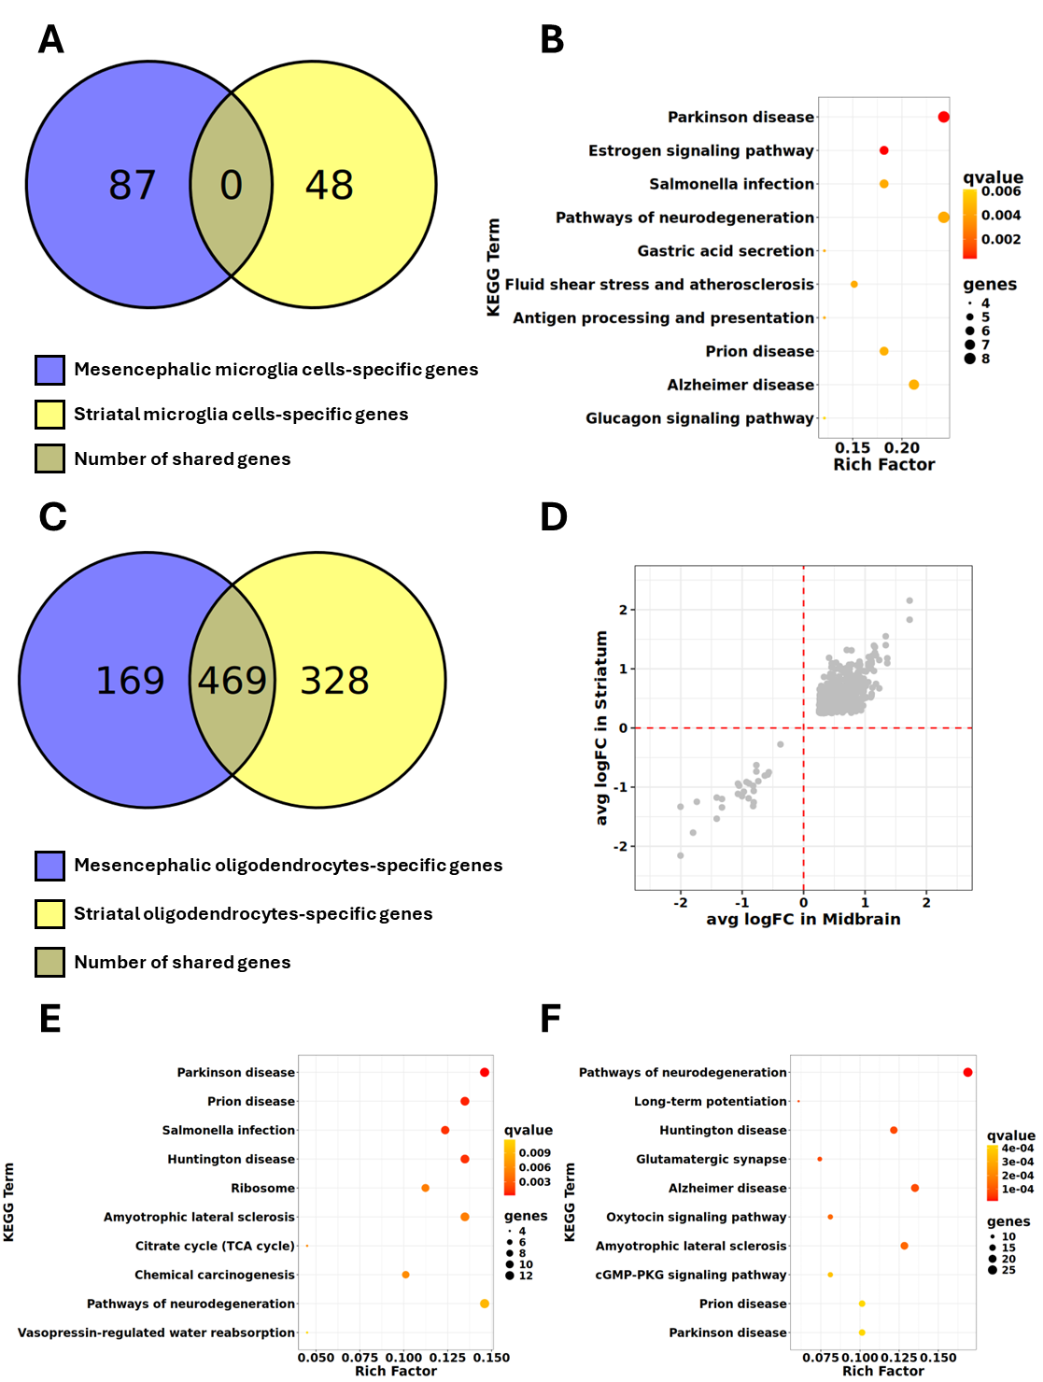

Figure S1. Computational analysis of microglia cells in A53T-α-Syn-Transgenic mice. (A)Venn diagram showing the number of selective and overlapping genes between striatal (Yellow) and mesencephalic (Blue) microglia cells (MG). Mesencephalic MG selectively expressed 87 genes, while striatal MG selectively expressed 48 genes. Notably, no genes are commonly expressed between these two cell populations, indicating that their gene expression profiles are differently dysregulated in the A53T-α-Syn-Transgenic model between the mesencephalon and striatum. (B) The bubble plot showing the KEGG pathway enrichment analysis of 48 genes selectively expressed in striatal MG. The X-axis displays the rich factor derived from enriched KEGG analysis, while the Y-axis indicates the pathway terms. Pathways are ranked according to their (FDR)-adjusted p-values. Bubble size reflects the gene ratio, representing the proportion of genes contributing to the enrichment relative to the total number of genes annotated to the corresponding pathway. Bubble colour denotes the enrichment significance, with colour intensity proportional to the adjusted p-value. (C) The Venn diagram illustrating the number of selectively expressed and overlapping genes between striatal oligodendrocytes (OLG) (Yellow) and mesencephalic OLG (Blue). Striatal OLG uniquely expressed 328 genes, while mesencephalic OLG expressed 169 exclusive genes. Additionally, 469 genes were commonly expressed by both cell populations. (D) The dot plot showing the correlation of Fold Change values for the 469 commonly expressed genes between mesencephalic and striatal OLG. The X-axis represents the fold change values for striatal OLG in A53T-α-Syn-Transgenic mice compared to WT, while the Y-axis represents those for mesencephalic OLG. (E-F) The bubble plot showing the KEGG pathway enrichment analysis for the 169 and 328 selectively expressed genes in mesencephalic and striatal OLG, respectively. The X-axis shows the enrichment factor obtained from the KEGG enrichment analysis, while the Y-axis lists the enriched pathway terms. Pathways are ordered according to their (FDR)-adjusted p-values. Bubble size represents the gene ratio, defined as the proportion of genes contributing to the enrichment relative to the total number of genes annotated to the corresponding pathway. Bubble colour indicates enrichment significance, with colour intensity corresponding to the adjusted p-value. Data reanalyzed from Jixing Zhong et al., 2021.

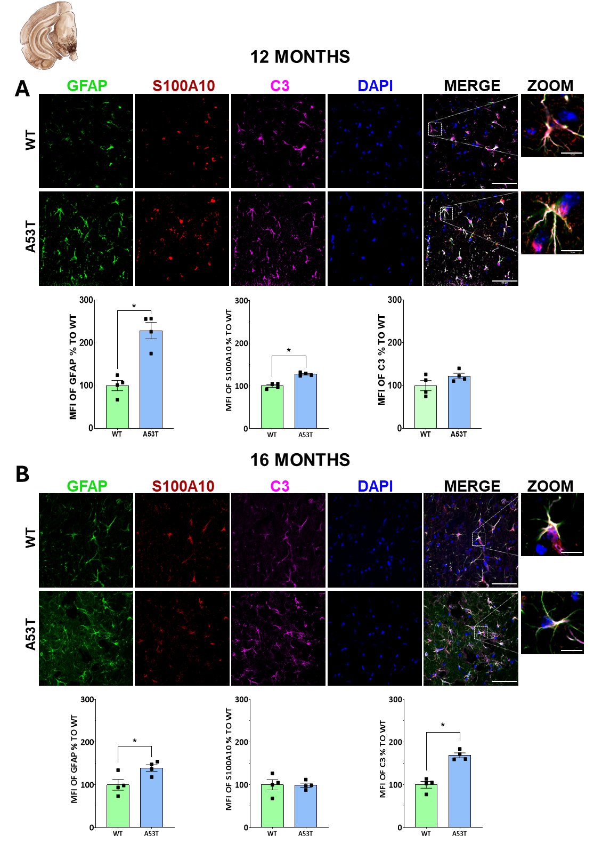
Figure S2. A53T-α-syn-Transgenic mice exhibited an age-dependent increase in reactive astrocyte markers within the substantia nigra pars compacta SNpc. Representative triple immunolabeling images for GFAP, C3, and S100A10 in the midbrain of WT and A53T α-syn mice at 12- and 16-months (A-B), scale bar: 50 µm; zoom scale bar: 10 µm. Unpaired Student’s t-test, *p<0.05.

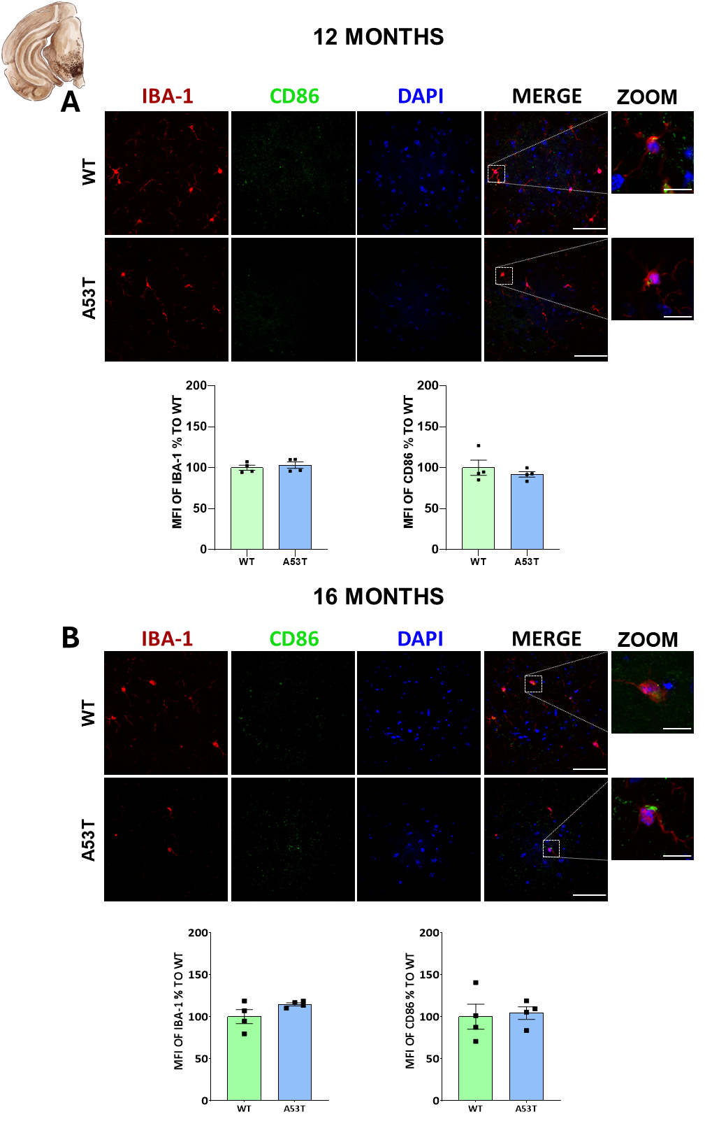
Figure S3. Unaltered microglial cell reactivity in the midbrain of A53T-α-Syn-Transgenic mice. Representative double immunolabelling images for IBA-1 and CD86 in the SNpc of WT and A53T-α-syn mice at 12 (A) and 16 months (B), scale bar: 50 µm; zoom scale bar: 10 µm. Unpaired Student’s t-test, *p<0.05.

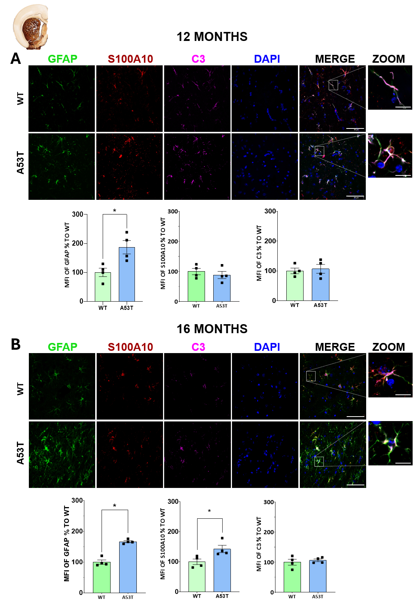
Figure S4. Preserved astrocytic reactivity in the Striatum of A53T-α-Syn-Transgenic Mice. Representative triple immunolabeling images for GFAP, C3, and S100A10 in the striatum of WT and A53T-α-Syn-Transgenic Mice at 12 (A) and 16 months (B), scale bar: 50 µm; zoom scale bar: 10 µm. Unpaired Student’s t-test, *p<0.05.

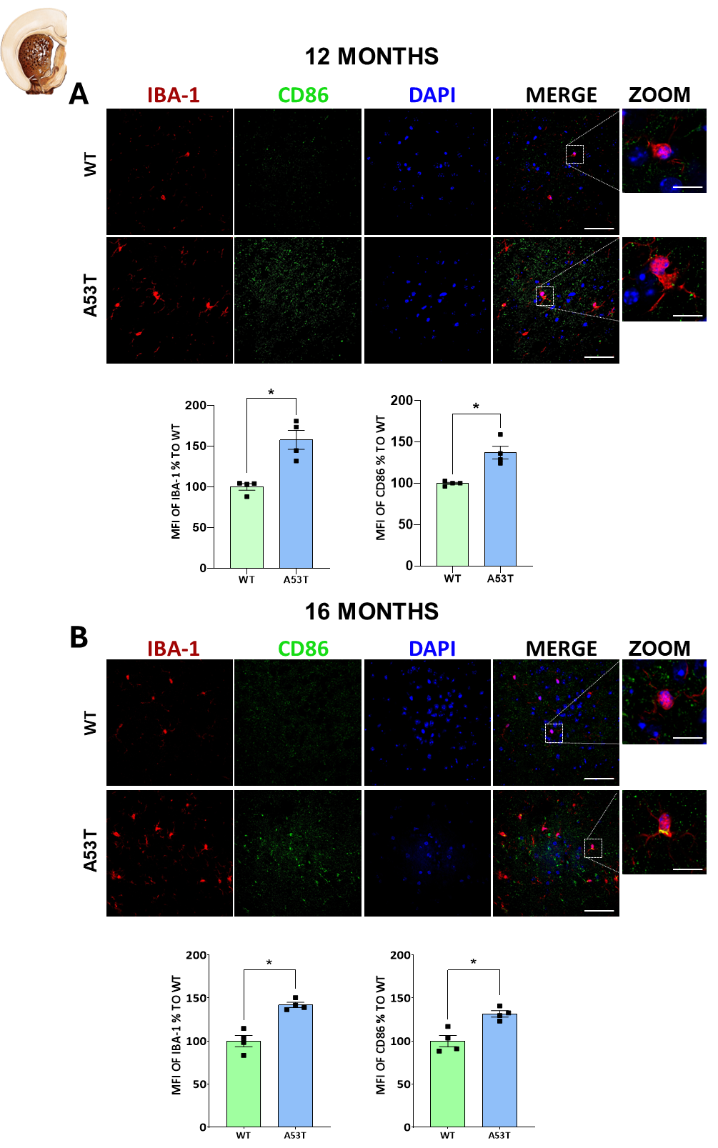

Figure S5. CD86-positive pro-inflammatory microglial activation in the striatum of A53T-α-Syn-Transgenic mice. Immunofluorescence analysis for IBA-1 and CD86 in the striatum of WT and A53T α-syn mice at 12 (A) and 16 months (B), scale bar: 50 µm; zoom scale bar: 10 µm. Unpaired Student’s t-test, *p<0.05.

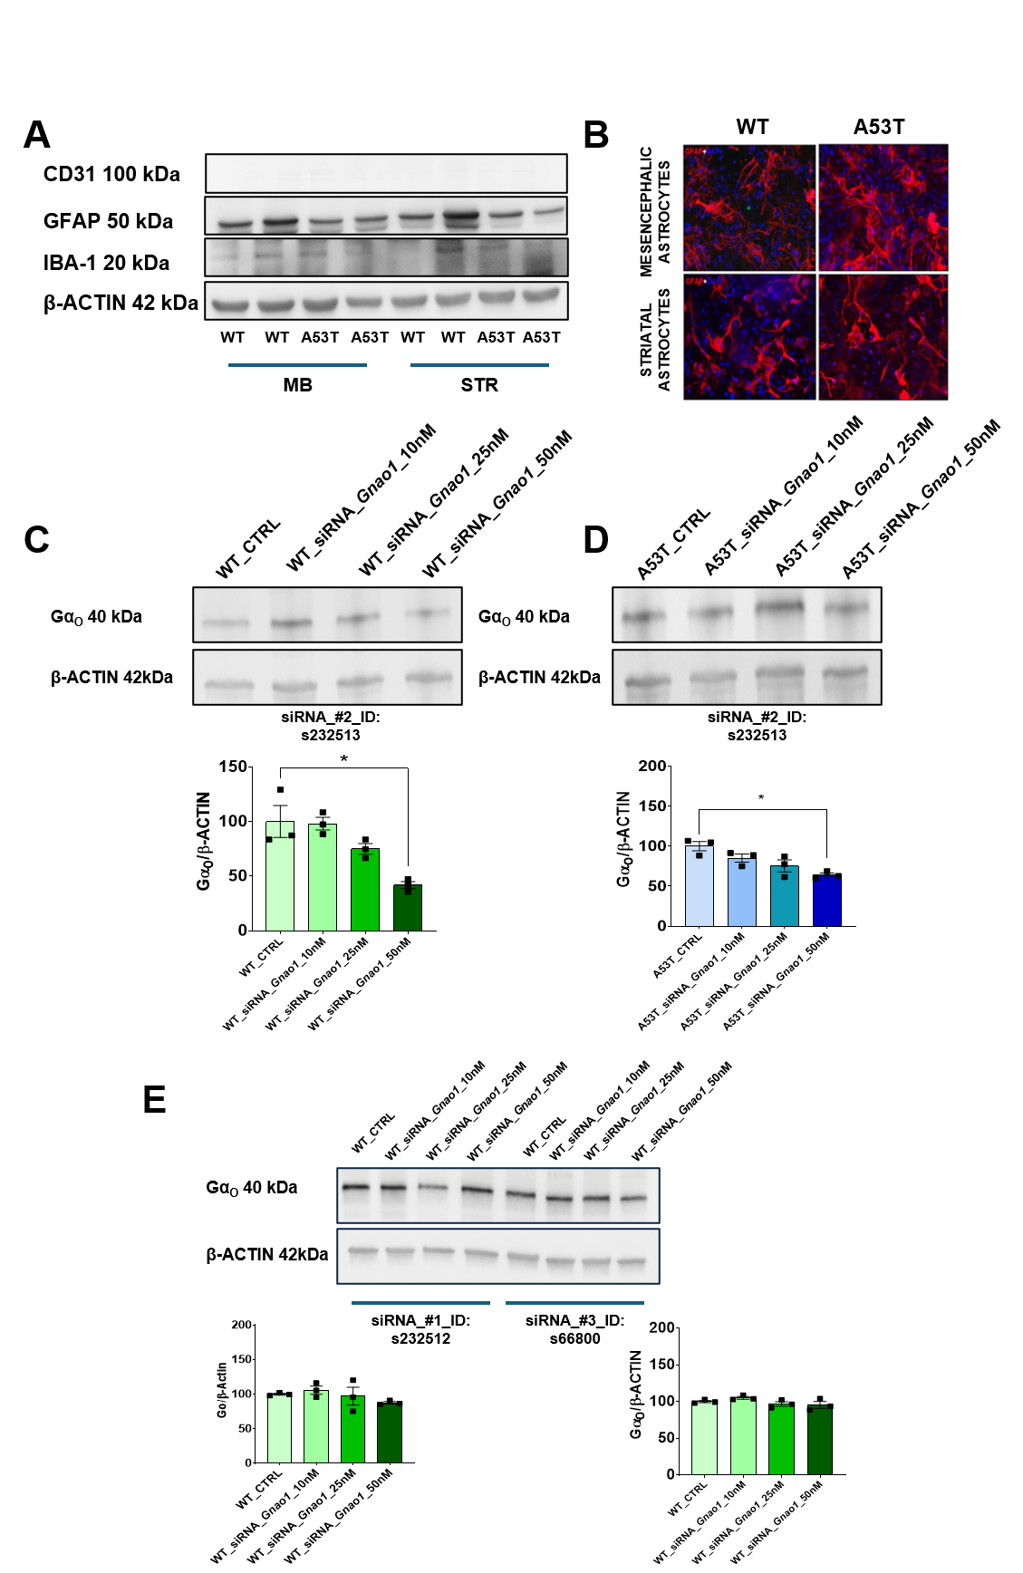
Figure S6. (A-B) Qualitative Western blot and immunofluorescence (GFAP red and DAPI blue) analysis on primary astrocytes. (C) Western blot validation analysis of Gnao1 siRNA knockdown efficiency (ID: 232513) in primary WT mesencephalic astrocytes 24 hours after transfection. Unpaired Student’s t-test. P<0.05 was considered statistically significant (*p<0.05 vs. WT_CTRL vs. WT_siRNA_Gnao1_50nM). (D) Validation of Gnao1 siRNA knockdown efficiency (ID: 232512) by Western blot analysis 24 hours post-transfection in primary A53T mesencephalic astrocytes Unpaired Student’s t-test. P<0.05 was considered statistically significant (*p<0.05 A53T_CTRL vs. A53T_siRNA_Gnao1_25nM: $p<0.05 A53T_CTRL vs. A53T_siRNA_Gnao1_50nM). (E) Validation of Gnao1-siRNAs interference efficiency (ID: 232513; ID:66800) by Western blot analysis 24 hours post-transfection in primary WT mesencephalic astrocytes.

