Supplementary Figures
Supplementary Fig. 1 Survival prognostic analysis (GSE236039)
Supplementary Fig. 2 Survival prognostic analysis (GSE203329)
Supplementary Fig. 3 Survival prognostic analysis (Intersection of GSE236039 and GSE203329)
Supplementary Fig. 4 Survival prognostic analysis (Union of GSE236039 and GSE203329)

Supplementary Fig. 1
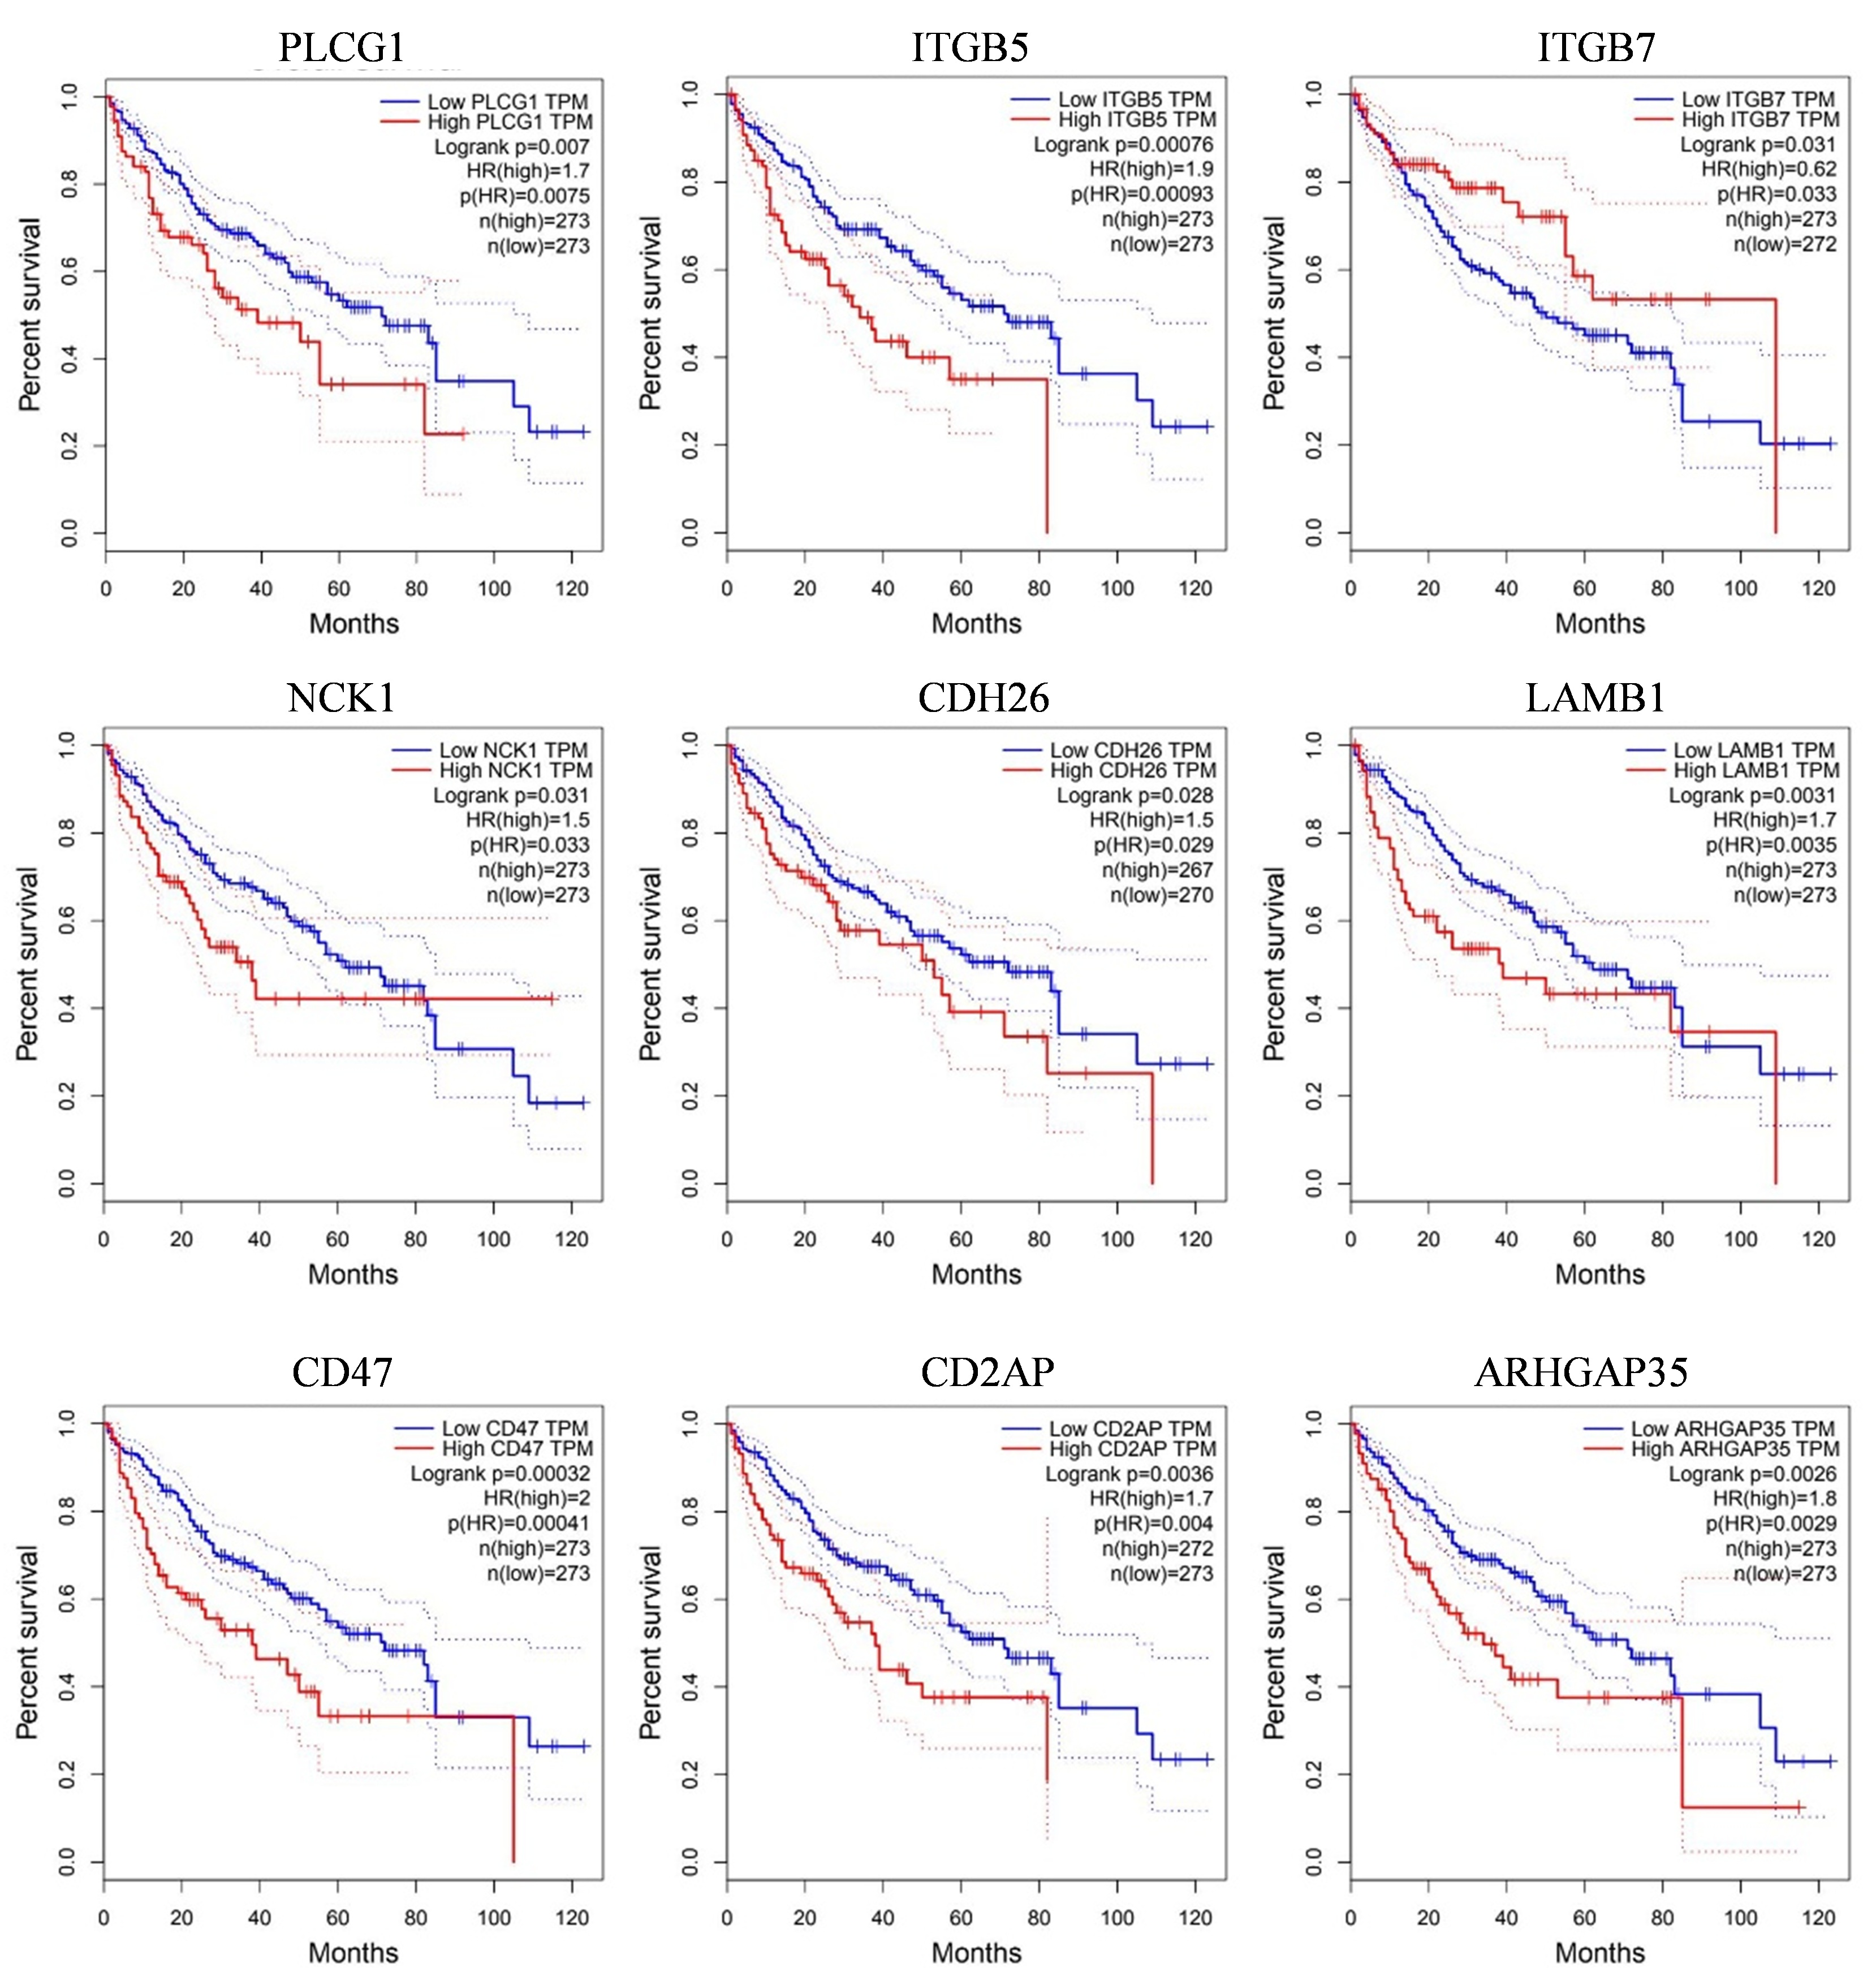

Supplementary Fig. 2
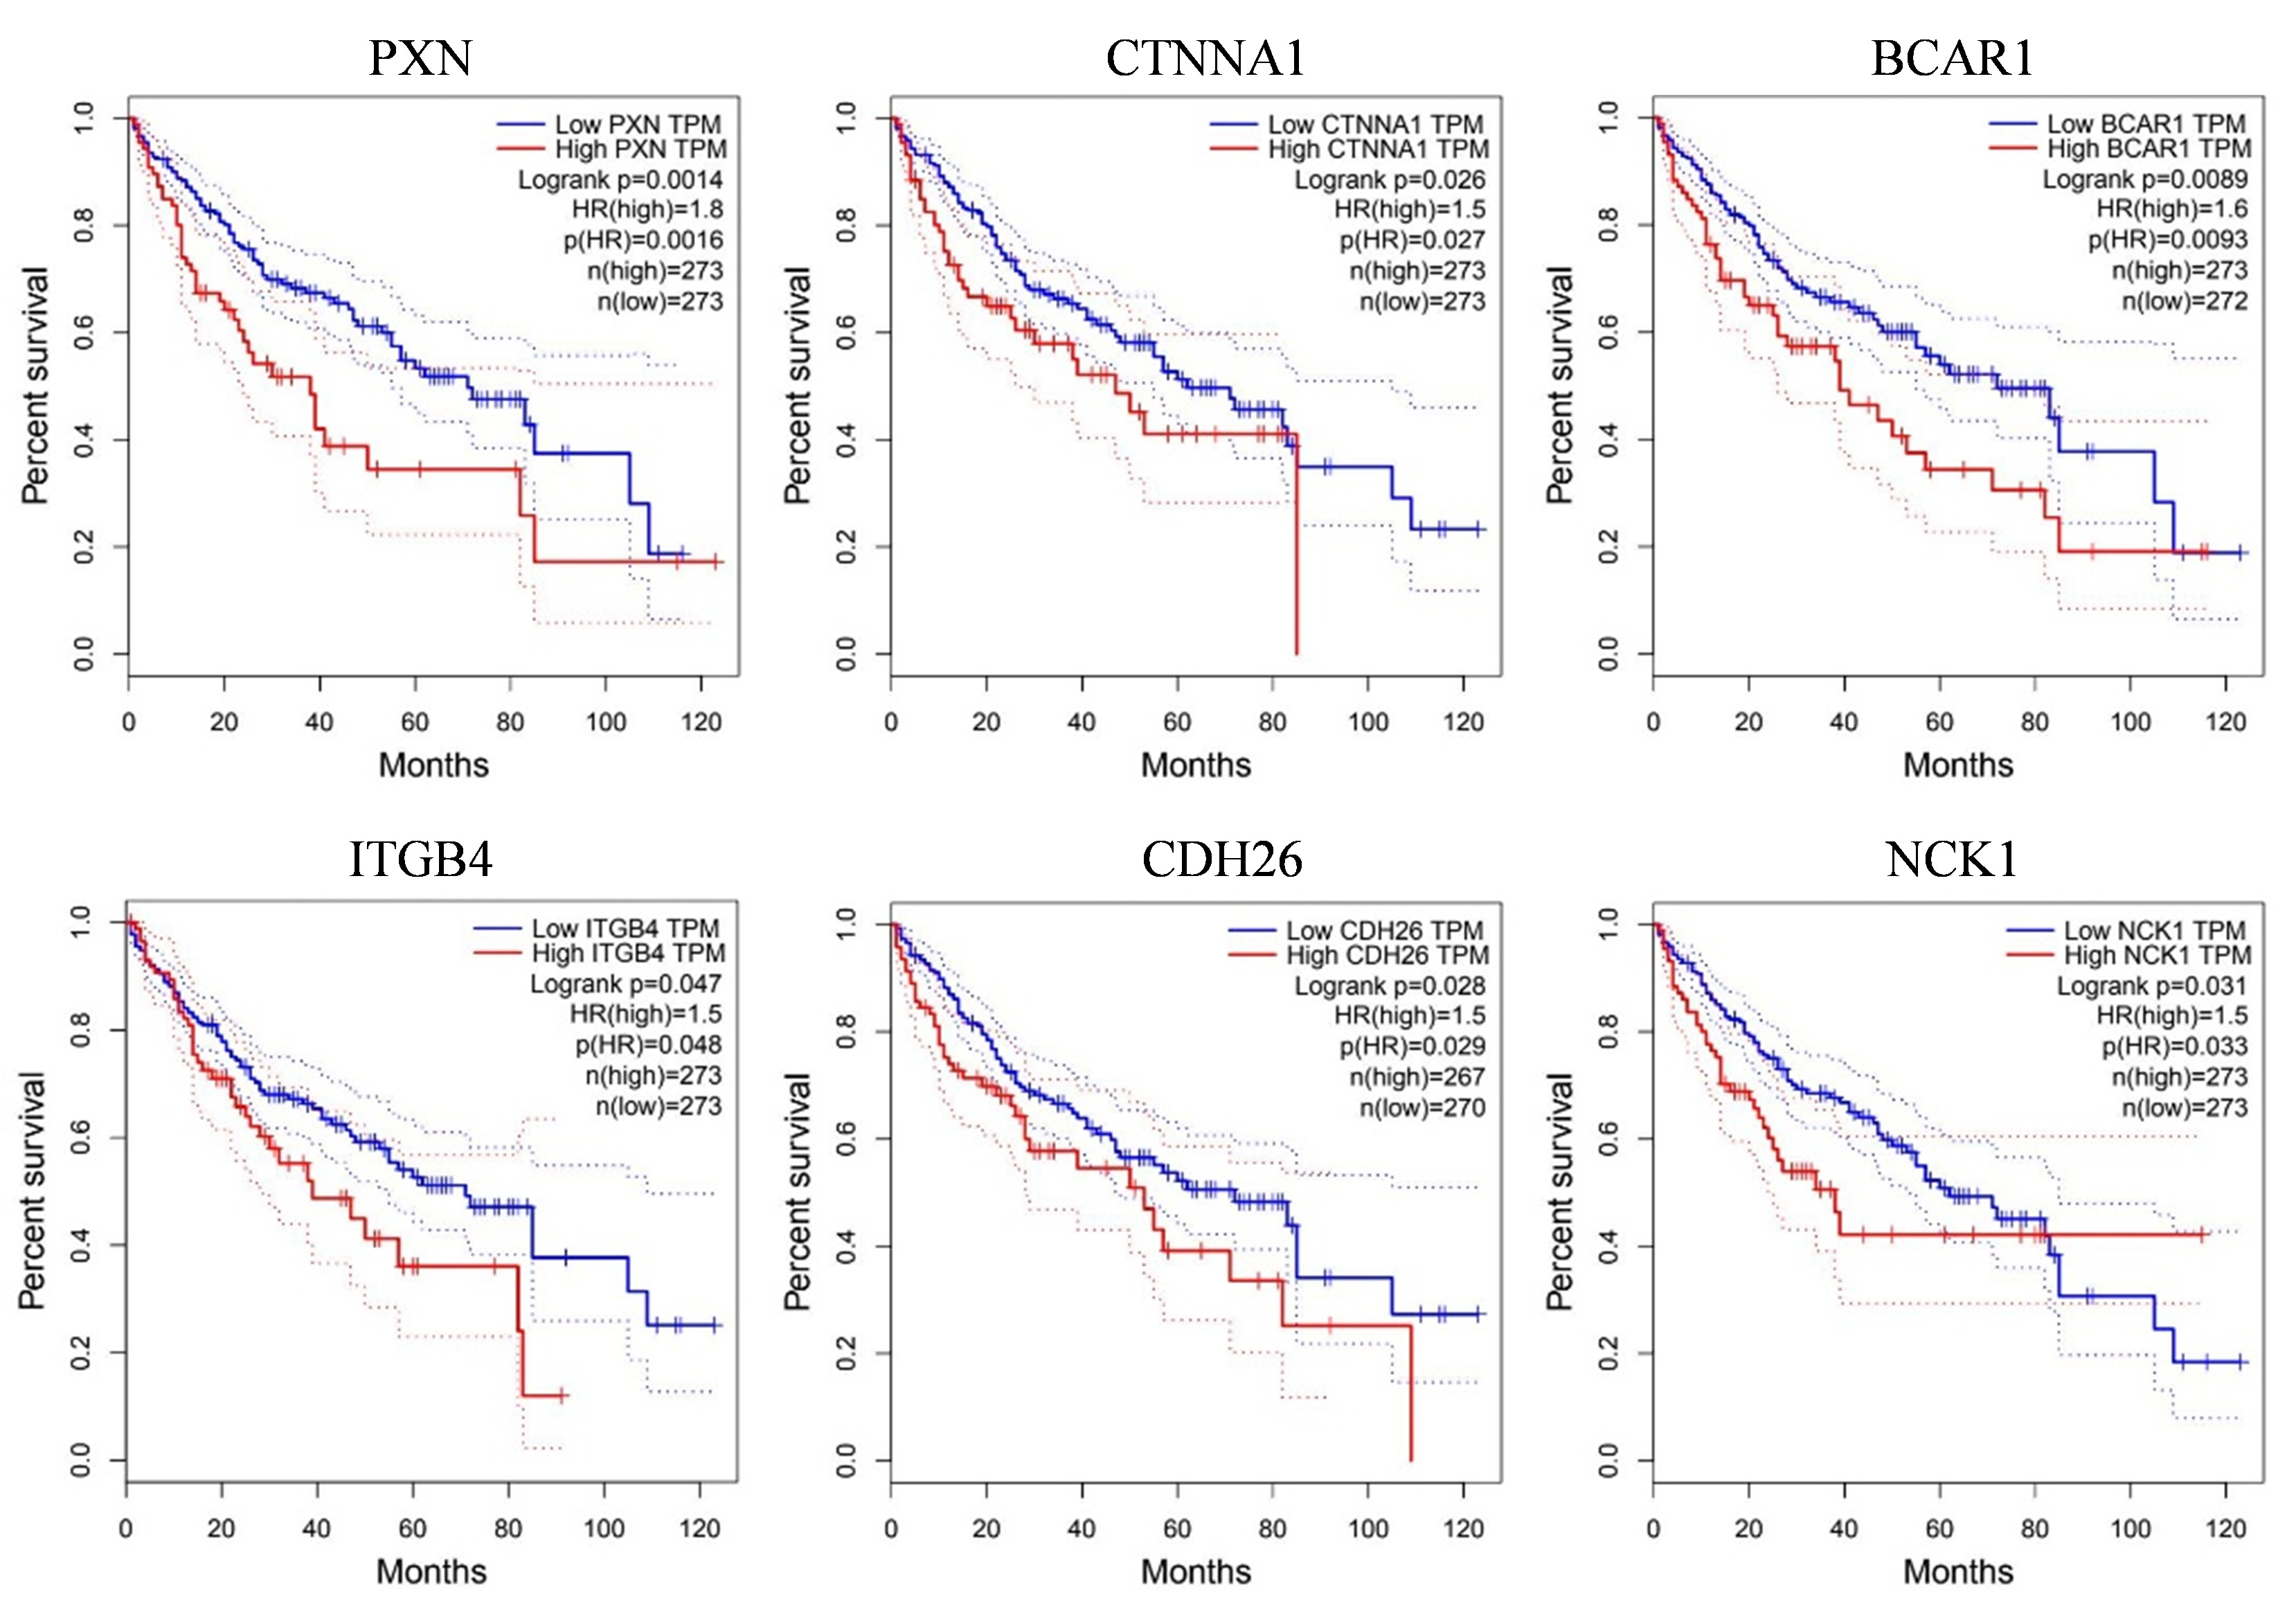

Supplementary Fig. 3
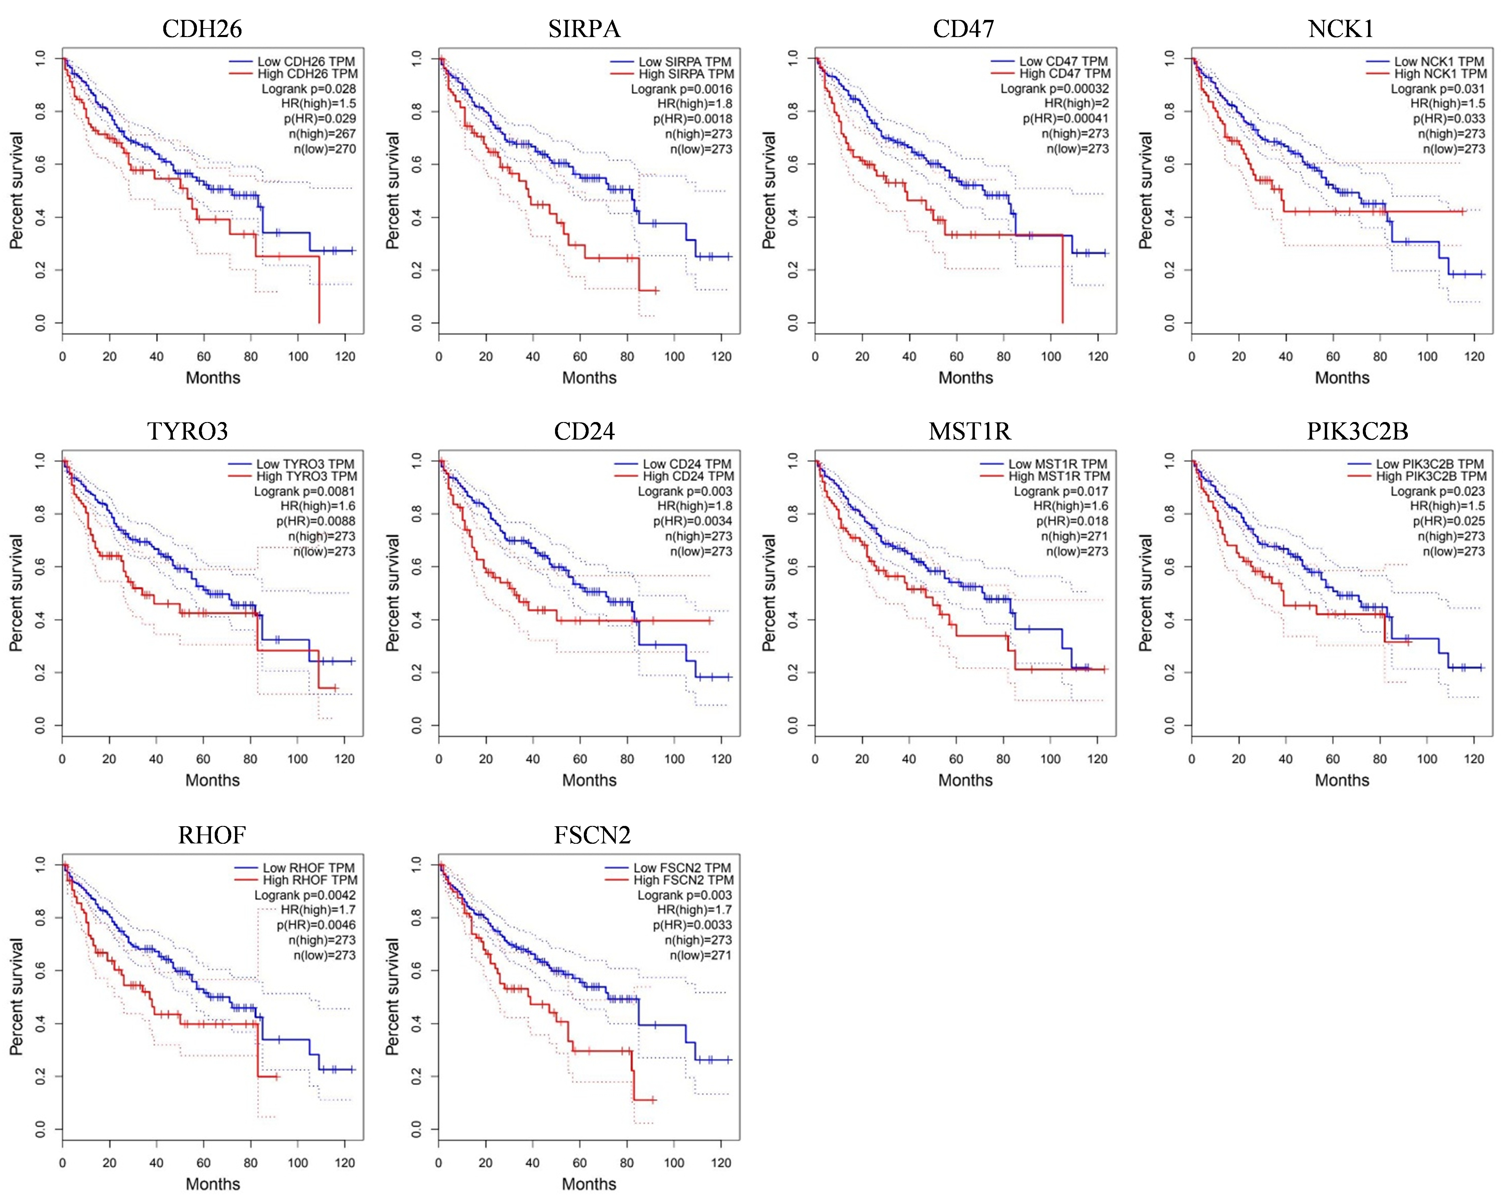

Supplementary Fig. 4
