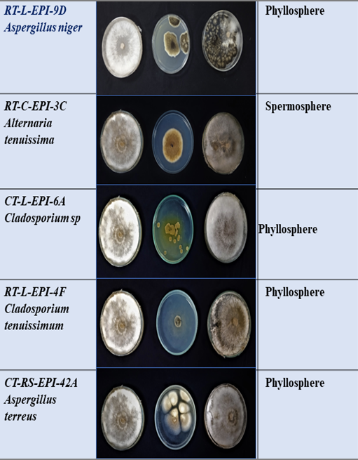 | 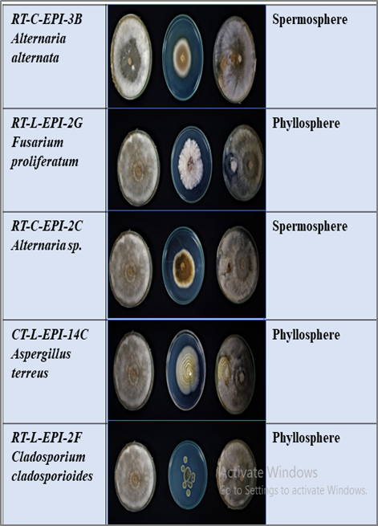
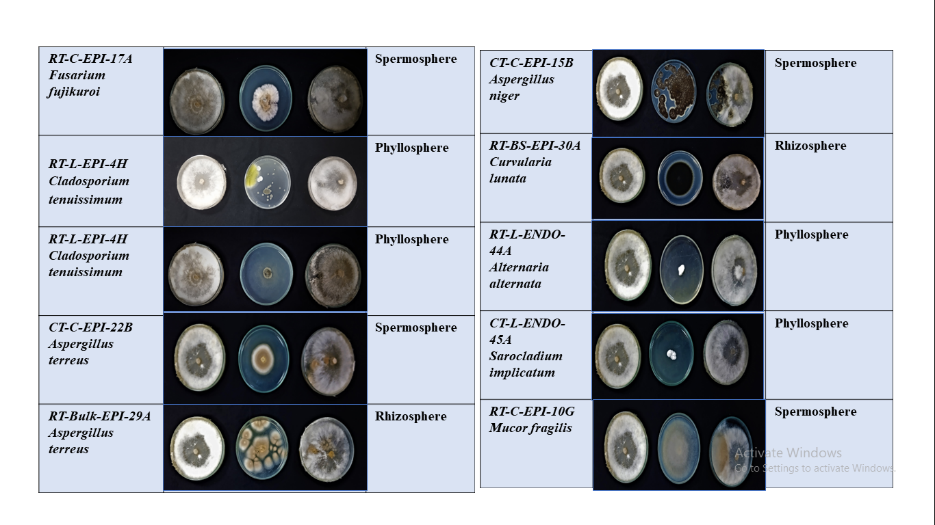
Supplementary figure 3.1: In vitro assay (by dual culture method) for the assessment of biocontrol potential of endophytic fungi isolated from Bihar, India

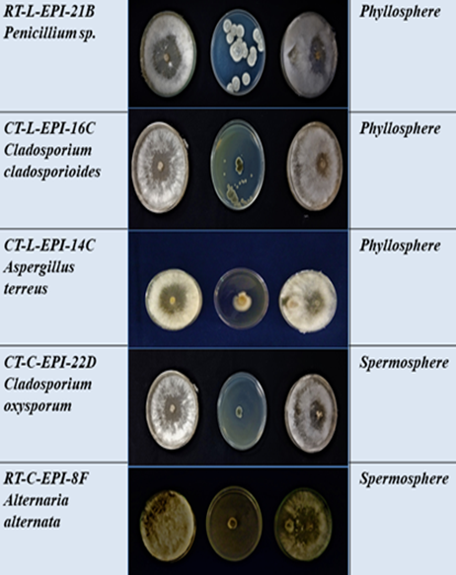 | 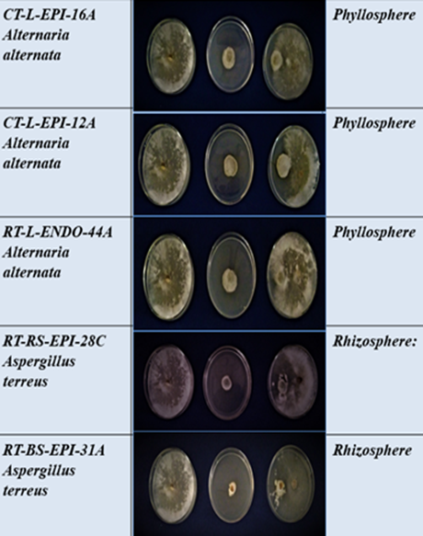
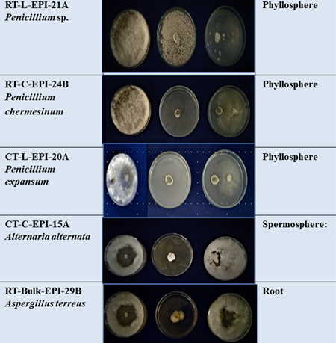 | 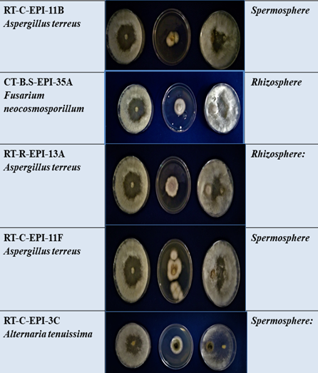
Supplementary figure 3.1: In vitro assay (by dual culture method) for the assessment of biocontrol potential of endophytic fungi isolated from Bihar, India

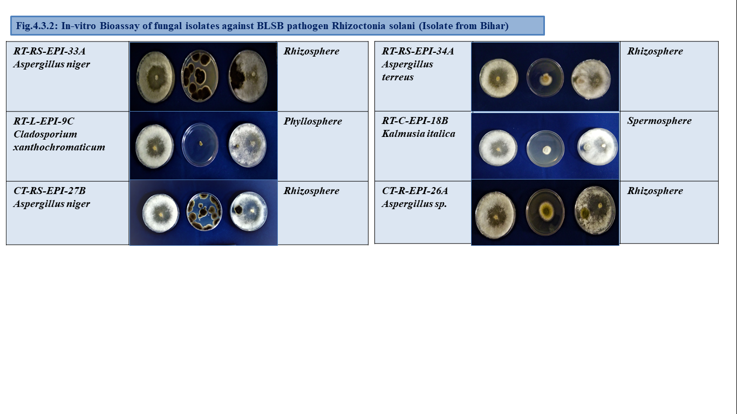 | 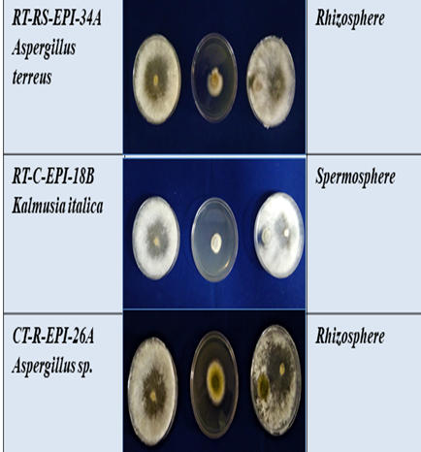
Supplementary figure 3.1: In vitro assay (by dual culture method) for the assessment of biocontrol potential of endophytic fungi isolated from Bihar, India

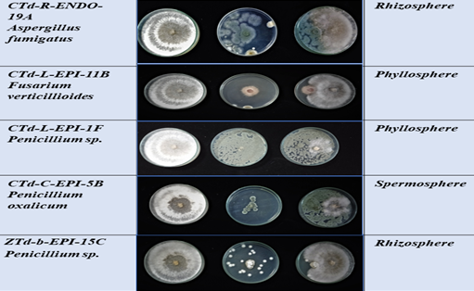 | 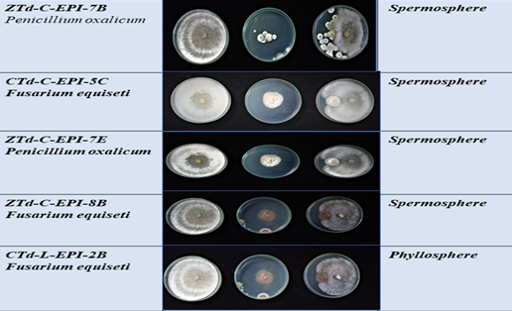
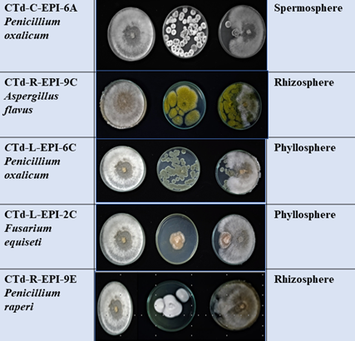 | 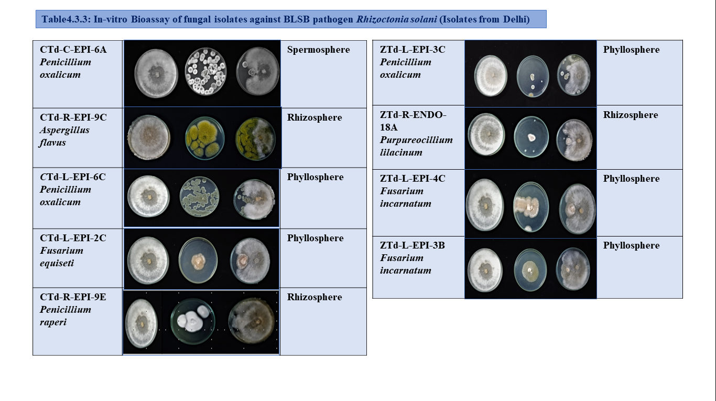
Supplementary figure 3.2: In vitro assay (dual culture method) for the assessment of biocontrol potential of endophytic fungi isolated from Delhi, India

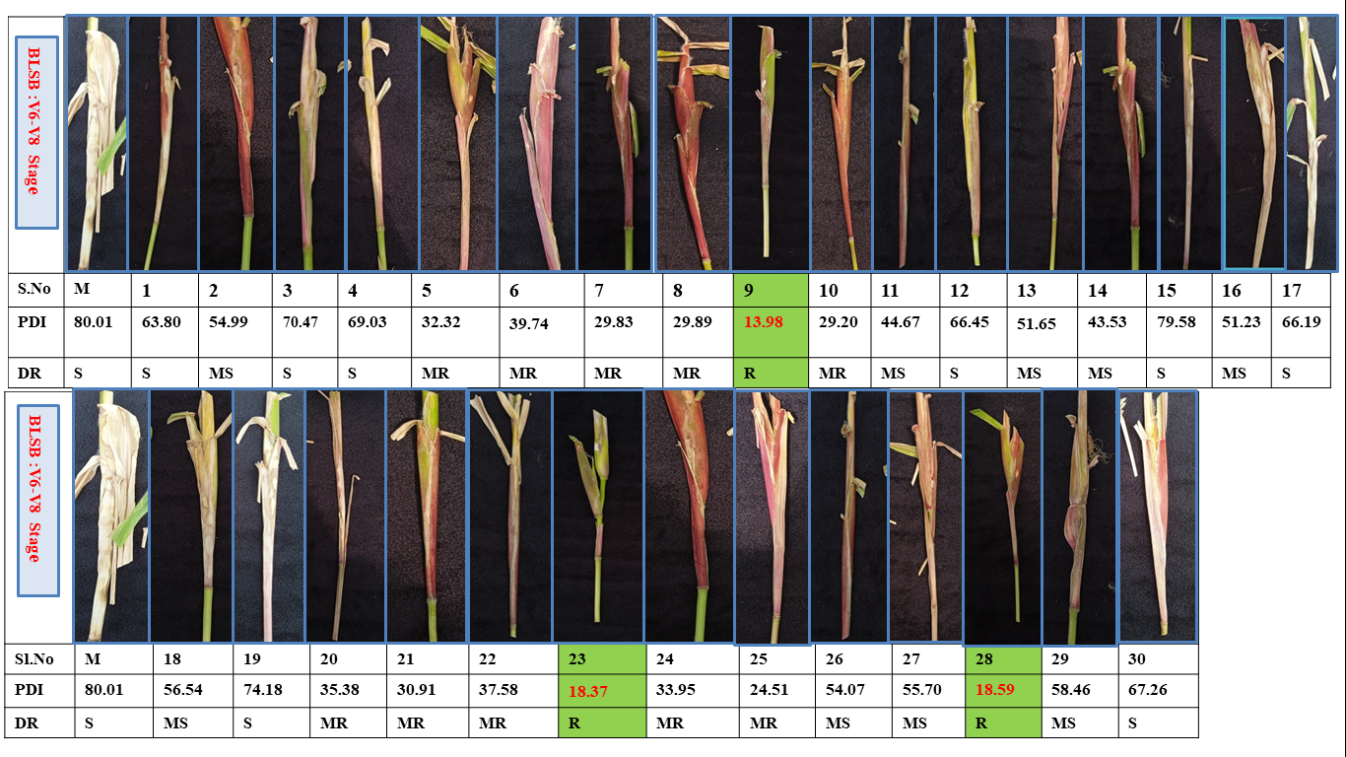
(R- Resistant; MR- Moderatly Resistant; MS- Moderatly Susceptible; S- Susceptible)
Supplementary figure 3.3: Banded leaf and sheath blight (BLSB) disease reaction on maize plants (Vivek QPM-9) upon endophytic fungi treatment. Numerical data shows the percent reduction in disease severity (RDS) upon maize tissue treated with endophytic fungi.

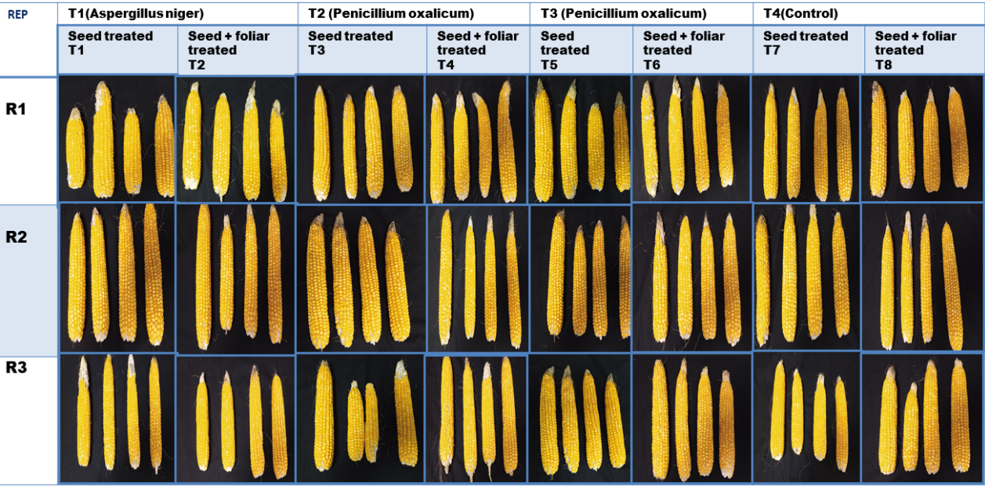
Supplementary figure 3.4: Cob harvested from the maize plants treated with selected endophytic fungal species

Supplementary table 3.1: Pattern observed of Bio-priming-induced defence genes
Gene/enzyme | Pattern observed
β-1,3-glucanase | Sharp early peak at 24 h (PEN2 ~5.2-fold, p<0.01); PEN1 highest at 48 h (**); all treatments decline by 96 h, PEN2 even drops below mock ()
Catalase (CAT) | Strong, significant induction at 48 h for PEN1/PEN2 (~0.8-fold, ***); ASPR peaks later, at 96 h
Peroxidase (POX) | Significant rise from 24 h onward (***); PEN2 peaks at 72 h (~3-fold); ASPR shows late significant increases (72–96 h, **)
Polyphenol oxidase (PPO) | Progressive, cumulative increase; significant from 48–72 h (PEN1/PEN2, */**); PEN2 shows the largest overall induction, peaking at 96 h (~8-fold)
Superoxide dismutase (SOD) | PEN2 dominates early — large, significant spikes at 24 h (~5.2-fold) and 48 h (~3.7-fold), with the whole panel significant (***)

