Supporting Information
Lattice Distortion-Enhanced Cuproptosis Nanoplatform for Synergistic Catalytic-Autophagy Tumor Therapy

Supplementary Figures
Figure S1. Synthesis of the tetranuclear dysprosium cluster based on an 8-hydroxyquinoline-2-carbaldehyde-condensed N-oxopyridine bis-hydrazone ligand L

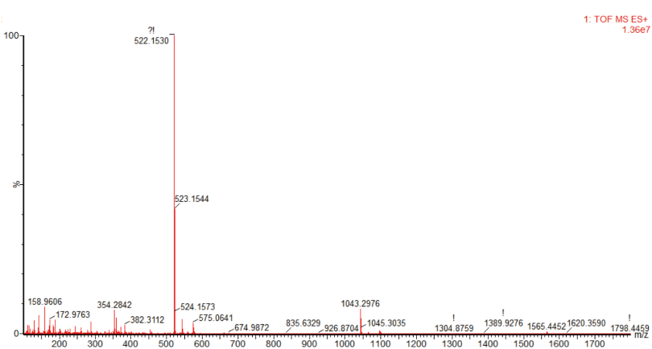
Figure S2. High-Resolution Mass Spectrum (HRMS) of Ligand L

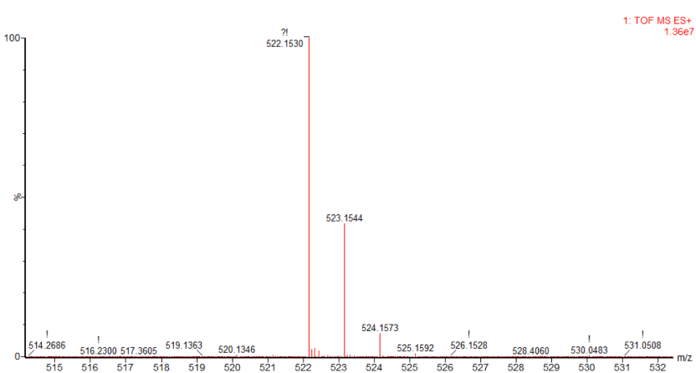
Figure S3. Isotopic Peaks of Ligand L

Single-crystal X-ray diffraction analysis reveals that the complex is a tetranuclear species, crystallizing in the triclinic system with the P-1 space group. The asymmetric unit consists of four Dy(III) ions, two (L)²⁻ ligands, four acetate ions, and three DMF molecules. Dy4, Dy2, Dy3, and Dy1 all adopt an eight-coordinate geometry. Dy4 is coordinated by O6, O7, N8, N9 from one (L)²⁻ ligand, O5 from another (L)²⁻ ligand, and two acetate ions. Dy3 is bonded to one DMF molecule, O6 and O7 from one (L)²⁻ ligand shared with Dy4, one acetate ion, as well as O4, O5, N6, and N7 from a (L)²⁻ ligand bridging Dy2 and Dy1. Dy2 is ligated by one acetate ion, O2, O10, N13, N14 from a (L)²⁻ ligand shared with Dy4 and Dy3, one acetate ion connected to Dy1, and O3, O9 from a (L)²⁻ ligand shared with Dy4 and Dy3. Dy1 is coordinated by O1, O2, N1, N2 from one (L)²⁻ ligand, one acetate ion, two DMF molecules, and O10 from a (L)²⁻ ligand bridging Dy4, Dy2, and Dy3.The Dy(III)–O bond lengths range from 2.282(7) Å to 2.493(5) Å, and the Dy(III)–N bond lengths fall in the range of 2.485(6) Å to 2.530(8) Å. The O–Dy(III)–O bond angles vary from 51.5(4)° to 168.7(2)°, while the O–Dy(III)–N bond angles span 62.5(2)° to 151.05(19)°.
Figure S4. Crystal structure of the tetranuclear dysprosium cluster (Dy₄L₂) metal complex
Figure S5. Crystal structure and coordination modes of the Dy₄L₂ metal complex
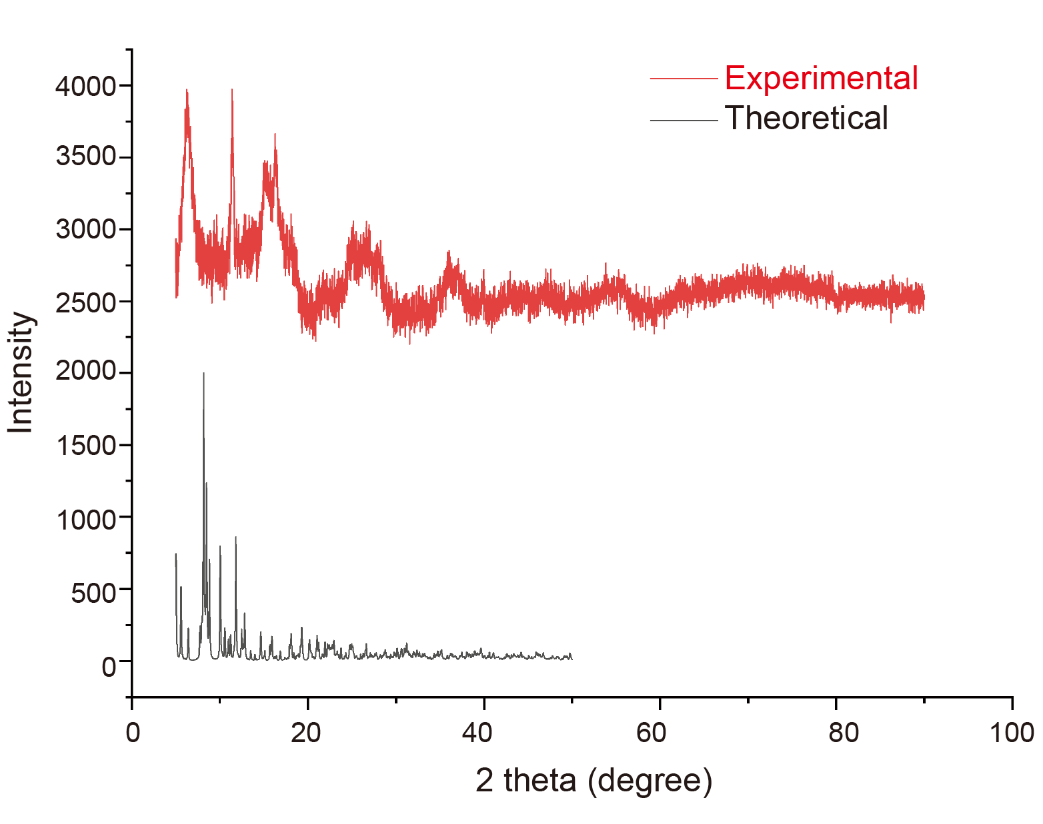
Figure S6. powder X-ray diffraction spectra of cluster Dy₄L₂
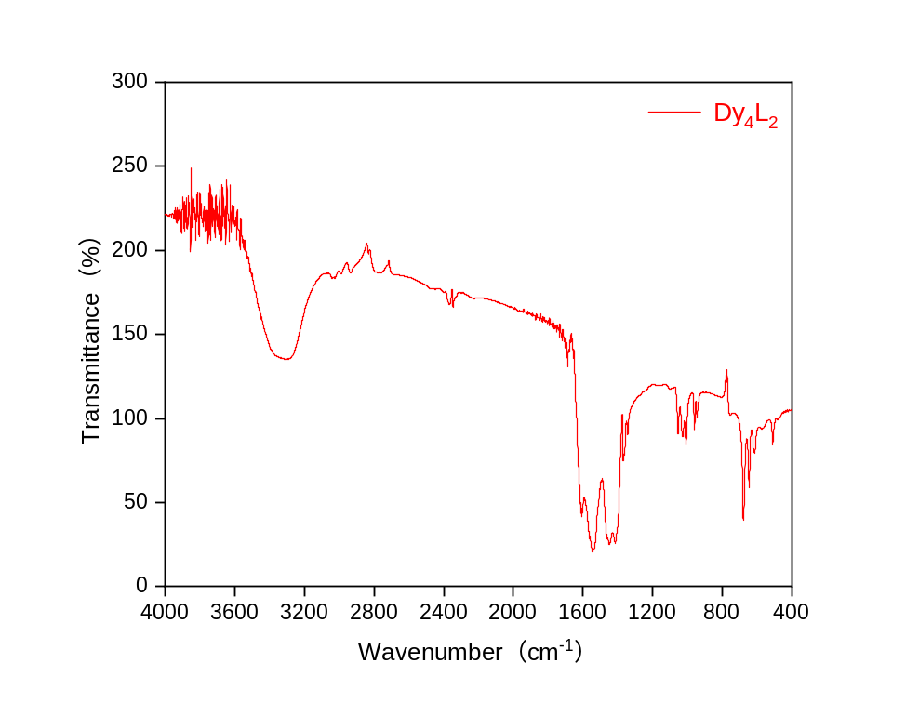
Figure S7. IR (KBr) spectra of cluster Dy₄L₂
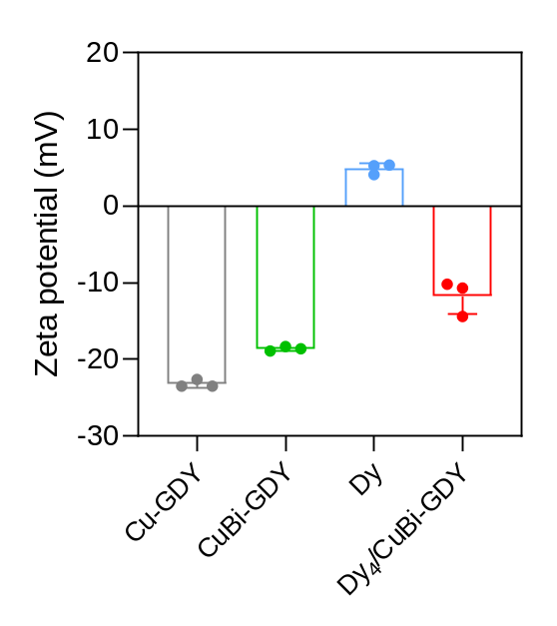
Figure S8. Zeta potentials of Dy, Cu/GDY, CuBi/GDY or Dy₄-CuBi/GDY determined by DLS (n = 3; mean ± SD).
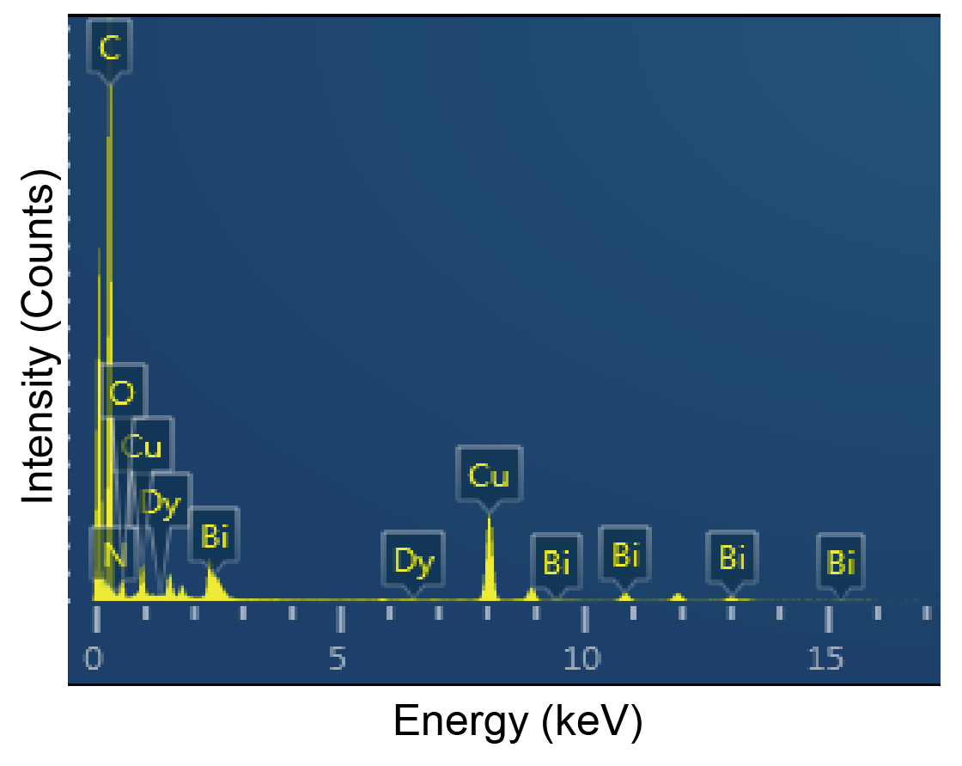
Figure S9. EDS elemental mapping and spectrum analysis of Dy₄-CuBi/GDY

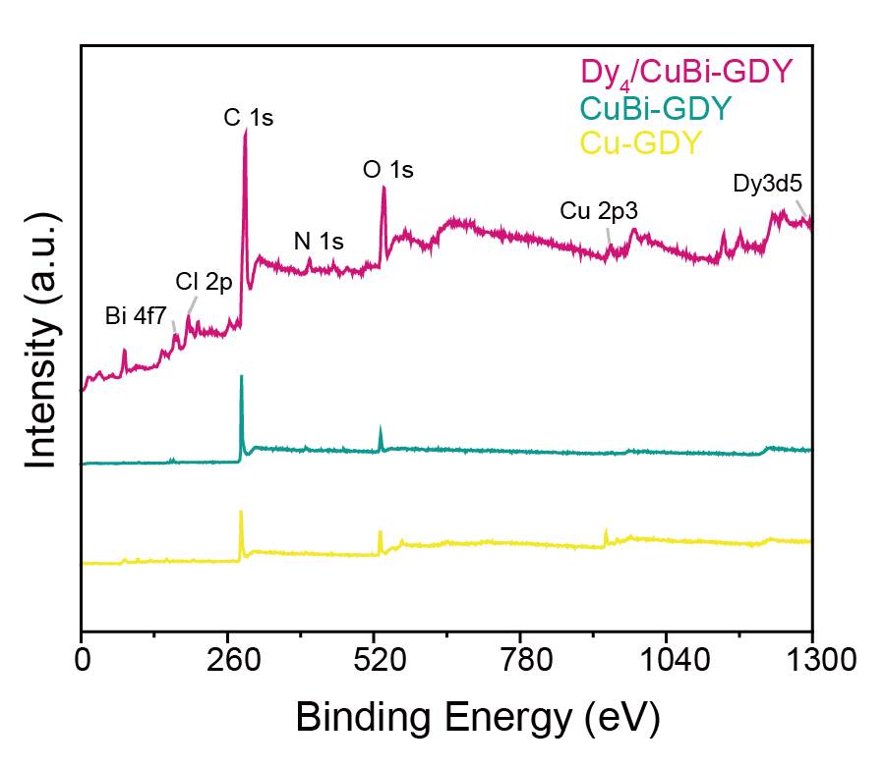
Figure S10. XPS survey spectra of Dy₄-CuBi/GDY, CuBi/GDY and Cu/GDY

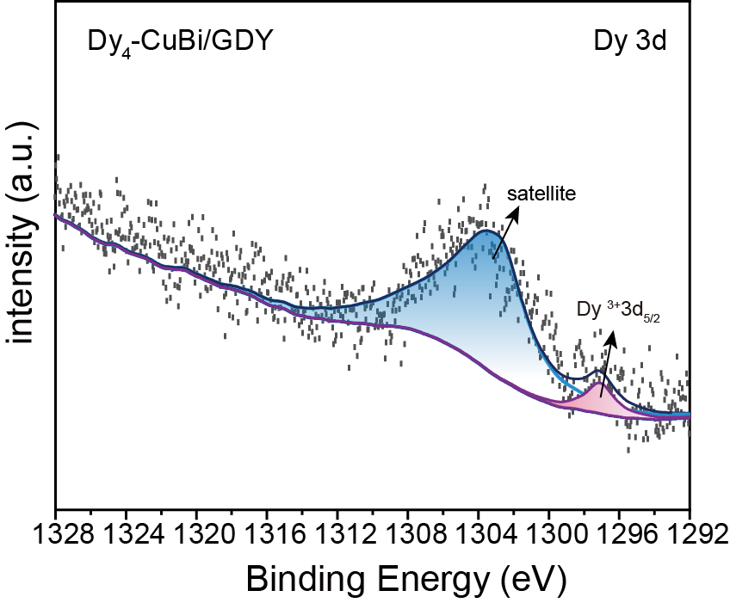
Figure S11. High-resolution XPS spectra of Dy in Dy₄-CuBi/GDY

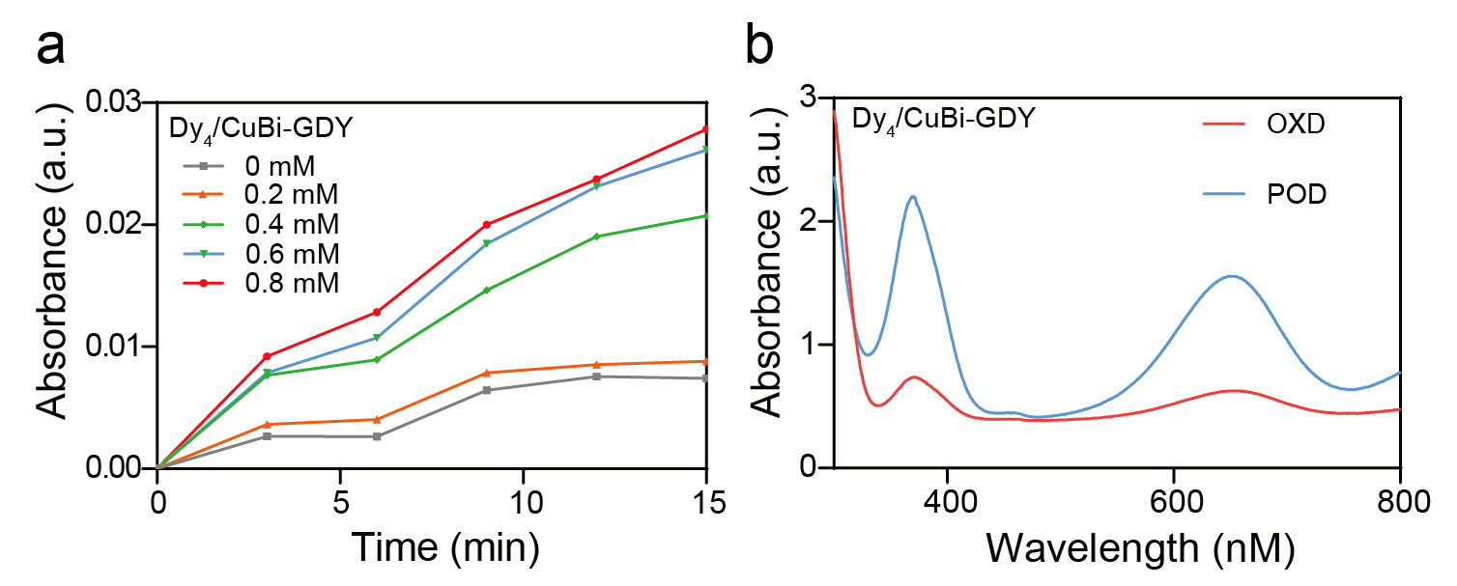
Figure S12. (a) absorbance changes at 652 nm during the reaction of Dy₄-CuBi/GDY with different concentrations of H₂O₂. (b) OXD- and POD-like catalytic activities of Dy₄-CuBi/GDY.

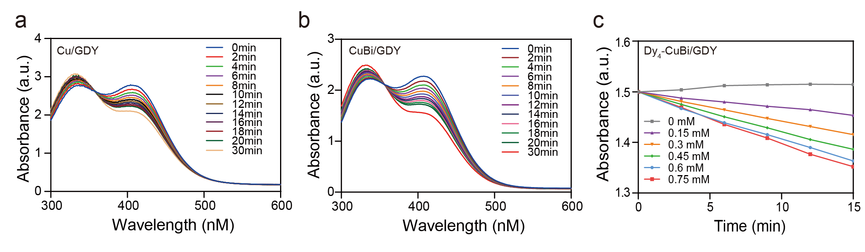
Figure S13. (a) Time-dependent UV–vis spectra of GSH consumption catalyzed by Cu/GDY. (b) time-dependent UV–vis spectra of GSH consumption catalyzed by CuBi/GDY. (c) absorbance changes at 412 nm for Dy₄-CuBi/GDY in the presence of different GSH concentrations.

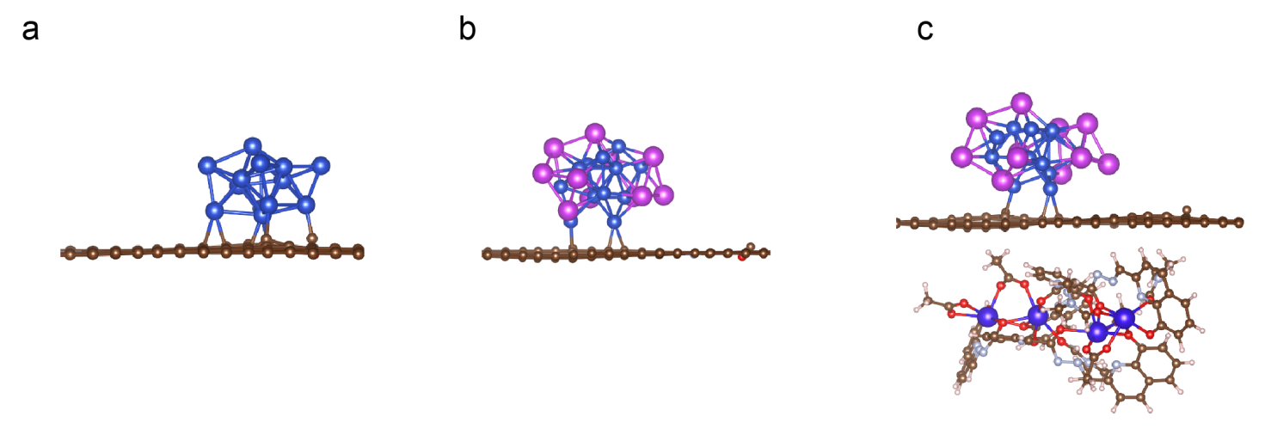
Figure S14. Structural model of Cu/GDY (a), CuBi/GDY (b) and Dy₄-CuBi/GDY (c).
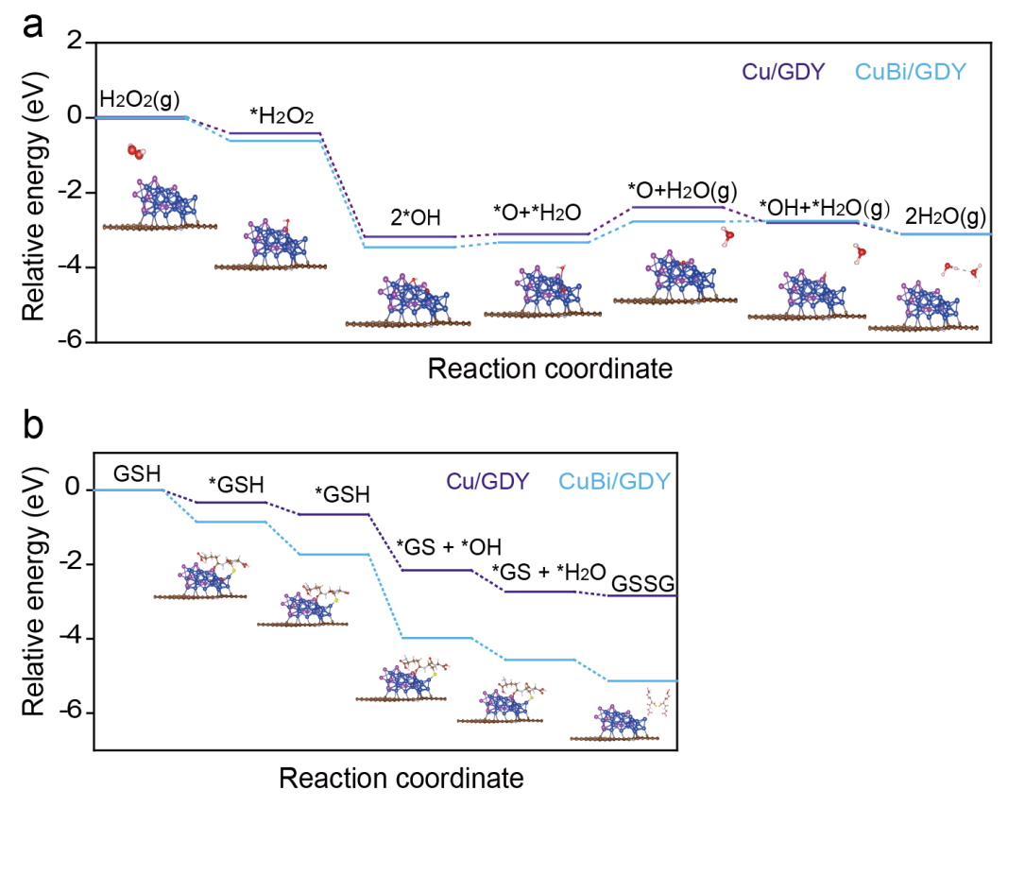
Figure S15. (a) Energy profiles of the POD reaction pathways on the Cu/GDY and CuBi/GDY surfaces. (b) Energy profiles of the glutathione oxidation reaction pathways on the Cu/GDY and CuBi/GDY surfaces.

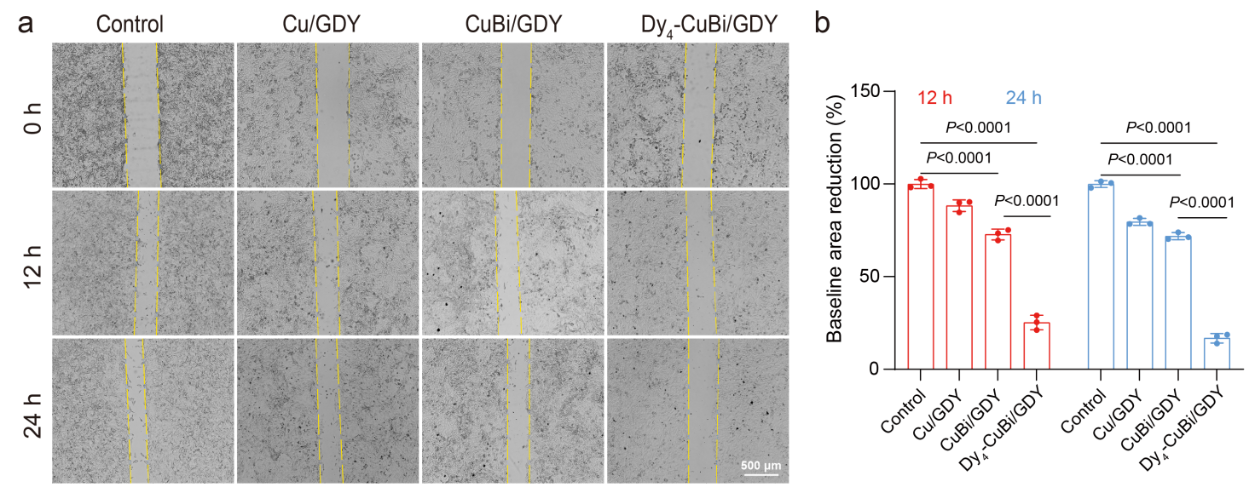
Figure S16. (a) Representative wound-healing images of 143B cells treated with different therapeutic groups at 12 h and 24 h. (b) corresponding quantitative analysis of wound closure. P values are determined by two-way ANOVA (n = 3; mean ± SD).

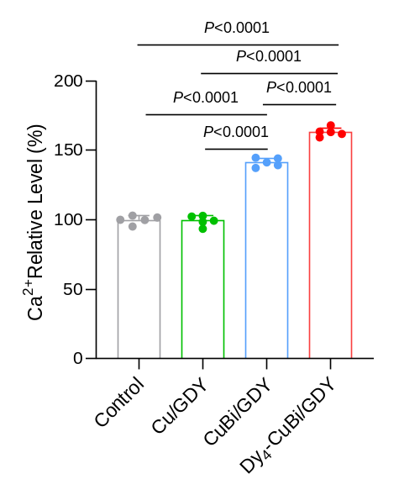
Figure S17. Intracellular Ca²⁺ levels in 143B cells after treatment with different therapeutic groups. P values are determined by one-way ANOVA (n = 3; mean ± SD).
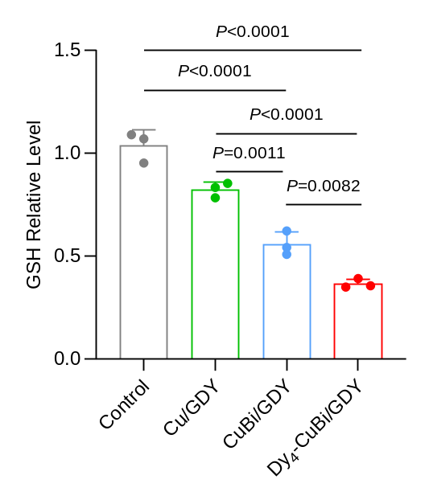
Figure S18. Intracellular relative GSH level. P values are determined by one-way ANOVA (n = 3; mean ± SD).
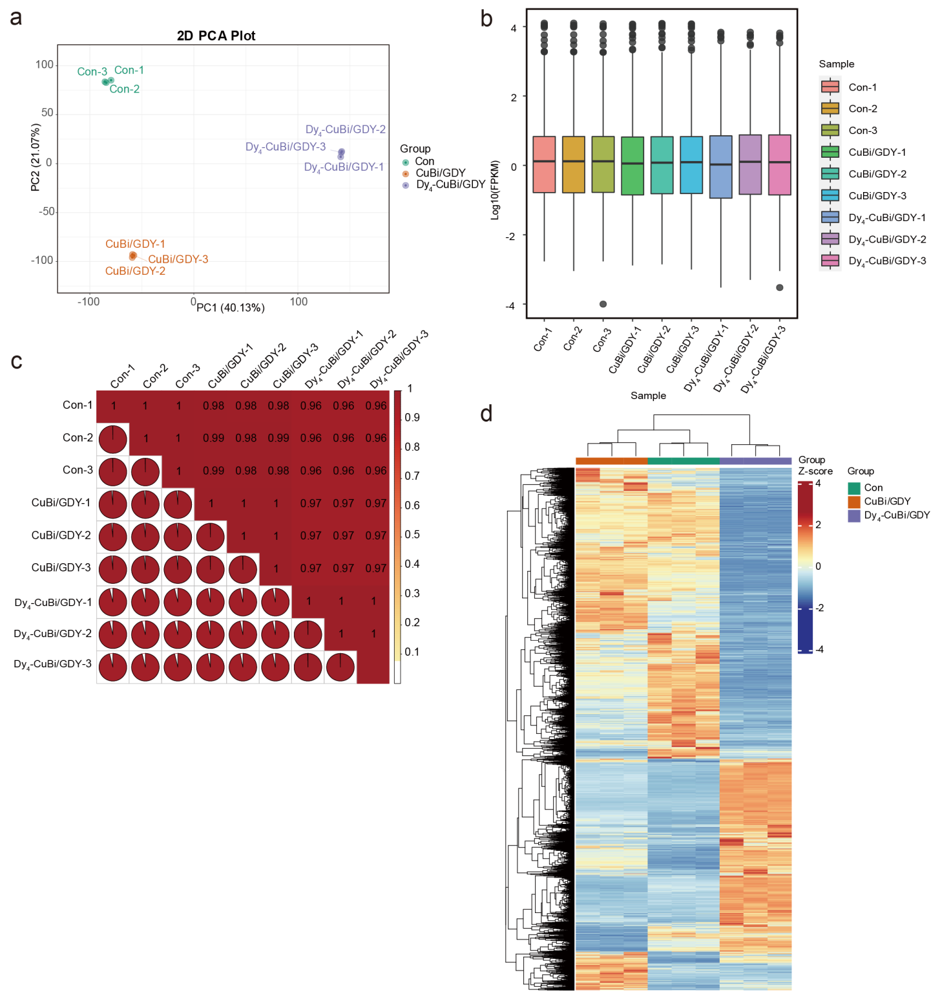

Figure S19. Distribution and expression consistency analysis of RNA-sequencing samples in 143B cells. (a) Two-dimensional principal component analysis (PCA) based on gene expression profiles. (b) Box plots showing the distribution of log₁₀(FPKM) values across the nine sequencing samples.(c) Sample-to-sample correlation heatmap generated from the expression matrix, with values representing pairwise correlation coefficients between samples. (d) Hierarchical clustering heatmap of differentially expressed genes (DEGs). The color bar at the top indicates the three experimental groups: Con, CuBi/GDY, and Dy₄-CuBi/GDY.
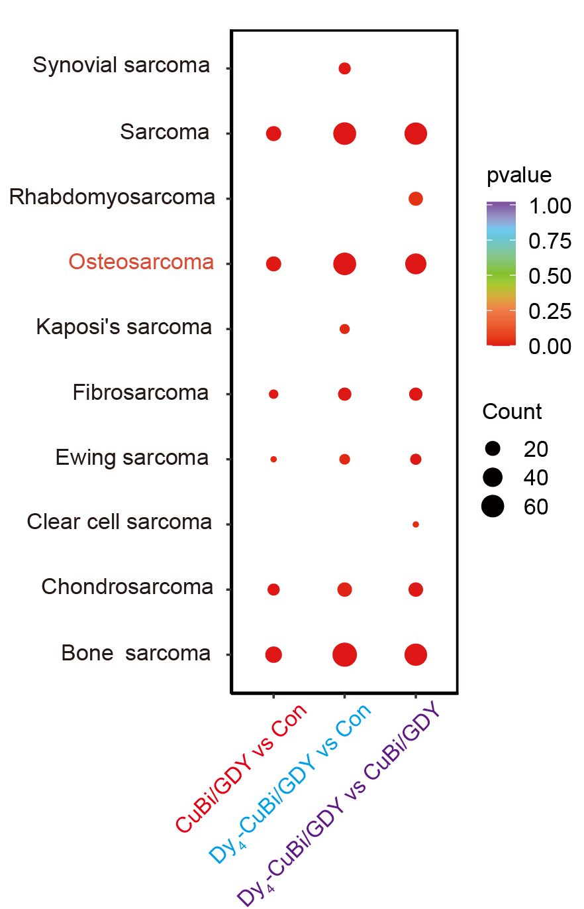
Figure S20. Enrichment analysis of differentially expressed genes in related diseases.
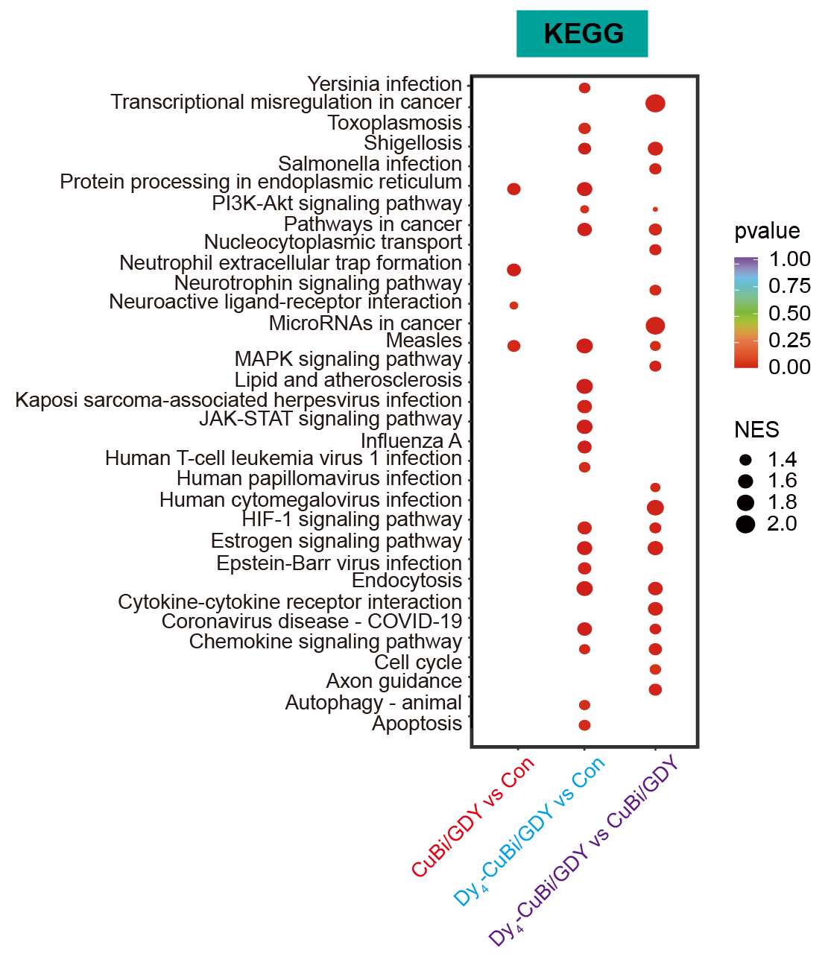
Figure S21. KEGG enrichment analyses of differentially expressed genes.
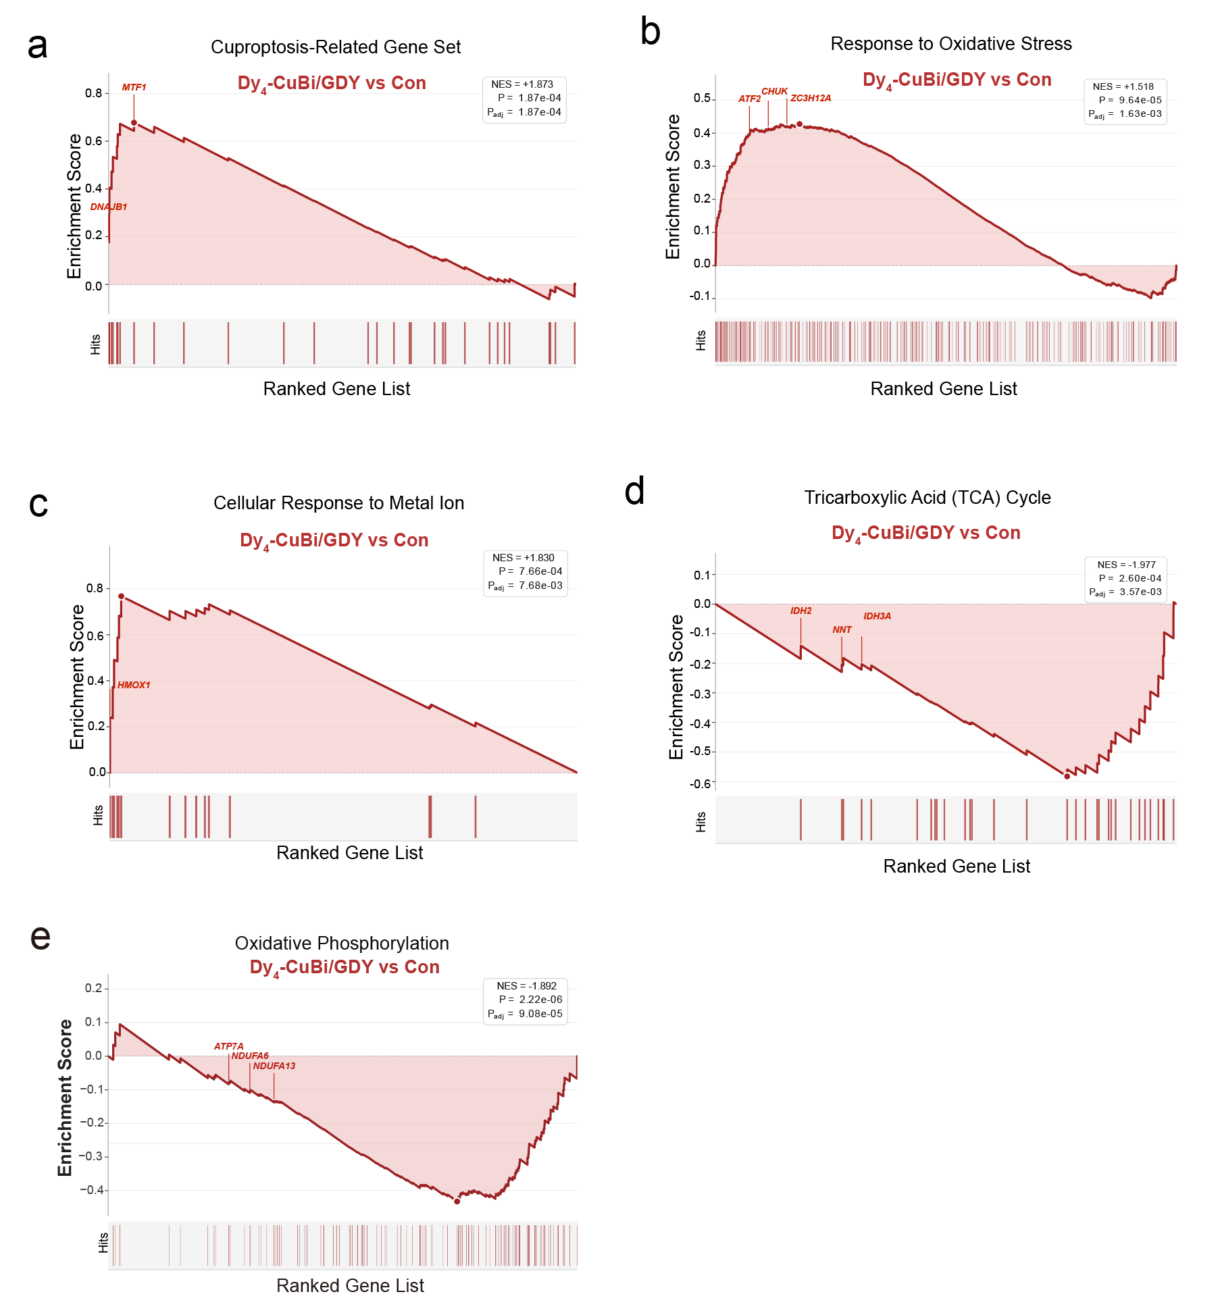

Figure S22. GSEA of Dy₄-CuBi/GDY versus Control showing positive enrichment of the cuproptosis-related gene set (a), response to oxidative stress (b) and cellular response to metal ion (c), together with negative enrichment of the tricarboxylic acid cycle (d) and oxidative phosphorylation (e).

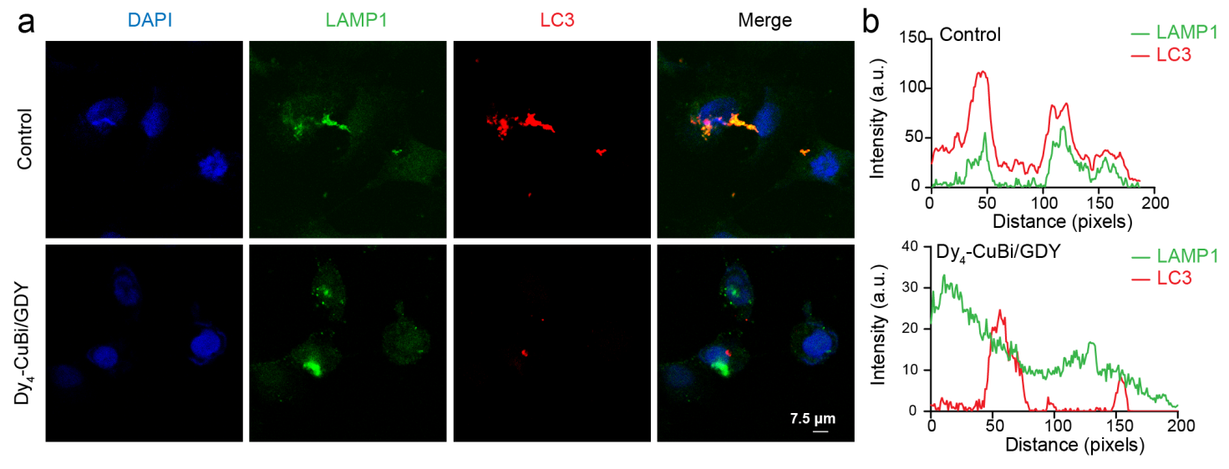
Figure S23. (a) Confocal microscopy analysis of colocalization of DAPI (blue), LC3 (red) and LAMP1 (green) in Dy₄-CuBi/GDY-treated 143B cells and analyzed (b).
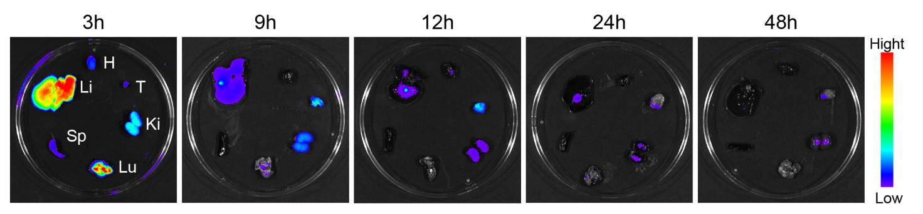
Figure S24. Ex vivo fluorescence imaging of major organs from tumor-bearing mice after tail-vein injection of the Dy₄-CuBi/GDY nanozyme.
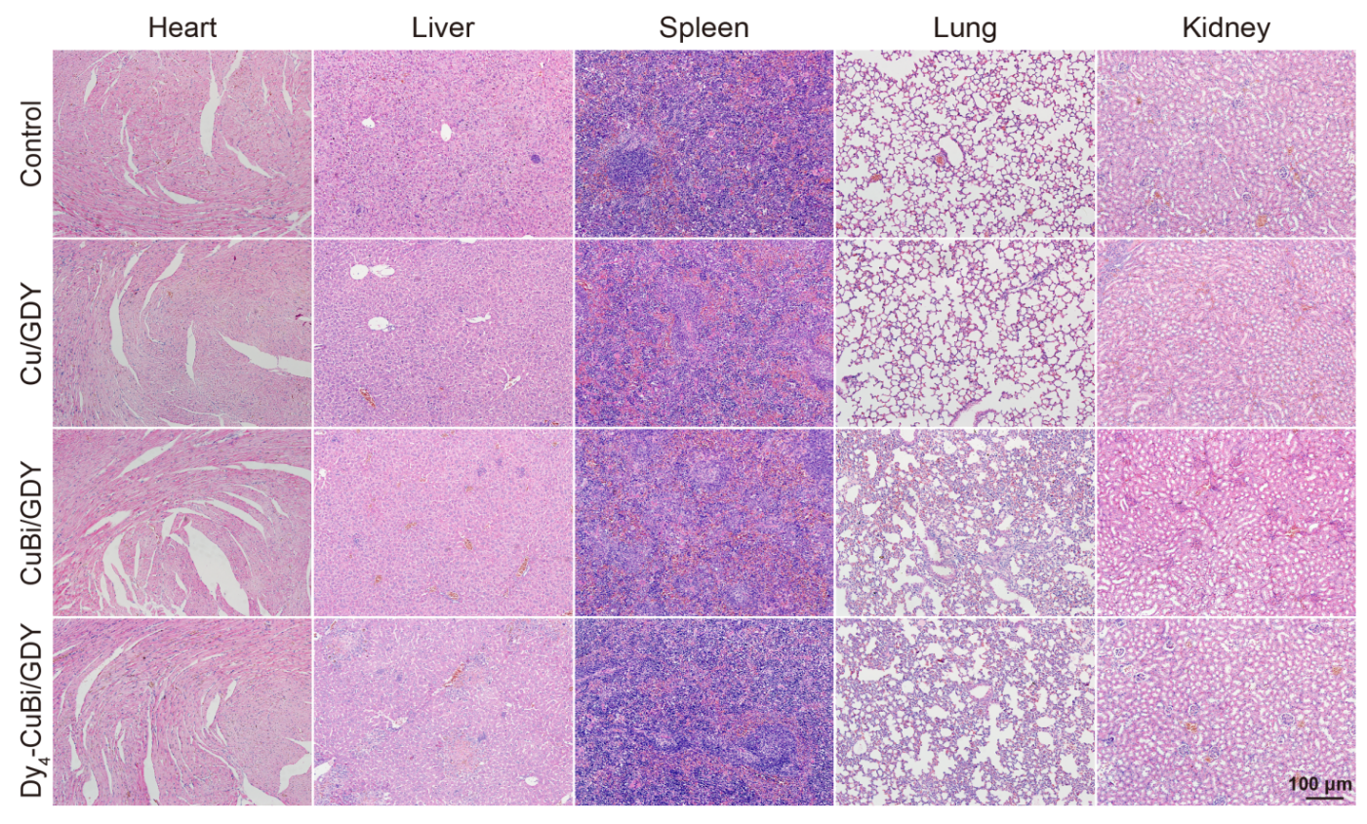
Figure S25. H&E staining of heart, liver, spleen, lung, and kidney sections collected 14 days after tail-vein injection of different treatment groups. Source data are provided as a Source Data file.
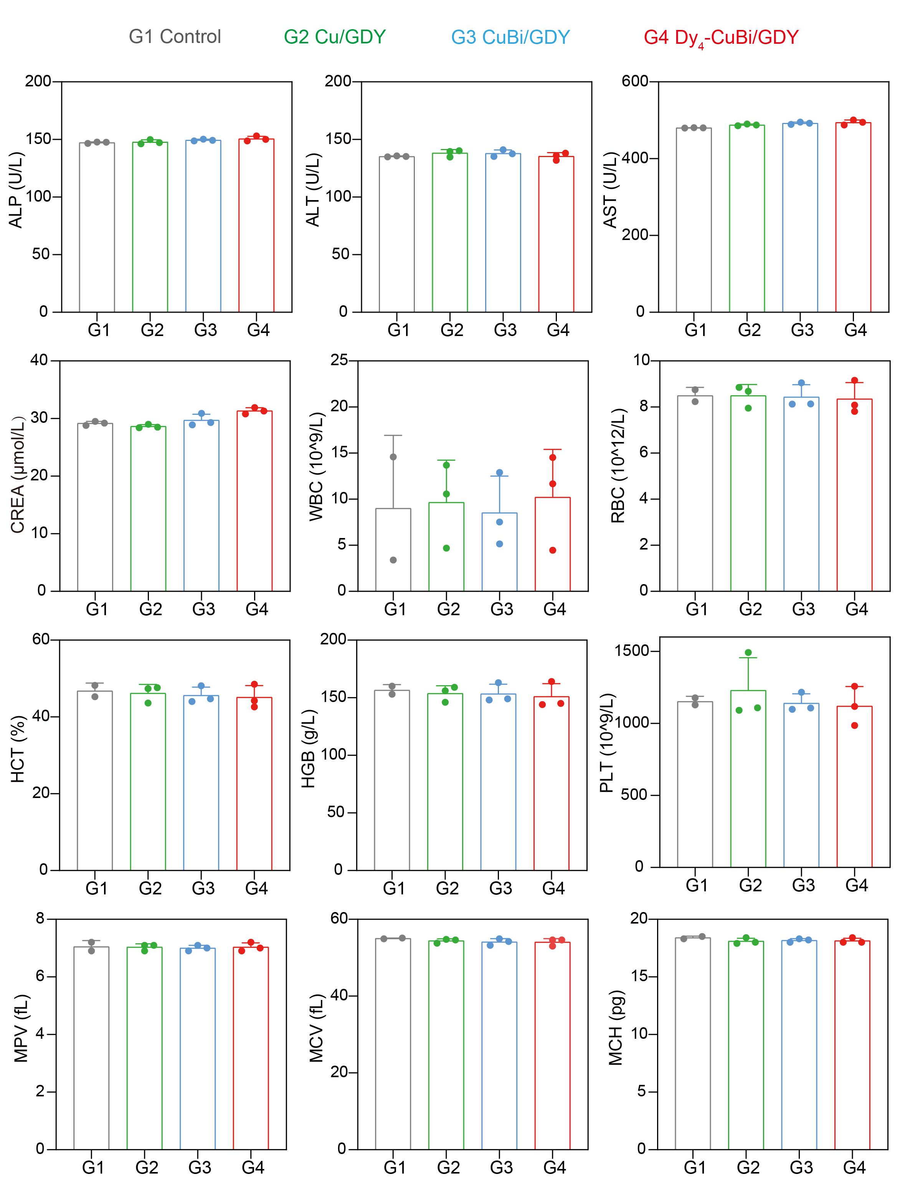
Figure S26. Blood biochemical and hematological analysis of mice bearing subcutaneous tumors after tail-vein injection of different treatment groups. G1 : Control, G2 : Cu/GDY, G3 : CuBi/GDY, G4 : Dy₄-CuBi/GDY. 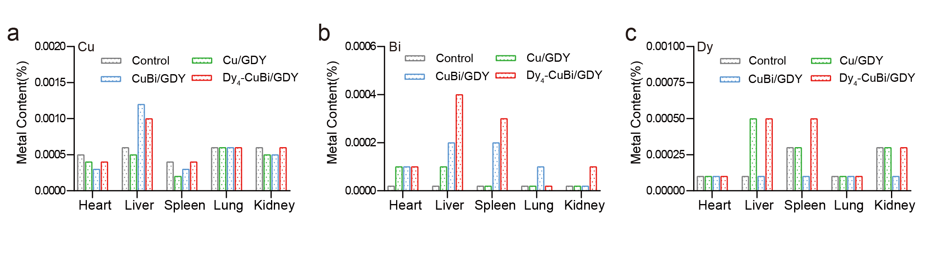Figure S27. Biodistribution of metal elements in mice from different treatment groups measured by ICP-MS.

Supplementary Table
Table S1. Crystallographic Parameters and Structural Refinement for a Tetranuclear Dysprosium Cluster
Identification code | DY2-100k-1
Empirical formula | C₇₁H₆₃Dy₄N₁₇O₂₁
Formula weight | 2140.38
Temperature/K | 100.00(10)
Crystal system | triclinic
Space group | P-1
a/Å | 14.5977(2)
b/Å | 16.3895(3)
c/Å | 18.3047(3)
α/° | 105.8700(10)
β/° | 91.1650(10)
γ/° | 90.7440(10)
Volume/Å3 | 4210.80(12)
Z | 2
ρcalcg/cm3 | 1.688
μ/mm‑1 | 3.585
F(000) | 2080.0
Radiation | MoK_{α} (λ = 0.71073)
2Θ range for data collection/° | 3.582 to 50.054
Index ranges | -17 ≤ h ≤ 17, -19 ≤ k ≤ 19, -21 ≤ l ≤ 21
Reflections collected | 57585
Independent reflections | 14880 [Rint = 0.0612, Rsigma = 0.0490]
Data/restraints/parameters | 14880/2462/1066
Goodness-of-fit on F2 | 1.037
Final R indexes [I>=2σ (I)]  Final R indexes [all data]  Largest diff. peak/hole /e Å-3 | R1 = 0.0512, wR2 = 0.1338  R1 = 0.0613, wR2 = 0.1418  4.69/-2.45

Table S2. Bond length parameters of the tetranuclear dysprosium cluster complex
Atom | Atom | Length/Å | Atom | Atom | Length/Å
Dy1 | Dy2 | 3.9436(5) | N10 | C38 | 1.315(10)
Dy1 | O1 | 2.279(6) | N11 | C39 | 1.360(10)
Dy1 | O2 | 2.436(5) | N11 | C43 | 1.353(10)
Dy1 | O10 | 2.371(7) | N12 | N13 | 1.398(10)
Dy1 | O11 | 2.349(6) | N12 | C44 | 1.325(11)
Dy1 | O12 | 2.422(7) | N13 | C45 | 1.270(12)
Dy1 | O13 | 2.351(6) | N14 | C46 | 1.319(13)
Dy1 | N1 | 2.510(8) | N14 | C54 | 1.362(13)
Dy1 | N2 | 2.526(7) | N15 | C58 | 1.326(13)
Dy2 | O2 | 2.462(5) | N15 | C59 | 1.455(13)
Dy2 | O3 | 2.418(5) | N15 | C60 | 1.455(13)
Dy2 | O9 | 2.397(5) | N16 | C55 | 1.369(17)
Dy2 | O10 | 2.429(6) | N16 | C56 | 1.430(13)
Dy2 | O14 | 2.316(6) | N16 | C57 | 1.516(14)
Dy2 | O15 | 2.516(10) | N17 | C65 | 1.345(14)
Dy2 | O16 | 2.461(11) | N17 | C66 | 1.481(16)
Dy2 | N13 | 2.530(8) | N17 | C67 | 1.483(15)
Dy2 | N14 | 2.503(8) | C1 | C2 | 1.390(13)
Dy2 | O16A | 2.478(11) | C1 | C6 | 1.434(15)
Dy2 | C63A | 2.806(15) | C2 | C3 | 1.431(15)
Dy2 | O15A | 2.467(11) | C3 | C4 | 1.366(15)
Dy3 | Dy4 | 3.8577(5) | C4 | C5 | 1.425(13)
Dy3 | O4 | 2.355(5) | C5 | C6 | 1.430(14)
Dy3 | O5 | 2.433(5) | C5 | C7 | 1.428(14)
Dy3 | O7 | 2.387(5) | C7 | C8 | 1.362(13)
Dy3 | O8 | 2.360(5) | C8 | C9 | 1.409(13)
Dy3 | O17 | 2.282(7) | C9 | C10 | 1.450(12)
Dy3 | O18 | 2.355(6) | C11 | C12 | 1.501(10)
Dy3 | N6 | 2.510(6) | C12 | C13 | 1.376(11)
Dy3 | N7 | 2.485(6) | C13 | C14 | 1.375(10)
Dy4 | O5 | 2.357(5) | C14 | C15 | 1.378(10)
Dy4 | O6 | 2.299(5) | C15 | C16 | 1.390(11)
Dy4 | O7 | 2.493(5) | C16 | C17 | 1.501(10)
Dy4 | O19 | 2.303(6) | C18 | C19 | 1.461(10)
Dy4 | O20 | 2.380(6) | C19 | C20 | 1.414(10)
Dy4 | O21 | 2.425(6) | C20 | C21 | 1.356(11)
Dy4 | N8 | 2.476(7) | C21 | C22 | 1.414(11)
Dy4 | N9 | 2.505(7) | C22 | C23 | 1.411(11)
Dy4 | C70 | 2.771(8) | C22 | C27 | 1.429(10)
O1 | C1 | 1.329(12) | C23 | C24 | 1.377(11)
O2 | C11 | 1.278(10) | C24 | C25 | 1.384(11)
O3 | N4 | 1.319(8) | C25 | C26 | 1.396(11)
O4 | C17 | 1.275(9) | C26 | C27 | 1.425(10)
O5 | C26 | 1.345(9) | C28 | C29 | 1.388(11)
O6 | C28 | 1.332(9) | C28 | C33 | 1.433(12)
O7 | C38 | 1.294(9) | C29 | C30 | 1.404(11)
O8 | N11 | 1.339(8) | C30 | C31 | 1.338(13)
O9 | C44 | 1.264(9) | C31 | C32 | 1.429(12)
O10 | C53 | 1.330(12) | C32 | C33 | 1.400(11)
O11 | C58 | 1.239(11) | C32 | C34 | 1.392(13)
O12 | C55 | 1.271(16) | C34 | C35 | 1.383(13)
O13 | C61 | 1.251(11) | C35 | C36 | 1.407(12)
O14 | C61 | 1.231(10) | C36 | C37 | 1.474(12)
O15 | C63 | 1.262(18) | C38 | C39 | 1.498(11)
O16 | C63 | 1.225(17) | C39 | C40 | 1.379(11)
O17 | C65 | 1.197(12) | C40 | C41 | 1.385(11)
O18 | C68 | 1.235(10) | C41 | C42 | 1.363(11)
O19 | C68 | 1.252(10) | C42 | C43 | 1.391(11)
O20 | C70 | 1.250(10) | C43 | C44 | 1.496(11)
O21 | C70 | 1.245(10) | C45 | C46 | 1.469(14)
N1 | C6 | 1.350(12) | C46 | C47 | 1.425(14)
N1 | C9 | 1.327(12) | C47 | C48 | 1.367(15)
N2 | N3 | 1.387(9) | C48 | C49 | 1.376(16)
N2 | C10 | 1.288(11) | C49 | C50 | 1.418(15)
N3 | C11 | 1.318(10) | C49 | C54 | 1.410(14)
N4 | C12 | 1.364(10) | C50 | C51 | 1.290(15)
N4 | C16 | 1.359(9) | C51 | C52 | 1.419(14)
N5 | N6 | 1.384(8) | C52 | C53 | 1.390(14)
N5 | C17 | 1.317(9) | C53 | C54 | 1.426(15)
N6 | C18 | 1.287(9) | C61 | C62 | 1.494(13)
N7 | C19 | 1.313(9) | C63 | C64 | 1.498(18)
N7 | C27 | 1.356(10) | C68 | C69 | 1.505(13)

Table S3. Bond angle parameters of the tetranuclear dysprosium cluster complex
Atom | Atom | Atom | Angle/˚ | Atom | Atom | Atom | Angle/˚
O1 | Dy1 | Dy2 | 132.15(18) | C38 | O7 | Dy4 | 117.0(4)
O1 | Dy1 | O2 | 168.7(2) | N11 | O8 | Dy3 | 120.9(4)
O1 | Dy1 | O10 | 101.4(2) | C44 | O9 | Dy2 | 120.5(5)
O1 | Dy1 | O11 | 101.9(2) | Dy1 | O10 | Dy2 | 110.5(2)
O1 | Dy1 | O12 | 90.7(2) | C53 | O10 | Dy1 | 125.0(6)
O1 | Dy1 | O13 | 81.4(2) | C53 | O10 | Dy2 | 119.3(6)
O1 | Dy1 | N1 | 67.0(2) | C58 | O11 | Dy1 | 154.8(6)
O1 | Dy1 | N2 | 128.6(2) | C55 | O12 | Dy1 | 121.7(8)
O2 | Dy1 | Dy2 | 36.61(13) | C61 | O13 | Dy1 | 129.9(6)
O2 | Dy1 | N1 | 124.1(2) | C61 | O14 | Dy2 | 138.1(6)
O2 | Dy1 | N2 | 62.5(2) | C63 | O15 | Dy2 | 90.9(9)
O10 | Dy1 | Dy2 | 35.25(15) | C63 | O16 | Dy2 | 94.4(9)
O10 | Dy1 | O2 | 68.4(2) | C65 | O17 | Dy3 | 135.7(7)
O10 | Dy1 | O12 | 74.6(2) | C68 | O18 | Dy3 | 139.4(5)
O10 | Dy1 | N1 | 142.5(2) | C68 | O19 | Dy4 | 132.9(6)
O10 | Dy1 | N2 | 117.8(2) | C70 | O20 | Dy4 | 94.4(5)
O11 | Dy1 | Dy2 | 107.32(15) | C70 | O21 | Dy4 | 92.3(5)
O11 | Dy1 | O2 | 84.04(19) | C6 | N1 | Dy1 | 115.7(6)
O11 | Dy1 | O10 | 139.6(2) | C9 | N1 | Dy1 | 123.9(6)
O11 | Dy1 | O12 | 137.2(2) | C9 | N1 | C6 | 120.2(8)
O11 | Dy1 | O13 | 76.0(2) | N3 | N2 | Dy1 | 120.9(5)
O11 | Dy1 | N1 | 77.5(2) | C10 | N2 | Dy1 | 123.0(6)
O11 | Dy1 | N2 | 69.3(2) | C10 | N2 | N3 | 115.8(7)
O12 | Dy1 | Dy2 | 92.68(19) | C11 | N3 | N2 | 109.5(7)
O12 | Dy1 | O2 | 91.4(2) | O3 | N4 | C12 | 119.4(6)
O12 | Dy1 | N1 | 70.2(3) | O3 | N4 | C16 | 120.1(6)
O12 | Dy1 | N2 | 71.0(2) | C16 | N4 | C12 | 120.6(6)
O13 | Dy1 | Dy2 | 70.28(15) | C17 | N5 | N6 | 108.1(6)
O13 | Dy1 | O2 | 90.84(19) | N5 | N6 | Dy3 | 120.3(4)
O13 | Dy1 | O10 | 75.5(2) | C18 | N6 | Dy3 | 121.4(5)
O13 | Dy1 | O12 | 146.7(3) | C18 | N6 | N5 | 118.2(6)
O13 | Dy1 | N1 | 132.9(2) | C19 | N7 | Dy3 | 122.1(5)
O13 | Dy1 | N2 | 137.5(2) | C19 | N7 | C27 | 119.4(6)
N1 | Dy1 | Dy2 | 155.89(17) | C27 | N7 | Dy3 | 115.9(5)
N1 | Dy1 | N2 | 61.7(2) | C33 | N8 | Dy4 | 116.9(5)
N2 | Dy1 | Dy2 | 97.27(16) | C36 | N8 | Dy4 | 122.5(5)
O2 | Dy2 | O15 | 93.9(4) | C36 | N8 | C33 | 119.9(7)
O2 | Dy2 | N13 | 145.7(2) | N10 | N9 | Dy4 | 121.7(4)
O2 | Dy2 | N14 | 128.7(2) | C37 | N9 | Dy4 | 122.8(5)
O2 | Dy2 | O16A | 140.6(4) | C37 | N9 | N10 | 115.4(7)
O2 | Dy2 | C63A | 124.8(5) | C38 | N10 | N9 | 108.9(6)
O3 | Dy2 | O2 | 67.65(17) | O8 | N11 | C43 | 120.7(6)
O3 | Dy2 | O10 | 111.3(2) | C43 | N11 | C39 | 121.6(7)
O3 | Dy2 | O15 | 66.2(3) | C44 | N12 | N13 | 108.1(7)
O3 | Dy2 | O16 | 72.7(4) | N12 | N13 | Dy2 | 120.4(5)
O3 | Dy2 | N13 | 121.9(2) | C45 | N13 | Dy2 | 123.2(7)
O3 | Dy2 | N14 | 149.1(2) | C45 | N13 | N12 | 116.2(8)
O3 | Dy2 | O16A | 73.9(4) | C46 | N14 | Dy2 | 122.2(6)
O3 | Dy2 | C63A | 69.4(5) | C46 | N14 | C54 | 119.5(9)
O3 | Dy2 | O15A | 71.7(4) | C54 | N14 | Dy2 | 118.0(7)
O9 | Dy2 | O2 | 95.07(18) | C58 | N15 | C59 | 120.7(9)
O9 | Dy2 | O3 | 71.95(18) | C58 | N15 | C60 | 121.8(9)
O9 | Dy2 | O10 | 157.1(2) | C60 | N15 | C59 | 117.4(9)
O9 | Dy2 | O15 | 129.7(3) | C55 | N16 | C56 | 124.3(13)
O9 | Dy2 | O16 | 90.6(4) | C55 | N16 | C57 | 112.5(12)
O9 | Dy2 | N13 | 62.5(2) | C56 | N16 | C57 | 123.0(12)
O9 | Dy2 | N14 | 124.2(2) | C65 | N17 | C66 | 121.9(10)
O9 | Dy2 | O16A | 80.7(4) | C65 | N17 | C67 | 120.6(10)
O9 | Dy2 | C63A | 102.9(4) | C66 | N17 | C67 | 117.4(9)
O9 | Dy2 | O15A | 126.5(3) | O1 | C1 | C2 | 124.4(10)
O10 | Dy2 | O2 | 67.1(2) | O1 | C1 | C6 | 118.3(8)
O10 | Dy2 | O15 | 68.3(3) | C2 | C1 | C6 | 117.3(9)
O10 | Dy2 | O16 | 112.2(4) | C1 | C2 | C3 | 120.0(10)
O10 | Dy2 | N13 | 124.9(2) | C4 | C3 | C2 | 123.0(10)
O10 | Dy2 | N14 | 65.1(2) | C3 | C4 | C5 | 119.2(10)
O10 | Dy2 | O16A | 122.2(4) | C4 | C5 | C6 | 118.0(10)
O10 | Dy2 | C63A | 99.3(4) | C4 | C5 | C7 | 125.5(9)
O10 | Dy2 | O15A | 74.2(4) | C7 | C5 | C6 | 116.5(9)
O14 | Dy2 | O2 | 76.5(2) | N1 | C6 | C1 | 115.6(8)
O14 | Dy2 | O3 | 133.9(2) | N1 | C6 | C5 | 121.9(9)
O14 | Dy2 | O9 | 83.68(19) | C5 | C6 | C1 | 122.5(9)
O14 | Dy2 | O10 | 78.3(2) | C8 | C7 | C5 | 119.8(9)
O14 | Dy2 | O15 | 146.3(3) | C7 | C8 | C9 | 120.1(10)
O14 | Dy2 | O16 | 147.7(4) | N1 | C9 | C8 | 121.5(8)
O14 | Dy2 | N13 | 75.5(2) | N1 | C9 | C10 | 114.0(8)
O14 | Dy2 | N14 | 76.8(2) | C8 | C9 | C10 | 124.6(9)
O14 | Dy2 | O16A | 140.6(4) | N2 | C10 | C9 | 117.3(8)
O14 | Dy2 | C63A | 156.1(5) | O2 | C11 | N3 | 127.3(7)
O14 | Dy2 | O15A | 148.6(3) | O2 | C11 | C12 | 120.3(7)
O15 | Dy2 | N13 | 120.3(4) | N3 | C11 | C12 | 112.3(7)

Table S4. XPS peak summary of Cu/GDY, CuBi/GDY and Dy₄-CuBi/GDY
Materials | C1s |  |  |  | Cu2p |  |  |  | Bi4f |  | Dy3d
Materials | C≡C | C=C | C-O | C=O | Cu⁺ |  | Cu²⁺ |  | Bi4f_{5/2} | Bi4f_{7/2} | 3d_{5/2}
 |  |  |  |  | 2p_{3/2} | 2p_{1/2} | 2p_{3/2} | 2p_{1/2} | Bi4f_{5/2} | Bi4f_{7/2} | 3d_{5/2}
Cu/GDY | 284.99 | 284.25 | 286.38 | 288.18 | 933.08 | 952.82 | 934.76 | 954.58 | _ | _ | _
CuBi/GDY | 284.93 | 284.48 | 285.98 | 288.06 | 932.74 | 952.32 | 934.38 | 953.73 | 164.16 | 158.88 | _
Dy₄-CuBi/GDY | 285.01 | 284.31 | 285.91 | 288.87 | 932.99 | 952.34 | 934.71 | 954.48 | 164.5 | 159.2 | 1297.08

