SUPPLEMENTARY MATERIAL: Low-Cost Gait Analysis Technologies for Clinical and Real-World Assessment: A Scoping Review of Validity, Reliability, and Clinical Utility
Table of Content
Supplementary Table S1. Characteristics of Included Human Studies and Population Classification
Supplementary Table S2. Technology Classification and Device Characteristics
Supplementary Table S3. Study-Level Validity Evidence
Supplementary Table S4. Study-Level Reliability, Measurement Error, and Responsiveness Evidence
Supplementary Table S5. Clinical Utility, Home-Use, Telehealth Readiness, and Affordability Evidence
Supplementary Table S6. Evidence Gaps Across Technologies and Implementation
Supplementary Table S7. Study-Level Classification of Gait Outcome Domains
Supplementary Table S8. Assessment Settings and Intended-Use Contexts
Supplementary Table S9. Study-Level Methodological Appraisal
Supplementary Figure S1. Evidence Map of Technology Categories Across Population Characteristics
Supplementary Figure S2. Evidence Map of Technology Categories Across Assessment Settings
Supplementary Figure S3. Evidence Map of Technology Categories by Intended-Use Context
Supplementary Figure S4. Evidence Map of Technology Categories by Country-Income Classification
Supplementary Figure S5. Evidence Gap Map Highlighting Research Priorities for Low-Cost Gait-Analysis Technologies
Appendix A. Complete Search Strategies for All Databases

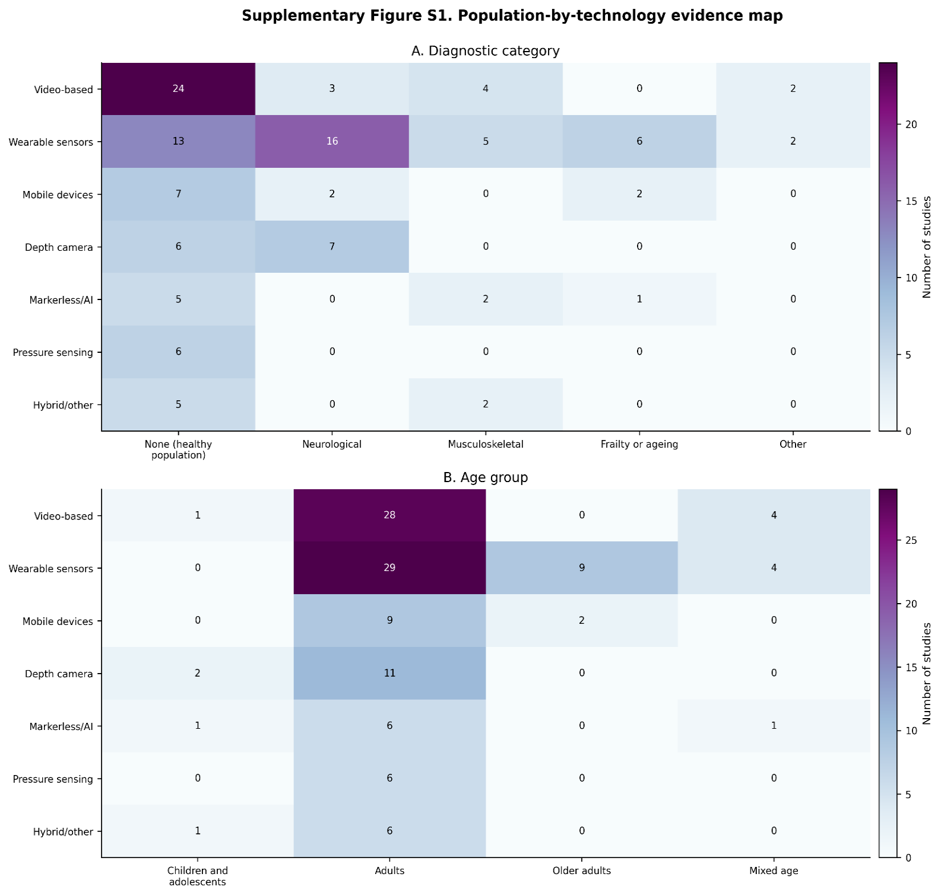
Supplementary Figure S1. Population-by-technology evidence map

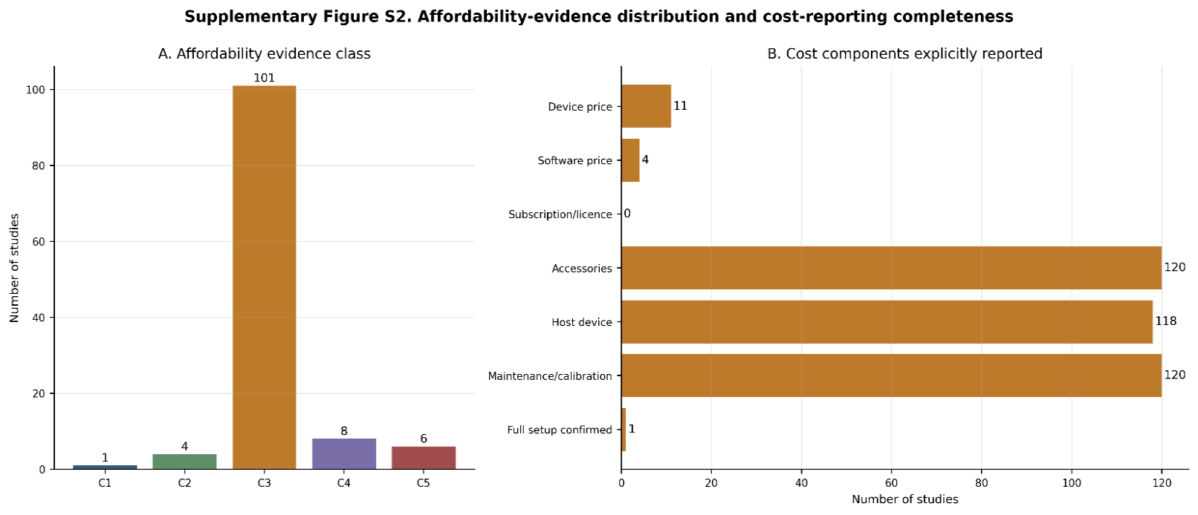
Supplementary Figure S2. Affordability-evidence distribution and cost-reporting completeness

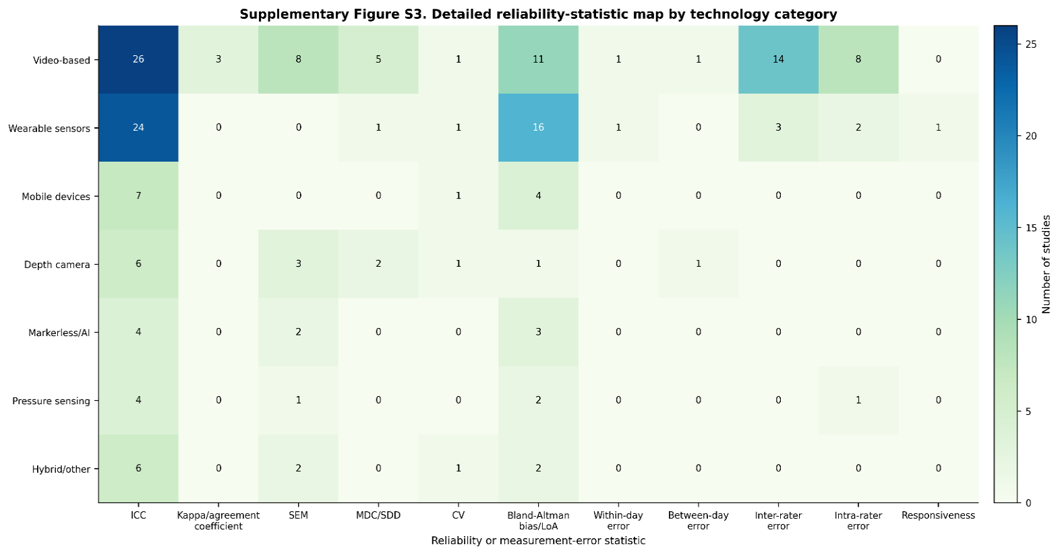
Supplementary Figure S3. Detailed reliability-statistic map

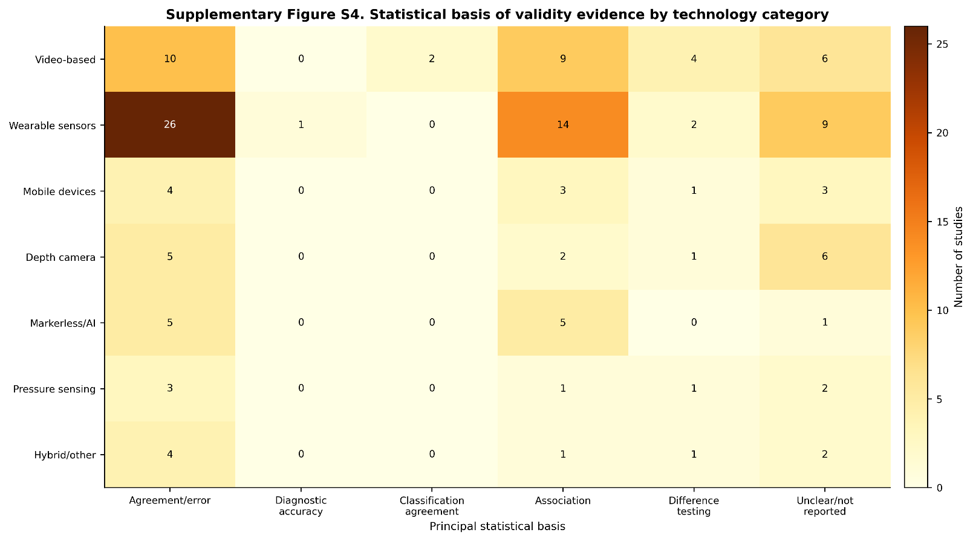
Supplementary Figure S4. Statistical basis of validity evidence

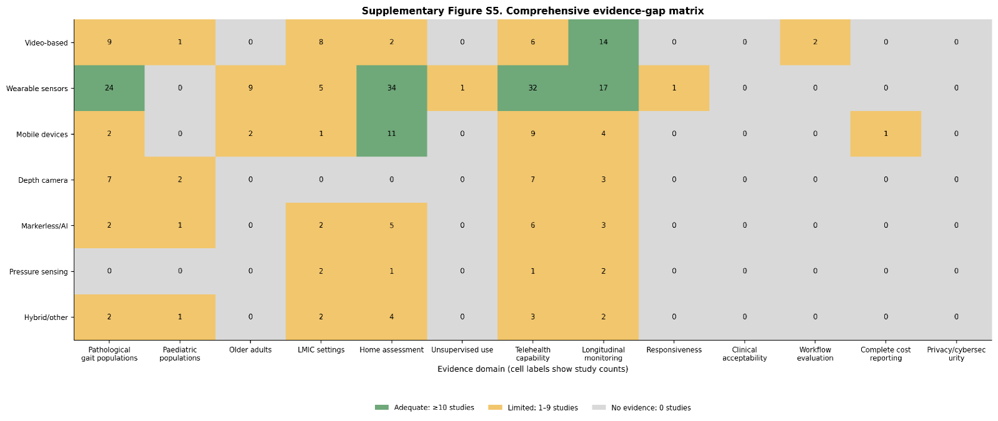
Supplementary Figure S5. Comprehensive evidence-gap matrix
The descriptive thresholds are: adequate evidence: ≥10 studies; limited evidence: 1–9 studies; no evidence: 0 studies.

Appendix A. Complete Search Strategies for All Databases
A1. PubMed/MEDLINE
(("Gait"[Mesh] OR "Walking"[Mesh] OR gait[tiab] OR walking[tiab] OR locomot*[tiab])
AND
("Wearable Electronic Devices"[Mesh] OR "Accelerometry"[Mesh] OR "Sensors"[Mesh] OR "Smartphone"[Mesh] OR "Video Recording"[Mesh] OR "Mobile Applications"[Mesh]
OR wearable*[tiab] OR sensor*[tiab] OR inertial[tiab] OR "inertial measurement unit*"[tiab]
OR IMU[tiab] OR IMUs[tiab] OR acceleromet*[tiab] OR gyroscop*[tiab]
OR smartphone*[tiab] OR "mobile phone*"[tiab] OR "mobile application*"[tiab]
OR app[tiab] OR apps[tiab] OR video[tiab]
OR camera-based[tiab] OR video-based[tiab]
OR "motion analysis"[tiab] OR "motion capture"[tiab]
OR Kinect[tiab] OR "depth sensor*"[tiab] OR markerless[tiab])
AND
("Reproducibility of Results"[Mesh]
OR validity[tiab] OR valid*[tiab] OR reliab*[tiab]
OR reproducib*[tiab] OR repeatab*[tiab]
OR feasib*[tiab] OR usability[tiab]
OR "ease of use"[tiab] OR acceptab*[tiab]
OR interpretab*[tiab] OR "clinical utility"[tiab]
OR utility[tiab] OR accuracy[tiab]
OR agreement[tiab]
OR "Bland-Altman"[tiab]
OR ICC[tiab]
OR "intraclass correlation"[tiab]
OR sensitivity[tiab]
OR specificity[tiab])
AND
(low-cost[tiab]
OR "low cost"[tiab]
OR affordable[tiab]
OR inexpensive[tiab]
OR portable[tiab]
OR consumer-grade[tiab]
OR "resource-limited"[tiab]
OR "resource constrained"[tiab]
OR clinic-based[tiab]
OR "point of care"[tiab]
OR accessible[tiab]
OR cost[tiab]
OR costs[tiab]))
NOT (animals[mh] NOT humans[mh])

A2. Embase (Ovid/Elsevier)
(
'gait'/exp
OR 'walking'/exp
OR gait:ti,ab
OR walking:ti,ab
OR locomot*:ti,ab
)
AND
(
'wearable device'/exp
OR 'sensor'/exp
OR 'accelerometer'/exp
OR 'smartphone'/exp
OR 'mobile application'/exp
OR 'video recording'/exp
OR wearable*:ti,ab
OR sensor*:ti,ab
OR inertial:ti,ab
OR 'inertial measurement unit*':ti,ab
OR imu:ti,ab
OR imus:ti,ab
OR acceleromet*:ti,ab
OR gyroscop*:ti,ab
OR smartphone*:ti,ab
OR 'mobile phone*':ti,ab
OR 'mobile application*':ti,ab
OR app:ti,ab
OR apps:ti,ab
OR video:ti,ab
OR 'camera-based':ti,ab
OR 'video-based':ti,ab
OR 'motion analysis':ti,ab
OR 'motion capture':ti,ab
OR kinect:ti,ab
OR 'depth sensor*':ti,ab
OR markerless:ti,ab
)
AND
(
'validity'/exp
OR 'reliability'/exp
OR 'reproducibility'/exp
OR valid*:ti,ab
OR reliab*:ti,ab
OR reproducib*:ti,ab
OR repeatab*:ti,ab
OR feasib*:ti,ab
OR usability:ti,ab
OR 'ease of use':ti,ab
OR acceptab*:ti,ab
OR interpretab*:ti,ab
OR 'clinical utility':ti,ab
OR utility:ti,ab
OR accuracy:ti,ab
OR agreement:ti,ab
OR 'bland-altman':ti,ab
OR icc:ti,ab
OR 'intraclass correlation':ti,ab
OR sensitivity:ti,ab
OR specificity:ti,ab
)
AND
(
'low cost':ti,ab
OR low-cost:ti,ab
OR affordable:ti,ab
OR inexpensive:ti,ab
OR portable:ti,ab
OR 'consumer-grade':ti,ab
OR 'resource-limited':ti,ab
OR 'resource constrained':ti,ab
OR accessible:ti,ab
)
AND [humans]/lim
AND [english]/lim

A3. CINAHL (EBSCOhost)
(
(MH "Gait+")
OR (MH "Walking+")
OR TI(gait OR walking OR locomot*)
OR AB(gait OR walking OR locomot*)
)
AND
(
(MH "Wearable Sensors+")
OR (MH "Accelerometers+")
OR (MH "Smartphone+")
OR (MH "Mobile Applications+")
OR (MH "Video Recording+")
OR TI(wearable* OR sensor* OR inertial OR "inertial measurement unit*" OR IMU OR IMUs OR acceleromet* OR gyroscop* OR smartphone* OR "mobile phone*" OR "mobile application*" OR app OR apps OR video OR camera-based OR video-based OR "motion analysis" OR "motion capture" OR Kinect OR "depth sensor*" OR markerless)
OR AB(wearable* OR sensor* OR inertial OR "inertial measurement unit*" OR IMU OR IMUs OR acceleromet* OR gyroscop* OR smartphone* OR "mobile phone*" OR "mobile application*" OR app OR apps OR video OR camera-based OR video-based OR "motion analysis" OR "motion capture" OR Kinect OR "depth sensor*" OR markerless)
)
AND
(
(MH "Validity")
OR (MH "Reproducibility of Results")
OR TI(valid* OR reliab* OR reproducib* OR repeatab* OR feasib* OR usability OR "ease of use" OR acceptab* OR interpretab* OR "clinical utility" OR utility OR accuracy OR agreement OR "Bland-Altman" OR ICC OR "intraclass correlation" OR sensitivity OR specificity)
OR AB(valid* OR reliab* OR reproducib* OR repeatab* OR feasib* OR usability OR "ease of use" OR acceptab* OR interpretab* OR "clinical utility" OR utility OR accuracy OR agreement OR "Bland-Altman" OR ICC OR "intraclass correlation" OR sensitivity OR specificity)
)
AND
(
TI("low cost" OR low-cost OR affordable OR inexpensive OR portable OR consumer-grade OR "resource-limited" OR "resource constrained" OR accessible)
OR AB("low cost" OR low-cost OR affordable OR inexpensive OR portable OR consumer-grade OR "resource-limited" OR "resource constrained" OR accessible)
)

Limiters: English Language; Human

A4. Scopus
TITLE-ABS-KEY
(
(gait OR walking OR locomot*)
AND
(
wearable* OR sensor* OR inertial
OR "inertial measurement unit*"
OR imu OR imus
OR acceleromet*
OR gyroscop*
OR smartphone*
OR "mobile phone*"
OR "mobile application*"
OR app
OR apps
OR video
OR "video-based"
OR "camera-based"
OR "motion analysis"
OR "motion capture"
OR kinect
OR "depth sensor*"
OR markerless
)
AND
(
valid*
OR reliab*
OR reproducib*
OR repeatab*
OR feasib*
OR usability
OR "ease of use"
OR acceptab*
OR interpretab*
OR "clinical utility"
OR utility
OR accuracy
OR agreement
OR "bland-altman"
OR icc
OR "intraclass correlation"
OR sensitivity
OR specificity
)
AND
(
"low cost"
OR low-cost
OR affordable
OR inexpensive
OR portable
OR consumer-grade
OR "resource-limited"
OR "resource constrained"
OR accessible
)
)
AND NOT TITLE-ABS-KEY(animal AND NOT human)
AND (LIMIT-TO(LANGUAGE,"English"))

A5. Web of Science Core Collection
TS=
(
(gait OR walking OR locomot*)
AND
(
wearable*
OR sensor*
OR inertial
OR "inertial measurement unit*"
OR IMU
OR IMUs
OR acceleromet*
OR gyroscop*
OR smartphone*
OR "mobile phone*"
OR "mobile application*"
OR app
OR apps
OR video
OR "video-based"
OR "camera-based"
OR "motion analysis"
OR "motion capture"
OR Kinect
OR "depth sensor*"
OR markerless
)
AND
(
valid*
OR reliab*
OR reproducib*
OR repeatab*
OR feasib*
OR usability
OR "ease of use"
OR acceptab*
OR interpretab*
OR "clinical utility"
OR utility
OR accuracy
OR agreement
OR "Bland-Altman"
OR ICC
OR "intraclass correlation"
OR sensitivity
OR specificity
)
AND
(
"low cost"
OR low-cost
OR affordable
OR inexpensive
OR portable
OR consumer-grade
OR "resource-limited"
OR "resource constrained"
OR accessible
)
)

Refined by: Languages = English

A6. IEEE Xplore
(
("Document Title":gait
OR "Document Title":walking
OR Abstract:gait
OR Abstract:walking)
AND
(
Abstract:wearable
OR Abstract:sensor
OR Abstract:inertial
OR Abstract:"inertial measurement unit"
OR Abstract:IMU
OR Abstract:accelerometer
OR Abstract:gyroscope
OR Abstract:smartphone
OR Abstract:"mobile application"
OR Abstract:video
OR Abstract:"motion analysis"
OR Abstract:"motion capture"
OR Abstract:Kinect
OR Abstract:markerless
)
AND
(
Abstract:validity
OR Abstract:reliability
OR Abstract:feasibility
OR Abstract:usability
OR Abstract:"clinical utility"
OR Abstract:accuracy
OR Abstract:agreement
)
)

