Supplementary material

Application of Calcium-rich Clay Mineral Under Nonwoven Fabric Mats and Sand Armor as Cap Layer for Interrupting N and P Release from River Sediments

Seung-Hee Hong ª, Chang-Gu Lee ^{b}, Seong-Jik Park ^{a,c,*}

ª Department of Integrated System Engineering, Hankyong National University, Anseong, 17579 Republic of Korea
^{b} Department of Environmental and Safety Engineering, Ajou University, Suwon 16499, Republic of Korea
^{c} Department of Bioresources and Rural System Engineering, Hankyong National University, Anseong, 17579 Republic of Korea

*Corresponding author: Tel. +82 670 5131; email: parkseongjik@hknu.ac.kr (S.-J. Park)

2.4 Analysis of sediments and water
Sediment water content was measured by weight loss after drying at 105 °C for 24 h. Dried sediment was then passed through a 2.0 mm sieve, with the fraction < 2.0 mm used for soil chemical analysis. The pH and EC were measured using a pH/EC meter (Seven-multi S40, Mettler Toledo, Switzerland) after 10 g of soil was shaken with 50 mL of deionized water for 30 min. Organic matter (OM) was determined by weight loss after heating in a furnace at 550 °C for 4 h. T-N was determined using the Kjeldahl digestion method using K₂SO₄ and CuSO₄ (9:1) as a catalyst. NH₃-N was measured using the colorimetric method after extracting 5.0 g of soil with 50 mL of 2 M KCl and filtering with a glass filter (No.2, Whatman, USA), while NO₃-N was measured using the Brucine method after extraction with 2 M KCl. T-P was determined by the ascorbic acid reduction method after thermal decomposition using perchloric acid (HClO₄). The available phosphate content was determined using the Lancaster method. COD was measured by titration with 0.1 N Na₂S₂O₃·5H₂O after oxidizing the soil with 0.1 N KMnO₄.
Prompt chemical analysis of water samples was assumed to reduce errors resulting from time delays. In the case of the water samples, DO was measured using a DO meter (HI 9146, Hanna, Romania). The pH and EC were measured using a pH/EC meter. COD was measured using the chromic acid method, in which the samples were oxidized by K₂Cr₂O₇. T-N was analyzed with a UV spectrophotometer (Optizen POP QX, Mecasys Co., Republic of Korea) after thermal decomposition using NaOH and K₂S₂O₈. NH₄-N was analyzed using the indophenol method, and NO₃-N was analyzed using the Brucine method. T-P was measured using the ascorbic acid reduction method after digestion with K₂S₂O₈, while PO₄-P was measured using the stannous chloride method.

2.5 Sequential extraction of phosphorus
The P fractions in the capping materials and sediments after the incubation experiments were analyzed according to the method described by Hieltjest and Lijklema (1980). Each fraction and its procurement method are as follows. (1) T-P: Add 20 mL of HClO₄ to 1 g of the sediment sample, boil for 2 h, add 100 mL of distilled water, adjust 5 mL of the solution to pH 1.8–2.2 using 5 N NaOH, and add another 50 mL of distilled water. (2) Adsorbed-P: Add 25 mL of 1-M NH₄Cl to 1 g of sample and shake for 2 h. (3) Non-apatite inorganic phosphorus (NAI-P): Add 25 mL of 0.1-N NaOH to 1 g of sample and shake for 17 h. (4) Apatite-P: Add 25 mL of 1-M HCl to 1 g of sample and shake for 24 h. (5) Residual-P: Subtract Adsorbed-P, NAI-P, and Apatite-P from T-P.

2.6 Data analysis
The flux of nutrients released from contaminated sediments to overlying water was calculated as follows (Schaanning et al., 2006; Lin et al., 2011):
$$J_{D}=\frac{∆C×V}{A×t}$$ | (1)
where J_{D} is the flux of nutrients released from contaminated sediments during the incubation experiment (mg/m²·d), ΔC is the difference between nutrient concentrations at time t and the start of the experiment (mg/L), V is the volume of overlying water (L), A is the cross-sectional area of the column reactor (m²), and t is the period between sampling and the start of the incubation experiment (d).

Table S1 Properties of water and sediment sampled from Geum River in February 2019.
Water |  | Sediment
Property | value | Property | Value
pH | 6.52 | pH | 6.18
EC (µS/cm) | 462 | EC (µS/cm) | 140.7
DO (mg/L) | 8.71 | Organic matter (%) | 9.98
SS (mg/L) | 230 | Water contents (%) | 49.47
ORP (mV) | -57.5 | TOC (%) | 2.62
T-N (mg/L) | 4.12 | T-N (mg/kg) | 2478
NH₄-N (mg/L) | 0.67 | NH₃-N (mg/kg) | 28.51
NO₃-N (mg/L) | 3.22 | NO₃-N(mg/kg) | 0.73
T-P (mg/L) | 0.13 | T-P (mg/kg) | 829.8
PO₄-P (mg/L) | 0.08 | SRP (mg/kg) | 2.3
COD (mg/L) | 10.4 | COD (mg/kg) | 60400

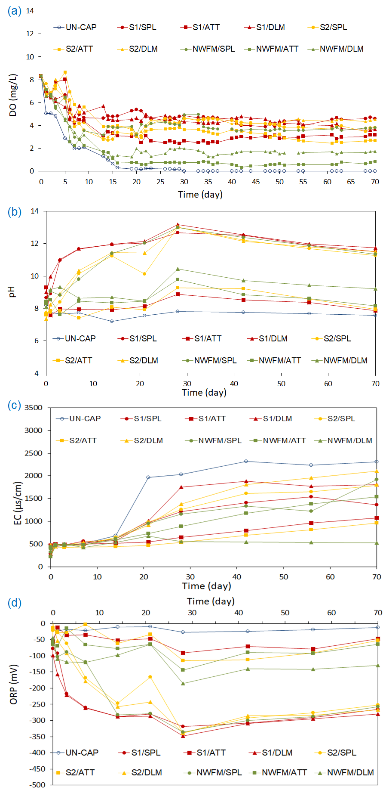
Fig. S1 Changes in water environmental conditions during 70 days of laboratory incubations: (a) dissolved oxygen (mg/L); (b) pH; (c) electric conductivity (μS/cm); (d) oxidation reduction potential (mV) in the water overlying uncapped sediments and sediments capped with different Ca-rich clay minerals (sepiolite (SPL), attapulgite (ATT), and dolomite (DLM)) and armor materials (sand 1 cm (S1), sand 2 cm (S2), and non-woven fabric mats (NWFM)) during 70 days of laboratory incubations.

