Enhancement of essential oil yield in Ocimum americanum L. across ontogenetic phases by Bacillus subtilis MTCC 8141 and Trichoderma harzianum MTCC 936 and its termiticidal efficacy against Odontotermes parvidens

Nilakhi Kakoti¹, Munmi Borkataky^{2*}
^{1, 2} Department of Life Sciences, Dibrugarh University, Dibrugarh, Assam, India
¹kakoti.nilz95@gmail.com
ORCID - 0000-0001-6724-1878
^{2*}mbk139@gmail.com
ORCID - 0000-0002-3433-4004
Corresponding author: Munmi Borkataky

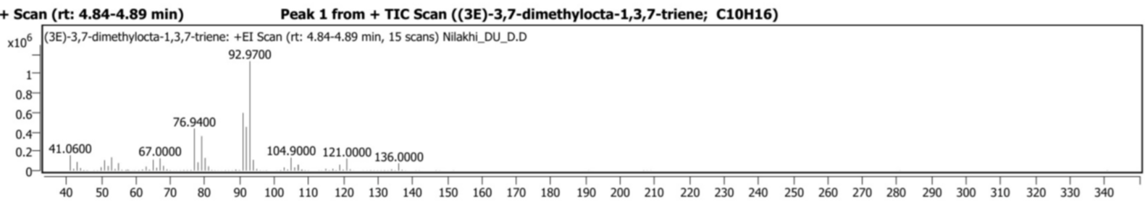
A

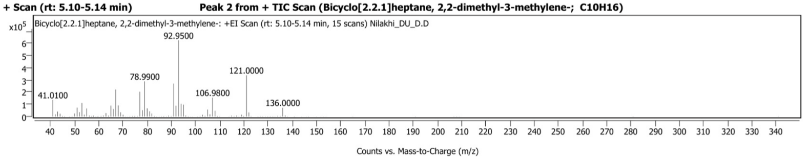
B

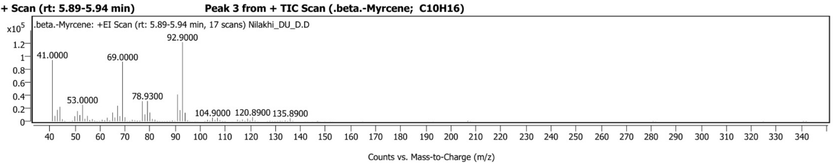
C
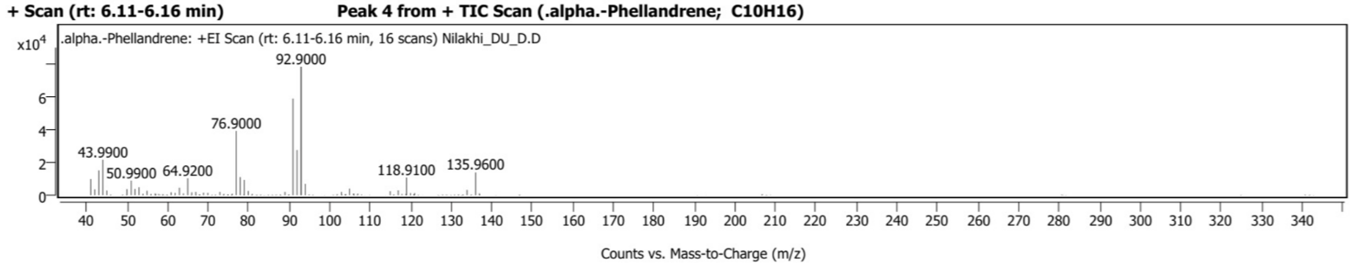
D

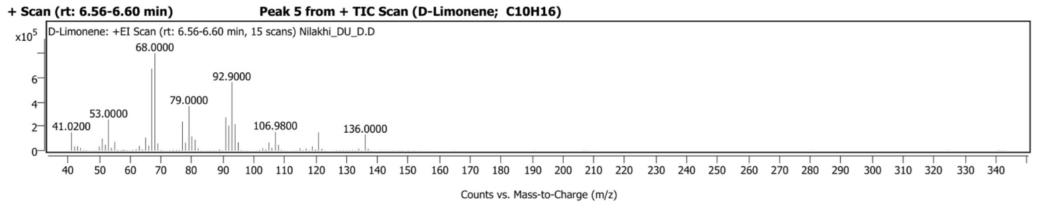
E

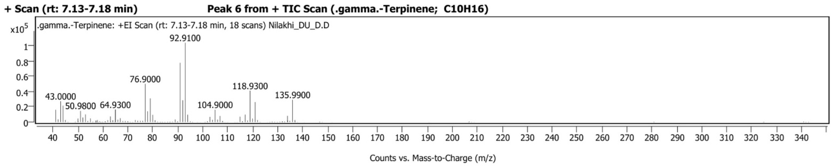
F

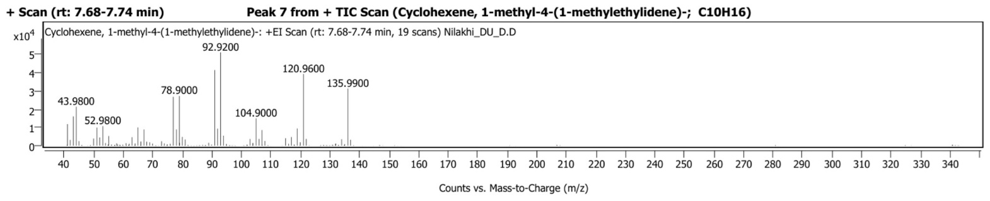
G

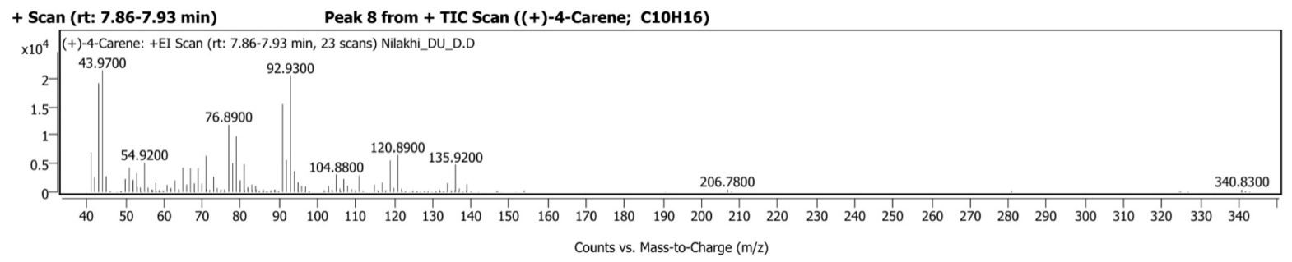
H

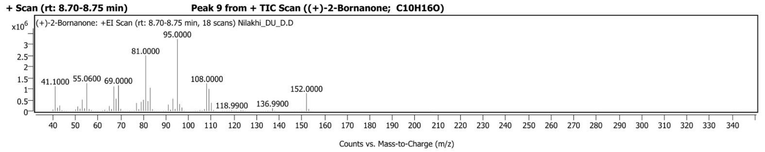
I

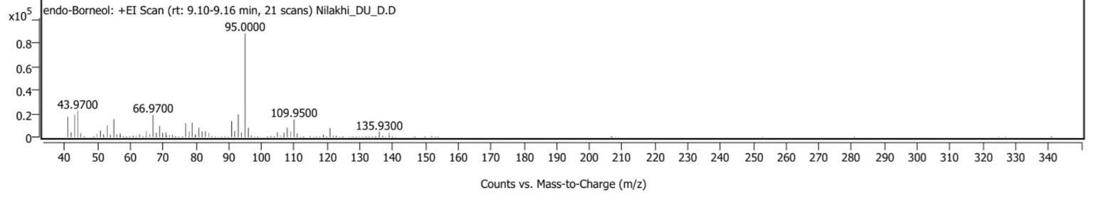
J

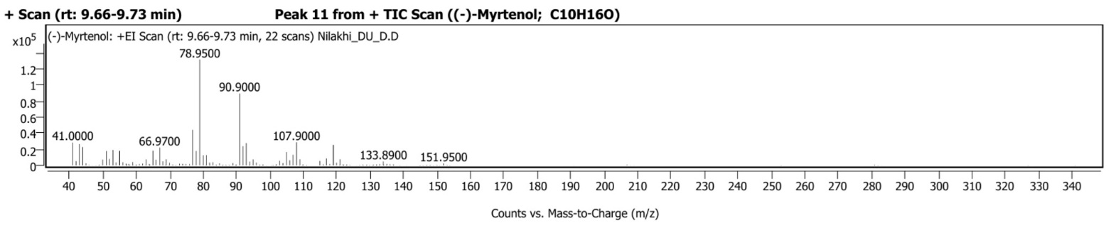
K

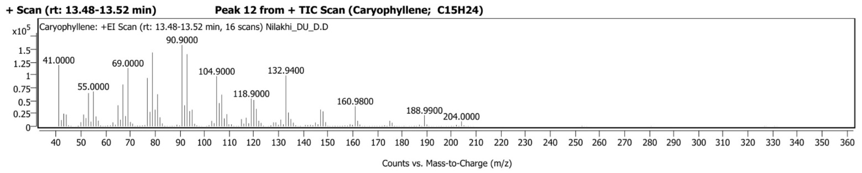
L

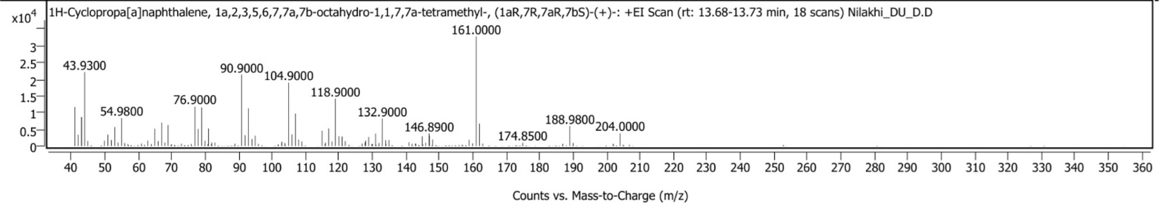
M

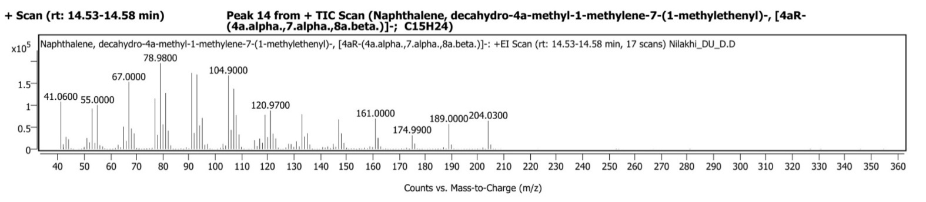
N

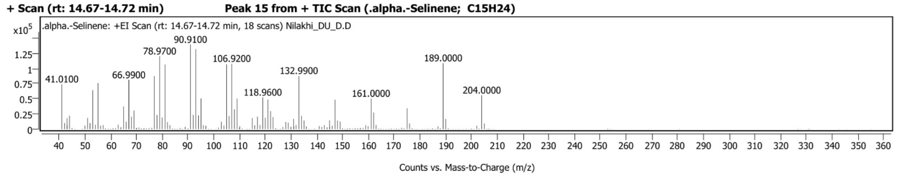
O
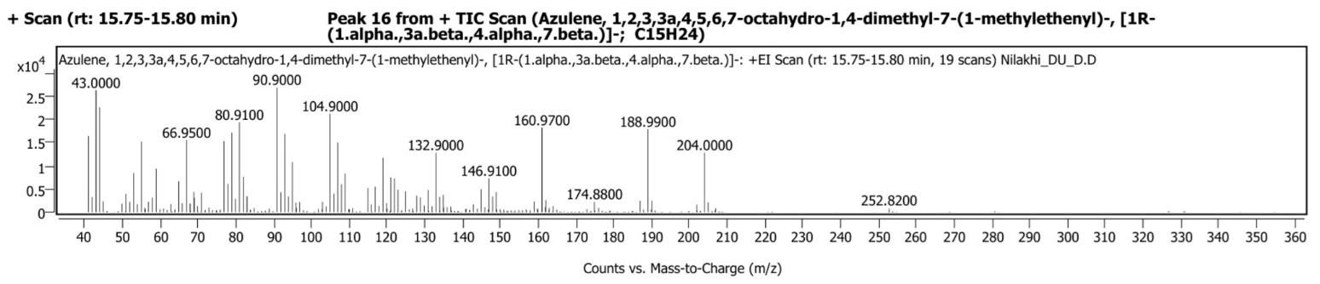
P

Fig. 1 (A-P) GC–MS chromatograms of the essential oils extracted from O. americanum inoculated plants

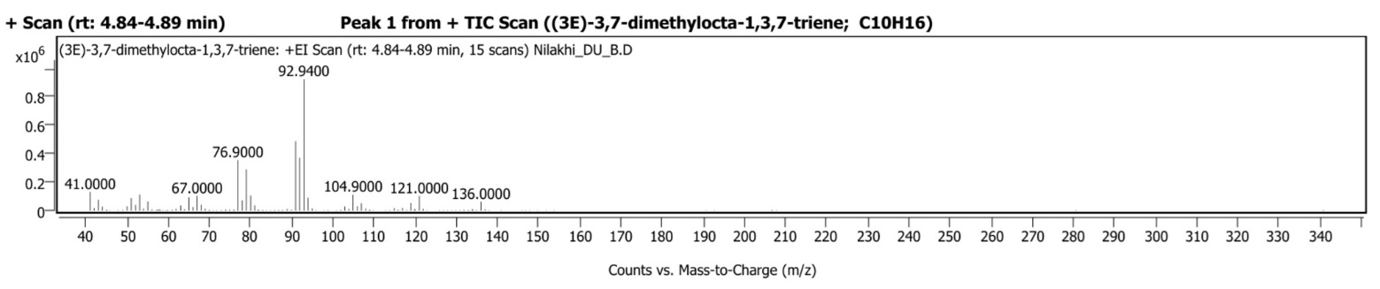
A

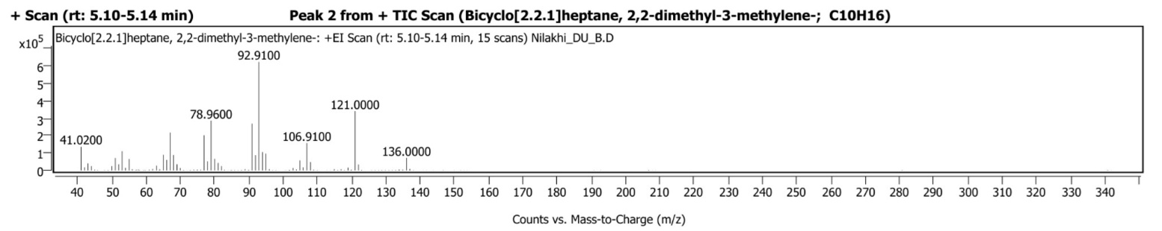
B

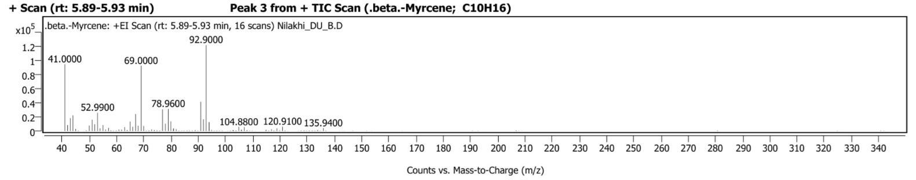
C

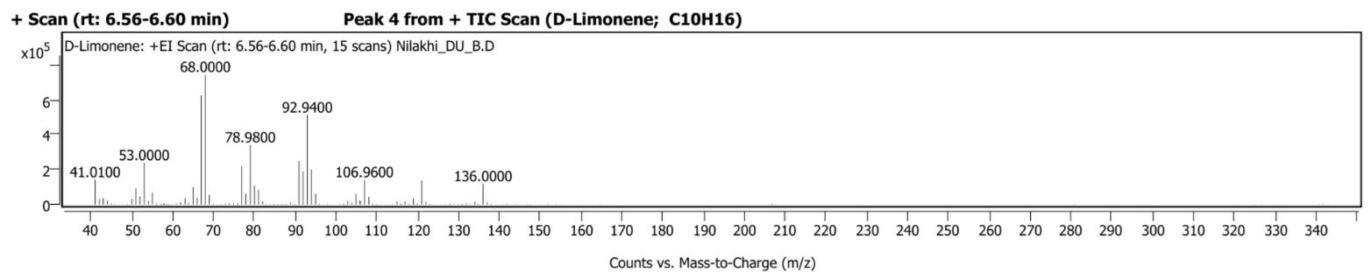
D

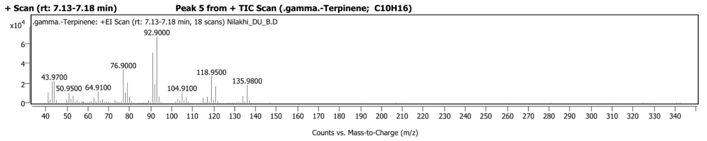
E

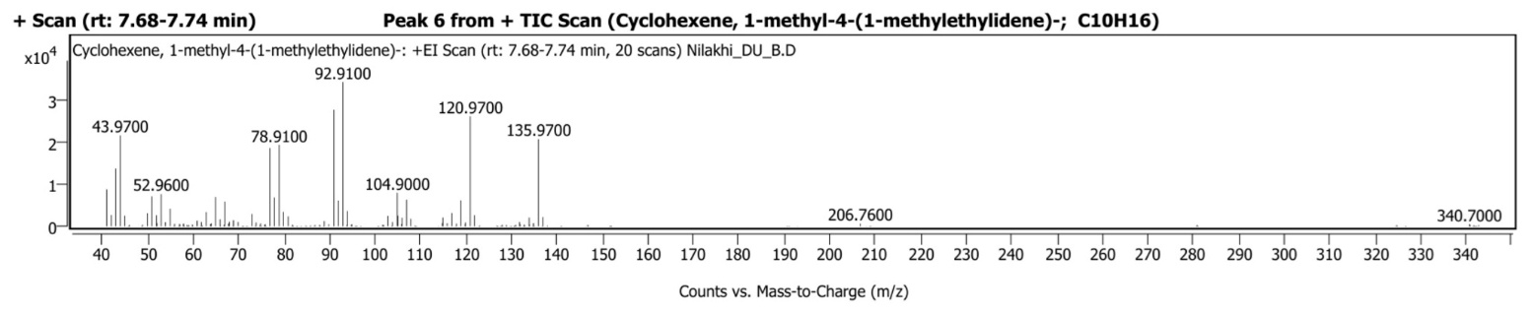
F

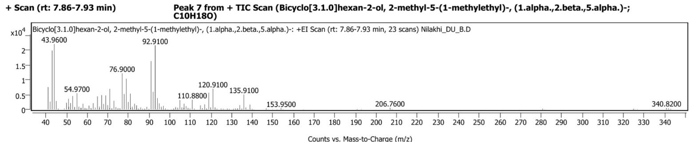
G

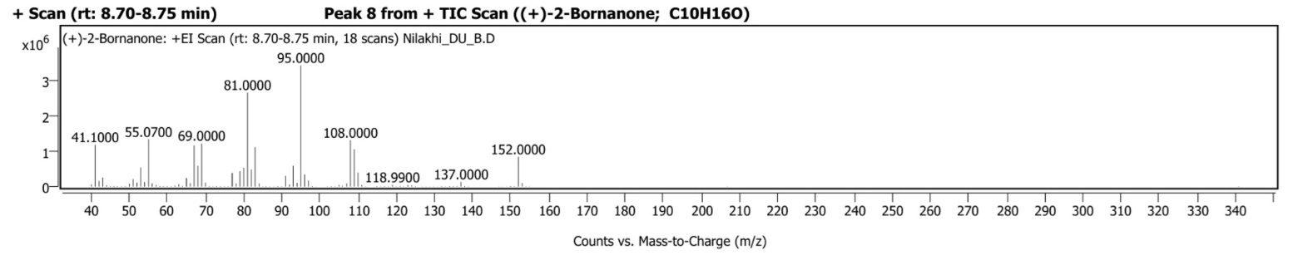
H

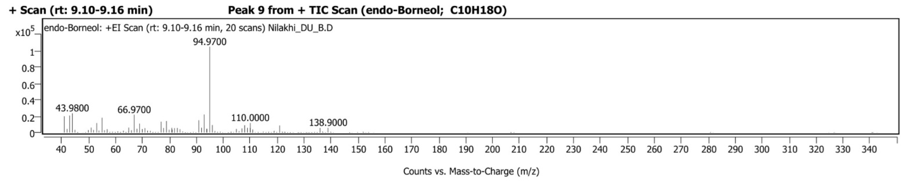
I

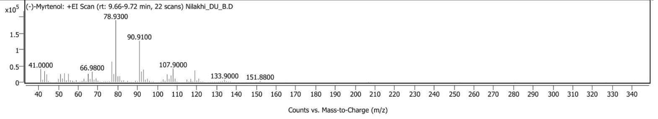
J

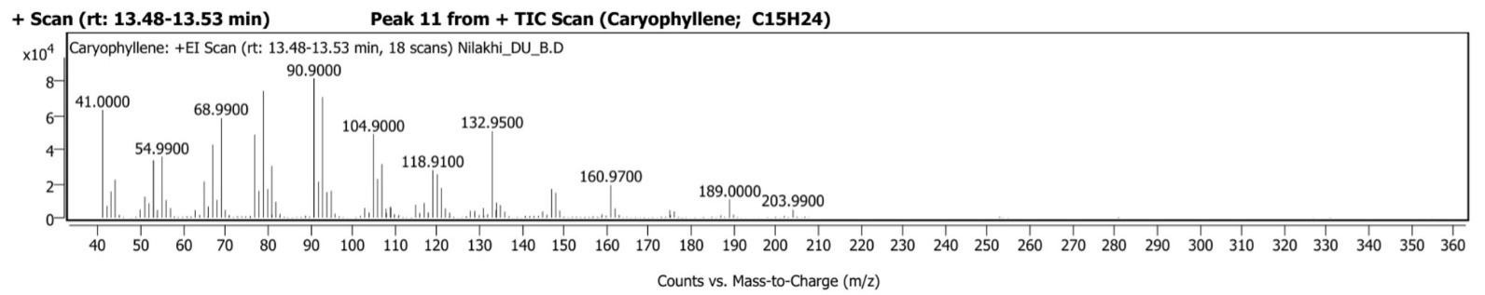
K

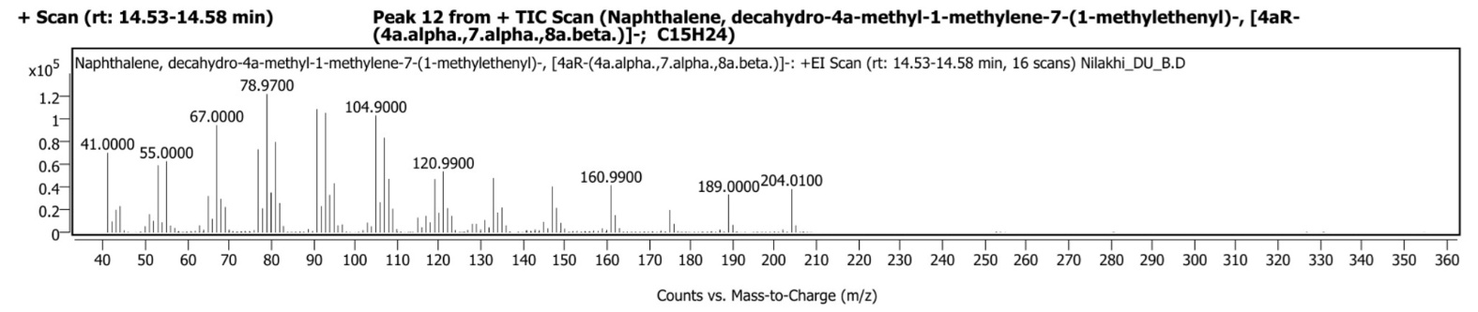
L

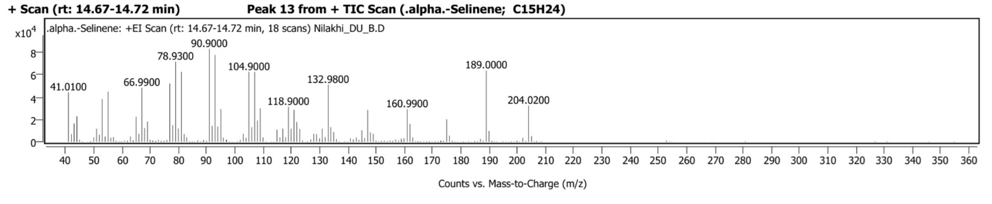
M

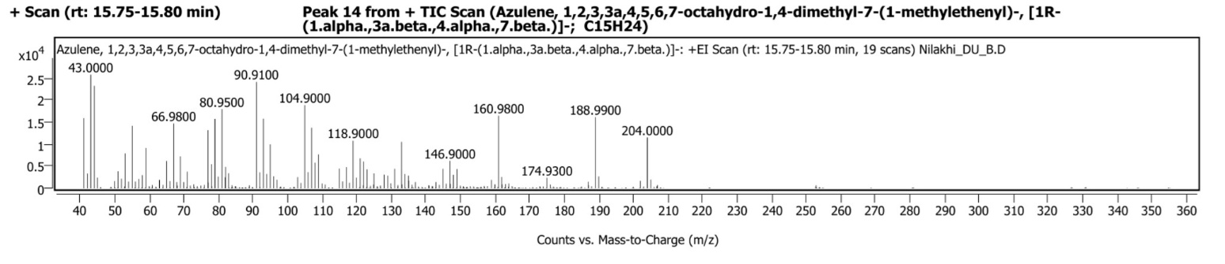
N

Fig. 2 (A-N) GC-MS chromatograms of the essential oils extracted from O. americanum plants treated with B.s MTCC 8141

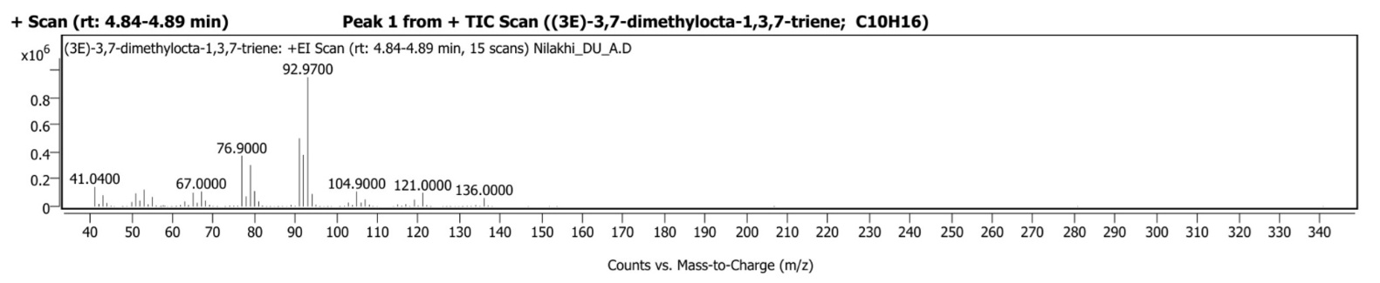
A

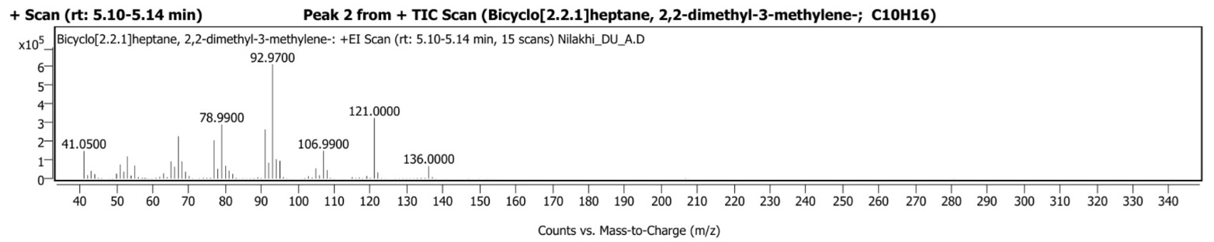
B

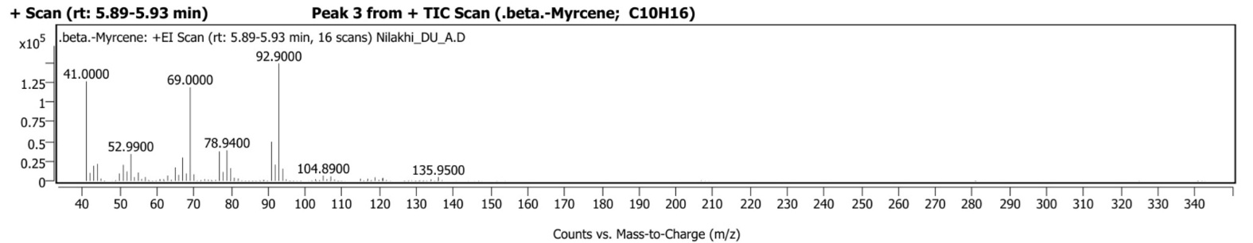
C

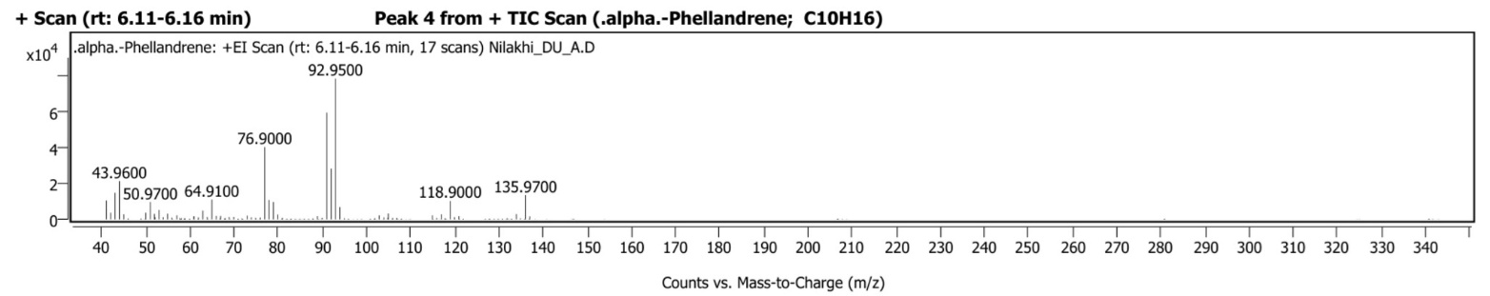
D

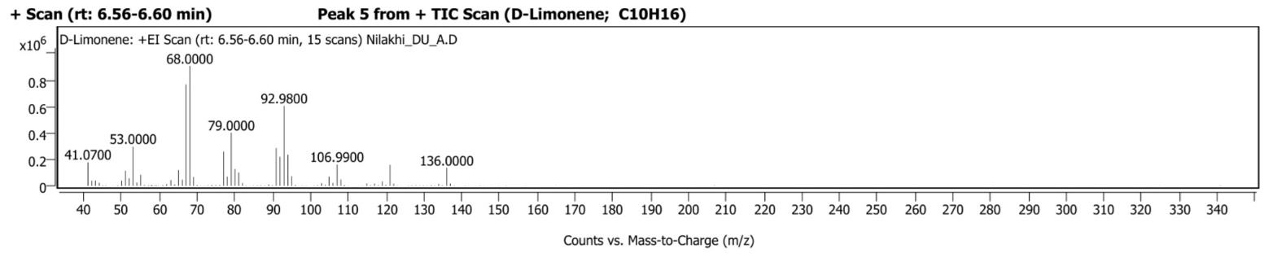
E

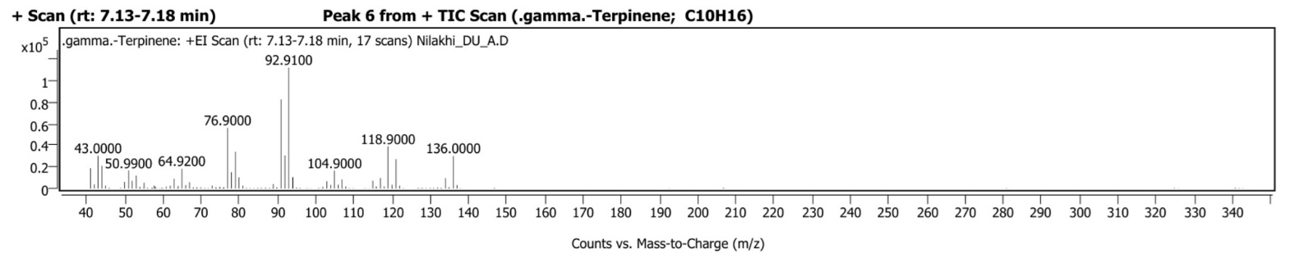
F

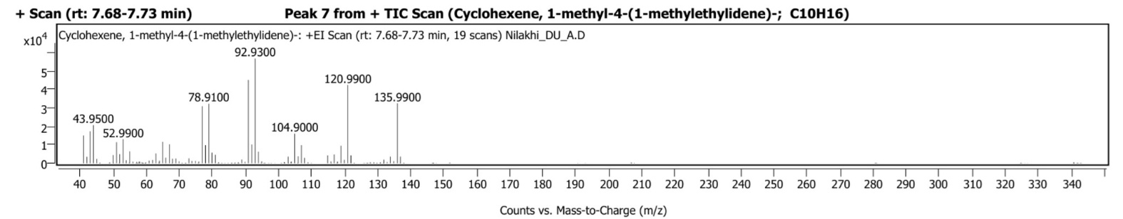
G

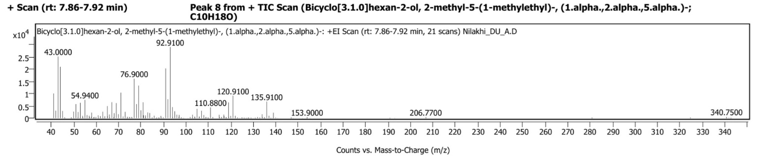
H

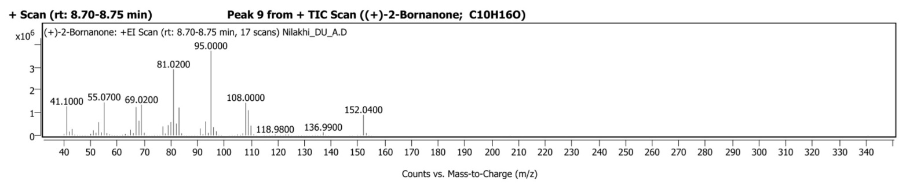
I

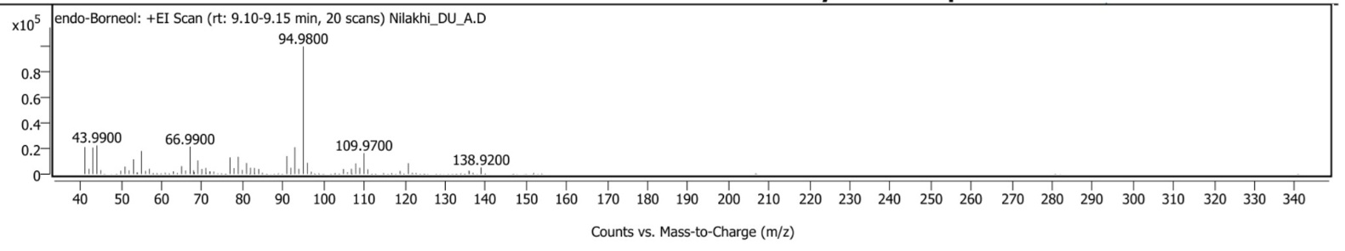
J

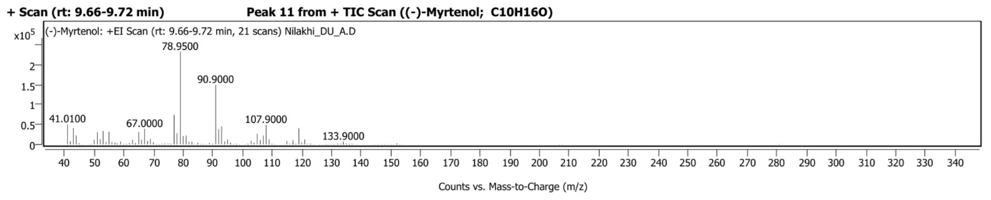
K

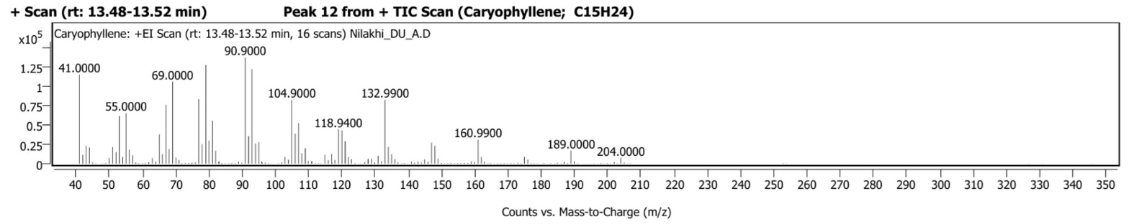
L

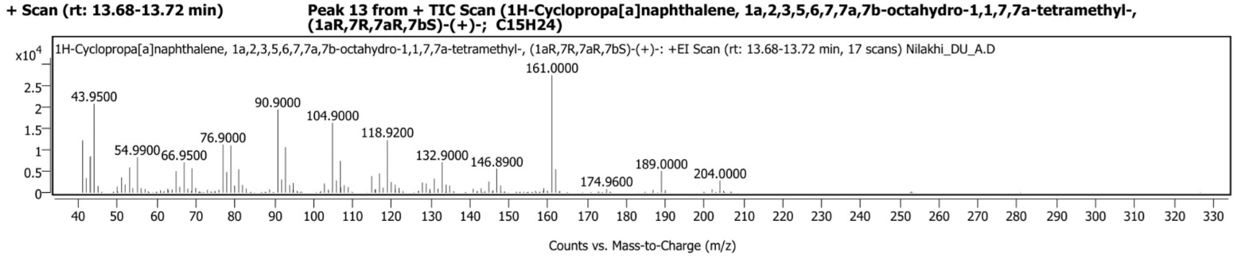
M

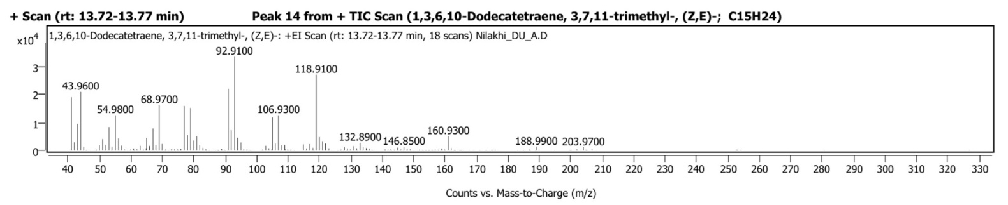
N

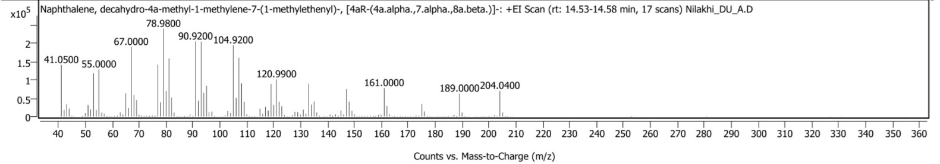
O

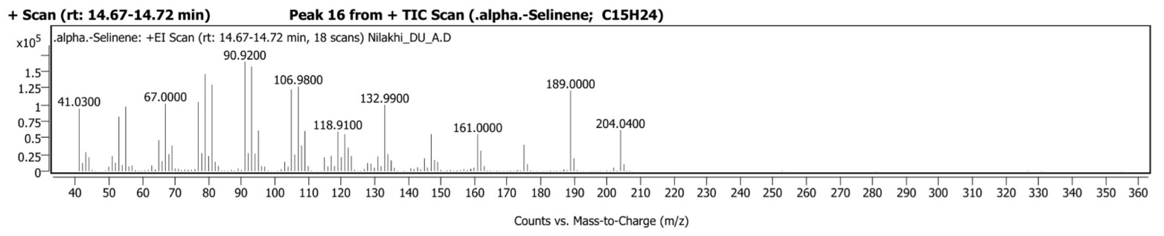
P

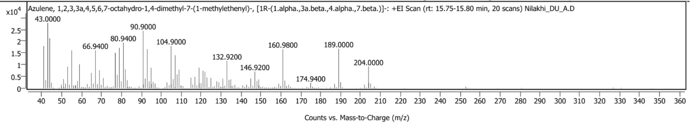
Q

Fig 3: (A-Q) GC-MS chromatograms of the essential oils extracted from O. americanum plants treated with T. h MTCC 936

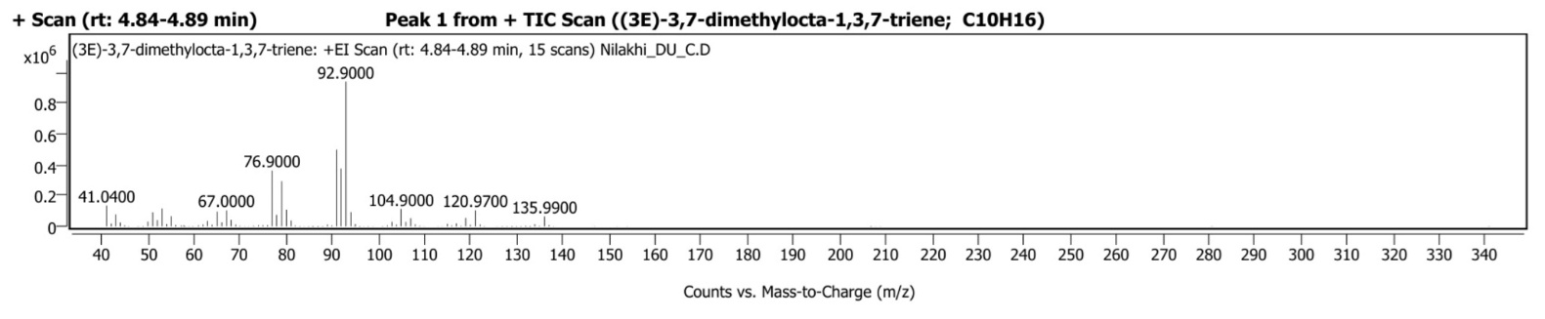
A

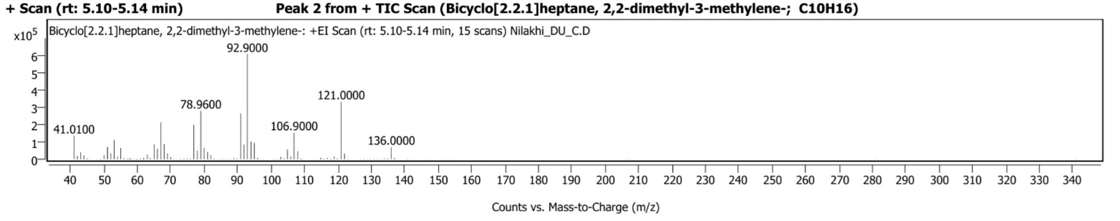
B

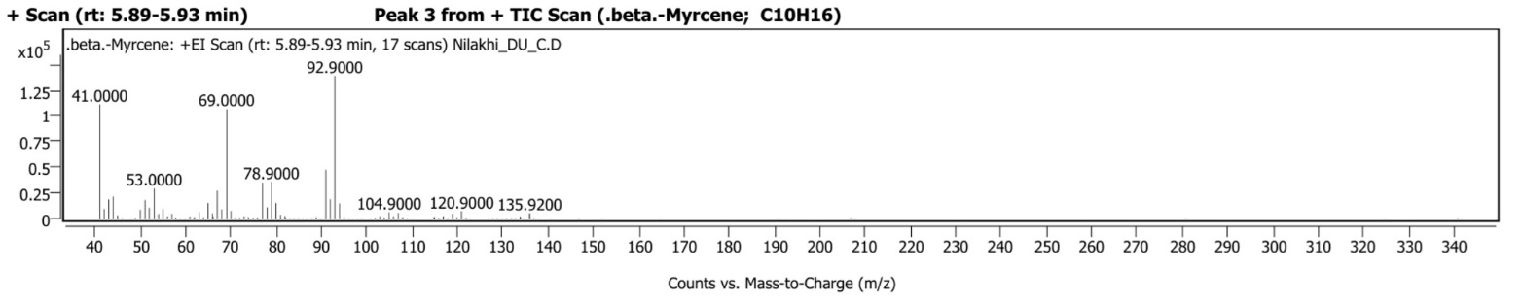
C

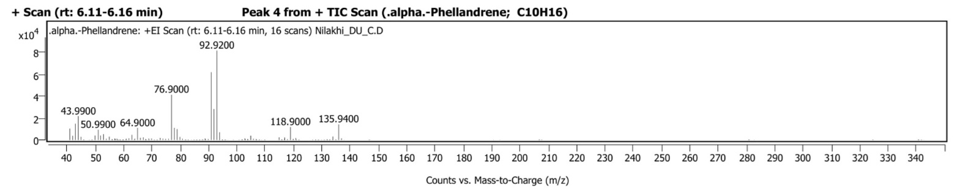
D

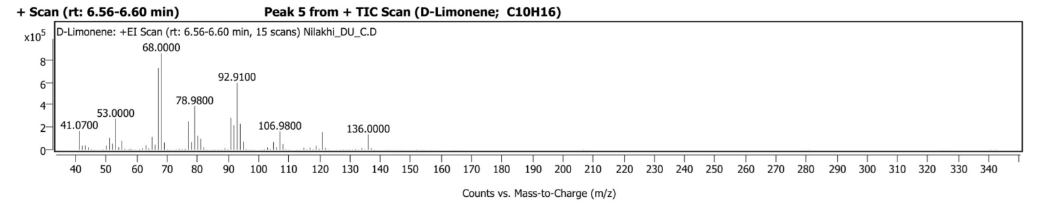
E

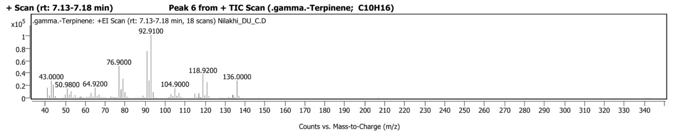
F

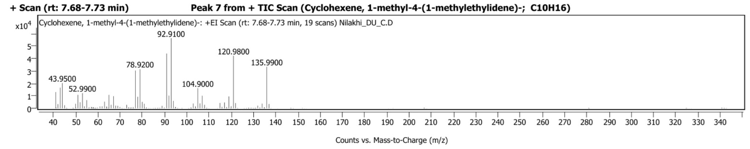
G

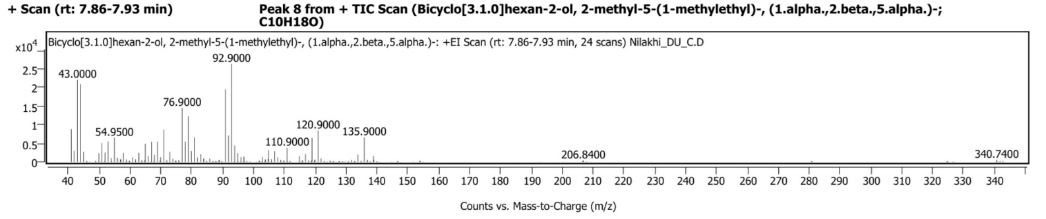
H

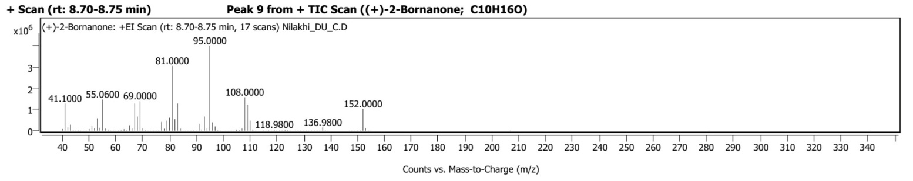
I

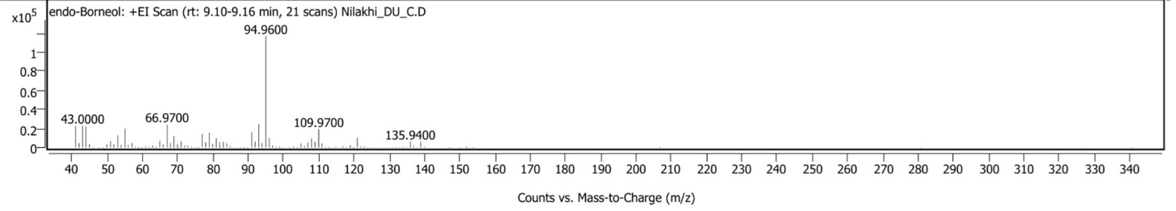
J

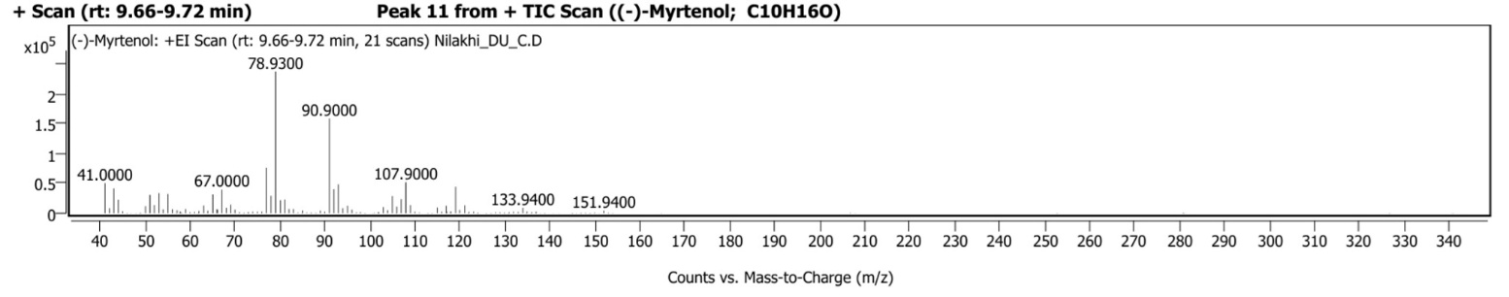
K

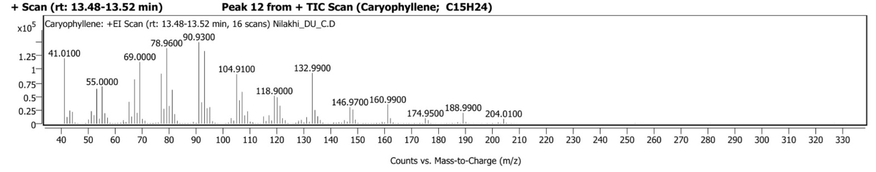
L

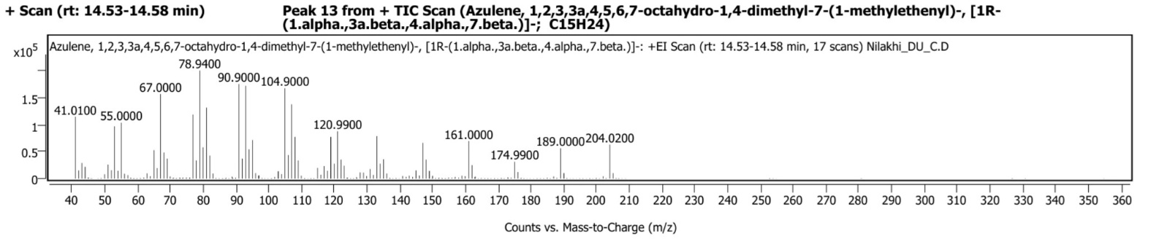
M

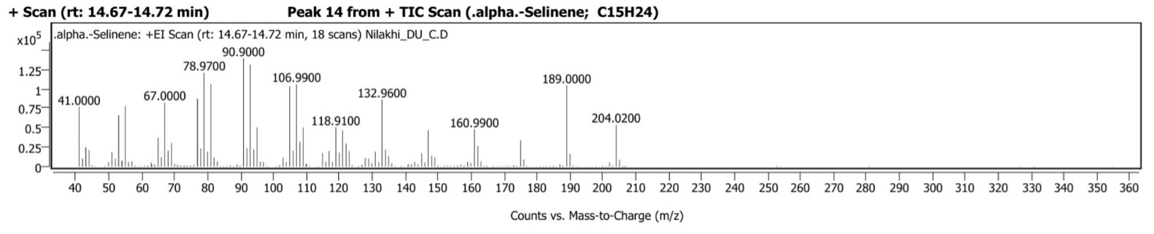
N

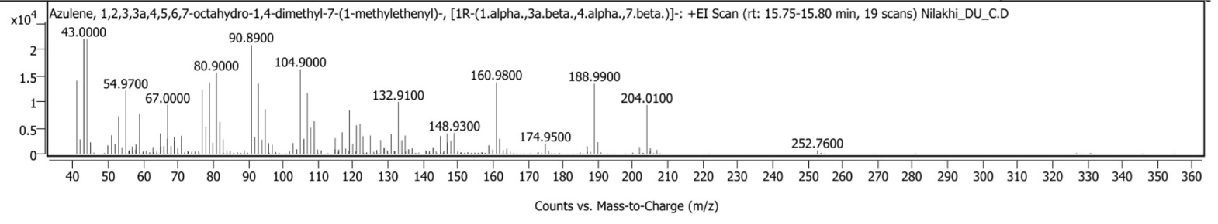
O

Fig. 4 (A-O) GC-MS chromatograms of the essential oils extracted from O. americanum plants treated with Mix inoculants (B.s MTCC 8141 + T. h MTCC 936)

