Enhancement of essential oil yield in Ocimum americanum L. across ontogenetic phases by Bacillus subtilis MTCC 8141 and Trichoderma harzianum MTCC 936 and its termiticidal efficacy against Odontotermes parvidens
Nilakhi Kakoti¹, Munmi Borkataky^{2*}
^{1, 2} Department of Life Sciences, Dibrugarh University, Dibrugarh, Assam, India
¹kakoti.nilz95@gmail.com
ORCID - 0000-0001-6724-1878
^{2*}mbk139@gmail.com
ORCID - 0000-0002-3433-4004
Corresponding author: Munmi Borkataky

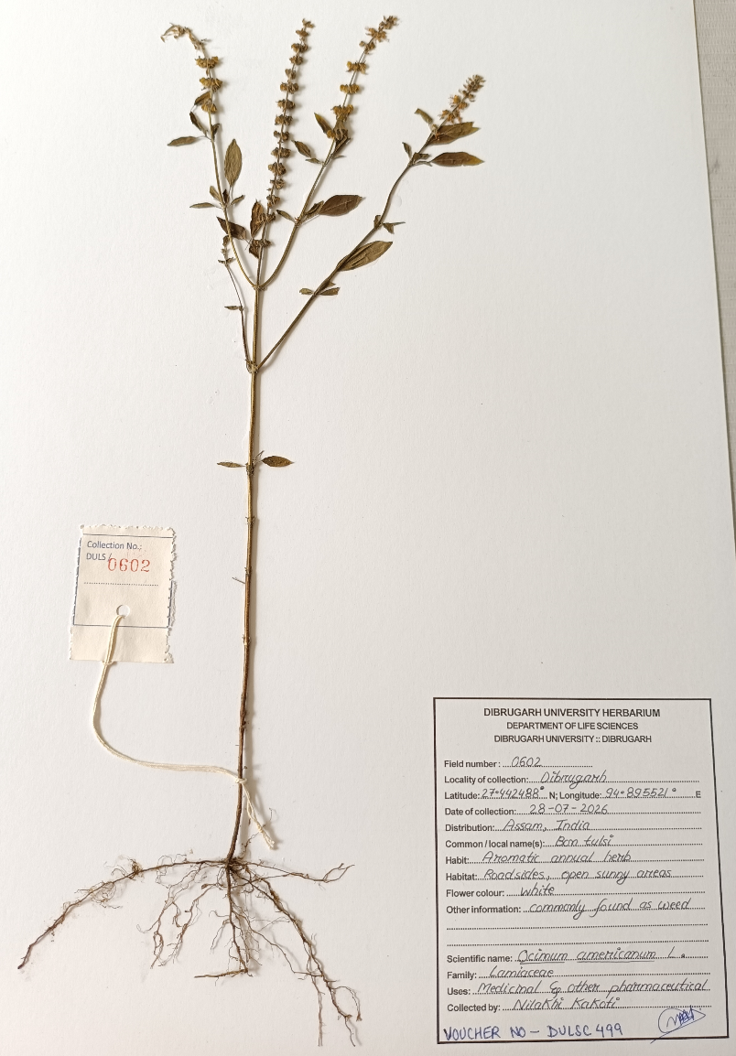
Fig. 1 Herbarium of O. americanum

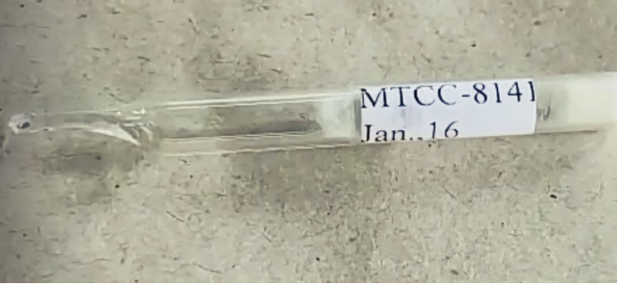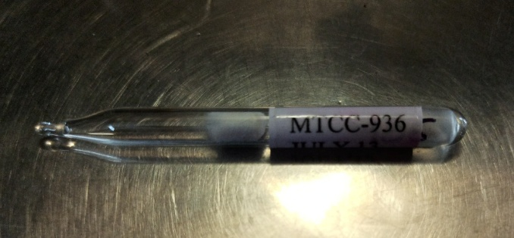
B
A

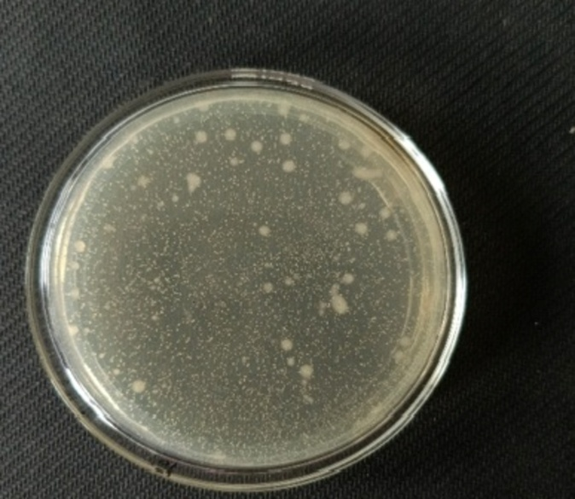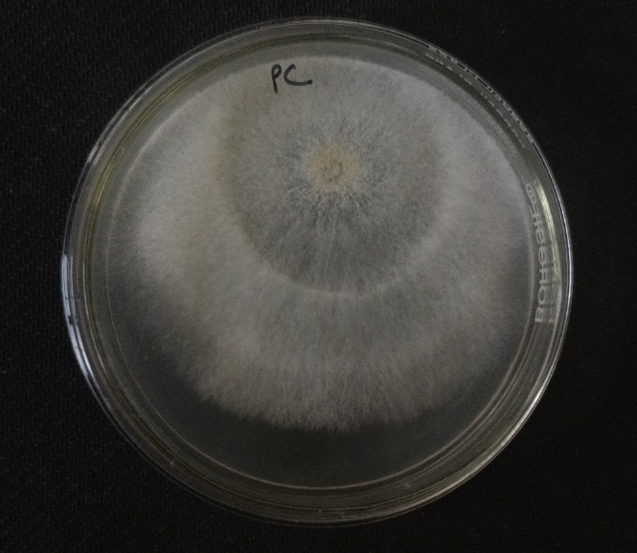
D
C

Fig. 2 (A) Freeze culture of B. s MTCC 8141 (B) Freeze culture of T. h MTCC 936 (C) Morphology of pure culture of B. s MTCC 8141 (D) Morphology of pure culture of T. h MTCC936

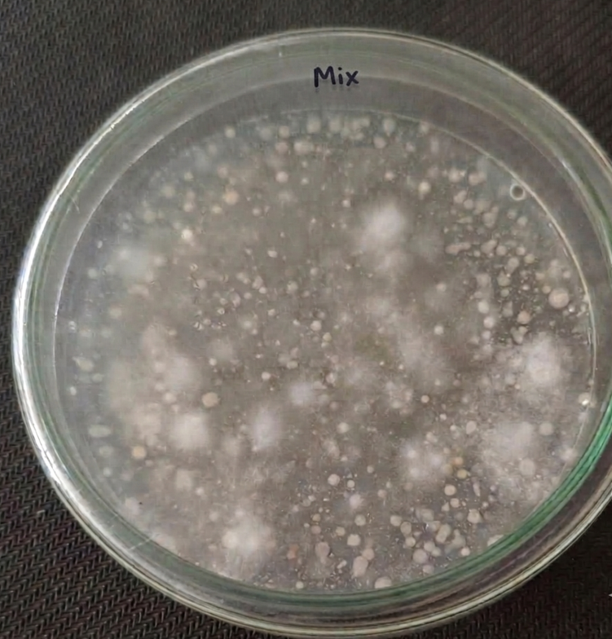
T. h MTCC 936
B. s MTCC 8141

Fig. 3 Mixed culture of B. s MTCC 8141 and T. h MTCC 936

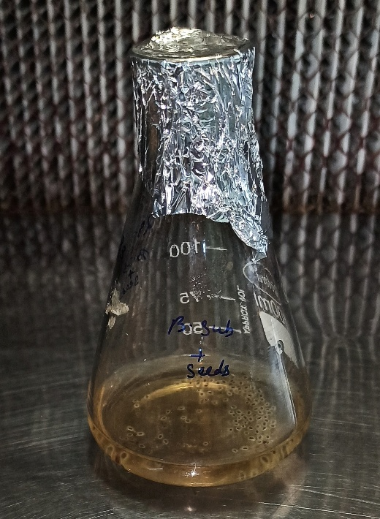
Fig. 4 Seeds biopriming with microbial inoculants

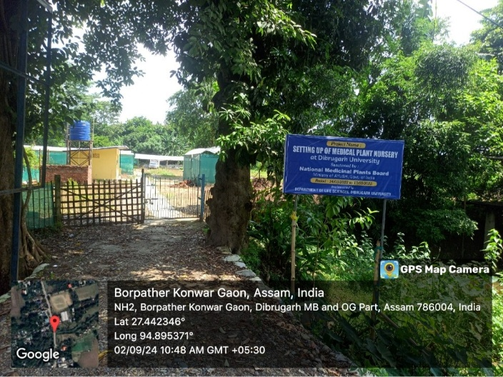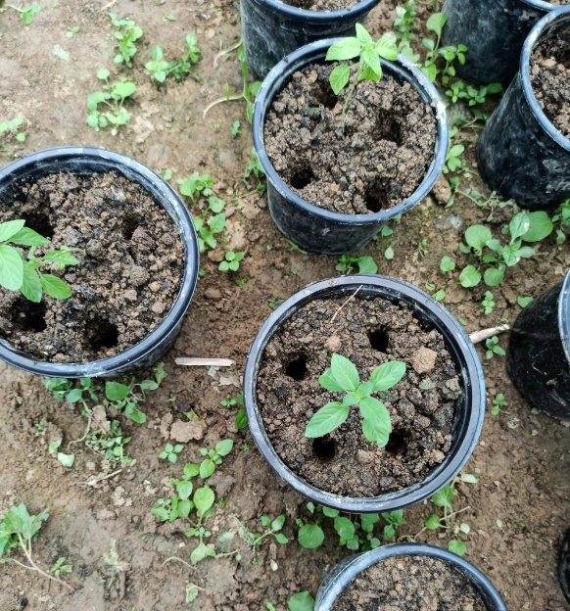
A
B

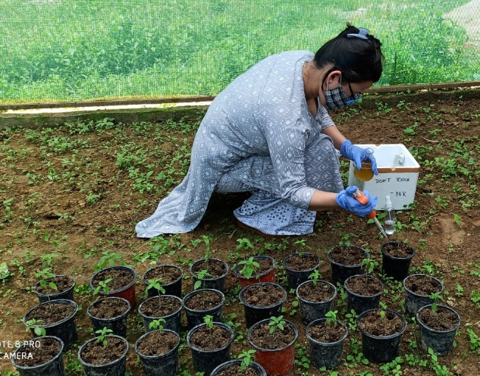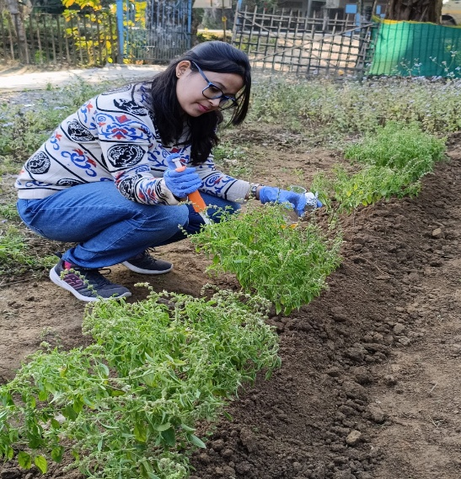
C
D

Fig. 5 (A) Medicinal nursery of Dibrugarh University (B) Pots containing an O. americanum seedling, with four inoculation holes arranged around the plant base, each receiving of microbial bioinoculant solution (C) Application of microbial inoculant suspensions to experimental pots (D) Re- inoculation of microbial inoculant to the experimental pots


B
A

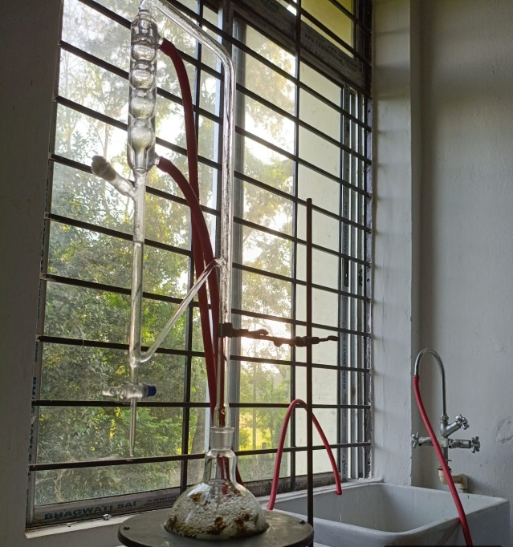
C

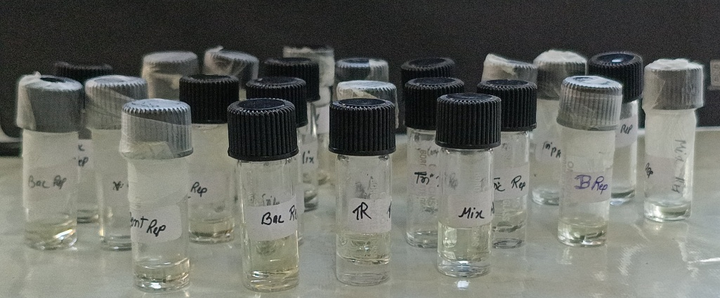
D
Fig. 6 (A) and (B) Collection of O. americanum leaves e for essential oil extraction (C) Extraction of essential oil in Clevenger apparatus (D) Extraction of essential oil from different growth phases of O. americanum
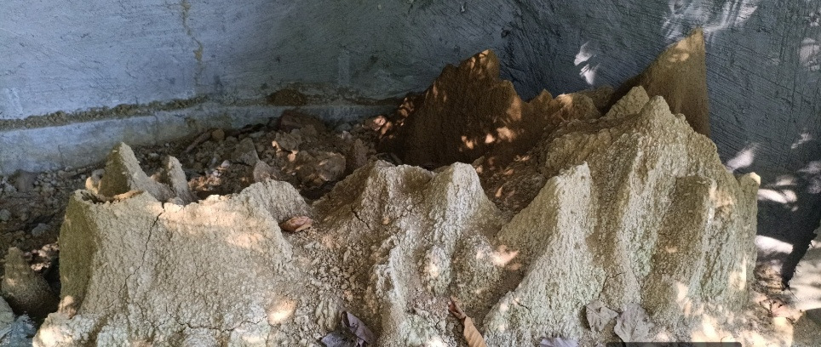
A

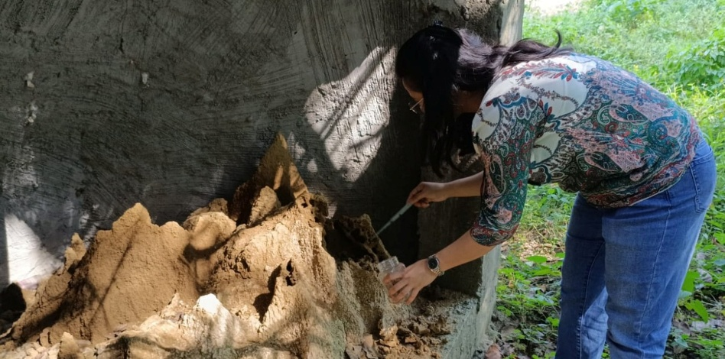
B

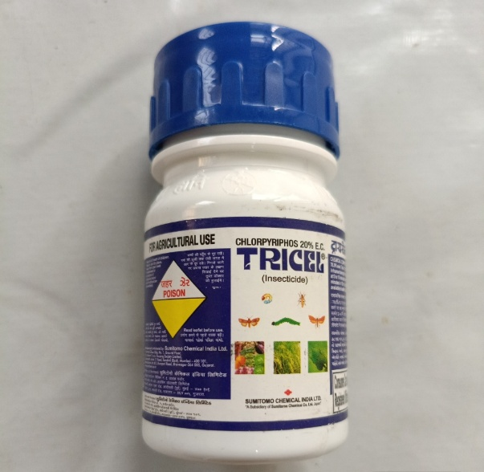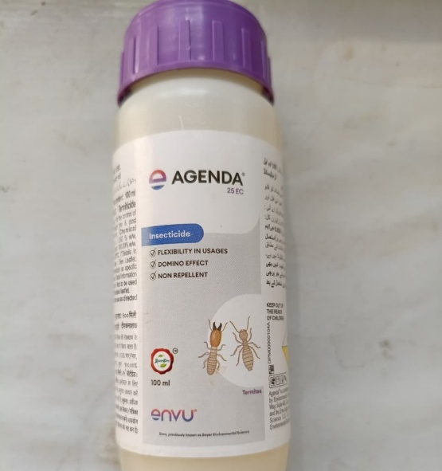
D
C

Fig. 7 (A) Mound of termites (B) Collection of the termites (C) Tricel (D) Agenda

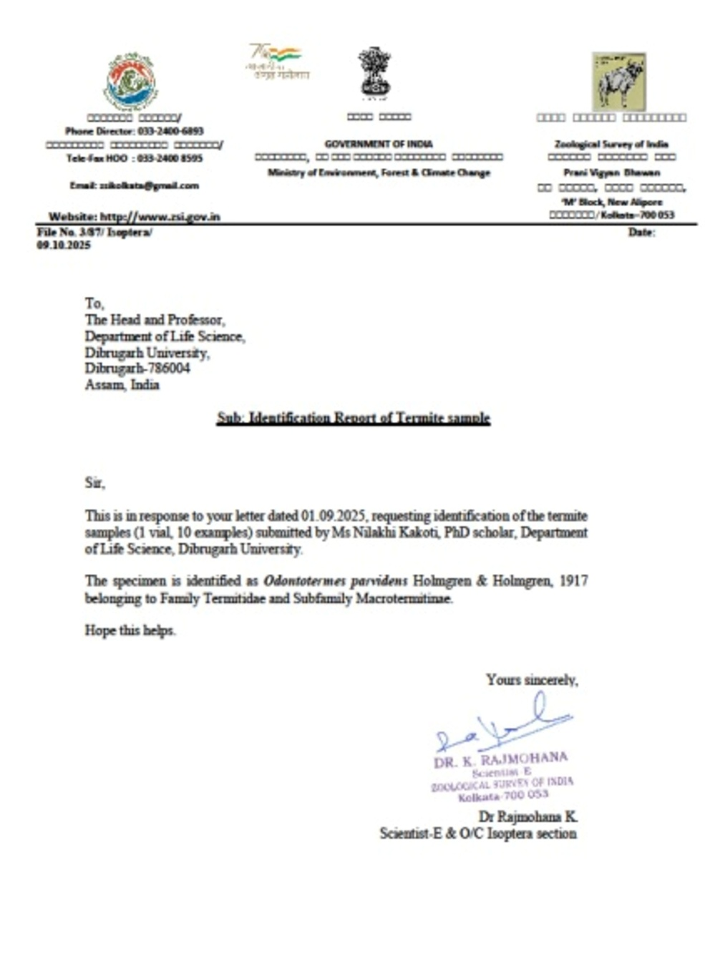
Fig. 8 Identification of the termites in ZSI, Kolkata, India

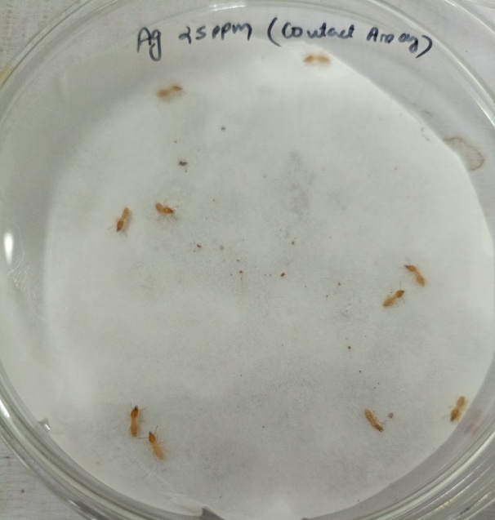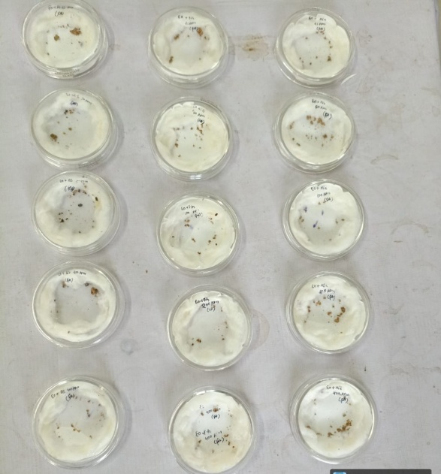
B
A

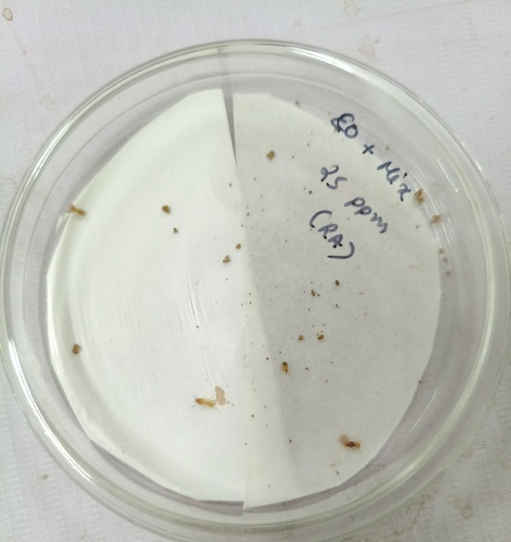
C

Fig. 9 Termiticidal Bioassay (A) Contact-toxicity assay (B) Fumigant assay (C) Repellent assay

Table 1 Compounds identified in the essential oils of O. americanum + control by GC-MS analysis
Peak | Compound Name | Chemical formula | Area Sum (%) | RT
1 | (3E)-3,7-dimethylocta-1,3,7-triene | C10H16 | 9.27 | 4.86
2 | Bicyclo [2.2.1] heptane, 2,2-dimethyl-3-methylene | C10H16 | 6.84 | 5.11
3 | β-Myrcene | C10H16 | 1.40 | 5.90
4 | α-Phellandrene | C10H16 | 0.64 | 6.13
5 | D-Limonene | C10H16 | 10.33 | 6.58
6 | γ-Terpinene | C10H16 | 1.40 | 7.15
7 | Cyclohexene, 1-methyl-4-(1-methylethylidene) | C10H16 | 0.97 | 7.70
8 | (+)-4-Carene: | C10H16 | 0.47 | 7.88
9 | (+)-2-Bornanone | C10H16O | 46.93 | 8.72
10 | endo-Borneol | C10H18O | 0.95 | 9.12
11 | (-)-Myrtenol | C10H16O | 2.03 | 9.68
12 | Caryophyllene | C15H24 | 4.59 | 13.50
13 | 1H Cyclopropa[a]naphthalene, 1a,2,3,5,6,7,7a,7b octahydro-1,1,7,7a tetramethyl-, (1aR,7R,7aR,7bS)- (+ | C15H24 | 0.62 | 13.70
14 | Naphthalene, decahydro-4a-methyl-1-methylene-7-(1-methylethenyl)-, [4aR-(4a. alpha.,7. alpha.,8a. beta.)] | C15H24 | 6.87 | 14.55
15 | α-Selinene | C15H24 | 5.49 | 14.69
16 | Azulene, 1,2,3,3a,4,5,6,7-octahydro-1,4-dimethyl-7-(1-methylethenyl)-, [1R-(1. alpha.,3a. beta.,4. alpha.,7. beta.)] | C15H24 | 1.20 | 15.77

Table 2 Compounds identified in the essential oils of O.a + B.s MTCC 8141 by GC-MS analysis
Peak | Compound Name | Chemical formula | Area Sum (%) | RT
1 | (3E)-3,7-dimethylocta-1,3,7-triene | C10H16 | 8.30 | 4.86
2 | Bicyclo [2.2.1] heptane, 2,2-dimethyl-3-methylene | C10H16 | 7.46 | 5.11
3 | β-Myrcene | C10H16 | 1.40 | 5.90
4 | D-Limonene | C10H16 | 10.43 | 6.58
5 | γ-Terpinene | C10H16 | 1.00 | 7.15
6 | Cyclohexene, 1-methyl-4-(1-methylethylidene) | C10H16 | 0.73 | 7.70
7 | Bicyclo [3.1.0] hexan-2-ol, 2-methyl-5-(1-methylethyl)-, (1. alpha.,2. beta.,5. alpha.) | C10H18O | 0.58 | 7.88
8 | (+)-2-Bornanone | C10H16O | 53.74 | 8.72
9 | endo-Borneol | C10H18O | 1.15 | 9.12
10 | (-)-Myrtenol | C10H16O | 3.28 | 9.68
11 | Caryophyllene | C15H24 | 2.86 | 13.50
12 | Naphthalene, decahydro-4a-methyl-1-methylene-7-(1-methylethenyl)-, [4aR-(4a. alpha.,7. alpha.,8a. beta.)] | C15H24 | 4.41 | 14.55
13 | α-Selinene | C15H24 | 3.43 | 14.69
14 | Azulene, 1,2,3,3a,4,5,6,7-octahydro-1,4-dimethyl-7-(1-methylethenyl)-, [1R-(1. alpha.,3a. beta.,4. alpha.,7. beta.)] | C15H24 | 1.20 | 15.77

Table 3 Compounds identified in the essential oils of O.a + T. h MTCC 936 by GC-MS analysis
Peak | Compound Name | Chemical formula | Area Sum (%) | RT
1 | (3E)-3,7-dimethylocta-1,3,7-triene | C10H16 | 7.38 | 4.86
2 | Bicyclo [2.2.1] heptane, 2,2-dimethyl-3-methylene | C10H16 | 6.36 | 5.11
3 | β-Myrcene | C10H16 | 1.50 | 5.90
4 | α-Phellandrene | C10H16 | 0.65 | 6.13
5 | D-Limonene | C10H16 | 10.48 | 6.58
6 | γ-Terpinene | C10H16 | 1.32 | 7.15
7 | Cyclohexene, 1-methyl-4-(1-methylethylidene) | C10H16 | 0.99 | 7.70
8 | Bicyclo [3.1.0] hexan-2-ol, 2-methyl-5-(1-methylethyl)-, (1. alpha.,2. alpha.,5. alpha.) | C10H18O | 0.58 | 7.88
9 | (+)-2-Bornanone | C10H16O | 46.97 | 8.72
10 | endo-Borneol | C10H18O | 0.94 | 9.12
11 | (-)-Myrtenol | C10H16O | 3.18 | 9.68
12 | Caryophyllene | C15H24 | 3.74 | 13.50
13 | 1H-Cyclopropa[a]naphthalene, 1a,2,3,5,6,7,7a,7b-octahydro-1,1,7,7a-tetramethyl-, (1aR,7R,7aR,7bS)- (+)- | C15H24 | 0.47 | 13.70
14 | 1,3,6,10-Dodecatetraene, 3,7,11-trimethyl-, (Z, E)- | C15H24 | 0.60 | 13.74
15 | Naphthalene, decahydro-4a-methyl-1-methylene-7-(1-methylethenyl)-, [4aR-(4a. alpha.,7. alpha.,8a. beta.)]- | C15H24 | 7.67 | 14.55
16 | α-Selinene | C15H24 | 5.98 | 14.69
17 | Azulene, 1,2,3,3a,4,5,6,7-octahydro-1,4-dimethyl-7-(1-methylethenyl)-, [1R-(1. alpha.,3a. beta.,4. alpha.,7. beta.)]- | C15H24 | 1.18 | 15.77

Table 4: Compounds identified in the essential oils of O.a + Mix (B.s MTCC 8141 + T. h MTCC 936) by GC-MS analysis
Peak | Compound Name | Chemical formula | Area Sum (%) | RT
1 | (3E)-3,7-dimethylocta-1,3,7-triene | C10H16 | 7.26 | 4.86
2 | Bicyclo [2.2.1] heptane, 2,2-dimethyl-3-methylene | C10H16 | 6.27 | 5.11
3 | β-Myrcene | C10H16 | 1.47 | 5.90
4 | α-Phellandrene | C10H16 | 0.63 | 6.13
5 | D-Limonene | C10H16 | 10.24 | 6.58
6 | γ-Terpinene | C10H16 | 1.26 | 7.15
7 | Cyclohexene, 1-methyl-4-(1-methylethylidene)- | C10H16 | 0.98 | 7.70
8 | Bicyclo [3.1.0] hexan-2-ol, 2-methyl-5-(1-methylethyl)-, (1. alpha.,2. beta.,5. alpha.)- | C10H18O | 0.66 | 7.88
9 | (+)-2-Bornanone | C10H16O | 50.38 | 8.72
10 | endo-Borneol | C10H18O | 1.17 | 9.12
11 | (-)-Myrtenol | C10H16O | 3.24 | 9.68
12 | Caryophyllene | C15H24 | 4.12 | 13.50
13 | Azulene, 1,2,3,3a,4,5,6,7-octahydro-1,4-dimethyl-7-(1-methylethenyl)-, [1R-(1. alpha.,3a. beta.,4. alpha.,7. beta.)]- | C15H24 | 6.45 | 14.55
14 | α-Selinene | C15H24 | 5.01 | 14.69
15 | Azulene, 1,2,3,3a,4,5,6,7-octahydro-1,4-dimethyl-7-(1-methylethenyl)-, [1R-(1. alpha.,3a. beta.,4. alpha.,7. beta.)]- | C15H24 | 0.88 | 15.77

