Supplementary Material

Cost-utility analysis on the inclusion of pneumococcal vaccines in the national immunization program for older adults in the Philippines – Evidence from a middle-income country in Asia

Authors
Haidee A. Valverde¹, Josephine G. Aldaba², Ruth Anne Hechanova-Cruz^{2, 3}, Joseph Carlo Cruz², Merrylle Morales- Dizon², Napoleon Beratio III², Denise Semana², Ma. Xienina Trinidad², Peter Francis Raguindin^{2, 4}

Author Affiliations
1 Institute of Health Policy and Developmental Studies, National Institutes of Health, University of the Philippines Manila, Manila, Philippines
2 Institute of Child Health and Human Development, National Institutes of Health, University of the Philippines Manila, Manila, Philippines
3 Research Institute for Tropical Medicine, Department of Health, Muntinlupa City, Philippines
4 Faculty of Health Sciences and Medicine, University of Lucerne, Lucerne, Switzerland
*Haidee A. Valverde and Josephine G. Aldaba are shared first authors

Corresponding author:
Peter Francis Raguindin
Faculty of Health Science and Medicine
University of Lucerne
Alpenquai 4, 6005 Lucerne
peter.raguindin@unilu.ch

Contents
Table S1. Epidemiologic parameters used in the economic model 3
Table S2. Case fatality rates used in economic model 6
Table S3. Disability or sequalae rates used in the economic model 9
Table S4. Vaccine efficacy/effectiveness estimates used in the economic model 11
Table S5. Vaccine efficacy/effectiveness waning versus invasive pneumococcal disease and non-bacteremic pneumococcal pneumonia (base-case scenario) 14
Table S6. Utility parameters and vaccine costs 15
Table S7. Direct medical costs and other data inputs 16
Figure S1. Probabilistic sensitivity analysis comparing different vaccination regimen against each other 17
a) PPV23 only versus PCV13 + PPV23 17
b) PPV23 only versus PCV15 + PPV23 18
c) PCV13 + PPV23 versus PPV23 only 18
d) PCV13 + PPV23 versus PCV15 + PPV23 19
e) PCV15 + PPV23 versus PPV23 only 19
f) PCV15 + PPV23 versus PCV13 + PPV23 20
Table S8. Cost utility analysis results of alternative scenario compared to base-case scenario 21
Table S9. Summary of assumptions and sources of costing for budget impact analysis 22
Table S10. Summary of net costs per year in budget impact analysis using different scenarios and different input parameters 23

Table S1. Epidemiologic parameters used in the economic model

Population | Estimated numbers | Remarks | References
60 years and older | 11,402,637 | Projected 2026 population | Philippine Statistics Authority website ¹

Epidemiologic parameters |  |  | Model inputs |  |  | Remarks | References
 | Point estimate | Uncertainty interval | Point estimate | Low values | High values | Remarks | References
Pneumococcal Meningitis |  |  | 0.000021 | 0.000019 | 0.000023 | calculated from IR of meningitis (in 100,000) x proportion of meningitis caused by SPN (proportion of nonfatal meningitis + proportion of fatal meningitis); confidence interval of SPN meningitis computed from point estimates and CIs of two sets of data (nonfatal and fatal) | Global Burden of Disease 2019 (modeled data)²
IR of meningitis among 55 and older (per 100,000) | 7.14 | (5.5 - 8.5) |  |  |  |  | Global Burden of Disease 2019 (modeled data)²
% of meningitis due to SPN | 29.8 | (28.8 - 30.8) |  |  |  |  | Global Burden of Disease 2019 (modeled data)²
Bacteremia without pneumonia |  |  | 0.000016 | 0.000013 | 0.00002 | No. of IPD= IR (per 100,000) x population | Rhodes, 2013 (IPD surveillance data from Thailand)³
IR of IPD (No. per 100,000 person-year) | 13.6 | (10.1 - 18) |  |  |  | No. of IPD= IR (per 100,000) x population | Rhodes, 2013 (IPD surveillance data from Thailand)³
Prevalence of SPN bacteremia without pneumonia (%) | 11.83 | (28.8 - 30.8) |  |  |  | No. of Bacteremia without pneumonia=  (No. of IPD) X (Prevalence of bacteremia w/o pneumonia) | Backhaus, 2016 (IPD surveillance data from Sweden before introduction of PCV)⁴
Bacteremia with pneumonia |  |  | 0.003545 | 0.002588 | 0.004685 | IR (per 100,000) x population= no. of pneumonia cases | GBD, 2021⁵  Morrill, 2014 (proportion of pneumococci disease hospitalized and treated outpatient) ⁶  Lupisan 2019 (proportion of hospitalized SPN pneumonia cases which are invasive and noninvasive)⁷
 |  |  |  |  |  | No. of pneumonia cases X % of hospitalized cases (from Morrill) = No. of SPN hospitalized cases (value A)
IR of LRI (lower respiratory infections-proxy for pneumonia) among 55 years and older (per 100,000 population) | 14,202.49 | (13,168.74 - 15,395.05) |  |  |  | No. of bacteremia with pneumonia= No. of SPN hospitalized cases X % invasive SPN pneumonia cases (from Lupisan)
% of LRI due to SPN | 25.2 | (24.8 - 25.6) |  |  |  | * Low and high values from uncertainty intervals of the GBD study on estimates of total LRI cases
% of SPN LRI hospitalized | 37.1 | (29.68 - 4.52) |  |  |  | Assume all invasive SPN LRI are hospitalized; low and high values +/- 20% | Morill et al. 2014 ⁶
% of hospitalized SPN LRI that are invasive | 26.7 | (21.36 - 2.04) |  |  |  | Low and high values +/-20% | Lupisan et al, 2019 ⁷
Pneumococcal pneumonia (nonbacteremic)- hospitalized - estimated numbers |  |  | 0.009733 | 0.007105 | 0.012861 | No. of pneumonia cases x % of hospitalized cases (from Morrill) = No. of SPN hospitalized cases | Morrill, 2014 (US data)⁶  Lupisan, 2019 (Philippine cohort study) ⁷
 |  |  |  |  |  | No.of nonbacteremic with pneumococcal pneumonia (NBPP)= No. of SPN hospitalized cases X % noninvasive SPN pneumonia cases (Lupisan)
% of hospitalized SPN LRI that are noninvasive or nonbacteremic | 73.3 | (58.64 - 7.96) |  |  |  | Low and high values +/-20% | Lupisan et al, 2019 ⁷
Pneumococcal pneumonia (nonbacteremic)- outpatient- estimated numbers |  |  | 0.022512 | 0.020542 | 0.02479 | No. of pneumonia cases x % of outpatient cases (from Morrill) | Morrill, 2014 ⁶  Lupisan, 2019 ⁷
% of SPN pneumonia treated as outpatient | 62.9 | (50.32 - 5.48) |  |  |  | Low and high values +/-20% | Morrill et al, 2014⁶
Abbreviations: SPN, Streptococcus pneumoniae; LRI, lower respiratory infections; NBPP, nonbacteremic pneumococcal pneumonia; IPD, invasive pneumococcal disease; IR, incidence rate; CI, confidence interval; GBD, Global Burden of Disease Study

Table S2. Case fatality rates used in economic model

Mortality | Model inputs |  | Estimated number | Low value | High value | Remarks | Reference
Pneumococcal Meningitis |  |  | 80.64 | 40.89 | 143.55 | CFR of pneumococcal meningitis among adults in low-income countries X No. of pneumococcal meningitis | van Ettekoven 2024 (SR-MA)⁸
 | Point estimate | Uncertainty interval |  |  |  |  | van Ettekoven 2024 (SR-MA)⁸
Case fatality rate | 0.345 | (0.235 – 0.474) |  |  |  |  | van Ettekoven, 2024⁸
Bacteremia without pneumonia |  |  | 389.96 | 190.848792 | 741.555 | Case fatality ratio (CFR) X No. of IPD; used ratio for >=60 years old with IPD (all syndromes) | Thomas, 2013 (India surveillance study)⁹
Case fatality rate | 0.261 | (0.172 – 0.375) |  |  |  | High and low values +/- 20% | Thomas, 2013⁹
Bacteremia with pneumonia |  |  | 11,333.99 | 5,295.22 | 21,566.65 | No. of estimated cases of bacteremia with pneumonia X CFR of bacteremic pneumonia (from Morrill, 2014) | Morrill et al, 2014⁶
Case fatality rate | 0.291 | (0.2328 – 0.3492) |  |  |  | High and low values +/- 20%
Nonbacteremic pneumococcal pneumonia (NBPP)- hospitalized |  |  | 10,157.95 | 5,932.22 | 16,107.38 | No. of estimated cases of bacteremia with pneumonia X CFR of hospitalized NBPP (from Morrill, 2014) | Morrill et al, 2014⁶
Case fatality rate | 0.095 | (0.076 – 0.114) |  |  |  | High and low values +/- 20% | Morrill et al, 2014⁶
Nonbacteremic pneumococcal pneumonia (NBPP)- outpatient |  |  | 9,150.76 | 5,344.02 | 14,510.28 | No. of estimated cases of NBPP (outpatient or ambulatory) X CFR (From Kolditz 2016) | Kolditz et al 2016 (cohort study in Germany)¹⁰
Case fatality rate | 0.037 | (0.0296 – 0.0444) |  |  |  | High and low values +/- 20%
Death from other causes (numbers) | 0.0356 | (0.028451- 0.042676) | 390,702 | 312,561 | 468,842 | Low and high values +/-20% | Philippine Statistics Authority 2023 ¹¹ ^{1,11}
Did not get PD (pneumococcal disease) and did not die (numbers) |  |  | 10,200,378.46 | 8,209,223.78 | 12,153,958.13 | Assumption (Difference between 2023 no. of deaths from PSA and estimated number of deaths due to pneumococcal disease; Low and high values +/-20%

Abbreviations: CFR, case fatality rate; NBPP, non-bacteremic pneumococcal pneumonia; IPD, invasive pneumococcal disease; PSA, Philippine Statistical Authority; SR-MA, systematic review and meta-analysis

Table S3. Disability or sequalae rates used in the economic model

Disability or Sequelae (Proportion of cases which result in disability or sequelae) | Point estimate | Low value | High value | References
Neurologic sequelae after pneumococcal meningitis | 0.347 | 0.282 | 0.451 | Edmond, 2010 (SR-MA)¹²
Pneumococcal meningitis seizure/epilepsy | 0.033 | 0.0264 | 0.0396 | Edmond, 2010; +/-20% ¹²
Pneumococcal meningitis hearing loss | 0.101 | 0.0808 | 0.1212 | Edmond, 2010; +/-20% ¹²
Pneumococcal meningitis neurocognitive impairment | 0.151 | 0.1208 | 0.1812 | Edmond, 2010; +/-20% ¹²
Pneumococcal meningitis behavioral problems | 0.062 | 0.0496 | 0.0744 | Edmond, 2010; +/-20% ¹²
Neurologic sequelae after bacteremia without pneumonia (Bacteremia) | 0.02 | 0.016 | 0.022 | Ubukata K. et al, 2013. ¹³ (Japanese CEA study); +/-20%
Bacteremia seizure/epilepsy | 0.002 | 0.0016 | 0.0024 | Assumption; +/-20%; Assumed the same proportion from the Edmond study
Bacteremia bearing loss | 0.006 | 0.0048 | 0.0072 | Assumption; +/-20%
Bacteremia neurocognitive impairment | 0.009 | 0.0072 | 0.0108 | Assumption; +/-20%
Bacteremia behavioral problems | 0.004 | 0.0032 | 0.0048 | Assumption; +/-20%
Neurologic sequelae after bacteremia with pneumococcal pneumonia (BPnP) | 0.07 | 0.063 | 0.077 | Ubukata K. et al, 2013. ¹³ (Japanese CEA study); +/-20%
BPnP seizure/Epilepsy | 0.007 | 0.0056 | 0.0084 | Assumption; +/-20%; Assumed the same proportion from the Edmond study
BPnP hearing loss | 0.02 | 0.016 | 0.024 | Assumption; +/-20%
BPnP neurocognitive impairment | 0.03 | 0.024 | 0.036 | Assumption; +/-20%
BPnP behavioral problems | 0.01 | 0.008 | 0.012 | Assumption; +/-20%
Neurologic sequelae after nonbacteremic pneumonia (NBPP) | 0 |  |  | Assume no neurologic sequelae after NBPP
Death after sequelae | 0.05 | 0.04 | 0.06 | Ubukata K. et al, 2013. ¹³ (Japanese); +/-20%
Disability after sequelae | 0.95 | 0.855 | 1.045 | Subtract from deaths after sequelae; +/-20%
Death from other causes | 0.035564 | 0.032007 | 0.03912 | Philippine Statistics Authority website¹¹ ;+/-20%
Did not get pneumococcal disease and did not die | 0.928489 | 0.923467 | 0.93142 | Assumed

Abbreviations: NBPP, non-bacteremic pneumococcal pneumonia; BPnP, bacteremic pneumococcal pneumonia; CEA, cost-effectiveness assessment; SR-MA, systematic review and meta-analysis

Table S4. Vaccine efficacy/effectiveness estimates used in the economic model

Vaccine Efficacies/Effectiveness (Base-case scenario) in % (95% CI)
Against vaccine-type IPD | VE vs IPD* | Low |  | High
PPV23 only | 68.7% | 48.82% |  | 79.55% |  | Vaccine serotype VE from Tsai 2015 (Taiwan, observational, moderate GRADE) (76% (95% CI 54 to 88)¹⁴ adjusted by vaccine serotype coverage (PPV23 90.40%)
sequential PCV13 + PPV23 | 42.36% | 15.65% |  | 58.93% |  | Hasegawa, 2024 (USA, observational, very low GRADE)¹⁵ adjusted by vaccine ST coverage (PCV13+PPV23 92.08%)
sequential PCV15 + PPV23 | 42.36% | 15.65% |  | 58.93% |  | Assumed same VE as PCV13+PPV23 adjusted by vaccine serotype coverage (PCV15+PPV23 92.08%)
* IPD includes meningitis, pneumonia with bacteremia and bacteremia without pneumonia
Against vaccine-type NBPP | NBPP | low |  | high
PPV23 only | 56.05% | 25.31% |  | 73.22% |  | VE from Maruyama 2010 (Japan, RCT, moderate GRADE)¹⁶ adjusted by vaccine serotype coverage
sequential PCV13 + PPV23* (add PPV23 VE to PCV13 VE) | 33.61% | -23.02% |  | 62.43% |  | Heo, 2021 (South Korea, observational, very low GRADE)¹⁷ adjusted by vaccine serotype coverage
sequential PCV15 + PPV23** (add PPV23 VE to PCV15 VE) | 33.61% | -23.02% |  | 62.43% |  | Assumed same VE as PCV13+PPV23 adjusted by vaccine serotype coverage
Vaccine Efficacies (alternate-case scenario) in %
Against vaccine-type IPD | Point estimate | Low |  | High
PPV23 only | 71.42% | -0.72% |  | 88.59% |  | Ortqvist 1998 (Sweden, RCT, Low GRADE)¹⁸, adjusted by vaccine serotype coverage (PPV23= 90.40%)
Sequential PCV13 + PPV23 (PCV13 VE adjusted by serotype coverage) | 61.35% | 33.87% |  | 74.27% |  | VE from Bonten 2015 (VE= 75%, 95% CI 41.4 to 90.8) ¹⁹ adjusted by serotype coverage (PCV13= 81.80%)
Sequential PCV15 + PPV23 (PCV15 VE adjusted by serotype coverage) | 65.33% | 36.06% |  | 79.09% |  | Assumed same VE as PCV13+PPV23 adjusted by vaccine serotype coverage (PCV15 87.10%)
sequential PCV13 + PPV23 (PPV23 VE for additional non PCV13/PPV23 serotype coverage) | 9.40% | -0.10% |  | 11.66% |  | Ortqvist 1998 VE; PPV23 VE adjusted by nonPCV13/PPV23 serotype (11.90%)¹⁸
sequential PCV15 + PPV23 (PPV23 VE for additional nonPCV15/PPV23 serotype coverage) | 3.91% | -0.04% |  | 4.85% |  | As above; PPV23 VE adjusted by non-PCV15/PPV23 ST (4.95%)
Against vaccine-type NBPP
PPV23 only | 28.93% | -104.86% |  | 71.40% |  | Pooled data of 2 RCTs (Ortqvist 1998 and Maruyama 2010)(VE= 32%, 95% CI -116 to 79)^{16,18} adjusted by vaccine serotype coverage (PPV23 90.40%)
Sequential PCV13 + PPV23 (PCV13 VE adjusted by serotype coverage) | 36.81% | 11.62% |  | 53.42% |  | VE from Bonten 2015 (VE= 45, 95% CI 14.2 to 65.30)¹⁹ adjusted by serotype coverage (PCV13 81.80%)
Sequential PCV15 + PPV23 (PCV15 VE adjusted by serotype coverage) | 39.20% | 12.37% |  | 56.88% |  | Assumed same VE as PCV13+PPV23 adjusted by vaccine serotype coverage (PCV15 87.10%)
sequential PCV13 + PPV23 (PPV23 VE for additional non-PCV13/PPV23 serotype coverage) | 3.81% | -13.80% |  | 9.40% |  | VE from pooled data from Ortqvist 1998 and Maruyama 2010) ^{16,18} ; PPV23 VE adjusted by non-PCV13/PPV23 serotype (11.90%)
sequential PCV15 + PPV23 (PPV23 VE for additional non-PCV15/PPV23 serotype coverage) | 1.58% |  | -5.74% |  | 3.91% |  | As above; PPV23 VE adjusted by non-PCV15/PPV23 ST (4.95%)

Abbreviations: IPD, invasive pneumococcal disease; PPV23, 23-valent pneumococcal polysaccharide vaccine (Pneumovax 23®); PCV13, 13 valent pneumococcal conjugate vaccine (Prevnar 13 ®); PCV15, 15-valent pneumococcal conjugate vaccine (Vaxneuvance ®); NBPP, non-bacteremic pneumococcal pneumonia; VE, vaccine efficacy; ST, serotype; GRADE; RCT, randomized controlled trial

Table S5. Vaccine efficacy/effectiveness waning versus invasive pneumococcal disease and non-bacteremic pneumococcal pneumonia (base-case scenario)

Year | VE (%) waning* against IPD (base-case scenario) |  | VE (%) waning against NBPP (base-case-scenario)
Year | PPV23 only (%) | Sequential PCV13 or PCV15 + PPV23 (%) | PPV23 only (%) | Sequential PCV13 or PCV15 + PPV23 (%)
year 0 | 68.7 | 34.99 | 56.05 | 33.61
year 1 | 64.12 | 34.99 | 52.31 | 33.61
year 2 | 59.54 | 34.99 | 48.58 | 33.61
year 3 | 54.96 | 34.99 | 44.84 | 33.61
year 4 | 50.38 | 34.99 | 41.1 | 33.61
year 5 | 45.8 | 34.99 | 37.37 | 33.61
year 6 | 41.22 | 31.491 | 33.63 | 30.25
year 7 | 36.64 | 27.992 | 29.89 | 26.89
year 8 | 32.06 | 24.493 | 26.16 | 23.53
year 9 | 27.48 | 20.994 | 22.42 | 20.17
year 10 | 22.9 | 17.495 | 18.68 | 16.81
year 11 | 18.32 | 13.996 | 14.95 | 13.44
year 12 | 13.74 | 10.497 | 11.21 | 10.08
year 13 | 9.16 | 6.998 | 7.47 | 6.72
year 14 | 4.58 | 3.499 | 3.74 | 3.36
year 15 | 0 | 0 | 0 | 0

Abbreviations: VE, vaccine efficacy; PPV23, 23-valent pneumococcal polysaccharide vaccine (Pneumovax 23®); PCV13, 13 valent pneumococcal conjugate vaccine (Prevnar 13 ®); PCV15, 15-valent pneumococcal conjugate vaccine (Vaxneuvance ®); NBPP, non-bacteremic pneumococcal pneumonia; IPD, invasive pneumococcal disease

Table S6. Utility parameters and vaccine costs

Utility Parameters
 | Point estimate | Low | High | References
Meningitis | 0.4 | 0.32 | 0.48 | Ngamprasertchai et al., 2023 ²⁰  (+/- 20%)
Bacteremia | 0.5 | 0.4 | 0.6 | Ngamprasertchai et al., 2023 ²⁰  (+/- 20%)
Pneumonia | 0.5 | 0.4 | 0.6 | Ngamprasertchai et al., 2023 ²⁰  (+/- 20%)
Neurological sequelae (epilepsy, hearing loss, neurocognitive impairment, behavioral problems) | 0.3 | 0.24 | 0.36 | Ubukata, 2013 ¹³  (+/- 20%)
Vaccine Costs
Vaccine | Price per dose | Wastage rate  (5 or 10%) | Storage  (4 or 8%) | Cost per dose  (in PHP)
PPV23 (DOH procurement Feb 2024) | redacted | 5% of price per dose | 8% of price per dose | 675.06
PCV13 | redacted | 10% of price per dose | 4% of price per dose | 764.52
PCV15 | redacted | 5% of price per dose | 8% of price per dose | 1,042.72

Table S7. Direct medical costs and other data inputs

Direct Medical Costs (PHP) | Mean | Low | High | Remarks
Meningitis (G00.1, G00.2, G00.9, G03.8, G03.9) | 50,115 | 45,104 | 55,127 | PhilHealth 2025 case rate ²¹ ; Edmond, 2010 (ICD10 codes for sequelae) ¹²; +/-10%
Bacteremia without pneumonia (P36.1, P36.8,P36.9, A40.3, A40.8, A40.9, A41.8, A41.9) | 62,400 | 56,160 | 68,640
Bacteremia with pneumonia (J10.0, J11.0, J12 to J18, J85.1, or J86) | 29,250 | 26,325 | 32,175
Sequelae
Seizure/Epilepsy (G40.0-G40.9) | 15,210 | 13,689 | 16,731
Hearing loss (RVS 69502) | 45,435 | 40,892 | 49,979
Neurocognitive impairment (F70-79, F82, F89, F90.8, G24-25, G80-83) | 18,525 | 16,673 | 20,378
Behavioural problems (F90-F99) | 15,210 | 13,689 | 16,731
Non-bacteremic Pneumoccocal pneumonia (ICD10 codes same as bacteremia with pneumonia)-hospitalized | 29,250 | 26,325 | 32,175 | PhilHealth, 2025 case rates²¹ ; +/-10%
Nonbacteremic Pneumoccocal pneumonia-nonhospitalized | 179.51 | 106.77 | 478.28 | Drug Price Reference Index²²; PSMID 2020 Clinical Practice Guidelines²³; mean using minimum and maximum prices
Others
 | Point estimate | Low | High | Remarks
Vaccine coverage | 0.95 | 0.5 | 1 | Present coverage is only 7%; 16% if only indigent senior citizens are considered as numerator
Discount rate | 0.07 | 0.03 | 0.1
Willingness-to-pay threshold (in PHP) | 173,742.26 | NA | NA | 75% of 2024 GDP per capita (2024 GDP per capita= PHP 173,742.26)²⁴

Figure S1. Probabilistic sensitivity analysis comparing different vaccination regimen against each other

Each point represents one simulation iteration mapping the incremental cost against incremental QALYs. The diagonal dotted line marks the willingness-to-pay threshold; points below the line indicate cost-effective outcomes. The ellipse represents the 95% confidence interval, enclosing the majority of simulated iterations to show the joint uncertainty of costs and QALYs. Red dots indicate simulations that crossed the willingness to pay threshold.

PPV23 only versus PCV13 + PPV23

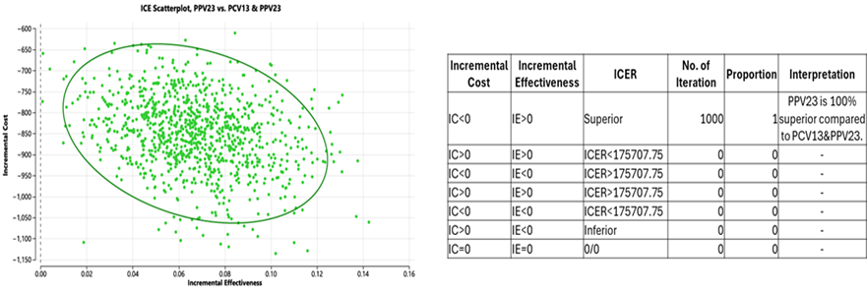
*Mean ICER PHP 12,649.55/QALY

The scatterplot comparing PPV23 with PCV13 and PPV23 showed that nearly all simulations fell within the quadrant of lower costs and higher effectiveness for PPV23. The incremental cost values were consistently negative, meaning PPV23 was less expensive, while incremental effectiveness values were positive, which implies that it produced greater health gains compared to the sequential strategy. This distribution indicated that PPV23 strongly dominated PCV13 and PPV23 across almost all simulations.
In 100% of simulations, PPV23 was both more effective and less costly than PCV13 and PPV23, confirming that PPV23 dominated the sequential strategy. No iterations suggested cost-effectiveness of PCV13 and PPV23 when compared directly with PPV23. The results showed with high certainty that PPV23 was the more efficient and economically attractive strategy when the two options were compared head-to-head.

PPV23 only versus PCV15 + PPV23
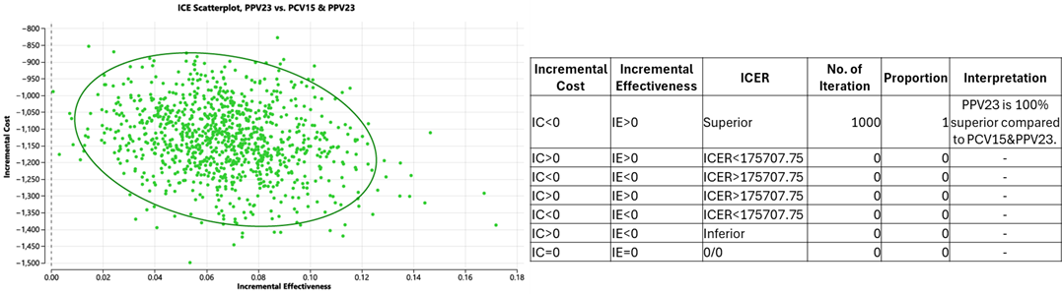
*Mean ICER PHP16,803.49/QALY
The scatterplot comparing PPV23 with PCV15 and PPV23 showed that nearly all simulations clustered in the region where PPV23 was both less costly and more effective. Incremental costs were consistently negative, while incremental effectiveness values were positive, which indicated that PPV23 dominated the sequential strategy across almost all parameter variations. The summary table confirmed this result, showing that in 100% of iterations PPV23 provided better health outcomes at lower costs compared with PCV15+PPV23. The findings reinforced PPV23 as the superior option when directly compared to the sequential strategy.

PCV13 + PPV23 versus PPV23 only
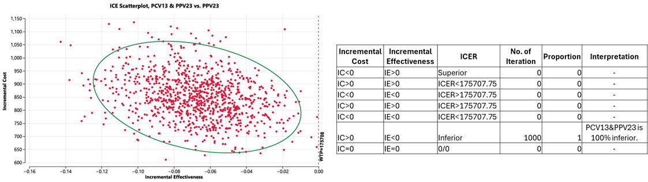
*Mean
The scatterplot comparing PCV13 and PPV23 with PPV23 showed that nearly all simulations were concentrated in the region where the sequential strategy was both more costly and less effective. Incremental cost values were positive, while incremental effectiveness values were consistently negative, indicating that PCV13 and PPV23 was dominated by PPV23 across simulations. The accompanying table confirmed this finding, showing that in 100% of iterations, PPV23 provided greater health gains at lower costs compared with the sequential option. The results revealed that adding PCV13 to PPV23 did not improve efficiency and instead reduced its cost-effectiveness relative to PPV23 alone

PCV13 + PPV23 versus PCV15 + PPV23
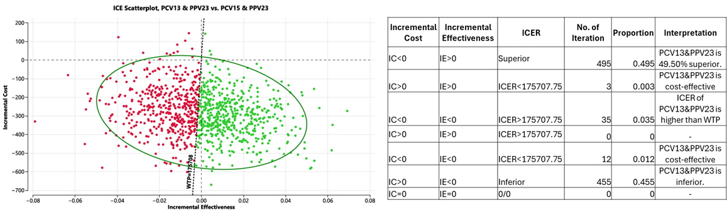
* Mean ICER–PHP 1,572,196.24/QALY

The scatterplot comparing PCV13 and PPV23 with PCV15 and PPV23 showed that the simulations were divided across both strategies. A large proportion of simulations fell in the left-hand quadrant, where PCV13 and PPV23 was less costly but also less effective than PCV15 and PPV23. Meanwhile, many points on the right indicated that PCV15 and PPV23 provided higher effectiveness but at additional cost. The summary table reflected this balance, with neither strategy consistently dominating the other across iterations. Notably, PCV13 and PPV23 was cost-effective in 51% of simulations compared with PCV15 and PPV23, suggesting that the sequential strategy with PCV13 tended to be the more favorable option under a majority of parameter assumptions.

PCV15 + PPV23 versus PPV23 only

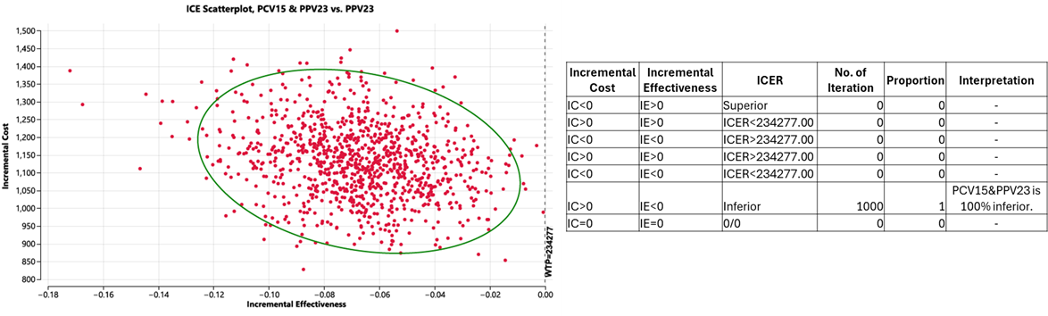
*Mean ICER –PHP16,803.49/QALY

The scatterplot comparing PCV15 and PPV23 with PCV13 and PPV23 revealed that the simulations were distributed across both strategies, with many points falling on either side of the cost-effectiveness threshold. A notable share of the scatter points favored PCV15 and PPV23, where it was both more effective and more costly, while others fell in the region where PCV13 and PPV23 was less costly but provided similar effectiveness. The table confirmed that the differences in effectiveness between the two sequential schedules were marginal. Given the same effectiveness, PCV15 and PPV23 was found to be cost-effective in 45.80% of the iterations compared with PCV13 and PPV23. The findings suggested that the choice between the two strategies is less clear-cut, with outcomes depending heavily on parameter variability.

PCV15 + PPV23 versus PCV13 + PPV23

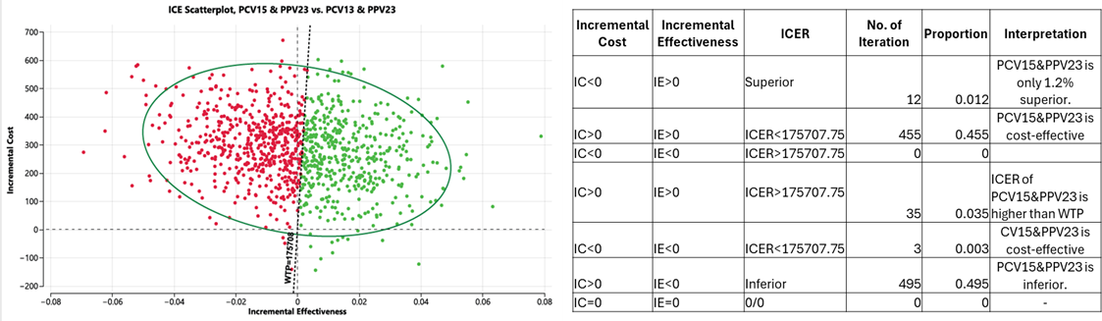
*Mean ICER –PHP1,572,196.24/QALY

The scatterplot comparing PCV15 and PPV23 with PCV13 and PPV23 revealed that the simulations were distributed across both strategies, with many points falling on either side of the cost-effectiveness threshold. A notable share of the scatter points favored PCV15 and PPV23, where it was both more effective and more costly, while others fell in the region where PCV13 and PPV23 was less costly but provided similar effectiveness. The table confirmed that the differences in effectiveness between the two sequential schedules were marginal. Given the same effectiveness, PCV15 and PPV23 was found to be cost-effective in 45.80% of the iterations compared with PCV13 and PPV23. The findings suggested that the choice between the two strategies is less clear-cut, with outcomes depending heavily on parameter variability.

Table S8. Cost utility analysis results of alternate scenario compared to the base-case scenario

Alternate Scenario ª
Strategy | Cost (PHP) per person | Incremental Cost (PHP) | Effectiveness/QALY per person | Incremental Effectiveness | ICER | NMB (PHP)
No Vaccine | 300.45 |  | 7.4 |  |  | 1,284,957.93
PPV23 | 808.87 | 508.42 | 7.49 | 0.09 | 5,642.87 | 1,300,103.68
PCV13 & PPV23 | 1,566.35 | 1,265.90 | 7.48 | 0.09 | 14,840.57 | 1,298,512.24
PCV15 & PPV23 | 1,825,71 | 1,525.26 | 7.50 | 0.10 | 15,453.45 | 1,300,581.03
Base Case Scenario ^{b}
Strategy | Cost (PHP) per person | Incremental Cost (PHP) | Effectiveness/QALY per person | Incremental Effectiveness | ICER | NMB (PHP)
No Vaccine | 300.45 |  | 7.4 |  |  | 1,284,957.93
PPV23 | 794.43 | 493.98 | 7.48 | 0.09 | 5,710.75 | 1,299,492.65
PCV13 & PPV23 | 1,588.97 | 1,288.52 | 7.46 | 0.07 | 19,289.21 | 1,295,275.39
PCV15 & PPV23 | 1,867.17 | 1,566.72 | 7.46 | 0.07 | 23,453.88 | 1,294,997.19

ª Based on the following scenario: Vaccinated 95% of target population using alternate--case VEs with linear waning of effectiveness of PPV23 to zero on year 15; and stable effectiveness of PCV13 and PCV15 regimens in the first five years after vaccination followed by linear waning to zero on year 15.
^{b.} Based on the following scenario: Vaccinated 95% of target population using base-case VEs with linear waning of effectiveness of PPV23 to zero on year 15; and stable effectiveness of PCV13 and PCV15 regimens in the first five years after vaccination followed by linear waning to zero on year 15.
NMB, net monetary benefit; ICER, incremental cost-effectiveness ratio; QALY, quality-adjusted life years; PCV, pneumococcal conjugate vaccine; PHP, Philippine peso; PPV23, 23-valent pneumococcal polysaccharide vaccine (Pneumovax 23®); PCV13, 13 valent pneumococcal conjugate vaccine (Prevnar 13 ®); PCV15, 15-valent pneumococcal conjugate vaccine (Vaxneuvance ®)

Table S9. Summary of assumptions and sources of costing for budget impact analysis
 | Source of costs | Vaccine efficacy/effectiveness used
Base cost scenario using base-case VE | PhilHealth case rates ²¹ | Base-case VE ^{14–17}
Alternate cost scenario using base-case VE | Median of actual hospitalization costs | Base-case VE ^{14–17}
Base cost scenario using alternative VE | PhilHealth case rates ²¹ | Alternate VE ^{16,18,19}
Alternate cost scenario using alternative VE | Median of actual hospitalization costs | Alternate VE ^{16,18,19}
 | Cost per case (in PHP)
 | Base cost (PhilHealth case rates) per case in PHP | Alternate cost (Median hospitalization costs) per case in PHP
Invasive pneumococcal disease (IPD)
Pneumococcal meningitis | 50,115.00 | 96,117.34
Bacteremia without pneumonia | 62,400.00 | 119,830.15
Bacteremia with pneumonia | 62,400.00 | 146,714.53
Nonbacteremic pneumococcal pneumonia (NBPP)
Pneumococcal pneumonia (hospitalized) | 29,250.00 | 26,884.38
Pneumococcal pneumonia (outpatient) | 179.51 | 179.51
 | Vaccine efficacy/effectiveness (in %)
 | Base-case VE | Alternate VE
IPD
PPV23 only | 68.7 | 71.42
PCV13 + PPV23 | 42.4 | 61.35 (for PCV13 serotypes) + 9.40 (for nonPCV13-PPV23 serotypes)
PCV15 + PPV23 | 42.4 | 65.33 (for PCV15 ST) + 3.91 (for nonPCV15-PPV23 ST)
NBPP
PPV23 only | 56.06 | 28.93
PCV13 + PPV23 | 33.61 | 36.81 (for PCV13 serotypes) + 3.81 (for nonPCV13-PPV23 serotypes)
PCV15 + PPV23 | 33.61 | 39.20 (for PCV15 ST) + 1.58 (for nonPCV15-PPV23 ST)

Table S10. Summary of net costs per year in budget impact analysis using different scenarios and different input parameters

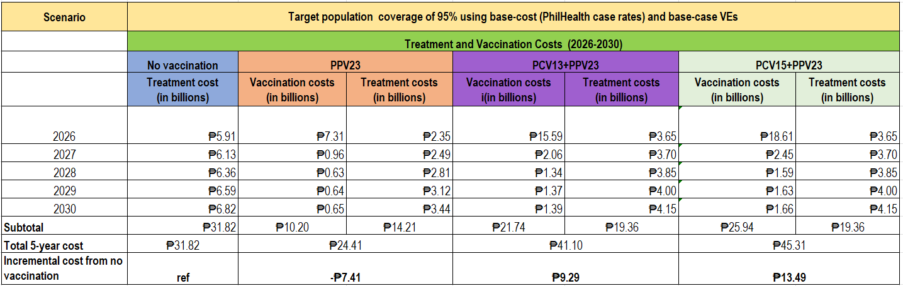
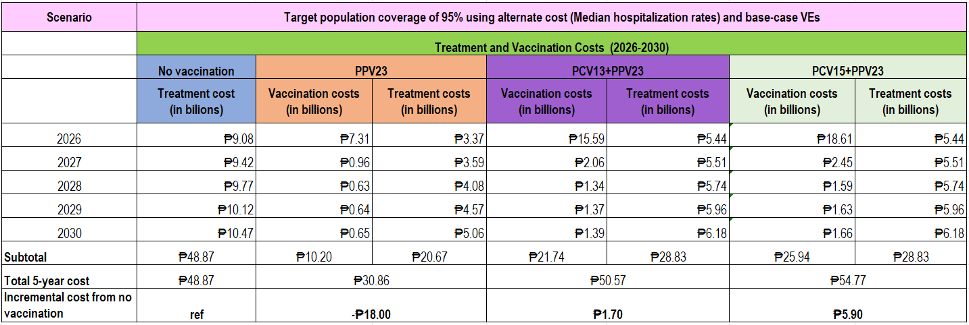
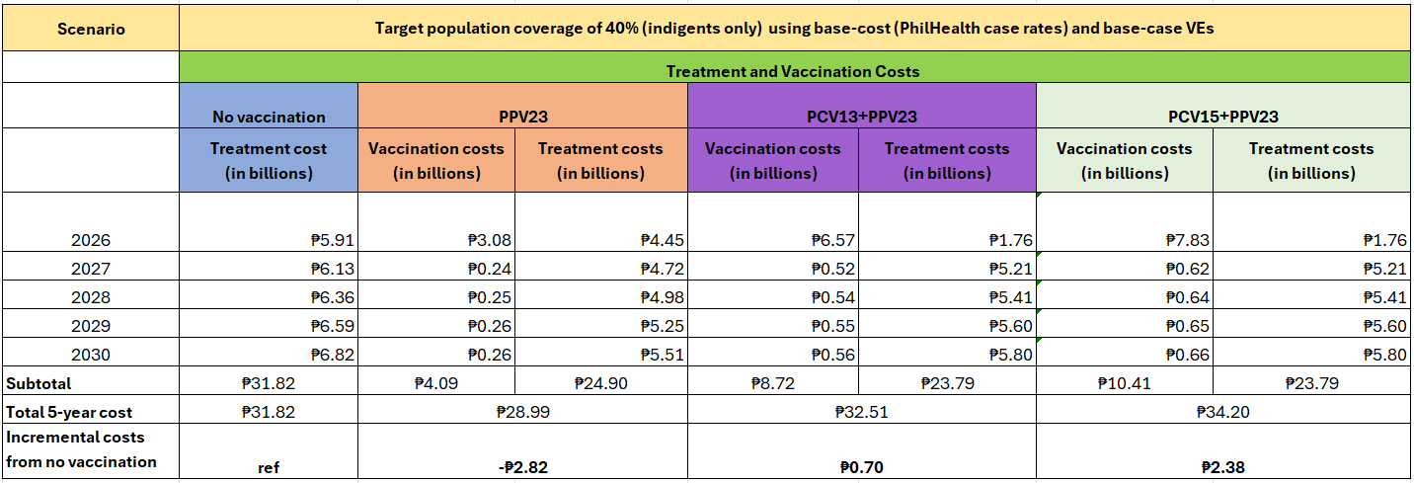
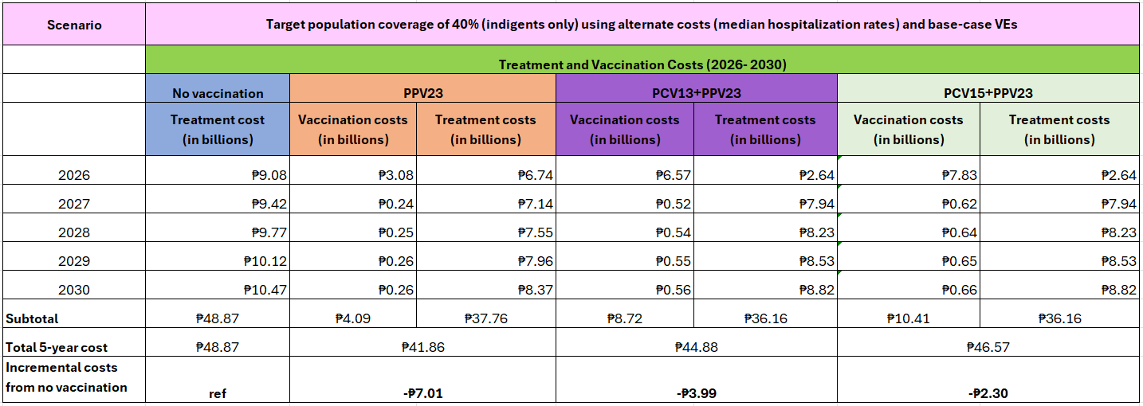

References:
1. Philippine Statistics Authority. Philippine Population Projection Statistics [Internet]. 2024 [cited 2025 Oct 14]. Available from: https://psa.gov.ph/statistics/census/projected-population
2. Wunrow HY, Bender RG, Vongpradith A, Sirota SB, Swetschinski LR, Novotney A, et al. Global, regional, and national burden of meningitis and its aetiologies, 1990–2019: a systematic analysis for the Global Burden of Disease Study 2019. Lancet Neurol. 2023 Aug;22(8):685–711. doi:10.1016/S1474-4422(23)00195-3
3. Rhodes J, Dejsirilert S, Maloney SA, Jorakate P, Kaewpan A, Salika P, et al. Pneumococcal Bacteremia Requiring Hospitalization in Rural Thailand: An Update on Incidence, Clinical Characteristics, Serotype Distribution, and Antimicrobial Susceptibility, 2005-2010. PLoS One. 2013 Jun 26;8(6). doi:10.1371/journal.pone.0066038 PubMed PMID: 23840395.
4. Backhaus E, Berg S, Andersson R, Ockborn G, Malmström P, Dahl M, et al. Epidemiology of invasive pneumococcal infections: Manifestations, incidence and case fatality rate correlated to age, gender and risk factors. BMC Infect Dis. 2016 Aug 3;16(1). doi:10.1186/s12879-016-1648-2 PubMed PMID: 27487784.
5. Bender RG, Sirota SB, Swetschinski LR, Dominguez RMV, Novotney A, Wool EE, et al. Global, regional, and national incidence and mortality burden of non-COVID-19 lower respiratory infections and aetiologies, 1990–2021: a systematic analysis from the Global Burden of Disease Study 2021. Lancet Infect Dis. 2024 Sep 1;24(9):974–1002. doi:10.1016/S1473-3099(24)00176-2 PubMed PMID: 38636536.
6. Morrill HJ, Caffrey AR, Noh E, LaPlante KL. Epidemiology of Pneumococcal Disease in a National Cohort of Older Adults. Infect Dis Ther. 2014;3(1):19–33. doi:10.1007/s40121-014-0025-y
7. Lupisan S, Suzuki A, Macalalad N, Egos R, Sombrero L, Okamoto M, et al. Etiology and epidemiology of community-acquired pneumonia in adults requiring hospital admission: A prospective study in rural Central Philippines. International Journal of Infectious Diseases. 2019 Mar 1;80:46–53. doi:10.1016/j.ijid.2018.12.005 PubMed PMID: 30550945.
8. Van Ettekoven CN, Liechti FD, Brouwer MC, Bijlsma MW, Van De Beek D. Global Case Fatality of Bacterial Meningitis during an 80-Year Period: A Systematic Review and Meta-Analysis. JAMA Netw Open. 2024 Aug 2;7(8):e2424802. doi:10.1001/jamanetworkopen.2024.24802 PubMed PMID: 39093565.
9. Thomas K, Mukkai Kesavan L, Veeraraghavan B, Jasmine S, Jude J, Shubankar M, et al. Invasive pneumococcal disease associated with high case fatality in India. J Clin Epidemiol. 2013 Jan;66(1):36–43. doi:10.1016/j.jclinepi.2012.04.006 PubMed PMID: 23177893.
10. Kolditz M, Tesch F, Mocke L, Höffken G, Ewig S, Schmitt J. Burden and risk factors of ambulatory or hospitalized CAP: A population based cohort study. Respir Med. 2016 Dec 1;121:32–8. doi:10.1016/j.rmed.2016.10.015 PubMed PMID: 27888989.
11. Philippine Statistics Authority. Registered Deaths in the Philippines, 2023 [Internet]. 2025 [cited 2025 May 2]. Available from: https://psa.gov.ph/statistics/vital-statistics/node/1684066658
12. Edmond K, Clark A, Korczak VS, Sanderson C, Griffiths UK, Rudan I. Global and regional risk of disabling sequelae from bacterial meningitis: A systematic review and meta-analysis. The Lancet Infectious Diseases. 2010. p. 317–28. doi:10.1016/S1473-3099(10)70048-7 PubMed PMID: 20417414.
13. Ubukata K. Juusyougata no rensa kyuujinnhaiennkyuukin kannsennsyou ni taisuru sa-berannsu no koutiku to byouinn kaiseki, sono sinndann tiryou ni kannsuru kennkyuu. Report of Health and Labour Sciences Research Grants. Tokyo; 2013.
14. Tsai YH, Hsieh MJ, Chang CJ, Wen YW, Hu HC, Chao YN, et al. The 23-valent pneumococcal polysaccharide vaccine is effective in elderly adults over 75 years old-Taiwan’s PPV vaccination program. Vaccine. 2015 Jun 9;33(25):2897–902. doi:10.1016/j.vaccine.2015.04.068 PubMed PMID: 25936662.
15. Hasegawa S, Jones MP, Kakiuchi S, Perencevich EN, Goto M. Comparative effectiveness of pneumococcal vaccination strategies to prevent invasive pneumococcal disease: a population-based cohort study at the veterans health administration in the United States. Clinical Microbiology and Infection. 2025 Mar 1;31(3):402–7. doi:10.1016/j.cmi.2024.09.006
16. Maruyama T, Taguchi O, Niederman MS, Morser J, Kobayashi H, Kobayashi T, et al. Efficacy of 23-valent pneumococcal vaccine in preventing pneumonia and improving survival in nursing home residents: Double blind, randomised and placebo controlled trial. BMJ (Online). 2010 Mar 13;340(7746):579. doi:10.1136/bmj.c1004 PubMed PMID: 20211953.
17. Heo JY, Seo Y Bin, Choi WS, Kim EJ, Jeong HW, Lee J, et al. Effectiveness of Pneumococcal Vaccination Against Pneumococcal Pneumonia Hospitalization in Older Adults: A Prospective, Test-Negative Study. Journal of Infectious Diseases. 2022 Mar 1;225(5):836–45. doi:10.1093/infdis/jiab474 PubMed PMID: 34537847.
18. Örtqvist Å, Hedlund J, Burman LÅ, Elbel E, Höfer M, Leinonen M, et al. Randomised trial of 23-valent pneumococcal capsular polysaccharide vaccine in prevention of pneumonia in middle-aged and elderly people. THE LANCET •. 1998.
19. Bonten MJM, Huijts SM, Bolkenbaas M, Webber C, Patterson S, Gault S, et al. Polysaccharide Conjugate Vaccine against Pneumococcal Pneumonia in Adults. New England Journal of Medicine. 2015 Mar 19;372(12):1114–25. doi:10.1056/nejmoa1408544 PubMed PMID: 25785969.
20. Ngamprasertchai T, Kositamongkol C, Lawpoolsri S, Rattanaumpawan P, Luvira V, Chongtrakool P, et al. A cost-effectiveness analysis of the 13-valent pneumococcal conjugated vaccine and the 23-valent pneumococcal polysaccharide vaccine among Thai older adult. Front Public Health. 2023;11. doi:10.3389/fpubh.2023.1071117 PubMed PMID: 37457251.
21. Philippine Health Insurance Corporation. PhilHealth Circular 2024. Annex A- List of Medical Case Rates [Internet]. 2025 [cited 2025 Sep 8]. Available from: https://www.philhealth.gov.ph/circulars/2024/archives.php
22. Department of Health. The Philippine Drug Price Reference Index. Manila; 2021.
23. Philippine Society for Microbiology and Infectious Diseases. Clinical Practice Guidelines Management and Prevention of Adult Community Acquired Pneumonia [Internet]. 2020 [cited 2025 May 8]. Available from: https://www.psmid.org/wp-content/uploads/2021/12/2020-Community-Acquired-Pneumonia-Clin
24. World Bank Group. GDP per capita (current US$)- Philippines [Internet]. 2024 [cited 2024 Feb 3]. Available from: https://data.worldbank.org/indicator/NY.GDP.PCAP.CD?locations=PH

