Supplementary Material
Contents
- Section 1: Fitting SEIHRD model to daily reported deaths for COVID-19 in 12 South American countries with most deaths
- Section 2: Fitting SEIHRD model to daily reported deaths for COVID-19 in 27 states of Brazil
- Section 3: Fitting SEIHRD to daily reported deaths for COVID-19 in 25 states of Peru
- Section 4: Geographical location of the 12 South American countries
- Section 5: COVID-19 vaccination scenario in South American countries

Section 1: Fitting SEIHRD model to daily reported deaths for COVID-19 in 12 South American countries with most deaths
In Figure S1, we fitted the SEIHRD model for 12 South American countries with highest reported COVID-19 deaths using similar approach as in the main text with $π=θ$.
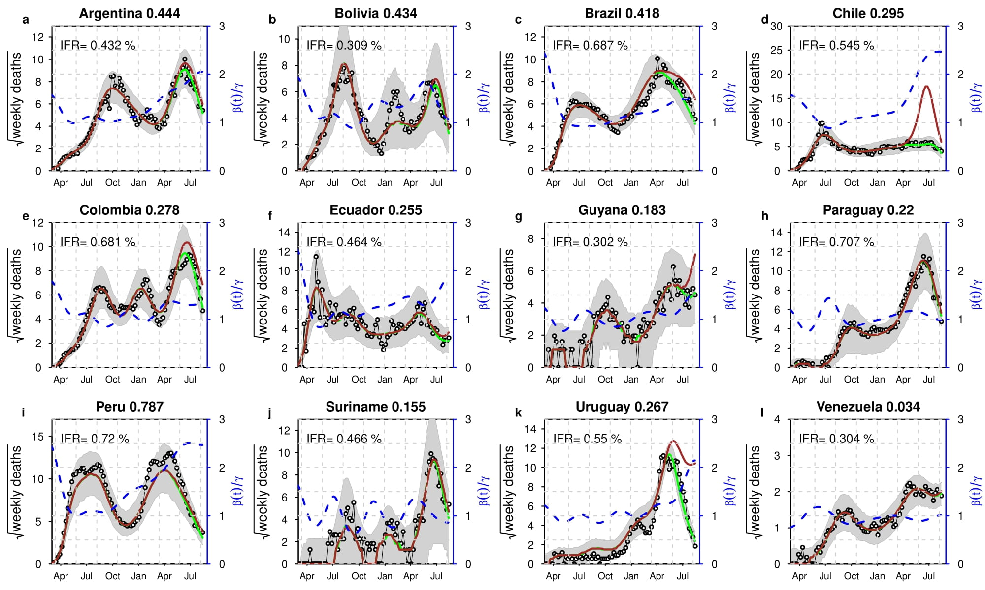
Figure S1: Fitting results for the twelve South American countries with highest reported COVID-19 deaths (represented by panels a-ls). Time series plots for the weekly reported COVID-19 deaths (in red circle) with simulation median (in black) and the basic reproduction number, $R_{0}(t)$, in solid blue line. The shaded region represents the 95% confidence interval of the simulation. The numbers from each panels a-o represent the IAR for the 12 countries, respectively. With $π=0.072$ fixed, $θ [0.042, 0.1],$ $n=9,$and IFR between 0.3% - 0.72%.

In Figure S2, we fitted the SEIHRD model for 12 South American countries with highest reported COVID-19 deaths using similar approach as in the main text, with varying $π$ and $θ$.
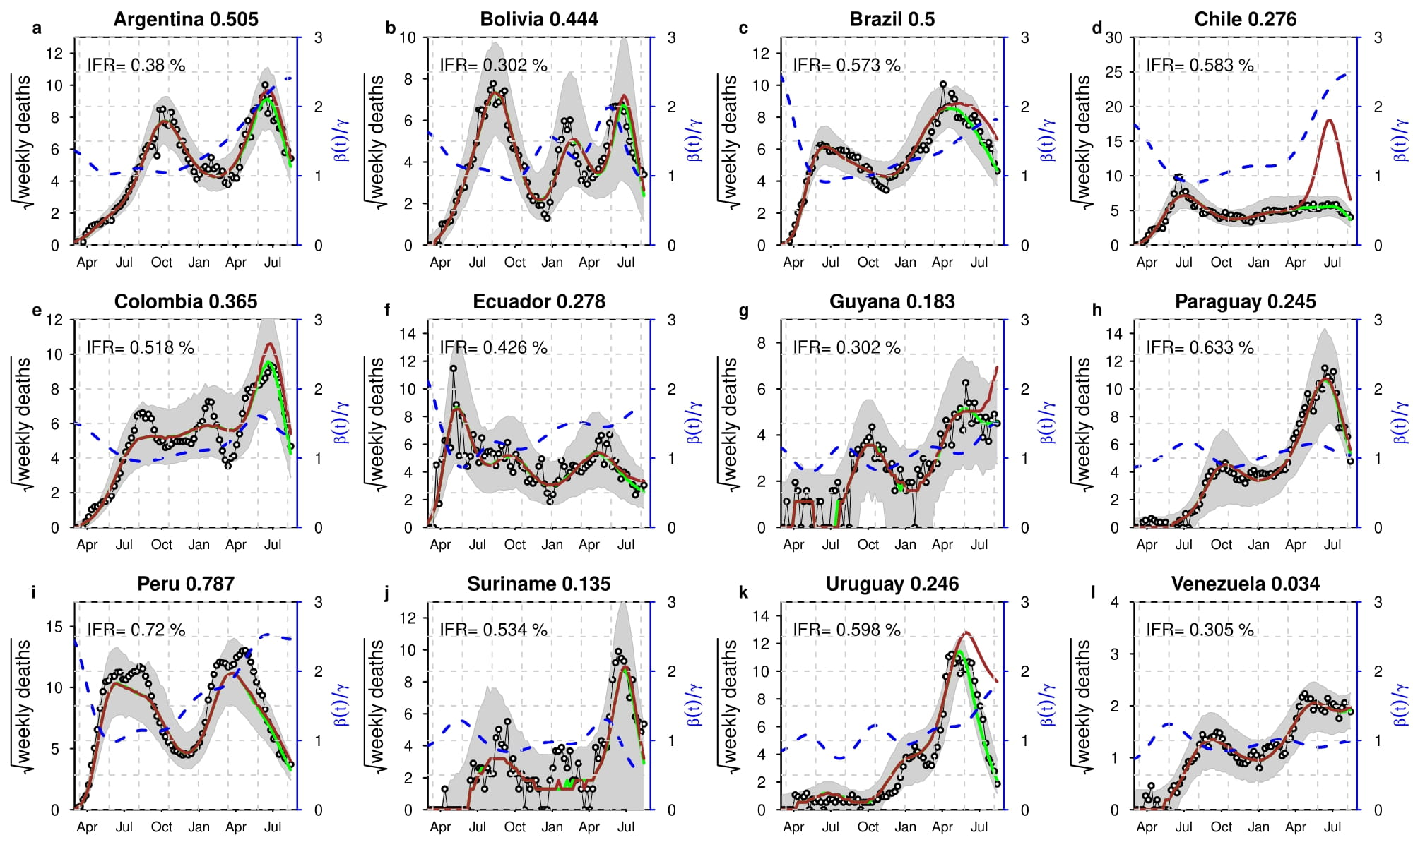
Figure S2: Fitting results for the twelve South American countries with highest reported COVID-19 deaths (represented by panels a-ls). Time series plots for the weekly reported COVID-19 deaths (in red circle) with simulation median (in black) and the basic reproduction number, $R_{0}(t)$, in solid blue line. The shaded region represents the 95% confidence interval of the simulation. The numbers from each panels a-o represent the IAR for the 12 countries, respectively. With $π=0.072$ fixed, $θ [0.042, 0.1],$ $n=8,$and IFR between 0.3% - 0.72%.

Section 2: Fitting SEIHRD model to daily reported deaths for COVID-19 in 27 states of Brazil

In Figure S3, we fitted the SEIHRD model to daily death in 27 states of Brazil using similar approach as in the main text.

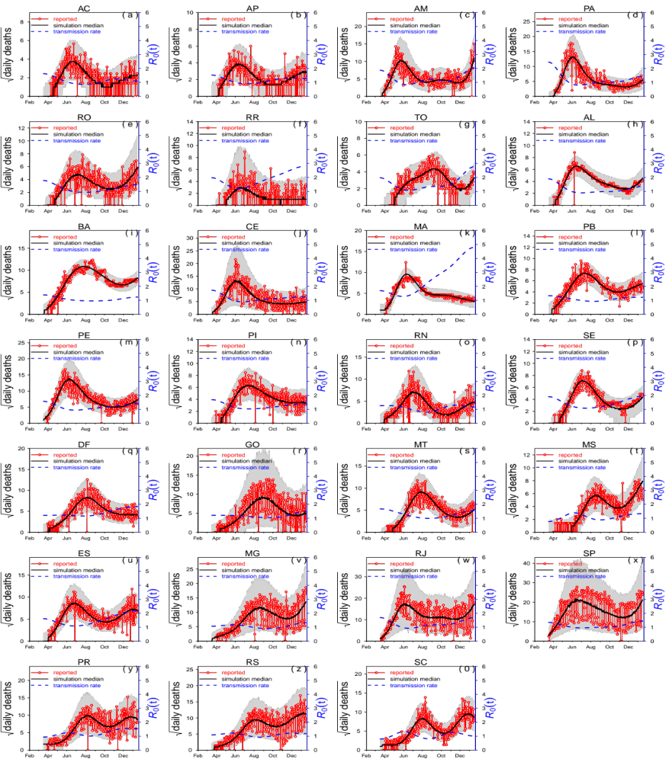
Figure S3. Fitting SEIRD model to daily reported death in 27 states of Brazil. The time series plots for the weekly reported COVID-19 deaths (in red circle) with simulation median (in black) and the time-varying effective reproduction number, $R_{0}(t)$, in solid blue line. The shaded region represents the 95% confidence interval of the simulation. Each panel represent a state in Brazil (more details for 27 Brazilian states can be found via https://en.wikipedia.org/wiki/List_of_Brazilian_states_by_population).
Section 3: Fitting SEIHRD to daily reported deaths for COVID-19 in 25 states of Peru
In this case, we presented reasonable fitting results for the SEIHRD model to daily reported deaths for COVID-19 in all the 25 states of Peru. We estimated the time-varying effective reproduction umber in each case as given in Figure S2 below.
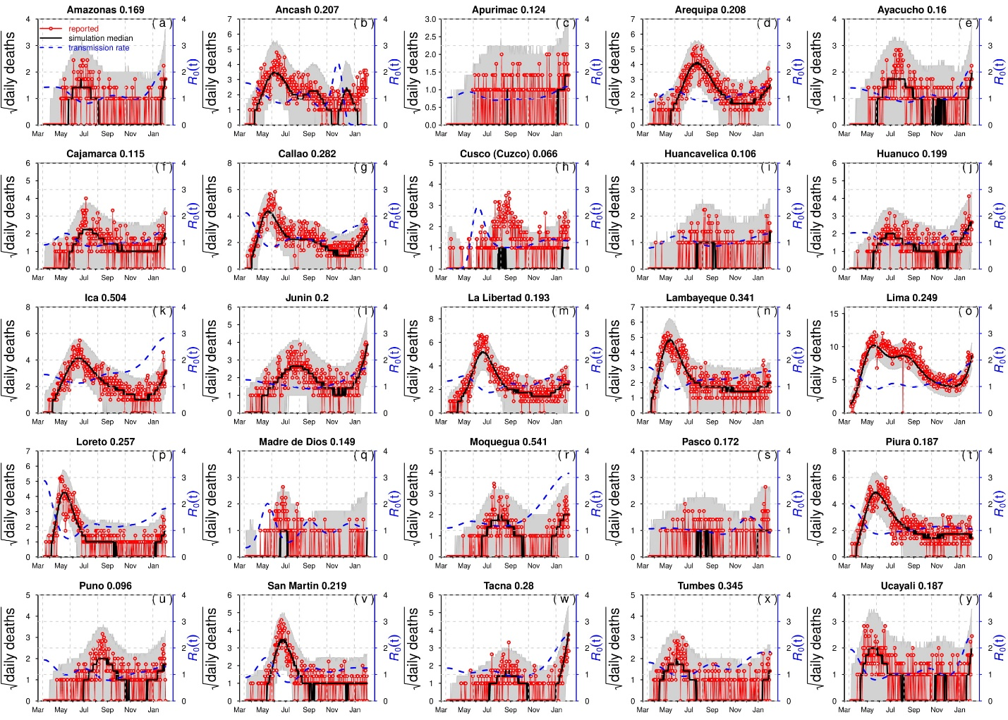
Figure S4. Fitting results of SEIHRD model to daily reported deaths for COVID-19 in 25 Peru states.

Section 4: Geographical location of the 12 South American countries
In this case, we depicted the twelve South American countries considered in the current study.

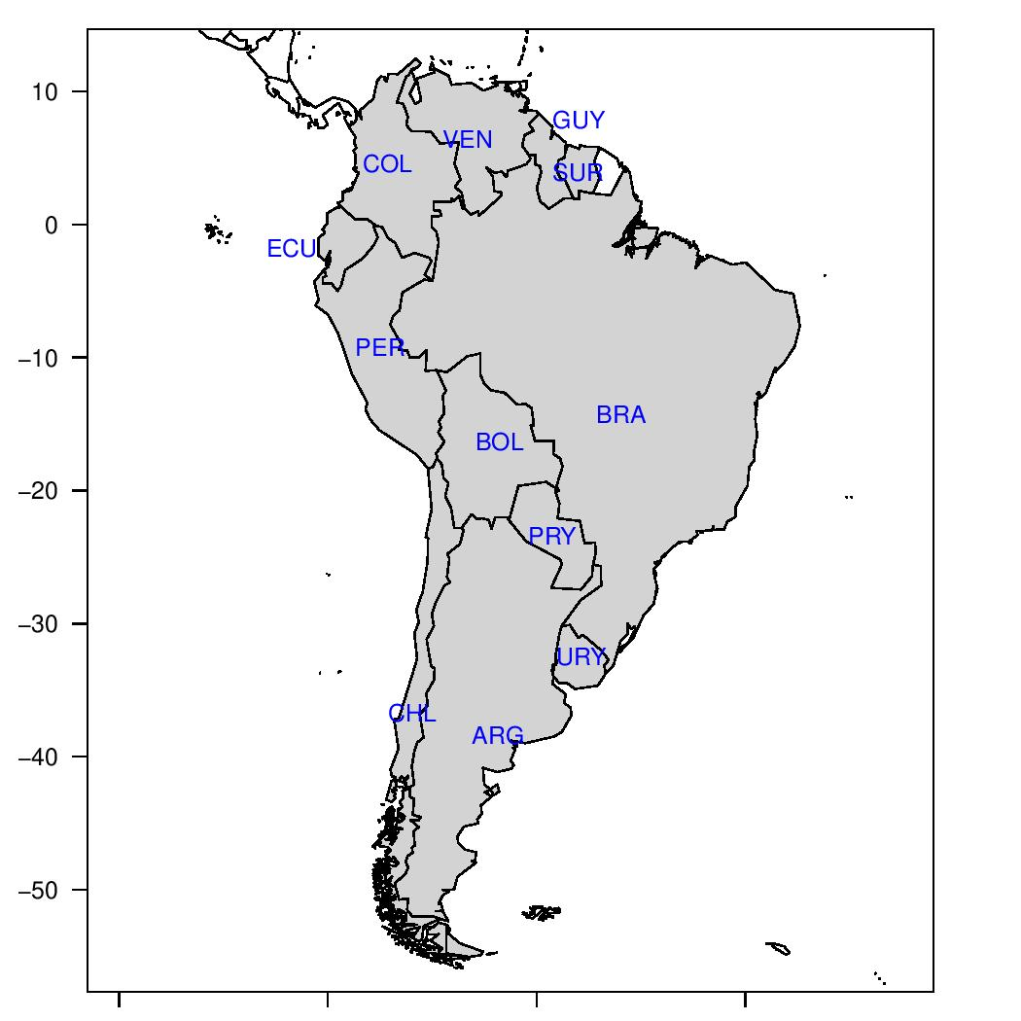

Figure S5. Geographical location of the 12 South American countries. The abbreviation ARG, BOL, BRA, CHL, COL, ECU, GUY, PRY, PER, SUR, URY, VEN, represent Argentina, Bolivia, Brazil, Chile, Columbia, Ecuador, Guyana, Paraguay, Peru, Suriname, Uruguay, Venezuela, respectively. The map is made with the free software R (http://www.r-project.org), R package Shapefiles, and the country borders data from Sandvik B., World Borders Dataset http://thematicmapping.org (2009)).

Section 5: COVID-19 vaccination scenario in South American countries
Table S1: The COVID-19 vaccination situation in South America by October 4, 2021^{1,2}.
Country | Vaccine doses (million) | Vaccine type (mostly used) | % of population fully vaccinated | % of population partly vaccinated
Argentina | 52,083,872 | Sputnik V | 50.49 | 15.11
Bolivia | 6,700,654 | Sputnik V | 27.54 | 8.40
Brazil | 225,795,545 | Coronavac | 44.27 | 27.04
Chile | 32,114,960 | Coronavac | 73.78 | 7.56
Colombia | 40,404,815 | Coronavac | 33.56 | 18.83
Ecuador | 20,841,350 | Pfizer/BioNTech | 55.45 | 8.00
Guyana | 543,180 | NA | 23.53 | 21.67
Paraguay | 4,640,590 | NA | 25.95 | 12.37
Peru | 26,543,168 | Coronavac | 34.44 | 14.07
Suriname | 401,242 | NA | 29.66 | 9.67
Uruguay | 6,264,161 | Pfizer/Sinovac | 74.19 | 4.38
Venezuela | 15,714,857 | Sputnik V/ Coronavac | 20.84 | 13.06

Reference
- World Health Organization (WHO). Coronavirus disease (‎COVID-19)‎ Dashboard; 2020 Available from: https://covid19.who.int/. Accessed October, 2021.
- Our World in Data. Coronavirus (‎COVID-19)‎ Vaccinations 2021 [Available from: https://ourworldindata.org/covid-vaccinations. Accessed October, 2021.

