Additional file 1. Supplementary information
Self-reported dietary patterns and breast cancer among women in Akwa Ibom State, Nigeria: an exploratory case-control study
Favour Inyene Etim¹, Inibehe Essien², Wilson Okwudili Nnanna², Daniel Okeke², Mustapha Dibassey, Israel Ben², Sunday Sambo¹, Blessed Nse Etoketim^{1,3*}
Supplementary methods, Tables S1-S22 and Figures S1-S20. Reference numbers correspond to the main manuscript. These materials report the frequency-and-portion analysis; no participant-level records are included.

Supplementary methods

Analysis populations and dietary-data handling
The study enrolled 101 controls and 70 cases at UUTH between 29 July and 26 December 2025. The primary comparison was restricted during analysis to the shared observed age range of 23-62 years. Descriptive summaries included 87 controls and 64 cases in this range. A complete combined dietary profile required a usable value for each of the 33 food indices; 83 controls and 62 cases met this requirement. Wider-age populations and the recorded-nonstudent population were analysed separately. No individual matching or random reduction of controls was applied.
Frequency and portion responses were linked by participant and food. A recorded frequency of zero produced a zero combined value irrespective of whether a typical portion had been entered. This rule did not recode the portion response. A missing, formula-containing or invalid frequency produced a missing combined value. Positive frequencies required an interpretable Small, Medium or Large portion. Missing or unrecognised portions were not replaced by Medium or treated as non-consumption.
Four frequency entries were unavailable across the enrolled sample: one blank, two spreadsheet formulas and one invalid letter code. Five additional positive-frequency entries had unavailable portions; these belonged to four participants. Within ages 23-62, two women had unavailable frequencies and four additional women had unavailable portions at positive frequencies, leaving 145 complete combined profiles. Valid but unusual responses were preserved; constant-frequency-profile exclusion was examined only in the specified sensitivity model.
Table S1. Analysis populations
Population | Controls | Cases | Total
All enrolled | 101 | 70 | 171
Age ≥23 | 87 | 70 | 157
Shared ages 23-62 | 87 | 64 | 151
Shared ages; complete frequency profile | 86 | 63 | 149
Shared ages; complete combined profile | 83 | 62 | 145
Age ≥23; complete combined profile | 83 | 67 | 150
All ages; complete combined profile | 96 | 67 | 163
Shared ages; recorded nonstudents | 69 | 57 | 126
Shared ages; complete nonstudents | 66 | 55 | 121
Ages 23-58; complete combined profile | 82 | 53 | 135
Populations overlap and must not be added. A complete combined profile has 33 usable frequency × portion indices; complete frequency data alone are insufficient when a positive frequency has an unavailable portion.

Table S2. Data handling and coding decisions
Domain | Applied rule
Source linkage | Coded identifiers linked frequency and portion sheets. Repeated demographic fields were compared numerically or after trimming outer whitespace.
Frequency | Entered integer codes 0-7 were retained. Blanks, formulas and invalid codes were unavailable; no frequency was imputed.
Portion | Small = 50, Medium = 100, Large = 150. These are assigned weights, not calibrated grams or millilitres.
Zero frequency | The combined index was zero when frequency was recorded as never. An unused or unrecognised portion remained separately identifiable.
Positive frequency | A usable S/M/L portion was required. N, blank, O or formula entries were unavailable rather than inferred non-consumption.
Student status | Occupation entries containing the word student were coded as recorded student occupation. This does not verify field of study or recruitment route.
Other covariates | Recorded age, anthropometry, family history, menopause, education and residence were retained. Contraception was not modelled because recording was incomplete and inconsistent.
Food coverage | The common 33 food items were analysed. Optional free-text additional foods and preparation notes were not assigned invented frequencies or portions.
Eligibility and scoring | Age restrictions were applied analytically. All enrolled records were retained; separate denominators were used for each summary and model.
The analysis did not convert missing responses to zero, use hypothetical preparation splits or infer nutrient intake from generic portion weights.

Food list and combined-index calculation
Table S3. Food items in the common questionnaire
Item | Questionnaire description
1 | Yam, cocoyam (boiled, pounded, ekpang nkukwo)
2 | Cassava (fufu, garri, abacha)
3 | Rice (white, stew, jollof, fried, coconut rice)
4 | Plantain (boiled, fried, porridge)
5 | Afang soup
6 | Moringa oleifera (leaves, soup)
7 | Pumpkin leaves (edikanikong soup)
8 | Waterleaf (edikanikong soup, stew)
9 | Okra (soup, stew)
10 | Egusi soup (melon seed-based)
11 | Fish (fresh, smoked, e.g., mackerel)
12 | Shrimp/crayfish (soup, stew)
13 | Periwinkle (isam)
14 | Crab
15 | Mango
16 | Guava
17 | Pawpaw (Carica papaya)
18 | Pineapple
19 | Beans (moi moi, ekpang nkukwo)
20 | Chicken (grilled, boiled, fried)
21 | Red meat (beef, goat)
22 | Palm oil (red, unrefined)
23 | Vegetable oil (refined, e.g., groundnut)
24 | Hibiscus tea (zobo)
25 | Fruit juice (fresh, e.g., pineapple)
26 | Soda (e.g., Coke, Fanta)
27 | Instant noodles
28 | Bread (white, wheat)
29 | Biscuits/cookies
30 | Fried snacks (e.g., puff-puff, buns)
31 | Garlic
32 | Ginger
33 | Turmeric
Food descriptions are retained with spelling and spacing standardised for display. The items include both dishes and ingredients and are not mutually exclusive food groups or a NOVA classification. All 33 items contributed to component derivation.
For participant i and food j, let cᵢⱼ denote the recorded frequency category and Pᵢⱼ the portion weight. The primary input was Jᵢⱼ = f(cᵢⱼ) × Pᵢⱼ. Dividing J by 100 expresses an assigned medium-reference portion index per week for descriptive reporting. This is not measured grams, millilitres, energy or antioxidant intake. Both J and J/100 yield identical standardised PCA inputs because their common positive scaling factor cancels.
Table S4. Frequency assignments and portion weights
Code | Recorded category | Primary weekly  assignment | Raw-code  multiplier | Alternative  multiplier
0 | Never | 0 | 0 | 0
1 | <1/month | 0.115385 | 1 | 1
2 | 1-3/month | 0.461538 | 2 | 2
3 | 1/week | 1 | 3 | 3
4 | 2-4/week | 3 | 4 | 4
5 | 5-6/week | 5.5 | 5 | 5
6 | 1/day | 7 | 6 | 7
7 | 2+/day | 14 | 7 | 14
Primary assignments use 0.5/month for <1/month, 2/month for 1-3/month, closed-range midpoints, and 2/day for ≥2/day. Monthly frequencies were multiplied by 12/52 to obtain assigned weekly frequencies. The open-ended highest-category sensitivity assigns 3/day. Raw codes and the alternative multiplier vector (0, 1, 2, 3, 4, 5, 7, 14) are numerical sensitivity codings, not observed weekly rates.
Portion-weight component of Table S4
Recorded portion | Numerical weight | Relative to Medium
S | 50 | 0.5
M | 100 | 1
L | 150 | 1.5
S = Small, M = Medium and L = Large. The 0.5/1/1.5 relationship has precedent in FFQ methodology [13] but was not locally validated here. Food-specific physical reference weights were unavailable. Nutrient values per 100 g in the regional composition table are not serving-size definitions [14].
For example, frequency code 6 and a Small portion give 7 × 50 = 350 index units, or 3.5 assigned medium-reference units per week. Under the raw-code sensitivity, the same responses give 6 × 50 = 300. Both are assigned indices; neither estimates calibrated food mass or volume.

Participant characteristics
Table S5. Characteristics of all enrolled participants
Characteristic | Controls  (n = 101) | Cases  (n = 70) | Standardised  difference
Age (years), mean (SD) | 34.80 (10.67) | 47.77 (12.29) | 1.127
Age (years), median (Q1-Q3) | 34.0 (26.0-41.0) | 48.0 (39.0-56.0) | ---
BMI (kg/m²), mean (SD) | 24.82 (5.69) | 24.19 (5.27) | -0.115
BMI (kg/m²), median (Q1-Q3) | 23.9 (20.6-28.1) | 23.2 (19.8-27.1) | -
Weight (kg), mean (SD) | 69.52 (14.56) | 66.99 (14.76) | -0.173
Weight (kg), median (Q1-Q3) | 70.0 (59.0-81.0) | 63.0 (55.2-79.0) | ---
Height (cm), mean (SD) | 167.87 (9.11) | 166.63 (9.84) | -0.131
Height (cm), median (Q1-Q3) | 168.0 (162.0-174.0) | 167.0 (159.0-172.0) | ---
Family history of breast cancer: yes | 13 (12.9) | 18 (25.7) | 0.330
Post-menopausal | 19 (18.8) | 40 (57.1) | 0.860
Rural residence | 29 (28.7) | 32 (45.7) | 0.357
Recorded student occupation | 29 (28.7) | 7 (10.0) | -0.488
Education: primary | 1 (1.0) | 1 (1.4) | 0.040
Education: secondary | 16 (15.8) | 11 (15.7) | -0.003
Education: tertiary | 84 (83.2) | 58 (82.9) | -0.008
Values are mean (SD), median (Q1-Q3) or n (%) as labelled. Standardised differences are cases minus controls and are not hypothesis tests. For continuous variables, the denominator is the square root of the mean of the two group variances; binary-category differences use the analogous proportion-based denominator. All displayed fields were available. Student status identifies recorded occupation, not an individually verified recruitment route.
Table S6. Characteristics of participants aged 23 and above
Characteristic | Controls  (n = 87) | Cases  (n = 70) | Standardised  difference
Age (years), mean (SD) | 37.07 (9.73) | 47.77 (12.29) | 0.965
Age (years), median (Q1-Q3) | 37.0 (28.0-43.0) | 48.0 (39.0-56.0) | ---
BMI (kg/m²), mean (SD) | 25.11 (5.88) | 24.19 (5.27) | -0.165
BMI (kg/m²), median (Q1-Q3) | 25.2 (20.7-28.4) | 23.2 (19.8-27.1) | -
Weight (kg), mean (SD) | 70.06 (14.72) | 66.99 (14.76) | -0.208
Weight (kg), median (Q1-Q3) | 70.0 (59.0-81.0) | 63.0 (55.2-79.0) | ---
Height (cm), mean (SD) | 167.67 (9.53) | 166.63 (9.84) | -0.107
Height (cm), median (Q1-Q3) | 167.0 (161.5-174.5) | 167.0 (159.0-172.0) | ---
Family history of breast cancer: yes | 12 (13.8) | 18 (25.7) | 0.303
Post-menopausal | 19 (21.8) | 40 (57.1) | 0.774
Rural residence | 26 (29.9) | 32 (45.7) | 0.331
Recorded student occupation | 18 (20.7) | 7 (10.0) | -0.300
Education: primary | 1 (1.1) | 1 (1.4) | 0.025
Education: secondary | 9 (10.3) | 11 (15.7) | 0.160
Education: tertiary | 77 (88.5) | 58 (82.9) | -0.162
Values are mean (SD), median (Q1-Q3) or n (%) as labelled. Standardised differences are cases minus controls and are not hypothesis tests. For continuous variables, the denominator is the square root of the mean of the two group variances; binary-category differences use the analogous proportion-based denominator. All displayed fields were available. Student status identifies recorded occupation, not an individually verified recruitment route.
Table S7. Characteristics of the primary combined-profile population
Characteristic | Controls  (n = 83) | Cases  (n = 62) | Standardised  difference
Age (years), mean (SD) | 37.28 (9.84) | 45.44 (10.63) | 0.797
Age (years), median (Q1-Q3) | 37.0 (28.0-44.0) | 46.0 (38.2-54.8) | ---
BMI (kg/m²), mean (SD) | 25.05 (5.99) | 24.14 (5.33) | -0.161
BMI (kg/m²), median (Q1-Q3) | 25.2 (20.6-28.4) | 23.2 (19.8-27.1) | ---
Weight (kg), mean (SD) | 70.06 (14.96) | 66.53 (14.77) | -0.237
Weight (kg), median (Q1-Q3) | 70.0 (59.0-81.0) | 62.0 (55.2-77.8) | ---
Height (cm), mean (SD) | 167.89 (9.69) | 166.29 (9.84) | -0.164
Height (cm), median (Q1-Q3) | 168.0 (161.5-175.0) | 167.0 (159.0-172.0) | ---
Family history of breast cancer: yes | 9 (10.8) | 16 (25.8) | 0.394
Post-menopausal | 19 (22.9) | 32 (51.6) | 0.622
Rural residence | 25 (30.1) | 29 (46.8) | 0.347
Recorded student occupation | 17 (20.5) | 7 (11.3) | -0.253
Education: primary | 1 (1.2) | 1 (1.6) | 0.035
Education: secondary | 8 (9.6) | 10 (16.1) | 0.195
Education: tertiary | 74 (89.2) | 51 (82.3) | -0.198
Values describe the 145 participants in the primary combined-profile analysis. Definitions match Table S5; main Table 1 describes all 151 women in the shared-age range.
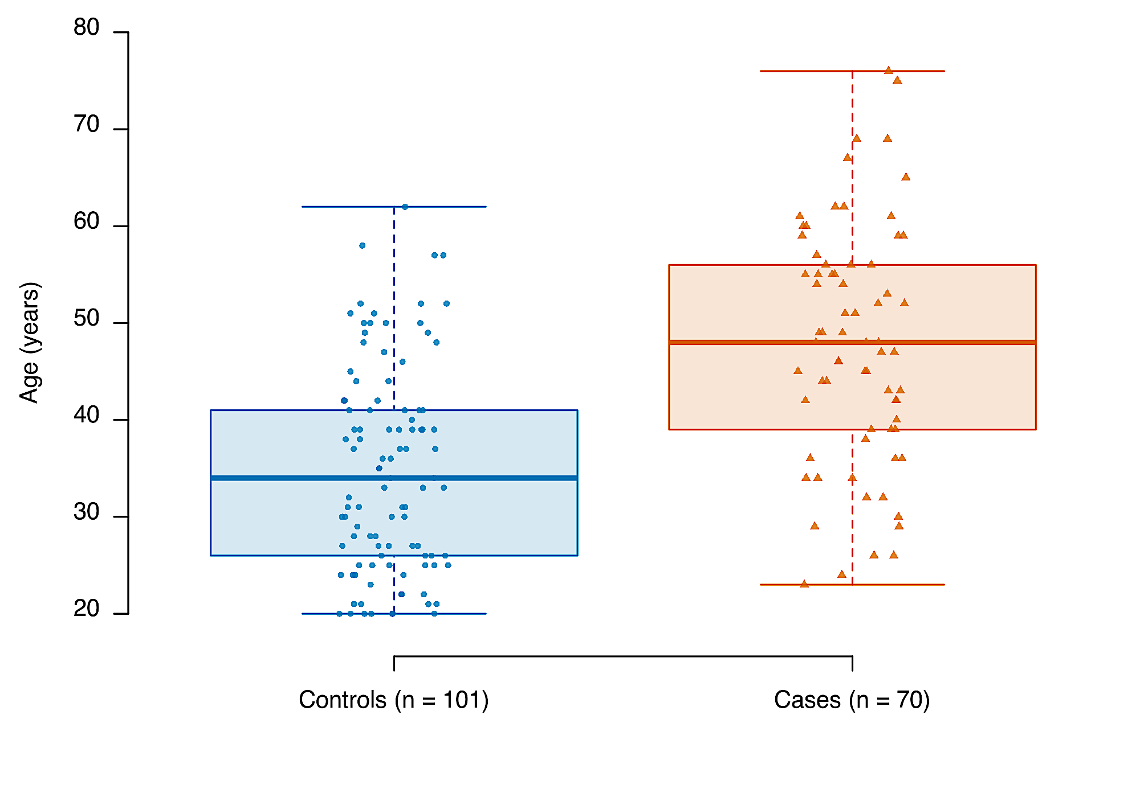
Figure S1. Age distribution of all enrolled participants. Recorded ages for 101 controls and 70 cases, before complete-profile restrictions. Boxes show the median and quartiles; whiskers extend to values within 1.5 interquartile ranges, and horizontally jittered points show individual values without identifiers. Colours and symbols distinguish groups, not significance. The analytical age restriction does not establish age matching.

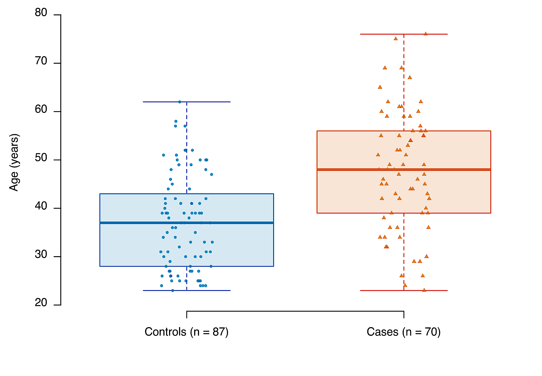
Figure S2. Age distribution among participants aged 23 and above. Recorded ages for 87 controls and 70 cases, before complete-profile restrictions. Boxes show the median and quartiles; whiskers extend to values within 1.5 interquartile ranges, and horizontally jittered points show individual values without identifiers. Colours and symbols distinguish groups, not significance. The analytical age restriction does not establish age matching.
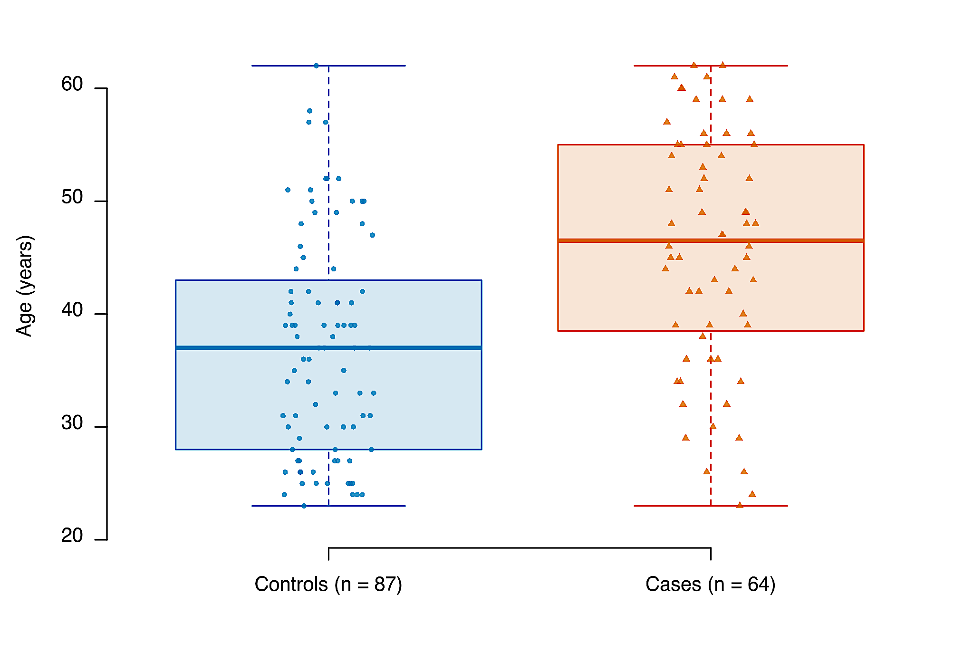
Figure S3. Age distribution in the shared-age descriptive population. Recorded ages for 87 controls and 64 cases aged 23-62, before complete-profile restrictions. Boxes show the median and quartiles; whiskers extend to values within 1.5 interquartile ranges, and horizontally jittered points show individual values without identifiers. Colours and symbols distinguish groups, not significance. The analytical age restriction does not establish age matching.

Portion distributions and combined-index summaries
Portion distributions are reported among participants with a valid positive frequency for each food in the shared-age descriptive population. Denominators therefore vary across foods and are not restricted to the 145 complete profiles. Unavailable portions remain a separate category in the denominator. Non-consumers and participants with unavailable frequencies are not included in that food’s consumer denominator. Full frequency and portion counts are supplied in Additional file 2.
Table S8. Recorded portions among control consumers
Food | Consumers  (n) | Small  n (%) | Medium  n (%) | Large  n (%) | Unavailable  n (%)
Yam / cocoyam | 86 | 18 (20.9) | 59 (68.6) | 9 (10.5) | 0 (0.0)
Cassava | 84 | 24 (28.6) | 49 (58.3) | 11 (13.1) | 0 (0.0)
Rice | 87 | 19 (21.8) | 47 (54.0) | 21 (24.1) | 0 (0.0)
Plantain | 85 | 24 (28.2) | 43 (50.6) | 18 (21.2) | 0 (0.0)
Afang soup | 84 | 16 (19.0) | 50 (59.5) | 18 (21.4) | 0 (0.0)
Moringa | 45 | 21 (46.7) | 17 (37.8) | 7 (15.6) | 0 (0.0)
Pumpkin leaves | 85 | 29 (34.1) | 38 (44.7) | 18 (21.2) | 0 (0.0)
Waterleaf | 82 | 30 (36.6) | 31 (37.8) | 21 (25.6) | 0 (0.0)
Okra | 87 | 33 (37.9) | 38 (43.7) | 16 (18.4) | 0 (0.0)
Egusi soup | 85 | 28 (32.9) | 44 (51.8) | 13 (15.3) | 0 (0.0)
Fish | 86 | 29 (33.7) | 40 (46.5) | 17 (19.8) | 0 (0.0)
Shrimp / crayfish | 86 | 33 (38.4) | 30 (34.9) | 23 (26.7) | 0 (0.0)
Periwinkle | 85 | 32 (37.6) | 25 (29.4) | 28 (32.9) | 0 (0.0)
Crab | 67 | 28 (41.8) | 23 (34.3) | 16 (23.9) | 0 (0.0)
Mango | 81 | 20 (24.7) | 36 (44.4) | 24 (29.6) | 1 (1.2)
Guava | 77 | 29 (37.7) | 35 (45.5) | 13 (16.9) | 0 (0.0)
Pawpaw | 81 | 33 (40.7) | 32 (39.5) | 15 (18.5) | 1 (1.2)
Pineapple | 83 | 21 (25.3) | 42 (50.6) | 20 (24.1) | 0 (0.0)
Beans | 87 | 17 (19.5) | 48 (55.2) | 22 (25.3) | 0 (0.0)
Chicken | 86 | 19 (22.1) | 41 (47.7) | 26 (30.2) | 0 (0.0)
Red meat | 84 | 31 (36.9) | 40 (47.6) | 13 (15.5) | 0 (0.0)
Palm oil | 87 | 29 (33.3) | 42 (48.3) | 15 (17.2) | 1 (1.1)
Vegetable oil | 85 | 38 (44.7) | 29 (34.1) | 17 (20.0) | 1 (1.2)
Hibiscus tea | 75 | 32 (42.7) | 27 (36.0) | 16 (21.3) | 0 (0.0)
Fruit juice | 76 | 32 (42.1) | 33 (43.4) | 11 (14.5) | 0 (0.0)
Soda | 79 | 44 (55.7) | 26 (32.9) | 9 (11.4) | 0 (0.0)
Instant noodles | 69 | 28 (40.6) | 31 (44.9) | 10 (14.5) | 0 (0.0)
Bread | 79 | 31 (39.2) | 28 (35.4) | 20 (25.3) | 0 (0.0)
Biscuits / cookies | 80 | 43 (53.8) | 22 (27.5) | 15 (18.8) | 0 (0.0)
Fried snacks | 76 | 32 (42.1) | 25 (32.9) | 19 (25.0) | 0 (0.0)
Garlic | 80 | 37 (46.2) | 35 (43.8) | 8 (10.0) | 0 (0.0)
Ginger | 80 | 40 (50.0) | 30 (37.5) | 10 (12.5) | 0 (0.0)
Turmeric | 78 | 41 (52.6) | 27 (34.6) | 10 (12.8) | 0 (0.0)
Percentages use each food’s positive-frequency consumer denominator and include unavailable portions. They may differ from percentages among all participants or among only those with known portions. S/M/L responses retain their observed categories; unavailable does not mean never consumed.
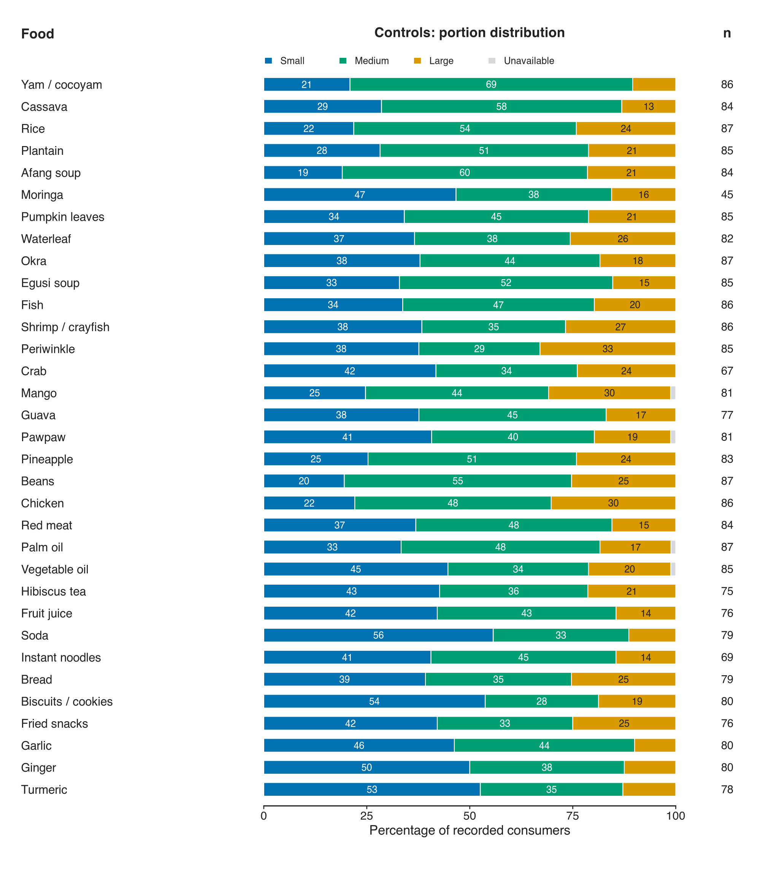
Figure S4. Portion-size distributions among control consumers. Each bar represents participants with positive recorded frequency for the food in the shared-age population. Blue, teal and gold indicate Small, Medium and Large; grey denotes an unavailable portion. Denominators are food-specific and include unavailable portions. Numbers and percentages appear in Table S8.

Table S9. Recorded portions among case consumers
Food | Consumers  (n) | Small  n (%) | Medium  n (%) | Large  n (%) | Unavailable  n (%)
Yam / cocoyam | 61 | 9 (14.8) | 40 (65.6) | 11 (18.0) | 1 (1.6)
Cassava | 63 | 13 (20.6) | 31 (49.2) | 19 (30.2) | 0 (0.0)
Rice | 64 | 18 (28.1) | 28 (43.8) | 18 (28.1) | 0 (0.0)
Plantain | 63 | 19 (30.2) | 32 (50.8) | 12 (19.0) | 0 (0.0)
Afang soup | 61 | 15 (24.6) | 31 (50.8) | 15 (24.6) | 0 (0.0)
Moringa | 37 | 19 (51.4) | 14 (37.8) | 4 (10.8) | 0 (0.0)
Pumpkin leaves | 63 | 25 (39.7) | 26 (41.3) | 12 (19.0) | 0 (0.0)
Waterleaf | 64 | 25 (39.1) | 24 (37.5) | 15 (23.4) | 0 (0.0)
Okra | 62 | 23 (37.1) | 25 (40.3) | 14 (22.6) | 0 (0.0)
Egusi soup | 64 | 24 (37.5) | 26 (40.6) | 14 (21.9) | 0 (0.0)
Fish | 64 | 25 (39.1) | 28 (43.8) | 11 (17.2) | 0 (0.0)
Shrimp / crayfish | 62 | 31 (50.0) | 17 (27.4) | 14 (22.6) | 0 (0.0)
Periwinkle | 64 | 36 (56.2) | 24 (37.5) | 4 (6.2) | 0 (0.0)
Crab | 56 | 33 (58.9) | 18 (32.1) | 5 (8.9) | 0 (0.0)
Mango | 61 | 24 (39.3) | 26 (42.6) | 11 (18.0) | 0 (0.0)
Guava | 60 | 24 (40.0) | 24 (40.0) | 12 (20.0) | 0 (0.0)
Pawpaw | 61 | 28 (45.9) | 25 (41.0) | 8 (13.1) | 0 (0.0)
Pineapple | 61 | 24 (39.3) | 25 (41.0) | 12 (19.7) | 0 (0.0)
Beans | 62 | 23 (37.1) | 28 (45.2) | 11 (17.7) | 0 (0.0)
Chicken | 64 | 31 (48.4) | 22 (34.4) | 11 (17.2) | 0 (0.0)
Red meat | 62 | 28 (45.2) | 25 (40.3) | 9 (14.5) | 0 (0.0)
Palm oil | 64 | 22 (34.4) | 26 (40.6) | 16 (25.0) | 0 (0.0)
Vegetable oil | 64 | 25 (39.1) | 27 (42.2) | 12 (18.8) | 0 (0.0)
Hibiscus tea | 61 | 29 (47.5) | 26 (42.6) | 6 (9.8) | 0 (0.0)
Fruit juice | 53 | 33 (62.3) | 16 (30.2) | 4 (7.5) | 0 (0.0)
Soda | 64 | 27 (42.2) | 26 (40.6) | 11 (17.2) | 0 (0.0)
Instant noodles | 55 | 14 (25.5) | 30 (54.5) | 11 (20.0) | 0 (0.0)
Bread | 62 | 19 (30.6) | 30 (48.4) | 13 (21.0) | 0 (0.0)
Biscuits / cookies | 61 | 26 (42.6) | 27 (44.3) | 8 (13.1) | 0 (0.0)
Fried snacks | 58 | 24 (41.4) | 27 (46.6) | 7 (12.1) | 0 (0.0)
Garlic | 57 | 32 (56.1) | 19 (33.3) | 6 (10.5) | 0 (0.0)
Ginger | 57 | 35 (61.4) | 14 (24.6) | 8 (14.0) | 0 (0.0)
Turmeric | 55 | 35 (63.6) | 11 (20.0) | 9 (16.4) | 0 (0.0)
Percentages use each food’s positive-frequency consumer denominator and include unavailable portions. They may differ from percentages among all participants or among only those with known portions. S/M/L responses retain their observed categories; unavailable does not mean never consumed.
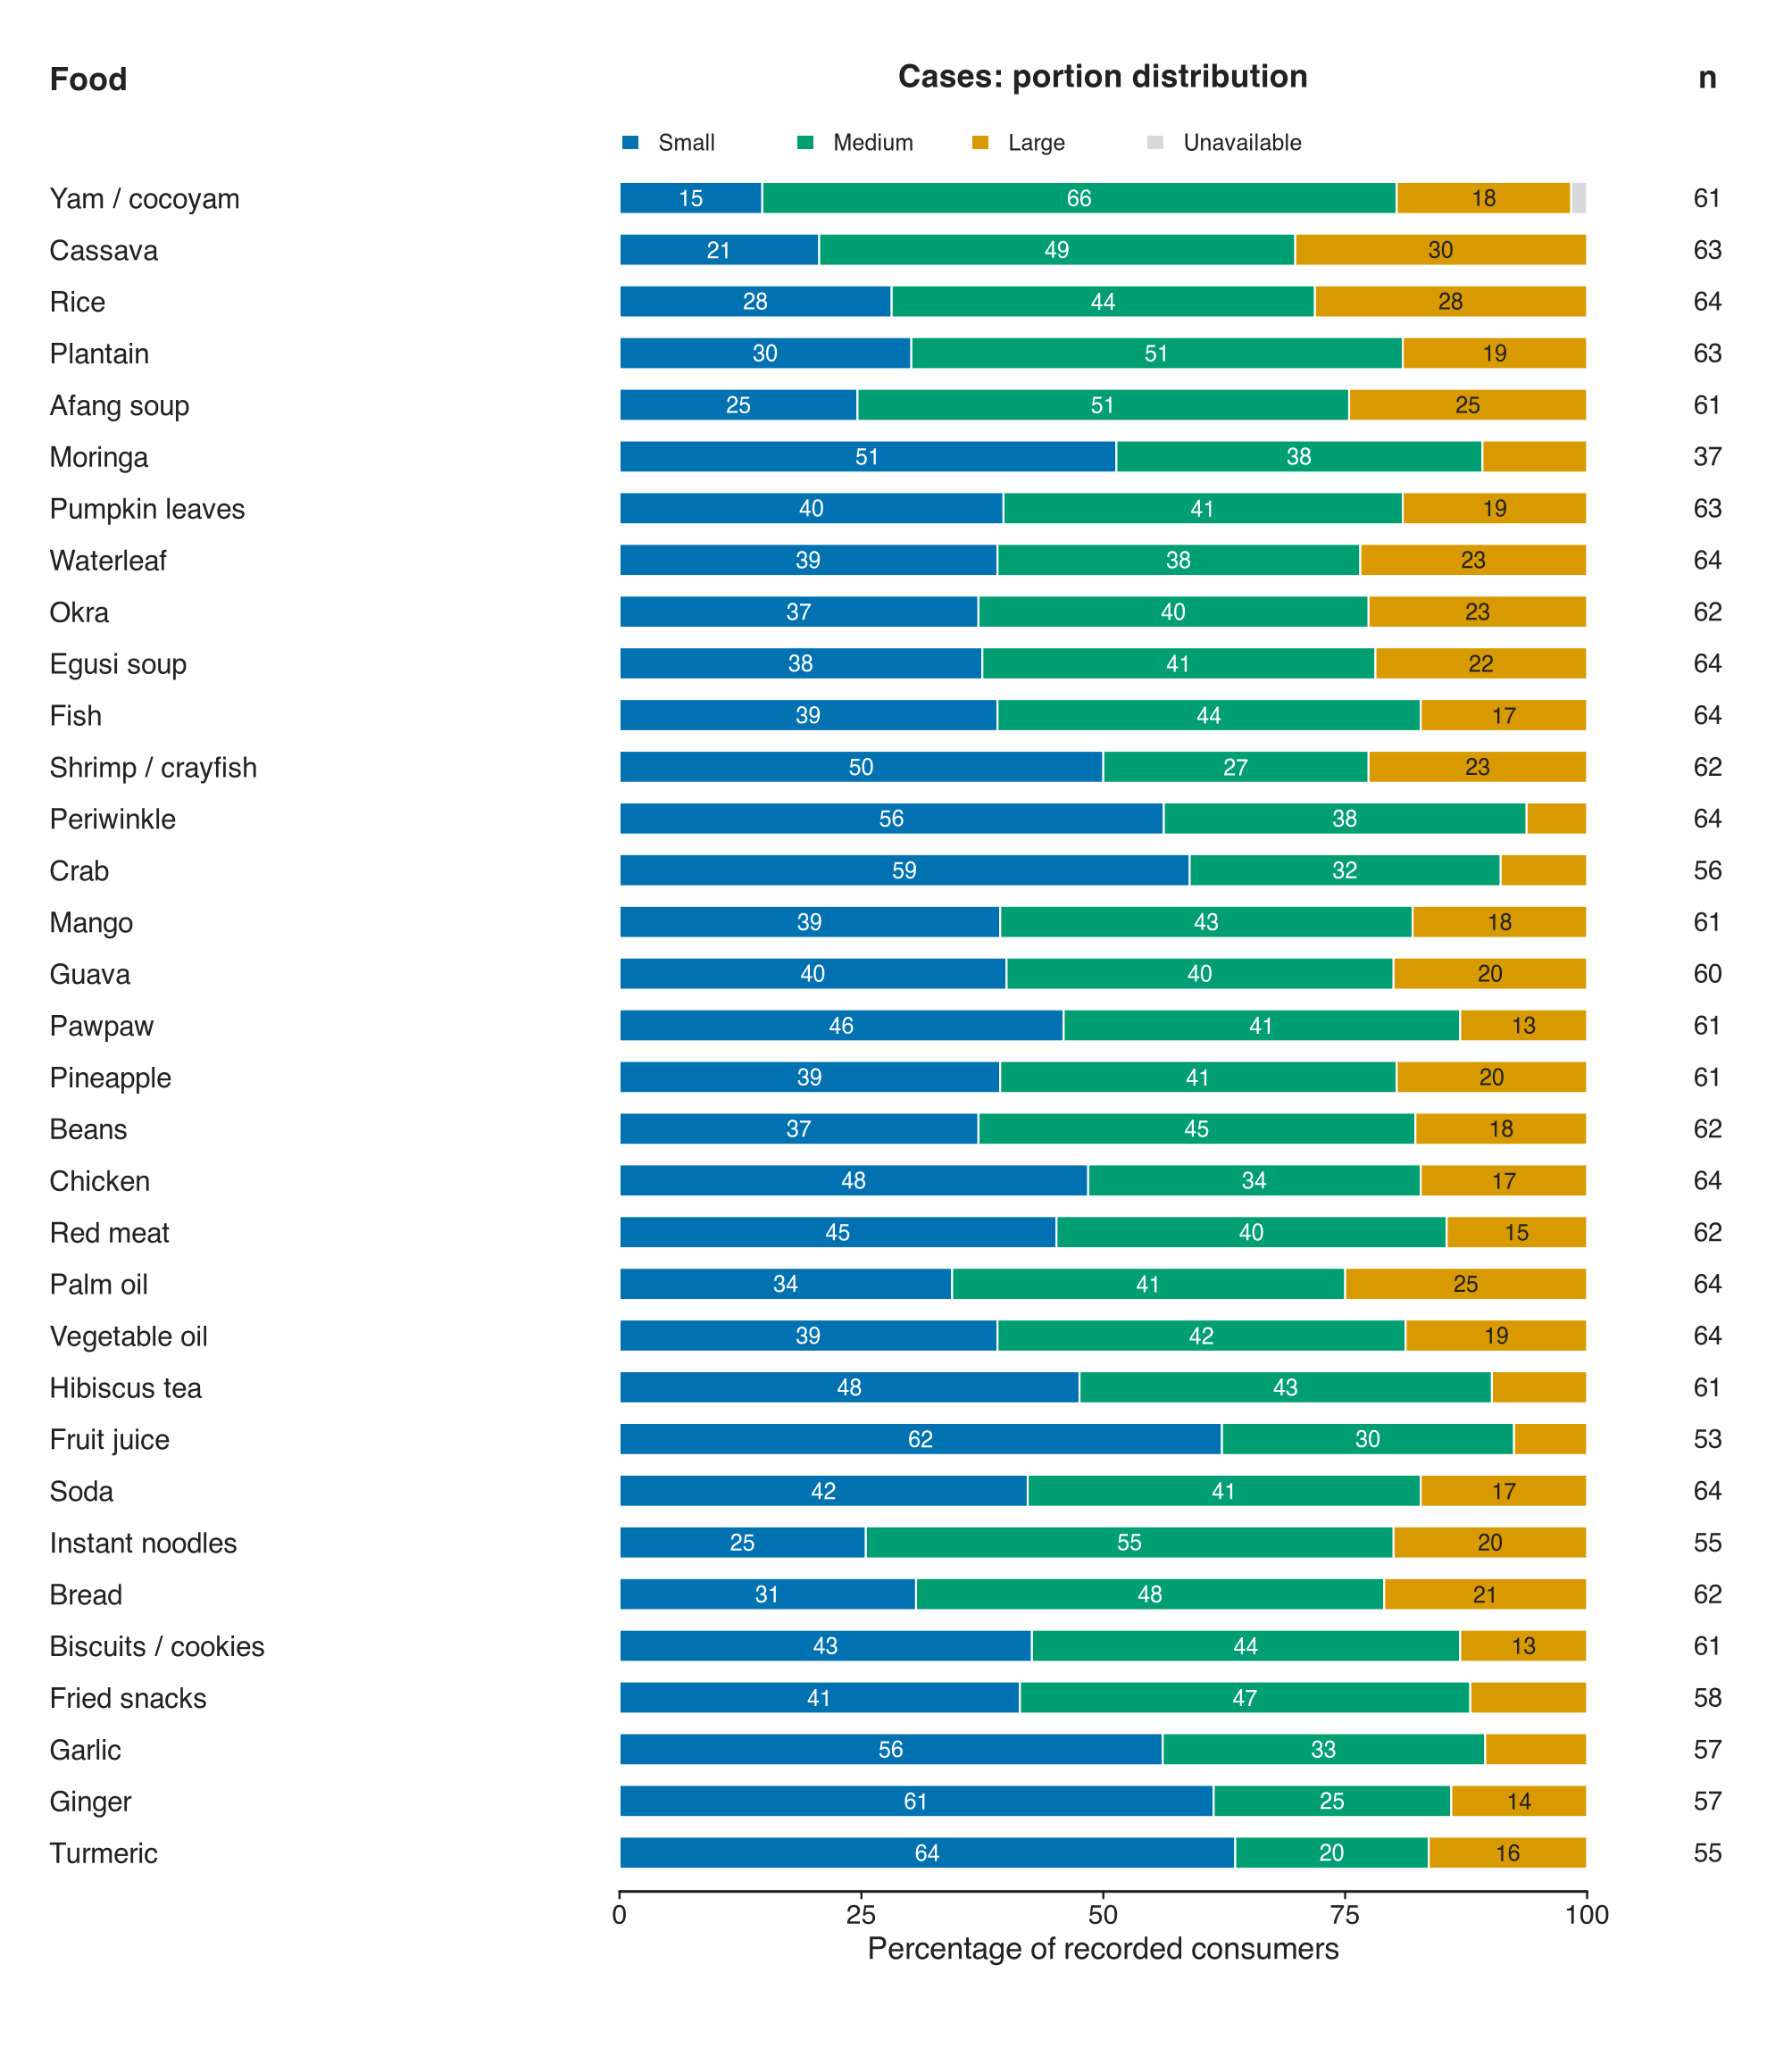
Figure S5. Portion-size distributions among case consumers. Each bar represents participants with positive recorded frequency for the food in the shared-age population. Blue, teal and gold indicate Small, Medium and Large; grey denotes an unavailable portion. Denominators are food-specific and include unavailable portions. Numbers and percentages appear in Table S9.
Table S10. Combined dietary indices in the shared-age descriptive population
Food | Controls  n | Controls  median (Q1-Q3) | Cases  n | Cases  median (Q1-Q3)
Yam / cocoyam | 87 | 0.69 (0.23-2.75) | 63 | 1.00 (0.46-3.00)
Cassava | 87 | 3.00 (1.00-3.50) | 64 | 3.00 (1.00-4.50)
Rice | 87 | 3.00 (0.69-5.50) | 64 | 1.50 (0.50-4.50)
Plantain | 87 | 1.00 (0.23-3.00) | 64 | 1.50 (0.50-3.00)
Afang soup | 87 | 1.00 (0.46-3.00) | 64 | 2.75 (0.92-3.75)
Moringa | 87 | 0.06 (0.00-0.69) | 64 | 0.12 (0.00-0.50)
Pumpkin leaves | 87 | 1.50 (0.46-3.00) | 64 | 1.50 (0.50-3.38)
Waterleaf | 87 | 1.50 (0.46-3.00) | 64 | 1.50 (0.50-3.00)
Okra | 87 | 1.00 (0.46-3.00) | 64 | 1.50 (0.50-3.12)
Egusi soup | 87 | 1.00 (0.23-3.00) | 64 | 1.50 (0.50-3.38)
Fish | 87 | 2.75 (0.69-5.50) | 64 | 1.50 (1.00-3.00)
Shrimp / crayfish | 87 | 1.50 (0.69-4.50) | 64 | 1.50 (0.50-3.00)
Periwinkle | 87 | 2.75 (0.69-5.00) | 64 | 1.50 (0.50-2.75)
Crab | 87 | 0.46 (0.06-2.75) | 64 | 1.00 (0.23-2.75)
Mango | 86 | 0.50 (0.12-2.94) | 64 | 0.85 (0.23-3.00)
Guava | 87 | 0.50 (0.12-1.50) | 64 | 1.00 (0.23-3.00)
Pawpaw | 86 | 1.00 (0.19-3.00) | 63 | 1.00 (0.23-3.00)
Pineapple | 87 | 1.00 (0.20-4.50) | 64 | 1.00 (0.46-3.00)
Beans | 87 | 1.50 (0.50-3.00) | 64 | 1.50 (0.49-3.00)
Chicken | 87 | 1.50 (0.50-3.00) | 64 | 1.00 (0.49-1.81)
Red meat | 87 | 1.50 (0.46-3.50) | 64 | 0.85 (0.46-3.00)
Palm oil | 86 | 3.00 (1.50-5.50) | 64 | 2.75 (1.38-4.50)
Vegetable oil | 86 | 2.75 (0.50-4.50) | 64 | 2.75 (1.00-3.75)
Hibiscus tea | 86 | 0.35 (0.12-1.50) | 64 | 1.00 (0.46-2.75)
Fruit juice | 87 | 0.50 (0.12-1.50) | 64 | 0.50 (0.23-1.50)
Soda | 87 | 0.50 (0.23-1.50) | 64 | 2.12 (0.50-3.00)
Instant noodles | 87 | 0.23 (0.06-0.85) | 64 | 2.12 (0.40-4.50)
Bread | 87 | 1.50 (0.23-3.25) | 64 | 2.75 (0.69-5.50)
Biscuits / cookies | 87 | 0.50 (0.12-2.88) | 64 | 1.50 (0.50-3.00)
Fried snacks | 87 | 0.69 (0.12-3.00) | 64 | 1.25 (0.23-3.00)
Garlic | 87 | 1.00 (0.23-3.50) | 64 | 0.50 (0.23-1.50)
Ginger | 87 | 1.00 (0.46-3.00) | 64 | 0.50 (0.23-1.50)
Turmeric | 87 | 0.50 (0.12-3.00) | 64 | 0.50 (0.06-1.50)
Values are J/100: assigned weekly frequency multiplied by the numerical portion weight and divided by 100. Units are assigned medium-reference portion-index units per week, not measured grams, millilitres or energy. Recorded non-consumers contribute zero; unavailable combined responses are excluded food by food. Denominators may therefore exceed the 83 controls and 62 cases with complete profiles. Means, SDs and missing counts are supplied in Additional file 2.

Dietary-component derivation and structure
PCA used the correlation matrix of the 33 combined variables in 145 participants. Each food was centred and scaled to its sample standard deviation. Leading eigenvalues were retained while exceeding their ordered 95th-percentile values from 2,000 independent within-food permutations, stopping at the first failure [19]. Varimax rotation used Kaiser normalisation [20]. The retained eigenvectors were divided by their eigenvalue square roots and multiplied by the rotation matrix, yielding uncorrelated unit-variance scores. Components were ordered by represented variance and oriented so their largest absolute loading was positive.
Loadings are correlations of the food variables with the derived scores. An absolute loading of at least 0.40 guided descriptive names and plot outlines but did not determine which weights entered the score. All 33 weights were retained. The labels describe food combinations, not presumed health effects. Centring, scaling, scoring weights, item-level adequacy diagnostics and full-precision loadings are included in Additional file 2.
Table S11. Full loading matrix of the primary combined dietary components
Food | FP01 | FP02 | FP03 | FP04 | FP05 | FP06
Yam / cocoyam | 0.074 | 0.501 | 0.013 | 0.481 | 0.028 | 0.049
Cassava | 0.484 | 0.246 | 0.142 | 0.100 | 0.013 | -0.286
Rice | 0.579 | 0.161 | 0.425 | 0.057 | 0.109 | -0.220
Plantain | 0.139 | 0.563 | -0.015 | 0.128 | 0.127 | 0.014
Afang soup | 0.771 | 0.103 | -0.066 | 0.000 | 0.080 | -0.126
Moringa | -0.143 | 0.074 | 0.009 | -0.032 | 0.129 | 0.605
Pumpkin leaves | 0.823 | 0.009 | 0.188 | -0.021 | 0.084 | 0.106
Waterleaf | 0.850 | 0.039 | 0.182 | -0.011 | 0.040 | 0.095
Okra | 0.811 | 0.088 | 0.213 | -0.016 | -0.147 | 0.103
Egusi soup | 0.780 | 0.197 | -0.150 | -0.003 | -0.001 | -0.019
Fish | 0.193 | -0.032 | 0.747 | 0.129 | 0.100 | -0.096
Shrimp / crayfish | 0.168 | -0.058 | 0.770 | 0.213 | 0.076 | 0.002
Periwinkle | 0.017 | -0.038 | 0.823 | -0.001 | 0.078 | 0.019
Crab | -0.078 | -0.037 | 0.425 | -0.089 | 0.020 | 0.312
Mango | 0.039 | -0.001 | -0.016 | -0.050 | 0.545 | -0.132
Guava | -0.047 | -0.025 | -0.030 | 0.024 | 0.680 | 0.109
Pawpaw | 0.607 | -0.135 | 0.240 | 0.101 | 0.333 | 0.214
Pineapple | 0.173 | 0.072 | 0.024 | 0.076 | 0.719 | 0.225
Beans | 0.465 | 0.020 | 0.077 | 0.109 | 0.486 | 0.014
Chicken | 0.073 | 0.482 | 0.325 | 0.329 | 0.301 | 0.036
Red meat | -0.030 | 0.317 | 0.236 | 0.021 | 0.303 | -0.088
Palm oil | 0.157 | 0.235 | 0.645 | -0.001 | -0.121 | -0.058
Vegetable oil | 0.234 | 0.223 | 0.576 | 0.107 | -0.187 | 0.195
Hibiscus tea | 0.176 | 0.122 | 0.077 | 0.087 | -0.118 | 0.709
Fruit juice | 0.044 | -0.034 | -0.027 | 0.145 | 0.068 | 0.590
Soda | 0.114 | 0.627 | -0.125 | -0.015 | 0.022 | 0.013
Instant noodles | 0.002 | 0.802 | 0.049 | -0.096 | -0.090 | -0.081
Bread | 0.146 | 0.623 | -0.004 | -0.092 | 0.089 | 0.026
Biscuits / cookies | 0.053 | 0.740 | 0.215 | 0.093 | -0.056 | 0.221
Fried snacks | -0.025 | 0.695 | 0.050 | 0.084 | -0.124 | 0.002
Garlic | 0.014 | 0.009 | 0.093 | 0.915 | 0.042 | 0.118
Ginger | -0.003 | 0.032 | 0.098 | 0.928 | 0.037 | 0.009
Turmeric | 0.023 | 0.053 | 0.073 | 0.925 | -0.010 | 0.057
Food-score correlations from the 145-person primary matrix. Values are rounded for display; plots use unrounded absolute loadings for the 0.40 outline threshold. FP01: leafy vegetables and soups; FP02: noodles, snacks, bread and soda; FP03: seafood and oils; FP04: garlic, ginger and turmeric; FP05: fruit and beans; FP06: hibiscus tea, Moringa and fruit juice. Names summarise rather than exhaust the contributions.
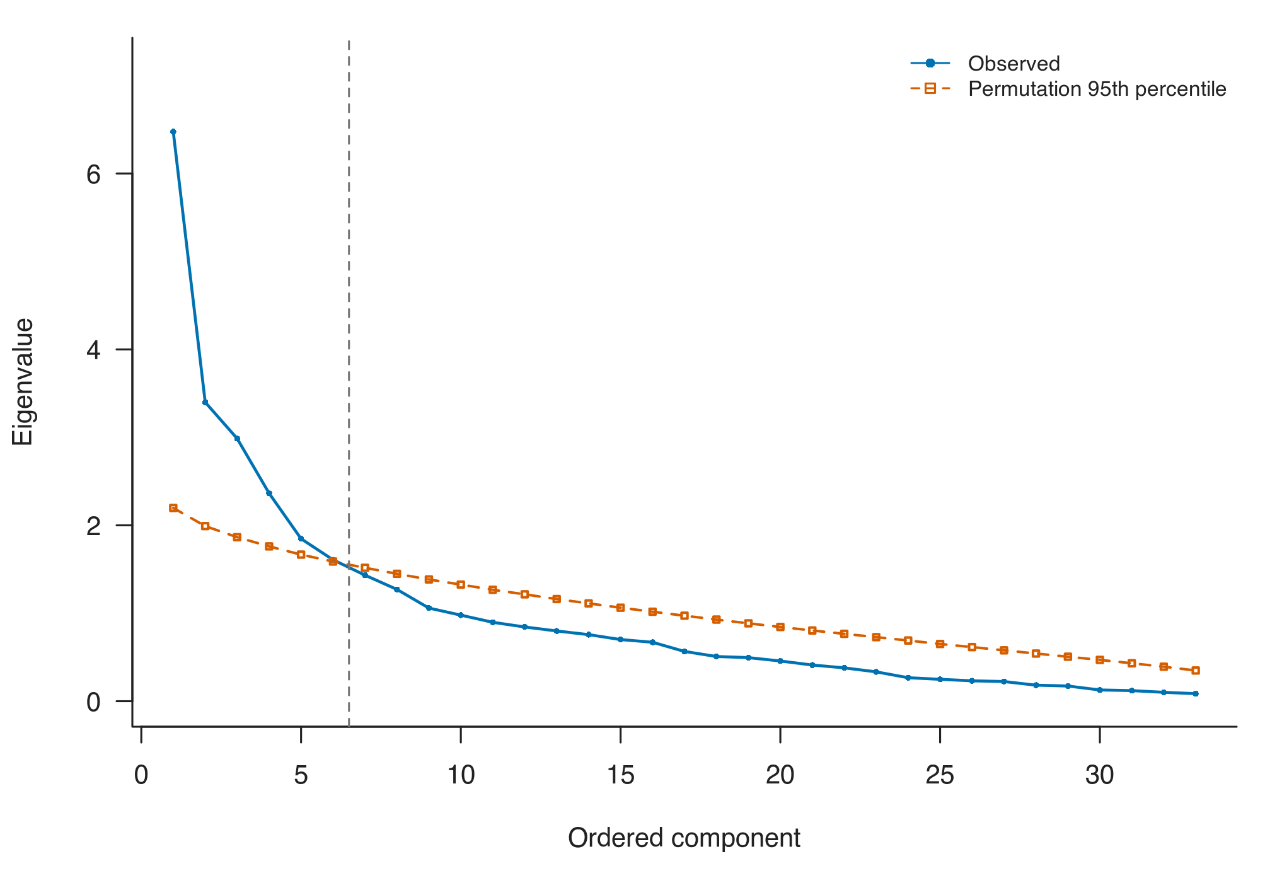
Figure S6. Permutation parallel analysis of the combined dietary variables. Observed ordered eigenvalues and corresponding 95th percentiles from 2,000 within-food permutations of the 145-person, 33-food matrix. Six leading components exceeded their reference values before the first failure. Full eigenvalues and reference values for every specification are provided in Additional file 2.
Table S12. Alternative representations and component structures
Specification | N | Independent  count | Aligned  count | Variance at  aligned count (%) | Minimum  congruence
Raw category × portion | 145 | 6 | 6 | 50.62 | 0.610
Ranks of combined indices | 145 | 6 | 6 | 51.57 | 0.567
Alternative multipliers × portion | 145 | 5 | 6 | 55.97 | 0.665
Assigned weekly frequency only | 145 | 6 | 6 | 55.17 | 0.736
Ordinal frequency only | 145 | 7 | 6 | 52.96 | 0.351
Top category 3/day × portion | 145 | 5 | 6 | 59.83 | 0.971
Controls only | 83 | 5 | 6 | 57.94 | 0.783
Recorded nonstudents | 121 | 6 | 6 | 57.17 | 0.940
All measurement representations use the same 145 complete-profile participants. Controls-only and nonstudent extraction use the indicated subsets. Each representation has an independently estimated retention count and a separate six-component alignment comparison. A fixed-six comparison does not replace its independently selected structure. Variance shown here is for the fixed-six solution.
Alignment maximised the sum of absolute Tucker congruences using exact one-to-one matching, followed by sign orientation. All matching qualities were retained [21]. The four-column panels below describe the same eight comparisons; values close to zero indicate poor resemblance. These comparisons do not validate the components or establish that aligned scores are identical exposures.
Table S12, panel A. Component-specific loading congruence
Component | Raw category × portion | Ranks of combined indices | Alternative multipliers × portion | Top category 3/day × portion
FP01 | 0.949 | 0.923 | 0.994 | 0.993
FP02 | 0.943 | 0.834 | 0.990 | 0.992
FP03 | 0.965 | 0.939 | 0.990 | 0.992
FP04 | 0.970 | 0.930 | 0.993 | 0.990
FP05 | 0.627 | 0.567 | 0.665 | 0.971
FP06 | 0.610 | 0.665 | 0.780 | 0.989
Congruence measures resemblance of loading vectors after sign/permutation alignment; 0.85 is a descriptive reference only.
Table S12, panel B. Component-specific loading congruence
Component | Assigned weekly frequency only | Ordinal frequency only | Controls only | Recorded nonstudents
FP01 | 0.981 | 0.946 | 0.975 | 0.940
FP02 | 0.973 | 0.627 | 0.783 | 0.990
FP03 | 0.960 | 0.831 | 0.958 | 0.992
FP04 | 0.982 | 0.942 | 0.961 | 0.977
FP05 | 0.885 | 0.674 | 0.790 | 0.984
FP06 | 0.736 | 0.351 | 0.878 | 0.972
Congruence measures resemblance of loading vectors after sign/permutation alignment; 0.85 is a descriptive reference only.

Joint bootstrap and component stability
Five hundred resamples were drawn separately within 83 controls and 62 cases with replacement [25]. In each resample, food standardisation, PCA and varimax rotation were repeated with the component count fixed at six. Exact loading-vector matching aligned components to the primary solution. Each re-estimated score was scaled by its standard deviation when projected into the original 145-person primary sample, and the main Firth model was refitted. The age-spline basis was fixed. No resample was discarded because of low congruence or an unfavourable association.
The 2.5th and 97.5th percentiles of valid bootstrap odds ratios were reported when at least 90% of requested fits succeeded. All 500 fits succeeded for every component. These exploratory intervals are conditional on the fixed component count and do not incorporate uncertainty from reselecting that count. Weakly matched components may represent different mixtures; their percentile intervals are not necessarily intervals for one uniquely identified population pattern.
Table S13. Variance, loading stability and joint-bootstrap OR intervals
Component | Variance  (%) | Median  congruence | Congruence  2.5th-97.5th | Congruence  ≥0.85 (%) | Bootstrap OR  2.5th-97.5th
FP01 | 14.31 | 0.971 | 0.665-0.991 | 88.6 | 0.770-1.857
FP02 | 11.10 | 0.953 | 0.429-0.990 | 68.4 | 0.994-3.832
FP03 | 10.37 | 0.922 | 0.751-0.979 | 83.4 | 0.254-0.923
FP04 | 9.40 | 0.948 | 0.840-0.985 | 97.0 | 0.115-0.708
FP05 | 6.11 | 0.835 | 0.255-0.951 | 43.2 | 0.632-1.527
FP06 | 5.31 | 0.693 | 0.132-0.932 | 21.6 | 0.588-1.830
All 500 stratified resamples were successful for each component. No low-congruence filtering was used. Percentile intervals are not multiplicity-adjusted and do not correct recruitment or recall bias. Three decimal places retain the near-null lower limit for FP02 (0.994).
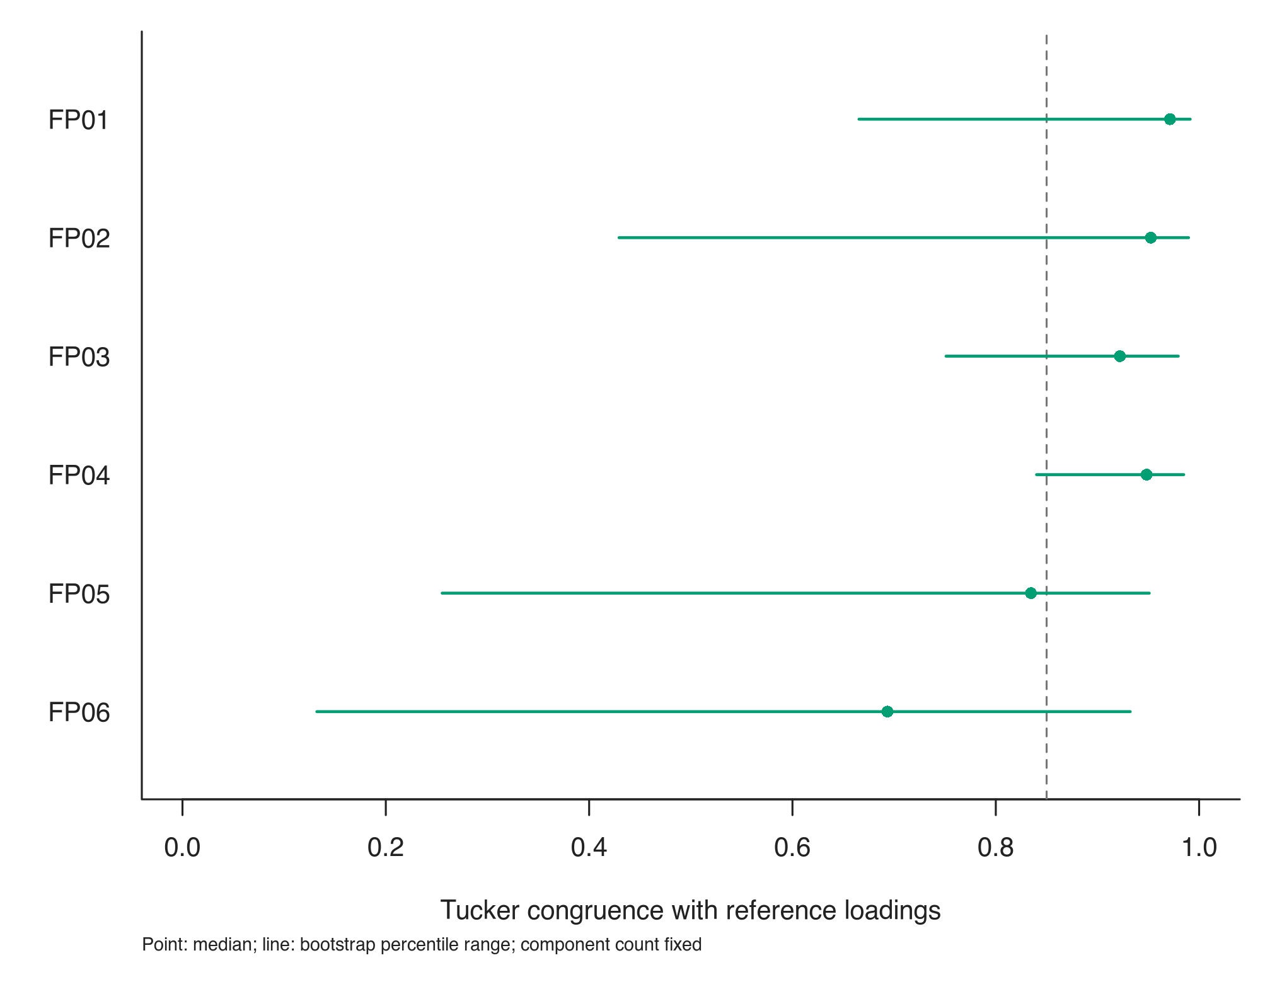
Figure S7. Bootstrap stability of the combined dietary components. Points are median Tucker congruences; lines show 2.5th -97.5th percentiles from 500 case/control-stratified resamples with six components re-estimated and aligned. The vertical 0.85 line is descriptive, not a pass/fail criterion. These intervals quantify loading resemblance, not disease-association uncertainty.

Association and sensitivity model definitions
Each component was fitted separately. Main models used 145 women. The natural cubic spline for age had two degrees of freedom, an internal knot at 40 and boundaries at 23 and 62 years; its basis was fixed for expanded-age and resampling analyses. Family history was Yes = 1 and rural residence was Rural = 1. BMI sensitivity used (BMI - 25)/5; linear-age sensitivity used (age - 40)/10. Post-menopause was coded 1. Education used primary and secondary indicators, with tertiary education as reference.
Firth models used pointwise 95% profile intervals and penalised likelihood-ratio tests [22, 23]. BH adjustment covered only the six M2 score tests [24]. Measurement comparisons re-estimated six aligned components and used their own SDs; other specifications retained the primary scoring basis. Sensitivity P values and intervals were not multiplicity-adjusted.
Table S14. Core and sensitivity specifications
Model | Specification | N | Controls /  cases
M0 | Score only | 145 | 83 / 62
M1 | Score + age spline | 145 | 83 / 62
M2 | Score + age spline + family history + residence | 145 | 83 / 62
S01 | M2; ages ≥23, no upper limit | 150 | 83 / 67
S02 | M2; all enrolled ages | 163 | 96 / 67
S03 | M2; exclude recorded students from both groups | 121 | 66 / 55
S04 | M2 + recorded student status | 145 | 83 / 62
S05 | M2 with linear rather than spline age | 145 | 83 / 62
S06 | M2; ages 23-58 | 135 | 82 / 53
S07 | M2 + recorded BMI | 145 | 83 / 62
S08 | M2 + menopausal status | 145 | 83 / 62
S09 | M2 + primary/secondary education indicators | 145 | 83 / 62
S10 | M2; raw frequency code × portion | 145 | 83 / 62
S11 | M2; ranks of combined indices | 145 | 83 / 62
S12 | M2; exclude constant-frequency profiles | 144 | 82 / 62
S13 | M2; alternative frequency multipliers × portion | 145 | 83 / 62
S14 | M2; assigned weekly frequency only | 145 | 83 / 62
S15 | M2; ordinal frequency only | 145 | 83 / 62
S16 | M2; highest category 3/day × portion | 145 | 83 / 62
M0-M2 are core models; S01-S16 are sensitivity specifications. Measurement comparisons S10, S11, S13-S16 all use 145 participants and six aligned components, regardless of the independent retention count. S13 uses the numerical vector 0, 1, 2, 3, 4, 5, 7, 14 rather than an observed weekly-rate scale. S14 and S15 omit portions only as explicitly labelled same-participant comparisons.
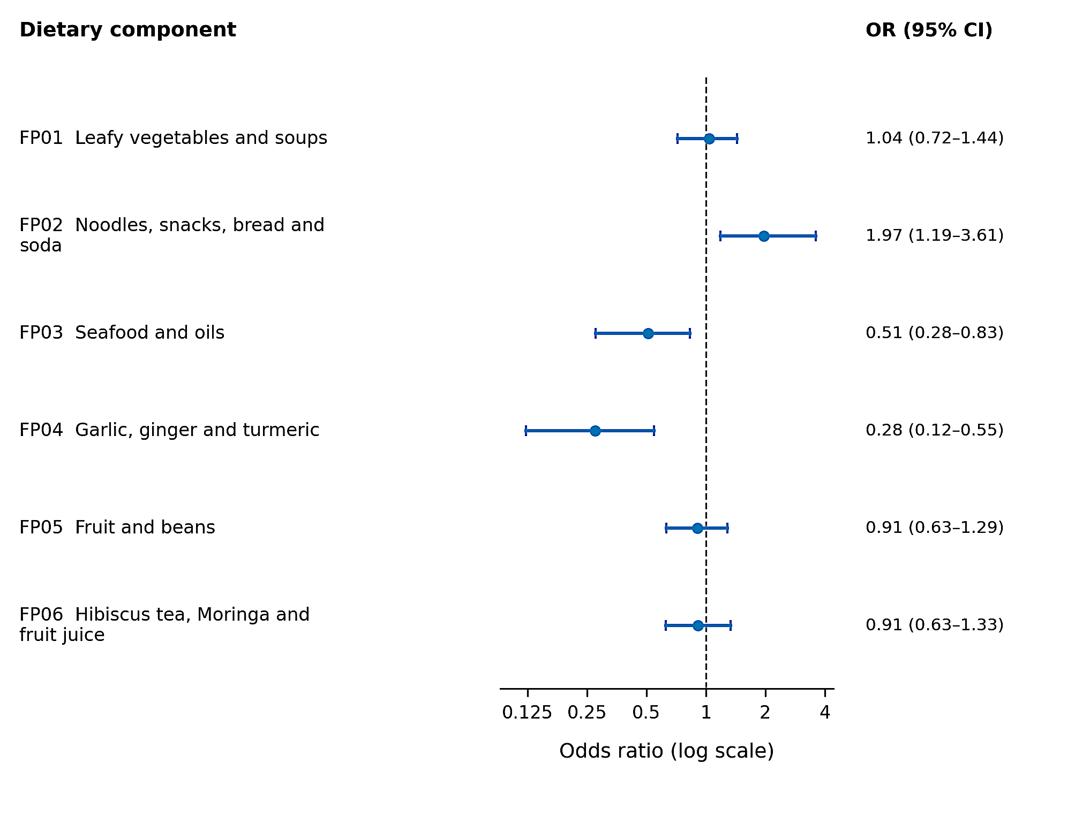
Figure S8. Main fixed-score frequency-and-portion associations. Each component was entered separately in a Firth model adjusted for an age spline, family history and residence. Points are ORs per primary-score SD; lines are pointwise 95% profile intervals for 145 women (83 controls; 62 cases). Main Figure 3 additionally presents the joint-bootstrap percentile intervals. Food descriptions are shorthand for the complete loading vectors, not separate food effects.

FP01: Leafy vegetables and soups
Table S15. FP01 main and sensitivity associations
Model | Specification | N | Controls /  cases | OR (95% CI) | Pᵃ
M2 | Main adjusted | 145 | 83 / 62 | 1.04 (0.72-1.44) | 0.8066
S01 | ages ≥23, no upper limit | 150 | 83 / 67 | 1.05 (0.72-1.45) | 0.7810
S02 | all enrolled ages | 163 | 96 / 67 | 1.07 (0.74-1.48) | 0.6821
S03 | exclude recorded students from both groups | 121 | 66 / 55 | 1.20 (0.73-1.99) | 0.4760
S04 | recorded student status | 145 | 83 / 62 | 1.02 (0.71-1.42) | 0.9091
S05 | linear rather than spline age | 145 | 83 / 62 | 1.04 (0.72-1.44) | 0.7955
S06 | ages 23-58 | 135 | 82 / 53 | 1.05 (0.72-1.46) | 0.7505
S07 | recorded BMI | 145 | 83 / 62 | 1.05 (0.73-1.45) | 0.7764
S08 | menopausal status | 145 | 83 / 62 | 1.04 (0.72-1.44) | 0.8058
S09 | primary/secondary education indicators | 145 | 83 / 62 | 1.06 (0.73-1.47) | 0.7292
S10 | raw frequency code × portion | 145 | 83 / 62 | 1.20 (0.85-1.72) | 0.3062
S11 | ranks of combined indices | 145 | 83 / 62 | 1.27 (0.89-1.84) | 0.1887
S12 | exclude constant-frequency profiles | 144 | 82 / 62 | 1.03 (0.71-1.43) | 0.8392
S13 | alternative frequency multipliers × portion | 145 | 83 / 62 | 1.05 (0.72-1.44) | 0.7814
S14 | assigned weekly frequency only | 145 | 83 / 62 | 1.20 (0.85-1.71) | 0.2986
S15 | ordinal frequency only | 145 | 83 / 62 | 1.38 (0.96-2.00) | 0.0784
S16 | highest category 3/day × portion | 145 | 83 / 62 | 0.99 (0.64-1.34) | 0.9622
ᵃ P values are not multiplicity-adjusted. CIs are pointwise profile penalised-likelihood intervals. Model definitions and units follow Table S14. S10, S11 and S13-S16 re-estimate six aligned components under alternative representations; low congruence can indicate a different exposure mixture. All other rows retain the primary score scale. These related analyses are not independent replications.
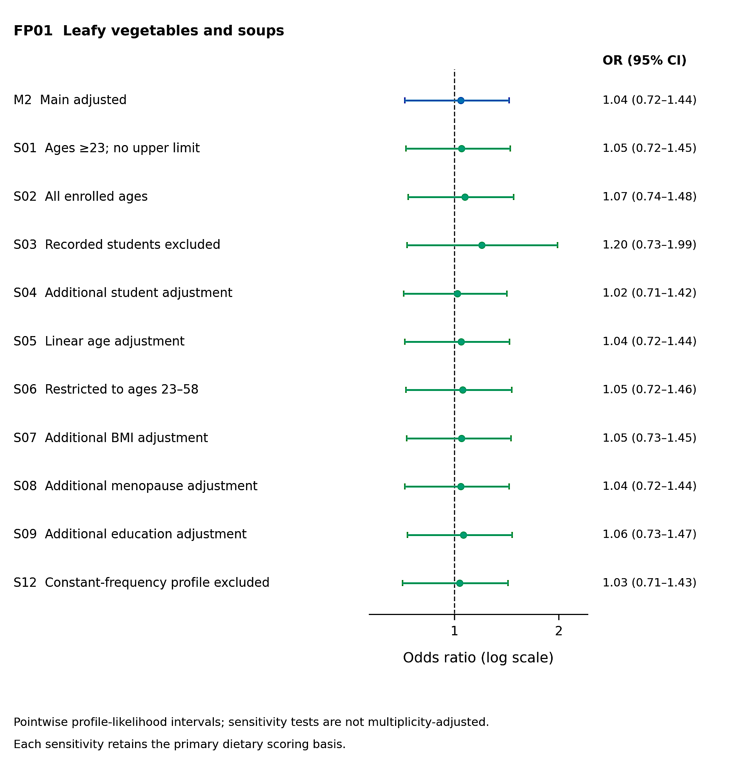
Figure S9. Population and covariate sensitivity analyses for FP01. Leafy vegetables and soups. The main result and population/covariate comparisons are displayed on a logarithmic odds-ratio scale. Each point and line is a Firth estimate and pointwise 95% profile interval. The fixed primary scoring basis is retained. S12 excludes constant-frequency profiles; no influence-based participant deletion was used. Corresponding estimates are in Table S15.
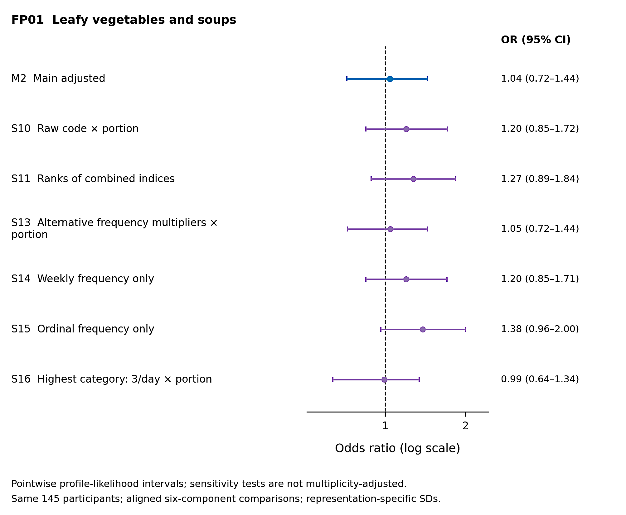
Figure S10. Measurement-representation sensitivity analyses for FP01. The main result is compared with raw-code products, ranks of the combined index, alternative frequency multipliers, weekly and ordinal frequency-only variables, and a 3/day highest-category assumption. All use the same 145 participants and six matched components, but each alternative uses its own score SD. Alignment does not guarantee identical component composition. CIs are pointwise and P values are not multiplicity-adjusted; Table S15 gives the numerical estimates.

FP02: Noodles, snacks, bread and soda
Table S16. FP02 main and sensitivity associations
Model | Specification | N | Controls /  cases | OR (95% CI) | Pᵃ
M2 | Main adjusted | 145 | 83 / 62 | 1.97 (1.19-3.61) | 0.0046
S01 | ages ≥23, no upper limit | 150 | 83 / 67 | 1.98 (1.19-3.61) | 0.0043
S02 | all enrolled ages | 163 | 96 / 67 | 2.02 (1.21-3.71) | 0.0038
S03 | exclude recorded students from both groups | 121 | 66 / 55 | 1.88 (1.11-3.52) | 0.0132
S04 | recorded student status | 145 | 83 / 62 | 2.05 (1.22-3.70) | 0.0034
S05 | linear rather than spline age | 145 | 83 / 62 | 1.93 (1.17-3.50) | 0.0058
S06 | ages 23-58 | 135 | 82 / 53 | 1.92 (1.16-3.53) | 0.0062
S07 | recorded BMI | 145 | 83 / 62 | 2.07 (1.23-3.71) | 0.0035
S08 | menopausal status | 145 | 83 / 62 | 1.98 (1.18-3.65) | 0.0047
S09 | primary/secondary education indicators | 145 | 83 / 62 | 1.92 (1.17-3.49) | 0.0059
S10 | raw frequency code × portion | 145 | 83 / 62 | 1.94 (1.28-3.12) | 0.0010
S11 | ranks of combined indices | 145 | 83 / 62 | 1.83 (1.25-2.79) | 0.0017
S12 | exclude constant-frequency profiles | 144 | 82 / 62 | 1.92 (1.16-3.51) | 0.0063
S13 | alternative frequency multipliers × portion | 145 | 83 / 62 | 2.33 (1.33-4.53) | 0.0012
S14 | assigned weekly frequency only | 145 | 83 / 62 | 1.86 (1.23-3.03) | 0.0021
S15 | ordinal frequency only | 145 | 83 / 62 | 1.03 (0.71-1.49) | 0.8857
S16 | highest category 3/day × portion | 145 | 83 / 62 | 2.39 (1.22-5.30) | 0.0045
ᵃ P values are not multiplicity-adjusted. CIs are pointwise profile penalised-likelihood intervals. Model definitions and units follow Table S14. S10, S11 and S13-S16 re-estimate six aligned components under alternative representations; low congruence can indicate a different exposure mixture. All other rows retain the primary score scale. These related analyses are not independent replications.
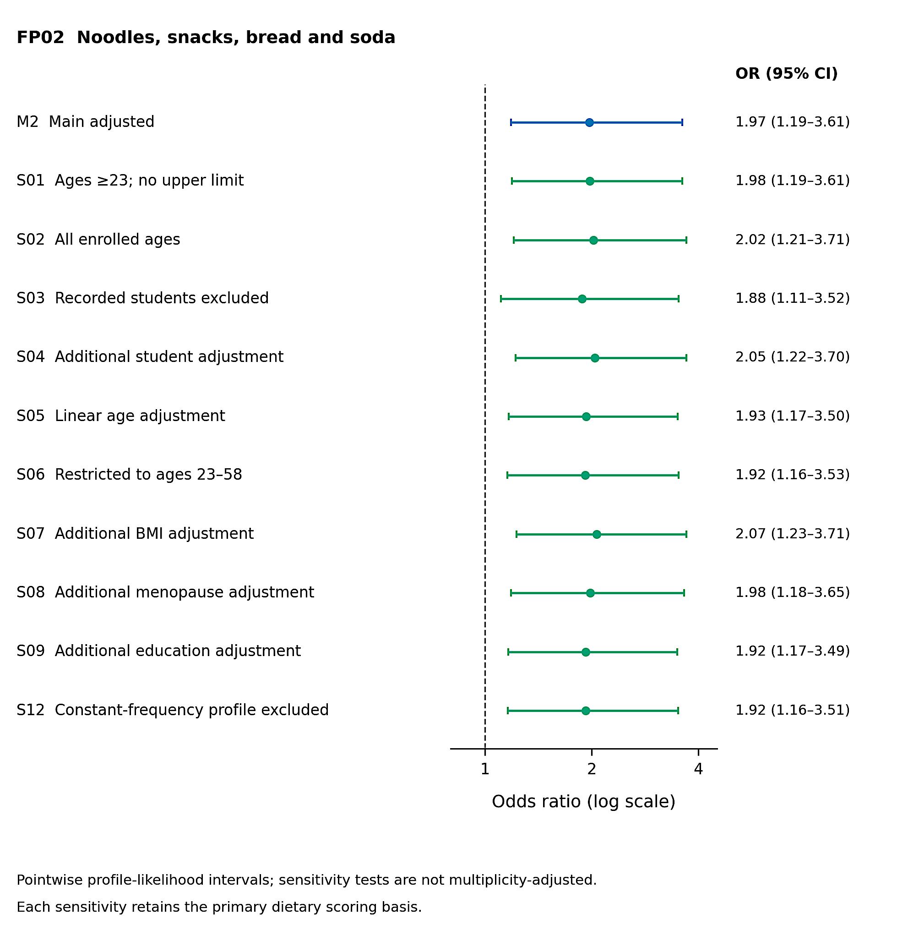
Figure S11. Population and covariate sensitivity analyses for FP02. Noodles, snacks, bread and soda. The main result and population/covariate comparisons are displayed on a logarithmic odds-ratio scale. Each point and line is a Firth estimate and pointwise 95% profile interval. The fixed primary scoring basis is retained. S12 excludes constant-frequency profiles; no influence-based participant deletion was used. Corresponding estimates are in Table S16.
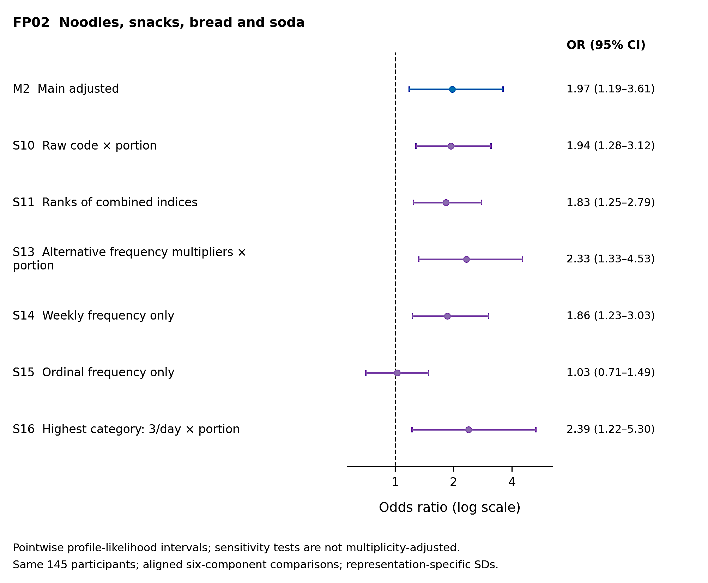
Figure S12. Measurement-representation sensitivity analyses for FP02. The main result is compared with raw-code products, ranks of the combined index, alternative frequency multipliers, weekly and ordinal frequency-only variables, and a 3/day highest-category assumption. All use the same 145 participants and six matched components, but each alternative uses its own score SD. Alignment does not guarantee identical component composition. CIs are pointwise and P values are not multiplicity-adjusted; Table S16 gives the numerical estimates.

FP03: Seafood and oils
Table S17. FP03 main and sensitivity associations
Model | Specification | N | Controls /  cases | OR (95% CI) | Pᵃ
M2 | Main adjusted | 145 | 83 / 62 | 0.51 (0.28-0.83) | 0.0047
S01 | ages ≥23, no upper limit | 150 | 83 / 67 | 0.51 (0.28-0.83) | 0.0045
S02 | all enrolled ages | 163 | 96 / 67 | 0.52 (0.28-0.85) | 0.0065
S03 | exclude recorded students from both groups | 121 | 66 / 55 | 0.52 (0.26-0.88) | 0.0105
S04 | recorded student status | 145 | 83 / 62 | 0.53 (0.29-0.87) | 0.0090
S05 | linear rather than spline age | 145 | 83 / 62 | 0.51 (0.27-0.83) | 0.0045
S06 | ages 23-58 | 135 | 82 / 53 | 0.53 (0.28-0.86) | 0.0080
S07 | recorded BMI | 145 | 83 / 62 | 0.51 (0.27-0.83) | 0.0050
S08 | menopausal status | 145 | 83 / 62 | 0.51 (0.27-0.83) | 0.0046
S09 | primary/secondary education indicators | 145 | 83 / 62 | 0.52 (0.28-0.84) | 0.0053
S10 | raw frequency code × portion | 145 | 83 / 62 | 0.63 (0.41-0.93) | 0.0183
S11 | ranks of combined indices | 145 | 83 / 62 | 0.62 (0.42-0.90) | 0.0119
S12 | exclude constant-frequency profiles | 144 | 82 / 62 | 0.50 (0.27-0.82) | 0.0036
S13 | alternative frequency multipliers × portion | 145 | 83 / 62 | 0.55 (0.29-0.89) | 0.0115
S14 | assigned weekly frequency only | 145 | 83 / 62 | 0.52 (0.32-0.80) | 0.0023
S15 | ordinal frequency only | 145 | 83 / 62 | 0.64 (0.42-0.93) | 0.0201
S16 | highest category 3/day × portion | 145 | 83 / 62 | 0.48 (0.23-0.85) | 0.0084
ᵃ P values are not multiplicity-adjusted. CIs are pointwise profile penalised-likelihood intervals. Model definitions and units follow Table S14. S10, S11 and S13-S16 re-estimate six aligned components under alternative representations; low congruence can indicate a different exposure mixture. All other rows retain the primary score scale. These related analyses are not independent replications.
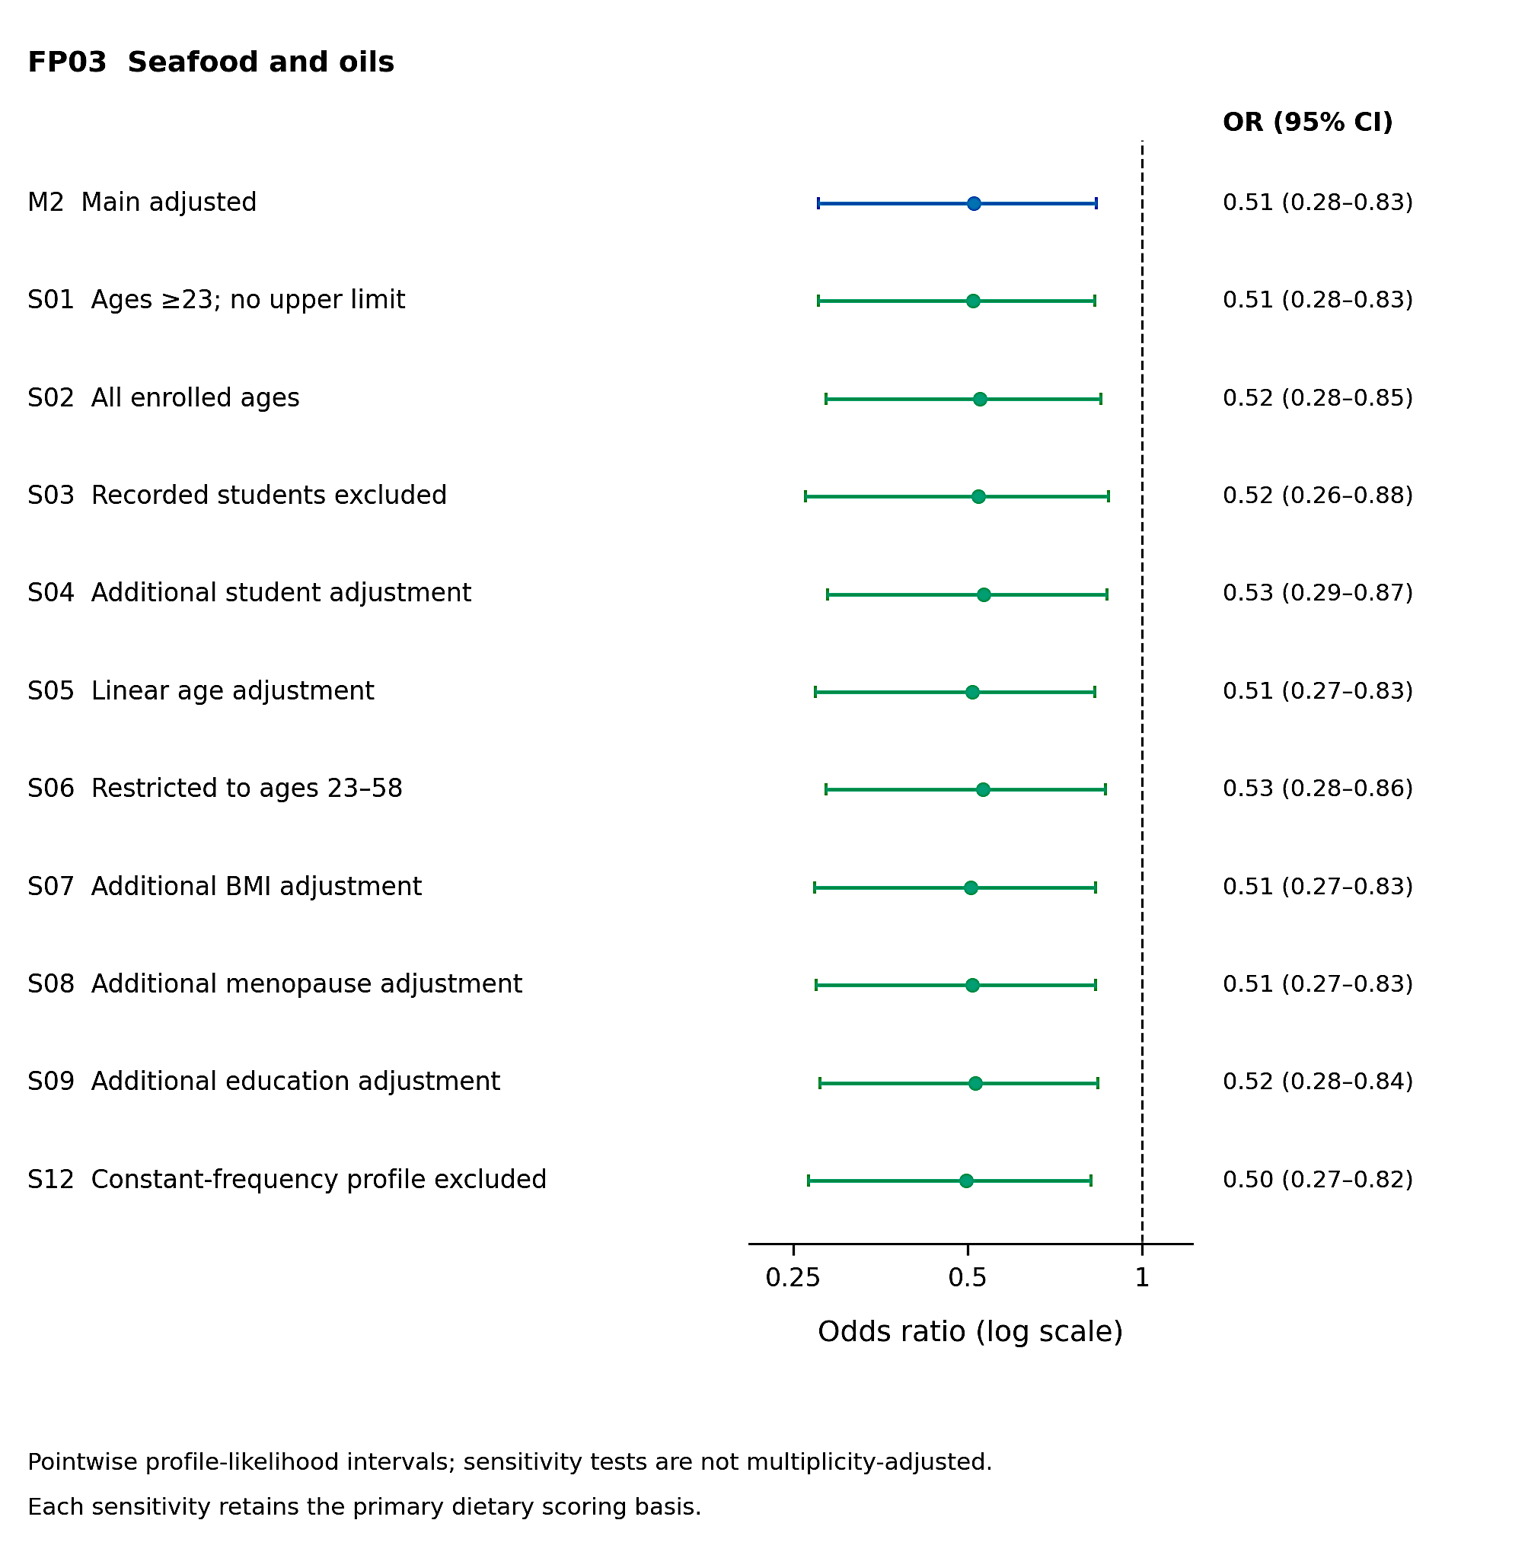
Figure S13. Population and covariate sensitivity analyses for FP03. Seafood and oils. The main result and population/covariate comparisons are displayed on a logarithmic odds-ratio scale. Each point and line is a Firth estimate and pointwise 95% profile interval. The fixed primary scoring basis is retained. S12 excludes constant-frequency profiles; no influence-based participant deletion was used. Corresponding estimates are in Table S17.
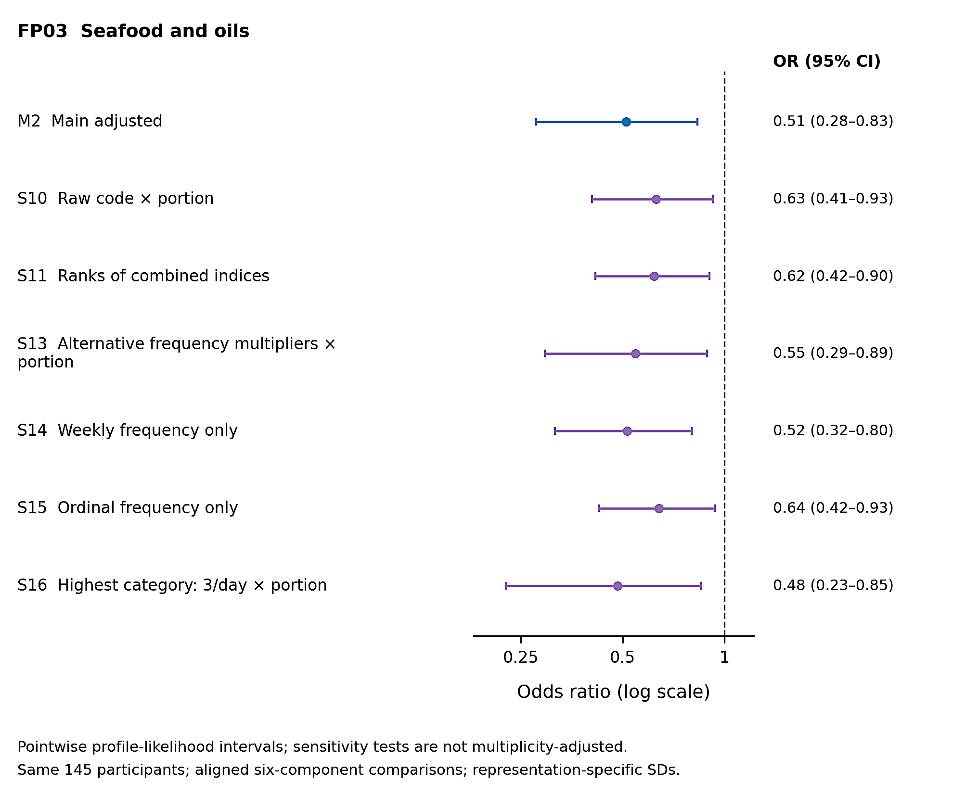
Figure S14. Measurement-representation sensitivity analyses for FP03. The main result is compared with raw-code products, ranks of the combined index, alternative frequency multipliers, weekly and ordinal frequency-only variables, and a 3/day highest-category assumption. All use the same 145 participants and six matched components, but each alternative uses its own score SD. Alignment does not guarantee identical component composition. CIs are pointwise and P values are not multiplicity-adjusted; Table S17 gives the numerical estimates.

FP04: Garlic, ginger and turmeric
Table S18. FP04 main and sensitivity associations
Model | Specification | N | Controls /  cases | OR (95% CI) | Pᵃ
M2 | Main adjusted | 145 | 83 / 62 | 0.28 (0.12-0.55) | <0.0001
S01 | ages ≥23, no upper limit | 150 | 83 / 67 | 0.27 (0.12-0.54) | <0.0001
S02 | all enrolled ages | 163 | 96 / 67 | 0.26 (0.11-0.52) | <0.0001
S03 | exclude recorded students from both groups | 121 | 66 / 55 | 0.29 (0.12-0.59) | 0.0003
S04 | recorded student status | 145 | 83 / 62 | 0.24 (0.10-0.49) | <0.0001
S05 | linear rather than spline age | 145 | 83 / 62 | 0.27 (0.12-0.54) | <0.0001
S06 | ages 23-58 | 135 | 82 / 53 | 0.26 (0.11-0.53) | <0.0001
S07 | recorded BMI | 145 | 83 / 62 | 0.29 (0.13-0.57) | <0.0001
S08 | menopausal status | 145 | 83 / 62 | 0.28 (0.12-0.55) | <0.0001
S09 | primary/secondary education indicators | 145 | 83 / 62 | 0.28 (0.13-0.55) | <0.0001
S10 | raw frequency code × portion | 145 | 83 / 62 | 0.49 (0.29-0.78) | 0.0016
S11 | ranks of combined indices | 145 | 83 / 62 | 0.46 (0.29-0.69) | 0.0001
S12 | exclude constant-frequency profiles | 144 | 82 / 62 | 0.26 (0.12-0.53) | <0.0001
S13 | alternative frequency multipliers × portion | 145 | 83 / 62 | 0.37 (0.18-0.69) | 0.0007
S14 | assigned weekly frequency only | 145 | 83 / 62 | 0.32 (0.17-0.56) | <0.0001
S15 | ordinal frequency only | 145 | 83 / 62 | 0.51 (0.33-0.77) | 0.0008
S16 | highest category 3/day × portion | 145 | 83 / 62 | 0.19 (0.07-0.46) | <0.0001
ᵃ P values are not multiplicity-adjusted. CIs are pointwise profile penalised-likelihood intervals. Model definitions and units follow Table S14. S10, S11 and S13-S16 re-estimate six aligned components under alternative representations; low congruence can indicate a different exposure mixture. All other rows retain the primary score scale. These related analyses are not independent replications.
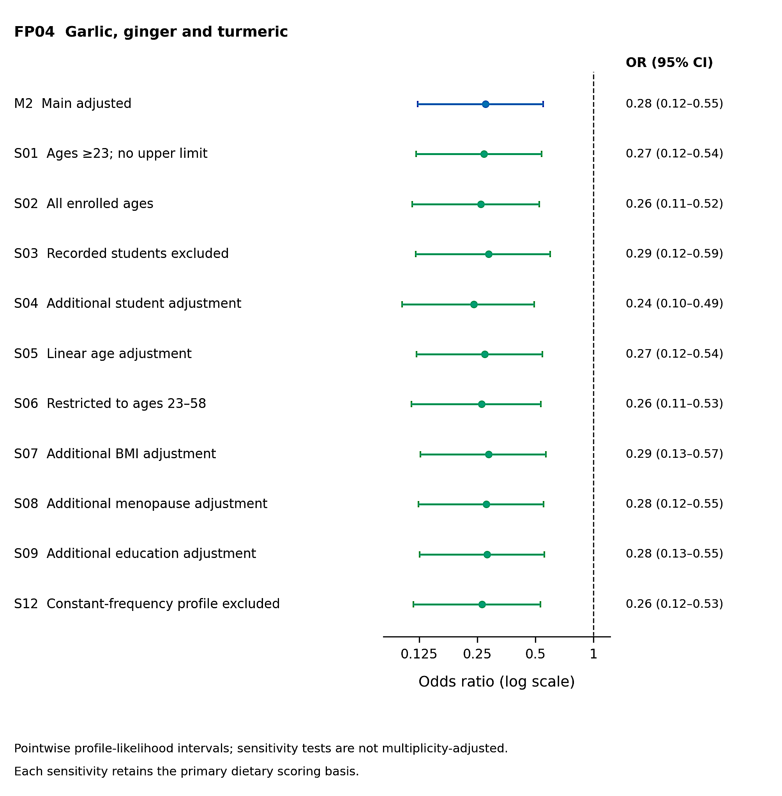
Figure S15. Population and covariate sensitivity analyses for FP04. Garlic, ginger and turmeric. The main result and population/covariate comparisons are displayed on a logarithmic odds-ratio scale. Each point and line is a Firth estimate and pointwise 95% profile interval. The fixed primary scoring basis is retained. S12 excludes constant-frequency profiles; no influence-based participant deletion was used. Corresponding estimates are in Table S18.
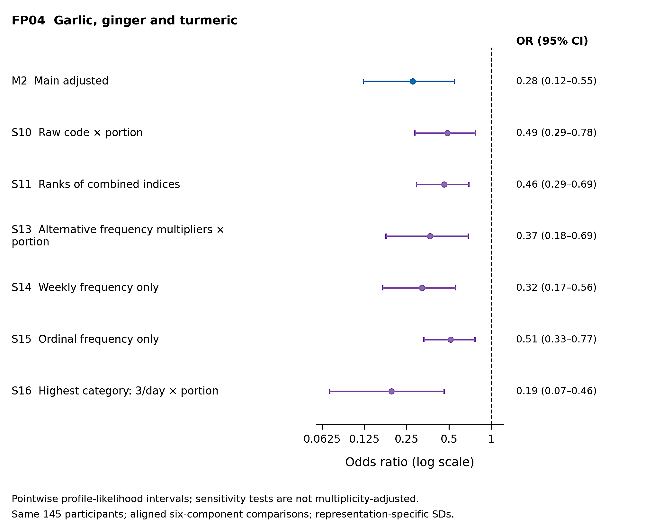
Figure S16. Measurement-representation sensitivity analyses for FP04. The main result is compared with raw-code products, ranks of the combined index, alternative frequency multipliers, weekly and ordinal frequency-only variables, and a 3/day highest-category assumption. All use the same 145 participants and six matched components, but each alternative uses its own score SD. Alignment does not guarantee identical component composition. CIs are pointwise and P values are not multiplicity-adjusted; Table S18 gives the numerical estimates.

FP05: Fruit and beans
Table S19. FP05 main and sensitivity associations
Model | Specification | N | Controls /  cases | OR (95% CI) | Pᵃ
M2 | Main adjusted | 145 | 83 / 62 | 0.91 (0.63-1.29) | 0.5822
S01 | ages ≥23, no upper limit | 150 | 83 / 67 | 0.90 (0.63-1.28) | 0.5670
S02 | all enrolled ages | 163 | 96 / 67 | 0.91 (0.63-1.30) | 0.6034
S03 | exclude recorded students from both groups | 121 | 66 / 55 | 0.92 (0.63-1.33) | 0.6562
S04 | recorded student status | 145 | 83 / 62 | 0.92 (0.64-1.30) | 0.6301
S05 | linear rather than spline age | 145 | 83 / 62 | 0.90 (0.63-1.28) | 0.5705
S06 | ages 23-58 | 135 | 82 / 53 | 0.92 (0.63-1.31) | 0.6320
S07 | recorded BMI | 145 | 83 / 62 | 0.91 (0.63-1.30) | 0.6054
S08 | menopausal status | 145 | 83 / 62 | 0.91 (0.63-1.29) | 0.5883
S09 | primary/secondary education indicators | 145 | 83 / 62 | 0.90 (0.63-1.28) | 0.5591
S10 | raw frequency code × portion | 145 | 83 / 62 | 0.92 (0.64-1.31) | 0.6437
S11 | ranks of combined indices | 145 | 83 / 62 | 1.27 (0.89-1.83) | 0.1870
S12 | exclude constant-frequency profiles | 144 | 82 / 62 | 0.89 (0.62-1.27) | 0.5226
S13 | alternative frequency multipliers × portion | 145 | 83 / 62 | 0.78 (0.53-1.12) | 0.1745
S14 | assigned weekly frequency only | 145 | 83 / 62 | 1.00 (0.70-1.42) | 0.9892
S15 | ordinal frequency only | 145 | 83 / 62 | 1.17 (0.79-1.74) | 0.4347
S16 | highest category 3/day × portion | 145 | 83 / 62 | 0.92 (0.64-1.31) | 0.6412
ᵃ P values are not multiplicity-adjusted. CIs are pointwise profile penalised-likelihood intervals. Model definitions and units follow Table S14. S10, S11 and S13-S16 re-estimate six aligned components under alternative representations; low congruence can indicate a different exposure mixture. All other rows retain the primary score scale. These related analyses are not independent replications.
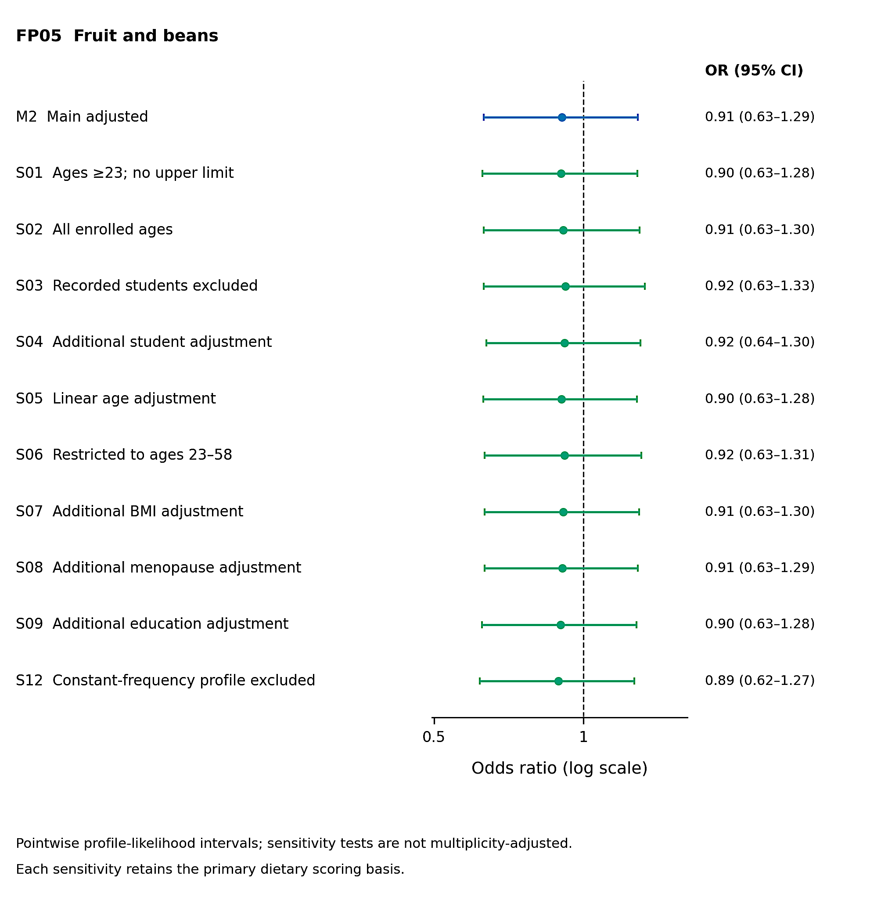
Figure S17. Population and covariate sensitivity analyses for FP05. Fruit and beans. The main result and population/covariate comparisons are displayed on a logarithmic odds-ratio scale. Each point and line is a Firth estimate and pointwise 95% profile interval. The fixed primary scoring basis is retained. S12 excludes constant-frequency profiles; no influence-based participant deletion was used. Corresponding estimates are in Table S19.
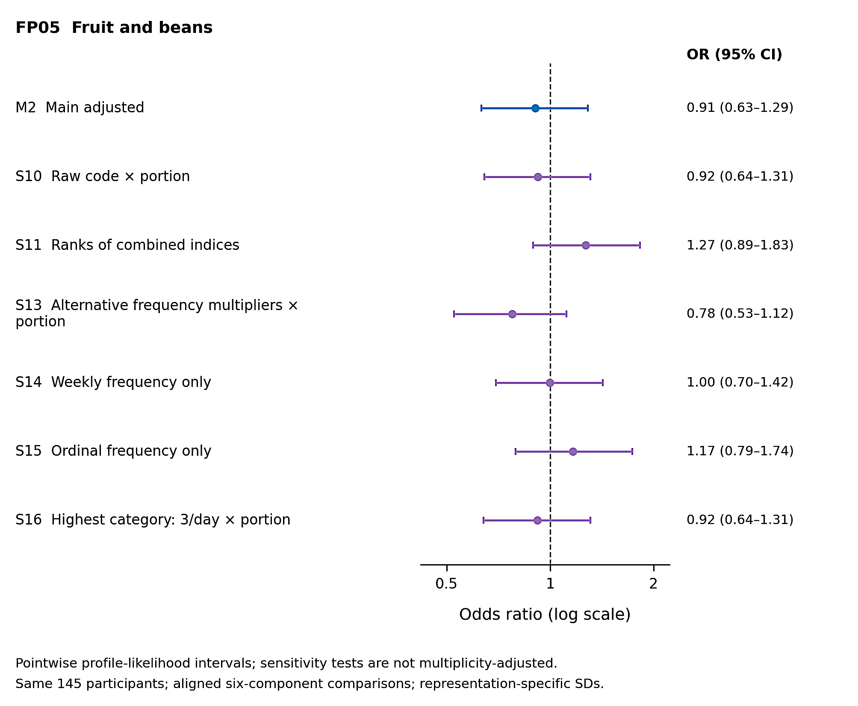
Figure S18. Measurement-representation sensitivity analyses for FP05. The main result is compared with raw-code products, ranks of the combined index, alternative frequency multipliers, weekly and ordinal frequency-only variables, and a 3/day highest-category assumption. All use the same 145 participants and six matched components, but each alternative uses its own score SD. Alignment does not guarantee identical component composition. CIs are pointwise and P values are not multiplicity-adjusted; Table S19 gives the numerical estimates.

FP06: Hibiscus tea, Moringa and fruit juice
Table S20. FP06 main and sensitivity associations
Model | Specification | N | Controls /  cases | OR (95% CI) | Pᵃ
M2 | Main adjusted | 145 | 83 / 62 | 0.91 (0.63-1.33) | 0.6368
S01 | ages ≥23, no upper limit | 150 | 83 / 67 | 0.91 (0.62-1.32) | 0.6036
S02 | all enrolled ages | 163 | 96 / 67 | 0.90 (0.61-1.31) | 0.5686
S03 | exclude recorded students from both groups | 121 | 66 / 55 | 0.83 (0.56-1.23) | 0.3525
S04 | recorded student status | 145 | 83 / 62 | 0.91 (0.62-1.33) | 0.6102
S05 | linear rather than spline age | 145 | 83 / 62 | 0.91 (0.62-1.33) | 0.6255
S06 | ages 23-58 | 135 | 82 / 53 | 0.92 (0.63-1.34) | 0.6579
S07 | recorded BMI | 145 | 83 / 62 | 0.92 (0.63-1.34) | 0.6461
S08 | menopausal status | 145 | 83 / 62 | 0.92 (0.63-1.33) | 0.6417
S09 | primary/secondary education indicators | 145 | 83 / 62 | 0.90 (0.62-1.31) | 0.5893
S10 | raw frequency code × portion | 145 | 83 / 62 | 0.87 (0.60-1.27) | 0.4840
S11 | ranks of combined indices | 145 | 83 / 62 | 1.24 (0.84-1.86) | 0.2768
S12 | exclude constant-frequency profiles | 144 | 82 / 62 | 0.90 (0.62-1.32) | 0.5931
S13 | alternative frequency multipliers × portion | 145 | 83 / 62 | 0.91 (0.62-1.32) | 0.6029
S14 | assigned weekly frequency only | 145 | 83 / 62 | 1.11 (0.77-1.60) | 0.5626
S15 | ordinal frequency only | 145 | 83 / 62 | 2.39 (1.58-3.84) | <0.0001
S16 | highest category 3/day × portion | 145 | 83 / 62 | 0.89 (0.61-1.30) | 0.5284
ᵃ P values are not multiplicity-adjusted. CIs are pointwise profile penalised-likelihood intervals. Model definitions and units follow Table S14. S10, S11 and S13-S16 re-estimate six aligned components under alternative representations; low congruence can indicate a different exposure mixture. All other rows retain the primary score scale. These related analyses are not independent replications.
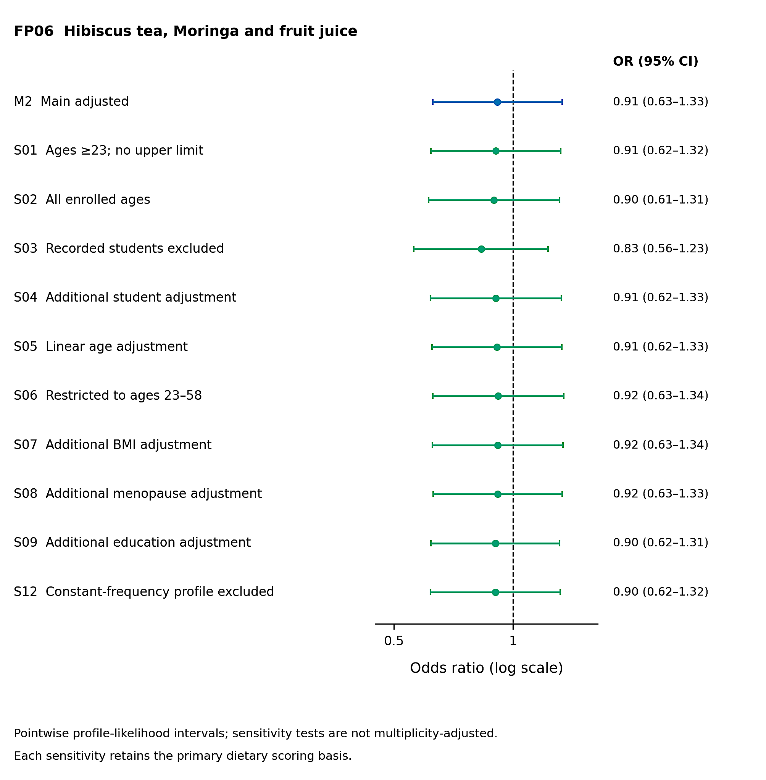
Figure S19. Population and covariate sensitivity analyses for FP06. Hibiscus tea, Moringa and fruit juice. The main result and population/covariate comparisons are displayed on a logarithmic odds-ratio scale. Each point and line is a Firth estimate and pointwise 95% profile interval. The fixed primary scoring basis is retained. S12 excludes constant-frequency profiles; no influence-based participant deletion was used. Corresponding estimates are in Table S20.
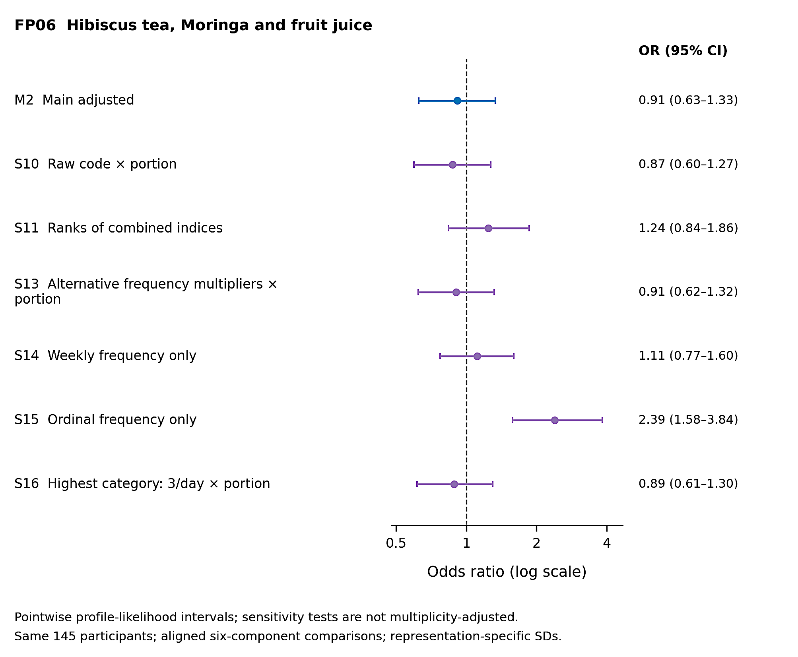
Figure S20. Measurement-representation sensitivity analyses for FP06. The main result is compared with raw-code products, ranks of the combined index, alternative frequency multipliers, weekly and ordinal frequency-only variables, and a 3/day highest-category assumption. All use the same 145 participants and six matched components, but each alternative uses its own score SD. Alignment does not guarantee identical component composition. CIs are pointwise and P values are not multiplicity-adjusted; Table S20 gives the numerical estimates.

Influence and estimator comparisons
Leave-one-participant-out analyses held the primary score and age-spline bases fixed. Each of 145 participants was omitted in turn for each component, yielding 870 fits. The summaries assess dependence on individual records, not the effect of re-deriving the component structure or a rule for excluding influential observations. All fits were numerically successful.
Table S21. Leave-one-participant-out influence summaries
Component | Successful /  requested | OR range | Largest absolute  change in log OR | Point-estimate  crossings of 1
FP01 | 145 / 145 | 1.012-1.207 | 0.148 | 0
FP02 | 145 / 145 | 1.844-2.824 | 0.358 | 0
FP03 | 145 / 145 | 0.476-0.540 | 0.073 | 0
FP04 | 145 / 145 | 0.221-0.299 | 0.220 | 0
FP05 | 145 / 145 | 0.827-0.974 | 0.091 | 0
FP06 | 145 / 145 | 0.872-1.040 | 0.130 | 1
A crossing records a sign change in the log-OR point estimate relative to the full-sample estimate, not a change in statistical significance. FP06 crossed one after one omission. FP02’s range shows variation in magnitude despite no directional reversal. No participant was excluded on the basis of these results.
Table S22. Conventional logistic-regression comparisons of M2
Component | OR (95% Wald CI) | P | Interval
FP01 | 1.03 (0.72-1.47) | 0.8843 | Wald
FP02 | 2.10 (1.19-3.71) | 0.0103 | Wald
FP03 | 0.48 (0.27-0.84) | 0.0105 | Wald
FP04 | 0.25 (0.11-0.54) | 0.0004 | Wald
FP05 | 0.90 (0.62-1.30) | 0.5673 | Wald
FP06 | 0.91 (0.62-1.34) | 0.6365 | Wald
Ordinary maximum-likelihood models use the same 145-person sample, primary dietary scores and M2 covariates. All six fits were reportable. Wald intervals and P values are estimator comparisons only and do not replace the Firth profile-likelihood results. P values are not multiplicity-adjusted.
The six-score Firth analyses included 18 core and 96 sensitivity fits. Checks covered full-rank design, convergence, modified-score residuals, penalised likelihood and profile calculations. The 500 joint resamples produced 3,000 valid Firth estimates. Analyses used R 4.6.1 and logistf 1.26.1 [26, 27].

