Stepwise utilization of H₂ between Geobacter sulfurreducens and Methanosarcina barkeri promoted CO₂-to-CH₄ conversion

Zhengnan Zhong, Haiquan Dong, Rongxin Xia, Junhu Zhou, Jun Cheng∗
State Key Laboratory of Clean Energy Utilization, Zhejiang University, Hangzhou 310027, China

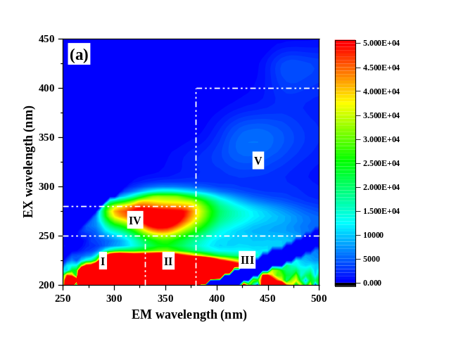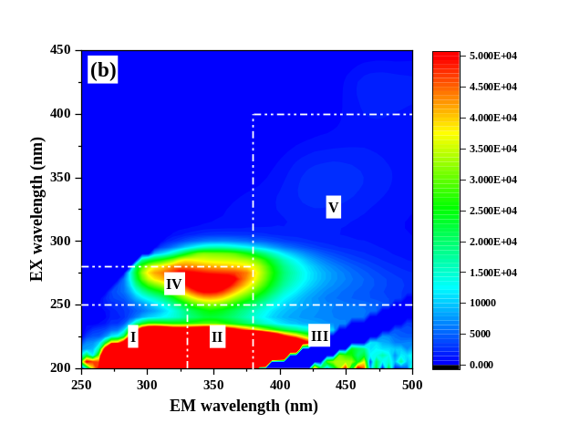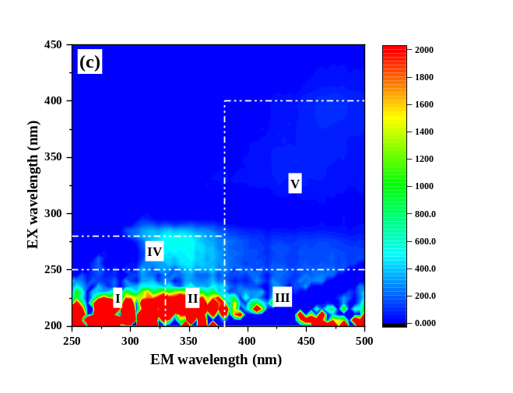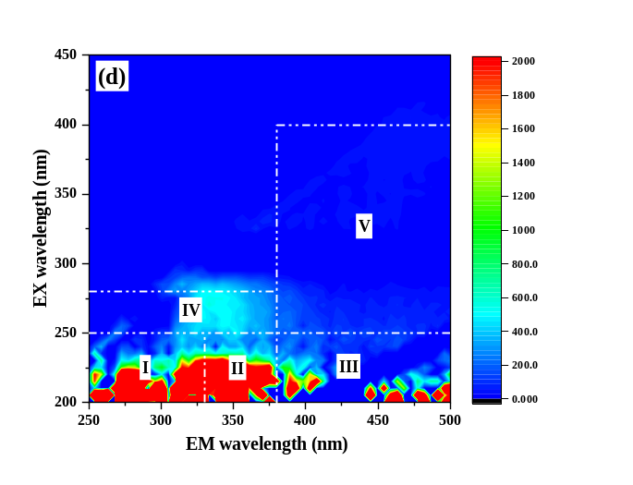

Fig. S1 Three-dimensional excitation emission matrix (3-DEEM) spectra analysis: M.barkeri group (a) S-EPS, (c) TB-EPS; M.barkeri and G.sulfurreducens group (b) S-EPS, (d) TB-EPS. (S-EPS: soluble extracellular polymer substances; TB-EPS: tightly bound EPS). Note: Region I (200 nm < Ex < 250 nm/250 nm < Em < 330 nm) were simple aromatic proteins, such as tyrosine; Region II (200 nm< Ex < 250 nm/330 nm< Em < 380 nm) were tryptophan-like substances; Region III (200 nm< Ex < 250 nm/380 nm< Em < 500 nm) were fulvic acid-like substances; Region IV (250 nm< Ex < 280 nm/250 nm< Em < 380 nm) were soluble microbial by-products; Region V (250 nm< Ex < 400 nm/380 nm< Em < 500 nm) were humic acid-like substances.
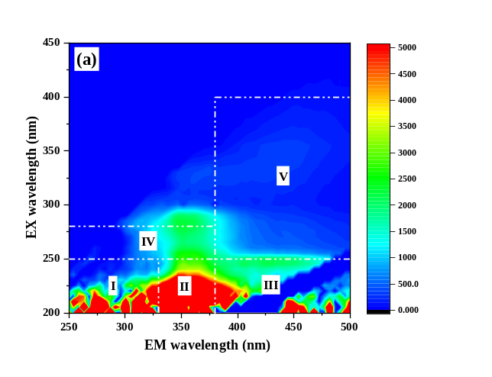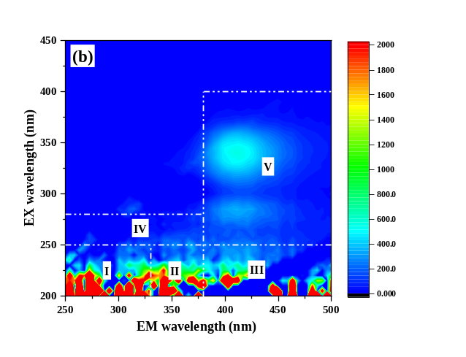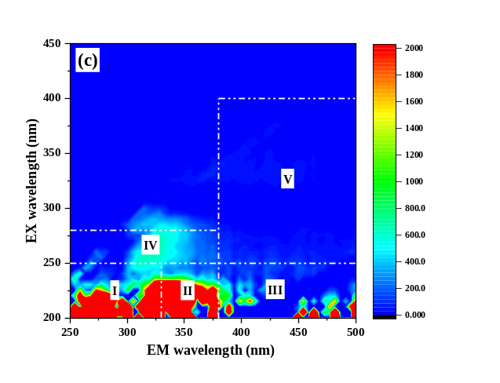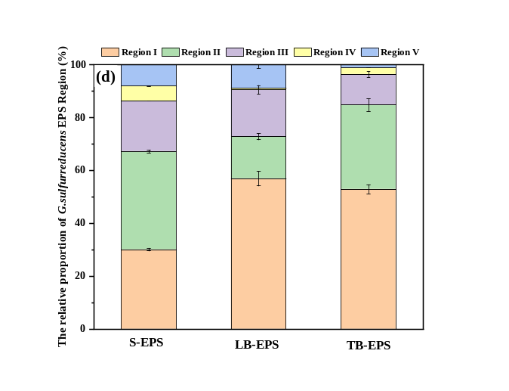

Fig. S2 Three-dimensional excitation emission matrix (3D-EEM) spectra analysis of G.sulfurreducens. (a) S-EPS: soluble extracellular polymeric substances; (b) LB-EPS: loosely bound EPS; (c) TB-EPS: tightly bound EPS; (d) The relative proportion of five regions.

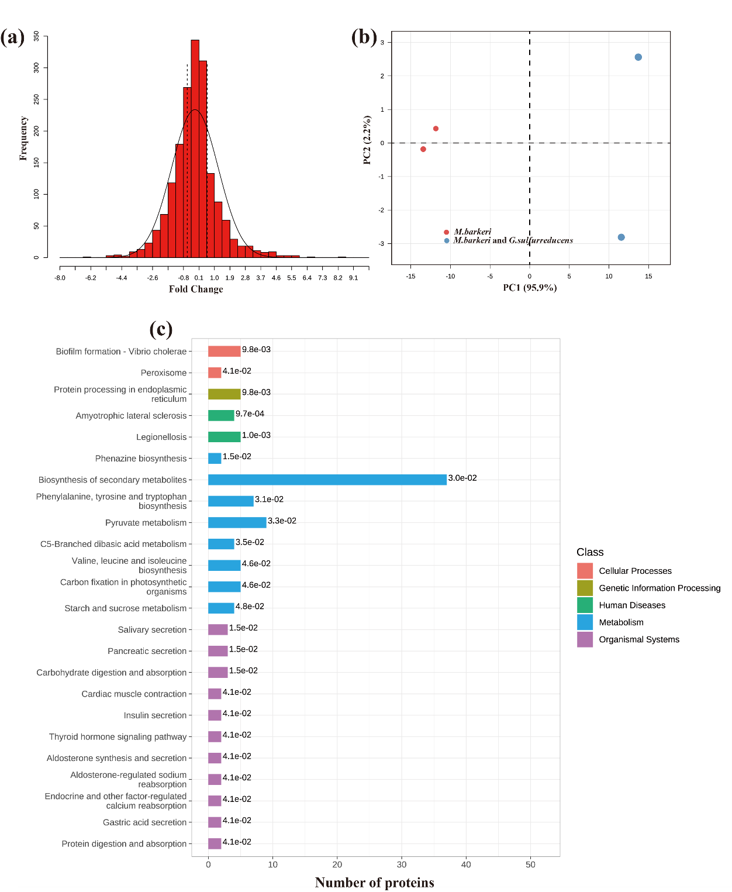
Fig. S3 Label-free quantitative proteomics of M.barkeri and G.sulfurreducens.(a) Fold change distribution plots of identified proteins; (b) Score plots of identified proteins; (c) KEGG annotation and enrichment analysis of differential proteins.`
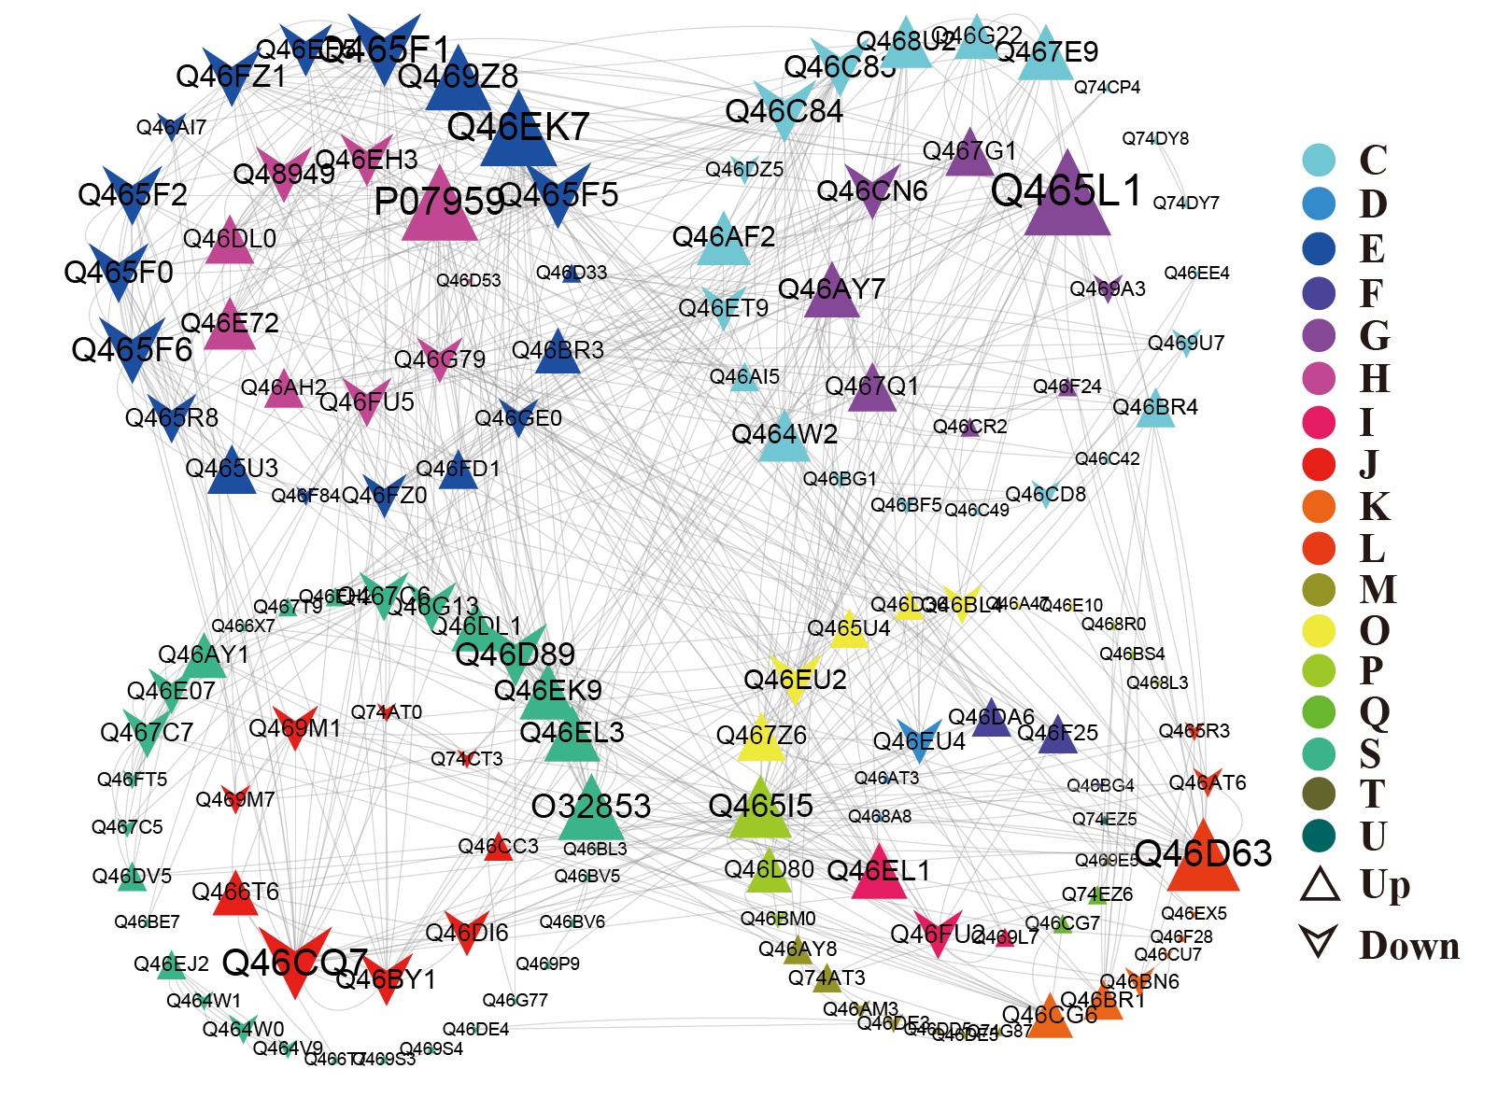
Fig. S4 Interaction network analysis of differentially expressed proteins in the M. barkeri and G. sulfurreducens co-culture.

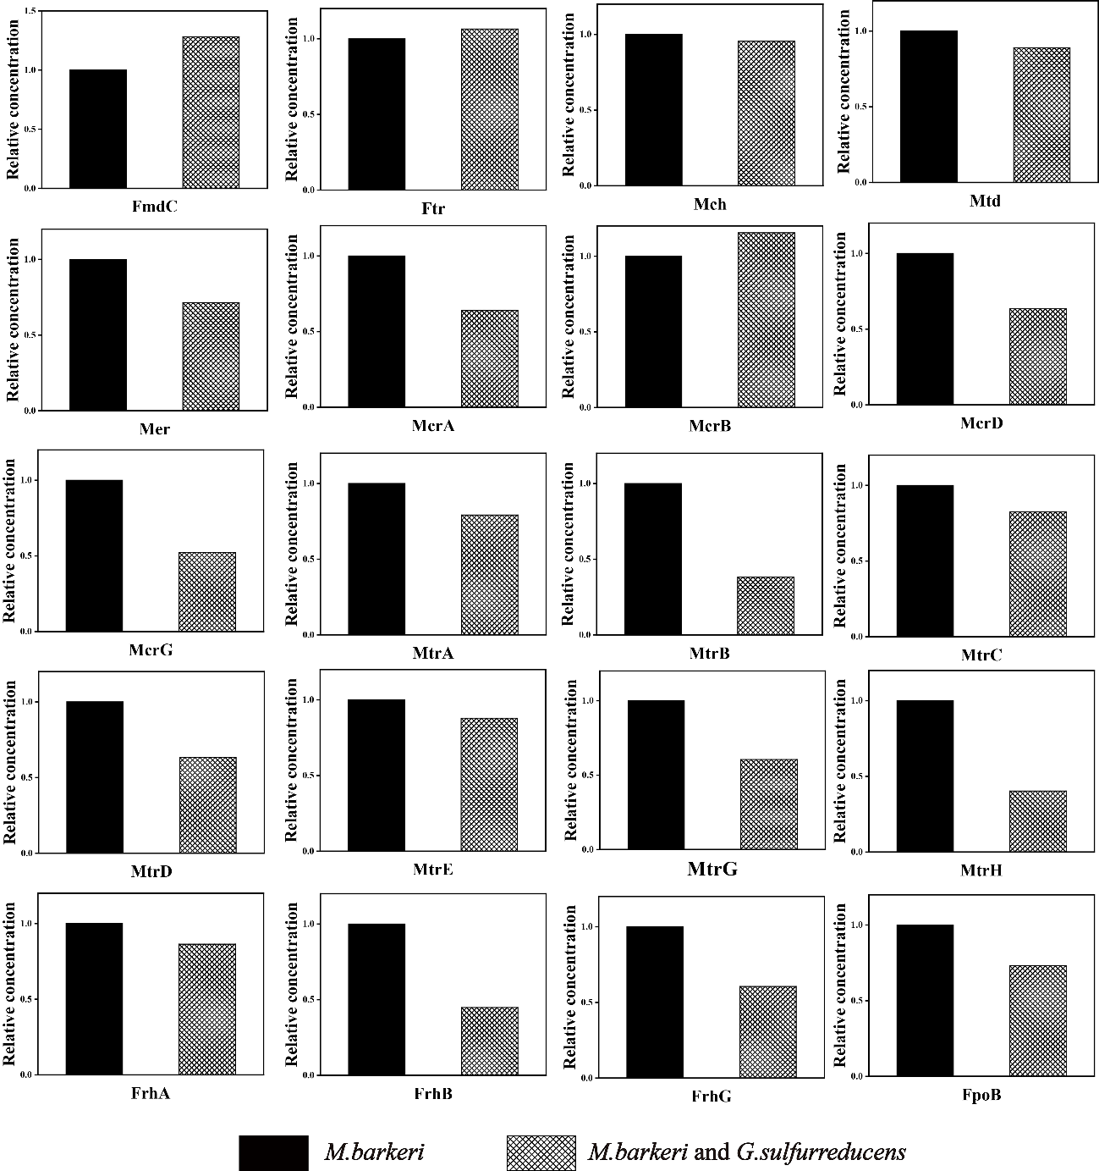

Fig. S5 Relative concentrations of undifferential proteins for H₂/CO₂ biomethanation in pure culture (M.barkeri) and co-culture (M.barkeri and G.sulfurreducens)
Table S1 The differential proteins associated with H₂ utilization in G. sulfurreducens
Protein.Group | Gene | Description | Fold Change | P-value
Q74F24 | hybL | Periplasmically oriented, membrane-bound [NiFe]-hydrogenase large subunit OS=Geobacter sulfurreducens | - | -
Q74F27 | hybS | Periplasmically oriented, membrane-bound [NiFe]-hydrogenase small subunit OS=Geobacter sulfurreducens | - | -
Q74F25 | hybB | Periplasmically oriented, membrane-bound [NiFe]-hydrogenase integral membrane subunit OS=Geobacter sulfurreducens | - | -
Q74GH2 | GSU0274 | Cytochrome c, and cytochrome b OS=Geobacter sulfurreducens | - | -
Q747K6 | imcH | Cytochrome c-type protein ImcH OS=Geobacter sulfurreducens | - | -
Q749U9 | GSU2643 | Lipoprotein cytochrome c OS=Geobacter sulfurreducens | - | -
Q74GA5 | nuoD | NADH-quinone oxidoreductase subunit D OS=Geobacter sulfurreducens | - | -
Q74F05 | GSU0804 | NAD(P)H dehydrogenase (quinone) OS=Geobacter sulfurreducens | - | -
Q74G99 | nuoJ-1 | NADH-quinone oxidoreductase subunit J OS=Geobacter sulfurreducens | - | -
Q74GZ6 | por | Pyruvate:ferredoxin/flavodoxin oxidoreductase OS=Geobacter sulfurreducens | - | -
Q748E7 | nfnA | NADH-dependent ferredoxin:NADP+ oxidoreductase, alpha subunit OS=Geobacter sulfurreducens | - | -

Table S2 The differential proteins associated with H₂/CO₂ biomethanation in M. barkeri
Protein.Group | Gene | Description | Fold Change | P-value
O32853 | mtxX | Putative methyltransferase mtx subunit X OS=Methanosarcina barkeri | 2.245 | 0.049
07959 | mcrC | Methyl-coenzyme M reductase operon protein C OS=Methanosarcina barkeri | 2.166 | 0.018
P0C0W3;  Q46E72 | mtmB2 | Monomethylamine methyltransferase MtmB2 OS=Methanosarcina barkeri | 2.185 | 0.009
P0C0W5;  P0C0W6 | mtbB1 | Dimethylamine methyltransferase MtbB1 OS=Methanosarcina barkeri | 2.387 | 0.013
P0C0W6 | mtbB2 | Dimethylamine methyltransferase MtbB2 OS=Methanosarcina barkeri | 2.303 | 0.003
Q464W2 | Mbar_A3717 | Carbon monoxide dehydrogenase OS=Methanosarcina barkeri | 1.979 | 0.032
Q465A8 | Mbar_A3671 | Carboxymuconolactone decarboxylase OS=Methanosarcina barkeri | 3.534 | 0.047
Q467E9 | Mbar_A3106 | H(+)-transporting ATP synthase, subunit beta OS=Methanosarcina barkeri | 5.352 | 0.016
Q46DL0 | Mbar_A1064 | Methanol:corrinoid methyltransferase OS=Methanosarcina barkeri | 5.640 | 0.019
Q46DL1 | Mbar_A1063 | Methanol corrinoid protein OS=Methanosarcina barkeri | 4.961 | 0.019
Q46FV6 | Mbar_A0252 | Iron-sulfur flavoprotein OS=Methanosarcina barkeri | 2.082 | 0.028
Q46AI5 | Mbar_A2179 | Flavodoxin OS=Methanosarcina barkeri | 5.039 | 0.007
Q46G22 | hppA | K(+)-insensitive pyrophosphate-energized proton pump OS=Methanosarcina barkeri | 22.323 | 0.001
Q46BF5 | Mbar_A1846 | Methanophenazine-reducing hydrogenase, large subunit OS=Methanosarcina barkeri | 0.626 | 0.044
Q46BG1 | Mbar_A1840 | Methanophenazine-reducing hydrogenase, large subunit OS=Methanosarcina barkeri | 0.478 | 0.021
Q46C83 | Mbar_A1562 | Formate dehydrogenase, beta subunit (F420) OS=Methanosarcina barkeri | 0.489 | 0.034
Q46CD8 | Mbar_A1499 | Heterodisulfide reductase, subunit D OS=Methanosarcina barkeri | 0.583 | 0.023
Q48949 | mtaA | Methylcobamide:CoM methyltransferase MtaA OS=Methanosarcina barkeri | 0.066 | 0.008
Q46C84 | Mbar_A1561 | Formate dehydrogenase, alpha subunit (F420) OS=Methanosarcina barkeri | 0.300 | 0.041
Q46G55 | Mbar_A0152 | Ech hydrogenase subunit A OS=Methanosarcina barkeri | 0.932 | 0.866
Q46G57 | Mbar_A0150 | Ech hydrogenase subunit C OS=Methanosarcina barkeri | 0.503 | 0.166
Q46G58 | Mbar_A0149 | Ech hydrogenase subunit D OS=Methanosarcina barkeri | 0.189 | 0.335
Q46G59 | Mbar_A0148 | Ech hydrogenase subunit E OS=Methanosarcina barkeri | 0.691 | 0.380
Q46G60 | Mbar_A0147 | Ech hydrogenase subunit F OS=Methanosarcina barkeri | 0.675 | 0.766
Q46G56 | Mbar_A0151 | Ech hydrogenase subunit B OS=Methanosarcina barkeri | 0.726 | 0.547
Q48943 | fmdC | Molybdenum-containing formylmethanofuran dehydrogenase 1 subunit C OS=Methanosarcina barkeri | 1.282 | 0.089
P55301 | ftr | Formylmethanofuran—tetrahydromethanopterin formyltransferase OS=Methanosarcina barkeri | 1.065 | 0.868
P94919 | mch | Methenyltetrahydromethanopterin cyclohydrolase OS=Methanosarcina barkeri | 0.955 | 0.822
Q46DH9 | mtd | F420-dependent methylenetetrahydromethanopterin dehydrogenase OS=Methanosarcina barkeri | 0.390 | 0.202
Q46FV4 | mer | 5,10-methylenetetrahydromethanopterin reductase OS=Methanosarcina barkeri | 0.714 | 0.598
O93716 | mtrH | Tetrahydromethanopterin S-methyltransferase subunit H OS=Methanosarcina barkeri | 0.404 | 0.427
Q9Y8K0 | mtrE | Tetrahydromethanopterin S-methyltransferase subunit E OS=Methanosarcina barkeri | 0.179 | 0.246
Q9Y8K1 | mtrD | Tetrahydromethanopterin S-methyltransferase subunit D OS=Methanosarcina barkeri | 0.634 | 0.317
Q9Y8K2 | mtrC | Tetrahydromethanopterin S-methyltransferase subunit C OS=Methanosarcina barkeri | 0.823 | 0.392
Q9Y8K3 | mtrB | Tetrahydromethanopterin S-methyltransferase subunit B OS=Methanosarcina barkeri | 0.383 | 0.375
Q9Y8K4 | mtrA | Tetrahydromethanopterin S-methyltransferase subunit A OS=Methanosarcina barkeri | 0.792 | 0.171
Q9Y8K6 | mtrG | Tetrahydromethanopterin S-methyltransferase subunit G OS=Methanosarcina barkeri | 0.605 | 0.365
P07959 | mcrC | Methyl-coenzyme M reductase operon protein C OS=Methanosarcina barkeri | 2.166 | 0.018
P07955 | mcrB | Methyl-coenzyme M reductase subunit beta OS=Methanosarcina barkeri | 1.154 | 0.526
P07958 | mcrD | Methyl-coenzyme M reductase operon protein D OS=Methanosarcina barkeri | 0.936 | 0.720
P07962 | mcrA | Methyl-coenzyme M reductase subunit alpha OS=Methanosarcina barkeri | 0.638 | 0.535
P07964 | mcrG | Methyl-coenzyme M reductase subunit gamma OS=Methanosarcina barkeri | 0.524 | 0.520
P96796 | hdrE | Dihydromethanophenazine:CoB--CoM heterodisulfide reductase subunit E OS=Methanosarcina barkeri | 1.078 | 0.880
P96797 | hdrD | Dihydromethanophenazine:CoB--CoM heterodisulfide reductase subunit D OS=Methanosarcina barkeri | 0.896 | 0.715
P80489 | frhA | Coenzyme F420 hydrogenase subunit alpha OS=Methanosarcina barkeri | 0.864 | 0.197
P80490 | frhB | Coenzyme F420 hydrogenase subunit beta OS=Methanosarcina barkeri | 0.448 | 0.339
P80491 | frhG | Coenzyme F420 hydrogenase subunit gamma OS=Methanosarcina barkeri | 0.605 | 0.609
Q46AS5 | Mbar_A2086 | Ferredoxin OS=Methanosarcina barkeri | 2.159 | 0.057
Q46BF4 | Mbar_A1847 | Methanophenazine-reducing hydrogenase, small subunit OS=Methanosarcina barkeri | 0.195 | 0.055
Q46BF6 | Mbar_A1845 | Methanophenazine-reducing hydrogenase, cytochrome B subunit OS=Methanosarcina barkeri | 0.176 | 0.236
Q46FV3 | Mbar_A0255 | F420H2 dehydrogenase subunit F OS=Methanosarcina barkeri | 0.693 | 0.389
Q466A8 | Mbar_A3411 | F420H2 dehydrogenase subunit B OS=Methanosarcina barkeri | 0.730 | 0.472
Q466A9 | Mbar_A3410 | F420H2 dehydrogenase subunit C OS=Methanosarcina barkeri | 1.710 | 0.251
Q466B0 | Mbar_A3409 | F420H2 dehydrogenase subunit D OS=Methanosarcina barkeri | 1.424 | 0.234
Q466B2 | Mbar_A3407 | F420H2 dehydrogenase subunit I OS=Methanosarcina barkeri | 1.567 | 0.120
Q466B9 | Mbar_A3400 | F420H2 dehydrogenase subunit O OS=Methanosarcina barkeri | 1.261 | 0.410

∗ Corresponding author: Prof. Dr. Jun Cheng, State Key Laboratory of Clean Energy Utilization, Zhejiang University, Hangzhou 310027, China. Tel.: +86 571 87952889; fax: +86 571 87951616. E-mail: juncheng@zju.edu.cn

