Supplementary Figure S2: Molecular docking simulation of donepezil with GATA-3
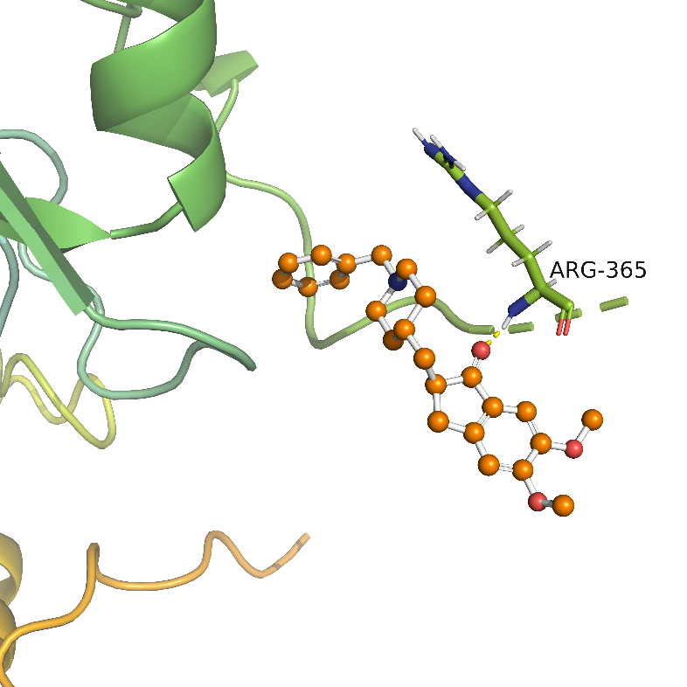

Figure legends: The bright yellow dotted lines are hydrogen bonds, the ball-and-stick structure is donepezil, the main body is GATA3, and the sticking out is the binding amino acid site. This proves that donepezil can form a hydrogen bond with the 365 amino acid ARG of the A chain on GATA3. We use AutoDock4.2 simulation, PyMol drawing.

