Conduction System Pacing versus Biventricular Pacing in Heart Failure with Reduced Ejection Fraction: A Bayesian Meta-Analysis
Short Title: Conduction System Pacing versus Biventricular Pacing in HFrEF
Authors
Omar Abdullah Gill, MBBS^{1,2}, Muhammad Zulfiqar Ali, MBBS², Abdullah Shawwa, MD³, Maham Fatima, MD², Wasif Rahim, MBBS², Usama Afzal Kamal, MBBS², Maria Qadri, MBBS⁴, Ali Haider Ehsan Khan, MBBS², Muhammad Usman Gill, BSc⁵, Prutha Pathak, MBBS, MPH⁶, Guilherme Dagostin de Carvalho, MD, MSc⁷, Prof. James M. Brophy, MD, PhD⁸
Affiliations:
¹Department of Cardiology, Mayo Hospital Lahore, Punjab, Pakistan.
²King Edward Medical University, Lahore, Punjab, Pakistan.
³School of Medicine, University of Jordan, Amman, Jordan.
⁴Jinnah Sindh Medical University, Karachi, Pakistan.
⁵National University of Modern Languages, Faisalabad
⁶Cardiovascular Disease Fellow, UCHealth Parkview Medical Center, Colorado, USA.
⁷Department of Cardiac Arrhythmias and Electrophysiology, Dante Pazzanese Institute of Cardiology, São Paulo, São Paulo, Brazil
⁸Research Institute of McGill University Health Centre, Centre for Health Outcomes Research, Montreal, Quebec, Canada.

TABLE OF CONTENTS
eTable1. Comprehensive search strategy for used databases with number of results. 4
eFigure1. PRISMA flow chart detailing studies selection procedure. 5
eMethodology of Bayesian Meta-Analysis 7
eMethods1. Details of primary outcomes and models. 7
eFigure2. Prior distribution for the overall treatment effect (θ). 7
eFigure3. Prior distribution for heterogeneity (τ) — Sensitivity Analysis 1. 10
eFigure4. Prior distribution for heterogeneity (τ) — Sensitivity Analysis 2. 12
eMethods2. Bayesian Subgroup Analysis. 13
eFigure5. Prior distribution for α₀ (HBP reference subgroup). 14
eFigure6. Prior distribution for β (LBAP vs. HBP subgroup difference). 14
eTable2. Prior distributions used in Bayesian meta-analysis, by outcome. 15
eMethods3. Calculation of Absolute Risk Differences. 17
eTable3. Baseline characteristics. 18
eTable4. Characteristics of included studies 20
eTable5. Secondary and Procedural Outcomes Posterior Distribution and Probabilities. 21-23
eFigure07. Leave-one-out sensitivity analysis: All-cause mortality. 24
eFigure08. Sensitivity analysis with different priors for Posterior Distributions 25
eFigure09. Sensitivity analysis with different priors for Predictive Intervals 26-27
eFigure10. Leave-one-out sensitivity analysis: Heart Failure Hospitalization. 29
Priors eliciting for QRS narrowing. 30
eFigure11. Forest plot: QRS narrowing. 31
eFigure12. Posterior probability distribution and cumulative curves: QRS. 32-33
eFigure13. Sensitivity analysis: QRS, pooled effect overall. 34
eFigure14. Sensitivity analysis: QRS, pooled effect in HBP 35
eFigure15. Sensitivity analysis: QRS, pooled effect in LBAP 36
eFigure16. Forest plot: LVEF. 37-38
eFigure17. Posterior probability distribution and cumulative curves: LVEF.. 39-40
eFigure18. Forest plot: LVESV. 41-43
eFigure19. Posterior probability distribution and cumulative curves: LVESV.. 44-45
eFigure20. Forest plot: LVEDV. 46
eFigure21. Posterior probability distribution and cumulative curves: LVEDV.. 47
eFigure22. Forest plot: NYHA Class. 48
eFigure23. Posterior probability distribution: NYHA Class. 49-51
eFigure24. Forest plot: Procedure Time. 52-54
eFigure25. Forest plot: Fluoroscopy Time. 55-56
eFigure26 Forest plot: Peri-procedural Complications. 57-58
eFigure27. Forest plot: Lead Revision/Displacement Complications. 59
eFigure28. Traffic light plot: Risk of Bias Assessment with RoB2 Tool 64
eFigure29. Summary Plot. 65-67
eTable6. Risk of bias of Cross over trials. 68-70
eTable7. GRADE assessment of the certainty of evidence . 71-74

References 75

eTable1. Comprehensive search strategy for used databases with number of results.

Database | String | Results
PubMed | (“heart failure” OR HF) AND (“Cardiac Resynchronization Therapy” OR CRT) AND (“Conduction System” OR CSP OR “His-optimized cardiac” OR “HOT-CRT” OR “His bundle” OR HBP OR “His Pacing” OR “His CRT” OR “Left Bundle” OR LBBP OR LBBAP) AND (RCT OR random OR randomly OR randomized OR randomization) | 880
Embase | (“conduction system pacing” OR “his bundle pacing” OR “left bundle branch pacing” OR “HBP” OR “LBBAP” OR “LVSP” OR “LBBP”) AND (“biventricular pacing” OR “cardiac resynchronization therapy”) | 501
Cochrane | #1 (“heart failure” OR HF)  #2 (“Conduction System” OR CSP OR “His-optimized cardiac” OR “HOT-CRT” OR “His bundle” OR HBP OR “His Pacing” OR “His CRT” OR “Left Bundle” OR LBBP OR LBBAP)  #3(RCT OR random OR randomly OR randomized OR randomization)  #1 AND#2AND #3 | 279
Clinicaltrial.gov | (“conduction system pacing” OR “his bundle pacing” OR “left bundle branch pacing” OR “HBP” OR “LBBAP” OR “LVSP” OR “LBBP”) AND (“biventricular pacing” OR “cardiac resynchronization therapy”) | 119

eFigure1. PRISMA flow chart detailing studies selection procedure.

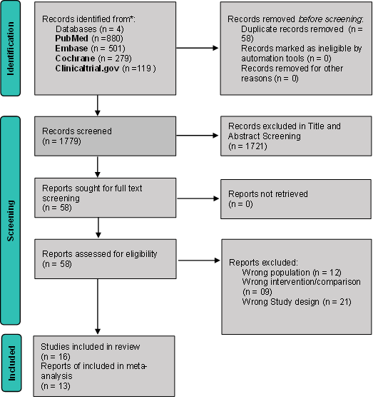

eMethodology of Bayesian Meta-Analysis
eMethods1 of Bayesian Meta-Analysis

For binary outcomes, we fitted a Bayesian binomial-normal hierarchical random-effects model. Rather than modelling observed log odds ratios directly, the model used the exact binomial likelihood for the numbers of events in the treatment and control groups within each study. Study-specific log odds ratios were assumed to arise from a common normal distribution centred on the overall treatment effect ($θ$) with between-study heterogeneity ($τ$). This approach is particularly appropriate when event counts are sparse because it avoids continuity corrections and preserves the exact binomial likelihood.".

Prior distributions
For the overall treatment effect, we specified a weakly informative prior,
eFigure2. Prior distribution for θ (overall treatment effect, log odds ratio scale): Normal(0, 0.82²).
$$θ∼Normal(0, {0.82}^{2}),$$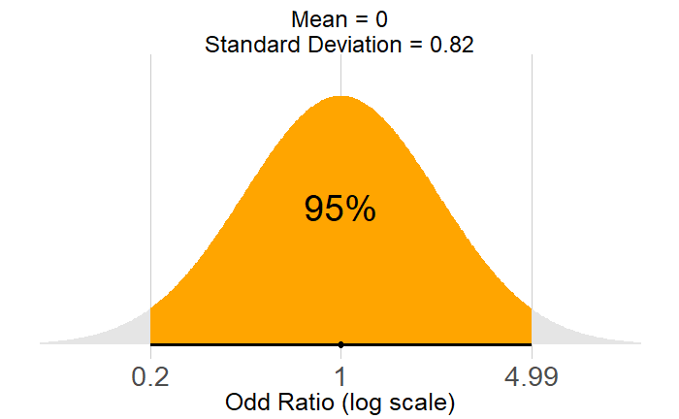
on the log odds ratio scale. This prior is centered at the null effect (log OR = 0; OR = 1) and assigns approximately 95% prior probability to odds ratios between 0.2 and 5, thereby allowing a broad range of clinically plausible treatment effects while reducing the influence of implausibly extreme values. The prior was chosen to exert minimal influence on the posterior distribution when sufficient data were available while providing regularization in the presence of sparse events and a limited number of studies.
Study-specific baseline log odds were assigned vague priors,
$$μ_{i}∼Normal(0, {1.5}^{2}),$$
reflecting minimal prior information regarding baseline event risks across studies.
For the between-study heterogeneity, informative empirical priors proposed by Turner et al. were used. Specifically,
$$τ∼LogNormal(-1.75, {0.63}^{2})$$

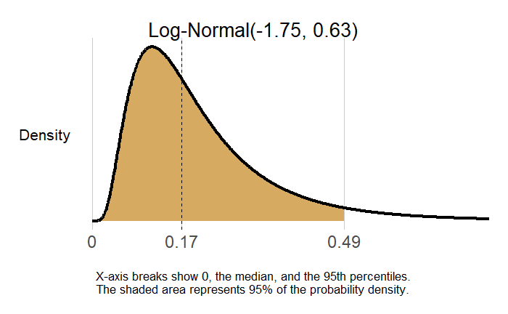
was specified for all-cause mortality, whereas
$$τ∼LogNormal(-1.635, {0.84}^{2})$$

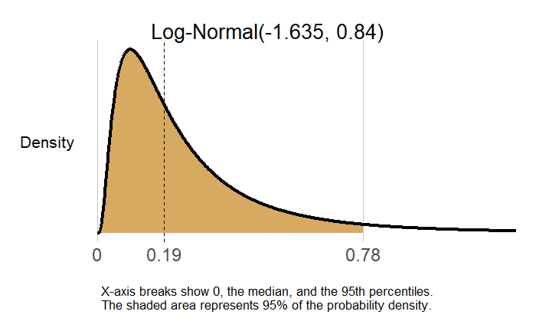
was specified for heart failure hospitalization. These priors were derived from empirical heterogeneity estimates across a large collection of randomized clinical trials and improve estimation when only a small number of studies contribute sparse binary outcome data.
Posterior inference was performed using Hamiltonian Monte Carlo as implemented in the Stan backend through the brms package. Four Markov chains were run, each with 4000 warm-up iterations followed by 8000 sampling iterations. Convergence was assessed using trace plots, the potential scale reduction factor ($\hat{R}<1.01$), effective sample sizes, and the absence of divergent transitions. Treatment effects are reported as posterior median odds ratios with corresponding 95% credible intervals obtained by exponentiating the posterior samples of the pooled log odds ratio.

Sensitivity analysis 1: Weakly informative heterogeneity prior
In the first sensitivity analysis, the treatment-effect prior remained unchanged,
(θ prior unchanged from eFigure2 — shown again for reference in Sensitivity Analysis 1.)
$$θ∼Normal(0,{0.82}^{2}),$$
whereas the empirical Turner prior for heterogeneity was replaced with a weakly informative Half-Normal prior,
$$τ∼Half\text{-}Normal(0.5).$$

eFigure3. Prior distribution for τ (between-study heterogeneity), Half-Normal(0.5) — Sensitivity Analysis 1.
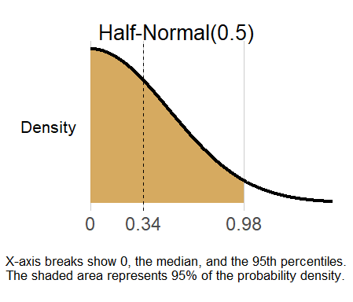
The scale parameter (0.5) was selected using the BayesianPriors package and follows the recommendations of Röver et al. and Spiegelhalter et al. for Bayesian random-effects meta-analysis. This prior places greater probability on small to moderate heterogeneity while still allowing larger values when supported by the observed data. The Half-Normal(0.5) prior places most of its probability mass on small values of the between-study heterogeneity parameter ($τ$), while still allowing moderate heterogeneity when supported by the observed data. The median of this prior is approximately 0.34, and the 95th percentile is 0.98 on the log odds ratio scale. Consequently, before observing the data, there is a 95% prior probability that the between-study standard deviation is less than 0.98.

Sensitivity analysis 2: Vague heterogeneity prior
A second sensitivity analysis retained the same weakly informative treatment-effect prior but assigned a substantially less informative prior to the heterogeneity parameter,
$$τ∼Half\text{-}Normal(1.0),$$
thereby allowing considerably larger between-study variability. This analysis evaluated whether the posterior treatment effect remained robust under minimal prior assumptions regarding heterogeneity.

eFigure4. Prior distribution for τ (between-study heterogeneity), Half-Normal(1.0) — Sensitivity Analysis 2.
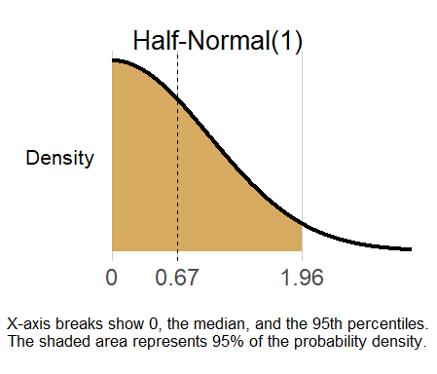

The Half-Normal(1) prior is less restrictive than the Half-Normal(0.5) prior and assigns greater probability to moderate and large values of the between-study heterogeneity parameter ($τ$). The median of this prior is approximately 0.67, and the 95th percentile is 1.96 on the log odds ratio scale. Thus, before observing the data, there is a 95% prior probability that the between-study standard deviation is less than 1.96.
.

eMethods2. Bayesian Subgroup Analysis
Prespecified subgroup analyses were performed to investigate whether the treatment effect differed according to the conduction system pacing modality (His bundle pacing [HBP] versus left bundle branch area pacing [LBAP]). Subgroup effects were estimated using a Bayesian random-effects meta-regression model, in which the subgroup indicator was included as a study-level covariate.
For study $i$,
$$y_{i}∼Normal(θ_{i},σ_{i}^{2}),$$
where $y_{i}$denotes the observed study-specific treatment effect (mean difference), and $σ_{i}^{2}$is the corresponding within-study sampling variance.
The true study-specific effects were assumed to follow
$$θ_{i}∼Normal(μ_{i},τ^{2}),$$
where
$$μ_{i}=α_{0}+βx_{i}.$$
Here,
- $x_{i}=0$for studies evaluating His bundle pacing (HBP),
- $x_{i}=1$for studies evaluating left bundle branch area pacing (LBAP).

The model parameters are defined as follows:
- $α_{0}$: pooled treatment effect for the reference subgroup (HBP);
- $β$: difference in treatment effect between LBAP and HBP;

- $τ$: between-study heterogeneity, assumed to be common across both subgroups.
Accordingly, the pooled treatment effect for each subgroup is
$$\text{HBP: }α_{0}, \\ \text{LBAP: }α_{0}+β.$$
Posterior distributions were obtained using Bayesian random-effects meta-analysis implemented in the bayesmeta package. Subgroup differences were summarized using the posterior distribution of $β$. Posterior probabilities that the treatment effect differed between pacing modalities were calculated directly from the posterior samples of the subgroup contrast. Posterior probabilities of benefit within each subgroup were calculated from the corresponding subgroup-specific posterior distributions.

For subgroup analyses, vague priors were assigned to the subgroup-specific treatment effects,
$$α_{0}∼Normal(0,{50}^{2}),$$
eFigure5. Prior distribution for α₀ (pooled treatment effect, His bundle pacing reference subgroup): Normal(0, 50²).
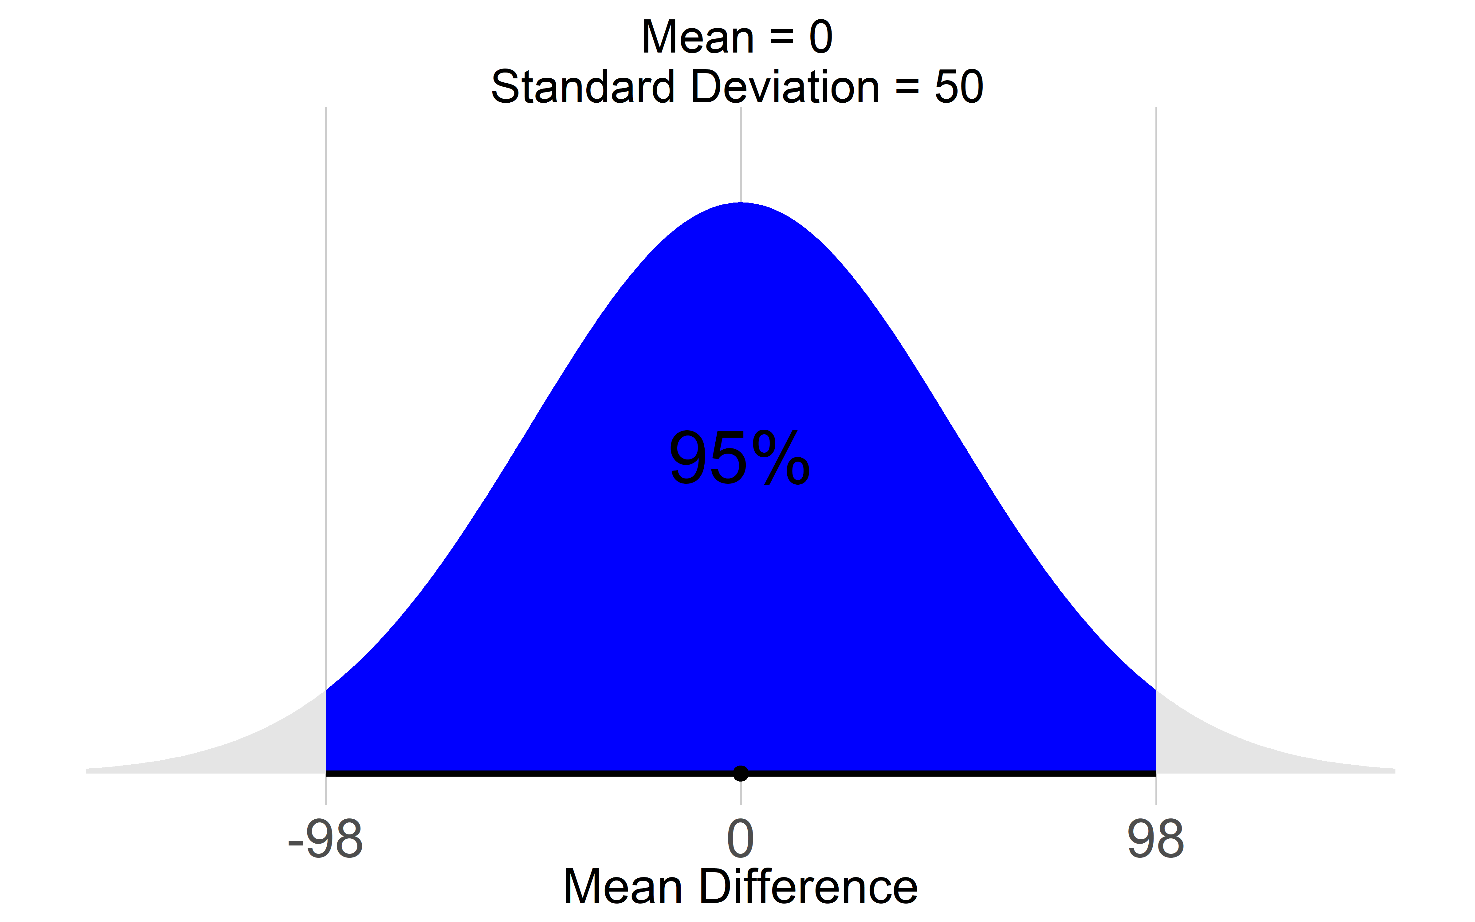

$$β∼Normal(0,{20}^{2}),$$
eFigure6. Prior distribution for β (subgroup difference, LBAP vs. HBP): Normal(0, 20²).
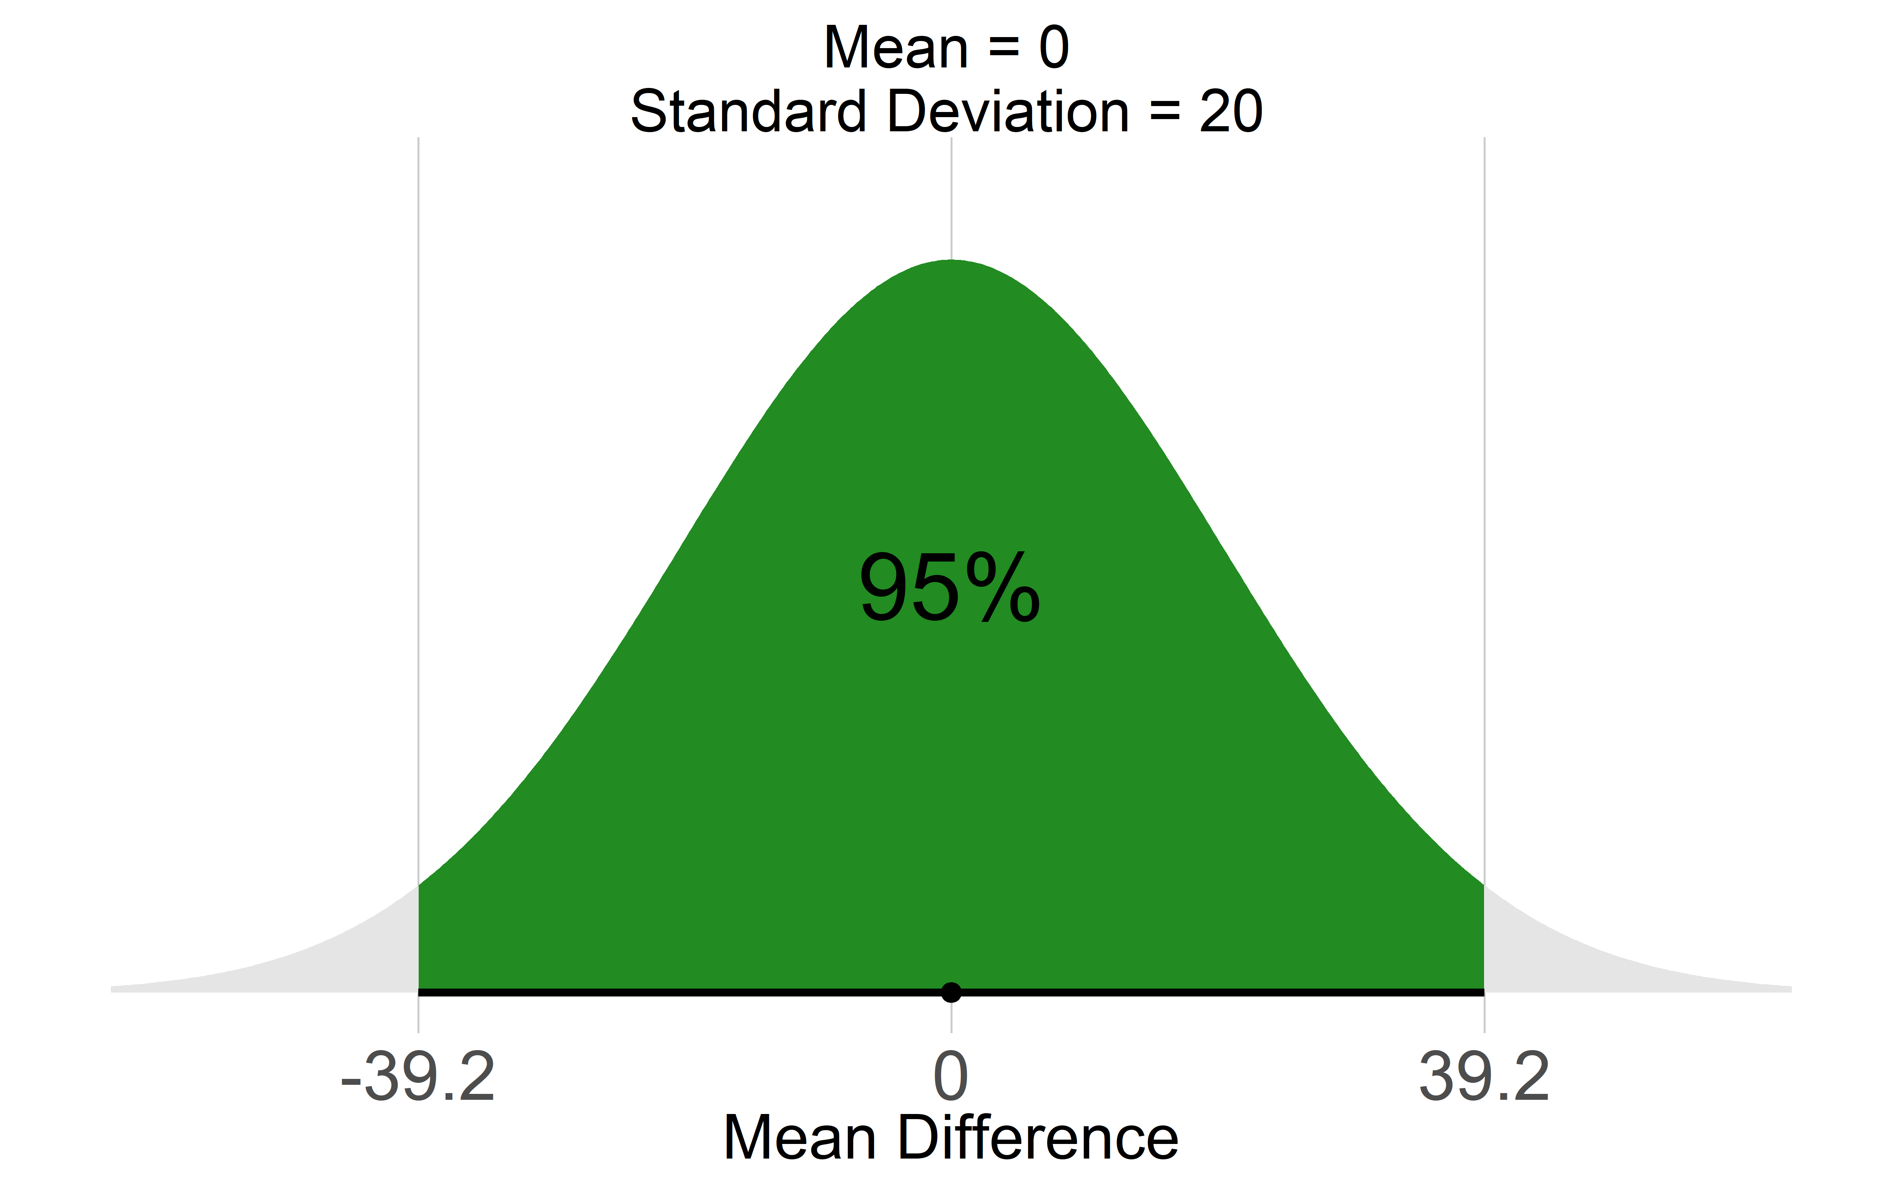

eTable2. Details of all outcome showing prior distributions used in Bayesian Meta-Analysis.

Outcome | Effect Size | Prior Type for Mu¹ | Mu Prior Distribution^{1,2} | Beta (Subgroup diff) | Prior Type for Tau³ | Tau Prior Distribution^{3,4}
LVEF | Mean Difference | Vague | Normal (0 , 50²) | Normal (0,20²) | Weakly-Informative | Half-Normal (5.21)
LVESV | Mean Difference | Vague | Normal (0 , 50²) | Normal (0,20²)
LVEDV | Mean Difference | Vague | Normal (0 , 50²) | Normal (0,20²) | Weakly-Informative | Half-Normal (20)
NYHA Class | Standardized Mean Difference | Vague | Normal (0 , 50²) | Normal (0,20²) | Weakly-Informative | Half-Normal (5.21)
Procedure Time | Mean Difference | Vague | Normal (0 , 100²) | Normal (0,20²) | Weakly-Informative | Half-Normal (5.21)
Fluoroscopy Time | Mean Difference | Vague | Normal (0 , 50²) | - | Weakly-Informative | Half-Normal (5.21)
Peri-procedural complications | Odd ratio | Weakly-Informative | Normal (0 , 0.82²) | - | Turner priors | Log-normal (-0.845, 0.84),
Lead Revisions/Displacement | Odd ratio | Weakly-Informative | Normal (0 , 0.82²) | - | Turner priors | Log normal (-0.845, 0.84),

¹ Mu = Overall Effect Parameter
² Normal (mean, standard deviation)
³ Tau = Between-Study Standard Deviation Parameter
⁴ Log-Normal (log-mean, sd); Half-Normal (scale)

eMethods 3. Calculation of Absolute Risk Differences
Although the primary treatment effect was estimated as an odds ratio (OR), absolute treatment effects are generally more informative for clinical decision-making. Therefore, posterior estimates of the pooled OR were translated into absolute risk differences (RDs) using the relationship between odds ratios and event probabilities.
For an assumed baseline event risk in the control (BiVP) group, $R_{C}$, the corresponding event risk in the treatment (CSP) group, $R_{T}$, was calculated as
$$R_{T}=\frac{OR×R_{C}}{1-R_{C}+OR×R_{C}},$$
where $OR$denotes the posterior odds ratio, $R_{C}$is the assumed control-group risk, and $R_{T}$is the estimated treatment-group risk.
The absolute treatment effect was then expressed as the risk difference,
$$RD=R_{C}-R_{T}.$$
Positive values indicate an absolute reduction in event risk with conduction system pacing (CSP), whereas negative values indicate an increased risk compared with biventricular pacing (BiVP).
Because the magnitude of the RD depends on the underlying baseline risk, calculations were performed over a clinically plausible range of control-group event risks. For each value of $R_{C}$, every posterior sample of the pooled odds ratio was transformed into the corresponding treatment risk using the equation above. This generated a posterior distribution of the absolute risk difference for each baseline risk, from which posterior medians, 95% credible intervals, and posterior probabilities of clinically meaningful benefit were calculated.
For the primary analyses, the baseline risks used for all-cause mortality and heart failure hospitalization were based on the observed event rates in the control groups of the included randomized controlled trials. Posterior probabilities of benefit were subsequently calculated directly from the posterior RD distributions.

Equations
Treatment risk:
$$R_{T}=\frac{OR×R_{C}}{1-R_{C}+OR×R_{C}}$$
Risk difference:
$$RD=R_{C}-R_{T}$$

eTable 3 Characteristics of the included studies

Study ID | year | Country | Name/NCT  Number | Study Design | Strauss  Criteria | Sample size  (CSP/BiVP) | Follow-up duration
Lustgarten, D.L et al. | 2015 | USA | - | Crossover | No | 29 | 6 mon and then crossed over to other intervention for 6 mon
Upadhyay G.A et al. | 2019 | USA | His-SYNC | RCT | Yes | 41 | 12.2 mon
Vinther M et al. | 2021 | Denmark | His Alternative | RCT | Yes | 50 | 6 Months
Huang W et al. | 2022 | China , Multicentre | ALTERNATIVE AF | Crossover | No | 50 | 9 months and then crossover to alternate intervention for 9 months.
Pujol-Lopez et al. | 2022 | Spain | Randomized, parallel, controlled, noninferiority trial | RCT. | Yes | 70 (35/35) | 6 months
Wang et al. | 2022 | China | Randomized, Control Trial | RCT | No | 40 (20/20) | 6 months
Vijayaraman et al. | 2023 | USA | HOT-CRT | RCT | No | 100 (50/50) | 6 months
Zimerman A et al. | 2026 | Brazil | Physio Sync HF | RCT | Yes | 173 (86/87) | 12 months
Cano Ó et al. | 2026 | Spain | LEFT-BUNDLE-CRT | RCT | Yes | 175(92/83) | 12 months
Pujol-López M et al. | 2025 | Spain | LEVEL AT | RCT. | Yes | 134 (67/67) | 12 months
Žižek D et al. | 2025 | Slovenia | CSP-SYNC | RCT | Yes | 62 (31/31) | 12 months
Chen et al. | 2026 | China | Heart Sync LBBP | RCT | No | 200 (100 / 100) | 36 months (median)
Frandsen et al. | 2026 | Denmark | His Alternative I | RCT | Yes | 50 (25/25) | 5.3 years
Zhang et al. | 2025 | China | - | _RCT | No | 39/35 | 6 months

eTable 4: Secondary and Procedural Outcomes Posterior distribution and Probabilties

Outcome | Effect Size | Median / Mean  (95% Credible Interval) | Tau  (95% Credible Interval) | 95% Prediction Interval | Median, RD (95% CrI) | Probability of Benefit (%)
All-cause mortality | Odd ratio | 0.63 (0.33, 1.13) | 0.28 (0.06, 0.78) | 0.28, 1.45 | 3.2% (−0.7%, 6.7%) | 94%
Heart Failure Hospitalization | Odd ratio | 0.74 (0.41, 1.36) | 0.56 (0.09, 1.22) | 0.21, 2.61 | 3% (−3.4%, 8.9%), | 84%
QRS duration (ms)¹ | Mean difference | -14.4 (-22.5, -5.8) | 11 (6.15, 17.57) | -42.8, 14.3 | - | 99.9%
LVEF (%) | Mean difference | 3.8 (0.2, 7.7) | 6.2 (3.9, 9.12) | -9.48, 16.9 | - | 98%
LVESV (ml)¹ | Mean difference | -6.23 (-11.30, -1.15) | 4.99 (1, 9.59) | -19.6, 7.01 | - | 99.1%
LVEDV (ml)¹ | Mean difference | -7.4 (-15.4, 1.13) | 8.41 (3.3, 16.6) | -28.7, 16.2 | - | 96%
NYHA class¹ | Mean difference | -0.19 (-0.37, -0.02) | 0.2 (0, 0.44) | -0.68, 0.27 | - | 98%
Procedural complications³ | Odds ratio | 0.68 (0.41, 1.11) | 0.35 (0.1, 0.88) | - | - | 93%
Lead revision/displacement³ | Odds ratio | 1.01 (0.52, 1.96) | 0.34 (0.07, 0.91) | - | - | 50%
Procedure Time¹ | Mean difference | 7.3 (0.1, 14.7) | 7.02 (0, 13.1) | - | - | 6%
Fluoroscopy time¹ | Mean difference | 0.33 (-3.75, 4.47) | 4.84 (2.31, 8.33) | - | - | 42%
-

¹Posterior Probability that treatment effect favoured Conduction System Pacing. (MD < 1)
² Posterior Probability that treatment effect favoured Conduction System Pacing. (MD > 0)
³Posterior Probability that treatment effect favoured Conduction System Pacing. (OR < 1)

eTable 5. Posterior subgroup estimates for Secondary outcomes comparing conduction system pacing with biventricular pacing. Posterior mean differences (MDs) with 95% credible intervals (CrIs) are shown for the overall analysis and prespecified subgroups according to conduction system pacing modality (His bundle pacing [HBP] and left bundle branch area pacing [LBAP]).

Outcome | Subgroup | Effect Size | Posterior MD (95% CrI) | Probability of Benefit %¹
QRS Duration | Overall | Mean Difference | -14.4 (-22.5, -6) | 99.9%
QRS Duration | HBP | Mean Difference | -24 (-37, -12) | 99.9%
QRS Duration | LBBAP | Mean Difference | -10.4 (-19, -2) | 98.9%
LVEF | Overall | Mean Difference | 4 (0.2, 7.7) | 98%²
LVEF | HBP | Mean Difference | 2.3 (-4.4, 9.2) | 75.0%
LVEF | LBBAP | Mean Difference | 4.4 (-0.3, 8.7) | 97.2%
LVESV | Overall | Mean Difference | -6.2 (-11.3, -1.2) | 99.1%
LVESV | HBP | Mean Difference | -2.2 (-11.4, 6.2) | 70.3%
LVESV | LBBAP | Mean Difference | -8 (-13.6, -2.5) | 99.6%
LVEDV | Overall | Mean Difference | -7.4 (-15.4, 1.1) | 96%
LVEDV | HBP | Mean Difference | -4.6 (-19.3, 10.4) | 74.2%
LVEDV | LBBAP | Mean Difference | -8.4 (-17.7, 1.6) | 95.5%
NYHA Class | Overall | Mean Difference | -0.19 (-0.4, -0.02) | 98%
NYHA Class | HBP | Mean Difference | -0.07 (-0.4, 0.3) | 68.0%
NYHA Class | LBBAP | Mean Difference | -0.24 (-0.5, -0.03) | 98.2%
¹ Posterior probabilities of benefit represent the probability that conduction system pacing improved each outcome relative to biventricular pacing (MD < 0 for QRS duration, LVESV, LVEDV, and NYHA class; MD > 0 for LVEF).
Abbreviations: CrI: Credible Interval; MD: Mean Difference; LVEF: Left Ventricular Ejection Fraction; LVEDV: Left Ventricular End-Diastolic Volume; LVESV: Left Ventricular End-Systolic Volume; NYHA: New-York Heart Association.

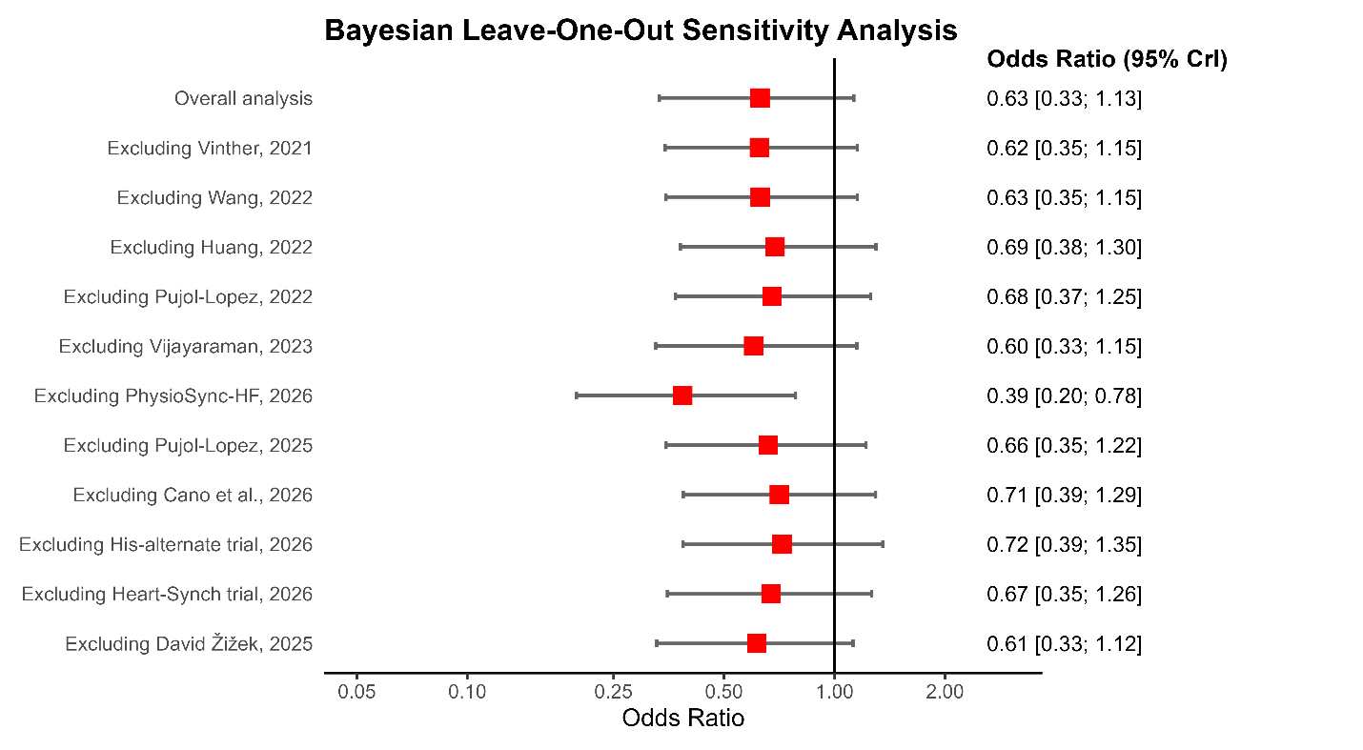
eFigure07. Leave-one-out sensitivity analysis of “All-cause mortality”, showing the effect of excluding individual studies on the pooled estimate.

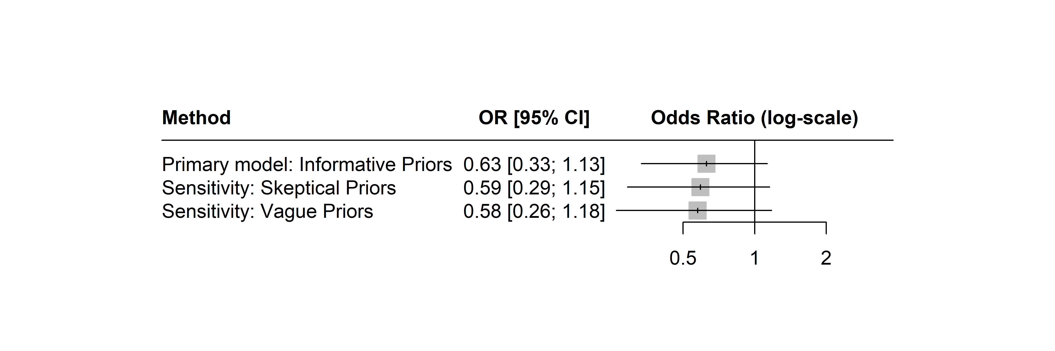
eFigure8. Sensitivity analysis of “All-cause mortality”, showing the effect of different prior distributions for tau Posterior Distributions.

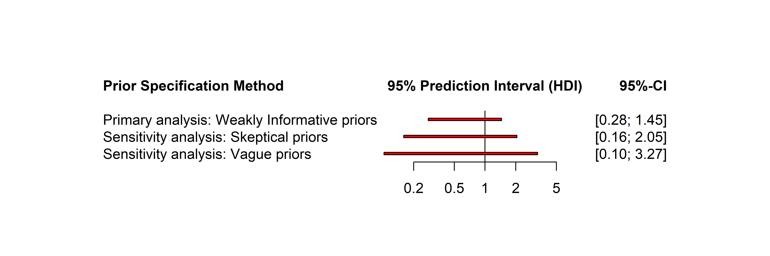eFigure09. Sensitivity analysis of “All-cause mortality”, showing the effect of different prior distributions for tau Predictive intervals.

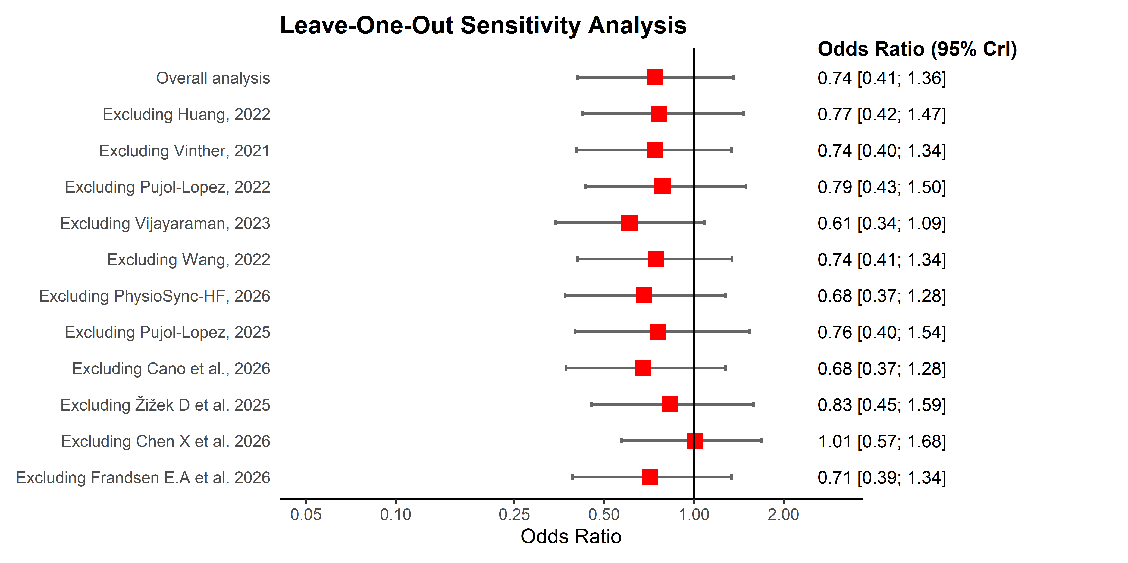
eFigure10. Leave-one-out sensitivity analysis of “Heart failure Hospitalization”, showing the effect of excluding individual studies on the pooled estimate.

Prior distribution for treatment effect in QRS
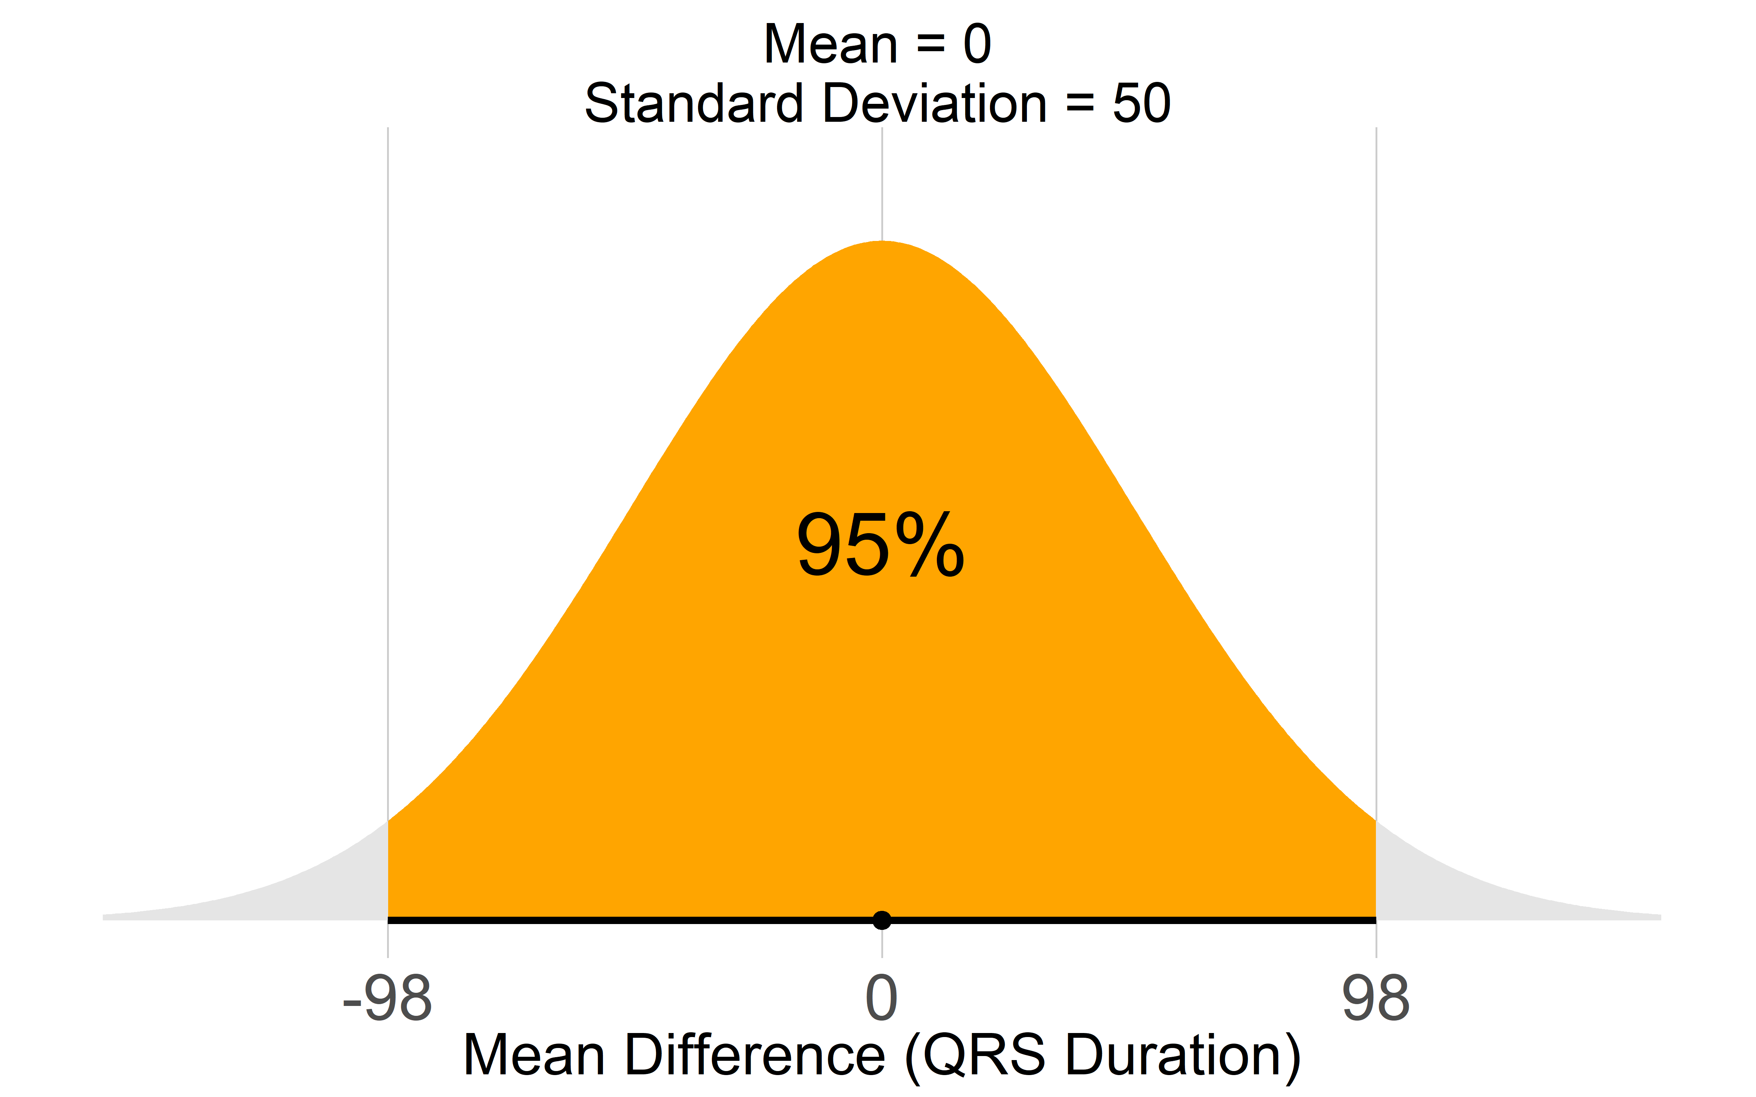

To calibrate this prior, we elicited a treatment effect size of 13.34 ms based on the observed range of effects from a previuos meta. Assuming that this value represents the 97.5th percentile of the distribution of true study-level effects, we first converted it to the corresponding heterogeneity scale and then derived the scale parameter of the half-normal prior using a standard two-stage normal calibration approach.

Prior distribution for heterogeneity (τ) QRS informative
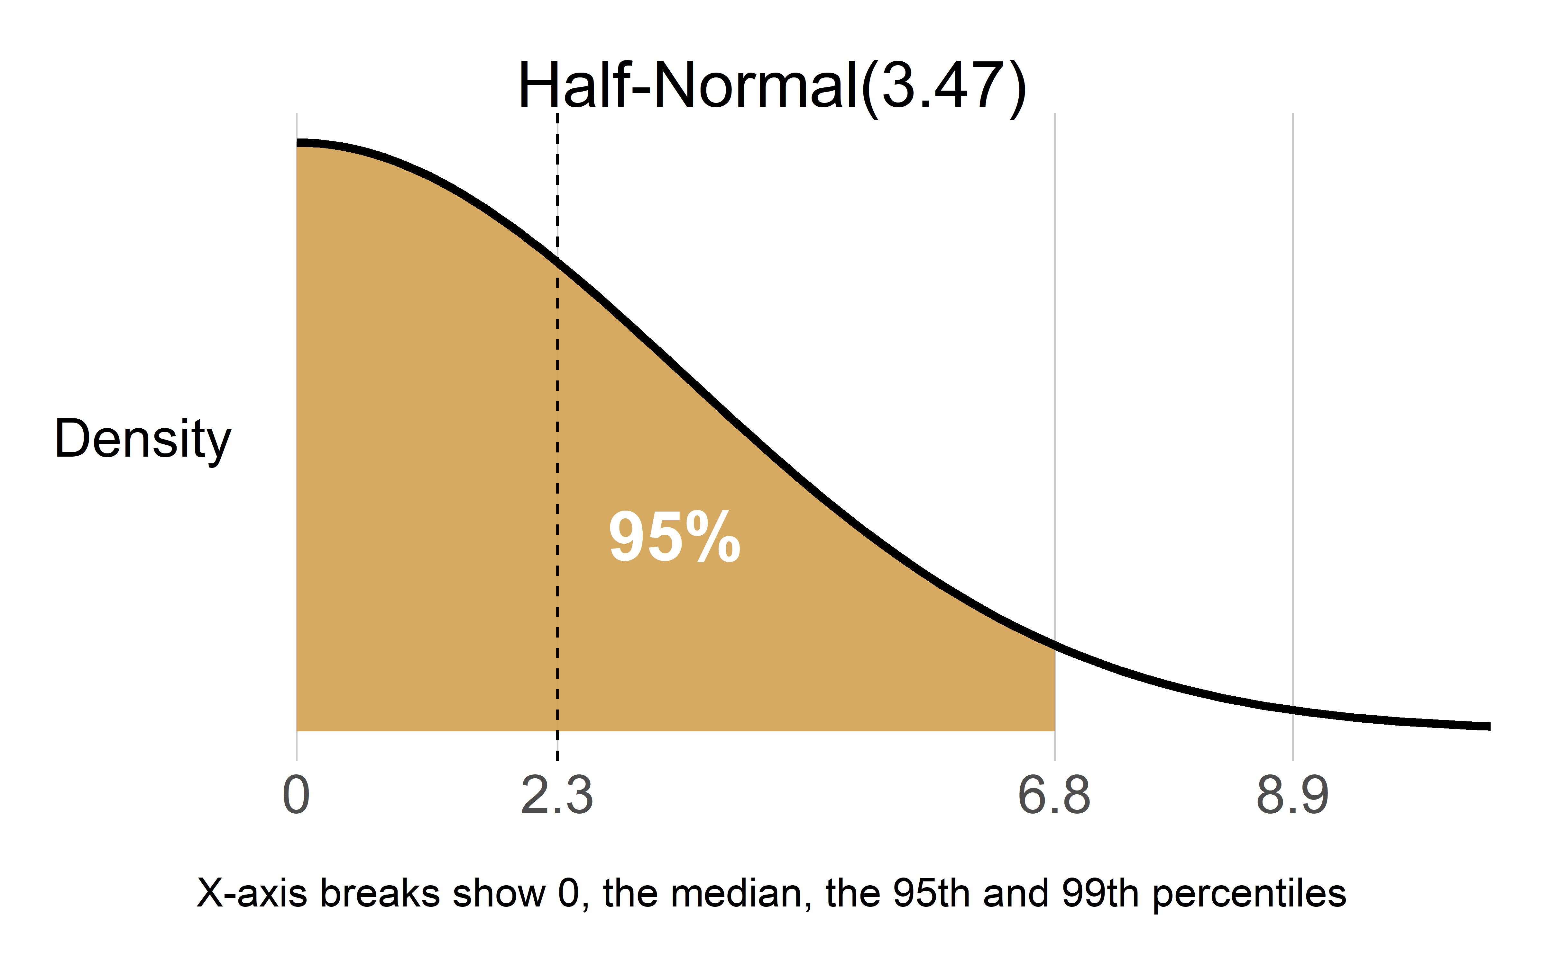

Prior distribution for heterogeneity (τ) QRS weakly informative

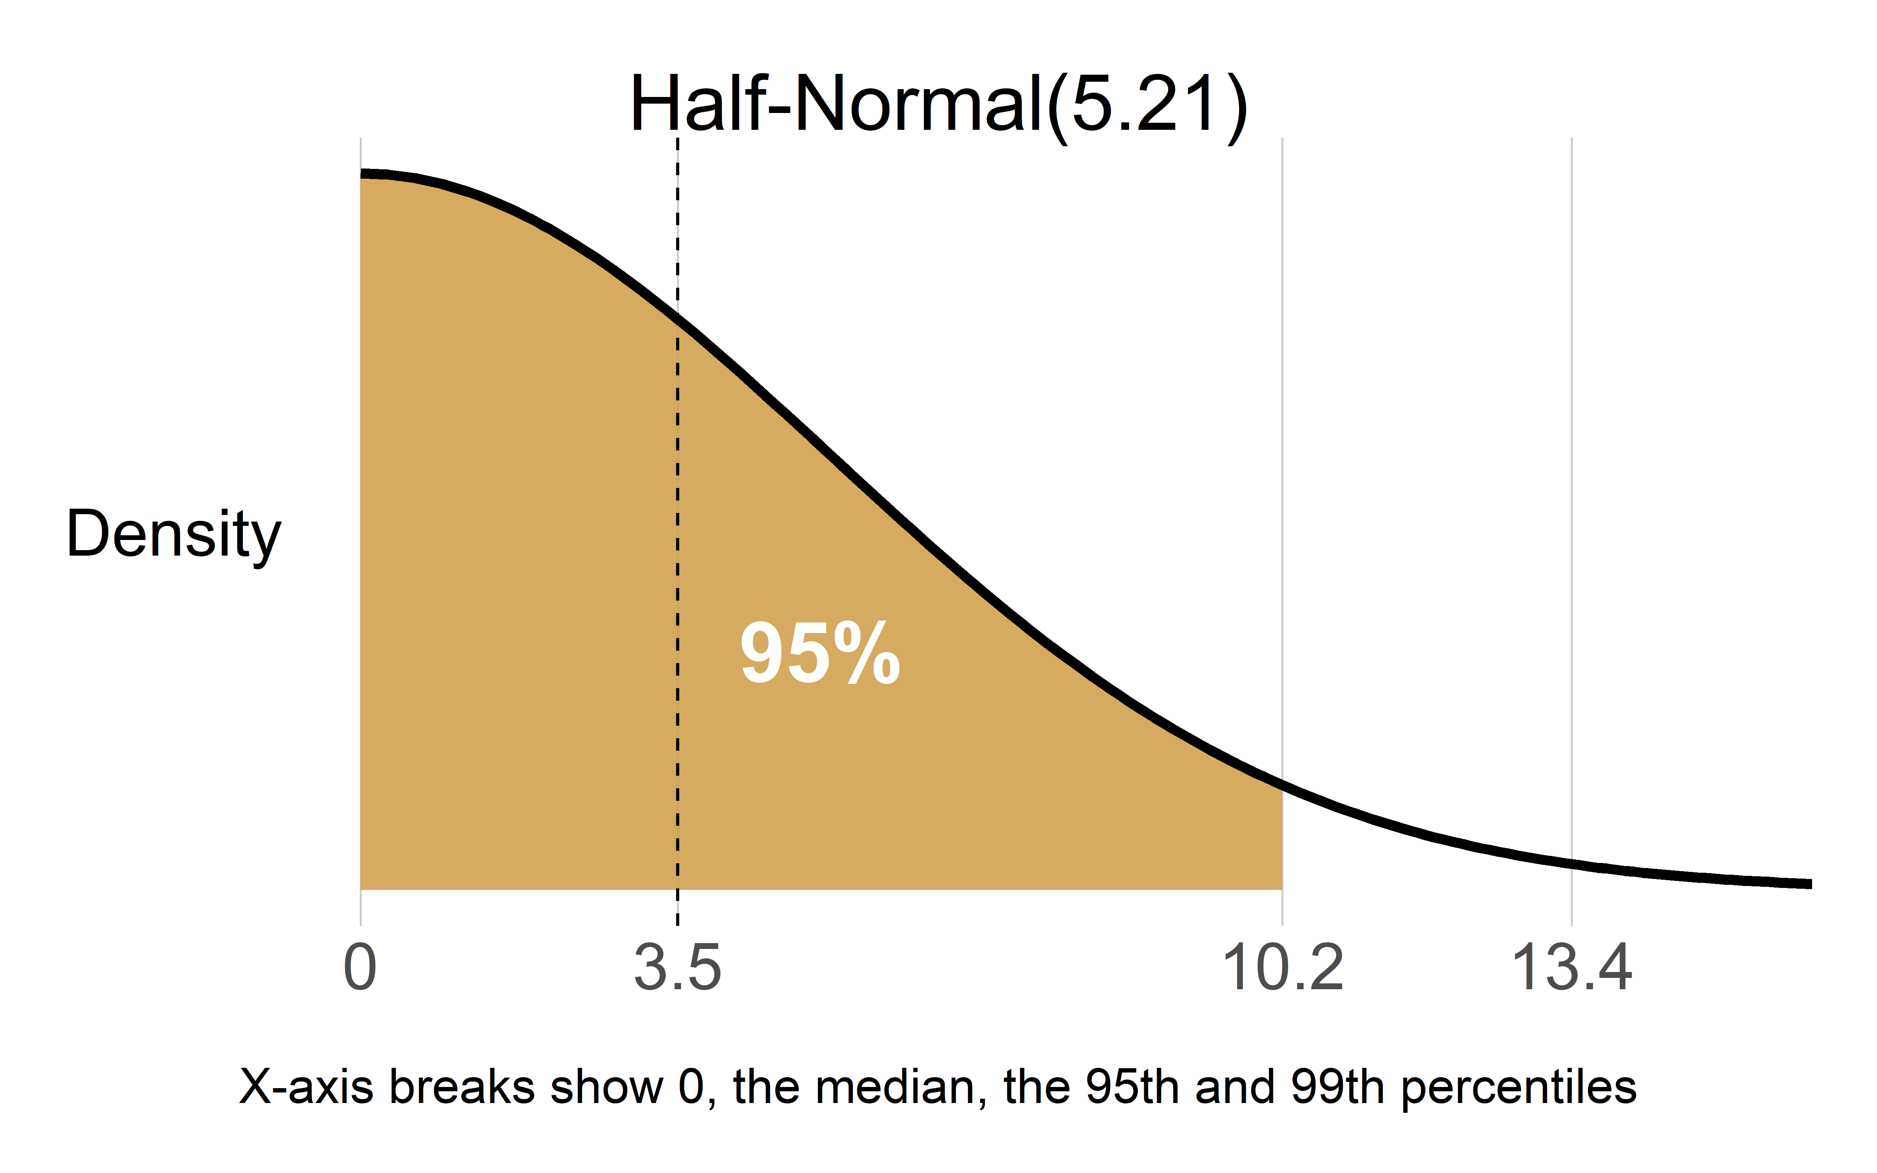

Prior distribution for heterogeneity (τ) QRS Vague

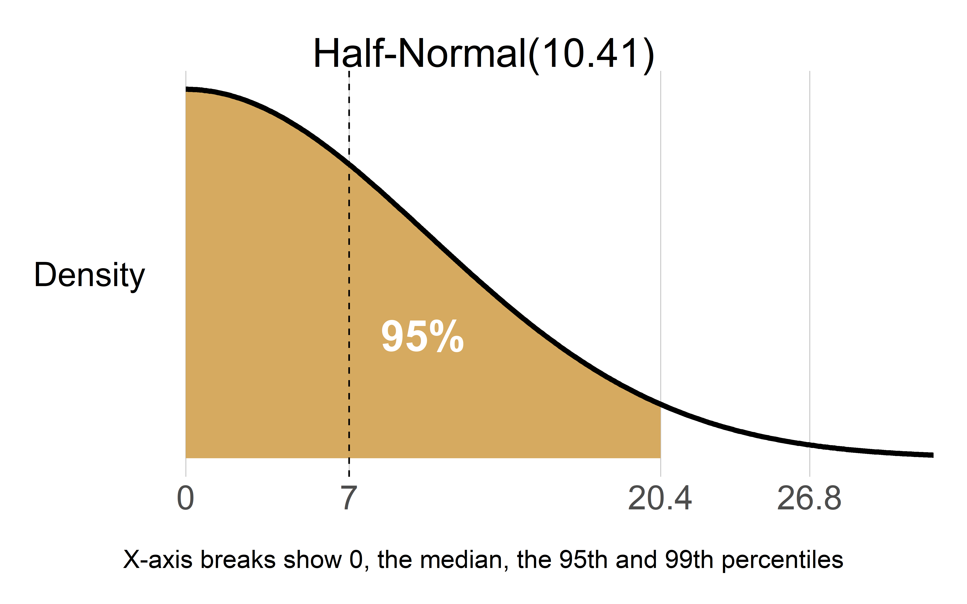

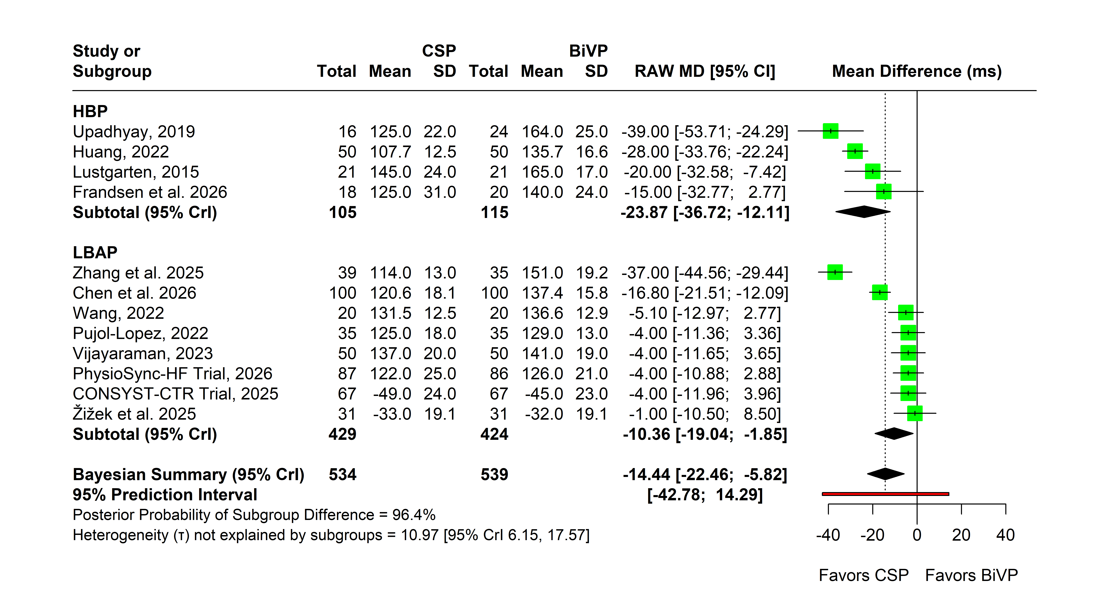
eFigure11. Forest plot of the Bayesian random-effects meta-analysis of QRS narrowing. Vague priors were specified as μ ~ N(0, 50²) for the overall treatment effect and weakly informative prior τ ~ Half-Normal(3.47) for the between-study standard deviation. Posterior study-specific and pooled mean differences (MDs) with corresponding 95% credible intervals (CrIs) are presented.
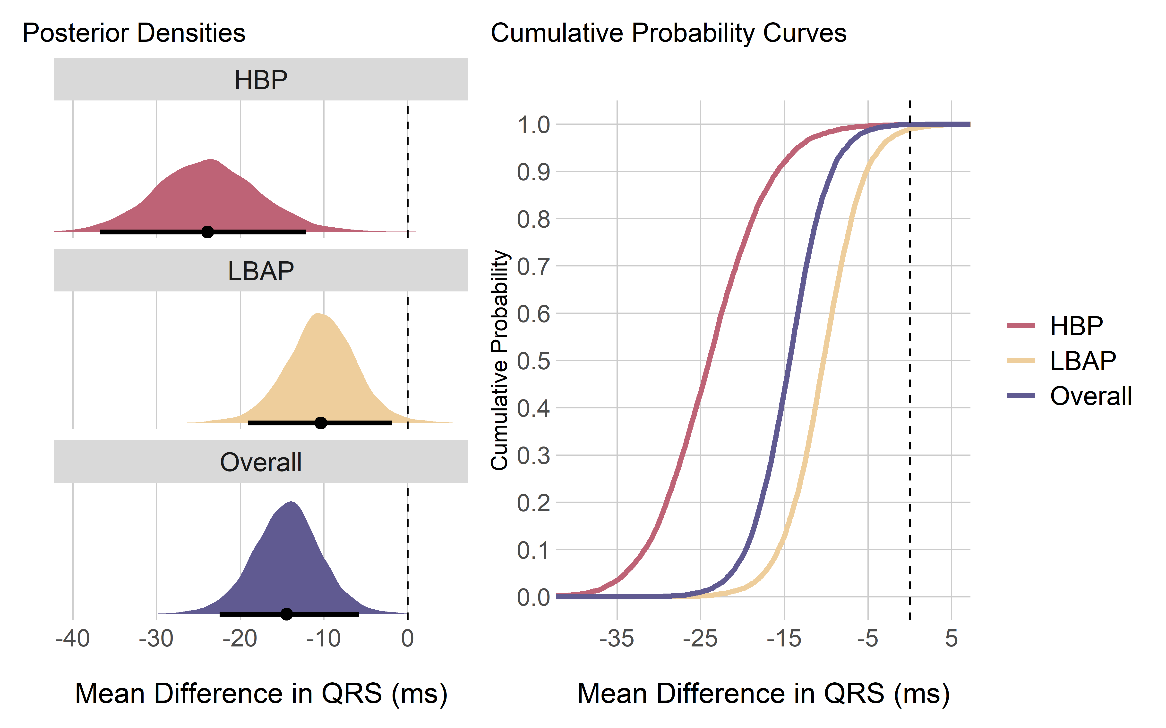
eFigure12. Posterior probability (PP) distribution densities and cumulative PP curves for “QRS”.

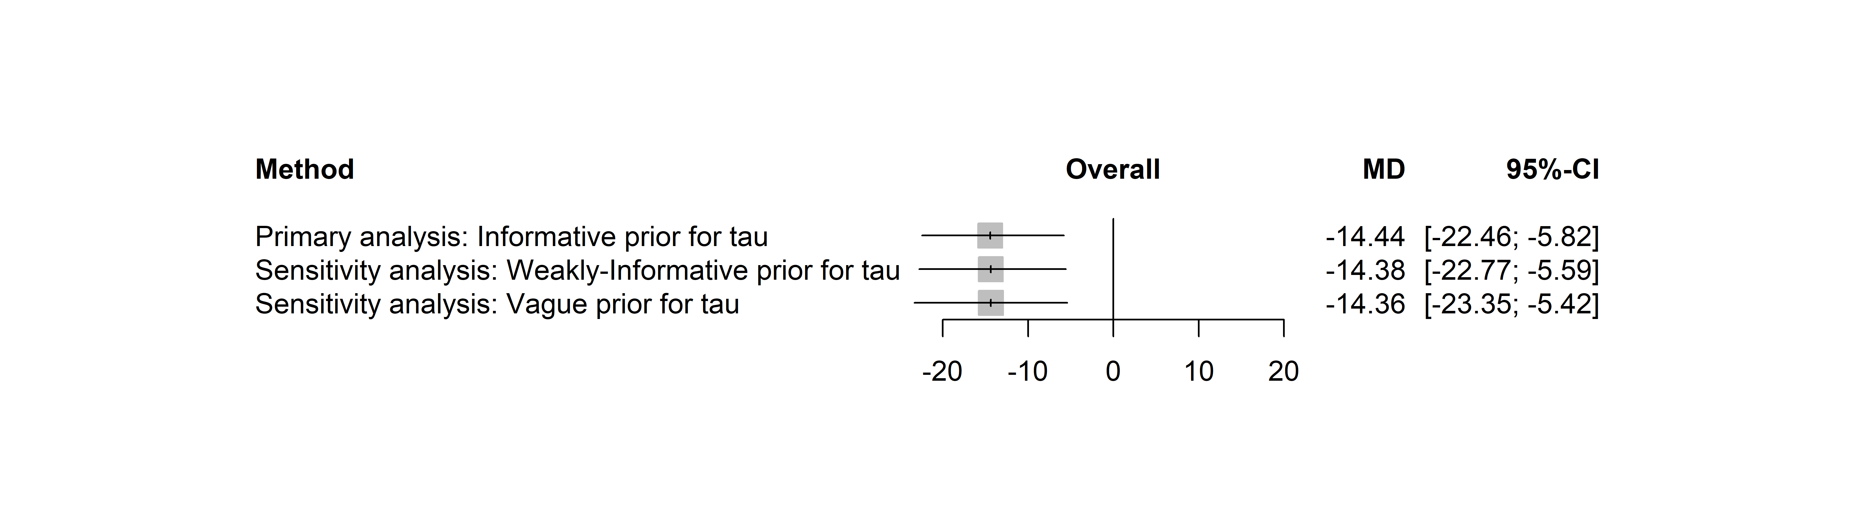
eFigure13. Sensitivity analysis plot for “QRS” showing pooled effect overall.

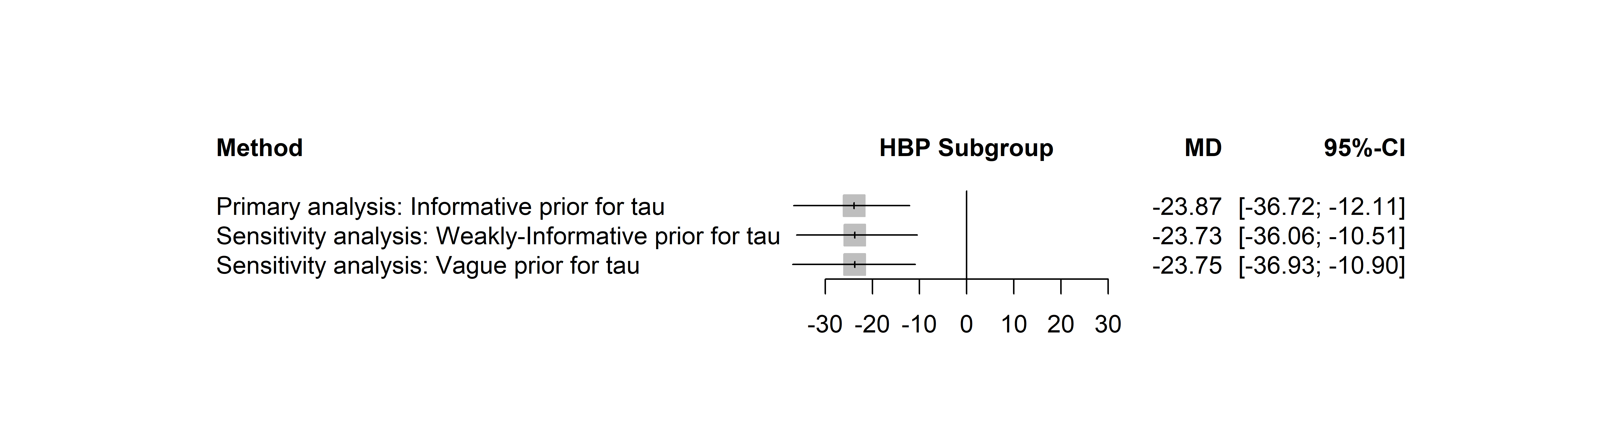
eFigure14. Sensitivity analysis plot for “QRS” showing pooled effect in “HBP subgroup”.

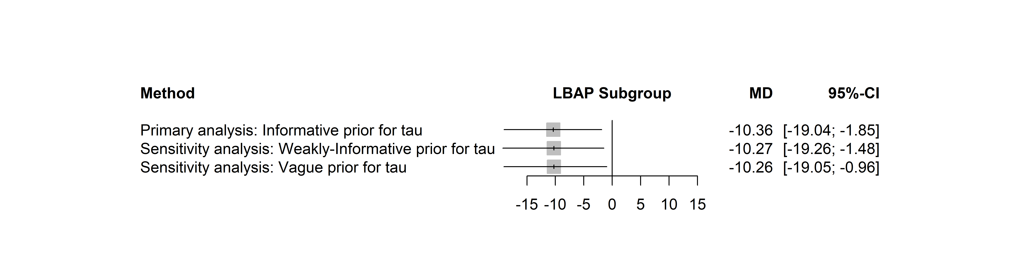
eFigure15. Sensitivity analysis plot for “QRS” showing pooled effect in “LBAP subgroup”

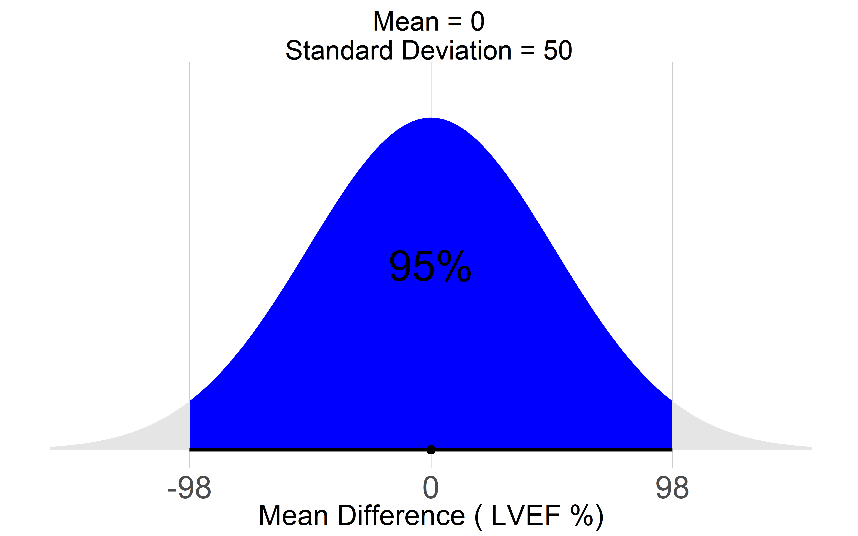
LVEF Prior distribution for treatment effect

Prior distribution for heterogeneity (τ) LVEF weakly informative

eFigure16. Forest plot of the Bayesian random-effects meta-analysis of LVEF. Vague priors were specified as μ ~ N(0, 50²) for the overall treatment effect and weakly informative prior τ ~ Half-Normal(5.21) for the between-study standard deviation. Posterior study-specific and pooled mean differences (MDs) with corresponding 95% credible intervals (CrIs) are presented.

eFigure17. Posterior probability (PP) distribution densities and cumulative PP curves for “LVEF”.

LVESV — Prior distribution for treatment effect

Prior distribution for heterogeneity (τ) LVESV weakly informative

eFigure18. Forest plot of the Bayesian random-effects meta-analysis of LVESV. Vague priors were specified as μ ~ N(0, 50²) for the overall treatment effect and weakly informative prior τ ~ Half-Normal(5.21) for the between-study standard deviation. Posterior study-specific and pooled mean differences (MDs) with corresponding 95% credible intervals (CrIs) are presented.

eFigure19. Prior distribution for between-study heterogeneity (τ) in “LVEDV”.

LVEDV Prior distribution for treatment effect

Prior distribution for heterogeneity (τ) LVEDV weakly informative

eFigure20. Forest plot of the Bayesian random-effects meta-analysis of LVEDV. Vague priors were specified as μ ~ N(0, 50²) for the overall treatment effect and weakly informative prior τ ~ Half-Normal(5.21) for the between-study standard deviation. Posterior study-specific and pooled mean differences (MDs) with corresponding 95% credible intervals (CrIs) are presented

eFigure21. Posterior probability (PP) distribution densities and cumulative PP curves for “LVEDV”.

NYHA — Prior distribution for treatment effect

Prior distribution for heterogeneity (τ) NYHA weakly informative

eFigure22. Forest plot of the Bayesian random-effects meta-analysis of NYHA class. Vague priors were specified as μ ~ N(0, 50²) for the overall treatment effect and weakly informative prior τ ~ Half-Normal(5.21) for the between-study standard deviation. Posterior study-specific and pooled mean differences (MDs) with corresponding 95% credible intervals (CrIs) are presented.

eFigure23. NYHA class — posterior probability (PP) distribution and cumulative PP curve

eFigure24. Forest plot detailing pooled estimates and variability in “Procedure Time” across studies.

eFigure25. Forest plot detailing pooled estimates and variability in “Fluoroscopy Time” across studies.

eFigure26. Forest plot representation of pooled estimates and variability in “Peri-procedural Complications” across studies.

eFigure27. Forest plot representation of pooled estimates and variability in “Lead Revision/displacement Complications” across studies.

eFigure28: Traffic light plot: Risk of Bias Assessment with RoB2 Tool
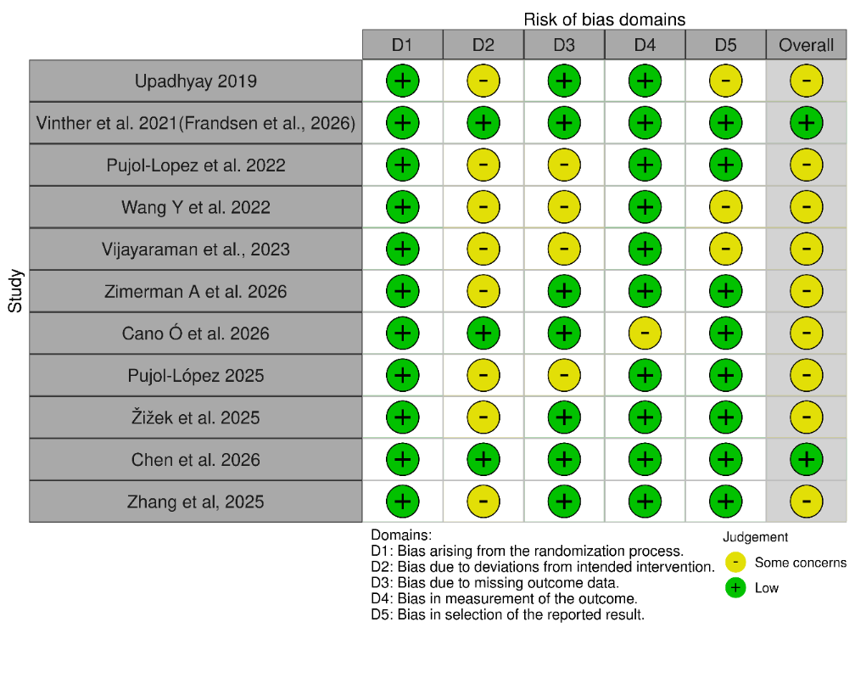

eFigure29: Summary plot: Risk of Bias Assessment with RoB2 Tool

eTable6 Rob 2 for Cross over trials

No | Study | Bias from randomization process | Bias arising from period and carryover effects | Bias due to deviations from intended interventions | Bias due to missing outcome data | Bias in measurement of the outcomes | Bias in selection of the reported result | Overall risk of bias
1 | Lustgarten et al. | Low | Some concerns | Some concerns | Low | Some concerns | Low | Some concerns
2 | Huang et al. | Low | Some concerns | Some concerns | Some concern | Low | Some concerns | Some concerns

eTable7 GRADE assessment of the certainty of evidence for the primary and secondary outcomes comparing conduction system pacing with biventricular pacing.

Certainty assessment |  |  |  |  |  |  | № of patients |  | Effect |  | Certainty
№ of studies | Study design | Risk of bias | Inconsistency | Indirectness | Imprecision | Other considerations | Conduction System Pacing | Biventricular Pacing | Relative  (95% CI) | Absolute  (95% CI) | Certainty
All-cause mortality
10 | randomised trials | not serious | not serious | not serious | serious | none | 19/521 (3.6%) | 31/519 (6.0%) | OR 0.63  (0.34 to 1.13) | 21 fewer per 1,000  (from 39 fewer to 7 more) | ⨁⨁◯◯  Low
Heart Failure Hospitalization
11 | randomised trials | not serious | not serious | not serious | serious | none | 39/555 (7.0%) | 61/572 (10.7%) | OR 0.74  (0.42 to 1.36) | 24 fewer per 1,000  (from 59 fewer to 33 more) | ⨁⨁◯◯  Low
QRS narrowing
12 | randomised trials | not serious | not serious | not serious | not serious | none | 534 | 539 | - | MD -14.44 lower  (22.46 lower to 5.82 lower) | ⨁⨁⨁◯  Moderate
LVEF improvement
13 | randomised trials | not serious | not serious | not serious | serious | none | 587 | 577 | - | MD 3.84 higher  (0.16 higher to 7.66 higher) | ⨁⨁⨁◯  Moderate
LVESV
11 | randomised trials | not serious | not serious | not serious | serious | none | 549 | 538 | - | MD 6.23 lower  (11.3 lower to 1.15 lower) | ⨁⨁⨁◯  Moderate
LVEDV
9 | randomised trials | not serious | not serious | not serious | serious | none | 432 | 426 | - | MD 7.44 lower  (15.4 lower to 1.13 higher) | ⨁⨁⨁◯  Moderate
NYHA class
9 | randomised trials | not serious | not serious | not serious | serious | none | 423 | 418 | - | MD -0.19 lower  (-0.37 lower to 0.02 lower) | ⨁⨁⨁◯  Moderate
Procedure Time
10 | randomised trials | not serious | not serious | not serious | not serious | none | 538 | 516 | - | MD 7.29 higher  (0.06 higher to 14.75 higher) | ⨁◯◯◯  Very Low
Fluoroscopy Time
8 | randomised trials | not serious | not serious | not serious | serious | none | 483 | 477 | - | MD 0.33 higher  (3.75 lower to 4.47 higher) | ⨁◯◯◯  Very Low
Peri-procedural Complications
11 | randomised trials | not serious | not serious | not serious | serious | none | 39/536 (7.3%) | 60/555 (10.8%) | OR 0.68  (0.41 to 1.11) | 32 fewer per 1,000  (from 61 fewer to 10 more) | ⨁◯◯◯  Very Low
Lead Revision/displacement Complications
10 | randomised trials | not serious | not serious | not serious | serious | none | 18/454 (4.0%) | 18/461 (3.9%) | OR 1.01  (0.52 to 1.96) | 0 fewer per 1,000  (from 18 fewer to 35 more) | ⨁◯◯◯  Very Low

References
1. Turner RM, Jackson D, Wei Y, Thompson SG, Higgins JPT. Predictive distributions for between-study heterogeneity and simple methods for their application in Bayesian meta-analysis. Stat Med. 2015;34(6):984–998.
2. Röver C, Bender R, Dias S, Schmid CH, Schmidli H, Sturtz S, Weber S, Friede T. On weakly informative prior distributions for the heterogeneity parameter in Bayesian random-effects meta-analysis. Res Synth Methods. 2021;12(4):448–474.
3. Röver C. Bayesian random-effects meta-analysis using the bayesmeta R package. J Stat Softw. 2020;93(6):1–51.
4. Spiegelhalter DJ, Abrams KR, Myles JP. Bayesian Approaches to Clinical Trials and Health-Care Evaluation. Chichester: John Wiley & Sons; 2004.
5. Carpenter B, Gelman A, Hoffman MD, Lee D, Goodrich B, Betancourt M, Brubaker M, Guo J, Li P, Riddell A. Stan: A probabilistic programming language. J Stat Softw. 2017;76(1):1–32.
6. Bürkner PC. brms: An R package for Bayesian multilevel models using Stan. J Stat Softw. 2017;80(1):1–28.
7. Page MJ, McKenzie JE, Bossuyt PM, Boutron I, Hoffmann TC, Mulrow CD, et al. The PRISMA 2020 statement: an updated guideline for reporting systematic reviews. BMJ. 2021;372:n71.
8. Higgins JPT, Thompson SG. Quantifying heterogeneity in a meta-analysis. Stat Med. 2002;21(11):1539–1558.

