Supplementary Fig. 1. ENG KO reduces the motility of patient-derived CAFs. Representative time-lapse images of Cas9-only control and patient-derived ENG-KO CAFs from Pt.3 and Pt.5 over 120 min. Yellow arrows and dotted lines indicate cell movement trajectories. Images were acquired at 10-min intervals. Scale bars, 10 μm.
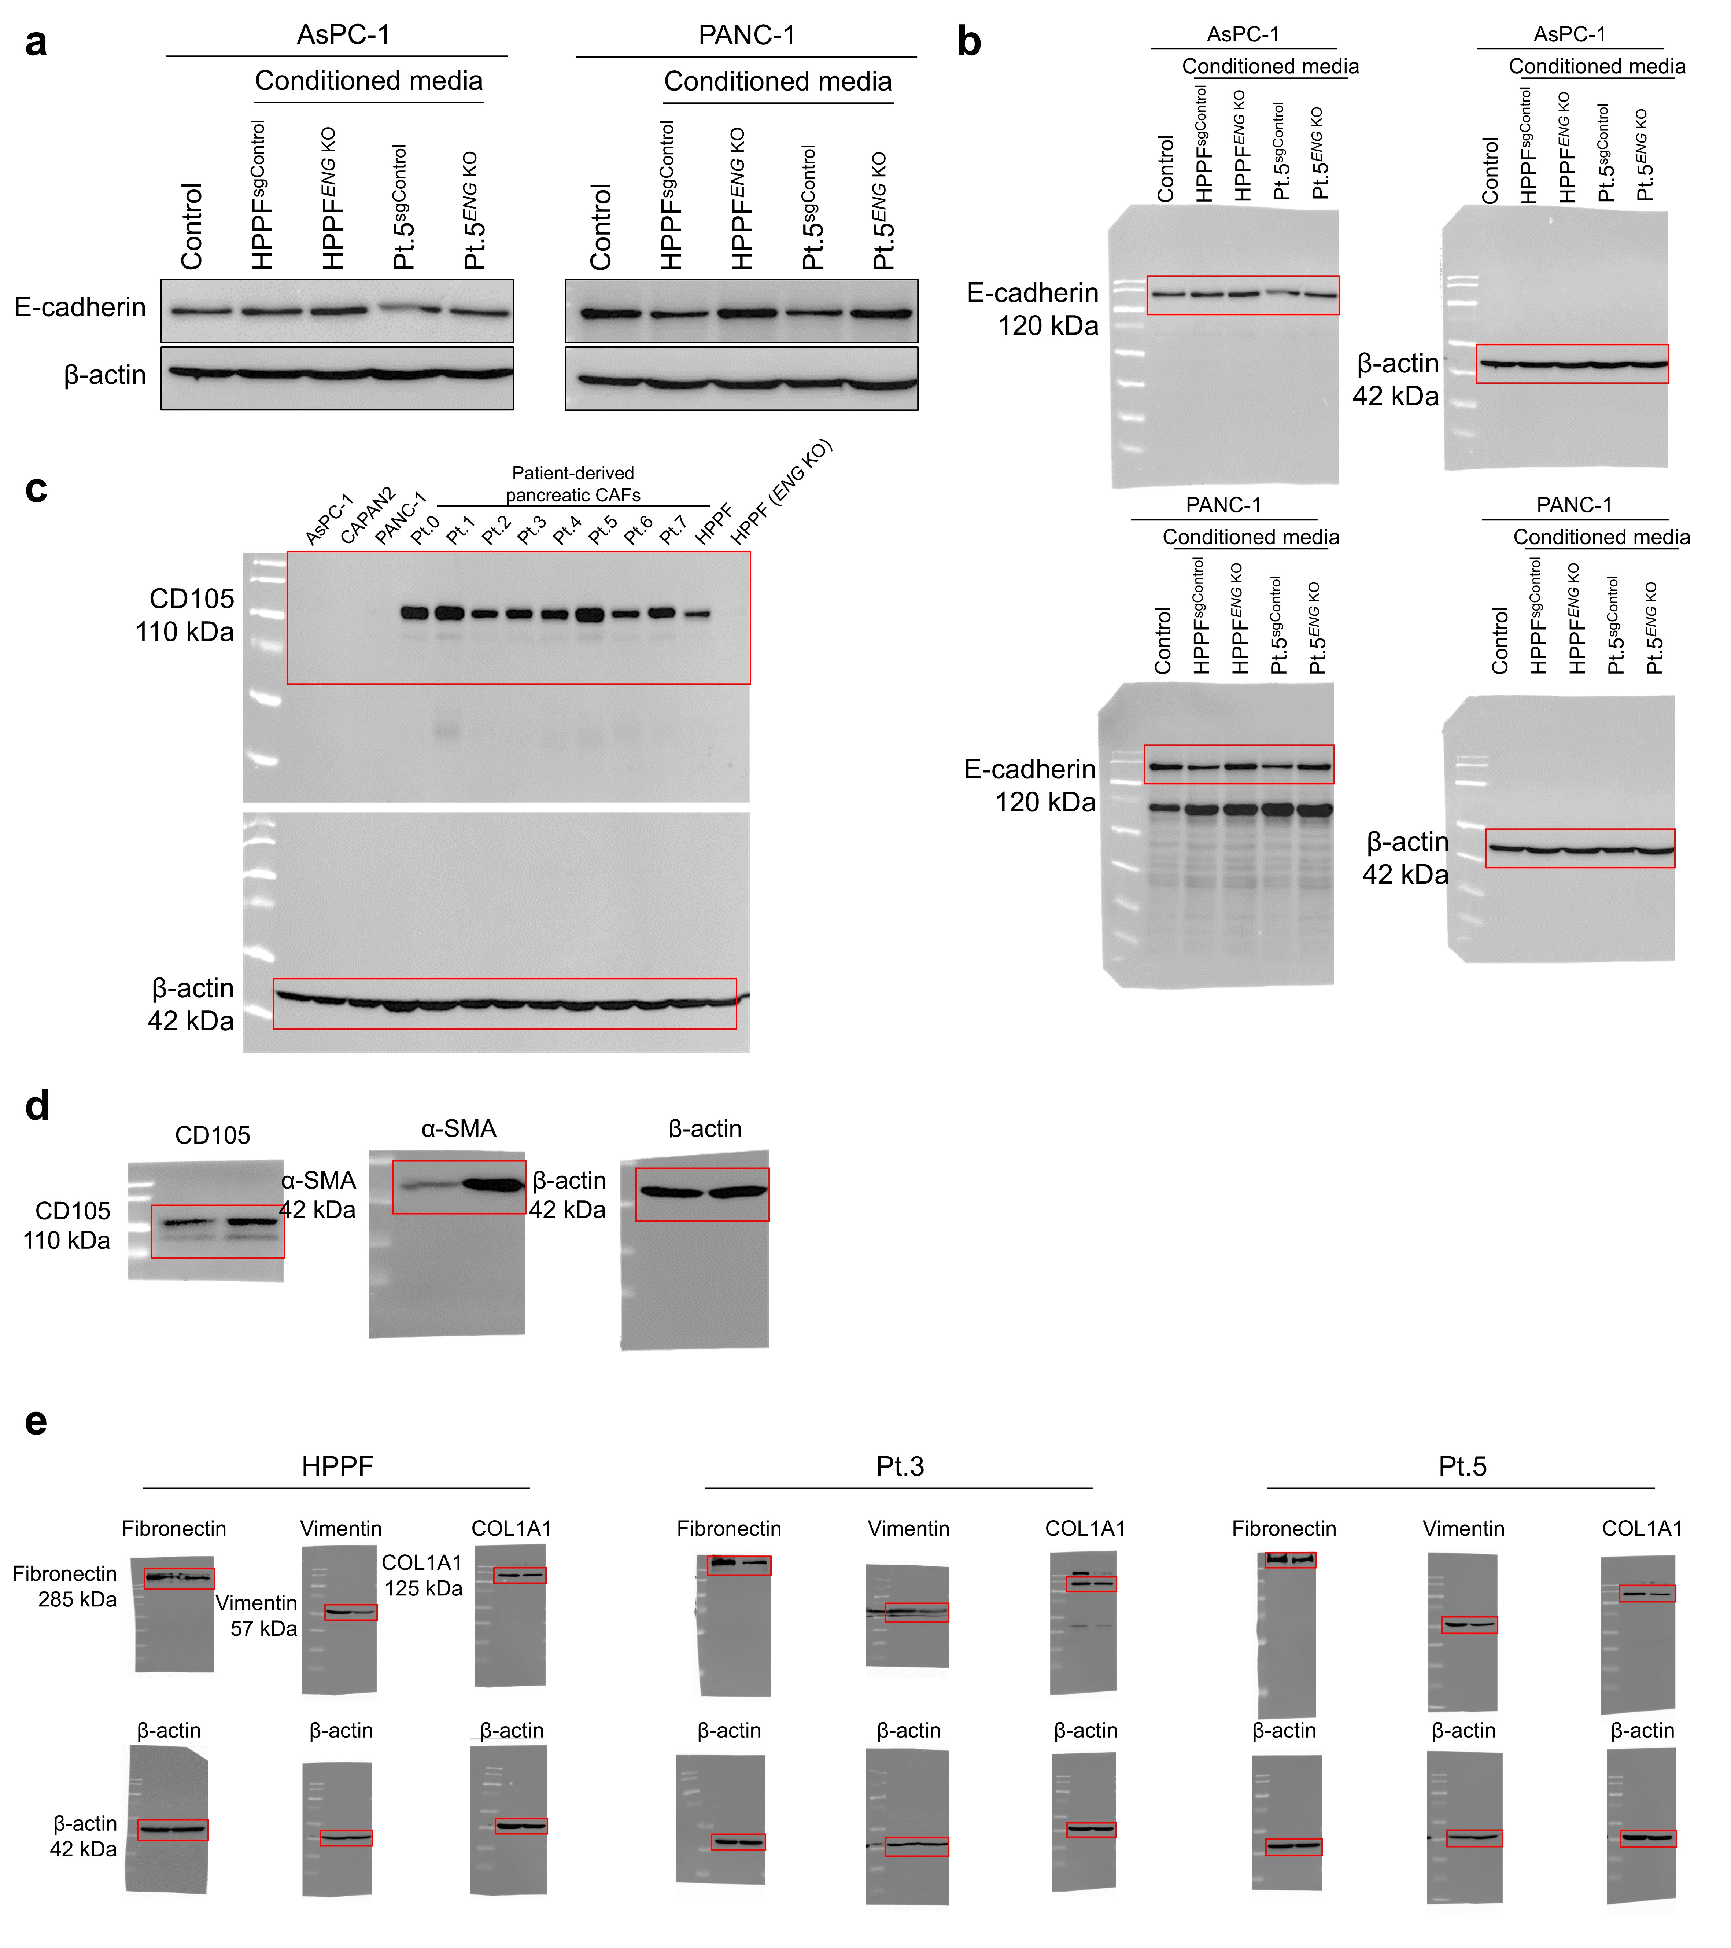
Supplementary Fig. 2. Uncropped immunoblot images. a, Immunoblot analysis of E-cadherin expression in AsPC-1 and PANC-1 cells treated with conditioned media from control or ENG-KO fibroblasts. Pt., patient-derived CAF donor number. b, Corresponding uncropped immunoblot images for E-cadherin and β-actin in AsPC-1 and PANC-1 cells treated with conditioned media from Cas9-only control or ENG-KO HPPFs and patient-derived CAFs. c, Uncropped immunoblot images for CD105 and β-actin used in Extended Data Fig. 1c. d, Uncropped immunoblot images for CD105, α-SMA and β-actin used in Fig. 1c. e, Uncropped immunoblot images for fibronectin, vimentin, COL1A1 and β-actin used in Fig. 2b.
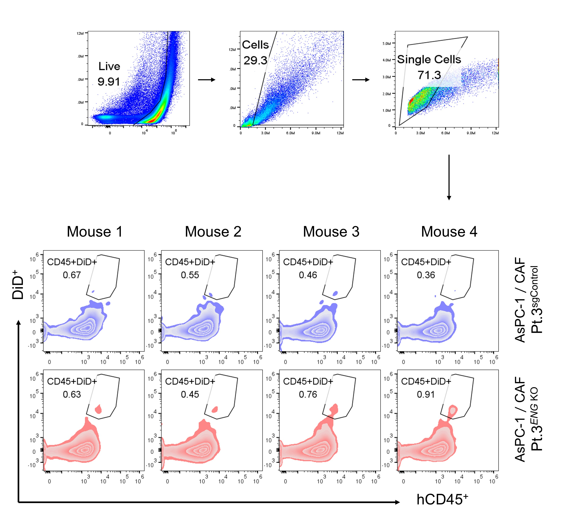
Supplementary Fig. 3. Gating strategy and individual flow cytometry plots for intratumoural transferred NK-cell analysis. Flow cytometry gating strategy used to identify transferred pNK cells in dissociated tumour tissues. Live single cells were gated, followed by identification of human CD45⁺DiD⁺ NK cells. Representative plots from individual mice bearing AsPC-1 tumours co-implanted with Cas9-only control or ENG-KO patient-derived CAFs are shown. CD45⁺DiD⁺ events indicate intravenously transferred NK cells recovered from tumour tissues.

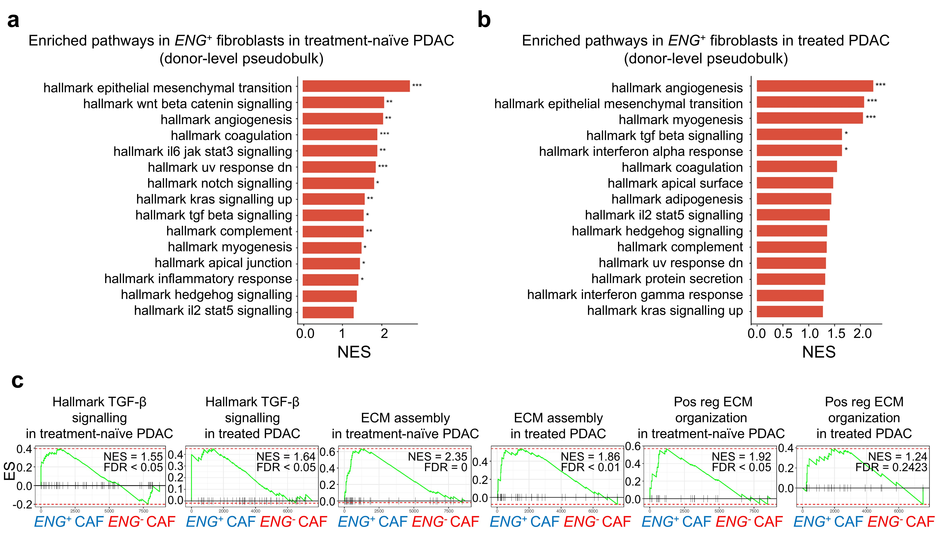
Supplementary Fig. 4. Patient-level pseudobulk gene set enrichment analysis of ENG⁺ and ENG⁻ fibroblasts. a,b, Hallmark gene set enrichment analysis showing pathways enriched in ENG⁺ compared with ENG⁻ fibroblasts from treatment-naïve (a) and treated (b) PDAC samples, using a patient-level pseudobulk approach. c, GSEA showing enrichment of hallmark TGF-β signalling and of ECM assembly and positive regulation of ECM organization in ENG⁺ versus ENG⁻ fibroblasts across both cohorts. Normalized enrichment scores (NES) and false-discovery rates (FDR) are shown.
Supplementary Fig. 5. ELISA-based binding profiles of recombinant CD105-specific scFvs. ELISA binding curves of recombinant anti-CD105 scFvs against purified biotinylated CD105-His. The absorbance at 450 nm is shown across serial concentrations of biotinylated CD105-His for each CLEN candidate (n = 3). Data are presented as mean ± s.d.
Supplementary Fig. 6. Binding specificity of recombinant anti-CD105 scFvs to parental K562 cells. Flow cytometric analysis of recombinant anti-CD105 scFv binding to parental K562 cells lacking CD105 expression. Binding was measured as FITC mean fluorescence intensity (MFI) across serial concentrations of the indicated anti-CD105 scFvs (n = 3). TRC105 and 9H10 were included as reference antibodies. Data are presented as mean ± s.d.
Supplementary Fig. 7. Antibody-induced CD105 endocytosis profiles of selected CD105-specific binders. Time-course quantification of antibody-induced CD105 endocytosis in CD105⁺ K562 cells treated with the indicated CLEN antibodies or reference antibodies TRC105 and 9H10 (n = 3). Data are presented as mean ± s.d.
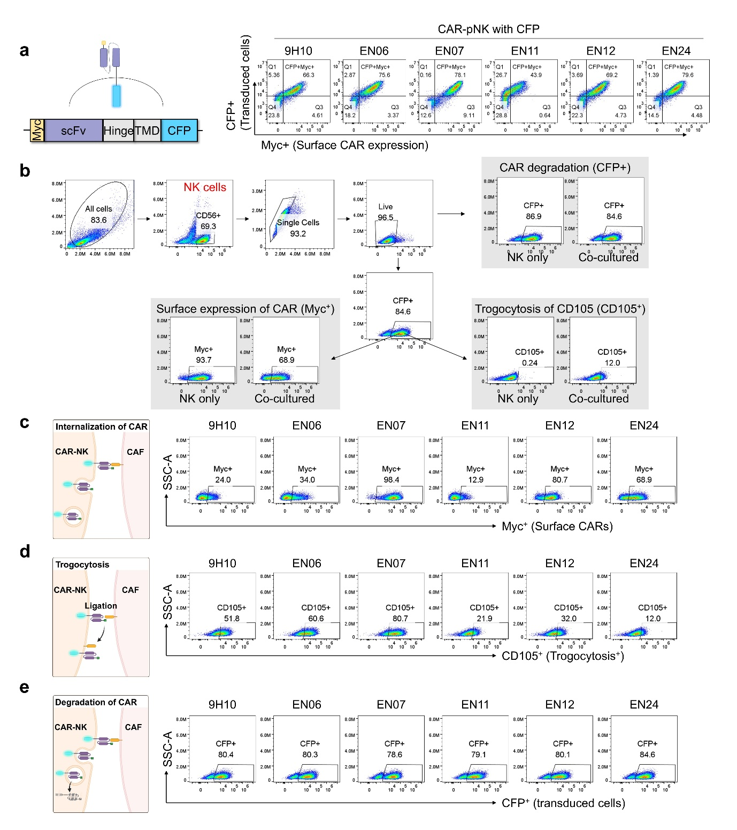
Supplementary Fig. 8. Flow cytometry gating strategy for post-engagement CAR-dynamic assays. a, Schematic of the CFP-tagged CD105-targeted CAR construct and representative flow cytometry plots showing CAR expression in transduced pNK cells. Surface CAR expression was detected using anti-Myc staining, and transduced cells were identified by CFP expression. b, Representative gating strategy used to quantify surface CAR expression, trogocytosis, and CAR degradation after co-culture with CD105⁺ CAFs. Live single NK cells were gated, followed by analysis of Myc⁺ surface CAR, CD105⁺ trogocytosis and CFP⁺ CAR degradation-associated signals. c, Representative flow cytometry plots for CAR internalization, measured by the loss of surface Myc signal after co-culture with CAF cells. d, Representative flow cytometry plots for trogocytosis, measured by the acquisition of CD105 signals on CAR-pNK cells after co-culture with CAFs. e, Representative flow cytometry plots for CAR degradation, assessed by measuring the CFP signal in transduced CAR-pNK cells after co-culture with CAFs.

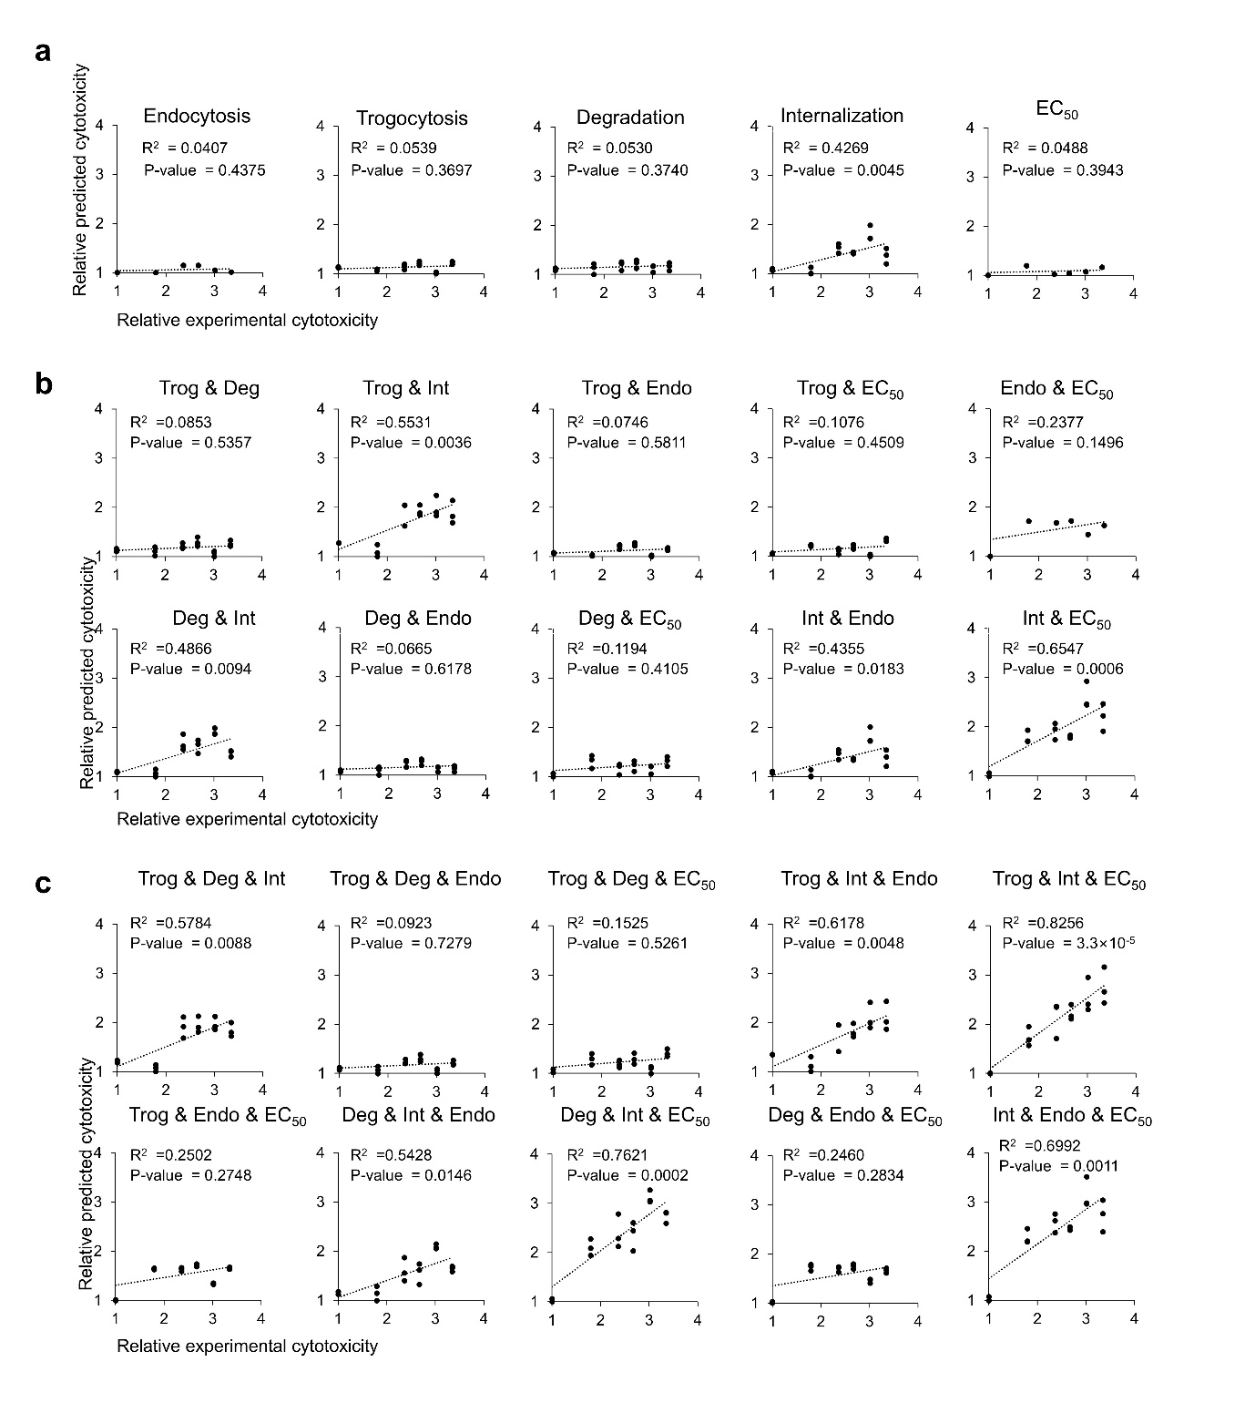
Supplementary Fig. 9. Regression analysis of CAR-dynamic parameters associated with CD105-CAR-NK cytotoxicity. a, Single-parameter ordinary least-squares regression models comparing predicted and experimentally observed cytotoxicity using CD105 endocytosis, trogocytosis, CAR degradation or internalization as individual predictors. b, Two-parameter regression models evaluating combinations of CAR-dynamic features, including trogocytosis, CAR degradation, CAR internalization, CD105 endocytosis and apparent binding potency. For each model, the relative predicted cytotoxicity is plotted against relative experimental cytotoxicity. Dashed lines indicate linear regression fits. R² and p-values are shown in each plot. c, Three-parameter regression models evaluating whether multi-feature combinations improve the prediction of CD105-CAR-NK cytotoxicity. The relative predicted cytotoxicity is plotted against relative experimental cytotoxicity for each model. Dashed lines indicate linear regression fits, and R² and p-values are shown within each plot.

Supplementary Fig. 10. Surface plasmon resonance (SPR)-based determination of the binding kinetics for CLEN24 and 9H10. Representative SPR sensorgrams showing the concentration-dependent binding of CLEN24 (a) and 9H10 (b) to recombinant CD105 (n = 3). c, Summary of the kinetic parameters, including the k_{on}, k_{off}, and K_{D}. Data are presented as mean ± s.d.
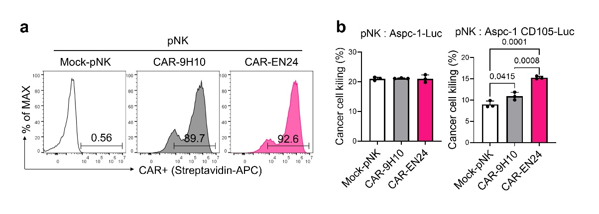
Supplementary Fig. 11. Validation of CD105-dependent killing activity of EN24-based CD105-CAR-pNK. a, Flow cytometric analysis of CAR expression in mock-pNK, 9H10-CAR-pNK and EN24-CAR-pNK cells. CAR expression was detected using biotinylated recombinant human CD105 protein followed by streptavidin–APC. b, Cytotoxicity of mock-pNK, 9H10-CAR-pNK, and EN24-CAR-pNK cells against CD105-negative AsPC-1-Luc and CD105-positive AsPC-1-CD105-Luc target cells.

Supplementary Fig. 12. Time-lapse imaging analysis of MTOC polarization dynamics during CD105-CAR-pNK-mediated target cell killing. Representative time-lapse confocal microscopy images showing microtubule-organizing centre (MTOC) dynamics during CD105-CAR-pNK cell-mediated target-cell killing. Images were acquired at 6-min intervals. Tubulin Tracker Deep Red-labelled MTOCs are shown in red, Pt.5-GFP target cells in green and CTV-labelled CAR-pNK cells in cyan. Dashed boxes indicate enlarged views of the immune synapse. Compared with 9H10-CD105-CAR-pNK cells, EN24-CD105-CAR-pNK cells exhibited more rapid MTOC depolarization following target-cell killing, consistent with efficient immune-synapse disengagement and accelerated CAR-off kinetics. Scale bars, 5 μm.
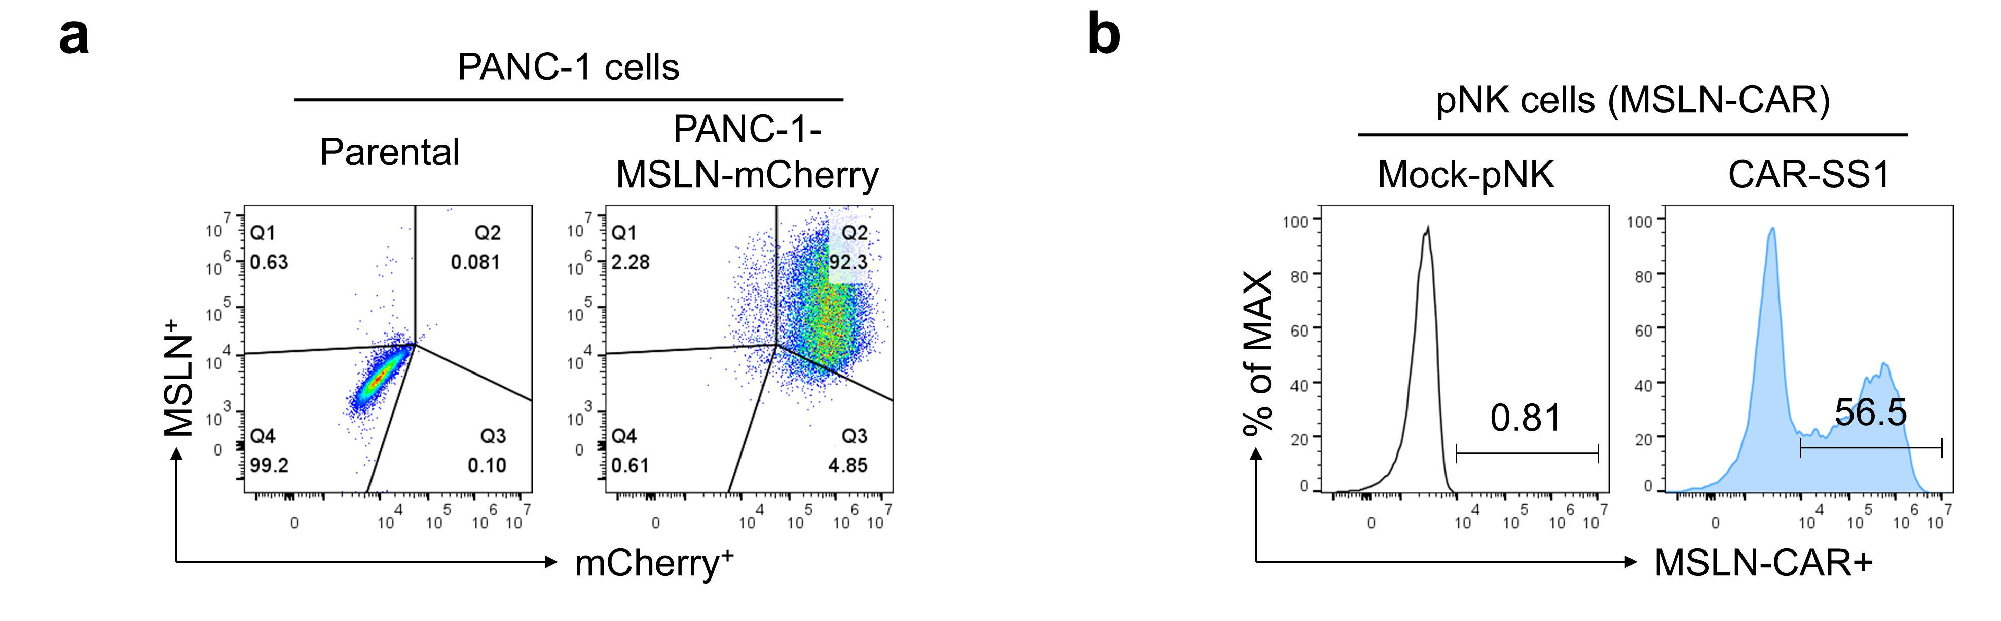
Supplementary Fig. 13. Validation of MSLN/mCherry-expressing PANC-1 cells and MSLN-CAR-pNK cells. a, Flow cytometric validation of MSLN and mCherry expression in parental and MSLN/mCherry-expressing PANC-1 cells. b, Flow cytometric validation of MSLN-CAR expression in pNK cells transduced with the SS1-based MSLN-CAR.

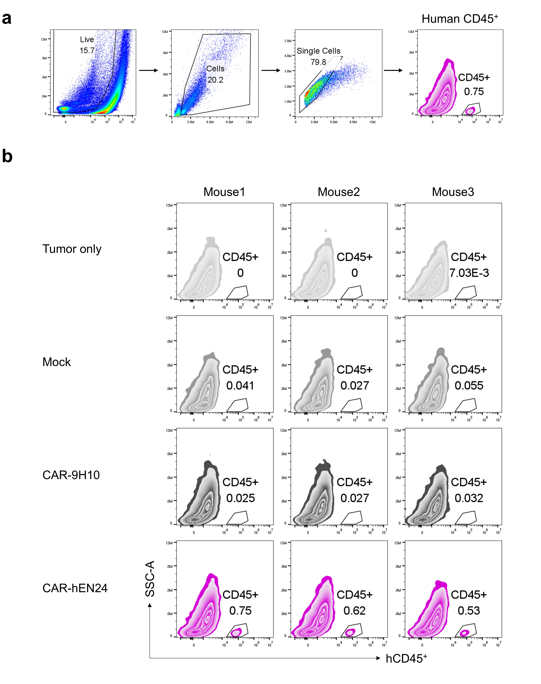
Supplementary Fig. 14. Gating strategy and individual flow cytometry plots for intratumoural human NK-cell accumulation in CAF-rich xenografts. a, Flow cytometry gating strategy used to identify transferred human NK cells in dissociated tumour tissues. Live single cells were gated, followed by human CD45⁺ cells. b, Representative flow cytometry plots from individual mice in the tumour-only, mock-pNK, 9H10-CAR-pNK, and hEN24-CAR-pNK treatment groups. Intratumoural transferred NK cells were identified as human CD45⁺ events.
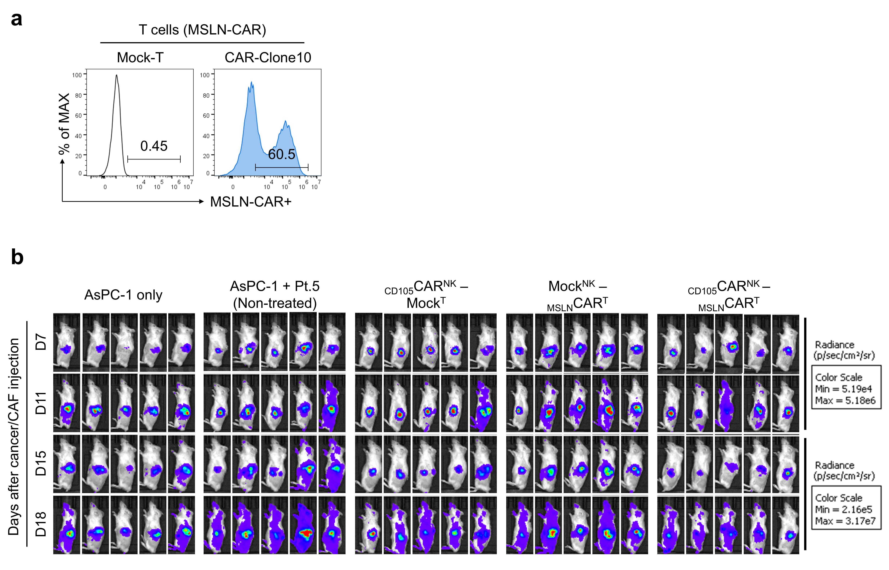
Supplementary Fig. 15. Validation of MSLN-CAR-T cells and longitudinal bioluminescence imaging of orthotopic PDAC tumours following sequential CD105-CAR-NK and MSLN-CAR-T-cell therapy. a, Flow cytometric validation of MSLN-CAR expression in T cells transduced with the Clone10 MSLN-CAR. b, Longitudinal IVIS imaging of orthotopic PDAC tumours in mice receiving the indicated treatments. AsPC-1-MSLN-Luc cells were co-implanted with patient-derived Pt.5 CAFs into the pancreas, followed by sequential administration of CD105-CAR-NK cells and MSLN-CAR-T cells. Bioluminescence images were acquired on days 7, 11, 15 and 18 after cancer/CAF implantation. Treatment groups included AsPC-1-only, AsPC-1 + Pt.5 CAFs (non-treated), CD105-CAR-NK followed by mock T cells, mock-pNK followed by MSLN-CAR-T cells, and CD105-CAR-NK followed by MSLN-CAR-T cells.

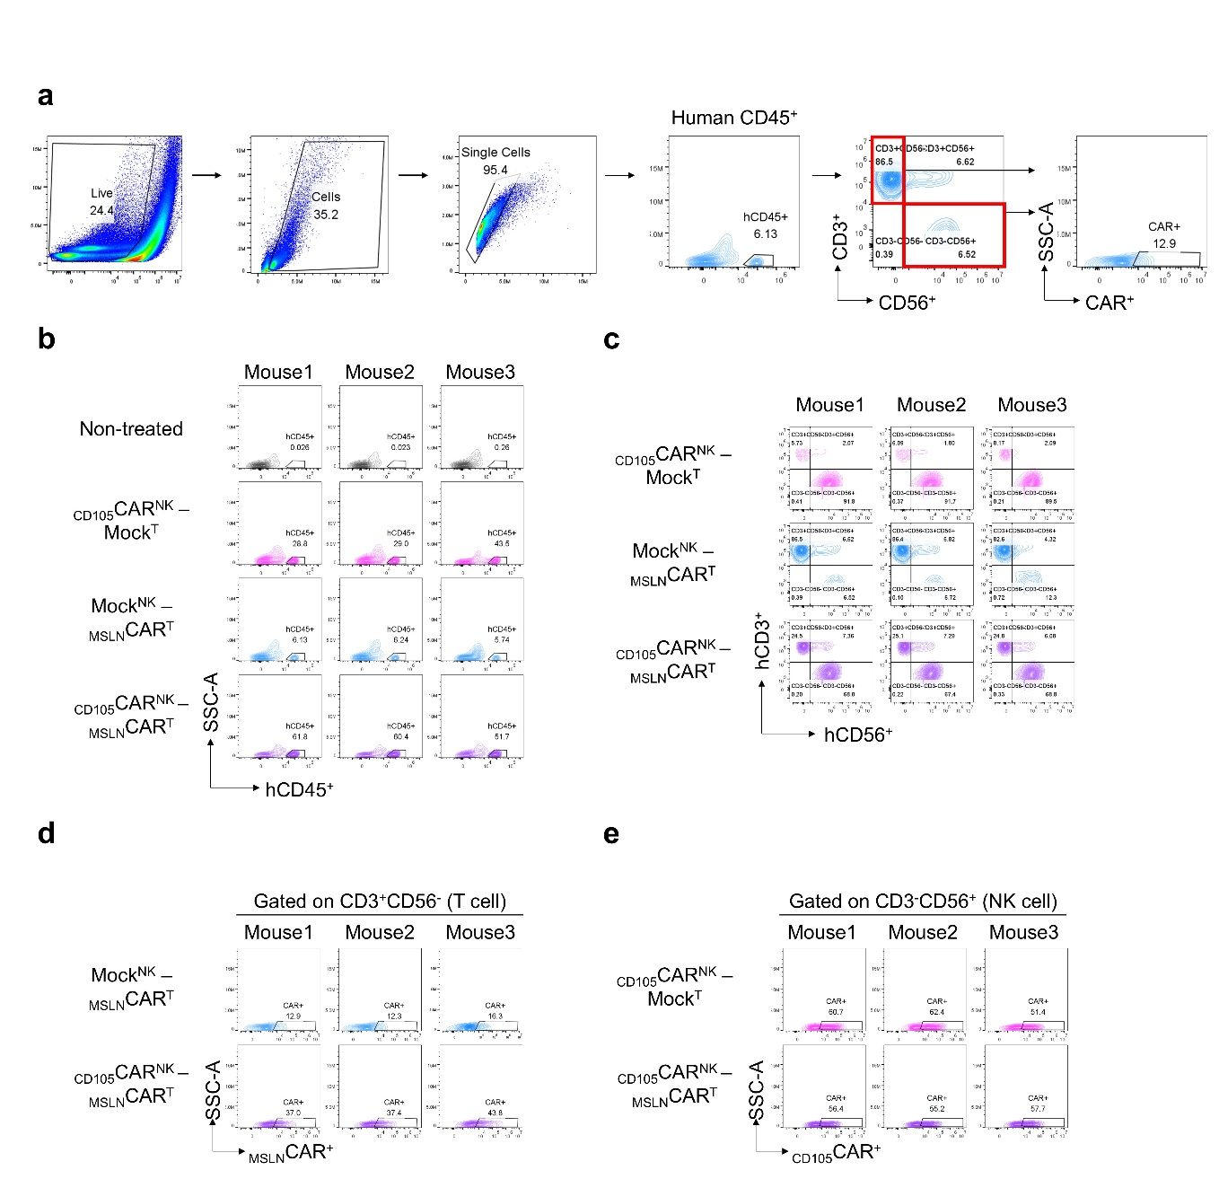

Supplementary Fig. 16. Gating strategy and individual flow cytometry plots for intratumoural human immune cells in the orthotopic PDAC model. a, Flow-cytometric gating strategy for identification and characterization of tumour-infiltrating human immune cells. b, Representative flow-cytometry plots showing human CD45⁺ cells in individual mice from the indicated treatment groups. c, Representative flow cytometry plots showing hCD3 and hCD56 expression among tumour-infiltrating human CD45⁺ cells from individual mice in the indicated treatment groups. d, Representative flow cytometry plots showing MSLN-CAR expression in tumour-infiltrating T cells (hCD3⁺hCD56⁻) from individual mice in the indicated treatment groups. e, Representative flow cytometry plots showing CD105-CAR expression in tumour-infiltrating NK cells (hCD3⁻hCD56⁺) from individual mice in the indicated treatment groups.

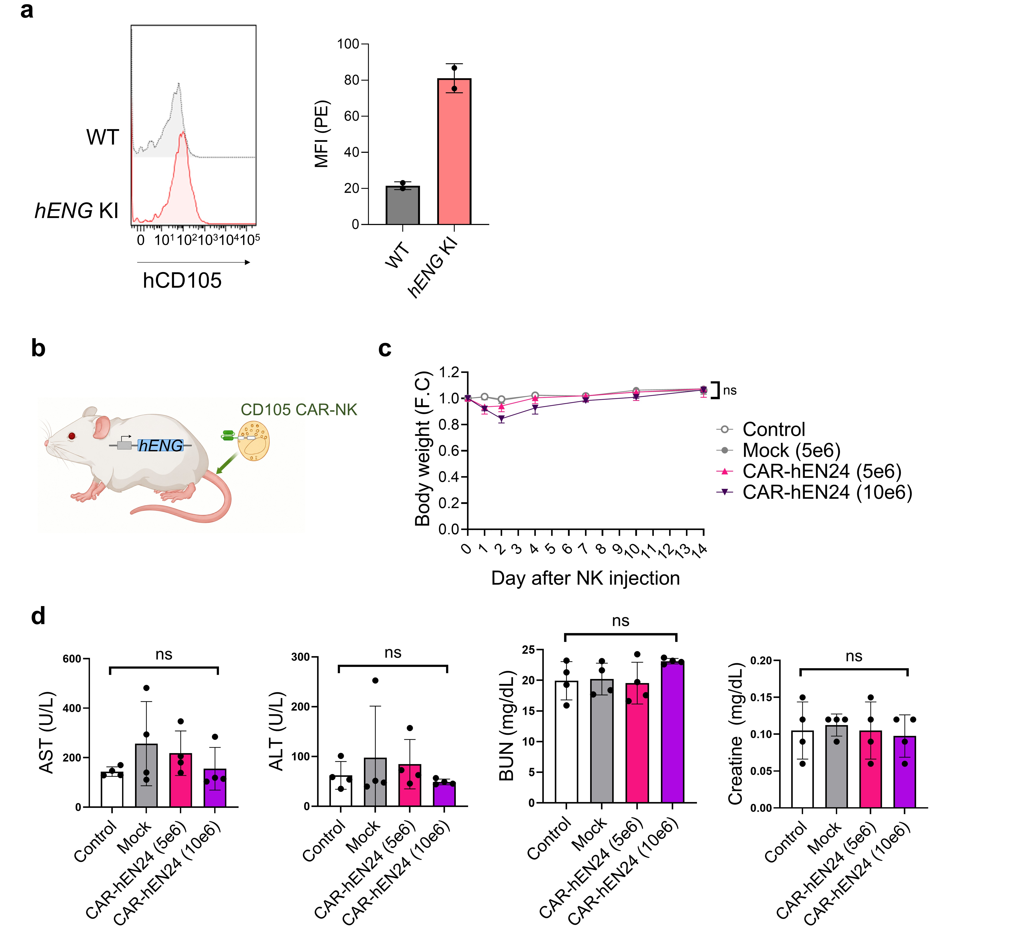
Supplementary Fig. 17. Systemic tolerability of hEN24-CD105-CAR-NK cells in hENG knock-in (KI) mice. a, Flow-cytometric validation of human CD105 expression in lung endothelial cells of hENG KI mice. Lung single-cell suspensions from wild-type (WT) and hENG KI mice were stained with anti-CD45, anti-CD31 and the human CD105-specific antibody 9H10, which was detected with a PE-conjugated anti-human IgG Fc secondary antibody. Left, representative histograms of human CD105 (hCD105) staining gated on CD45⁻CD31⁺ lung endothelial cells. Right, quantification of the PE median fluorescence intensity (MFI) within the same gate (n = 2 mice per genotype). b, Schematic of hENG KI mice used for systemic tolerability assessment following CD105-CAR-NK administration. c, Longitudinal changes in body weight following intravenous administration of vehicle, mock-pNK cells or hEN24-CD105-CAR-pNK cells at the indicated doses (5 × 10⁶ or 1 × 10⁷ cells; n = 4 mice per group, two males and two females). Body weight was normalized to the value measured before NK-cell administration and is shown as fold change (F.C.). d, Serum biochemical parameters measured at the experimental endpoint, including aspartate aminotransferase (AST), alanine aminotransferase (ALT), blood urea nitrogen (BUN) and creatinine, for vehicle, mock-pNK and both hEN24-CD105-CAR-pNK dose groups (n = 4 mice per group). No significant differences were observed among the indicated groups; statistical significance was determined using two-way ANOVA with Tukey’s multiple comparisons test for panel c and one-way ANOVA with Tukey’s multiple comparisons test for panel d. Data are presented as the mean ± s.d. ns, not significant.

Supplementary Tables
Supplementary Table 1. EC₅₀ values of anti-CD105 scFvs determined by ELISA against biotinylated CD105-His.
Clone ID | EC₅₀ (nM)
CLEN01 | n.d.
CLEN02 | >1000
CLEN03 | 30.1 ± 9.6
CLEN04 | n.d.
CLEN05 | 405.6 ± 51.9
CLEN06 | 28.9 ± 6.0
CLEN07 | 2.9 ± 0.2
CLEN08 | –
CLEN09 | 422.7 ± 240.9
CLEN10 | n.d.
CLEN11 | 8.4 ± 0.9
CLEN12 | 6.7 ± 1.2
CLEN13 | 514.4 ± 60.9
CLEN14 | >1000
CLEN15 | 644.6 ± 217.0
CLEN16 | 572.7 ± 105.1
CLEN17 | n.d.
CLEN18 | >1000
CLEN19 | >1000
CLEN20 | n.d.
CLEN21 | 56.6 ± 11.7
CLEN22 | n.d.
CLEN23 | 6.5 ± 0.6
CLEN24 | 24.2 ± 3.9
CLEN25 | n.d.
TRC105 | 22.9 ± 1.8
9H10 | 2.0 ± 0.2
Values are mean ± s.d. of three independent experiments. Antibody clones are designated CLENnn and their CAR counterparts ENnn throughout. Tables 1 and 3 report independent experiments performed with different antigens (CD105-His here; CD105-wtFc in Table 3) and are therefore not directly comparable. n.d., not detectable; –, no expression.
Supplementary Table 2. EC₅₀ values of anti-CD105 scFvs determined by a cell-binding assay on CD105⁺ K562 cells.
Clone ID | EC₅₀ (nM)
CLEN06 | 4.6 ± 0.7
CLEN07 | 19.7 ± 1.5
CLEN11 | 6.0 ± 1.4
CLEN12 | 2.0 ± 0.5
CLEN21 | 24.9 ± 0.6
CLEN24 | 10.4 ± 1.5
TRC105 | 22.4 ± 4.2
9H10 | 7.0 ± 0.4
Values are mean ± s.d. of three independent experiments. Tables 2 and 4 report independent cell-binding experiments performed on separate occasions; the differences between them (CLEN24, 10.4 versus 6.0 nM; TRC105, 22.4 versus 7.4 nM) reflect independent assay batches, including a change in TRC105 antibody lot. 9H10 was included as a reference antibody only in Table 2, because its maximal binding signal was substantially higher than that of the CLEN clones and compressed the dynamic range of the curve fits; TRC105 alone was therefore used as the reference antibody in the humanized-variant experiments (Tables 3 and 4).
Supplementary Table 3. EC₅₀ values of humanized CLEN24 clones determined by ELISA against recombinant CD105-wtFc.
Clone ID | EC₅₀ (nM)
CLEN24 | 29.0 ± 6.3
CLhEN24 | 28.4 ± 5.0
CLhEN24-5 | 8.2 ± 1.2
CLhEN24-10 | 24.1 ± 0.2
CLhEN24-12 | 11.2 ± 3.0
CLhEN24-16 | 66.5 ± 2.0
CLhEN24-20 | 101.1 ± 5.4
TRC105 | 44.3 ± 22.0
Values are mean ± s.d. of three independent experiments, performed independently of Table 1. 9H10 was not included as a reference antibody in the humanized-variant experiments (see Supplementary Table 2).
Supplementary Table 4. EC₅₀ values of humanized CLEN24 clones determined by a cell-binding assay on CD105⁺ K562 cells.
Clone ID | EC₅₀ (nM)
CLEN24 | 6.0 ± 0.2
CLhEN24 | 8.1 ± 0.1
CLhEN24-5 | 10.2 ± 1.0
CLhEN24-10 | 27.8 ± 1.2
CLhEN24-12 | 8.6 ± 0.5
CLhEN24-16 | 14.5 ± 0.9
CLhEN24-20 | 15.7 ± 0.4
TRC105 | 7.4 ± 0.1
Values are mean ± s.d. of three independent experiments, performed independently of Table 2.
Supplementary Videos
Supplementary Videos 1-4. Representative live-cell holotomography videos using an HT-X1 system, showing CAF motility corresponding to Fig.1e. Supplementary Video 1, Pt.3 Cas9-only control; Video 2, Pt.3 ENG-KO; Video 3, Pt.5 Cas9-only control; Video 4, Pt.5 ENG-KO.
Supplementary Videos 5 and 6. Representative live-cell holotomography videos using an HT-X1 system, showing CAR ON/OFF assay corresponding to Fig. 5e. Supplementary Video 5, 9H10-CAR-pNK; Video 6, EN24-CAR-pNK.
Supplementary Videos 7-9. Representative live-cell imaging videos of the killing assay in a multicellular spheroid model corresponding to Fig. 6d. Supplementary Video 7, non-treated group, control; Supplementary Video 8, mock-pNK treatment; and Supplementary Video 9, hEN24-CAR-pNK treatment. AsPC-1-mCherry cancer cells are shown in red, HPPF-GFP cells in green, and Hoechst-labelled CAR-NK cells in blue.
Supplementary Videos 10-14. Representative live-cell imaging videos of the killing assay in a multi-spheroids model during the sequential treatment, corresponding to Fig. 6e. Supplementary Video 10, non-treated group, control; Supplementary Video 11, MSLN-CAR-pNK treatment; Supplementary Video 12, 9H10-CD105-CAR-pNK treatment; Supplementary Video 13, hEN24-CD105-CAR-pNK treatment; and and Supplementary Video 14, sequential hEN24-CD105-CAR-pNK followed by MSLN-CAR-pNK treatment. PANC-1-MSLN-mCherry cancer cells are shown in red, HPPF-GFP cells in green, and Hoechst-labelled CAR-NK cells in blue.

