Supplementary Figures

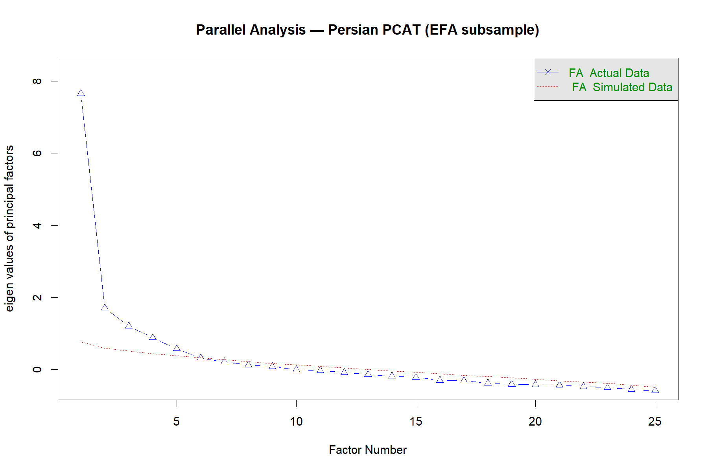Supplementary Figure S1. Parallel analysis based on the polychoric correlation matrix in the EFA subsample (n = 218), using minimum-residual factor extraction. The analysis selected five factors.

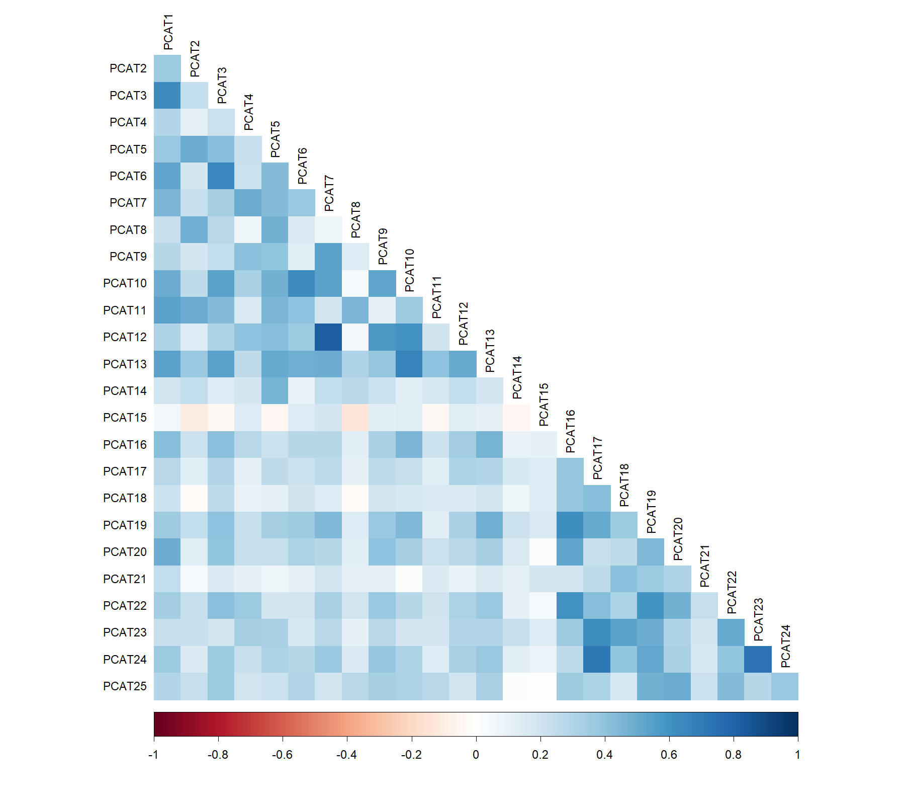
Supplementary Figure S2. Heatmap of the polychoric correlations among the 25 scored PCAT items in the EFA subsample (n = 218).

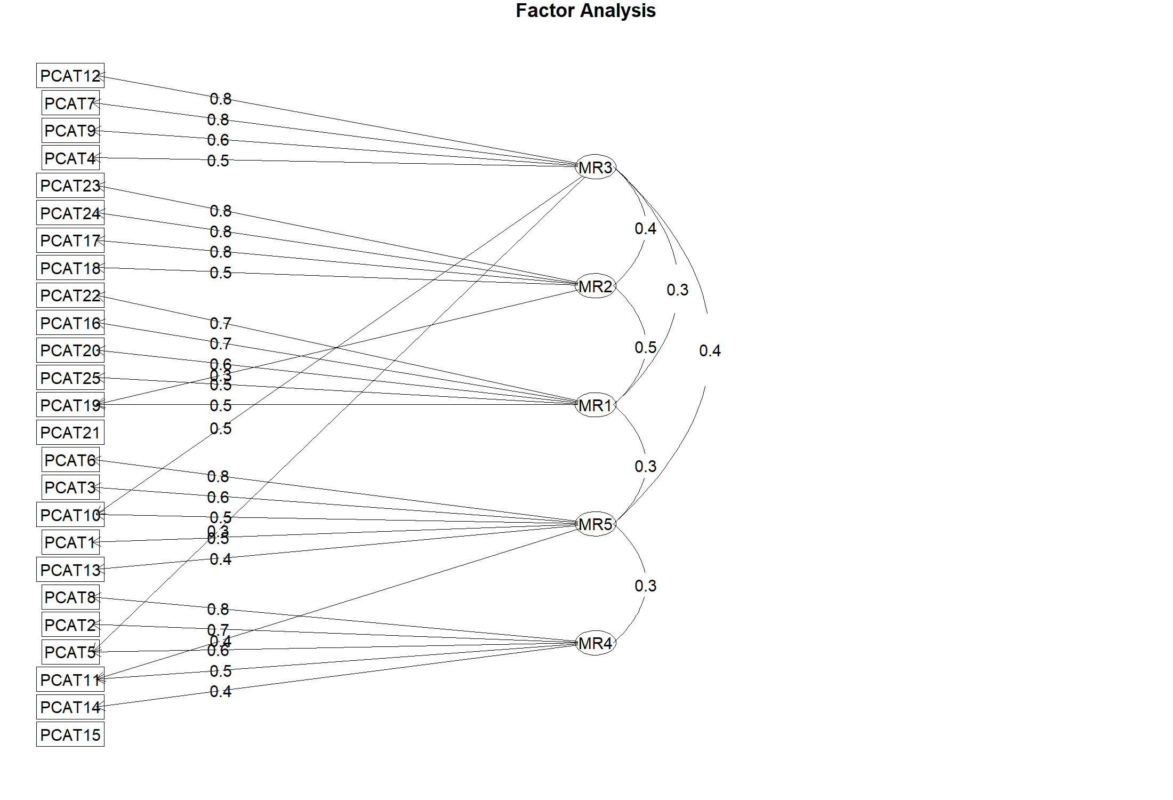

Supplementary Figure S3. Parallel-Analysis-Selected Five-Factor EFA Diagram. Factor diagram for the five-factor minimum-residual oblimin EFA solution in the exploratory subsample (n = 218).

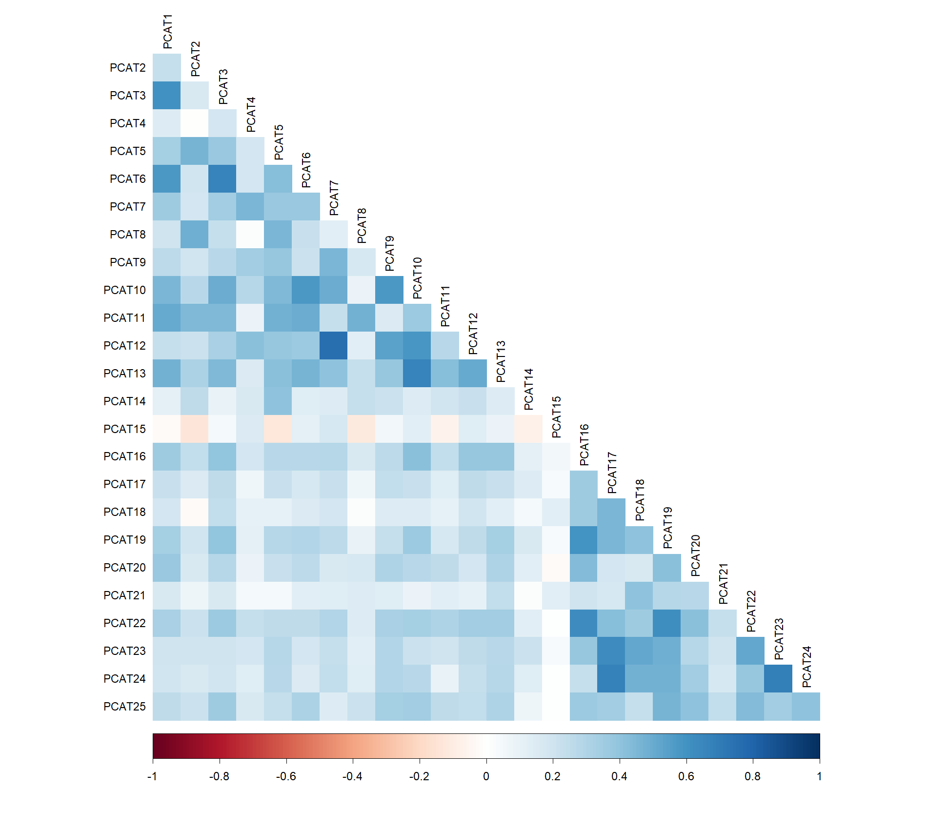
Supplementary Figure S4
Full-Sample Polychoric Correlation Matrix of the Persian PCAT. Heatmap of the polychoric correlations among the 25 scored PCAT items using the full PCAT sample (N = 437).

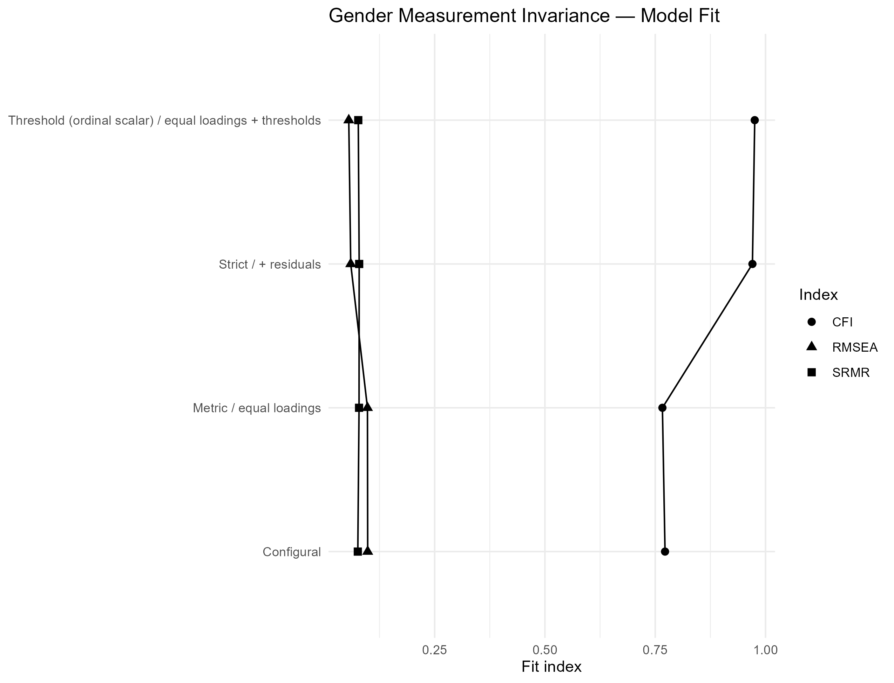

Supplementary Figure S5. Fit-index profile for configural, metric, threshold (ordinal scalar), and strict multi-group CFA models across men and women.

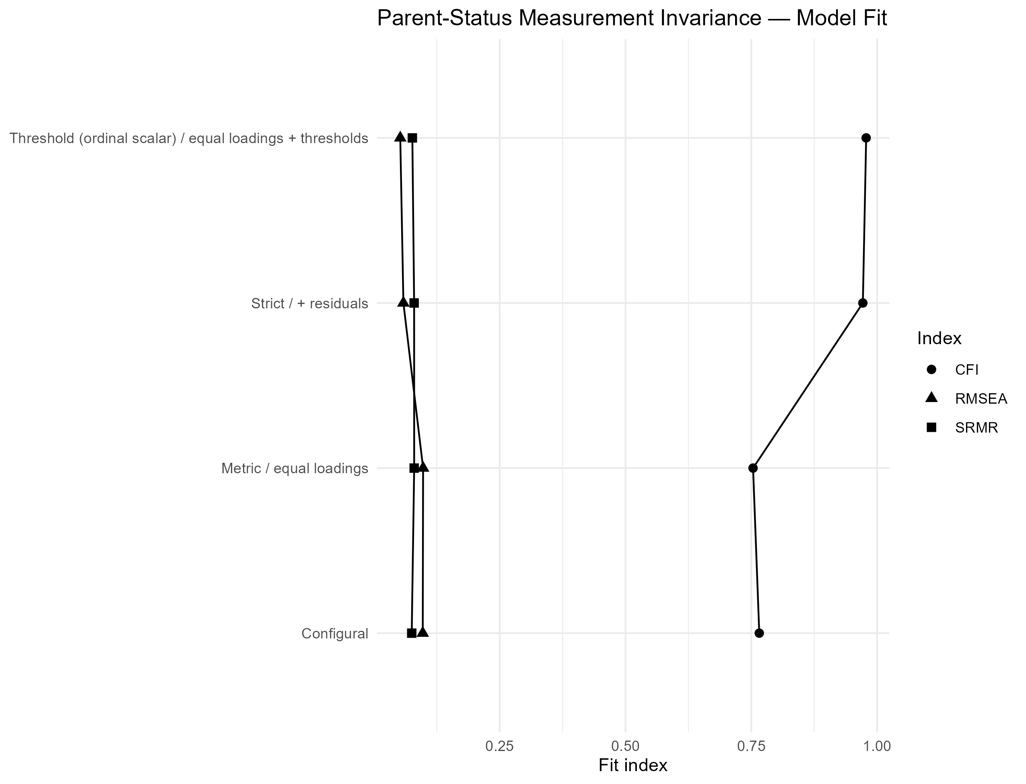
Supplementary Figure S6. Fit-index profile for configural, metric, threshold (ordinal scalar), and strict multi-group CFA models across parents and nonparents.

Supplementary Figure S7. Correlation heatmap corresponding to the full-sample EGA of the 25 PCAT items (N = 437).

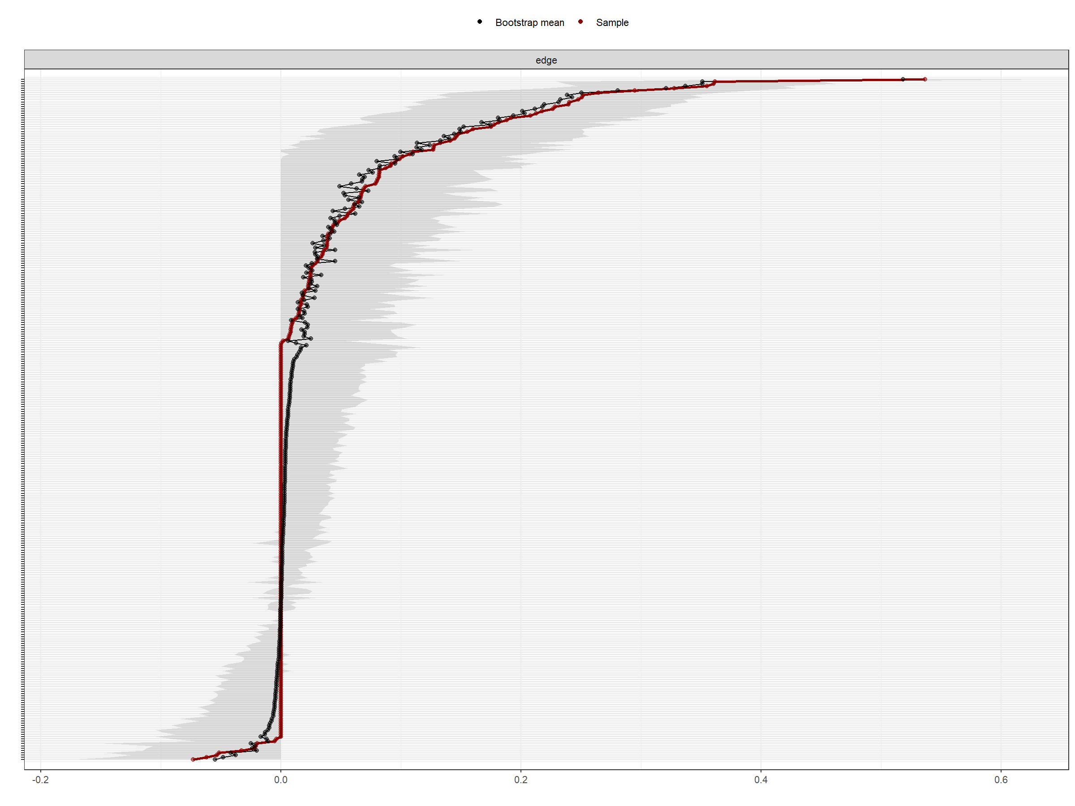
Supplementary Figure S8. Nonparametric bootstrap confidence intervals for estimated edge weights in the EBICglasso PCAT network based on 1,000 bootstrap samples.

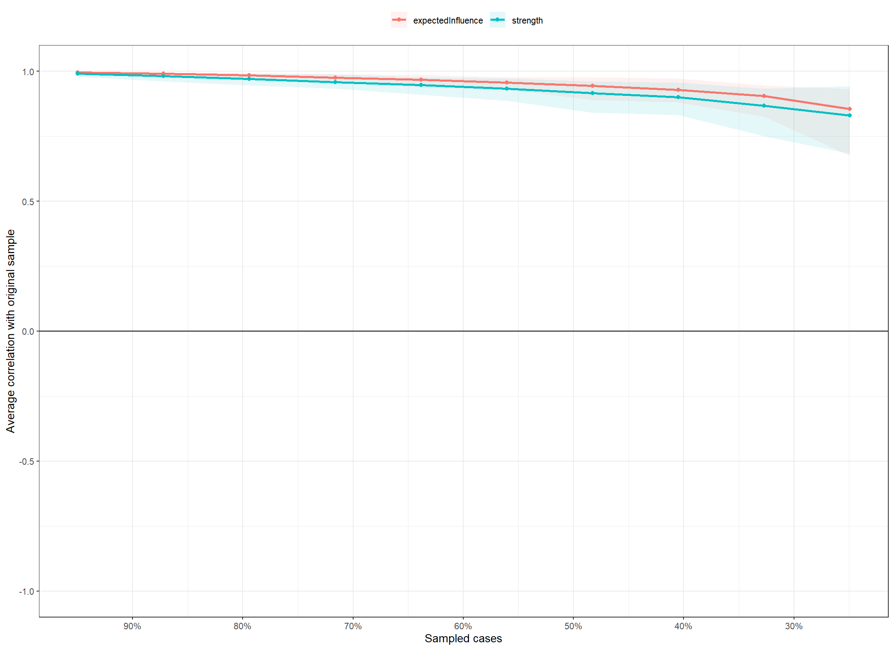
Supplementary Figure S9. Case-dropping bootstrap results for node strength and expected influence in the EBICglasso PCAT network, based on 1,000 bootstrap samples.

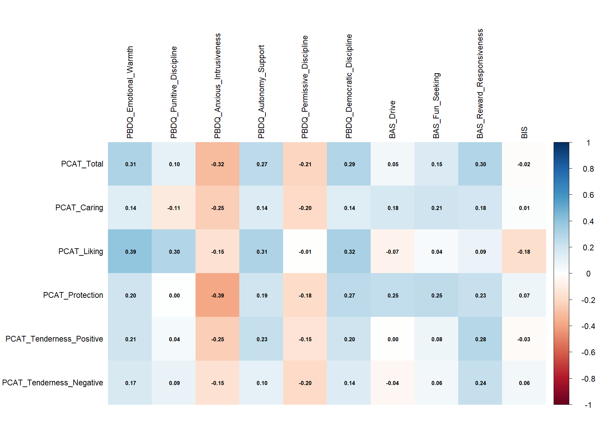

Supplementary Figure S10. Heatmap of Pearson correlations between PCAT total/subscale scores and external PBDQ and BIS/BAS dimensions in the complete external-validity subsample (n = 149).
Suggested filename for submission: Validity_Pearson_heatmap.png

