Supporting Information: Mechanism and Inhibition of Preferential Corrosion of Cold-Sprayed Copper in Dilute Nitric Acid
Sebastian A. Skaanvik^{1*}, Sherry Cao¹, Jessica E. M. Winslade¹, Xuejie Li¹, Diego A. Membreno¹, Mehran Behazin², Peter G. Keech³, David W. Shoesmith^{1,4}, and James J. Noël^{1,4*}
¹Department of Chemistry, Western University, London, ON, N6A 5B7, Canada
²Nuclear Waste Management Organization, Toronto, ON, M4T 2S3, Canada
³Department of Chemical Engineering and Applied Chemistry, University of Toronto, Toronto, ON, M5S 3E5, Canada
⁴Surface Science Western, Western University, London, ON, N6G 0J3, Canada
Correspondence: sskaanvi@uwo.ca/jjnoel@uwo.ca

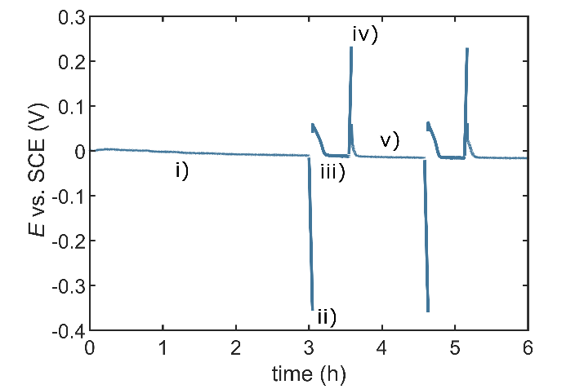
- Potentiodynamic Polarization Sequence
Figure S1: Sequence for potentiodynamic polarization experiments: i) initial period at the E_{corr} to let the system reach a steady state (2 hours); ii) Cathodic sweep, starting from E_{corr}; iii) 30-minute period at the E_{corr} to let the system reach a steady state again; iv) Anodic sweep, starting from E_{corr}; v) 60-minute period at the E_{corr}; subsequently, the potentiodynamic polarization sequence was further carried out repetitively from step ii-v.
- Evaluation of Corrosion Damage at Particle-Particle Boundaries
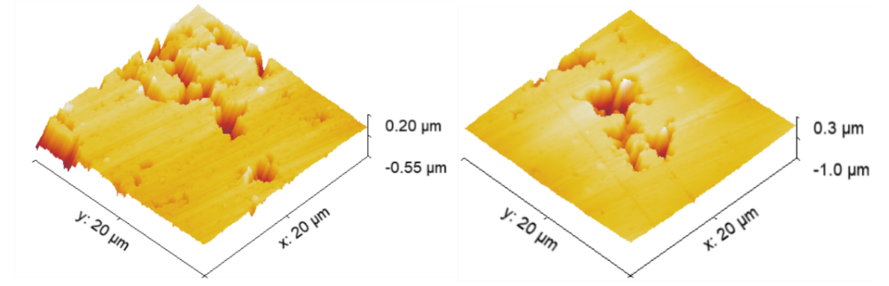
Figure S2: Atomic force microscopy topographic imaging for determining the depth of corrosion damage at the particle-particle boundaries of cold-sprayed copper after immersion in 0.1 M HNO₃ for 72 h under constant Ar-sparging.
- Evaluation of Particle-Particle Boundaries Dissolution Under Inert Conditions
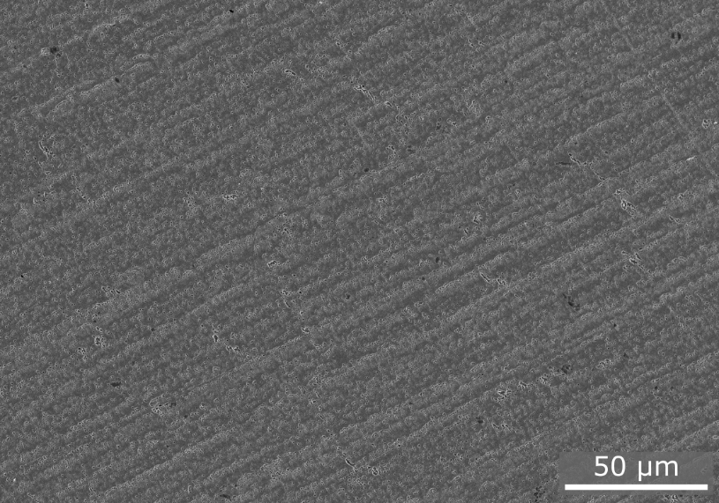
Figure S3: Scanning electron micrograph of cold-sprayed copper after immersion in 0.05 M H₂SO₄ for 72 h under constant Ar-sparging.
- Atomic Force Microscopy Images of Cold-Sprayed Cu After Immersion in 0.1 M HNO₃ + 4 mM HCl
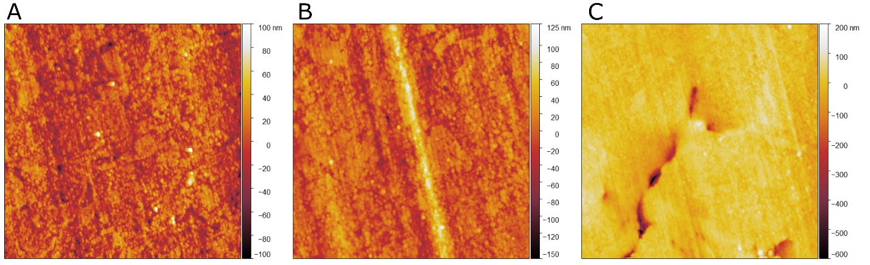
Figure S4: Atomic force microscopy topography images of cold-sprayed copper after 72 h immersion in deaerated 0.1 M HNO₃ + 4 mM HCl. A/B) Regions with no pores. C) Region with pores.

- Cu Particles Collected from Immersion Solution
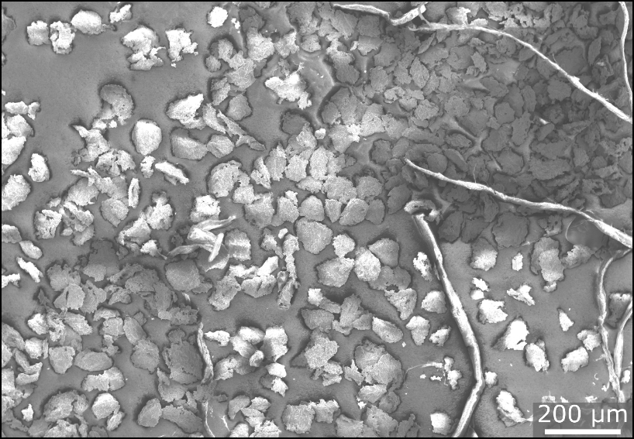
Figure S5: Scanning electron micrograph of particles collected after 24 h immersion of cold-sprayed copper in aerated 0.1 M HNO₃.
- Potentiodynamic Polarization Curves of Wrought Copper in 0.1 M HNO₃
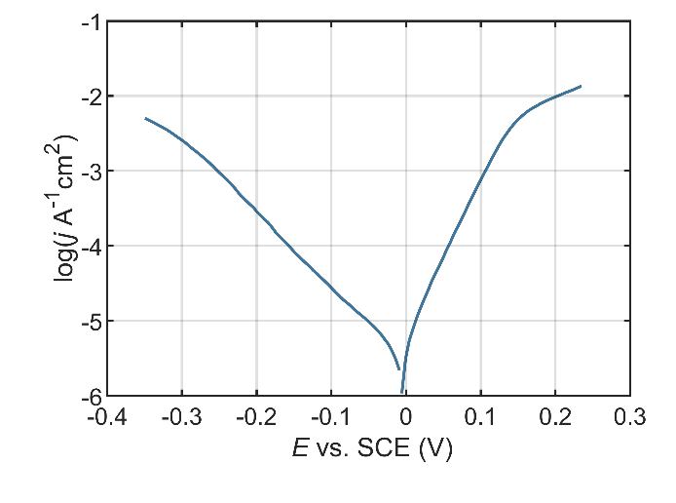
Figure S6: Potentiodynamic polarization curves of oxygen-free, phosphorus-doped, wrought copper in deaerated 0.1 M HNO₃. The scan rate was 2 mV/s, and scans started at E_{corr}.
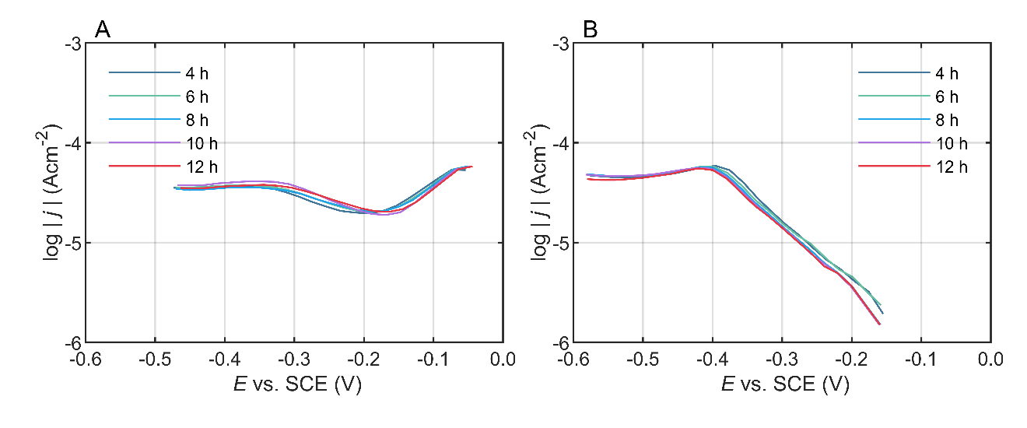
- Effect of Chloride on Oxygen Evolution on Copper in 0.05 M H₂SO₄
Figure S7: Potentiodynamic polarization curves of oxygen-free, phosphorus-doped, wrought copper in aerated, 0.1 M HNO₃ without (A) and with (B) 4 mM HCl . The scan rate was 2 mV/s, and scans started at E_{corr}.

