Electronic Supplementary Material
The Diagnostic Value of EZH2 in Distinguishing NET G3 from NEC: An Immunohistochemical Study of 1618 Neuroendocrine Neoplasms of Various Origins and Grades
Katharina Ofner, Moritz Jesinghaus, et al. – Endocrine Pathology
Supplementary Table S1 Diagnostic performance of alternative H-score thresholds (NET G3, n = 56, vs. LCNEC/SCNEC, n = 391)
A Lower threshold: an H-score below the threshold is taken as evidence for NET G3
Threshold | Sensitivity for NET G3, % (95% CI) | Specificity vs. LCNEC/SCNEC, % (95% CI) | LR+ (95% CI)
<50 | 39.3 (27.6–52.4) | 94.4 (91.6–96.3) | 7.0 (4.1–11.7)
<75 | 50.0 (37.3–62.7) | 90.5 (87.2–93.1) | 5.3 (3.5–7.9)
<100 | 67.9 (54.8–78.6) | 86.2 (82.4–89.3) | 4.9 (3.6–6.7)
<125 | 67.9 (54.8–78.6) | 82.4 (78.3–85.8) | 3.8 (2.9–5.1)
<150 | 75.0 (62.3–84.5) | 76.7 (72.3–80.6) | 3.2 (2.5–4.1)
B Upper threshold: an H-score above the threshold is taken as evidence for NEC
Threshold | Sensitivity for NEC, % (95% CI) | Specificity vs. NET G3, % (95% CI) | LR+ (95% CI) | NET G3 above threshold, n
>150 | 71.9 (67.2–76.1) | 82.1 (70.2–90.0) | 4.0 (2.3–7.1) | 10
>175 | 63.2 (58.3–67.8) | 82.1 (70.2–90.0) | 3.5 (2.0–6.2) | 10
>200 | 52.2 (47.2–57.1) | 91.1 (80.7–96.1) | 5.8 (2.5–13.6) | 5
>225 | 42.2 (37.4–47.1) | 94.6 (85.4–98.2) | 7.9 (2.6–23.8) | 3
>250 | 30.7 (26.3–35.4) | 98.2 (90.6–99.7) | 17.2 (2.4–120.6) | 1
Thresholds used in this study: <100 (low expression) and >200 (high expression). The specificity of the lower threshold is the proportion of LCNEC/SCNEC at or above it; the specificity of the upper threshold is the proportion of NET G3 at or below it. LR, likelihood ratio; CI, confidence interval.
Supplementary Table S2 Diagnostic performance of EZH2 expression groups for the distinction between NET G3 and NEC (LCNEC/SCNEC)
Comparison | Criterion | Sensitivity, % (95% CI) | Specificity, % (95% CI) | PPV, % (95% CI) | NPV, % (95% CI) | LR+ (95% CI) | LR− (95% CI)
NET G3 (n = 56) vs. LCNEC/SCNEC (n = 391) | Low (<100) → NET G3 | 67.9 (54.8–78.6) | 86.2 (82.4–89.3) | 41.3 (31.8–51.5) | 94.9 (92.1–96.8) | 4.9 (3.6–6.7) | 0.37 (0.25–0.55)
NET G3 (n = 56) vs. LCNEC/SCNEC (n = 391) | High (>200) → NEC | 52.2 (47.2–57.1) | 91.1 (80.7–96.1) | 97.6 (94.5–99.0) | 21.4 (16.7–27.1) | 5.8 (2.5–13.6) | 0.53 (0.46–0.60)
GEP-NET G3 (n = 39) vs. GEP-LCNEC/SCNEC (n = 122) | Low (<100) → NET G3 | 64.1 (48.4–77.3) | 82.0 (74.2–87.8) | 53.2 (39.2–66.7) | 87.7 (80.4–92.5) | 3.6 (2.3–5.5) | 0.44 (0.29–0.67)
GEP-NET G3 (n = 39) vs. GEP-LCNEC/SCNEC (n = 122) | High (>200) → NEC | 44.3 (35.8–53.1) | 92.3 (79.7–97.3) | 94.7 (85.6–98.2) | 34.6 (26.2–44.2) | 5.8 (1.9–17.4) | 0.60 (0.50–0.72)
Intermediate expression (100–200) was present in 23.2 (14.1–35.8)% of NET G3 and 34.0 (29.5–38.8)% of LCNEC/SCNEC (likelihood ratio 0.68). Predictive values depend on the proportion of NET G3 and NEC in the cohort (here 1:7); assuming equal pre-test probabilities, the post-test probability of NET G3 given low expression is 83.1% and that of NEC given high expression is 85.4%. PPV, positive predictive value; NPV, negative predictive value; LR, likelihood ratio; CI, confidence interval.
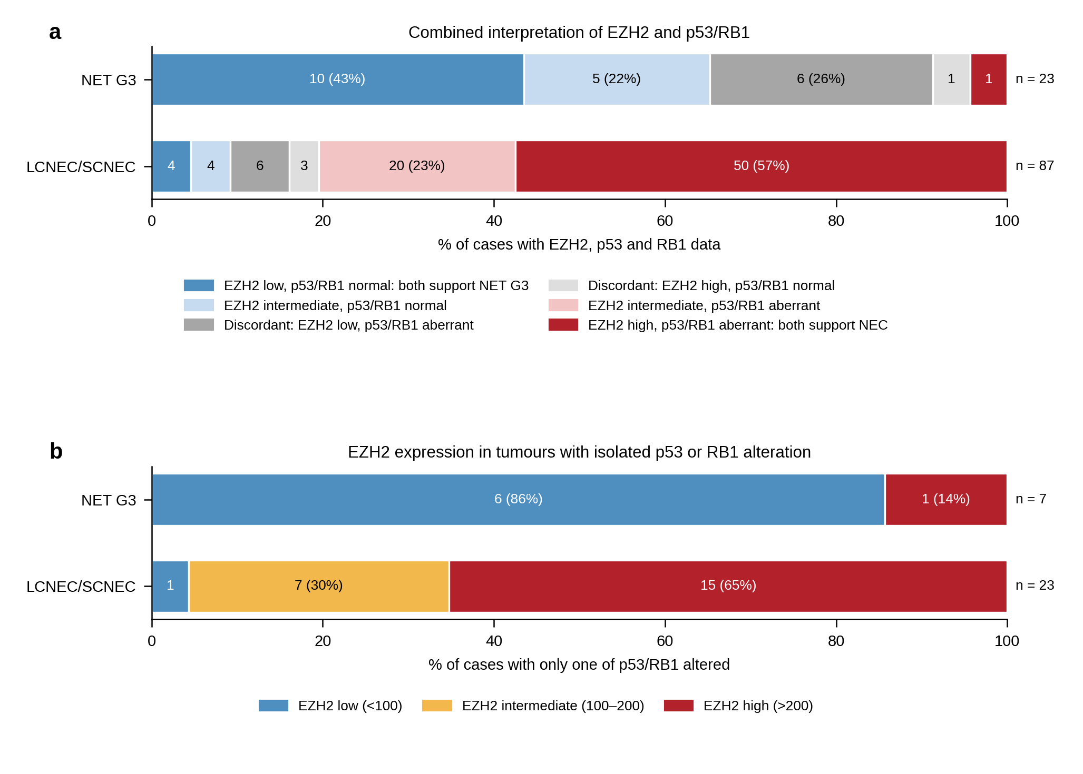
Supplementary Fig. S1 Combined interpretation of EZH2 and p53/RB1 immunohistochemistry in NET G3 and LCNEC/SCNEC. a Cases with EZH2, p53 and RB1 data (23 NET G3, 87 LCNEC/SCNEC), categorised by whether EZH2 and p53/RB1 point to the same diagnosis; p53/RB1 aberrant denotes aberrant p53 and/or loss of RB1; discordant cases are shown separately as EZH2-low tumours with aberrant p53/RB1 and EZH2-high tumours with normal p53/RB1. b EZH2 expression group in tumours with alteration of only one of p53 and RB1 (7 NET G3, 23 LCNEC/SCNEC).

