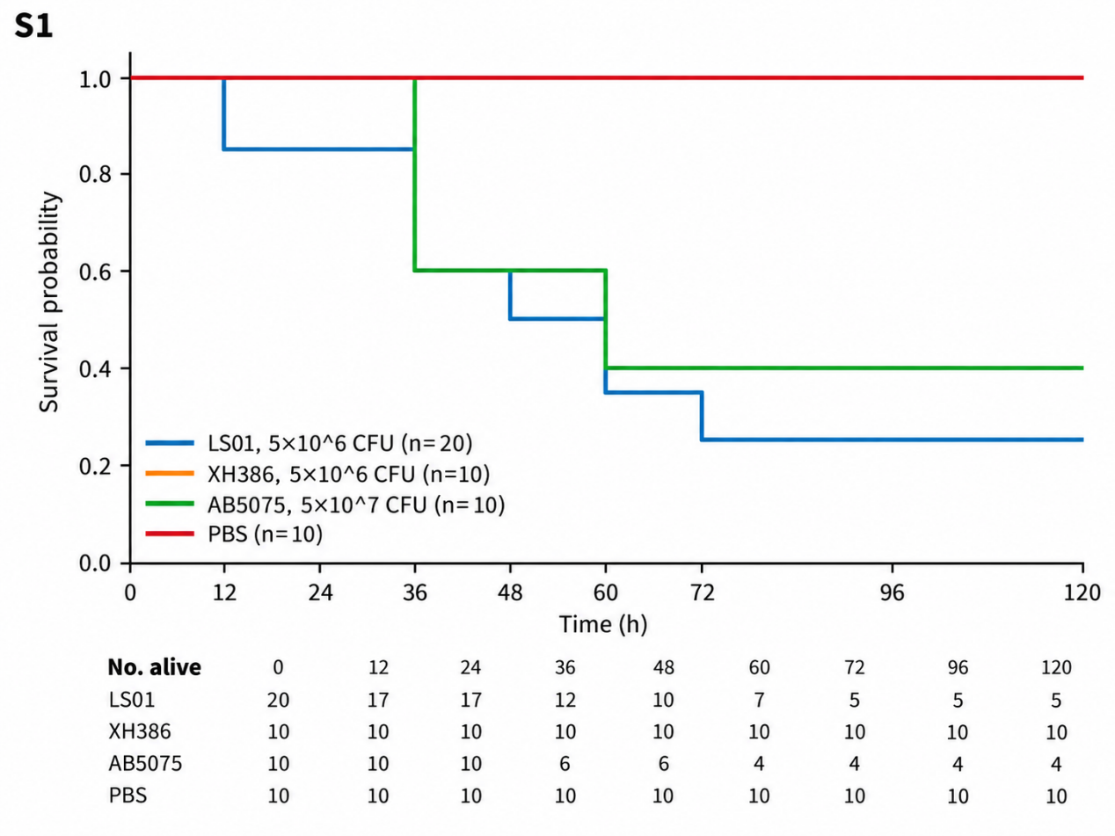
Supplementary Figure S1. Exploratory murine dose-ranging survival analysis. Kaplan–Meier survival through 120 h is shown for the LS01 cohort challenged with 5 × 10^6 CFU (n = 20; the same cohort used in the primary equal-dose experiment), an additional XH386 cohort challenged with 5 × 10^6 CFU (n = 10), an additional AB5075 cohort challenged with 5 × 10^7 CFU (n = 10), and PBS-treated controls (n = 10). Because the LS01 cohort was shared with the primary experiment and the additional cohorts differed in bacterial inoculum and group size, this analysis was interpreted descriptively and was not used for direct between-strain statistical inference.

